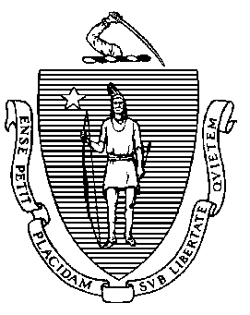 | Massachusetts Department of  Elementary and Secondary Education
 | Office of Educator Licensure | Telephone: (781) 338-6600
 | 135 Santilli Highway, Everett, MA 02149-1962 | TTY: .NET. Relay (800) 439-2370

ABE TEACHER’S LICENSE

Applicant’s Checklist

Dear Applicant,

Thank you for your interest in applying for the Adult Basic Education Teacher’s License.

In order to expedite the processing of your application, we ask that you review and complete the checklist below to be sure that all necessary documents have been submitted. The Department looks forward to evaluating your application once all the required documents have been received. We cannot return any originals, so please keep copies for yourself.

I hope to welcome you soon as a licensed educator in Massachusetts.

Sincerely,

Jeffrey C. Riley
Commissioner of Elementary and Secondary Education

- I have submitted copies of official transcripts and/or I have made arrangements to have my college(s) send the transcript(s) directly to the Office of Educator Licensure to the attention of the ABE Licensure Coordinator.

- I have submitted a copy of my resume or curriculum vita, which includes the months and years of employment.

- If applicable, I have submitted proof of name change by submitting a copy of one of the following: marriage certificate, court order, or valid driver’s license (if it bears the applicant’s social security number).

- If applying for the professional level of the license, and if applicable to the route to licensure, I have submitted the ABE Teaching Experience Verification Form as evidence of my ABE teaching experience.

- I have enclosed a certified bank check, personal check or money order, for the appropriate fee as per the Frequently Asked Questions.

- I have signed and dated the application and read and answered all of the questions.

- I am enclosing all the required documents together with my application (other than any transcripts that my college will send directly).

Please address all correspondence to the attention of:

MASSACHUSETTS DEPARTMENT OF ELEMENTARY AND SECONDARY EDUCATION
Office of Educator Licensure

135 Santilli Highway Everett, MA 02149

