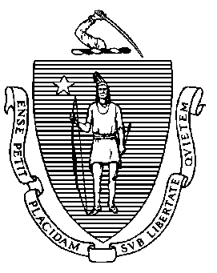 | Massachusetts Department of  Elementary and Secondary Education
 | Office of Educator Licensure |  |  |  |  |  | Telephone: (781) 338-6600
 | 135 Santilli Highway, Everett, MA 02149-1962 |  |  |  |  |  | TTY: N.E.T. Relay (800) 439-2370
Request for a Hard Copy of Massachusetts Educator License
Please note: for faster processing, you may order a hard copy of your Massachusetts Educator License in ELAR
    - Go to www.doe.mass.edu/licensure/ and Login to ELAR
    - On the Welcome to ELAR screen, click on the Request a Duplicate License link and follow prompts.
If you wish to mail in a hard copy of this form please complete all areas of this form so that we may process your request in a timely manner. Please type or print.
Current Last Name |  |  | Previous Last Name |  |  |  |  | First Name |  |  |  |  | MI
Street Address and Apartment Number (if any)
City |  |  |  |  |  | State |  |  |  |  |  | Zip Code
Date of Birth (Month/Day/Year) |  |  |  | Social Security # or MEPID # |  |  |  |  |  | MA License #
Email Address
- $25.00 fee: Please enclose a certified check, money order or personal check payable to the Commonwealth of Massachusetts. If you prefer to use MasterCard, Visa Or Discover you will need to apply for the hard copy online. We no longer accept mailed in credit card forms.
Please print out this form and sign below.
Signature (Current Name) |  |  |  |  |  |  |  |  |  |  | Date
- The signed and dated Request for a Hard Copy of Massachusetts Educator License form and payment can be:
Mailed to: |  | Massachusetts Department of Elementary and Secondary Education  Office of Educator Licensure  135 Santilli Highway  Everett, MA 02149-1962  *Please do not upload the Charge Card Authorization form to your ELAR account or fax it to the Office of Educator Licensure.

