Educator Licensure and Renewal Portal
Applicant User Guide
General Site Navigation 2
Start an Application 3
Submitting an Application 8
Pending or Idle Legacy Applications 12

General Site Navigation
When you first log into your account, you will see your Dashboard. Your Dashboard will show site announcements, a link to messages sent to you, any notifications sent to your activity feed, and links to your current licenses and applications.

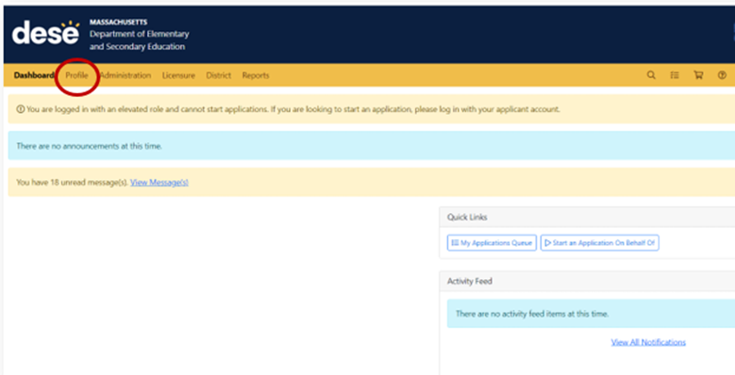

Clicking on the Profile link in the top navigation menu will take you to your main account page. The top link in the left-hand navigation will be your profile information, which includes demographic information. In this section you may edit some of your demographic information by clicking on the blue Edit button next to your personal information.

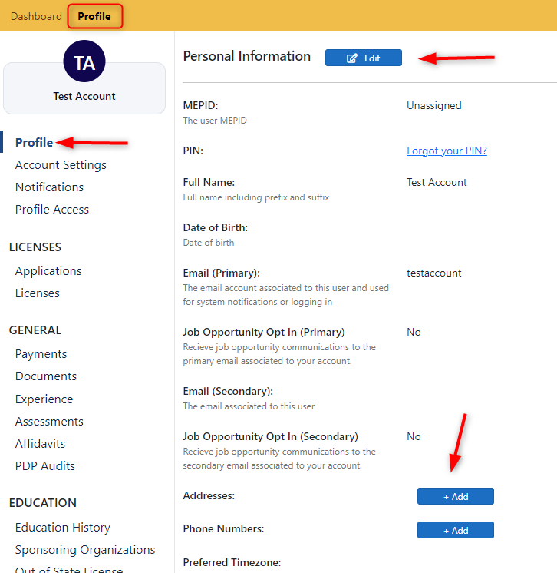

In addition to your profile information, you may also access all messages sent to you by clicking on the Notifications link in the left-hand navigation. Here you will see any notifications sent to you and message threads you are a part of.
Various other links are available in the left-hand navigation on your Profile tab. These include links to your licenses or open applications, as well as any assessment/MTEL results. You may view your MTEL results by clicking on the Assessments link in the left-hand navigation.
Furthermore, you may upload any necessary documentation to your profile by clicking on the Documents link in the left-hand navigation under the General section. Here, you will first click on the Choose File button, which will open a module that will allow you to select the file from your computer you wish to upload. Once you have selected the file, you must choose the Type of document from the dropdown menu. You may also enter a description of the file if you would like. Click +Add once the file is selected and the document type chosen. At this point, you may upload additional documents, or you may click on the Submit button to finalize and save the upload. 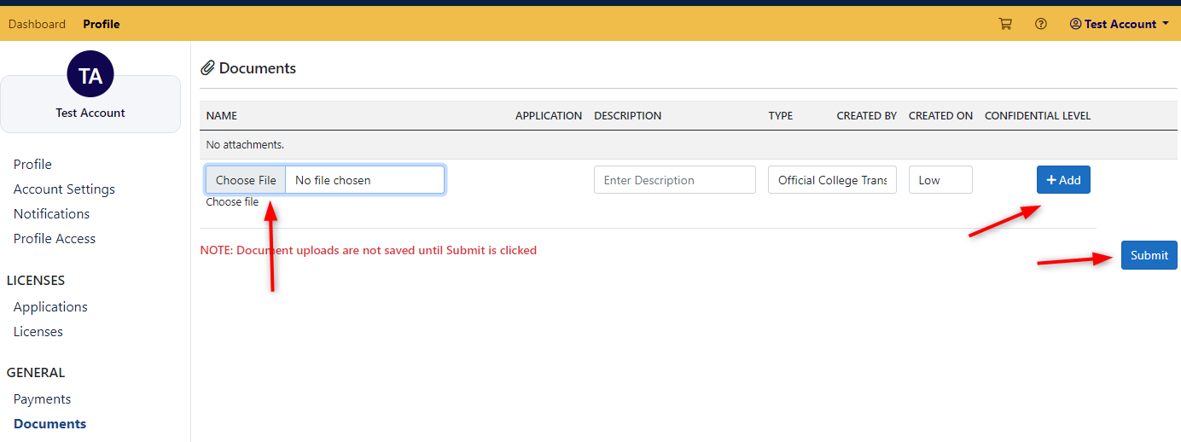

Start an Application
Once you are logged in to your account, there are a few ways to start an application. From your Dashboard, you may simply click on the link titled Start an Application. This will immediately start the Wizard. Alternatively, you may click on your Profile tab in the top navigation menu, and then click Applications in the left-hand navigation. You will then click on the +New button, which will then start the Wizard.

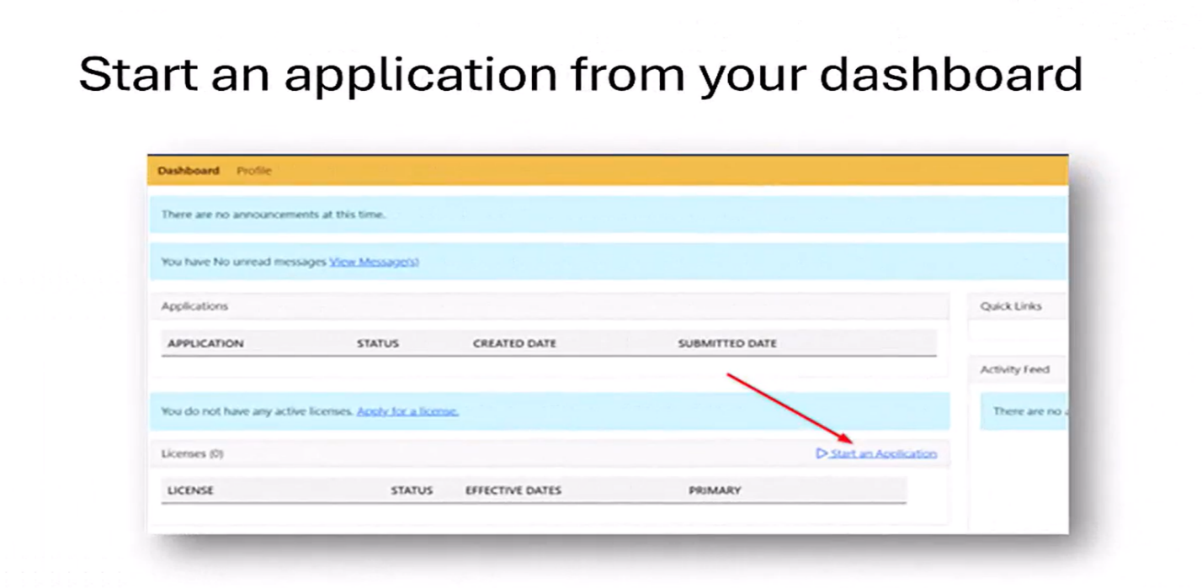

Once you are in the application Wizard, you will see various options available in the dropdown menu*(*Note that educators will only see the options for which they are eligible to apply). You may restart the application wizard over multiple times if necessary to start the process over.

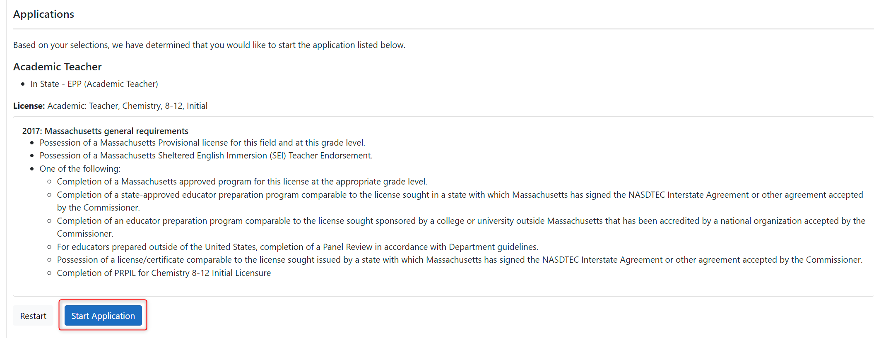
Also, note that the associated regulations for a credential application will appear before starting your application. If the license you are applying for has more than one requirement set, you may select the requirement set that best fits your situation. Once you have selected the requirement set (if more than one is available), you may click on the Start Application button, and an application will immediately be created.

You may also begin an application from your Profile.
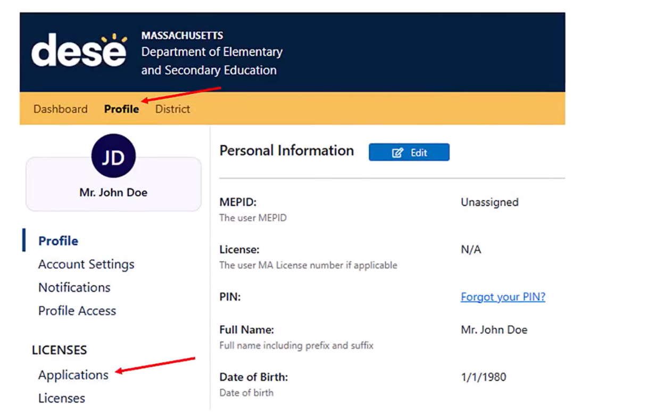

Click on + New Button to Start Licensure Wizard

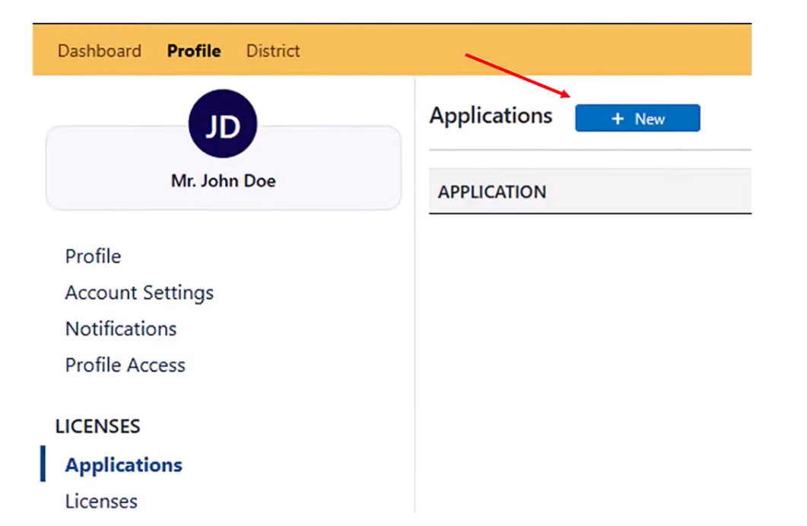

In Licensure Wizard you will see options available in drop-down wizard

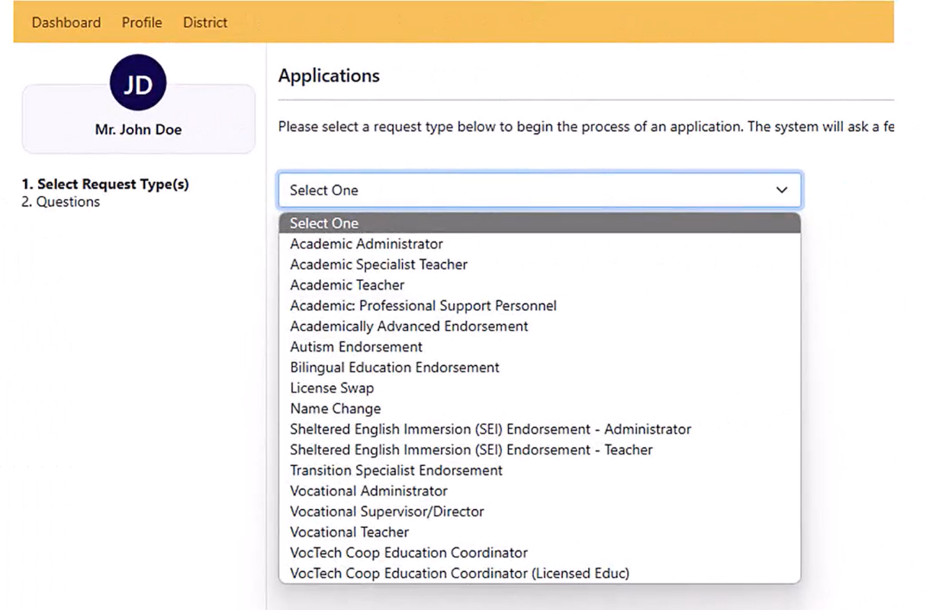

As you make selections new drop-down menus will be presented to narrow the options. You can re-start the Licensure Wizard multiple times if necessary to start the process over.

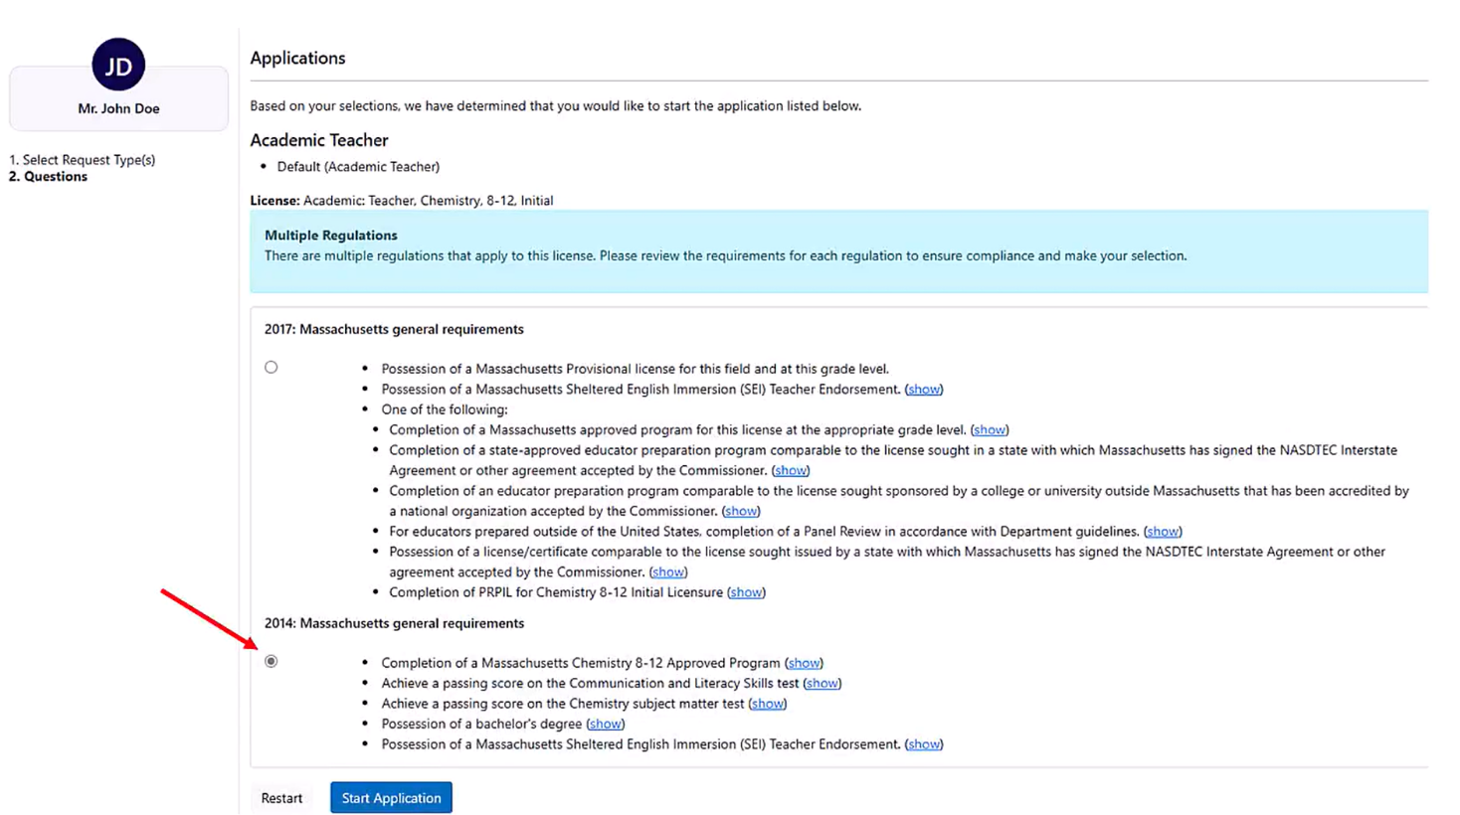

Applicants can click on a requirements set that best fits their situation, they should only be seeing the requirements sets that apply to them. Click on Start Application to begin. Select Restart Button to start the process over.

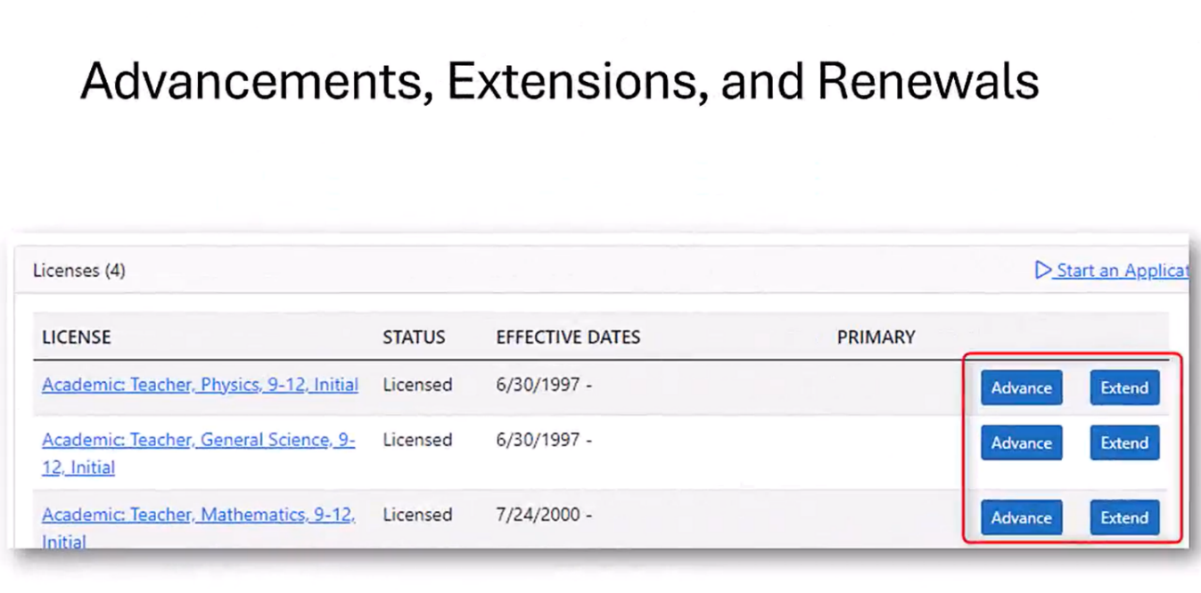

Advancements, Extensions, and Renewals are not accessed via the Licensure Wizard. If an educator is seeking to advance, extend, or renew, they will be able to access their current licenses via their Dashboard and will have an Advance or Extend button next to those licenses if that functionality applies to them.
Clicking on those buttons will bypass the Licensure Wizard and immediately place the educator on the pathway / application to advance, extend, or renew that licensure application.

Submitting an Application
Once the application is created, you will be in the Overview section of the application, where you will be able to see any licenses, you hold as well as any applications you may have already started. To complete the application, you will need to click on the specific Elements of the application either on the left-side navigation under Elements, or in the middle section of the screen under the Requirements section of the application.
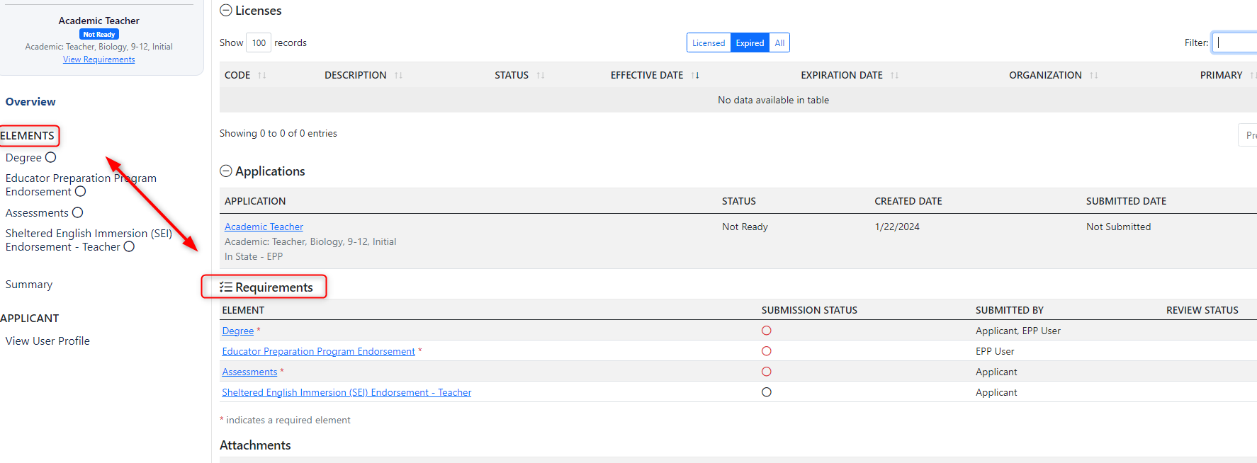
You may view each element by clicking on the element links underneath the Requirements section in the application overview or in the left-hand navigation of the application. You will need to make sure you check the confirmation box for each element before clicking Save & Continue. Once the element is confirmed, you may click Save & Continue and move to the next element.* (*Note: If an element in your application does not apply to your situation based on the requirements you have selected, you may skip that element and proceed with the application submission).

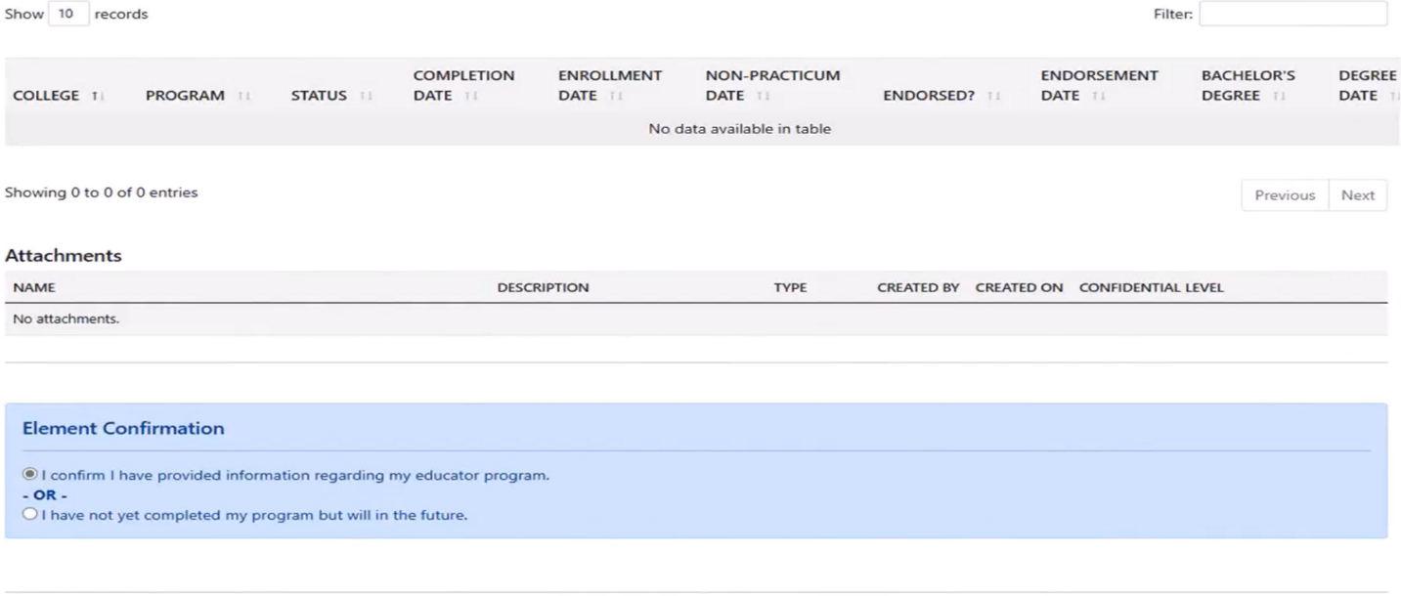

You may also add attachments to certain application elements. To add an attachment to an element, click on the Choose File button under the Attachments section of the element. After you have uploaded a document, you may then click the +Add button, which will open another choose file window to add another attachment to the element. When you are finished adding attachments click the Save Attachments button to save the attachments to your application.

You may add multiple documents to a single element, and you may add attachments to elements even after you have confirmed the element. When you have submitted the application, you will not be able to add a document to a specific element, however, you will be able to upload additional supporting documents to your ELAR profile. Any documents added to an application element will also appear in the Documents section of your profile.

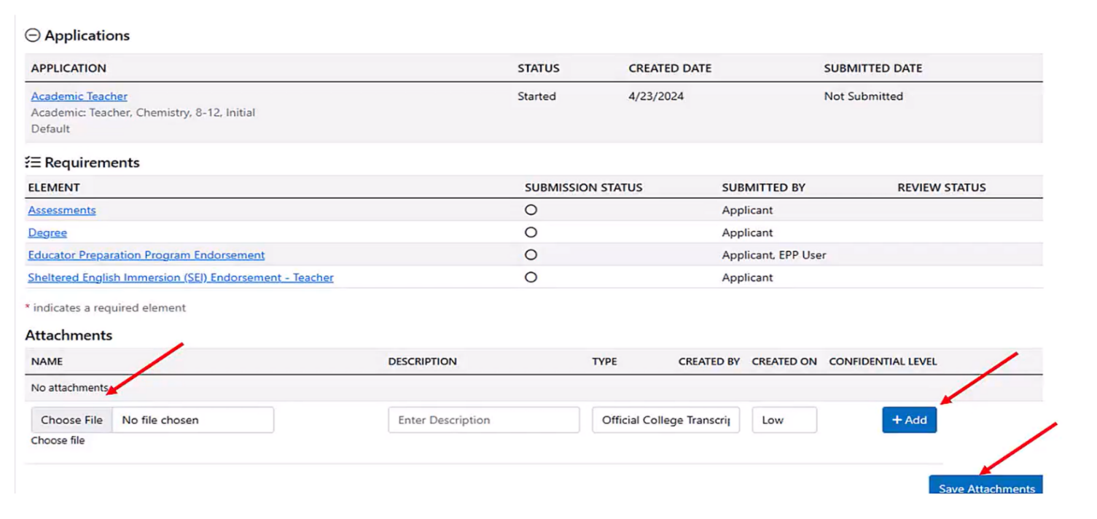

Each element will have a green check next to it if that element is confirmed and ready for submission. Once all elements are ready for submission, you may go to the Application Summary. You will automatically go to the summary after clicking Save & Continue on the last element of the application, or by clicking the “Summary” link in the left-hand navigation of the application.

In the summary, click the button that says, Mark as Ready for Submittal.

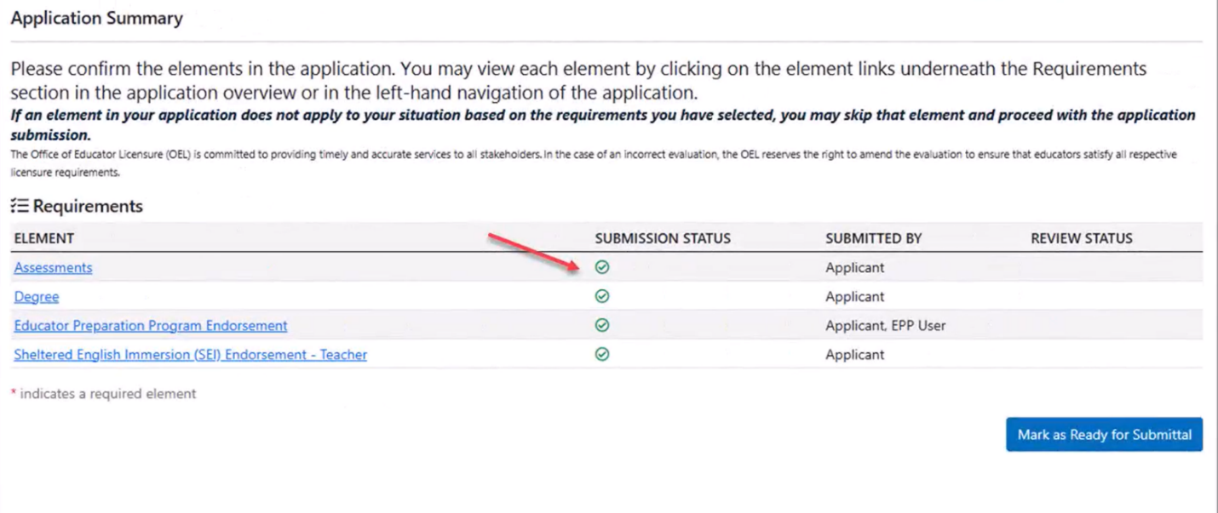
A pop-up will appear with directions on whether to proceed with the submittal process for any applications or close the pop-up in order to start other applications. If you want to continue with the submittal process, including the completion of the affidavit, click on Submit Eligible Applications.

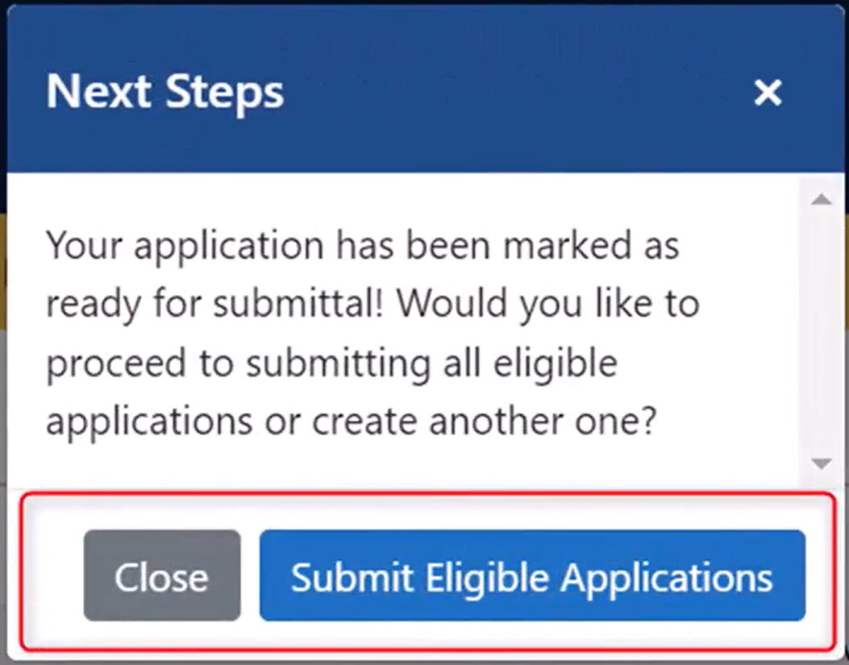

Next, you will see any applications that are ready for submittal. Please click on each application you would like to submit, then click on Proceed to Affirmation. From there, you will complete the affidavit by selecting the appropriate response to each question. You are able to include an explanation as necessary to any of the items listed. After answering each affidavit, signing it via your PIN (you will need to click on the “Forgot your PIN” link next to the Sign button to see the PIN that has been automatically assigned to you) and then clicking “Submit Affidavit.”

After successfully submitting your affidavit, you will then be taken back to your checkout page, and the Application Payment modal will open up. Fill out a payment option.

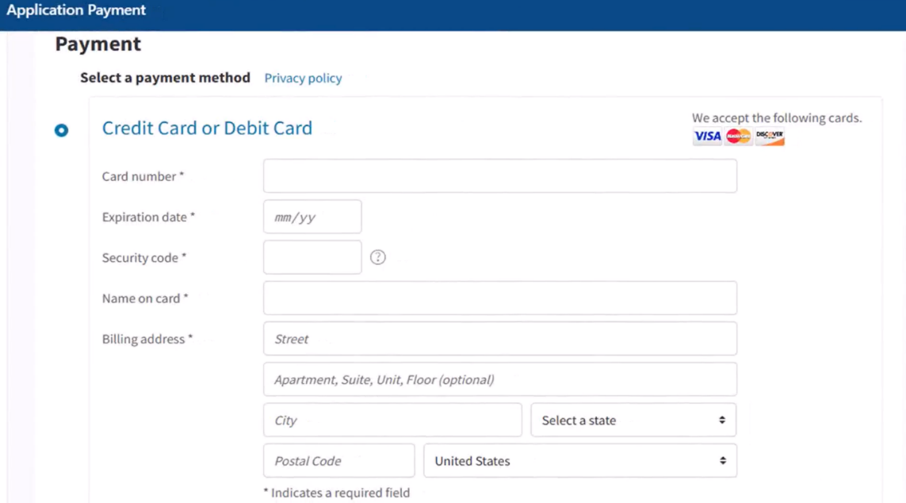

After entering in the payment information, scroll down to the bottom of the payment pop-up and click on “Review Payment.” After reviewing the information, click on “Submit Payment.” Once the payment is made, the application is submitted. For specific types of applications, such as professional license renewals, the application will be auto approved upon submittal. Other applications will show as “Submitted.” Once an application is assigned to a Licensure staff member (evaluator), it will show as “Pending Review.” If the application needs additional information, the evaluator will put the application back to “Pending,” and you will receive a notification regarding what other documentation or information your application needs. If an application is marked as “Approved,” you will be notified, and any license associated with the application will be issued.

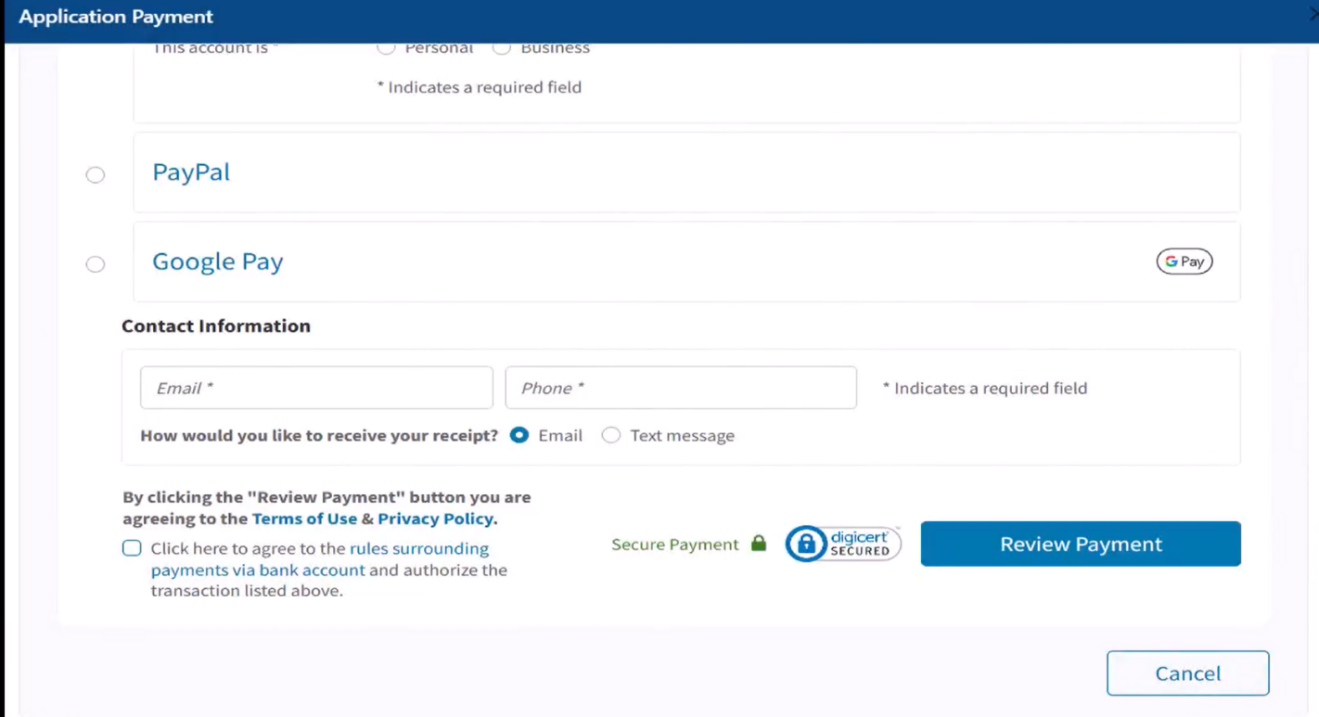

Pending or Idle Legacy Applications

If you had already paid for and submitted an application on the original ELAR website and it was pending or idle, it will appear as an ELAR 1.0 application on your account. You may access the application from the dashboard, or in the applications link on your profile. In order to resubmit an application that is “Pending,” you will need to click on the blue “Resubmit” button. This will open the application back up for you to add any additional documentation and information, and then you may continue with the submittal process as described above. You will not need to pay or fill out another affidavit for an application that was originally submitted on the original ELAR website.
