How to Apply for a License in ELAR: A Step-by-Step Guide
August 2021

Access ELAR System
- Go to www.doe.mass.edu/licensure/ | 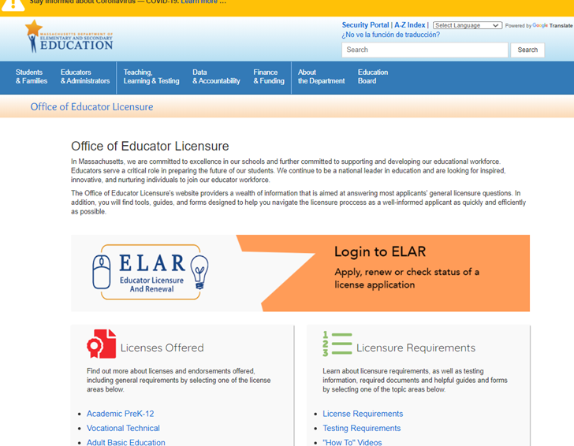
- Click on ELAR Login Image

Log-in to ELAR Portal
- Input your Username and Password (please note: these are case sensitive)  Note:  - If you do not have an ELAR account yet, or are not sure, click on the Create ELAR Profile link and create a new profile/account. If you do have a profile the system will locate it and notify you.  - If you do not know if you have an account, or have forgotten your ELAR Username or Password, click on the Forgot User Name/Password link and follow prompts. Again, if you already have a profile, you will be alerted.  - You will be required to provide an email address in your ELAR account. It is important that you keep your contact information in ELAR up to date. Most especially your email and mailing addresses. | 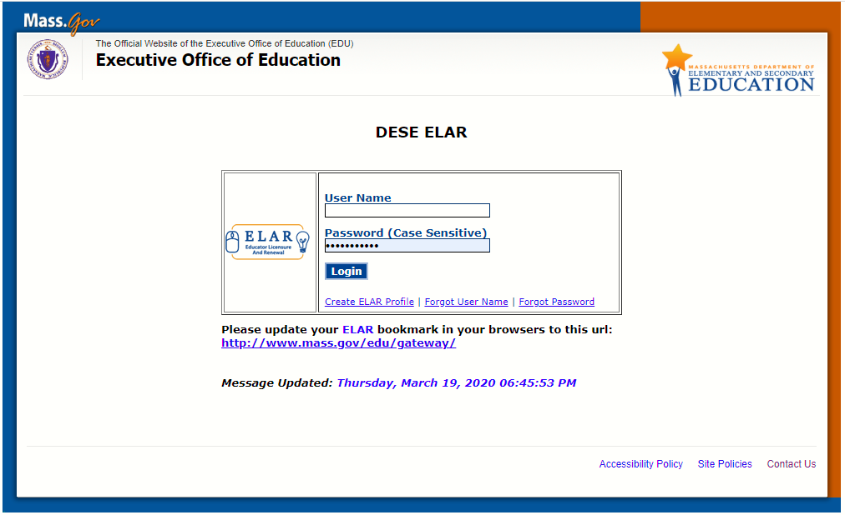

ELAR Welcome Page
- On your ELAR Welcome page click on the Apply for a new license, apply for an Endorsement, or advance to the next level license link | 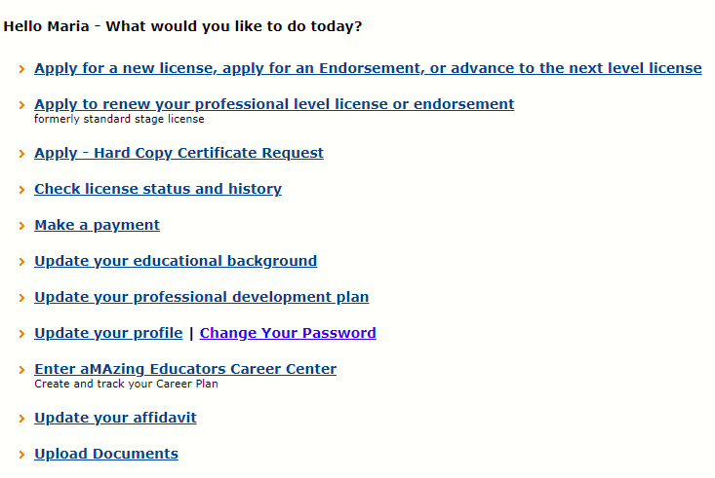
Apply for Licensure - Introduction Page
- Review instructions for how to navigate within the ELAR system.  - Click Next button | 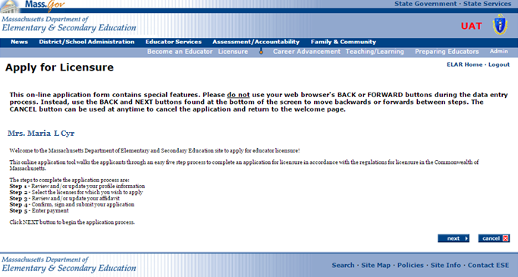

Step 1: Apply for Licensure
- Verify profile information.  - Click Next button  Note:  - The Department of Elementary and Secondary Education will communicate with you regarding your application via email so please ensure that you have provided a current and valid email address.  - You cannot update your name, birth date, or social security number.  To update your name, please follow the instructions on and upload the: Request for Name Change form into your ELAR account.  To update your social security number, please upload a copy of your social security card into your ELAR account. | 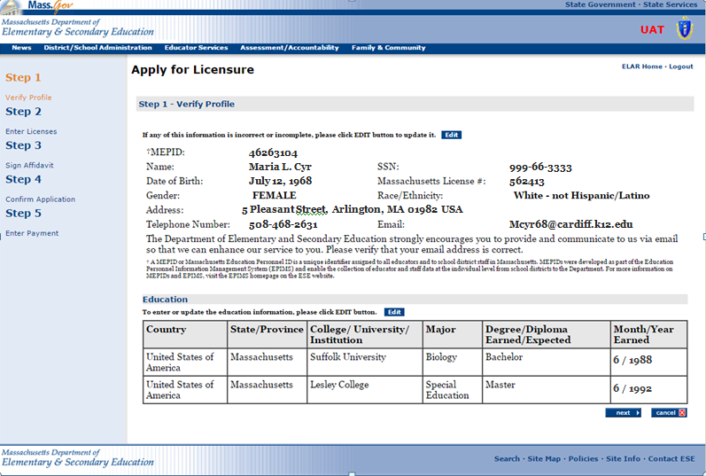

Step 2: Enter Licenses for Approval
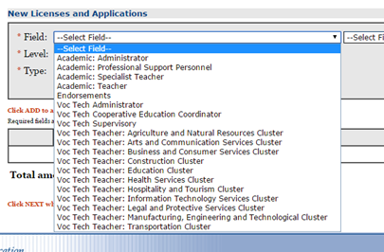  - Select the License Category in the first Field drop-down list  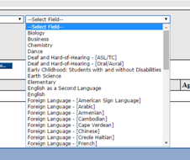  - Select the content area of the license in the second Field drop-down list  - Select the Level in the drop-down list  - Select the Type in the drop-down list  - Click on the add… button | 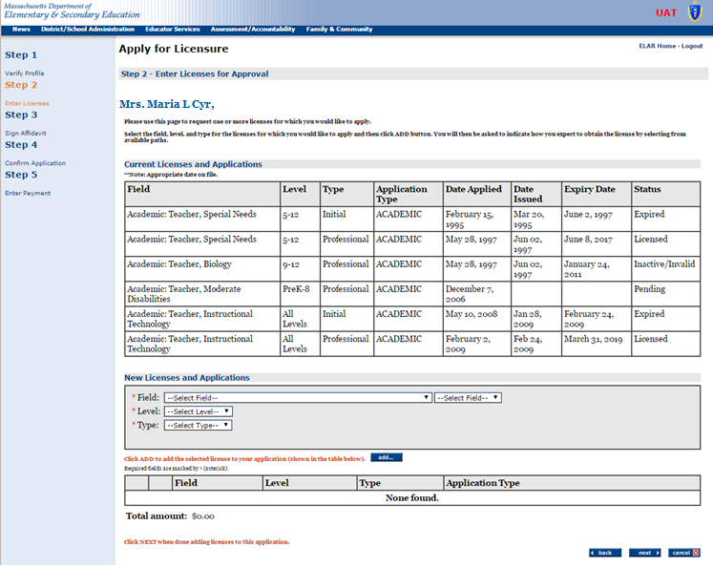
Note: When you click on the Add button another window will open up outlining the license requirements

Step 2a: Enter License Requirements
Most licenses have multiple paths and requirement sets that lead to licensure. The path that is most appropriate for you will depend upon your educational background, experience, license(s) already held, if you passed all required Massachusetts Tests for Educator Licensure (MTEL), and whether you hold the Sheltered English Immersion Endorsement, etc.  Shown on this page are examples of some common paths to the license you seek. You can click on any of the requirements that make up a path to learn more about how to satisfy that particular requirement.  A path has already been selected for you; however, you may select a different path, one that you believe best represents your qualifications. Please note that should you choose a path that is not the most appropriate path for you, you will be placed upon the proper path during the evaluation of your license application.  If only one path is available to you, it will already be selected.  - After reviewing the possible paths and licensure requirements, click on the Next button at the bottom of the page. You will be brought back to the previous screen. | 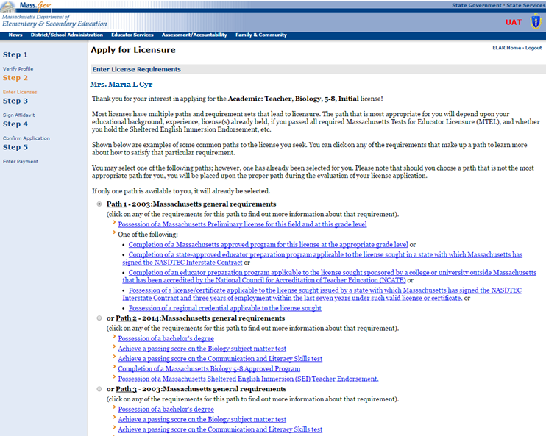

Step 2a: Enter Licenses for Approval
- At this point in the application, you can edit the license you are applying for or remove the license that you selected to apply for.  - Click the Next button when you are ready to move forward with your application.  - Upon clicking the Next button; a new screen will pop-up - the Recommended Licenses screen. | 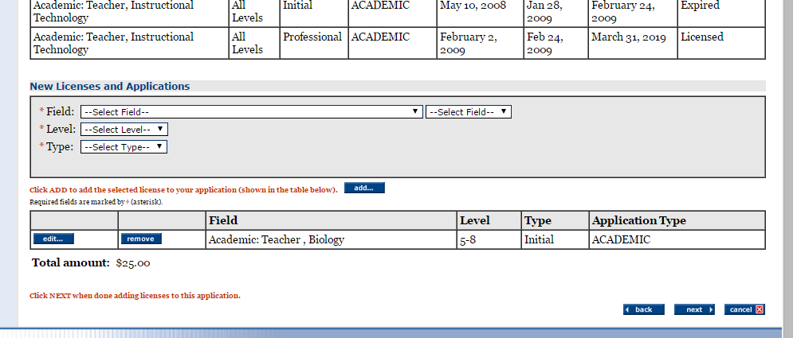
- The purpose of this screen is to make you aware of the content areas that are in high demand and to suggest that you consider applying for those licenses as well.  - Click on the Next button | 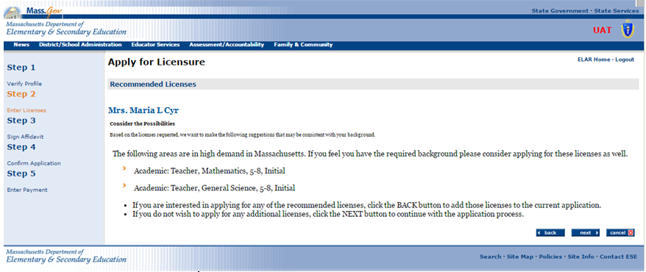

Step 3: Sign Affidavit
- Carefully read and affirm that the following statements are true (a check mark indicates the statement is true).  - Click on the box next to any statement to check/uncheck it.  - Please explain any unchecked boxes in the area provided at the bottom of the screen or mail in a separate written explanation pertaining to your “Affidavit” attached to your application.  - If you wish to exit without saving, click CLOSE.  - When finished, click SIGN button to save your changes.  By SIGNING you are confirming that all the information in your affidavit is true and contains no misrepresentations or falsehoods. | 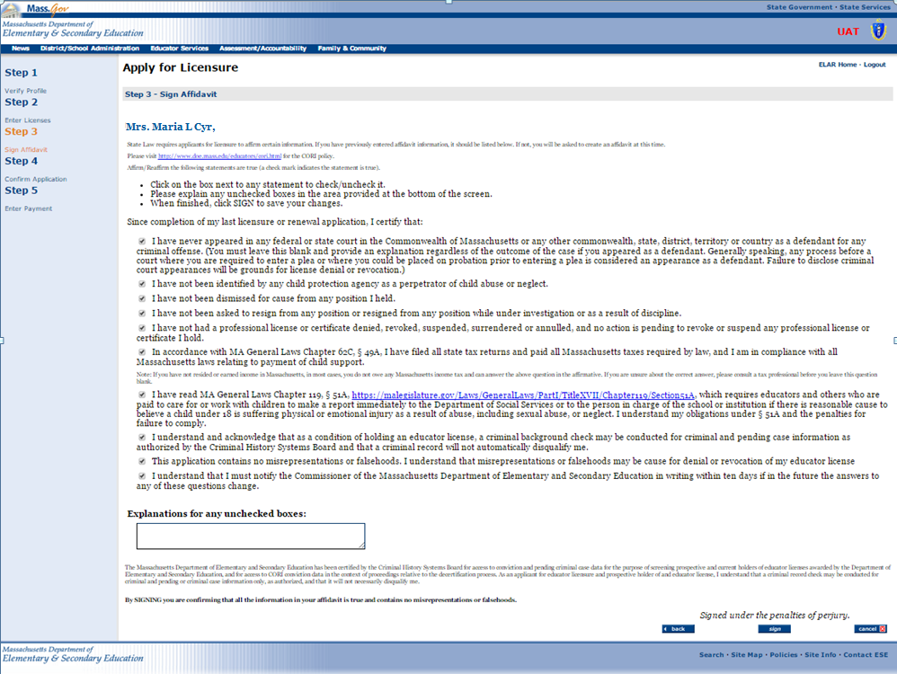

Step 3: Sign Affidavit
- You will see a pop-up window confirming that you have successfully signed your affidavit.  - Click on the OK button | 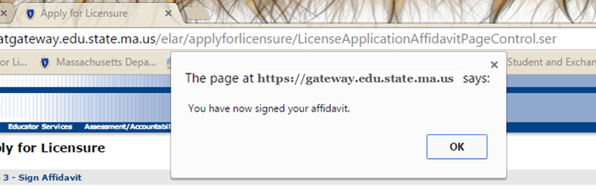
Step 4: Confirm Application
- You will now be prompted to sign your application.  - Click on the Sign button | 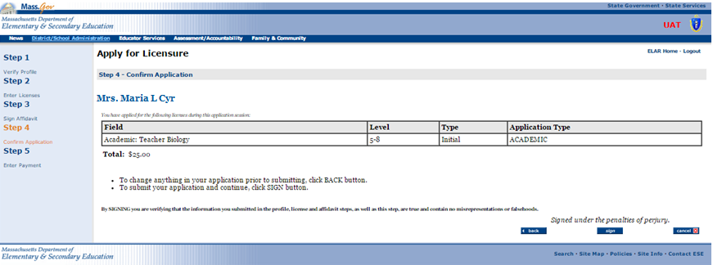
- A window will pop-up verifying that you have signed your application.  - Click on the OK button | 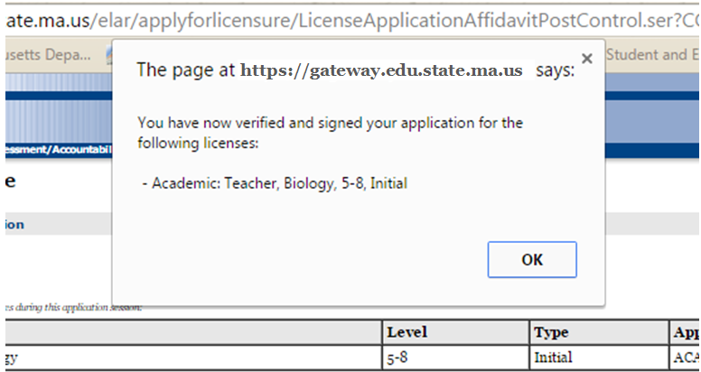

Step 5: Make Payment
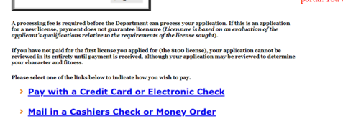
- You will now be prompted to make a payment. Licensure fees are: $100 for the first licensure application and $25 for each additional application. Please note that if you apply for two licenses at once, but only pay the fee for the “additional” license ($25 fee), neither applications will be evaluated until a total payment of $100 has been received.

Step 5: Make Payment – Credit Card Online
- Fees can be paid online using a credit card. Select Pay Online with a Credit Card or Electronic Check link  - Click Ok button | 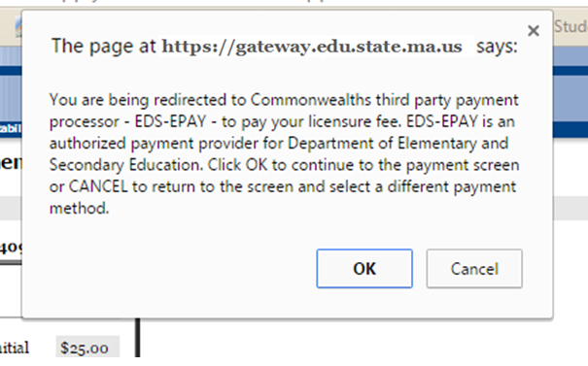
- Enter credit card information  - Click on Continue button | 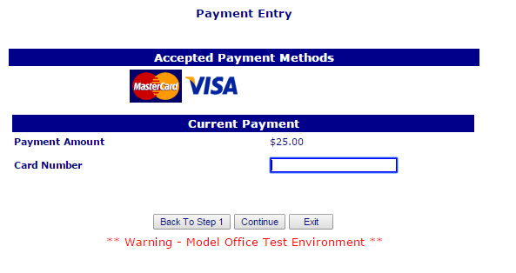

Step 5: Make Payment – Mail in Cashier’s Check or Money Order Payment
If you have applied online and would rather mail in your payment by check:  - Fill in all required information (Note, the check# and institution fields can be left blank as you will be attaching your check to the next page and mailing it in.)  - Click on the Next button  - Print out the page and mail it to the Office of Educator Licensure  Massachusetts Department of Elementary and Secondary Education  Office of Educator Licensure  135 Santilli Highway, Everett, MA 02149. | 