How to Pay for an Unpaid* License/Endorsement/or Renewal Application in ELAR: A Step-by-Step Guide
August 2021

*Please note that this guide is only for those who have already submitted an application/applied in ELAR but have not yet paid for it.

Access ELAR System
- Go to: www.doe.mass.edu/licensure/ | 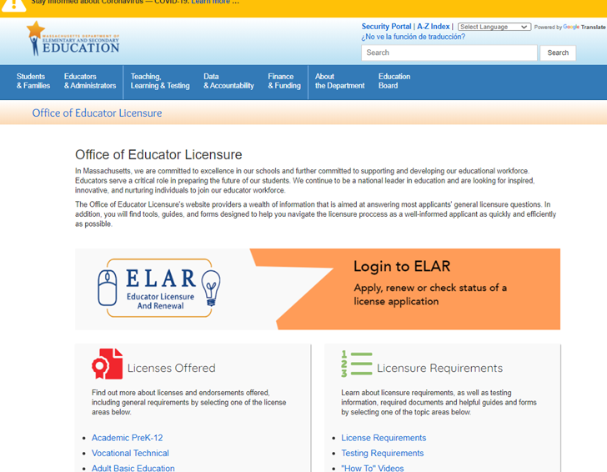
- Click on ELAR Login Image

Log-in to ELAR Portal
- Input your Username and Password (please note: these are case sensitive)  Note:  - If you do not have an ELAR account yet, or are not sure, click on the Create ELAR Profile link and create a new profile/account. If you do have a profile the system will locate it and notify you.  - If you do not know if you have an account, or have forgotten your ELAR Username or Password, click on the Forgot User Name/Password link and follow prompts. Again, if you already have a profile, you will be alerted.  - You will be required to provide an email address in your ELAR account. It is important that you keep your contact information in ELAR up to date. Most especially your email and mailing addresses. | 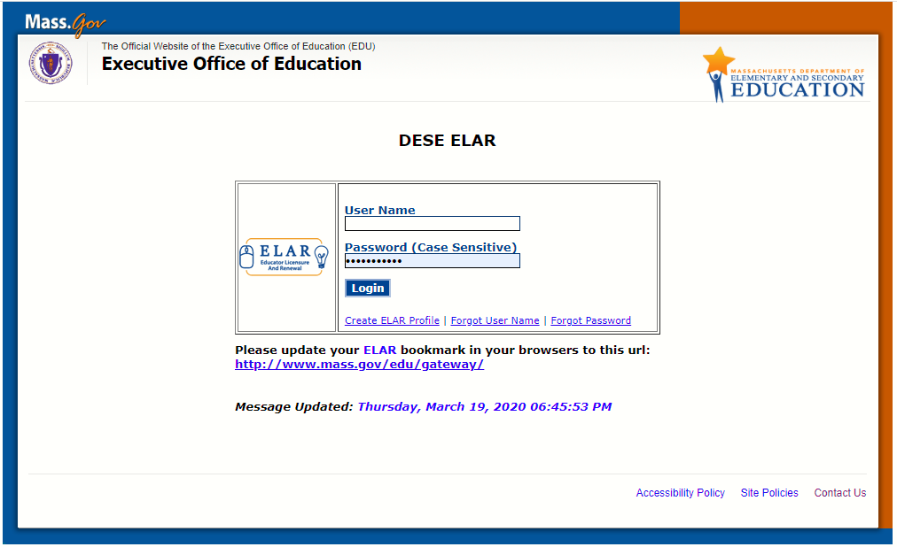

ELAR Welcome Page
- On your ELAR Welcome page, click on Make a payment link | 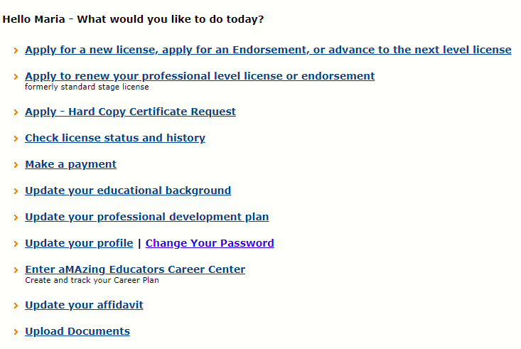
Payment History Page
- On the Payment History page, you will see a Payments table - payments already submitted (if applicable) as well as a table of Services Awaiting Payment.  - Click on the check box (in the Pay Now column) associated with the service to be paid.  - Click on the Pay button. |  | 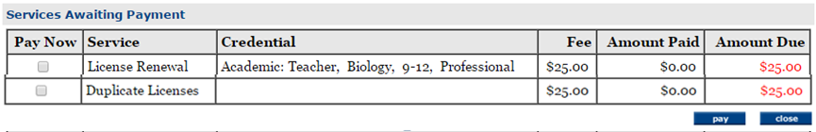

Sign Affidavit
- Carefully read and affirm that the following statements are true (a check mark indicates the statement is true).  - Click on the box next to any statement to check/uncheck it.  - Please explain any unchecked boxes in the area provided at the bottom of the screen or mail in a separate written explanation pertaining to your “Affidavit” attached to your application.  - If you wish to exit without saving, click CLOSE.  - When finished, click SIGN button to save your changes.  By SIGNING you are confirming that all the information in your affidavit is true and contains no misrepresentations or falsehoods. | 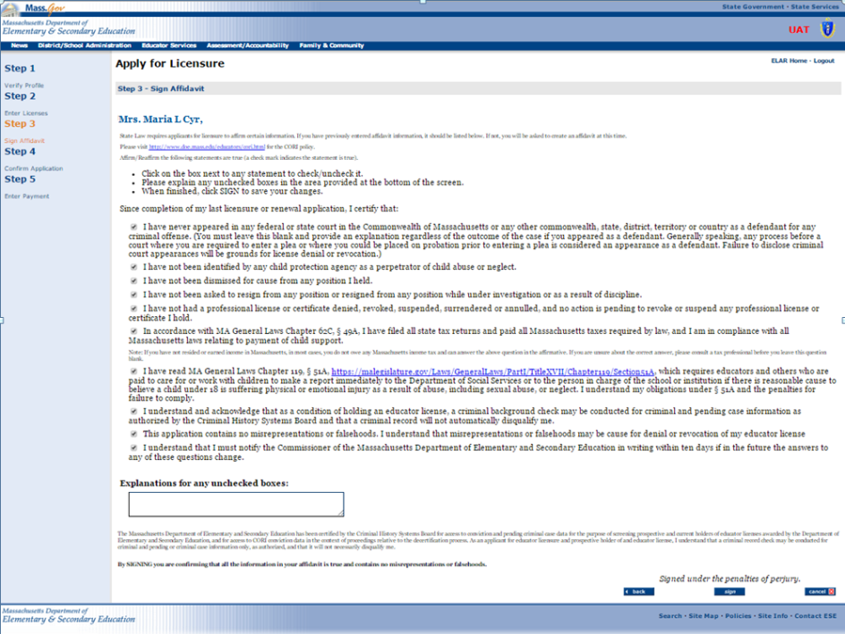
- You will see a pop-up window confirming that you have successfully signed your affidavit.  Click on the OK button | 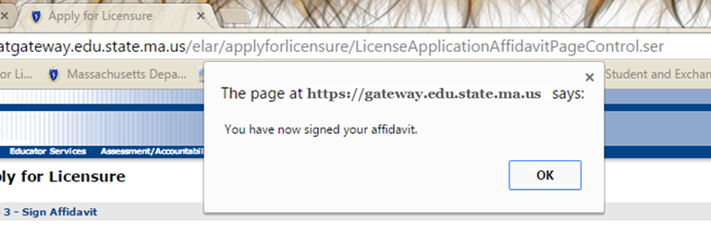

Make Payment
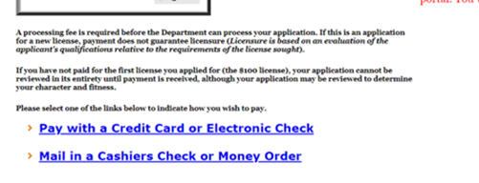
- You will now be prompted to make a payment.
*Warning: Please make sure you are using updated systems and browsers because the vendor made upgrades to the payment system and the system no longer supports payments being made via old browsers due to security concerns.
Make Payment – Credit Card Online
- Fees can be paid online using a MC/Visa credit card or Electronic Check. Select Pay with a Credit Card or Electronic Check link.  - Click Ok button | 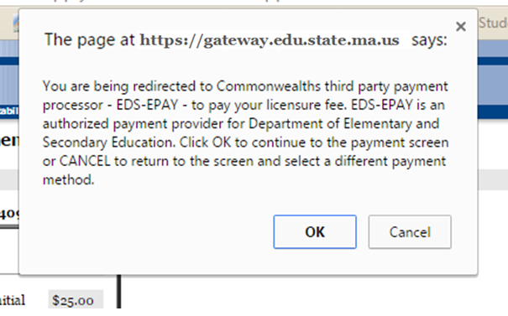
- Enter credit card information  - Click on Continue button | 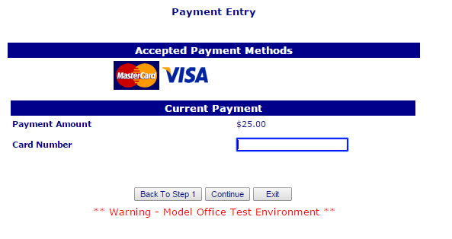

Make Payment – Mail in Bank/Cashier’s Check or Money Order
If you have applied online and would rather mail in your payment by check:  - Fill in all required information (Note, the check# and institution fields can be left blank as you will be attaching your check to the next page and mailing it in.)  - Click on the Next button  - Print out the page and mail it to the Office of Educator Licensure  Massachusetts Department of Elementary and Secondary Education  Office of Educator Licensure  75 Pleasant Street  Malden, MA 02148 | 