How to Renew a License in ELAR: A Step by Step Guide
August 2021

Access ELAR System
- Go to www.doe.mass.edu/licensure | 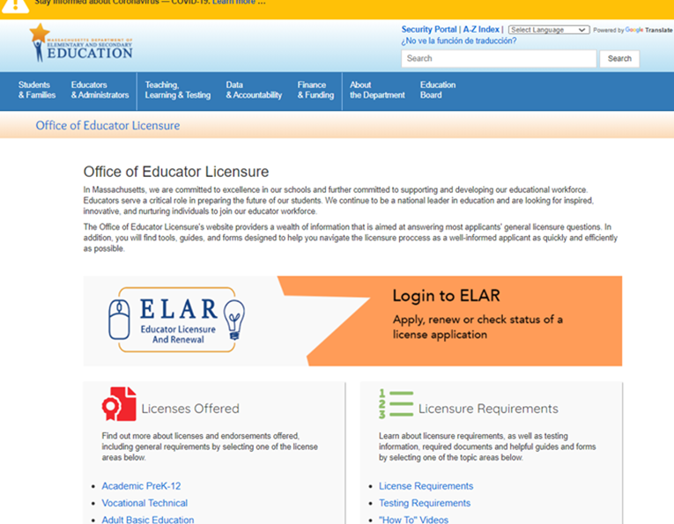
- Click on ELAR Login Image

Log-in to ELAR Portal
- Input your Username and Password (please note: these are case sensitive)  Note:  - If you do not have an ELAR account yet, or are not sure, click on the Create ELAR Profile link and create a new profile/account. If you do have a profile the system will locate it and notify you.  - If you do not know if you have an account, or have forgotten your ELAR Username or Password, click on the Forgot Username/Password link and follow prompts. Again, if you already have a profile, you will be alerted.  - You will be required to provide an email address in your ELAR account. It is important that you keep your contact information in ELAR up to date. Most especially your email and mailing addresses. | 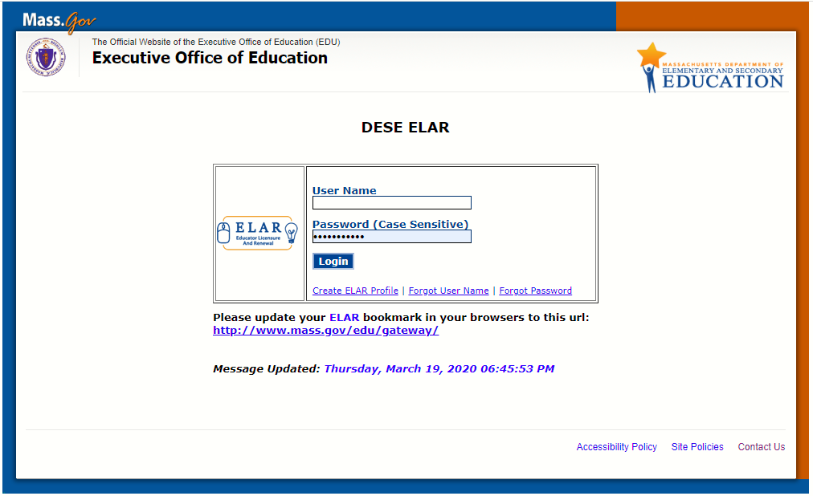

ELAR Welcome Page
- On your ELAR Welcome page, click on Apply to renew your professional level license or endorsement link | 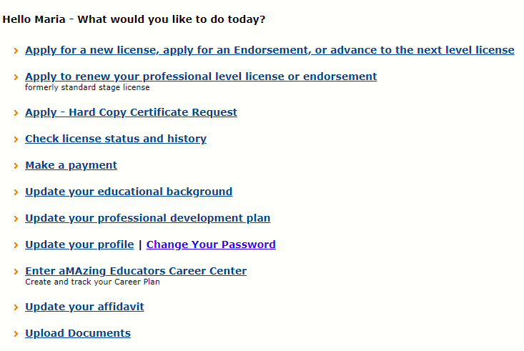
Apply for Renew Professional Level License(s) - Introduction Page
- Review instructions for how to navigate within the ELAR system.  - Click Next button | 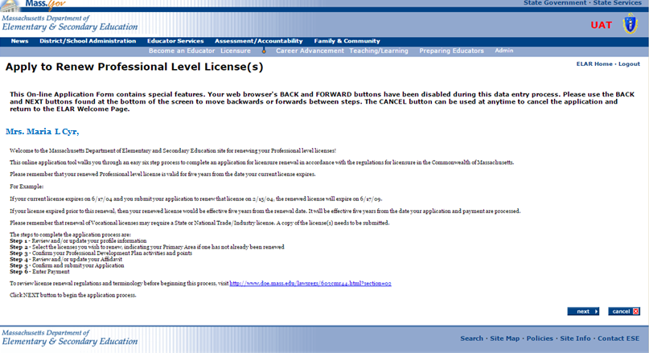

Step 1: Verify Profile
- Verify profile information.  - Click Next button  Note:  - The Department of Elementary and Secondary Education will communicate with you regarding your application via email so please ensure that you have provided a current and valid email address.  - You cannot update your name, birth date, or social security number.  To update your name, please follow the instructions on and submit the: Request for Name Change/Hard Copy form.  To update your social security number, please send a copy of your social security card to the Office of Educator Licensure. | 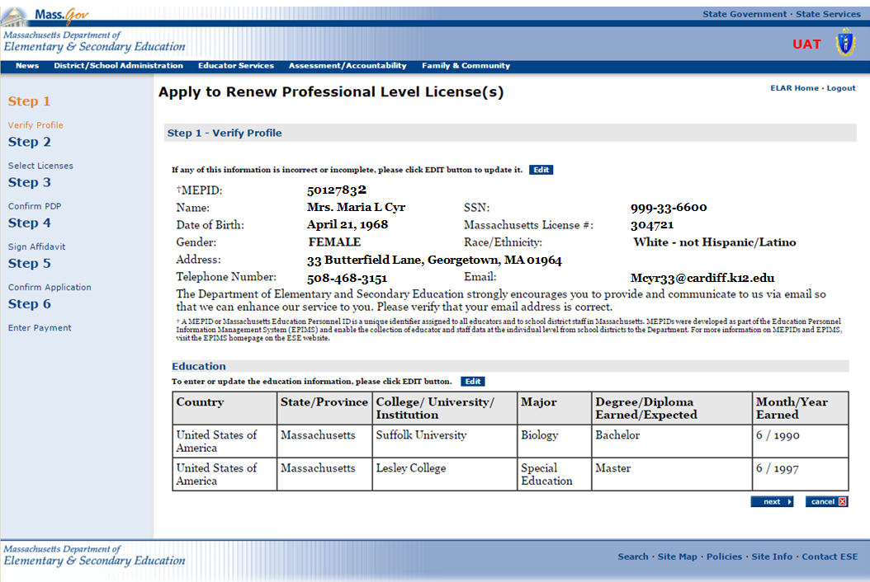
Step 2: Select Professional Level Licenses for Renewal
- Select the License you wish to renew by checking the box next to the license.  - If this is not your primary area and you wish to change this license to your primary area license, select the radial button in the Primary Area column.  - The fee for renewing your primary license is $100, additional licenses are $25  - Click on the Next button. |  | 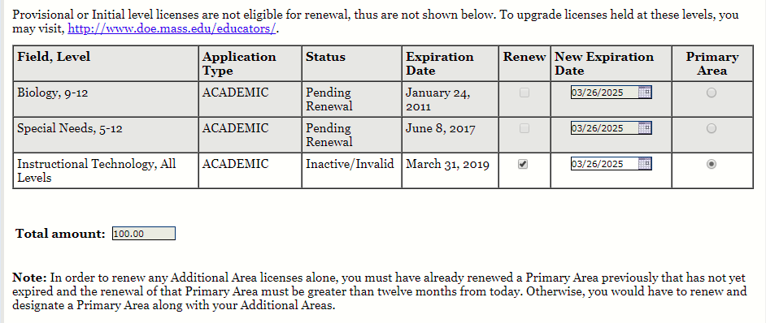
Note: Licenses due for renewal, can be renewed up to one year prior to the renewal expiration date. For example if your license expires December 27, 2019, it can be renewed any time after December 27, 2018. It cannot be renewed before December 27, 2018. If your Primary license is less than one year from the renewal expiration date, you will be unable to renew one or more Additional licenses. For example, if your Primary license expires on July 22, 2019, and your Additional license expired or is due to expire before July 22, 2019, you will not be able to renew the Additional license without designating and renewing one of your Professional licenses as the Primary license.

Step 3: Confirm PDP
- Respond to Q #1 – Are you currently employed in the role of your professional level license in a MA public school. Choose yes or no (click on circle next to answer).  - If you choose yes, you will be asked to verify that your supervisor approved your professional development plan. Again, select yes or no. | 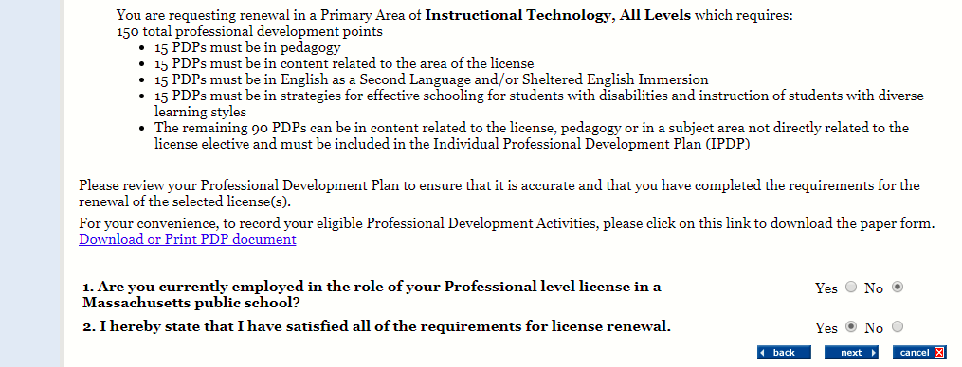
- Q #2 - Verify that you have satisfied all of the requirements for license renewal. Again, select yes or no.
Note: If you are renewing a primary license upon attesting to having satisfied the requirements of license renewal, you are attesting to having the correct number and types of PDP’s.
- Click on the Next button.
Step 4: Sign Affidavit
- Carefully read and affirm that the following statements are true (a check mark indicates the statement is true).  - Click on the box next to any statement to check/uncheck it.  - Please explain any unchecked boxes in the area provided at the bottom of the screen or mail in a separate written explanation pertaining to your “Affidavit” attached to your application.  - If you wish to exit without saving, click CLOSE.  - When finished, click SIGN button to save your changes.  By SIGNING you are confirming that all the information in your affidavit is true and contains no misrepresentations or falsehoods. | 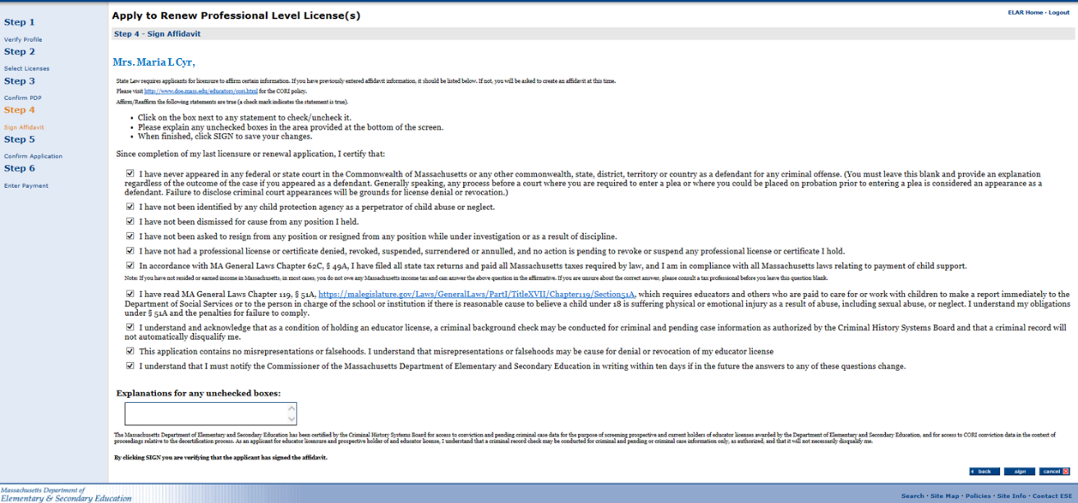
Step 5: Confirm Application
- Confirm your application by clicking on the Submit button. A new window will pop up confirming that you have successfully signed your application. Click OK button.
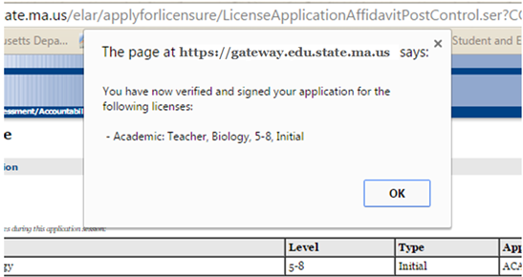

Step 6: Enter Payment
- Acceptable forms of payment are: credit card, electronic check, cashier’s check, money order, or personal check.
- Select the Pay with a Credit Card or Electronic Check link to make a payment using a credit card
- Select the Cashier’s Check / Money Order Payment to make a payment using a cashier’s check, money order, or personal check.
- Fill in all required information on the new page
- Print out page and mail it along with the check/money order to the Office of Educator Licensure

Massachusetts Department of Elementary and Secondary Education
Office of Educator Licensure
75 Pleasant Street
Malden, MA 02148
