How to Upload Documents to ELAR: A Step by Step Guide
August 2021

What documents can be uploaded?
Generally speaking, any document (employment verification form, internship letter, course description, name change request form, etc.) whose scanned/copied image is legible when viewed by a licensure specialist, can be uploaded and saved into your ELAR account. Documents that should not be uploaded include: applications and credit card authorization forms (these should not be uploaded or faxed), copies of transcripts wherein the Registrar’s signature is not visible/legible on the scanned/copied image and documents that bear an embossed seal; these documents would need to be mailed in to the Office of Educator Licensure, 75 Pleasant Street, Malden, MA 02148. Please put one of the following identifiers on all documents mailed in to the office: MEPID or License # (can found in your profile in ELAR), or your social security #.
Please note: when uploading official copies of transcripts (both paper copies received via mail from a College/University as well as those received electronically via email from a College/University/or third party such as eScrip-Safe, National Student Clearinghouse, Parchment etc.);
- Please make sure you upload both the front and back sides of each page. The Registrar’s signature should be legible as well as the degree conferred and conferral date (if applicable).
- If your transcript is under a different name (first or last) than that of your ELAR account; please also upload proof of name change (marriage certificate/divorce certificate, etc.).
- Any transcript that does not have a legible Registrar’s signature on it will not be considered official for the purpose of licensure (see Appendix B for additional information).
Access ELAR System
- Go to www.doe.mass.edu/licensure/ | 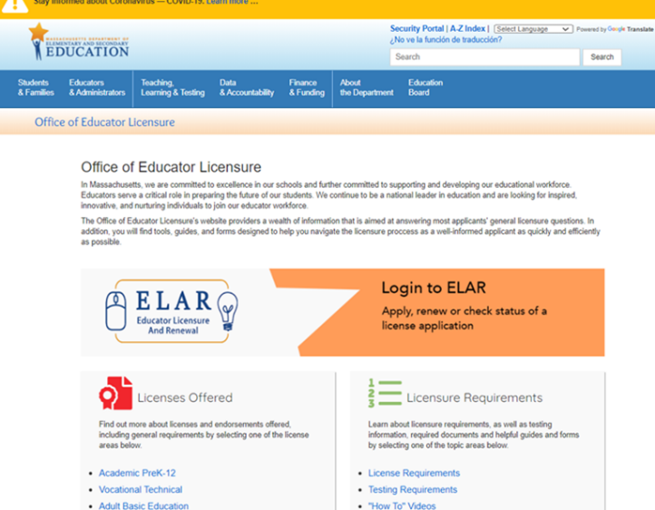
- Click on ELAR Login Image

Log-in to ELAR Portal
- Input your User Name and Password (please note: these are case sensitive)  Note:  - If you do not have an ELAR account yet, or are not sure, click on the Create ELAR Profile link and create a new profile/account. If you do have a profile the system will locate it and notify you.  - If you do not know if you have an account, or have forgotten your ELAR User Name or Password, click on the Forgot User Name/Password link and follow prompts. Again, if you already have a profile, you will be alerted.  - You will be required to provide an email address in your ELAR account. It is important that you keep your contact information in ELAR up to date. Most especially your email and mailing addresses. | 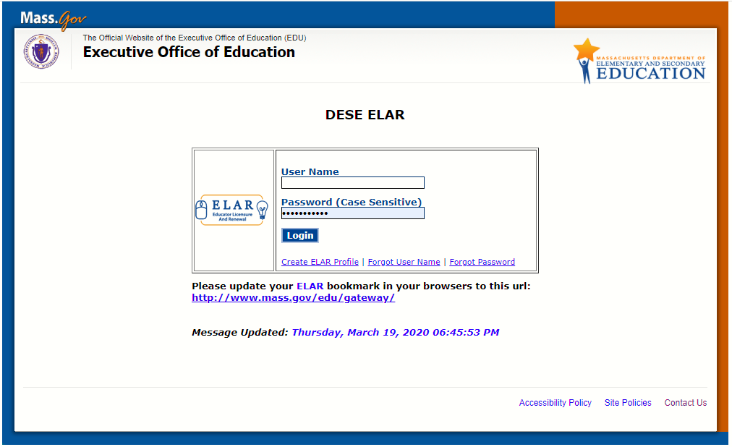

ELAR Welcome Page
- On your ELAR Welcome page, click on Upload Documents link  Note: If you are a Sponsoring Organization uploading a document on behalf of a candidate, click on Administrative Inquiry and search for the candidate by MEPID. Once you’ve opened the candidate’s ELAR profile, follow the directions outlined below.  *Please note: if you have not paid the license application fee for your first license, the Upload Documents button will not be visible. | 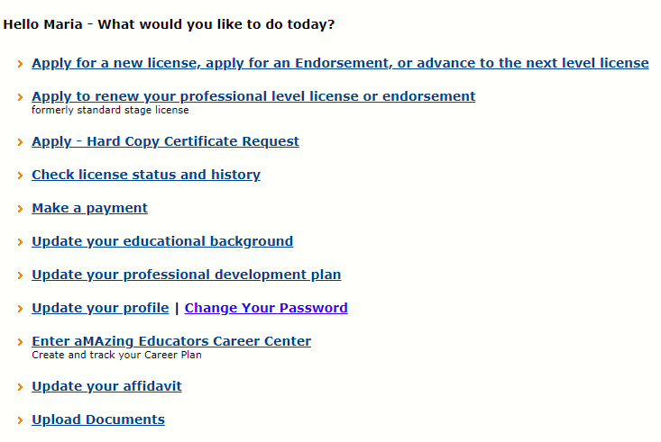
For Sponsoring Organizations Only: Upload Documents Button
- Scroll down the Activity Summary Page to find the green button labeled “Upload Documents” | 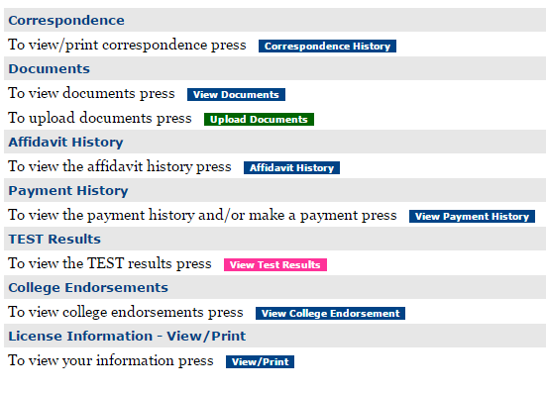

Browse for Document
- Click on the “Browse” OR “Choose File” button (the button may be labeled differently – based upon the type of Administrative access that you have in ELAR. | 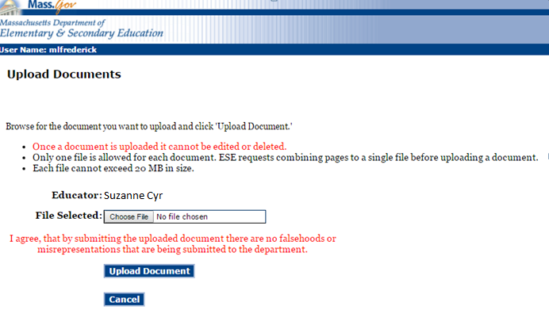  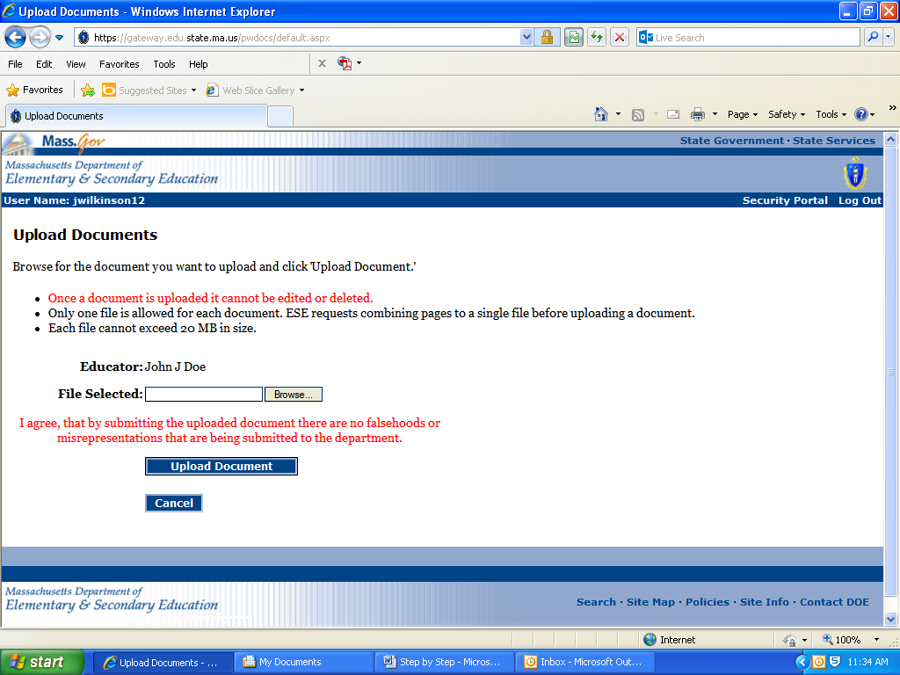
Select Document
- Locate the file you have saved to your computer (PDF, JPG), and double click on it (or highlight it and click “open”).  Note:  - Refer to appendices A-C: to determine if this is an appropriate method of delivery for the document you wish to upload; to ensure that the transcript you are uploading may be deemed ‘Official’ by ESE; and to ensure that a licensure specialist can verify degree conferral (where applicable). |  | 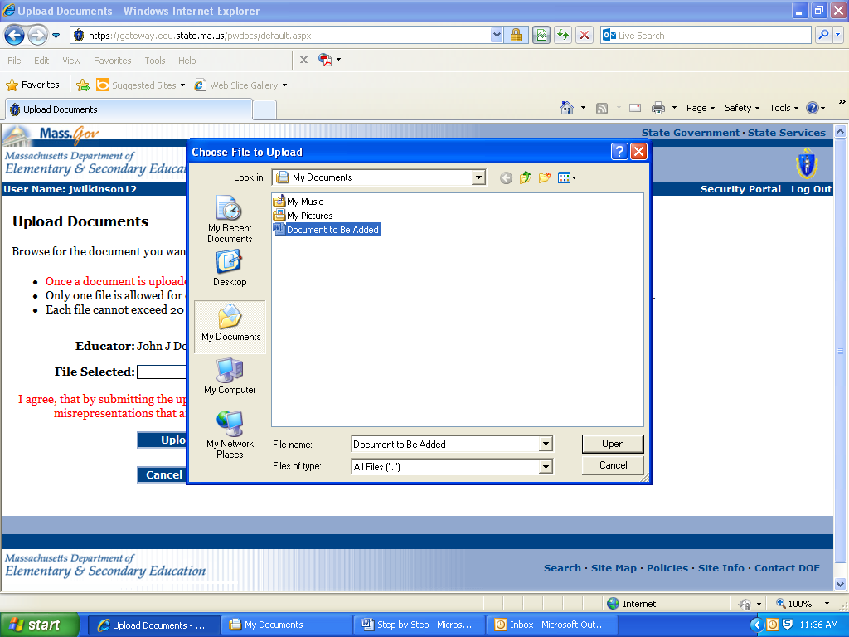

- Click on the Upload Document button | 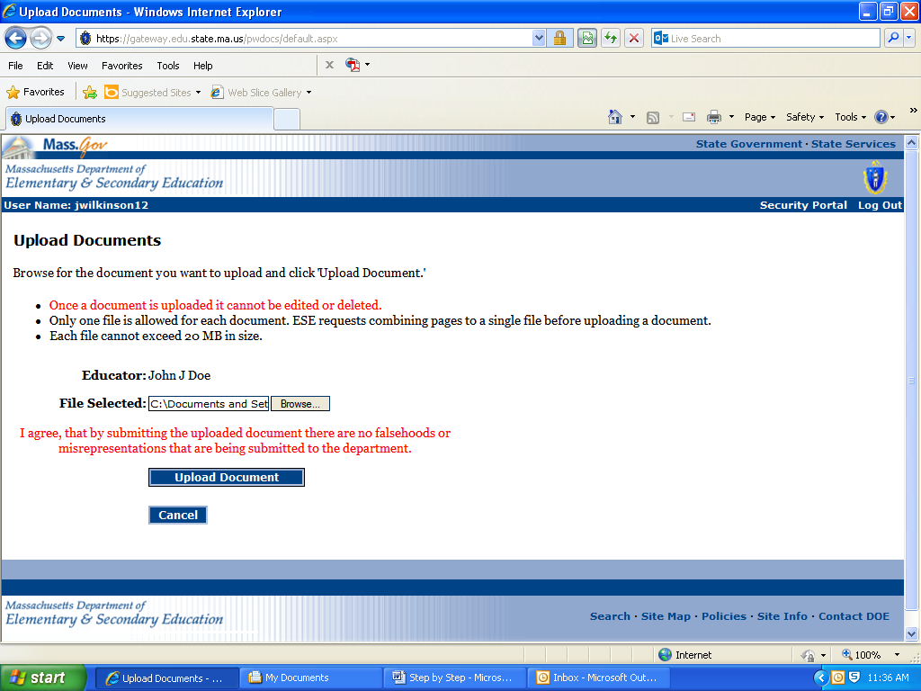
Identify Type of Document
- Select the document type being uploaded from the dropdown menu (please note that types beginning with “Voc” should only be selected when the related license application is for Vocational Licensure). | 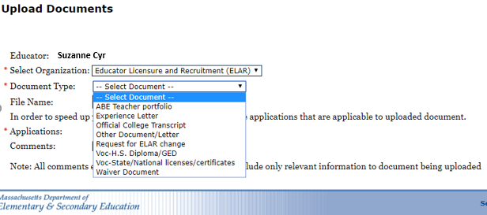
Choose Licensure Application
- Select which open License Application you wish the document to apply to. You may choose “All,” “None” or identify as many individual applications as necessary. | 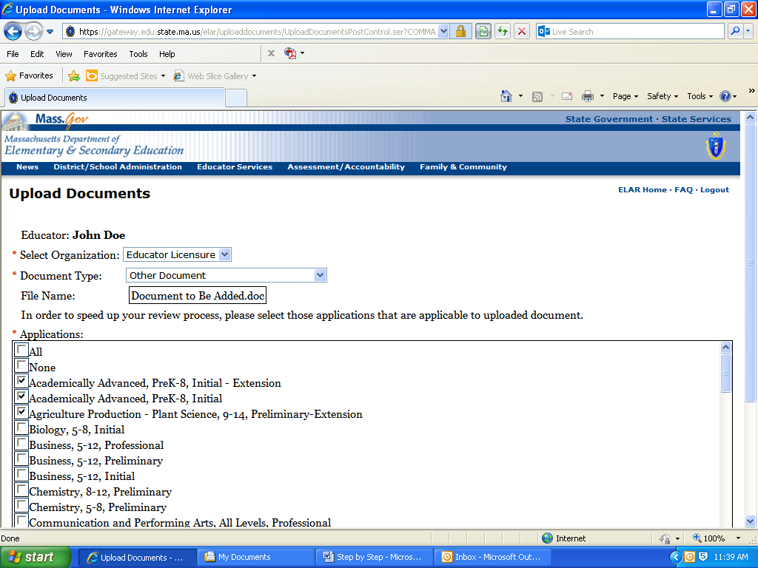
Add Comments if Desired
- Type short comment into Comments box (if desired).  For example:  - When uploading transcripts into your file, you could type the name of the organization from which the transcripts are from in the Comments box.  - When uploading an experience/employment letter into your file, you could type the school district/organization’s name in the Comments box. | 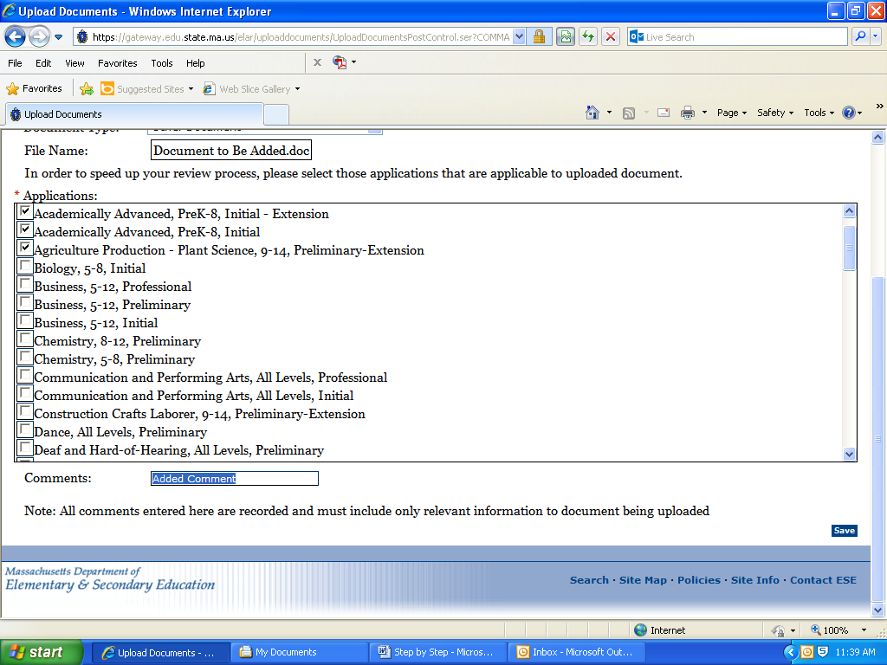

- Click ‘Save’ | 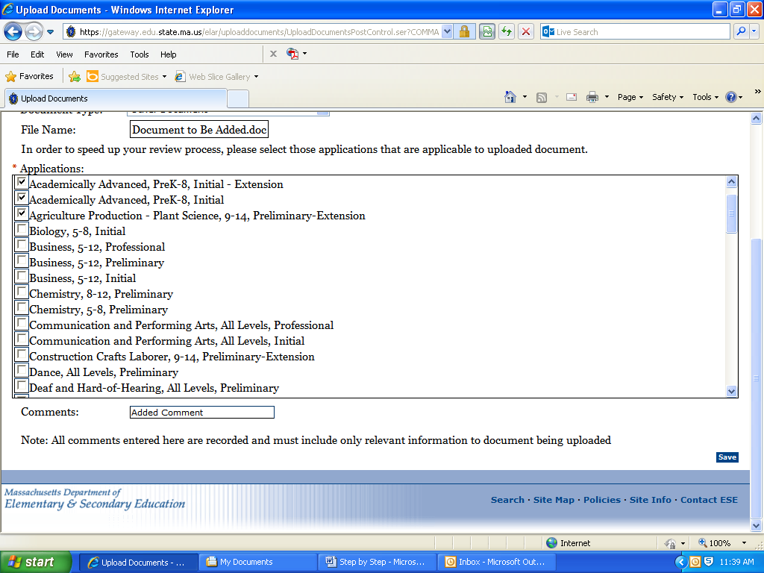
- Click “Done” to return to the Inquiry - Activity Summary page or click the Upload More Documents button to continue to add documents to the file. | 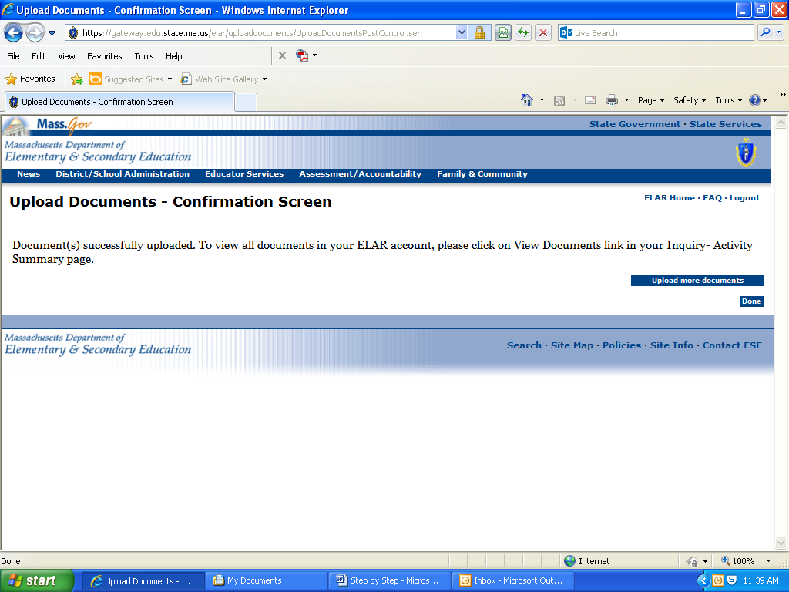

Hard copies of licensure applications/renewals and Credit Card Authorization Forms (payment form) should never be uploaded or faxed. Neither should documents that bear an embossed seal and copies of transcripts wherein the Registrar’s signature is not visible/legible on the scanned/copied image These documents should be mailed to the Office of Educator Licensure, 75 Pleasant Street, Malden, MA 02148. Please put one of the following identifiers on all documents mailed in to the office: MEPID or License # (can found in your profile in ELAR), or your social security #.
Example of a scanned transcript with a Registrar’s signature on the scanned/copied that is not legible.  ESE would consider this transcript to be unofficial. | 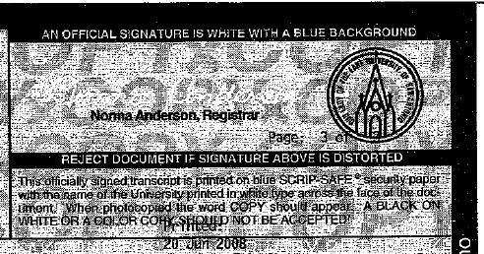
Image 1: Example of an emossed seal on the Out-of-State Approved Program Verification Form. Seal is not visible in the scanned/copied image.  Image 2: Example of a stamped seal on the Out-of-State Approved Program Verification Form. | 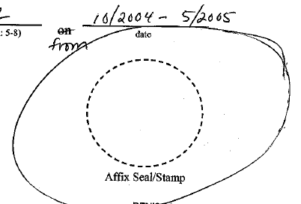  Image 1: Out of State Verification Form | 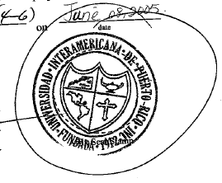  Image 2: Out of State Verification Form
 | Can’t see embossed seal/stamp = Unacceptable | Can see stamped seal/stamp = Acceptable

Verifying that the transcript is official:
When reviewing a transcript to verify that it is official a licensure evaluator must be able to see the Registrar’s signature. This holds true for paper copies of transcripts that are: uploaded by the college/university, applicant, or school district into ELAR; mailed to a recipient in a “sealed envelope”; or faxed to the Department. This also holds true for electronic transcripts that are emailed to a recipient and uploaded into ELAR. A paper transcript that is put into an electronic format and uploaded into ELAR would not be considered as an electronic transcript. Electronic transcripts are transcripts that are electronically delivered (often by a “third party” such as eScrip-Safe, National Student Clearinghouse, Parchment, etc.) to the email address of a designated recipient. Electronic transcripts may or may not include the Registrar’s signature but may still be deemed “official” by the provider of the electronic transcript. However, for the purpose of licensure, electronic transcripts that lack a Registrar’s signature, are not considered official transcripts unless the Department has received the transcript directly from that third party vendor. See example below.

Example of transcript sent directly to student from eSCRIP-SAFE without Registrar’s signature.  This transcript would not be considered official even if uploaded by the college/university. | 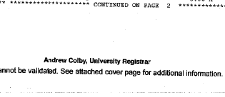  eSCRIP-SAFE transcript lacking Registrar’s signature
Examples of transcripts bearing legible Registrar signatures.  These transcripts would be considered official regardless of the manner they were received – uploaded to ELAR as a PDF, mail, fax, etc. | 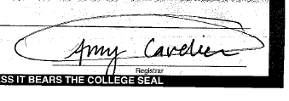 | 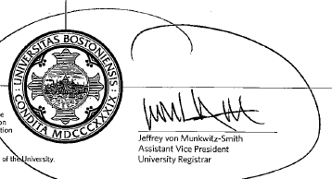

Verifying degree conferral:
Along with verifying that a transcript is official, a licensure evaluator may also need to verify conferral of a degree (verification of Bachelor or Master’s degree). To verify conferral of a degree, the transcript must note degree conferred as well as confferal date. See examples below.
Examples of transcripts indicating degree conferred and conferral date. | 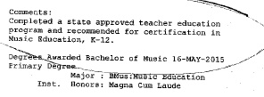 | 