 | Create and Manage Your ELAR Profile
What is ELAR?
Educator Licensure And Renewal (ELAR) is our comprehensive online application system: https://gateway.edu.state.ma.us/elar provides customized access to your personal profile, a correspondence review section, and up-to-the-minute checks on submitted application statuses. The website and ELAR are accessible 24 hours-per-day.
- Apply or renew online; pay online.
- Check licensure application status/history.
- Print an unofficial copy of your license.
- Upload supporting documents.
- View previous correspondence.
How do I Access / Log-in to ELAR?
There are two ways that ELAR can be accessed;
- through the ELAR log-in screen www.doe.mass.edu/licensure |  |  | - through the MassEdu Gateway (Security Portal) www.mass.gov/edu/gateway
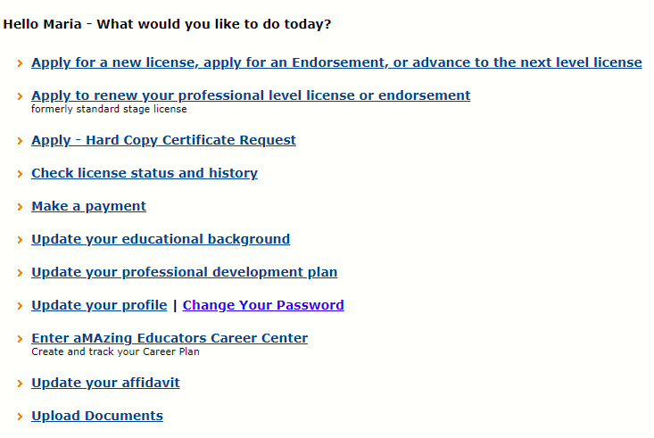  Image of ELAR Welcome Page Screen |  |  | 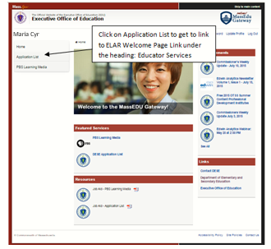
Create a Profile:
If this is your first time using the ELAR system, you will need to create a profile. You may find you already have a User Name and Password. That is, if you applied for a Massachusetts Educator's license before, or have ever worked for a Massachusetts school or school district. If you find this to be true, continue by creating a NEW Profile and you will be directed to your credentials. When creating a Profile, there are a few things that can happen:
- You are asked to create a user Profile. This information is stored for ESE identification and administrative purposes only. Personal information is not shared or sold in any way. The process of creating a Profile consists of 4 pages, each asking for pertinent information that will be used in the ELAR application suite. Your User Name will be assigned automatically and cannot be changed. Your password should be changed to something that you and only you can remember. You will be asked to supply a Password Hint Question and Answer. This is a security feature that helps prevent unauthorized log in.
- You are asked for additional information. A school/district administrator or the ESE may have created a Profile for you while entering license information or adding you to a staff directory. You can complete the Profile setup by supplying a Password Hint Question and Answer. This is a further security feature that helps prevent unauthorized log in. Upon completion of this, you will receive your User Name and Password online.
- Your Profile is a partial match. You have supplied information that matches ESE records, but we are unable to complete the setup due to conflicting data (usually supplied to us by the Directory Administrator of the school system that you work in). Please contact your Directory Administrator to resolve the problem expediently. If they are unable to assist you, contact a ESE Customer Service Representative at (781) 338-6600.
- Your Profile is an exact match. You already have a Profile and you are reminded of your User Name. You are then given a chance to change your password after answering your Password Hint Question and Answer

Forgot or Lost User Name/Password?
If you are having difficulty entering your proper Username or Password, please remember Passwords and User Names are "case sensitive". When re-setting a password please note that passwords should be at least 6 characters long (numbers, letters or a combination of both), can’t be a password that you have used in the past (you will receive an error message), and should not contain symbols.

Retrieve User Name/Reset Password (ELAR Members only).

Massachusetts Educators:
The Department of Elementary and Secondary Education issues User Names for Massachusetts Educators to view their licensure information and apply for or renew a Massachusetts Educator's License.

School and district staff, and staff from other organizations:
The Department also issues User Names for school and district staff, and staff from other organizations, who need access to secure web-based applications available through the Department's ESE Security Portal.
People who have created or updated their user profile through the Educator Licensure And Renewal (ELAR) application are able to provide more information that allows the Department to securely identify them.

The Retrieve User Name/Reset Password link is for ELAR members. If you use ESE Security Portal Applications on behalf of your school, district, or other organization, please see your organization's Directory Administrator. Your Directory Administrator can reset your password. A listing of District Directory Administrators can be found at: http://www.doe.mass.edu/infoservices/data/diradmin/list.aspx

Often, people who access ESE Security Portal applications for their school, district, or other organization, are also licensed Massachusetts Educators. If this is true for you, you can either use the Retrieve Username/Reset Password tool or contact your organization's Directory Administrator. If you select the Retrieve Username/Reset Password link, you will find yourself creating what seems to be a 'new' Profile; this is normal. If a Profile exists with your name and personal information, you will be reminded of your User Name once we receive enough information to make a match. At this time, you will also be able to change your Password.
Retrieve User Name/Reset Password https://gateway.edu.state.ma.us/docs/loginhelp.asp?mode=find
