How to Print an Unofficial Copy of Your License(s)/Endorsement(s) from ELAR: A Step by Step Guide
August 2021

The Paperless Initiative:
The Department has been exploring a range of actions to increase the efficiency and cost-effectiveness within the Office of Educator Licensure.
We have made a number of changes in the way we process applications and continue to look for ways to improve the services we offer to current and prospective educators. Among the changes is a decision to move toward increasingly paperless processes in an effort to streamline the review process, reduce wait times, and become more environmentally sensitive. This effort includes a number of technology enhancements that have been put in place (such as the ability for applicants to upload documents directly into their ELAR account) to allow virtually all communication regarding a licensure application to be processed electronically with the ELAR system.

As of April 28, 2011, the Department's online Educator Licensure and Recruitment system (ELAR) serves as the official record for educator licensure. As such, the Department no longer sends hard copy licenses as a matter of practice to verify that an educator holds a license and has met the requirements to become an educator in the Commonwealth. Upon issuance of a license, educators receive notification via email as well as directions on how to look up their license status in ELAR and a general overview of how they may advance their license to the next stage.

Educators and school districts are encouraged to use ELAR to verify licensure. Both are able to print out an educator’s profile page to verify the license number as well as the fields and grade levels held. Educators are also able to print out an unofficial copy of their license, as outlined in this Guide. However, should they wish to receive an official hard copy of their license, they may do so by logging into their ELAR account and applying for a hard copy certificate.
Access ELAR System
- Go to www.doe.mass.edu/licensure/ | 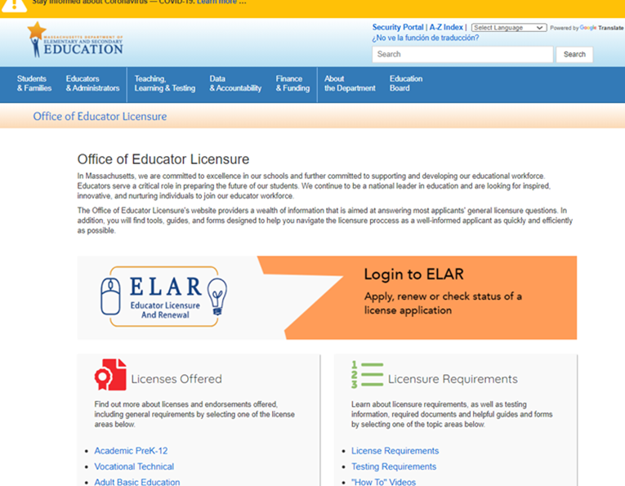
- Click on ELAR Login Image

Log-in to ELAR Portal
- Input your Username and Password (please note: these are case sensitive)  Note:  - If you do not have an ELAR account yet, or are not sure, click on the Create ELAR Profile link and create a new profile/account. If you do have a profile the system will locate it and notify you.  - If you do not know if you have an account, or have forgotten your ELAR Username or Password, click on the Forgot User Name/Password link and follow prompts. Again, if you already have a profile, you will be alerted.  - You will be required to provide an email address in your ELAR account. It is important that you keep your contact information in ELAR up to date. Most especially your email and mailing addresses. | 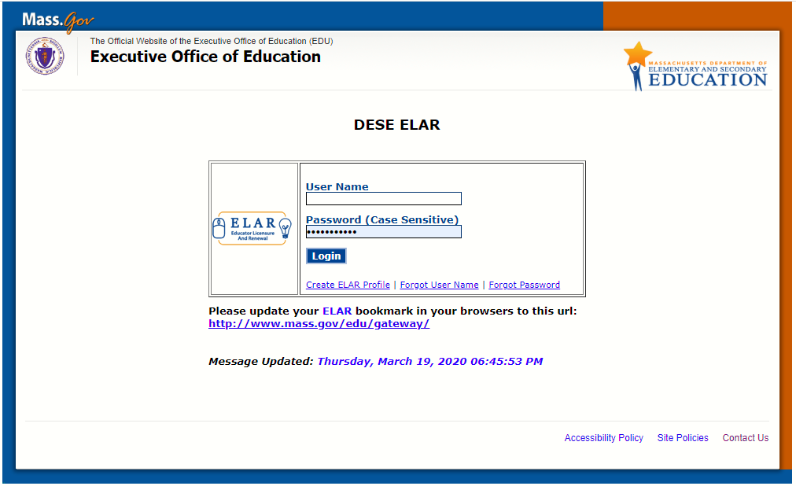

ELAR Welcome Page
- On the ELAR Welcome Page, click on the Check license status and history link | 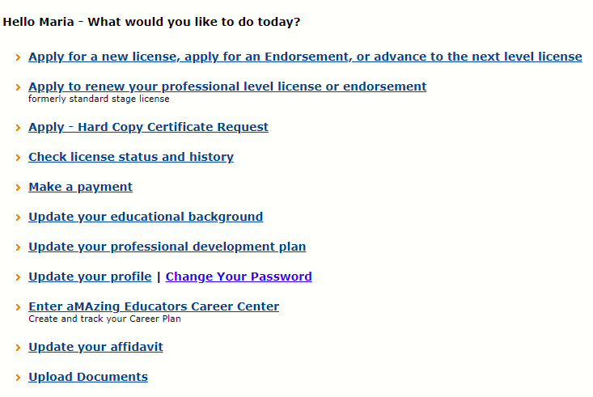
Inquiry - Activity Summary Page [ License Information - View/Print button]
- Scroll down to the bottom of your Inquiry-Activity Summary page.  - Click on the View/Print button | 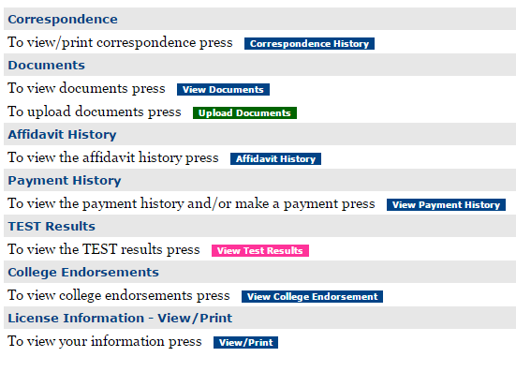

Print Unofficial Copy
- A pop-up screen will appear allowing you to click on the Print button, select your printer and print an unofficial copy of your license(s)/endorsement(s). | 