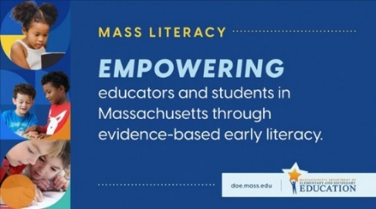
Mass Literacy: Where to Start?
The Mass Literacy Guide highlights evidence-based practices for early literacy across curriculum, instruction, and leadership. Wondering where to start? Here are six practices to prioritize for an early literacy program based on evidence of what works, to support and cultivate the literacy talents of ALL our students in grades preK-3.
Schedule time for a core literacy block in every grade, allocating sufficient time for all the components of the core literacy block with whole group and differentiated instruction.
Read more about this practice
Invest in building a culturally responsive and sustaining school in which diverse students are equitably welcomed, challenged, supported, and inspired to reach their full potential.
Read more about this practice

Teach literacy using evidence-based instructional practices for foundational skills, engaging with complex text, writing, and oral language. Phase out unsupported practices.
Read more about these practices

Utilize a valid and reliable universal screening assessment three times per year to identify children who need enhanced instruction to ensure their success.
Read more about this practice

Establish a school Literacy Leadership Team to manage all the pieces of the school’s literacy program, including setting specific literacy goals and determining professional development needs.
Read more about this practice

Create routines for data-based decision making, including protected time for all the adults who serve each group of students to review learning data and plan responsive instruction.
Read more about this practice

High-quality curricular materials are a necessary basis of a strong K-3 literacy program. Teachers need access to high-quality core curricular materials from which to plan.
Visit CURATE to learn more about high-quality instructional materials.

