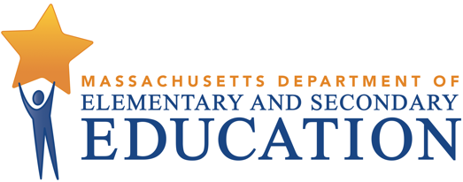
Learning Acceleration in Massachusetts
Background
Despite the efforts of teachers, administrators and families during the 2020-2021 school year, many students missed out on critical instructional time, particularly our traditionally underserved students. To effectively meet the resulting extensive and varied needs of students, the Department is strongly recommending that districts focus their instructional efforts on the evidence-based approach of learning acceleration, which asserts that regular access to grade-appropriate work is critical to student academic development. This is different from another common, but less effective, approach known as remediation, which is often based on the misconception that for students to learn new information, they must first go back and master everything they missed. When used exclusively, remediation practically guarantees that students will lose more academic ground and often serves to reinforce misguided beliefs that some students cannot do grade-level work.
Acceleration Roadmap
In the spring of 2021, The Department of Elementary and Secondary Education (Department) published the Acceleration Roadmap to support teachers and leaders in implementing a learning acceleration approach during the 2021-2022 school year. The Roadmap provides high-leverage recommendations and targeted resources, and is organized around three overarching priorities, including:
- Fostering a sense of belonging and partnership among students and families,
- Continuously monitoring students’ understanding, and
- Ensuring strong grade-appropriate instruction with just-in-time scaffolds when they are needed.
An overview of some of the key recommendations are included in the chart below. Educators and system leaders are encouraged to take a self-assessment to identify key priorities to focus their efforts this school year, as opposed to attempting to complete every action outlined in the Roadmap.
 | District-Level Infrastructure | Instructional Leadership Routines
Sense of Belonging | - Establish an attendance team.  - Engage students and families with regular 2-way communication.  - Conduct an equity audit to identify an equity-focused goal for the year.  - Provide focused PD on culturally responsive practices. | - Regularly analyze data from surveys/ communication with students and families  - Establish strong systems for building relationships and promoting SEL.  - Align efforts to district equity goal.
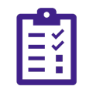  Monitor Understanding | - Adopt high quality curriculum with embedded unit assessments.  - Provide professional development on data analysis and data-informed instruction.  - Establish data teams and coaches to support schools and teachers. | - Conduct pre-unit assessments to identify lagging or strong prerequisite skills.  - Regularly collect and analyze student performance data to inform instructional adjustments.
Strong Instruction | - Adopt high quality curriculum with embedded unit assessments.  - Conduct a culturally responsive audit of materials.  - Provide focused PD on curriculum adoption and observation-feedback.  - Adopt Tier 2 & 3 supports that are aligned to the high-quality instructional materials used for Tier 1 instruction. | - Use protocols to study classroom assignments for grade-appropriateness.  - Coach teachers to adjust pacing guides to address essential skill or knowledge gaps while maintaining focus on grade-level work.  - Coach teachers to identify and provide effective “just-in-time” supports.
