Spring 2022 MCAS Tests:
Summary of State Results
February 2023

Massachusetts Department of Elementary and Secondary Education
75 Pleasant Street, Malden, MA 02148-4906
Phone 781-338-3000 TTY: N.E.T. Relay 800-439-2370
www.doe.mass.edu

This document was prepared by the
Massachusetts Department of Elementary and Secondary Education
Jeffrey C. Riley
Commissioner

The Massachusetts Department of Elementary and Secondary Education, an affirmative action employer, is committed to ensuring that all of its programs and facilities are accessible to all members of the public.
We do not discriminate on the basis of age, color, disability, gender identity,
national origin, race, religion, sex or sexual orientation.
Inquiries regarding the Department’s compliance with Title IX and other civil rights laws may be directed to the
Human Resources Director, 75 Pleasant St., Malden, MA 02148 781-338-6105.

© 2023 Massachusetts Department of Elementary and Secondary Education
Permission is hereby granted to copy any or all parts of this document for non-commercial educational purposes. Please credit the “Massachusetts Department of Elementary and Secondary Education.”

This document printed on recycled paper

Massachusetts Department of Elementary and Secondary Education
75 Pleasant Street, Malden, MA 02148-4906
Phone 781-338-3000 TTY: N.E.T. Relay 800-439-2370
http://www.doe.mass.edu/

Contents
I. Introduction 1
Which MCAS Tests Were Administered in 2022? 1
Who Participated in MCAS in 2022? 1
What Were the Administration Guidelines for the Spring 2022 MCAS Tests? 2
How Are MCAS Results Reported? 2
How Are MCAS Results Used? 4
II. Statewide Achievement Level Results 5
Student Achievement in Grades 3–8 and 10 5
Student Achievement on STE Tests in Grades 5 and 8 7
III. Statewide Scaled Score Results 9
Average Scaled Scores 9
Average Scaled Scores by Grade for State’s Largest Racial/Ethnic Groups 9
Average Scaled Score by Grade for Special Populations 13
IV. Statewide Achievement Gaps 17
V. Student Enrollment and Participation 20
2022 Student Enrollment 20
2022 Participation Rates 21
VI. Competency Determination Attainment Results 23
Competency Determination Attainment Through Spring 2022 25

I. Introduction
The Massachusetts Comprehensive Assessment System (MCAS) is the Commonwealth’s standards-based student assessment program. This report summarizes the state-level results from the spring 2022 administration of MCAS tests in English Language Arts (ELA), Mathematics, and Science and Technology/Engineering (STE). The report provides trends in state results and changes in academic achievement gaps between demographic groups. For information on school- and district-level MCAS results, please visit the School and District Profiles website.

Which MCAS Tests Were Administered in 2022?
In 2022, Massachusetts continued the process of transitioning the MCAS program to next-generation tests. The next-generation tests include new test designs and item types and are administered primarily via computer, though the Department offers paper-based tests on an ongoing basis as an accommodation for some students.
Table 1 shows which MCAS tests were administered at each grade level in spring 2022 and whether the tests were next-generation (NG) or legacy (L) assessments.
Table 1: Spring 2022 MCAS Tests Administered, by Grade Level
Content Area | Grade Level
 | 3 | 4 | 5 | 6 | 7 | 8 | 9 | 10
English Language Arts | NG | NG | NG | NG | NG | NG |  | NG
Mathematics | NG | NG | NG | NG | NG | NG |  | NG
Science and Technology/Engineering  Biology & Introductory Physics  Chemistry & Technology/Engineering |  |  | NG |  |  | NG | NGª Lª | NGª  Lª
ªStudents in grade 9 or 10 were able to take one of the high school STE next-generation tests in Biology and Introductory Physics or legacy tests in Chemistry and Technology/Engineering. Grade 10 STE results are reported based on students' best performance on any STE test taken in grade 9 or grade 10; only students continuously enrolled in the state from fall of grade 9 through spring of grade 10 are included in state results.

Who Participated in MCAS in 2022?
All students who are enrolled in the tested grades and who are educated at public expense are required by state and federal law to participate in MCAS testing. In spring 2022, a total of 520,128 students in grades 3–8 and 10 participated in at least one MCAS test and are included in these summaries. On individual tests, the percentage of enrolled students who participated was consistently high, ranging from 97 to 99%.
Section V of this report provides detailed information about the demographics of the student population that was enrolled and participated in MCAS testing and summarizes changes to the population between 2021 and 2022. For additional information on state-level MCAS participation, go to the Assessment section of the State Profile on the School and District Profiles website and select “MCAS Participation Report.”
MCAS-Alt Participation
Students with significant cognitive disabilities who are unable to take the standard MCAS tests, even with accommodations, are required to participate in the MCAS Alternate Assessment (MCAS-Alt). The MCAS-Alt enables these students to submit portfolios of their work that demonstrate their performance on the curriculum framework learning standards. The number of students who participated in the MCAS-Alt in 2022 is as follows:
- ELA: 5,837 students
- Math: 5,929 students
- STE: 2,458 students

What Were the Administration Guidelines for the Spring 2022 MCAS Tests?
Table 2 provides information about the spring 2022 test administrations, including administration dates, numbers of sessions, and recommended testing times. All MCAS test administrations are untimed. The Department provides recommended session lengths to assist schools with planning.
Table 2: Spring 2022 MCAS Test Administrations
Test | Administration Dates | Number of Sessions | Recommended Testing Time for Spring 2022
ELA Grades 3–8 | March 28–April 29ª | 2 | 120–150 minutes per session
ELA Grade 10 | March 22–23 | 2 | 90–150 minutes per session
Mathematics Grades 3–8 | April 25–May 27ª | 2 | 90 minutes per session
Mathematics Grade 10 | May 17–18 | 2 | 90–120 minutes per session
STE Grades 5 and 8 | April 26–May 27ª | 2 | 60–90 minutes per session
STE High School | June 7–8 | 2 | 60–90 minutes per session
ªAt grades 3–8, schools scheduled tests within a testing window.
MCAS test sessions are composed of a variety of question types, and the number of questions and score points vary by grade and subject. See the MCAS test designs for detailed information.

How Are MCAS Results Reported?
Student results on the MCAS tests are reported using scaled scores and achievement levels. Students receive a separate score and attain a separate achievement level in each subject area. In this report, performance at the state level is summarized using the percentage of students attaining each achievement level. For reporting next-generation results, an additional metric is also used: the average scaled score for the student group being evaluated. The sections below provide more information about these metrics.
Achievement Levels
In March 2017, the Board of Elementary and Secondary Education adopted new achievement levels for the next-generation tests. These next-generation achievement levels differ from the legacy MCAS achievement levels and are reported using a different scale. The next-generation achievement levels are designed to provide an indication of whether a student is on track to succeed in the subject matter and whether extra academic assistance may be needed for the student.
Table 3 presents the achievement levels and scaled scores for the next-generation ELA, Mathematics, and STE tests at grades 3–8 and 10. Table 4 presents the achievement levels and scaled scores for the legacy MCAS tests, which in 2022 included only the high school STE tests in Chemistry and Technology/Engineering.
Table 3: Next-Generation MCAS Achievement Levels
Achievement Level | Scaled Score Range | Definition
Exceeding Expectations | 530–560 | A student who performed at this level exceeded grade-level expectations by demonstrating mastery of the subject matter.
Meeting Expectations | 500–529 | A student who performed at this level met grade-level expectations and is academically on track to succeed in the current grade in this subject.
Partially Meeting Expectations | 470–499 | A student who performed at this level partially met grade-level expectations in this subject. The school, in consultation with the student’s parent/guardian, should consider whether the student needs additional academic assistance to succeed in this subject.
Not Meeting Expectations | 440–469 | A student who performed at this level did not meet grade-level expectations in this subject. The school, in consultation with the student’s parent/guardian, should determine the coordinated academic assistance and/or additional instruction the student needs to succeed in this subject.

Table 4: Legacy MCAS Achievement Levels
Achievement Level | Scaled Score Range | Definition
Advanced | 260–280 | Students at this level demonstrate a comprehensive and in-depth understanding of rigorous subject matter and provide sophisticated solutions to complex problems.
Proficient | 240–258 | Students at this level demonstrate a solid understanding of challenging subject matter and solve a wide variety of problems.
Needs Improvement | 220–238 | Students at this level demonstrate a partial understanding of subject matter and solve some simple problems.
Failing | 200–218 | Students at this level demonstrate a minimal understanding of subject matter and do not solve simple problems.
Average Scaled Scores
As shown in Table 3, students receive a scaled score between 440 and 560 for each next-generation test they take. Because of the design of the next-generation scale, the scaled scores for a group of students can be used to calculate an average (mean) scaled score, which indicates average performance for the group. Average scaled scores can be calculated at the classroom, school, district, or state level, and for student subgroups.
In section III of this report, average scaled scores are used to summarize and compare student achievement on the next-generation tests. A benefit of using average scaled scores is that the performance of all students in the group contributes to the measure. Note that average scaled scores are not reported for legacy tests, as the legacy scale was not designed to support this metric.

How Are MCAS Results Used?
MCAS test results are used for four primary purposes:
- to inform and improve curriculum and instruction;
- to evaluate student, school, and district performance according to the Massachusetts curriculum framework content standards and MCAS performance standards;
- at the high school level, to determine whether a student has met the state requirements for the Competency Determination (i.e., whether a student is eligible for a high school diploma); and
- at the high school level, to determine whether a student has met one of the eligibility requirements for the John and Abigail Adams Scholarship and the Stanley Z. Koplik Certificate of Mastery Award.
Information about high school graduation requirements is available at doe.mass.edu/mcas/graduation.html; Competency Determination attainment in 2022 is presented in section VI of this report.

II. Statewide Achievement Level Results
This section reports statewide results from the spring 2022 MCAS tests by achievement level. In the figures and tables in this section, results for the ELA and Mathematics tests at grades 3–8 and 10; the STE tests at grades 5 and 8; and the high school STE tests in Biology and Introductory Physics are reported using the next-generation achievement levels (Exceeding Expectations, Meeting Expectations, Partially Meeting Expectations, Not Meeting Expectations).

Student Achievement in Grades 3–8 and 10
Figure 1 shows the percentage of students scoring at each achievement level on the 2022 ELA tests. The percentage of students scoring Meeting Expectations or higher ranged from a high of 58% at grade 10 to a low of 38% at grade 4.
Figure 1: 2022 Percentage of Students by Grade and Achievement Level, ELA
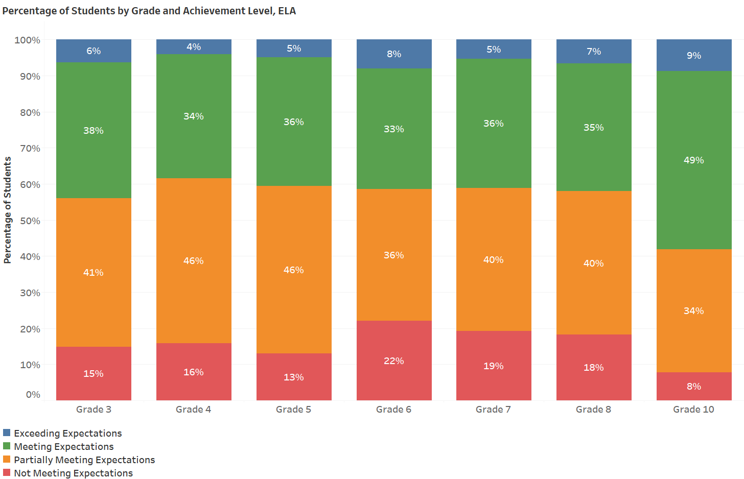

Table 5 summarizes changes in the percentage of students scoring Meeting Expectations or higher on the ELA tests in 2019, 2021, and 2022 (the Department did not administer the spring 2020 MCAS tests due to the cancellation of testing and school closures related to COVID-19). The percentage point change columns illustrate the two- and three-year trends.
Table 5: Percentage Changes in ELA Achievement in 2019, 2021, and 2022, and Three-Year Trends
Grade | Percentage of Students Scoring  Meeting Expectations or Higher in ELA |  |  | 2021–2022 Percentage Point Change | 2019–2022 Percentage Point Change
 | 2019 | 2021 | 2022
Grade 3 | 56 | 51 | 44 | -7 | -12
Grade 4 | 52 | 49 | 38 | -11 | -14
Grade 5 | 52 | 47 | 41 | -6 | -11
Grade 6 | 53 | 47 | 41 | -6 | -12
Grade 7 | 48 | 43 | 41 | -2 | -7
Grade 8 | 52 | 41 | 42 | 1 | -10
Grades 3–8 | 52 | 46 | 41 | -5 | -11
Grade 10 | 61 | 64 | 58 | -6 | -3

Figure 2 shows the percentage of students scoring at each achievement level on the 2022 Mathematics tests. The percentage of students scoring Meeting Expectations or higher ranged from a high of 49% at grade 10 to a low of 36% at grades 5 and 8.
Figure 2: 2022 Percentage of Students by Grade and Achievement Level, Mathematics
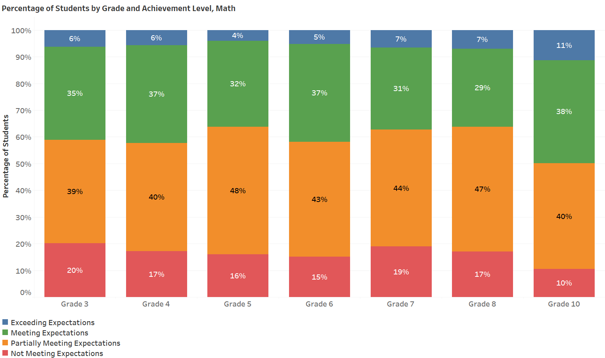
Table 6 summarizes changes in the percentage of students scoring Meeting Expectations or higher on the Mathematics tests in 2019, 2021, and 2022. The percentage point change columns illustrate the two- and three-year trends.
The Department did not administer the spring 2020 MCAS tests due to the cancellation of testing and school closures related to COVID-19.
Table 6: Percentage Changes in Mathematics Achievement in 2019, 2021, and 2022, and Three-Year Trends
Grade | Percentage of Students Scoring  Meeting Expectations or Higher in Mathematics |  |  | 2021–2022 Percentage Point Change | 2019–2022 Percentage Point Change
 | 2019 | 2021 | 2022
Grade 3 | 49 | 33 | 41 | 8 | -8
Grade 4 | 50 | 33 | 42 | 9 | -8
Grade 5 | 48 | 33 | 36 | 3 | -12
Grade 6 | 52 | 33 | 42 | 9 | -10
Grade 7 | 48 | 35 | 37 | 2 | -11
Grade 8 | 46 | 32 | 36 | 4 | -10
Grades 3–8 | 49 | 33 | 39 | 6 | -10
Grade 10 | 59 | 52 | 50 | -2 | -9

Student Achievement on STE Tests in Grades 5 and 8
Figure 3 shows the percentage of students at each achievement level in both grades on the STE tests. In 2022, 43% of students statewide scored Meeting Expectations or higher on the grade 5 STE test, while 42% scored Meeting Expectations or higher on the grade 8 STE test.

Figure 3: 2022 Percentage of Students by Grade and Achievement Level, Science and Technology/Engineering
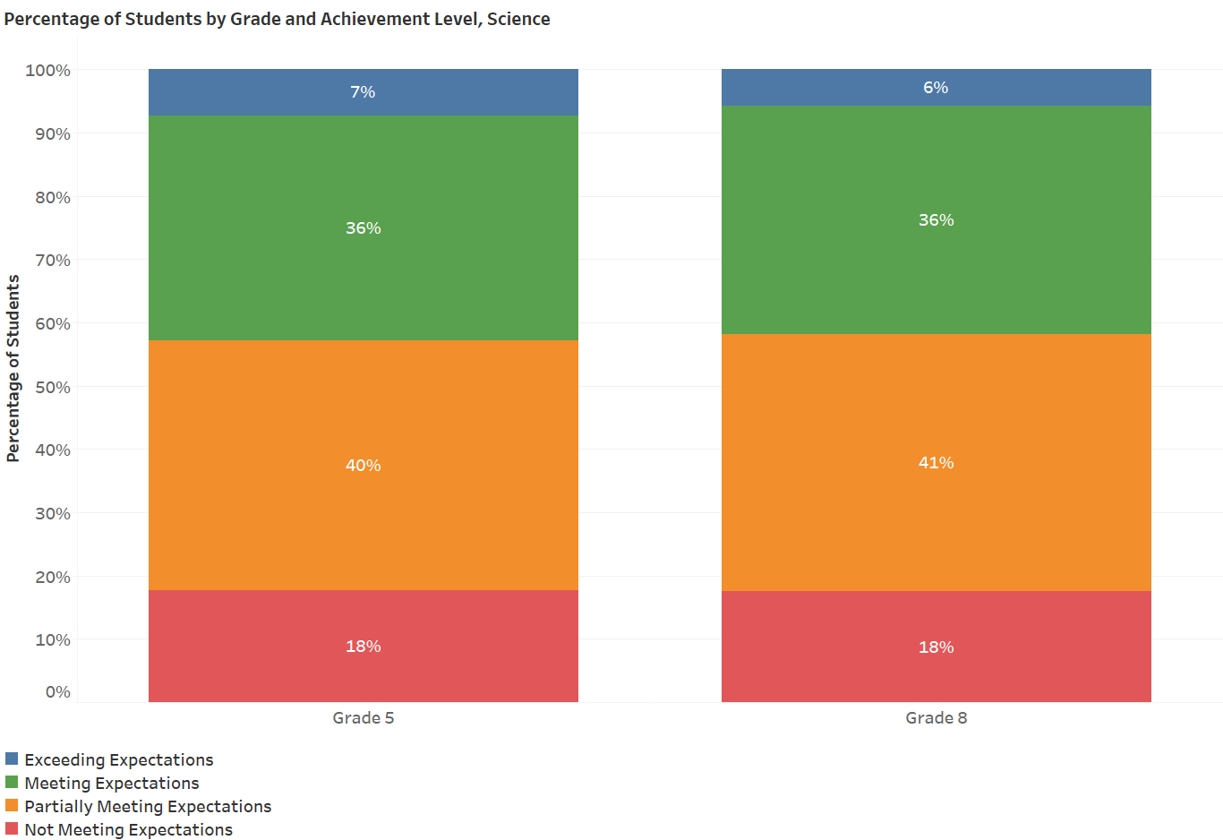

Table 7 summarizes changes in the percentage of students scoring Meeting Expectations or higher on the grades 5 and 8 STE tests in 2019, 2021, and 2022 (the Department did not administer the spring 2020 MCAS tests due to the cancellation of testing and school closures related to COVID-19). The percentage point change columns illustrate the two- and three-year trends.

Table 7: Percentage Changes in STE Achievement in 2019, 2021, and 2022, and the Two- and Three-Year Trends
Grade | Percentage of Students Scoring  Meeting Expectations or Higher in STE |  |  | 2021–2022 Percentage Point Change | 2019–2022 Percentage Point Change
 | 2019 | 2021 | 2022
Grade 5 | 49 | 42 | 43 | 1 | -6
Grade 8 | 46 | 41 | 42 | 1 | -4

III. Statewide Scaled Score Results
This section reports state-level results from the spring 2022 MCAS tests by average scaled score. As described on page 3, students receive a scaled score between 440 and 560 for each test they take. The scaled scores for a group of students can be used to calculate an average (mean) scaled score, which indicates average performance for the group. By comparing the average scaled score to the score ranges for the achievement levels, shown in Table 8, a determination can be made about whether, on average, the students in the group are meeting expectations.
Table 8: Achievement Levels and Scaled Scores
Achievement Level | Scaled Score Range
Exceeding Expectations | 530–560
Meeting Expectations | 500–529
Partially Meeting Expectations | 470–499
Not Meeting Expectations | 440–469

Average Scaled Scores
Table 9 shows the average scaled score for all students in the state, by grade, for ELA, Mathematics, and grades 5 and 8 STE. At all grades, the average scaled score is just above or below 500, which is the minimum score for the Meeting Expectations achievement level.
Table 9: 2022 Average State-Level Scaled Scores by Grade
Grade | ELA Average Scaled Score | ELA Number of Students | Math Average Scaled Score | Math Number of Students | STE  Average Scaled Score | STE  Number of Students
3 | 497 | 63,639 | 493 | 63,698
4 | 493 | 64,134 | 494 | 64,148
5 | 495 | 65,365 | 493 | 65,398 | 495 | 65,172
6 | 493 | 65,472 | 495 | 65,427
7 | 493 | 67,078 | 492 | 66,988
8 | 494 | 69,338 | 493 | 69,194 | 494 | 68,770
3–8 | 494 | 395,026 | 493 | 394,853 | 495 | 133,942
10 | 503 | 66,570 | 501 | 66,201 | 499 | 64,183ª
ªGrade 10 STE figures include students in the class of 2024 who participated in an STE test in grade 9 in 2021 or grade 10 in 2022; only students continuously enrolled in Massachusetts public schools from fall of grade 9 through spring of grade 10 are included.

Average Scaled Scores by Grade for State’s Largest Racial/Ethnic Groups
Table 10 shows the average scaled scores for 2019, 2021, and 2022 in grades 3–8 and 10 in ELA, Mathematics, and STE, for the state’s largest racial/ethnic reporting groups. The data illustrate the change in performance for each group and allow for comparisons between groups and between grade levels. Grades 3–8 and 10 results for other student groups, including grade-level results, are available in the statewide Next Generation MCAS Achievement Report on the School and District Profiles website.
Table 10: Average Scaled Score by Grade for Largest Racial/Ethnic Groups in 2019, 2021, and 2022
Grade | Student Group | ELA |  |  | Mathematics |  |  | STE
 |  | 2019 | 2021 | 2022 | 2019 | 2021 | 2022 | 2019 | 2021 | 2022
Grade 3 | African American/Black | 495 | 490 | 488 | 488 | 474 | 481
 | Asian | 513 | 509 | 507 | 514 | 505 | 511
 | Hispanic/Latino | 495 | 488 | 484 | 489 | 473 | 480
 | White | 508 | 504 | 501 | 503 | 494 | 498
Grade 4 | African American/Black | 493 | 489 | 485 | 488 | 474 | 482
 | Asian | 512 | 507 | 502 | 515 | 505 | 511
 | Hispanic/Latino | 492 | 486 | 482 | 489 | 473 | 481
 | White | 505 | 503 | 497 | 503 | 494 | 499
Grade 5 | African American/Black | 493 | 487 | 487 | 489 | 479 | 483 | 487 | 481 | 482
 | Asian | 512 | 507 | 506 | 514 | 507 | 510 | 510 | 506 | 508
 | Hispanic/Latino | 492 | 485 | 485 | 489 | 478 | 481 | 487 | 481 | 481
 | White | 504 | 501 | 499 | 502 | 495 | 497 | 504 | 500 | 501
Grade 6 | African American/Black | 490 | 484 | 482 | 489 | 478 | 483
 | Asian | 515 | 511 | 508 | 519 | 510 | 514
 | Hispanic/Latino | 490 | 483 | 480 | 490 | 478 | 483
 | White | 506 | 502 | 498 | 504 | 494 | 499
Grade 7 | African American/Black | 488 | 484 | 485 | 485 | 480 | 480
 | Asian | 511 | 508 | 508 | 518 | 513 | 514
 | Hispanic/Latino | 488 | 482 | 482 | 486 | 479 | 479
 | White | 503 | 499 | 497 | 502 | 496 | 497
Grade 8 | African American/Black | 489 | 484 | 486 | 488 | 478 | 482 | 485 | 482 | 482
 | Asian | 513 | 510 | 509 | 518 | 511 | 514 | 509 | 509 | 509
 | Hispanic/Latino | 487 | 482 | 483 | 487 | 478 | 481 | 485 | 482 | 481
 | White | 504 | 499 | 498 | 502 | 493 | 497 | 503 | 500 | 499
Grades 3–8 | African American/Black | 491 | 486 | 485 | 488 | 477 | 482 | 486 | 481 | 482
 | Asian | 513 | 509 | 507 | 516 | 509 | 512 | 510 | 507 | 508
 | Hispanic/Latino | 491 | 484 | 483 | 488 | 477 | 481 | 486 | 481 | 481
 | White | 505 | 501 | 498 | 503 | 494 | 498 | 503 | 500 | 500
Grade 10 | African American/Black | 494 | 495 | 494 | 492 | 487 | 488 |  |  | 487ª
 | Asian | 517 | 518 | 514 | 523 | 521 | 521 |  |  | 513
 | Hispanic/Latino | 492 | 492 | 492 | 491 | 485 | 488 |  |  | 485
 | White | 511 | 513 | 506 | 509 | 505 | 505 |  |  | 504
ªAverage scaled scores for Grade 10 STE are available for 2022 only, the first year of next-generation tests in that subject.

Figures 4 and 5 show the three-year changes in average scaled scores in ELA and Mathematics, from 2019 to 2022, for the state’s largest student racial/ethnic reporting groups. In the figures, blue bars represent a positive change in average scaled scores for the three-year period. Orange bars represent negative change.

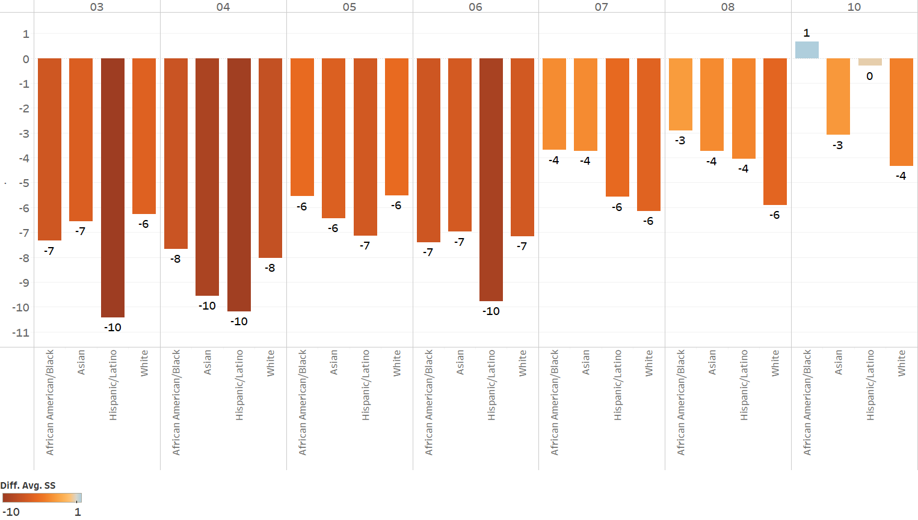
Figure 4: ELA Average Scaled Score Point Change in 2019, 2021, and 2022 Among Four Largest Racial/Ethnic Groups

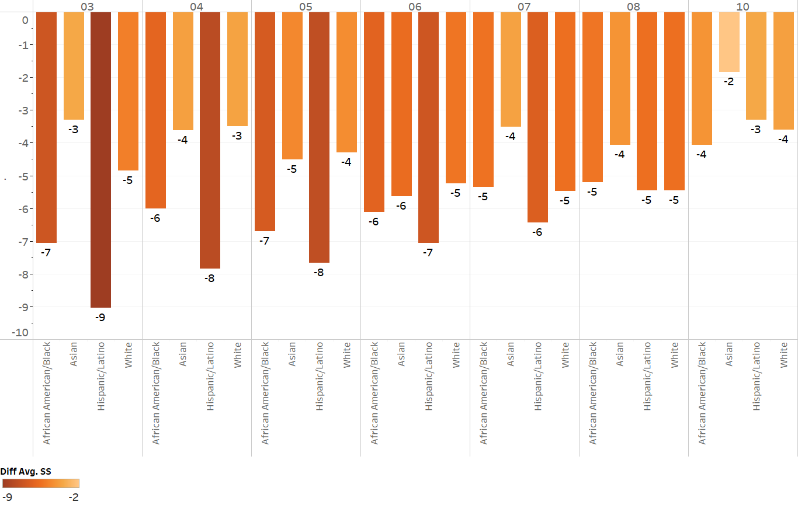
Figure 5: Mathematics Average Scaled Score Point Change in 2019, 2021, and 2022 Among Four Largest Racial/Ethnic Groups

Average Scaled Score by Grade for Special Populations
Table 11 presents the average scaled scores in grades 3–8 and 10 in ELA, Mathematics, and STE for economically disadvantaged and low-income students, English learners, and students with disabilities. The data illustrate the change in performance for each group and allow for comparisons between groups and between grade levels. Grades 3–8 and 10 results for other student groups, including grade-level results, are available in the statewide Next Generation MCAS Achievement Report on the School and District Profiles website.
Table 11: Average Scaled Score by Grade for Special Populations in 2019, 2021, and 2022
Grade | Student Group | ELA |  |  | Mathematics |  |  | STE
 |  | 2019 | 2021 | 2022 | 2019 | 2021 | 2022 | 2019 | 2021 | 2022
Grade 3 | All Students | 504 | 500 | 497 | 499 | 488 | 493
 | Economically Disadvantaged | 495 | 489 |  | 489 | 475
 | Low Income |  |  | 487 |  |  | 482
 | English Learners | 488 | 481 | 478 | 485 | 469 | 476
 | Students with Disabilities | 486 | 485 | 480 | 481 | 472 | 475
Grade 4 | All Students | 502 | 498 | 493 | 499 | 488 | 494
 | Economically Disadvantaged | 492 | 487 |  | 489 | 475
 | Low Income |  |  | 484 |  |  | 483
 | English Learners | 484 | 476 | 474 | 483 | 467 | 475
 | Students with Disabilities | 484 | 482 | 477 | 480 | 472 | 476
Grade 5 | All Students | 501 | 497 | 495 | 499 | 490 | 493 | 499 | 494 | 495
 | Economically Disadvantaged | 492 | 486 |  | 489 | 479 |  | 488 | 482
 | Low Income |  |  | 486 |  |  | 483 |  |  | 484
 | English Learners | 479 | 470 | 473 | 480 | 468 | 473 | 474 | 467 | 468
 | Students with Disabilities | 483 | 480 | 479 | 480 | 475 | 477 | 481 | 479 | 478
Grade 6 | All Students | 501 | 497 | 493 | 501 | 490 | 495
 | Economically Disadvantaged | 489 | 483 |  | 490 | 478
 | Low Income |  |  | 482 |  |  | 484
 | English Learners | 470 | 462 | 461 | 478 | 466 | 470
 | Students with Disabilities | 478 | 474 | 472 | 480 | 473 | 477
Grade 7 | All Students | 499 | 494 | 493 | 498 | 492 | 492
 | Economically Disadvantaged | 488 | 483 |  | 486 | 480
 | Low Income |  |  | 484 |  |  | 481
 | English Learners | 472 | 464 | 463 | 474 | 467 | 466
 | Students with Disabilities | 478 | 474 | 473 | 477 | 473 | 473
Grade 8 | All Students | 500 | 495 | 494 | 499 | 489 | 493 | 498 | 496 | 494
 | Economically Disadvantaged | 487 | 482 |  | 487 | 478 |  | 486 | 483
 | Low Income |  |  | 484 |  |  | 483 |  |  | 483
 | English Learners | 468 | 462 | 461 | 475 | 466 | 469 | 469 | 467 | 465
 | Students with Disabilities | 477 | 474 | 472 | 478 | 471 | 474 | 480 | 478 | 476
Grades 3–8 | All Students | 501 | 497 | 494 | 499 | 490 | 493 | 499 | 495 | 495
 | Economically Disadvantaged | 491 | 485 |  | 488 | 477 |  | 487 | 482
 | Low Income |  |  | 484 |  |  | 483 |  |  | 483
 | English Learners | 479 | 472 | 470 | 480 | 467 | 473 | 472 | 467 | 467
 | Students with Disabilities | 481 | 478 | 475 | 480 | 473 | 475 | 481 | 478 | 477
Grade 10 | All Students | 506 | 507 | 503 | 505 | 501 | 501 |  |  | 499
 | Economically Disadvantaged | 493 | 494 |  | 492 | 487
 | Low Income |  |  | 493 |  |  | 490 |  |  | 487
 | English Learners | 468 | 465 | 470 | 476 | 468 | 473 |  |  | 467
 | Students with Disabilities | 486 | 487 | 485 | 484 | 480 | 482 |  |  | 481

Figures 6 and 7 show the three-year changes in average scaled scores in ELA and Mathematics for grades 3–8 and 10, from 2019 to 2022 for English learners (EL), former EL, students with disabilities, and all students. In the figures, blue bars represent a positive change in average scaled scores for the three-year period. Orange bars represent negative change.
Figure 6: ELA Average Scaled Score Point Change in 2019, 2021, and 2022 Among English Learners (EL), former EL, Students with Disabilities, and All Students

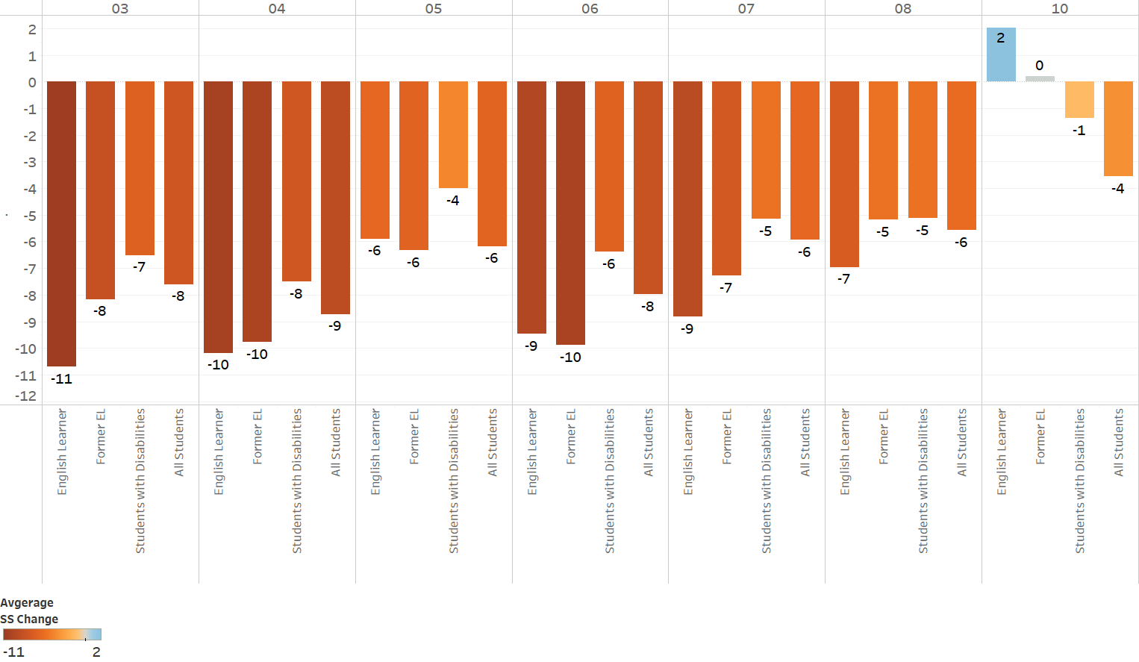
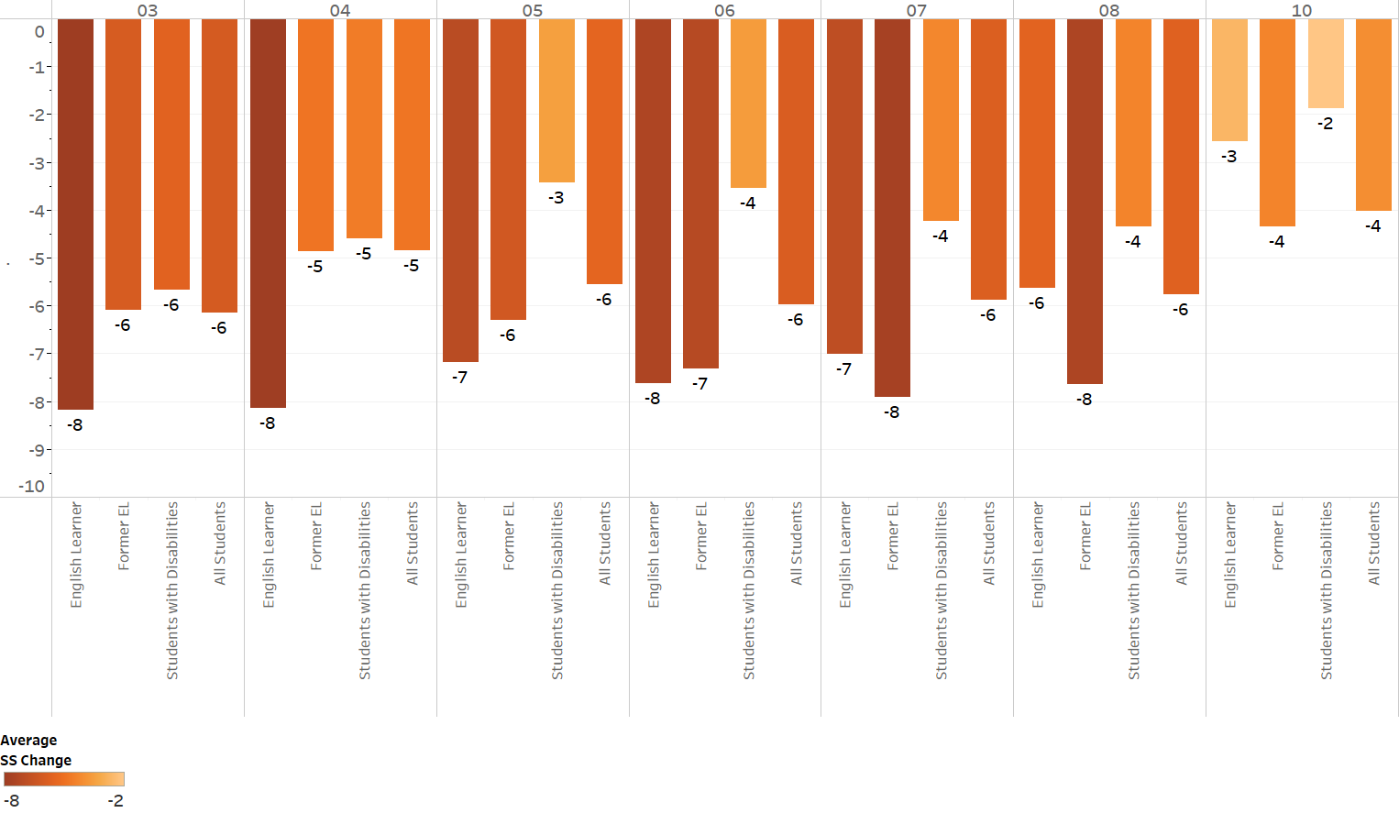
Figure 7: Mathematics Average Scaled Score Point Change in 2019, 2021, and 2022 Among English Learners (EL), former EL, Students with Disabilities, and All Students

IV. Statewide Achievement Gaps
In 2010, Massachusetts passed legislation requiring the state to monitor achievement gaps and authorized the Department of Elementary and Secondary Education to take steps to intervene and attempt to close those gaps through its school accountability and assistance programs.
This section presents information about academic achievement gaps in Massachusetts from 2019 through 2022. The Department defines an achievement gap as a disparity in academic performance between two demographic groups. The figures displayed here identify achievement gaps that are based on race and special education status.
For the ELA and Mathematics tests at grades 3–8 and 10, achievement gaps are measured using the between-group differences in the percentage of students scoring in the Meeting Expectations or higher achievement levels. Figures 8, 9, 10, and 11 show the achievement gaps for the 2019, 2021, and 2022 ELA and Mathematics tests at grades 3–8 and 10.

V. Student Enrollment and Participation
This section profiles the enrolled student population in 2022 and summarizes changes to the population between 2021 and 2022. Participation rates for the spring 2022 tests are also presented.

2022 Student Enrollment
Figure 12 shows the 2022 statewide student enrollment in grades 3–8 and 10 by race/ethnicity. Table 12 shows the two-year enrollment changes in those grade levels for racial/ethnic groups and other student groups.
Figure 12: 2022 Student Enrollment in Grades 3–8 and 10 by Race/Ethnicity

Table 12: Two-Year Enrollment Changes in Grades 3–8 and 10
Race/Ethnicity | 2021  Enrolled Students | 2022 Enrolled Students | Percent Group Change
Asian | 34,913 | 35,157 | 0.1%
African American/Black | 46,064 | 45,334 | <0.1%
Hispanic/Latino | 111,090 | 113,943 | 0.8%
Multi-race, Non-Hispanic/Latino | 20,441 | 20,735 | 0.1%
American Indian or Alaskan Native | 1,071 | 1,098 | <0.1%
Native Hawaiian or Pacific Islander | 409 | 408 | <0.1%
White | 275,165 | 267,150 | -1.0%
Total | 489,153 | 483,825 | -1.1%
Other Student Groups (cont’d.) | 2021  Enrolled Students (cont’d.) | 2022 Enrolled Students (cont’d.) | Percent Group Change (cont’d.)
Male | 251,219 | 248,726 | -1.0%
Female | 237,628 | 234,480 | -1.3%
Non-Binary | 304 | 617 | 102.9%
English Learner | 46,012 | 52,763 | 14.7%
Low Incomeª | - | 225,427 | -
Economically Disadvantaged | 189,103 | - | -
Students with Disabilities | 99,950 | 100,766 | 0.8%
ª Beginning in 2022, the Department replaced the Economically Disadvantaged student group with the Low Income student group. More information is available at doe.mass.edu/infoservices/data/sims/redefining-lowincome.html.

2022 Participation Rates
Table 13 presents information on the number and percentage of enrolled students who participated in the spring 2022 MCAS tests. The figures include participation rates for students administered the standard MCAS and the MCAS-Alt; enrolled students educated with public funds, including regular education students; students with disabilities; and EL students. As in previous years, participation rates were very high, ranging from 97 to 99%.
Table 13: Number of Enrolled and Percentage of Tested Students, Spring 2022
Grade | English Language Arts |  | Mathematics |  | Science and Technology/Engineering
 | Number | Percent | Number | Percent | Number | Percent
Grade 3 | 66,436 | 99 | 66,437 | 99
Grade 4 | 66,765 | 99 | 66,769 | 99
Grade 5 | 68,052 | 99 | 68,026 | 99 | 68,029 | 99
Grade 6 | 68,216 | 99 | 68,198 | 99
Grade 7 | 70,109 | 98 | 70,125 | 98
Grade 8 | 72,805 | 98 | 72,779 | 98 | 72,780 | 97
Grade 10 | 70,018 | 98 | 69,886 | 98 | 73,423 | n/a

How is participation calculated?
For ELA and Mathematics in grades 3–8 and 10, participation rates indicate the number of students who participated in standard MCAS tests and the MCAS-Alt divided by the number of students enrolled during the testing window. For high school STE, participation is not calculated since students have the option to participate in one of the end-of-course subject tests in either grade 9 or grade 10. EL students enrolled in U.S. schools for the first time were not required to take ELA tests; however, they were reported in ELA school and district participation rates based on their participation in the ACCESS for ELLs (Assessing Comprehension and Communication in English State-to-State for English Language Learners) tests. The Department used ACCESS for ELLs testing for state and federal accountability purposes, which require that all EL students, except for students for whom an accommodation was not available, participate in the EL assessment.
Students absent during testing, including students not tested for medical reasons, were counted against school and district participation as non-participants. Students who transferred out of their school and/or district during the testing window were excluded from the corresponding school/district participation calculations.
How are absent students treated in MCAS performance results?
The federal Elementary and Secondary Education Act requires that absent students be counted as non-participants for school and district accountability calculations. Schools are placed in a lower accountability level if their participation rates fall below 95% in the aggregate or for a subgroup over a two-year period.

VI. Competency Determination Attainment Results
The class of 2003 was the first graduating class in Massachusetts that was required to earn a Competency Determination (in addition to meeting local requirements) to be eligible to graduate from high school. Graduation requirements are available at doe.mass.edu/mcas/graduation.html.
To be eligible to receive a high school diploma, students in the class of 2024 must meet the following MCAS graduation requirements (in addition to meeting all local graduation requirements):

Pass the ELA and Mathematics tests in one of two ways:
- earn a scaled score of 472 or higher on the grade 10 ELA test or retest; or earn a scaled score of 455–471 on the ELA test or retest and fulfill the requirements of an Educational Proficiency Plan (EPP) in ELA;
- earn a scaled score of 486 or higher on the grade 10 Mathematics test or retest; or earn a scaled score of 469–485 on the Mathematics test or retest and fulfill the requirements of an EPP in Mathematics
Pass the Science and Technology/Engineering test in one of the following ways:
- earn a scaled score of 467 or higher on the next-generation Biology test; or earn a scaled score of 470 or higher on the next-generation Introductory Physics test; or earn a scaled score of 220 (Needs Improvement) or higher on the legacy Chemistry or Technology/Engineering test

Table 14 displays the cumulative percentage of all students and student groups in the class of 2024 who have already met or partially met the MCAS requirement for graduation by performing at the next-generation equivalent to the Needs Improvement level or higher in ELA, Mathematics, and STE through the spring 2022 test administration. In 2022, 81% of students in the class of 2024 met the next-generation graduation requirement by performing at the equivalent to the Needs Improvement level or higher in all three subjects by the end of grade 10. Information about graduation requirements is available at doe.mass.edu/mcas/graduation.html.

Table 14: Percentage of Students Who Passed the High School MCAS Tests
on the First Attempt
Subgroup | Class of 2024 |  |  |  |  | Class of 2023^{a, b} | Class of 2021ª
 | ELA | Math | ELA and Math | STE | All Three Tests | ELA and Math  (STE Not Required) | All Three Tests
All Students | 93 | 88 | 86 | 86 | 81 | 88 | 87

Gender
Female | 94 | 89 | 87 | 88 | 83 | 90 | 89
Male | 92 | 88 | 85 | 84 | 79 | 86 | 85
Non-Binary | 91 | 92 | 87 | 88 | 79 | 98 | 91

Race/Ethnicity
African American/Black | 92 | 80 | 79 | 75 | 68 | 78 | 77
Asian | 96 | 95 | 94 | 93 | 91 | 96 | 94
Native Hawaiian or Pacific Islander | 91 | 79 | 79 | 75 | 73 | 90 | 88
Hispanic/Latino | 85 | 77 | 73 | 71 | 63 | 72 | 73
Multi-Race, Non-Hispanic/Latino | 94 | 89 | 87 | 88 | 82 | 90 | 89
Amer. Ind. or Alaska Nat. | 92 | 85 | 84 | 85 | 79 | 77 | 83
White | 96 | 93 | 92 | 92 | 89 | 94 | 92

Student Status
High Needs^{c} | 88 | 80 | 77 | 75 | 68 | 75 | 74
Non-Disabled | 95 | 93 | 91 | 90 | 87 | 92 | 93
Students with Disabilities | 84 | 68 | 66 | 66 | 55 | 67 | 63
English Learner (EL) | 64 | 56 | 44 | 40 | 29 | 36 | 43
Former EL^{d} | 97 | 90 | 89 | 85 | 80 | 86 | 88
EL and Former EL | 75 | 68 | 60 | 56 | 47 | 56 | 61
Low Income^{e} | 88 | 80 | 77 | 75 | 67
Economically Disadvantaged^{f} |  |  |  |  |  | 75 | 74
ªTo provide comparable data, results for the classes of 2023 and 2021 are based on MCAS tests through the spring 2021 and spring 2019 administrations, respectively. Class of 2022 data are not provided due to the cancellation of state assessments related to COVID-19 during the 2019–2020 school year.
^{b}Due to different school reopening schedules in spring 2021 and the resulting lower number of students tested, approximately 10% of students did not participate in the grade 10 tests and were excluded from CD attainment results for the class of 2023. Results for the classes of 2024 and 2021 are therefore not directly comparable to those for the class of 2023.
^{c}From 2015 to 2021, the High Needs group included students with disabilities, English learner and former English learner students, and economically disadvantaged students; beginning in 2022, the Low Income student group replaced the Economically Disadvantaged student group.
^{d}Beginning in 2018, the Former English Learner group included students who exited EL status over the previous four-year period.
^{e}Beginning in 2022, the Low Income student group replaced the Economically Disadvantaged student group.
^{f}Spring 2021 was the last test administration that the Economically Disadvantaged student group was used.

Competency Determination Attainment Through Spring 2022

Table 15 shows the number and cumulative percentage of students in the class of 2024 who have fully met the CD standard. In ELA and Mathematics, these students performed at the next-generation equivalent to Proficient or higher; in STE, these students performed at Needs Improvement or higher or at the next-generation equivalent, through the spring 2022 test administration. The table also shows the number and percentage of students who have met individual components of the CD requirement.

Table 15: Number and Percentage of Students in the Class of 2024 Scoring at the Next-Generation Equivalent to Proficient or Higher in ELA and Mathematics and the Next-Generation Equivalent to Needs Improvement or Higher in STE through the Spring 2022 Administration
CD Requirement | Number | Percent
Earned CD | 47,437 | 66
ELA and Mathematics Proficient or Higher | 48,196 | 67
ELA Proficient or Higher | 62,281 | 87
Mathematics Proficient or Higher | 48,950 | 69
STE Needs Improvement or Higher | 61,240 | 86

Due to rounding at individual achievement levels, the percentages in this figure, and in other figures in this report, may not add up to 100%. For the same reason, when percentages for Meeting Expectations and Exceeding Expectations are aggregated to report the percentage of students at “Meeting Expectations or higher,” the sum of the percentages for the individual achievement levels may not equal the aggregated total.
Due to rounding, average scaled scores in this report may differ in some instances by one-tenth of a point from average scaled scores reported in the Department’s online systems.
The achievement figures for students in the class of 2024 may be lower than the corresponding figures for grade 10 students cited elsewhere in this report because the figures for students in the class of 2024 include students participating in a retest administration (primarily students retained in grade) while those for grade 10 students include first-time spring MCAS administration testers only.

