| To: | Principals, District EL Program Directors, ACCESS for ELLs Test Coordinators, and ACCESS for ELLs Technology Coordinators |
| --- | --- |
| From: | Dan Wiener, Administrator of Inclusive Assessment  Alexis Glick, English Proficiency Assessment Coordinator  Bridgette Kelly, Educational Specialist |
| Date: | December 11, 2017 |
| Re: | **EL Assessment Update: Preparing for the ACCESS for ELLs Test Window Opening** |

This update provides additional guidance to schools administering the online and paper ACCESS for ELLs 2.0 tests. The testing window for ACCESS for ELLs 2.0 for Massachusetts begins on Thursday, January 4, 2018, and ends on Wednesday, February 7.

**New documents available on the Department’s webpage**

* [Massachusetts Supplement to the TAM 2018 (Goldenrod insert)](http://www.doe.mass.edu/mcas/access/)
* [WIDA AMS Supplement – Submit Incomplete Domain](http://www.doe.mass.edu/mcas/access/) (online testing only) **coming soon**
* [Instructions for Student Transfers During Testing](http://www.doe.mass.edu/mcas/access/studenttransfer-instruct.html)
* [Tier Override Policy](http://www.doe.mass.edu/mcas/access/tieroverride-policy.html) (online testing only)
* [Tier Override Request Template](http://www.doe.mass.edu/mcas/access/) (online testing only)
* [Guidance to Students Prior to Taking the Online Speaking Test](http://www.doe.mass.edu/mcas/access/speakingguidance.html) (online testing only)

**Monitoring Technology Readiness for WIDA ACCESS Online Testing**

District test and technology coordinators should monitor their technology readiness for ACCESS for ELLs testing prior to the testing window by accessing the new Device Toolkit in [WIDA Assessment Management S](https://www.drcedirect.com/all/eca-portal-ui/welcome/WIDA)ystem (AMS).

After logging in to [WIDA AMS](https://www.drcedirect.com/all/eca-portal-ui/welcome/WIDA), go to All Applications>Device Toolkit. To view your district, select “WIDA” as the Testing Program and then select your district (See example below).

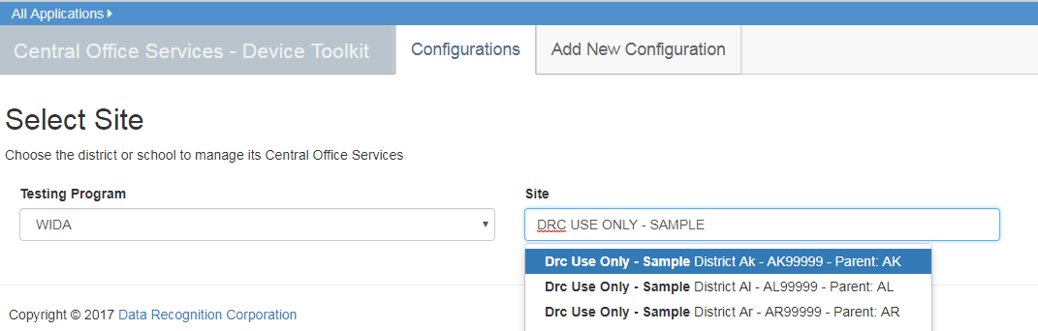

You will then see a circular graph showing the status of your district’s technology readiness. You can click in the "Add and Remove Charts” to select Test Site Management (TSM) Devices." The Configurations must be green and fully functional for the Testing Devices and TSM Devices to function correctly.

**District test and technology coordinators should collaborate to ensure that Configurations and the necessary Testing Devices and TSM Devices are fully functional prior to testing.**

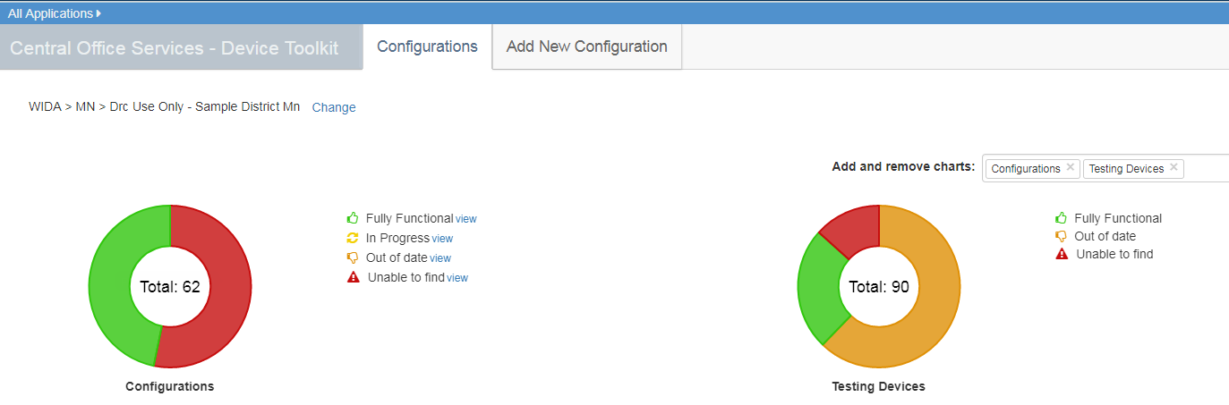

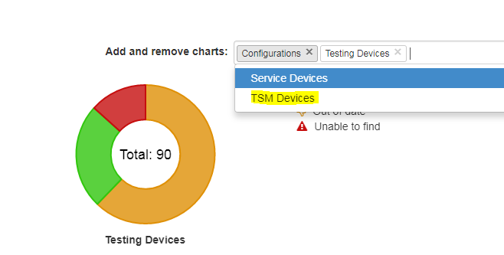

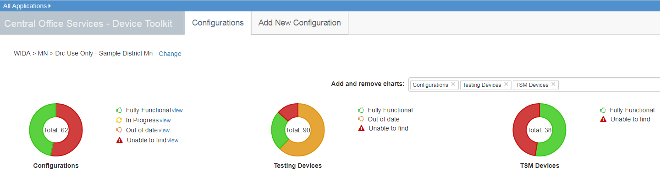

Please contact Data Recognition Corporation with any questions regarding Technology Readiness at [WIDA@DataRecognitionCorp.com](mailto:WIDA@DataRecognitionCorp.com) or 855 787-9615 and contact Student Assessment Services with any other questions about ACCESS for ELLs testing at [ACCESS@doe.mass.edu](mailto:ACCESS@doe.mass.edu) or by phone at 781-338-3625.

Thank you for your attention to this important information.