ACCESS for ELLs

2017 Statewide Results
February 2017

Massachusetts Department of Elementary and Secondary Education
75 Pleasant Street, Malden, MA 02148
Phone 781-338-3000 TTY: N.E.T. Relay 800-439-2370
www.doe.mass.edu

This document was prepared by the
Massachusetts Department of Elementary and Secondary Education
Jeffrey Wulfson
Acting Commissioner

The Massachusetts Department of Elementary and Secondary Education, an affirmative action employer, is committed to ensuring that all of its programs and facilities are accessible to all members of the public.
We do not discriminate on the basis of age, color, disability, gender identity, national origin, race, religion,
sex, or sexual orientation.
Inquiries regarding the Department’s compliance with Title IX and other civil rights laws may be directed to the
Human Resources Director, 75 Pleasant St., Malden, MA 02148 781-338-6105.

© 2017 Massachusetts Department of Elementary and Secondary Education
Permission is hereby granted to copy any or all parts of this document for non-commercial educational purposes. Please credit the “Massachusetts Department of Elementary and Secondary Education.”

Massachusetts Department of Elementary and Secondary Education
75 Pleasant Street, Malden, MA 02148-4906
Phone 781-338-3000 TTY: N.E.T. Relay 800-439-2370
http://www.doe.mass.edu/

Table of Contents

Executive Summary 1
I. Background 3
II. Summary of the 2017 Statewide ACCESS for ELLs Results 5
Student Participation 5
Student Performance 5
Composite Scores 7
Results of the 2017 Alternate ACCESS for ELLs 9
Alternate ACCESS for ELLs Composite Scores 11
Progress Toward English Proficiency: Annual “Growth-to-Proficiency” Targets 13
III. Performance of ELL Students from the State’s Twenty Highest Incidence First-Language Groups 15
Appendix A. ACCESS for ELLs Overall Proficiency Level Cut Scores by Grade Level 24
Appendix B. Alternate ACCESS for ELLs Proficiency Level Cut Scores by Domain and Composite Score 24
Appendix C. Performance Definitions for the Levels of English Language Proficiency 25
Appendix D. Alternate ACCESS for ELLs Performance Definitions 27
Appendix E. Features of the ACCESS for ELLs Tests 28

Executive Summary
Major Findings
2017 was the fifth year that Massachusetts administered the ACCESS for ELLs tests, which are based on the WIDA English Language Development Standards. Massachusetts joined the WIDA consortium in May 2012.
In 2017, 86,757 EL students in Massachusetts who were enrolled in grades K–12 participated in all four sections of the ACCESS tests, including 1,253 students who participated in Alternate ACCESS for ELLs, the alternate assessment for English proficiency. The overall participation rate was 97 percent, one percentage point below that of 2014, 2015, and 2016.
In 2017, 46,255 students (fifty-three percent) participated in a computer-based (online) ACCESS for ELLs test, while 40,362 students (forty-seven percent) participated in a paper-based test.
Overall Achievement
Figure 1 provides a comparison of the percentages of students at each proficiency level by grade on the 2016 and 2017 ACCESS for ELLs tests. The combined percentage of students attaining the highest levels (Level 5 and Level 6) on the ACCESS tests in 2017 decreased in comparison to 2016 for all grades, ranging from 2 percent in Kindergarten to 14 percent in grade 5.
In 2016, the ACCESS for ELLs “cut scores” to attain each proficiency level were reset and in 2017 the results on the new score scale were reported for the first time. The new scale was more rigorous than the earlier scale, meaning that a higher score was required to earn the same score as on the previous test (ACCESS for ELLs 1.0). Therefore, students generally scored somewhat lower in 2017.

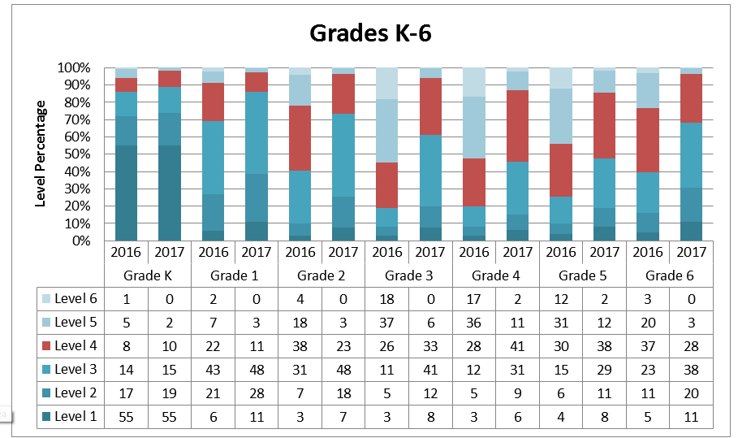
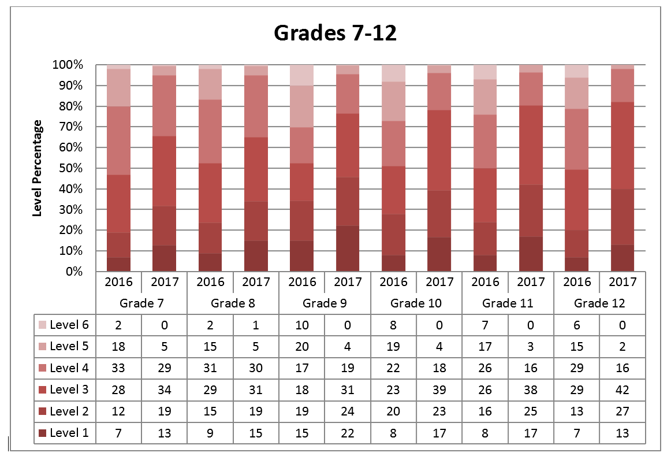
Figure 1. Percentage of Students at Each Performance Level on the 2016 and 2017 ACCESS for ELLs 2.0 (Grades K−6 and 7−12)

I. Background
This report summarizes the results of 86,757 EL students in Massachusetts who participated in the 2017 Assessing Comprehension and Communication in English State-to-State for English Language Learners 2.0 (ACCESS for ELLs 2.0) tests, which are intended to measure the English language proficiency of English learner (EL) students.

ACCESS for ELLs 2.0 tests measure how well EL students have achieved the English Language Development (ELD) Standards developed by the WIDA consortium. Massachusetts adopted the WIDA standards because they measure academic literacy in four subjects, plus social and instructional language; and because they are also aligned with the 2011 Massachusetts Curriculum Frameworks (incorporating the Common Core State Standards).

ACCESS for ELLs consists of four separate domain tests in reading, writing, listening, and speaking. Only students who participate in all four domains receive an overall score. Students participate in tests designed for specific grade-level clusters as follows:

Format | Grade-Level Cluster Tests
Online | 1, 2-3, 4-5, 6-8, 9-12
Paper | K, 1, 2, 3, 4-5, 6-8, 9-12

In 2016, WIDA introduced a new computer-based test. Schools were given a choice to administer either computer- and paper-based tests, with an expectation that the state would complete its transition to computer-based testing for the 2019 test administration. Paper-based tests remain available for use as an accommodation due to a disability or lack of familiarity with or ability to use a computer.

For paper-based testing students take either Tier A, B, or C of the designated grade-cluster test (in grades 1-12), depending on their level of English language proficiency. For computer-based testing, the Listening and Reading tests are adaptive and students are directed to questions of equal, lesser, or greater difficulty depending on how they responded to previous questions. Based on Listening and Reading responses, the students are routed automatically to the appropriately tiered Speaking and Writing tests.

Students taking the ACCESS test received scale scores between 100−600 in each domain. Proficiency level scores were also reported as a whole number followed by a decimal (e.g., Level 3.4), indicating the student’s language proficiency level based on scale scores, and the relative position within the proficiency level of the student’s scale score, rounded to the nearest tenth. Proficiency is reported in one of six English language proficiency levels: 1-Entering, 2-Emerging, 3-Developing, 4-Expanding, 5-Bridging, and 6-Reaching (see Appendix C).

Assessment subscores were also reported using the same scale scores and proficiency levels in the four domains of listening, speaking, reading, and writing; and subscores are reported as a composite score in the combined areas shown below:
- Overall composite score combining the four domain scores in the following weights (Listening 15%, Speaking 15%, Reading 35%, Writing 35%);
- Oral Language composite score, combining equally weighted scale scores from Listening (50%) and Speaking (50%);
- Literacy composite score, combining equally weighted scale scores from Reading (50%) and Writing (50%);
- Comprehension composite score, combining scale scores for Listening (30%) and Reading (70%).

Standard Setting on ACCESS 2.0 Tests
In 2016, the WIDA consortium reset proficiency standards on its ACCESS for ELLs 2.0 assessment. The standards on ACCESS 2.0 are more rigorous than the standards on ACCESS 1.0, meaning that a higher level of achievement on the new test is required to earn the same proficiency level as on the ACCESS 1.0 tests, which were phased out after 2015. The new standards were applied to ACCESS scores for the first time in 2017. Resetting the proficiency standards was intended by WIDA to ensure that ELL students were well-prepared to meet the rigor of the new College and Career Ready Standards now in place in Massachusetts and in other WIDA states. However, the resetting of standards had the effect of greatly reducing the number of students who qualified under the previous ACCESS 1.0 criteria to exit EL status. Massachusetts subsequently elected to revise its criteria for eligibility to exit EL status to a level that was judged to be comparable to the exit criteria on the previous score scale.
Reclassification of EL students
Prior to 2017, the criteria used to exit students from EL status had been the attainment of an overall score of Level 5.0. Based on 2017 results using the ACCESS 2.0 revised score scale, the Department recommended instead that districts consider exiting students from EL status when they met the following criteria, based on the likelihood that they would be able to perform standards-based classroom work in English:
- An overall score of Level 4.2; and
- A composite literacy score of Level 3.9

As before, the Department also recommended the use of other relevant data before exiting a student from EL status, including:
  - observations and the judgment of teachers;
  - student’s classroom work;
  - MCAS and locally-administered diagnostic test results.

Verifying the New Exit Criteria − A Comparability Study
The Student Assessment office conducted a study to determine the comparability of ACCESS 1.0 and ACCESS 2.0 proficiency standards, specifically in terms of the overall ACCESS 2.0 test scores and the composite literacy scores. Three distinct methods were used to identify the equivalent proficiency level for a score of Level 5.0 and overall literacy Level 4.5 on the ACCESS 1.0 scale converted to the ACCESS 2.0 scale. The results of the three methods yielded similar results, and are described below.
- Equipercentile linking, which compares the scores of students on both tests at each percentile rank; e.g., the scores for an ELL student in the 15th percentile were calculated on both the 2015 ACCESS 1.0 (old scale) and 2017 ACCESS 2.0 (new scale);
- The WIDA Score Lookup Calculator, which converts a given score on the ACCESS 1.0 scale to a score on the ACCESS 2.0 scale. We used this method to determine comparable scores on the new scale for students who previously took ACCESS 1.0;
- Comparing the percentage of students attaining Level 5.0 on ACCESS 1.0 with the score attained by the same percentage of students on ACCESS 2.0.
All three methods yielded scores of Level 4.2, with a literacy composite of 3.9, on the new ACCESS 2.0 scale.

Alternate ACCESS for ELLs

The Alternate ACCESS for ELLs was administered in Massachusetts to EL students with significant cognitive disabilities. The Alternate ACCESS is given in grades 1–12 to students whose disabilities prevent meaningful participation in the ACCESS for ELLs general assessment, and is recommended for students who participate in the state’s academic alternate assessment, the MCAS-Alt. It is administered individually by trained and qualified educators in four grade-level clusters: Grades 1–2, 3–5, 6–8, and 9–12. Students are assessed in the four domains of reading, writing, listening, and speaking. Results are reported at six performance levels (Levels P3−P2−P1−A3−A2−A1; see Appendix C for descriptors), and on a numerical scale from 900 to 960. In 2017, 1,253 Massachusetts students in grades 1-12 participated in the Alternate ACCESS for ELLs test during the five-week January–February 2017 testing window.

II. Summary of the 2017 Statewide ACCESS for ELLs Results

Student Participation
Participation in the 2017 ACCESS for ELLs 2.0 tests is summarized below and includes students in grades K−12 who participated in all four test domains―reading, writing, listening, and speaking. Table 1 provides the number and percentage of EL students who participated in the 2017 ACCESS for ELLs 2.0 tests by grade cluster and years of enrollment in Massachusetts.

Table 1. Participation of EL Students on 2017 ACCESS for ELLs 2.0
by Grade Cluster and Years of Enrollment in Massachusetts
Grade Cluster/ Years of Enrollment | Grade  K |  |  |  | Grades  1-2 |  |  |  | Grades  3-5 |  |  | Grades  6–8 |  |  |  | Grades  9–12 |  |  |  |  | Total
 | # |  | % |  | # |  | % |  | # |  | % |  | # |  | % |  | # |  | % |  |  | # |  | %
First Year |  | 9,955 |  | 99 |  | 2,721 |  | 98 |  | 3,224 | 99 |  |  | 2,880 | 99 |  |  | 4,771 |  | 98 |  |  | 23,511 |  | 99
Second Year |  | 386 |  | 99 |  | 9,948 |  | 98 |  | 2,228 | 99 |  |  | 2,062 | 99 |  |  | 3,312 |  | 96 |  |  | 17,903 |  | 98
Third Year |  | 0 |  | 0 |  | 8,097 |  | 99 |  | 1,780 | 99 |  |  | 1,497 | 98 |  |  | 2,348 |  | 95 |  |  | 13,722 |  | 98
Fourth Year |  | 0 |  | 0 |  | 795 |  | 99 |  | 7,152 | 99 |  |  | 1,107 | 98 |  |  | 1,667 |  | 94 |  |  | 10,721 |  | 98
Fifth Year or More |  | 0 |  | 0 |  | 4 |  | 100 |  | 8,412 | 98 |  |  | 7,282 | 96 |  |  | 5,191 |  | 87 |  |  | 20,889 |  | 94
All Students |  | 10,341 |  | 99 |  | 21,565 |  | 98 |  | 22,796 | 98 |  |  | 14,828 | 97 |  |  | 17,289 |  | 93 |  |  | 86,819 |  | 97
In 2017, kindergarten had the highest participation rate at 99 percent, and grade cluster 9–12 had the lowest participation rate at 93 percent. As in past years, the participation rate by years of enrollment for students in grade clusters 6–8 and 9–12 appears to decline the longer a student received language services. This was particularly evident in grade cluster 9–12, where 98 percent in their first year of enrollment participated compared to 90 percent in their fifth (or more) year of enrollment.

Student Performance
Results for the 2017 ACCESS 2.0 for ELLs 2.0 test administration, disaggregated by years of enrollment for each grade cluster, are summarized on the following pages. Results for students who took the Alternate ACCESS for ELLs are summarized separately because of basic differences in the reporting of the proficiency levels and calculation of the scale scores (see page 10). However, they are included in the number tested in tables 2 through 6. Results were not reported if fewer than 10 students were tested.

Grade K

Table 2. Performance of EL Students on 2017 ACCESS for ELLs 2.0
by Years of Enrollment in Massachusetts:
Kindergarten
Years of Enrollment | Number Tested | Average Scale Score | Percentage of Students at Each Performance Level
 |  |  | Level 1 | Level 2 | Level 3 | Level 4 | Level 5 | Level 6
First Year | 9,945 | 217 | 56 | 18 | 15 | 9 | 2 | 0
Second Year | 386 | 228 | 48 | 24 | 17 | 11 | 1 | 0
Third Year | - | - | - | - | - | - | - | -
Fourth Year | - | - | - | - | - | - | - | -
Fifth Year or More | - | - | - | - | - | - | - | -
All Students | 10,331 | 217 | 55 | 19 | 15 | 10 | 2 | 0

Grade Cluster 1–2

Table 3. Performance of EL Students on 2017 ACCESS for ELLs 2.0
by Years of Enrollment in Massachusetts:
Grade Cluster 1–2
Years of Enrollment | Number Tested | Average Scale Score | Percentage of Students at Each Performance Level
 |  |  | Level 1 | Level 2 | Level 3 | Level 4 | Level 5 | Level 6
First Year | 2,707 | 262 | 38 | 28 | 26 | 7 | 1 | 0
Second Year | 9,771 | 288 | 6 | 27 | 50 | 13 | 3 | 0
Third Year | 7,985 | 312 | 2 | 16 | 52 | 25 | 4 | 0
Fourth Year | 776 | 306 | 2 | 22 | 56 | 19 | 1 | 0
Fifth Year or More | - | - | - | - | - | - | - | -
All Students | 21,243 | 294 | 8 | 23 | 48 | 17 | 3 | 0

Grade Cluster 3–5

4. Performance of EL Students on 2017 ACCESS for ELLs 2.0
by Years of Enrollment in Massachusetts:
Grade Cluster 3–5
Years of Enrollment | Number Tested | Average Scale Score | Percentage of Students at Each Performance Level
 |  |  | Level 1 | Level 2 | Level 3 | Level 4 | Level 5 | Level 6
First Year | 3,201 | 298 | 37 | 22 | 21 | 13 | 5 | 1
Second Year | 2,210 | 332 | 8 | 18 | 36 | 28 | 7 | 2
Third Year | 1,745 | 342 | 2 | 11 | 40 | 36 | 10 | 1
Fourth Year | 7,053 | 338 | 1 | 8 | 42 | 41 | 8 | 1
Fifth Year or More | 8,250 | 357 | 1 | 5 | 34 | 47 | 13 | 2
All Students | 22,459 | 339 | 7 | 10 | 35 | 37 | 9 | 1

Grade Cluster 6–8

Table 5. Performance of EL Students on 2017 ACCESS for ELLs 2.0
by Years of Enrollment in Massachusetts:
Grade Cluster 6-8
Years of Enrollment | Number Tested | Average Scale Score | Percentage of Students at Each Performance Level
 |  |  | Level 1 | Level 2 | Level 3 | Level 4 | Level 5 | Level 6
First Year | 2,870 | 316 | 40 | 26 | 18 | 12 | 3 | 1
Second Year | 2,037 | 341 | 15 | 27 | 31 | 21 | 5 | 1
Third Year | 1,475 | 353 | 6 | 22 | 39 | 26 | 6 | 1
Fourth Year | 1,087 | 359 | 3 | 17 | 40 | 35 | 4 | 0
Fifth Year or More | 7,066 | 362 | 2 | 13 | 41 | 39 | 4 | 0
All Students | 14,535 | 349 | 12 | 19 | 35 | 30 | 4 | 0

Grade Cluster 9–12

Table 6. Performance of EL Students on 2017 ACCESS for ELLs 2.0
by Years of Enrollment in Massachusetts:
Grade Cluster 9-12
Years of Enrollment | Number Tested | Average Scale Score | Percentage of Students at Each Performance Level
 |  |  | Level 1 | Level 2 | Level 3 | Level 4 | Level 5 | Level 6
First Year | 4,755 | 338 | 39 | 25 | 21 | 11 | 5 | 0
Second Year | 3,283 | 355 | 17 | 31 | 33 | 15 | 4 | 0
Third Year | 2,328 | 362 | 11 | 28 | 41 | 17 | 3 | 0
Fourth Year | 1,642 | 369 | 7 | 24 | 46 | 20 | 3 | 0
Fifth Year or More | 4,928 | 375 | 3 | 16 | 50 | 27 | 3 | 0
All Students | 16,936 | 358 | 17 | 24 | 37 | 18 | 4 | 0

Composite Scores

Students received four composite scores in oral language, comprehension, and literacy, in addition to an overall composite score, which provide details and context for their performance. These are derived from a combination of weighted scale scores from the four language domains as follows:
- Overall―combining the four domain scores, as follows: Listening (15%), Speaking (15%), Reading (35%), and Writing (35%)
- Oral Language (Oral Lang)―combining equally weighted scale scores for Listening and Speaking (50% each)
- Comprehension (Compr)—combining scale scores for Listening (30%) and Reading (70%)
- Literacy―combining equally weighted scale scores for Reading and Writing (50% each)

Median scale scores and proficiency levels by years of enrollment are presented below.

Kindergarten

Table 7. Composite Scores of EL Students on 2017 ACCESS for ELLs 2.0
by Years of Enrollment in Massachusetts:
Grade Cluster K
Years of Enrollment | Number Tested |  | Oral Lang Scale Score |  | Oral Lang Prof Level | Compr Scale Score | Compr Prof Level | Literacy Scale Score | Literacy Prof Level
First Year | 9,945 |  | 278 |  | 3.9 | 208 | 2.4 | 191 | 1.9
Second Year | 386 |  | 296 |  | 4.3 | 220 | 2.5 | 199 | 1.9
Third Year | - |  | - |  | - | - | - | - | -
Fourth Year | - |  | - |  | - | - | - | - | -
Fifth Year or More | - |  | - |  | - | - | - | - | -
All Students | 10,331 |  | 278 |  | 3.9 | 209 | 2.4 | 192 | 1.9
Grade Cluster 1–2

Table 8. Composite Scores of EL Students on 2017 ACCESS for ELLs 2.0
by Years of Enrollment in Massachusetts:
Grade Cluster 1–2
Years of Enrollment | Number Tested | Oral Lang Scale Score | Oral Lang Prof Level | Compr Scale Score | Compr Prof Level | Literacy Scale Score | Literacy Prof Level
First Year | 2,707 | 254 | 2.9 | 283 | 3.1 | 265 | 2.5
Second Year | 9,771 | 304 | 4.1 | 302 | 4.0 | 282 | 2.9
Third Year | 7,985 | 314 | 4.0 | 323 | 4.2 | 311 | 3.4
Fourth Year | 776 | 310 | 3.8 | 316 | 3.8 | 305 | 3.2
Fifth Year or More | - | - | - | - | - | - | -
All Students | 21,243 | 301 | 3.9 | 308 | 4.0 | 291 | 3.1

Grade Cluster 3–5

Table 9. Composite Scores of EL Students on 2017 ACCESS for ELLs 2.0
by Years of Enrollment in Massachusetts:
Grade Cluster 3–5
Years of Enrollment | Number Tested | Oral Lang Scale Score | Oral Lang Prof Level | Compr Scale Score | Compr Prof Level | Literacy Scale Score | Literacy Prof Level
First Year | 3,201 | 288 | 3.0 | 322 | 3.1 | 304 | 2.8
Second Year | 2,210 | 336 | 3.9 | 347 | 4.0 | 330 | 3.5
Third Year | 1,745 | 349 | 4.2 | 355 | 4.4 | 339 | 3.7
Fourth Year | 7,053 | 342 | 4.2 | 351 | 4.5 | 337 | 3.8
Fifth Year or More | 8,250 | 371 | 4.6 | 370 | 4.8 | 351 | 3.9
All Students | 22,459 | 345 | 4.2 | 354 | 4.4 | 337 | 3.7
Grade Cluster 6–8

Table 10. Composite Scores of EL Students on 2017 ACCESS for ELLs 2.0
by Years of Enrollment in Massachusetts:
Grade Cluster 6–8
Years of Enrollment | Number Tested | Oral Scale Score | Oral Perf Level | Compr Scale Score | Compr Perf Level | Literacy Scale Score | Literacy Perf Level
First Year | 2,870 | 320 | 3.0 | 338 | 2.9 | 314 | 2.6
Second Year | 2,037 | 353 | 3.6 | 359 | 3.5 | 337 | 3.1
Third Year | 1,475 | 369 | 4.0 | 368 | 3.8 | 347 | 3.3
Fourth Year | 1,087 | 378 | 4.2 | 372 | 3.9 | 352 | 3.4
Fifth Year or More | 7,066 | 380 | 4.3 | 375 | 4.1 | 355 | 3.5
All Students | 14,535 | 363 | 3.9 | 365 | 3.7 | 343 | 3.2

Grade Cluster 9–12

Table 11. Composite Scores of EL Students on 2017 ACCESS for ELLs 2.0
by Years of Enrollment in Massachusetts:
Grade Cluster 9–12
Years of Enrollment | Number Tested | Oral Lang Scale Score | Oral Lang Prof Level | Compr Scale Score |  | Compr Prof Level | Literacy Scale Score | Literacy Prof Level
First Year | 4,755 | 319 | 2.6 |  | 360 | 2.9 | 346 | 2.9
Second Year | 3,283 | 342 | 2.9 |  | 372 | 3.3 | 362 | 3.2
Third Year | 2,328 | 352 | 3.1 |  | 378 | 3.4 | 367 | 3.3
Fourth Year | 1,642 | 362 | 3.3 |  | 384 | 3.6 | 373 | 3.4
Fifth Year or More | 4,925 | 372 | 3.6 |  | 389 | 3.9 | 376 | 3.6
All Students | 16,936 | 348 | 3.1 |  | 375 | 3.4 | 363 | 3.2

Results of the 2017 Alternate ACCESS for ELLs
The Alternate ACCESS assessment was first administered in 2014 to EL students with significant cognitive disabilities. The Alternate ACCESS for ELLs results were reported at six proficiency levels: A1-Initiating, A2-Exploring, A3-Engaging, P1-Entering, P2-Emerging, and P3-Developing, and on a numerical scale from 900 to 960. Alternate ACCESS proficiency levels A1, A2, and A3 align with the lower, middle, and upper section respectively of ACCESS proficiency level 1-Entering. Alternate ACCESS proficiency levels P1, P2, and P3 coincide with ACCESS composite proficiency levels 1, 2, and 3 respectively (see Figure 1 below). See Appendix D for the performance definitions of the Alternate ACCESS for ELLs proficiency levels.

Figure 1
Overlay of ACCESS and Alternate ACCESS Proficiency Levels

Results of the 2017 Alternate ACCESS for ELLs test administration, disaggregated by years of enrollment for each grade cluster, are summarized below.

Alternate ACCESS: Grade Cluster 1–2

Table 12. Performance of EL Students on 2017 Alternate ACCESS for ELLs
by Years of Enrollment in Massachusetts:
Grade Cluster 1–2
Years of Enrollment | Number Tested | Average Scale Score | Percentage of Students at Each Alternate Performance Level
 |  |  | A1: Initiating | A2: Exploring | A3: Engaging | P1: Entering | P2: Emerging | P3: Developing
First Year | 14 | 933 | 21 | 14 | 21 | 29 | 14 | 0
Second Year | 149 | 938 | 5 | 9 | 30 | 38 | 19 | 0
Third Year | 92 | 938 | 2 | 10 | 32 | 34 | 23 | 0
Fourth Year | 18 | 942 | 0 | 6 | 6 | 44 | 44 | 0
Fifth Year or More | - | - | - | - | - | - | - | -
All Students | 273 | 938 | 4 | 10 | 28 | 36 | 22 | 0

Alternate ACCESS: Grade Cluster 3–5

Table 13. Performance of EL Students on 2017 Alternate ACCESS for ELLs
by Years of Enrollment in Massachusetts:
Grade Cluster 3-5
Years of Enrollment | Number Tested | Average Scale Score | Percentage of Students at Each Alternate Performance Level
 |  |  | A1: Initiating | A2: Exploring | A3: Engaging | P1: Entering | P2: Emerging | P3: Developing
First Year | 22 | 933 | 14 | 23 | 32 | 27 | 5 | 0
Second Year | 18 | 939 | 0 | 11 | 28 | 33 | 28 | 0
Third Year | 35 | 939 | 9 | 3 | 23 | 31 | 34 | 0
Fourth Year | 99 | 940 | 3 | 7 | 16 | 36 | 37 | 0
Fifth Year or More | 161 | 942 | 2 | 4 | 10 | 28 | 56 | 0
All Students | 335 | 941 | 4 | 6 | 16 | 31 | 43 | 0

Alternate ACCESS: Grade Cluster 6–8

Table 14. Performance of EL Students on 2017 Alternate ACCESS for ELLs
by Years of Enrollment in Massachusetts:
Grade Cluster 6-8
Years of Enrollment | Number Tested | Average Scale Score | Percentage of Students at Each Alternate Performance Level
 |  |  | A1: Initiating | A2: Exploring | A3: Engaging | P1: Entering | P2: Emerging | P3: Developing
First Year | 10 | 937 | 10 | 10 | 30 | 30 | 20 | 0
Second Year | 25 | 940 | 0 | 8 | 12 | 48 | 32 | 0
Third Year | 22 | 937 | 5 | 14 | 27 | 32 | 23 | 0
Fourth Year | 20 | 940 | 5 | 5 | 20 | 30 | 40 | 0
Fifth Year or More | 216 | 943 | 3 | 4 | 12 | 26 | 56 | 0
All Students | 293 | 942 | 3 | 5 | 14 | 29 | 49 | 0

Alternate ACCESS: Grade Cluster 9–12

Table 15. Performance of EL Students on 2017 Alternate ACCESS for ELLs
by Years of Enrollment in Massachusetts:
Grade Cluster 9-12
Years of Enrollment | Number Tested | Average Scale Score | Percentage of Students at Each Alternate Performance Level
 |  |  | A1: Initiating | A2: Exploring | A3: Engaging | P1: Entering | P2: Emerging | P3: Developing
First Year | 16 | 937 | 6 | 19 | 25 | 38 | 13 | 0
Second Year | 29 | 936 | 0 | 28 | 28 | 31 | 14 | 0
Third Year | 20 | 936 | 5 | 25 | 20 | 40 | 40 | 0
Fourth Year | 25 | 942 | 0 | 0 | 20 | 40 | 40 | 0
Fifth Year or More | 262 | 941 | 2 | 4 | 15 | 34 | 45 | 0
All Students | 352 | 940 | 2 | 8 | 17 | 34 | 39 | 0

Alternate ACCESS for ELLs Composite Scores
Students who took the Alternate ACCESS for ELLs received three composite scores in addition to an overall composite score which provided details and a context for their performance. The composite scores included oral language, comprehension, and literacy, and were derived from a combination of weighted scale scores from the four language domains in the same proportions as for the ACCESS for ELLs, as follows:
- Oral Language (Oral Lang)―combining equally weighted scale scores for Listening and Speaking (50% each)
- Comprehension (Compr)—combining scale scores for Listening (30%) and Reading (70%)
- Literacy―combining equally weighted scale scores for Reading and Writing (50% each)

The overall composite proficiency levels were reported on the scale of A1–A2–A3–P1–P2–P3, and as scale scores. The tables below provide median scale scores for students who took the Alternate ACCESS for ELLs. Appendix B provides a crosswalk of the Alternate ACCESS for ELLs proficiency level scores and the scale scores, and shows the cut scores for each level. Note: cut scores vary in each domain.

Alternate ACCESS: Grade Cluster 1–2

Table 16. Composite Scores of EL Students on 2017
Alternate ACCESS for ELLs by Years of Enrollment in Massachusetts:
Grade Cluster 1-2
Years of Enrollment | Number Tested |  | Oral Scale Score |  |  | Comprehension  Scale Score |  | Literacy  Scale Score
First Year | 14 | 938 |  | 934 |  |  | 931
Second Year | 149 | 941 |  |  | 939 |  |  |  | 937
Third Year | 92 | 941 |  |  | 940 |  |  |  | 938
Fourth Year | 18 | 943 |  |  | 945 |  |  |  | 943
Fifth Year or More | - | - |  |  | - |  |  |  | -
All Students | 273 | 941 |  |  | 939 |  |  |  | 937

Alternate ACCESS: Grade Cluster 3–5

Table 17. Composite Scores of EL Students on 2017
Alternate ACCESS for ELLs by Years of Enrollment in Massachusetts:
Grade Cluster 3–5
Years of Enrollment | Number Tested | Oral Scale Score | Comprehension Scale Score | Literacy Scale Score
First Year | 22 | 935 | 933 | 933
Second Year | 18 | 942 | 941 | 938
Third Year | 35 | 941 | 940 | 939
Fourth Year | 99 | 943 | 941 | 940
Fifth Year or More | 161 | 944 | 943 | 942
All Students | 335 | 942 | 941 | 940

Alternate ACCESS: Grade Cluster 6–8

Table 18. Composite Scores of EL Students on 2017
Alternate ACCESS for ELLs by Years of Enrollment in Massachusetts:
Grade Cluster 6–8
Years of Enrollment | Number Tested | Oral Scale Score | Comprehension Scale Score | Literacy Scale Score
First Year | 10 | 937 | 940 | 938
Second Year | 25 | 941 | 942 | 940
Third Year | 22 | 940 | 939 | 935
Fourth Year | 20 | 944 | 942 | 938
Fifth Year or More | 216 | 944 | 944 | 942
All Students | 293 | 943 | 943 | 941

Alternate ACCESS: Grade Cluster 9–12

Table 19. Composite Scores of EL Students on 2017
Alternate ACCESS for ELLs by Years of Enrollment in Massachusetts:
Grade Cluster 9–12
Years of Enrollment | Number Tested | Oral Scale Score | Comprehension Scale Score | Literacy Scale Score
First Year | 16 | 937 | 939 | 937
Second Year | 29 | 938 | 938 | 935
Third Year | 20 | 938 | 938 | 935
Fourth Year | 25 | 942 | 943 | 942
Fifth Year or More | 262 | 943 | 943 | 941
All Students | 352 | 942 | 942 | 940

Progress Determinations and Targets

Overview
An EL student’s progress in learning English is based on annual Student Growth Percentiles for ACCESS (SGPAs) which measures an EL student’s growth from one year to the next as determined by their ACCESS for ELLs test results; and whether each student’s SGPA meets or exceeds their growth-to-proficiency target. This will allow the Department to determine whether:
- each Massachusetts student’s ACCESS results shows sufficient growth from one year to the next in order to be “on track” to attain English proficiency in no more than six years;
- each Massachusetts district has met its target, based on a pre-determined percentage of students in the district who must meet growth-to-proficiency targets each year.

Features of the progress reporting element and how progress will be calculated to determine whether a student is on track to become English proficient within six years:

- A Student Growth Percentile for ACCESS (SGPA), a whole number from 1−99, was calculated for each Massachusetts student based on mode-adjusted overall scale scores if the student took ACCESS tests in both the current and one previous school year. Each student’s Year 2 results were compared with the Year 1 results of students who scored similarly.
- Growth-to-proficiency targets were calculated using the ACCESS for ELLs test results of students who took the ACCESS tests in both 2016 and 2017. Growth-to-proficiency targets are dependent on the student’s level of proficiency on the previous year’s ACCESS test and the number of years the student has attended a Massachusetts school. Table 1 shows the target SGPA needed by a student each year to attain English language proficiency (i.e., a score of Level 4.2 Overall Score and a Composite Literacy score of Level 3.9) within six years.
- Each student’s SGPA is compared with his or her growth-to-proficiency target. A growth-to-proficiency “indicator” (i.e., either yes or no) is given to each student depending on whether they met their target SGPA. An EL student is considered to have “made progress” if his or her current year’s SGPA is greater than or equal to the target listed in the appropriate area of the matrix in Table 1. Only those students who earned an overall score on both the current and one previous year’s ACCESS test are included in calculations for growth-to-proficiency.
- A statewide progress target is set by the Department each year indicating the required percentage of students in every district who must have met or exceeded their growth-to-proficiency targets in order for the district to have made sufficient progress. The statewide target is the same for all districts; however, the target increases annually, as follows: one percentage point each year between 2014 and 2016; and .5 percentage point beginning in 2017 (see Table 2).

Table 1.
Growth-to-Proficiency Targets
Expressed as Student Growth Percentile for ACCESS (SGPA)

ACCESS for ELLs 2.0 − Prior Year Proficiency Level
 |  | Level 1.0  to 1.9 | Level 2.0  to 2.9 | Level 3.0  to 3.9 | Level 4.0  to 4.1 | Level 4.2 and above
Prior Years in a Massachusetts
School
 | 1 | 47 | 43 | 39 | 30 | *
 | 2 | 57 | 48 | 40 | 31 | *
 | 3 | 63 | 50 | 42 | 32 | *
 | 4 | 69 | 52 | 47 | 34 | *
 | 5+ | 71 | 68 | 56 | 51 | *
* Students in Level 4.2 and above must gain at least one point on the ACCESS score scale each year they retain EL status.

Proficient Students Who Retain Their English Learner Status the Following Year
Students whose prior year’s proficiency level was at least Level 4.2 overall and Level 3.9 composite literacy and were not exited from EL status will be required to gain at least one point on the ACCESS vertical score scale and remain at least at Level 4.2 on the subsequent year’s ACCESS test in order to meet their growth-to-proficiency targets.

Table 2.
Annual District Progress Targets
Target percentage of students in a district who must “make progress”
by meeting growth-to-proficiency targets
District progress targets increased by one percentage point each year between 2014−2016, and will increase by .5 percentage points each year beginning in 2017.
2014 | 2015 | 2016 | 2017 | 2018 | 2019 | 2020
50% | 51% | 52% | 52.5% | 53% | 53.5% | 54%

Growth-to-Proficiency Determinations for Students Who Took the Alternate ACCESS for ELLs

Students taking the Alternate ACCESS are eligible to receive a growth-to-proficiency determination if they participated in the ACCESS testing program in two successive years. Meeting the growth target on Alternate ACCESS is based on whether the student has increased his or her score level by at least one point in one or more subdomains of the Alternate ACCESS assessment (i.e., either in Listening, Speaking, Reading, or Writing). Students that moved between the Alternate ACCESS assessment and the regular ACCESS assessment must also demonstrate a score level increase of 1 point, as indicated on the Overlay of ACCESS and Alternate ACCESS Proficiency Levels in Figure 1. For example, a student scoring at level 1 on the ACCESS test who switched to the Alternate ACCESS test the following year must obtain Level P2 on any Alternate ACCESS domain test.

Table 20. Percent of Massachusetts Students Meeting Growth-to-Proficiency Targets
Grade Cluster | Years of Enrollment | Number Tested | Percentage of Students Making Progress
Grades 1–2
 | First Year | 208 | 55
 | Second Year | 9,468 | 56
 | Third Year | 7,832 | 54
 | Fourth Year | 779 | 34
 | Fifth Year | 4 | 75
 | All Students | 18,291 | 55
Grades 3–5
 | First Year | 96 | 60
 | Second Year | 1,992 | 70
 | Third Year | 1,680 | 61
 | Fourth Year | 7,031 | 60
 | Fifth Year | 7,934 | 51
 | All Students | 18,733 | 58
Grades 6–8
 | First Year | 83 | 65
 | Second Year | 1,878 | 68
 | Third Year | 1,444 | 59
 | Fourth Year | 1,057 | 57
 | Fifth Year | 6,884 | 40
 | All Students | 11,346 | 49
Grades 9–12
 | First Year | 118 | 41
 | Second Year | 3,085 | 56
 | Third Year | 2,371 | 48
 | Fourth Year | 1,705 | 45
 | Fifth Year | 5,437 | 31
 | All Students | 12,716 | 42
Total
 | First Year | 505 | 54
 | Second Year | 16,423 | 59
 | Third Year | 13,327 | 55
 | Fourth Year | 10,572 | 55
 | Fifth Year | 20,259 | 42
 | All Students | 61,086 | 52

III. Performance of EL Students from the State’s Twenty Highest Incidence First-Language Groups
Table 21 shows the number and percent of the highest incidence languages spoken by Massachusetts students in 2017. Tables 22–29 show the results of EL students on the 2017 ACCESS for ELLs 2.0 tests by grade cluster and years of enrollment, disaggregated for the eight highest incidence first languages of participating students: Spanish, Portuguese, Chinese, Cape Verdean, Haitian Creole, Arabic, Vietnamese, and Khmer/Khmai.
Table 21.
Number and Percentage of Enrolled EL Students by Highest-incidence
First (Native) Languages

First Languageª |  | Number |  | Percent
1. | Spanish | 46,845 | 54.0
2. | Portuguese | 8,460 | 9.8
3. | Chinese^{b} | 3,885 | 4.5
4 | Cape Verdean | 3,539 | 4.1
5 | Haitian Creole | 3,410 | 3.9
6. | Arabic | 2,946 | 3.4
7. | Vietnamese | 2,191 | 2.5
8. | Khmer/Khmai | 1,492 | 1.7
9. | Russian | 1,101 | 1.3
10. | French | 719 | 0.8
11. | Nepali | 633 | 0.7
12. | Somali | 627 | 0.7
13. | Twi | 592 | 0.7
14. | Swahili | 508 | 0.6
15. | French Patois | 472 | 0.5
16. | Japanese | 411 | 0.5
17 | Albanian | 409 | 0.5
18. | English | 365 | 0.4
19. | Hindi | 354 | 0.4
20. | Korean | 348 | 0.4
ª Data of the 20 highest-incidence first language groups were based on the latest SIMS data.
^{b} The Chinese language group includes the students whose first language was reported in SIMS as Chinese, Cantonese, Mandarin, Fukien, or Taiwanese.

Table 22. Performance of ELL Students on 2017 ACCESS for ELLs
by Grade Cluster and Years of Enrollment in Massachusetts
First Language: SPANISH
Grade Cluster /  Years of Enrollment | Number Tested | Average Scale Score | Percentage of Students at Each Performance Level
 |  |  | Level 1 | Level 2 | Level 3 | Level 4 | Level 5 | Level 6
Grade K
First Year | 4,751 | 208 | 62 | 18 | 12 | 7 | 1 | 0
Second Year | 250 | 227 | 50 | 23 | 17 | 10 | 1 | 0
Third Year | 0 | - | - | - | - | - | - | -
Fourth Year | 0 | - | - | - | - | - | - | -
Fifth Year or More | 0 | - | - | - | - | - | - | -
All Students | 5,001 | 209 | 61 | 18 | 12 | 7 | 1 | 0
Grade 1-2
First Year | 1,184 | 251 | 49 | 26 | 21 | 4 | 0 | 0
Second Year | 4,817 | 281 | 9 | 33 | 48 | 9 | 1 | 0
Third Year | 4,271 | 307 | 4 | 20 | 54 | 21 | 2 | 0
Fourth Year | 521 | 305 | 3 | 22 | 57 | 17 | 1 | 0
Fifth Year or More | - | - | - | - | - | - | - | -
All Students | 10,796 | 289 | 11 | 26 | 48 | 13 | 1 | 0
Grade 3-5
First Year | 1,343 | 285 | 48 | 24 | 17 | 9 | 2 | 0
Second Year | 1,000 | 323 | 12 | 22 | 41 | 21 | 4 | 0
Third Year | 950 | 337 | 5 | 13 | 44 | 32 | 6 | 0
Fourth Year | 3,874 | 335 | 2 | 10 | 45 | 38 | 5 | 0
Fifth Year or More | 5,191 | 354 | 2 | 7 | 36 | 44 | 10 | 1
All Students | 12,358 | 336 | 8 | 11 | 38 | 35 | 7 | 1
Grade 6-8
First Year | 1,396 | 301 | 54 | 26 | 13 | 7 | 1 | 0
Second Year | 1,024 | 329 | 21 | 34 | 31 | 12 | 2 | 0
Third Year | 859 | 347 | 9 | 26 | 40 | 23 | 3 | 0
Fourth Year | 597 | 354 | 6 | 21 | 42 | 29 | 2 | 0
Fifth Year or More | 4,621 | 358 | 5 | 17 | 42 | 34 | 2 | 0
All Students | 8,497 | 343 | 15 | 21 | 36 | 25 | 2 | 0
Grade 9-12
First Year | 2,445 | 321 | 53 | 26 | 15 | 5 | 1 | 0
Second Year | 1,845 | 344 | 23 | 37 | 29 | 9 | 1 | 0
Third Year | 1,468 | 355 | 15 | 33 | 39 | 13 | 1 | 0
Fourth Year | 1,012 | 365 | 9 | 28 | 45 | 17 | 1 | 0
Fifth Year or More | 3,423 | 372 | 7 | 20 | 48 | 23 | 2 | 0
All Students | 10,193 | 351 | 22 | 27 | 35 | 14 | 2 | 0

Table 23. Performance of ELL Students on 2017 ACCESS for ELLs
by Grade Cluster and Years of Enrollment in Massachusetts
First Language: PORTUGUESE
Grade Cluster /  Years of Enrollment | Number Tested | Average Scale Score | Percentage of Students at Each Performance Level
 |  |  | Level 1 | Level 2 | Level 3 | Level 4 | Level 5 | Level 6
Grade K
First Year | 985 | 210 | 60 | 19 | 12 | 7 | 1 | 0
Second Year | 20 | 249 | 30 | 20 | 30 | 10 | 10 | 0
Third Year | 0 | - | - | - | - | - | - | -
Fourth Year | 0 | - | - | - | - | - | - | -
Fifth Year or More | 0 | - | - | - | - | - | - | -
All Students | 1005 | 211 | 60 | 19 | 13 | 7 | 1 | 0
Grade 1-2
First Year | 409 | 258 | 40 | 32 | 24 | 4 | 0 | 0
Second Year | 1,029 | 290 | 4 | 24 | 57 | 12 | 3 | 0
Third Year | 767 | 313 | 1 | 16 | 53 | 26 | 3 | 0
Fourth Year | 58 | 317 | 0 | 10 | 59 | 29 | 2 | 0
Fifth Year or More | - | - | - | - | - | - | - | -
All Students | 2,263 | 293 | 10 | 22 | 50 | 16 | 2 | 0
Grade 3-5
First Year | 511 | 294 | 38 | 25 | 24 | 10 | 3 | 0
Second Year | 365 | 336 | 5 | 16 | 38 | 34 | 7 | 2
Third Year | 142 | 347 | 2 | 10 | 32 | 42 | 13 | 1
Fourth Year | 702 | 341 | 1 | 6 | 40 | 44 | 8 | 0
Fifth Year or More | 633 | 360 | 0 | 4 | 28 | 52 | 14 | 1
All Students | 2,353 | 335 | 9 | 11 | 33 | 37 | 9 | 1
Grade 6-8
First Year | 436 | 321 | 31 | 32 | 22 | 11 | 3 | 0
Second Year | 294 | 350 | 10 | 22 | 34 | 26 | 6 | 2
Third Year | 127 | 369 | 2 | 9 | 38 | 39 | 10 | 2
Fourth Year | 90 | 367 | 0 | 14 | 36 | 41 | 8 | 1
Fifth Year or More | 413 | 373 | 1 | 6 | 32 | 52 | 8 | 0
All Students | 1,360 | 351 | 13 | 19 | 30 | 31 | 6 | 1
Grade 9-12
First Year | 638 | 349 | 26 | 27 | 26 | 14 | 6 | 0
Second Year | 397 | 373 | 6 | 22 | 40 | 27 | 6 | 0
Third Year | 161 | 375 | 6 | 17 | 47 | 24 | 5 | 0
Fourth Year | 121 | 381 | 6 | 13 | 48 | 24 | 9 | 0
Fifth Year or More | 162 | 379 | 1 | 19 | 42 | 36 | 2 | 0
All Students | 1,479 | 364 | 14 | 23 | 35 | 22 | 6 | 0

Table 24. Performance of ELL Students on 2017 ACCESS for ELLs
by Grade Cluster and Years of Enrollment in Massachusetts
First Language: CHINESE
Grade Cluster /  Years of Enrollment | Number Tested | Average Scale Score | Percentage of Students at Each Performance Level
 |  |  | Level 1 | Level 2 | Level 3 | Level 4 | Level 5 | Level 6
Grade K
First Year | 635 | 233 | 45 | 15 | 23 | 14 | 3 | 0
Second Year | - | - | - | - | - | - | - | -
Third Year | - | - | - | - | - | - | - | -
Fourth Year | - | - | - | - | - | - | - | -
Fifth Year or More | - | - | - | - | - | - | - | -
All Students | 636 | 233 | 45 | 15 | 22 | 14 | 3 | 0
Grade 1-2
First Year | 143 | 280 | 22 | 29 | 34 | 10 | 4 | 1
Second Year | 599 | 306 | 2 | 15 | 46 | 25 | 11 | 2
Third Year | 436 | 327 | 2 | 5 | 42 | 40 | 10 | 1
Fourth Year | 18 | 319 | 11 | 0 | 39 | 50 | 0 | 0
Fifth Year or More | 0 | - | - | - | - | - | - | -
All Students | 1,196 | 311 | 4 | 13 | 43 | 29 | 10 | 1
Grade 3-5
First Year | 187 | 323 | 21 | 21 | 22 | 20 | 11 | 5
Second Year | 96 | 345 | 7 | 11 | 27 | 32 | 15 | 7
Third Year | 71 | 363 | 1 | 3 | 23 | 39 | 28 | 6
Fourth Year | 382 | 350 | 1 | 4 | 31 | 45 | 15 | 4
Fifth Year or More | 317 | 376 | 0 | 2 | 15 | 43 | 31 | 9
All Students | 1,053 | 354 | 5 | 7 | 24 | 38 | 20 | 6
Grade 6-8
First Year | 107 | 363 | 7 | 20 | 28 | 22 | 17 | 7
Second Year | 71 | 363 | 10 | 20 | 23 | 21 | 21 | 6
Third Year | 60 | 386 | 2 | 10 | 15 | 42 | 27 | 5
Fourth Year | 28 | 378 | 0 | 14 | 21 | 46 | 14 | 4
Fifth Year or More | 144 | 380 | 2 | 7 | 24 | 55 | 11 | 1
All Students | 410 | 373 | 4 | 13 | 23 | 38 | 17 | 4
Grade 9-12
First Year | 173 | 383 | 8 | 18 | 27 | 26 | 18 | 3
Second Year | 125 | 395 | 3 | 14 | 28 | 31 | 19 | 5
Third Year | 100 | 396 | 2 | 12 | 29 | 30 | 23 | 4
Fourth Year | 51 | 390 | 4 | 14 | 33 | 24 | 22 | 4
Fifth Year or More | 141 | 491 | 6 | 9 | 35 | 35 | 11 | 2
All Students | 590 | 391 | 5 | 14 | 30 | 30 | 18 | 3

Table 25. Performance of ELL Students on 2017 ACCESS for ELLs
by Grade Cluster and Years of Enrollment in Massachusetts
First Language: CAPE VERDEAN
Grade Cluster /  Years of Enrollment | Number Tested | Average Scale Score | Percentage of Students at Each Performance Level
 |  |  | Level 1 | Level 2 | Level 3 | Level 4 | Level 5 | Level 6
Grade K
First Year | 270 | 207 | 60 | 22 | 13 | 4 | 1 | 0
Second Year | 15 | 238 | 33 | 40 | 7 | 20 | 0 | 0
Third Year | - | - | - | - | - | - | - | -
Fourth Year | - | - | - | - | - | - | - | -
Fifth Year or More | - | - | - | - | - | - | - | -
All Students | 285 | 208 | 59 | 23 | 13 | 5 | 1 | 0
Grade 1-2
First Year | 55 | 237 | 62 | 20 | 15 | 4 | 0 | 0
Second Year | 263 | 275 | 11 | 40 | 44 | 4 | 1 | 0
Third Year | 243 | 305 | 3 | 20 | 58 | 18 | 1 | 0
Fourth Year | 31 | 296 | 0 | 42 | 52 | 6 | 0 | 0
Fifth Year or More | - | - | - | - | - | - | - | -
All Students | 592 | 285 | 12 | 30 | 48 | 10 | 1 | 0
Grade 3-5
First Year | 150 | 270 | 59 | 24 | 13 | 3 | 0 | 0
Second Year | 86 | 309 | 13 | 41 | 31 | 15 | 0 | 0
Third Year | 47 | 326 | 6 | 21 | 49 | 21 | 2 | 0
Fourth Year | 254 | 333 | 2 | 10 | 51 | 32 | 4 | 0
Fifth Year or More | 409 | 354 | 1 | 5 | 40 | 44 | 9 | 1
All Students | 946 | 329 | 12 | 14 | 38 | 31 | 5 | 1
Grade 6-8
First Year | 111 | 293 | 53 | 41 | 4 | 3 | 0 | 0
Second Year | 89 | 330 | 15 | 31 | 44 | 10 | 0 | 0
Third Year | 62 | 353 | 8 | 11 | 48 | 24 | 8 | 0
Fourth Year | 69 | 360 | 1 | 10 | 48 | 41 | 0 | 0
Fifth Year or More | 405 | 368 | 1 | 11 | 40 | 44 | 3 | 0
All Students | 736 | 349 | 11 | 18 | 37 | 32 | 2 | 0
Grade 9-12
First Year | 258 | 335 | 40 | 26 | 29 | 4 | 0 | 0
Second Year | 186 | 359 | 11 | 30 | 45 | 13 | 1 | 0
Third Year | 102 | 371 | 2 | 24 | 52 | 22 | 1 | 0
Fourth Year | 105 | 376 | 1 | 15 | 59 | 23 | 2 | 0
Fifth Year or More | 328 | 382 | 5 | 12 | 48 | 32 | 4 | 0
All Students | 980 | 363 | 14 | 21 | 44 | 19 | 2 | 0

Table 26. Performance of ELL Students on 2017 ACCESS for ELLs
by Grade Cluster and Years of Enrollment in Massachusetts
First Language: HAITIAN CREOLE
Grade Cluster /  Years of Enrollment | Number Tested | Average Scale Score | Percentage of Students at Each Performance Level
 |  |  | Level 1 | Level 2 | Level 3 | Level 4 | Level 5 | Level 6
Grade K
First Year | 269 | 213 | 60 | 17 | 15 | 8 | 1 | 0
Second Year | 15 | 254 | 27 | 27 | 27 | 20 | 0 | 0
Third Year | - | - | - | - | - | - | - | -
Fourth Year | - | - | - | - | - | - | - | -
Fifth Year or More | - | - | - | - | - | - | - | -
All Students | 284 | 215 | 58 | 17 | 15 | 9 | 1 | 0
Grade 1-2
First Year | 108 | 265 | 29 | 40 | 25 | 6 | 0 | 0
Second Year | 250 | 287 | 6 | 31 | 52 | 10 | 2 | 0
Third Year | 221 | 307 | 5 | 15 | 58 | 19 | 2 | 0
Fourth Year | 24 | 301 | 13 | 25 | 54 | 8 | 0 | 0
Fifth Year or More | 0 | - | - | - | - | - | - | -
All Students | 603 | 391 | 10 | 27 | 49 | 12 | 1 | 0
Grade 3-5
First Year | 130 | 294 | 33 | 31 | 27 | 8 | 1 | 1
Second Year | 91 | 337 | 4 | 16 | 37 | 36 | 5 | 0
Third Year | 82 | 348 | 2 | 7 | 38 | 40 | 11 | 1
Fourth Year | 267 | 338 | 3 | 10 | 39 | 41 | 7 | 0
Fifth Year or More | 308 | 355 | 2 | 6 | 38 | 45 | 9 | 1
All Students | 878 | 338 | 7 | 12 | 36 | 37 | 7 | 1
Grade 6-8
First Year | 139 | 321 | 30 | 32 | 24 | 12 | 2 | 0
Second Year | 79 | 346 | 9 | 25 | 39 | 25 | 1 | 0
Third Year | 58 | 354 | 5 | 26 | 41 | 22 | 3 | 2
Fourth Year | 49 | 367 | 0 | 8 | 43 | 45 | 4 | 0
Fifth Year or More | 367 | 367 | 2 | 10 | 40 | 46 | 2 | 0
All Students | 692 | 354 | 9 | 17 | 37 | 34 | 2 | 0
Grade 9-12
First Year | 282 | 345 | 27 | 34 | 26 | 10 | 3 | 0
Second Year | 172 | 363 | 12 | 24 | 44 | 17 | 3 | 0
Third Year | 100 | 368 | 7 | 27 | 47 | 17 | 2 | 0
Fourth Year | 93 | 375 | 3 | 20 | 55 | 18 | 3 | 0
Fifth Year or More | 306 | 381 | 5 | 13 | 48 | 32 | 2 | 0
All Students | 953 | 365 | 13 | 24 | 41 | 20 | 2 | 0

Table 27. Performance of ELL Students on 2017 ACCESS for ELLs
by Grade Cluster and Years of Enrollment in Massachusetts
First Language: ARABIC
Grade Cluster /  Years of Enrollment | Number Tested | Average Scale Score | Percentage of Students at Each Performance Level
 |  |  | Level 1 | Level 2 | Level 3 | Level 4 | Level 5 | Level 6
Grade K
First Year | 384 | 220 | 52 | 18 | 18 | 10 | 2 | 0
Second Year | 12 | 218 | 58 | 25 | 8 | 8 | 0 | 0
Third Year | - | - | - | - | - | - | - | -
Fourth Year | - | - | - | - | - | - | - | -
Fifth Year or More | - | - | - | - | - | - | - | -
All Students | 396 | 220 | 52 | 18 | 18 | 10 | 2 | 0
Grade 1-2
First Year | 135 | 262 | 39 | 26 | 30 | 5 | 0 | 0
Second Year | 406 | 290 | 6 | 23 | 51 | 14 | 5 | 0
Third Year | 293 | 319 | 1 | 10 | 49 | 34 | 5 | 0
Fourth Year | 20 | 314 | 0 | 20 | 50 | 25 | 5 | 0
Fifth Year or More | - | - | - | - | - | - | - | -
All Students | 855 | 296 | 10 | 19 | 47 | 20 | 4 | 0
Grade 3-5
First Year | 132 | 303 | 34 | 25 | 19 | 14 | 7 | 1
Second Year | 93 | 329 | 9 | 19 | 35 | 27 | 10 | 0
Third Year | 95 | 338 | 3 | 17 | 38 | 32 | 7 | 3
Fourth Year | 217 | 340 | 3 | 12 | 32 | 47 | 6 | 1
Fifth Year or More | 180 | 362 | 1 | 4 | 31 | 42 | 19 | 3
All Students | 717 | 337 | 9 | 14 | 30 | 35 | 10 | 2
Grade 6-8
First Year | 112 | 311 | 42 | 28 | 15 | 13 | 3 | 0
Second Year | 71 | 348 | 17 | 20 | 24 | 37 | 3 | 0
Third Year | 82 | 344 | 13 | 27 | 35 | 22 | 2 | 0
Fourth Year | 67 | 363 | 3 | 21 | 28 | 40 | 7 | 0
Fifth Year or More | 134 | 381 | 2 | 9 | 31 | 49 | 10 | 0
All Students | 466 | 355 | 16 | 20 | 26 | 32 | 5 | 0
Grade 9-12
First Year | 152 | 354 | 24 | 24 | 25 | 22 | 5 | 0
Second Year | 76 | 357 | 13 | 29 | 41 | 13 | 4 | 0
Third Year | 113 | 361 | 14 | 27 | 39 | 15 | 4 | 1
Fourth Year | 67 | 370 | 9 | 19 | 43 | 27 | 1 | 0
Fifth Year or More | 104 | 377 | 2 | 19 | 47 | 28 | 4 | 0
All Students | 512 | 363 | 14 | 24 | 37 | 21 | 4 | 0

Table 28. Performance of ELL Students on 2017 ACCESS for ELLs
by Grade Cluster and Years of Enrollment in Massachusetts
First Language: VIETNAMESE
Grade Cluster /  Years of Enrollment | Number Tested | Average Scale Score | Percentage of Students at Each Performance Level
 |  |  | Level 1 | Level 2 | Level 3 | Level 4 | Level 5 | Level 6
Grade K
First Year | 266 | 234 | 45 | 15 | 21 | 16 | 3 | 0
Second Year | 13 | 196 | 69 | 23 | 0 | 8 | 0 | 0
Third Year | - | - | - | - | - | - | - | -
Fourth Year | - | - | - | - | - | - | - | -
Fifth Year or More | - | - | - | - | - | - | - | -
All Students | 279 | 232 | 46 | 15 | 20 | 16 | 3 | 0
Grade 1-2
First Year | 54 | 260 | 44 | 19 | 30 | 7 | 0 | 0
Second Year | 325 | 396 | 3 | 19 | 54 | 18 | 5 | 1
Third Year | 280 | 318 | 2 | 15 | 46 | 30 | 6 | 0
Fourth Year | 17 | 308 | 6 | 24 | 29 | 41 | 0 | 0
Fifth Year or More | - | - | - | - | - | - | - | -
All Students | 676 | 303 | 6 | 17 | 48 | 23 | 5 | 1
Grade 3-5
First Year | 47 | 315 | 28 | 17 | 28 | 15 | 13 | 0
Second Year | 37 | 342 | 14 | 16 | 22 | 27 | 22 | 0
Third Year | 41 | 353 | 0 | 2 | 27 | 61 | 7 | 2
Fourth Year | 269 | 346 | 1 | 6 | 34 | 46 | 14 | 0
Fifth Year or More | 187 | 365 | 3 | 3 | 24 | 49 | 17 | 5
All Students | 581 | 350 | 4 | 6 | 29 | 44 | 15 | 2
Grade 6-8
First Year | 58 | 334 | 29 | 22 | 24 | 14 | 7 | 4
Second Year | 40 | 350 | 10 | 20 | 35 | 30 | 5 | 0
Third Year | 26 | 369 | 4 | 12 | 35 | 35 | 15 | 0
Fourth Year | 19 | 376 | 0 | 5 | 42 | 32 | 16 | 5
Fifth Year or More | 160 | 374 | 6 | 6 | 34 | 44 | 9 | 1
All Students | 303 | 363 | 10 | 12 | 33 | 35 | 9 | 1
Grade 9-12
First Year | 83 | 367 | 20 | 13 | 36 | 19 | 11 | 0
Second Year | 71 | 371 | 7 | 30 | 32 | 28 | 1 | 1
Third Year | 55 | 383 | 4 | 15 | 42 | 33 | 7 | 0
Fourth Year | 30 | 389 | 3 | 17 | 23 | 50 | 7 | 0
Fifth Year or More | 112 | 389 | 9 | 11 | 36 | 35 | 10 | 0
All Students | 352 | 379 | 10 | 16 | 35 | 31 | 8 | 0

Table 29. Performance of ELL Students on 2017 ACCESS for ELLs
by Grade Cluster and Years of Enrollment in Massachusetts
First Language: KHMER/KHMAI
Grade Cluster /  Years of Enrollment | Number Tested | Average Scale Score | Percentage of Students at Each Performance Level
 |  |  | Level 1 | Level 2 | Level 3 | Level 4 | Level 5 | Level 6
Grade K
First Year | 195 | 208 | 64 | 11 | 17 | 7 | 1 | 0
Second Year | - | - | - | - | - | - | - | -
Third Year | - | - | - | - | - | - | - | -
Fourth Year | - | - | - | - | - | - | - | -
Fifth Year or More | - | - | - | - | - | - | - | -
All Students | 201 | 210 | 62 | 11 | 18 | 7 | 1 | 0
Grade 1-2
First Year | 11 | 287 | 0 | 45 | 45 | 9 | 0 | 0
Second Year | 193 | 285 | 6 | 30 | 51 | 11 | 2 | 0
Third Year | 198 | 309 | 4 | 16 | 56 | 22 | 3 | 0
Fourth Year | 22 | 306 | 0 | 27 | 59 | 14 | 0 | 0
Fifth Year or More | - | - | - | - | - | - | - | -
All Students | 424 | 297 | 4 | 23 | 54 | 16 | 2 | 0
Grade 3-5
First Year | 19 | 318 | 21 | 11 | 37 | 26 | 5 | 0
Second Year | - | - | - | - | - | - | - | -
Third Year | - | - | - | - | - | - | - | -
Fourth Year | 171 | 337 | 2 | 8 | 43 | 37 | 9 | 1
Fifth Year or More | 301 | 363 | 1 | 3 | 25 | 53 | 16 | 2
All Students | 504 | 352 | 2 | 5 | 33 | 45 | 13 | 2
Grade 6-8
First Year | 11 | 343 | 18 | 9 | 45 | 18 | 9 | 0
Second Year | - | - | - | - | - | - | - | -
Third Year | - | - | - | - | - | - | - | -
Fourth Year | - | - | - | - | - | - | - | -
Fifth Year or More | 264 | 365 | 1 | 12 | 44 | 38 | 5 | 0
All Students | 287 | 363 | 2 | 12 | 45 | 37 | 5 | 0
Grade 9-12
First Year | 16 | 364 | 0 | 25 | 56 | 19 | 0 | 0
Second Year | - | - | - | - | - | - | - | -
Third Year | - | - | - | - | - | - | - | -
Fourth Year | - | - | - | - | - | - | - | -
Fifth Year or More | 45 | 374 | 0 | 16 | 73 | 7 | 4 | 0
All Students | 76 | 371 | 0 | 18 | 68 | 9 | 4 | 0

Appendix A. ACCESS for ELLs Overall Proficiency Level Cut Scores by Grade Level
Six WIDA English Language Proficiency levels are used to report ACCESS for ELLs results:
1-Entering, 2-Emerging, 3-Developing, 4-Expanding, 5-Bridging, and 6-Reaching. The cut scores below (based on scale scores) were used to determine the overall proficiency levels for students in each grade level:

Grade | ACCESS for ELLs Proficiency Level Cut Scores
 | 2 | 3 | 4 | 5 | 6
K | 229 | 261 | 293 | 325 | 350
1 | 242 | 274 | 315 | 344 | 368
2 | 254 | 289 | 329 | 359 | 383
3 | 265 | 300 | 340 | 371 | 396
4 | 279 | 309 | 350 | 382 | 406
5 | 286 | 317 | 358 | 390 | 415
6 | 291 | 324 | 365 | 399 | 423
7 | 298 | 331 | 372 | 406 | 431
8 | 304 | 337 | 378 | 412 | 438
9 | 311 | 344 | 385 | 418 | 446
10 | 318 | 350 | 391 | 424 | 453
11 | 325 | 356 | 397 | 429 | 459
12 | 331 | 362 | 402 | 434 | 466

Appendix B. Alternate ACCESS for ELLs Proficiency Level Cut Scores by Domain and Composite Score

Domain | A1 | A2 | A3 | P1 | P2 | P3
Listening | 900 | 925 | 932 | 937 | 942
Reading | 900 | 924 | 932 | 937 | 942
Speaking | 900 | 925 | 930 | 939 | 945
Writing | 900 | 923 | 931 | 938 | 947 | 953
Oral Composite | 900 | 925 | 931 | 938 | 944
Literacy Composite | 900 | 924 | 932 | 938 | 945
Comprehension Composite | 900 | 924 | 932 | 937 | 942
Overall Composite | 900 | 924 | 931 | 938 | 944

Appendix C. Performance Definitions for the Levels of English Language Proficiency
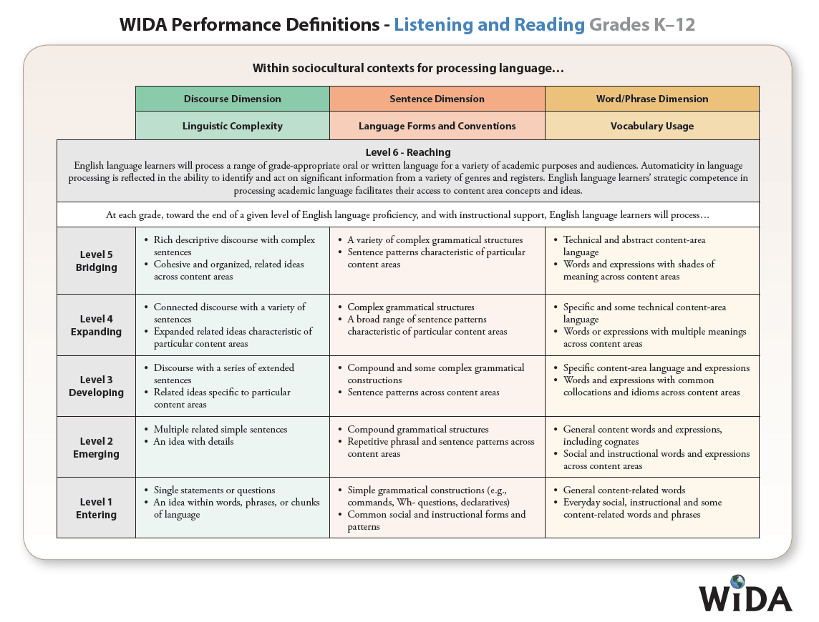
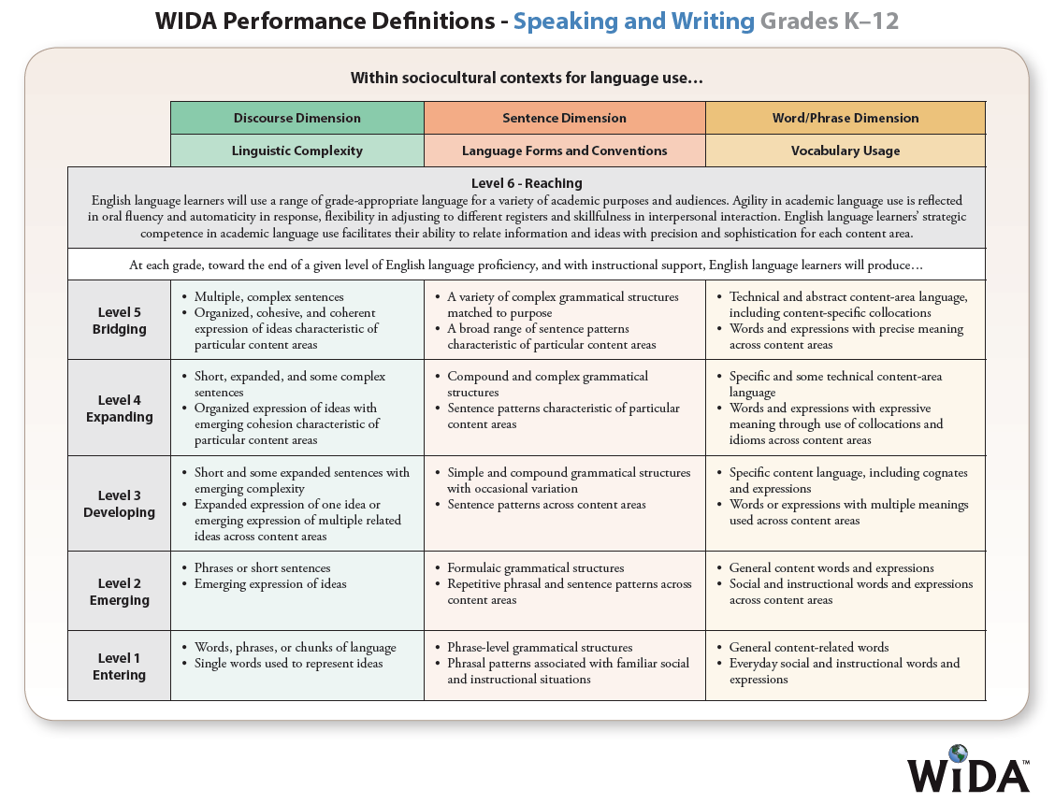

Appendix D. Alternate ACCESS for ELLs Performance Definitions

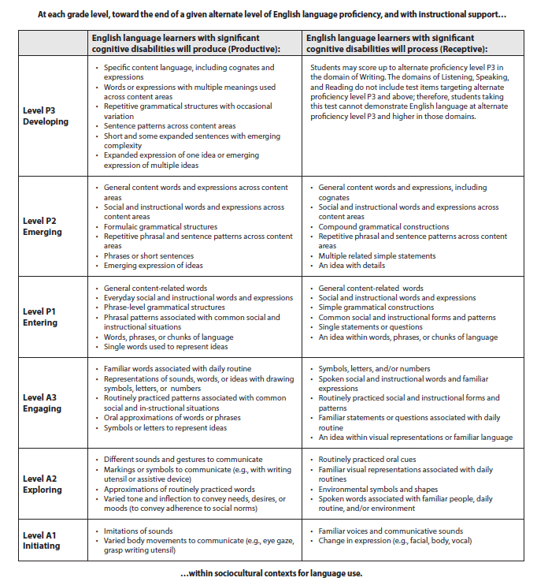

Appendix E. Features of the ACCESS for ELLs Tests

Test Feature | Description
Students tested in  grade-level clusters | Paper based - Grades K; 1; 2; 3; 4-5; 6-8; 9-12  Computer Based – Grades 1;-2-3; 4-5; 6-8; 9-12
Paper format tests administered in “Tiers” | Depending on English proficiency level, the student takes a grade-cluster test at either:  - Tier A (low English language proficiency)  - Tier B (intermediate English language proficiency)  - Tier C (high English language proficiency)
Scores reported as a Proficiency Level | Proficiency Level 1–Level 6  1-Entering, 2-Emerging,  3-Developing, 4-Expanding,  5-Bridging, 6-Reaching  Also reported as a whole number and decimal to denote placement within each level; e.g., 3.4
Scores reported as a Scale Score | Score Range: 100–600
Scores reported to Parent/Guardians, Schools, and Districts | Proficiency levels in:  - Each Domain: Reading, Writing, Listening, and Speaking  - Four Composite Areas:  - Oral Language (Listening 50% and Speaking 50%)  - Literacy (Reading 50% and Writing 50%)  - Comprehension (Listening 30% and Reading 70%)  - Overall (15% Listening, 15% Speaking, 35% Reading, and 35% Writing)
Standards Assessed by the Test | WIDA English Language Development Standards:  - Social and Instructional Language  - Language of English Language Arts  - Language of Mathematics  - Language of Science  - Language of Social Studies

62 students were not able to complete four domains of 2017 ACCESS assessment due to various online testing technical issues, but were included as participating students for accountability, due to an accountability appeal filed by the school. Therefore, the total number of participating EL students was 86,819, which is 62 students more than the total number of 86,757 noted in the Executive Summary on page 1.
To calculate SGPA and the Growth-to-Proficiency table, the scale scores of students who took ACCESS tests on paper were adjusted to correct for variations that occur when students of comparable ability receive different scores due to their testing mode (online versus paper).

