|  |  |  |
| --- | --- | --- |
| DESE logo | | |
|  | ACCESS for ELLs  2018 Statewide Results |
|  |
| January 2019  Massachusetts Department of Elementary and Secondary Education  75 Pleasant Street, Malden, MA 02148  Phone 781-338-3000 TTY: N.E.T. Relay 800-439-2370  [www.doe.mass.edu](http://www.doe.mass.edu) |
| DESE logo  This document was prepared by the  Massachusetts Department of Elementary and Secondary Education  Jeffrey C. Riley  Commissioner  The Massachusetts Department of Elementary and Secondary Education, an affirmative action employer, is committed to ensuring that all of its programs and facilities are accessible to all members of the public.  We do not discriminate on the basis of age, color, disability, gender identity, national origin, race, religion,  sex, or sexual orientation.  Inquiries regarding the Department’s compliance with Title IX and other civil rights laws may be directed to the  Human Resources Director, 75 Pleasant St., Malden, MA 02148 781-338-6105.  © 2019 Massachusetts Department of Elementary and Secondary Education  Permission is hereby granted to copy any or all parts of this document for non-commercial educational purposes. Please credit the “Massachusetts Department of Elementary and Secondary Education.”  Massachusetts Department of Elementary and Secondary Education  75 Pleasant Street, Malden, MA 02148-4906  Phone 781-338-3000 TTY: N.E.T. Relay 800-439-2370  [http://www.doe.mass.edu/](http://www.doe.mass.edu/%20)  State Seal of Massachusetts | | |

**Table of Contents**

Executive Summary 1

I. Background 3

II. Summary of the Statewide ACCESS for ELLs Results 5

Student Participation 5

Student Achievement 6

Composite Scores 9

Results of the Alternate ACCESS for ELLs 10

[III. NEW REPORTING ELEMENTS FOR EL STUDENTS 12  
  
 Reporting Element #1: ELs Making Progress Toward English Proficiency 13  
  
 Reporting Element #2: ELs Attaining English Proficiency 16  
  
 Reporting Element #3: ELs Exiting EL Status Based on Attaining Proficiency 18  
  
 Reporting Element #4: FELs Meeting Challenging State Academic Standards 20  
  
 Reporting Element #5: ELs Who Have Not Attained English Proficiency Within Six Years 22](#_Toc534215986)

IV. ACCESS Results for EL Students from the State’s Highest Incidence First-Language Groups 24

Appendix A. Performance Definitions for the access for ells Levels of English Language Proficiency 29

Appendix B. Alternate ACCESS for ELLs Performance Definitions 31

**APPENDIX C: FURTHER CLARIFICATION OF FUTURE PROGRESS TARGETS AND DIFFICULTY INDICES………………………………………………………………………………………………..32**

# Executive Summary

The ACCESS for ELLs (“ACCESS”) is an assessment of English language proficiency administered through the WIDA consortium to students who have been reported to the Department of Elementary and Secondary Education (the “Department”) as English learners. The assessment system is based on the WIDA English Language Development Standards. The ACCESS for ELLs 2.0 is administered to all publicly funded English learners (ELs) in grades K−12, and the Alternate ACCESS for ELLs is administered to EL students in grades 1−12 who have a significant cognitive disability and who are unable to take the regular ACCESS tests. The ACCESS is available in paper-based and online versions for grades 1−12 (kindergarten tests are available on paper only). Massachusetts has been transitioning to online ACCESS testing since 2016 and is expected to test the vast majority of students online in spring 2019. The Alternate ACCESS is available on paper only. Massachusetts joined the WIDA consortium in May 2012 and administered the ACCESS tests for the sixth consecutive year in 2018.

**Participation Rates**

In 2018, 94,149 EL students in Massachusetts who were enrolled in grades K–12 completed the ACCESS tests, including 1,292 students who participated in the Alternate ACCESS, an overall participation rate of 97.8 percent, one-half percentage point higher than in 2017. Absent students totaled 2,187. In 2018, 71,157 or 87 percent of students in grades 1–12 took online ACCESS tests (rather than paper-based tests) compared with 62 percent taking online ACCESS in 2017. Overall participation results are shown beginning on page 5.

**Overall Achievement**

Achievement results are shown in detail beginning on page 6. The combined percentage of students attaining the highest levels on the ACCESS tests (i.e., *Level 4.2* through *Level 6*) in 2018 is comparable to the percentage in 2017 (22.4 percent of students in 2017 and 22 percent in 2018).

**New Reporting Requirements**

This report has been reorganized to include the requirements for reporting the proficiency and progress of ELs as described in Title III of the federal *Every Student Succeeds Act* (ESSA) and in the *Language Opportunities for Our Kids* (LOOK) Act, a 2017 state law. Five required elements are summarized below and described in detail beginning on page 12 in this report.

* Reporting Element #1: The number and percentage of ELs making progress toward achieving English language proficiency
  + 51.8% of Massachusetts students made progress (i.e., met their target scores on the ACCESS tests) in 2017; 51.2% of students made progress in 2018.
* Reporting Element #2: The number and percentage of ELs attaining English language proficiency
  + 19.5% of students attained English proficiency in 2017; 19.8% of students attained English proficiency in 2018.
* Reporting Element #3: The number and percentage of ELs who exit English learner status based on their attainment of English language proficiency
  + 48.4% of students who attained English proficiency exited EL status in 2017; 62.4% of students who attained English proficiency exited EL status in 2018.
* Reporting Element #4: The number and percentage of ELs meeting challenging State academic standards on the next-generation MCAS tests for ELA and Math for each of the four years after such children are no longer receiving EL services
  + 49 percent of former EL students (i.e., FEL students) scored *Meeting Expectations* or *Exceeding Expectations* in ELA and 46 percent in Mathematics in 2018 (compared with 51 percent of *all* students who scored *Meeting Expectations* or *Exceeding Expectations* in ELA and 47 percent in Mathematics).
* Reporting Element #5: The number and percentage of ELs who have not attained EL proficiency within 6 years of initial classification as an English learner (i.e., 5 years plus an initial baseline year, or within 6 years)
  + 15.2% of ELs had not met proficiency after six years in 2017; 15% of ELs had not met proficiency after six years in 2018.

# I. Background

This report summarizes the results of 94,149 EL students in Massachusetts who participated in the 2018 Assessing Comprehension and Communication in English State-to-State for English Language Learners (ACCESS for ELLs and Alternate ACCESS for ELLs) tests, which were developed by the WIDA consortium, and are intended to measure the English language proficiency of English learner (EL) students in consortium member states. Thirty-nine states currently participate in ACCESS testing.

ACCESS for ELLs (ACCESS) tests measure how well EL students have achieved the *English Language Development (ELD) Standards* developed bythe WIDA consortium. Massachusetts adopted the WIDA standards because they describe English language instruction in four subdomains (listening, reading, speaking, and writing); academic literacy in four subjects, plus social and instructional language; and because the WIDA standards are aligned with the *2017 Massachusetts Curriculum Frameworks*.

ACCESS for ELLs tests consist of four separate domain tests in reading, writing, listening, and speaking. Only students who participate in all four domains receive overall scores. Students participate in tests designed for specific grade-level clusters as follows:

**ACCESS for ELLs Tests**

| **Format** | **Grade-Level Cluster Tests** |
| --- | --- |
| Online | 1, 2-3, 4-5, 6-8, 9-12 |
| Paper | K, 1, 2, 3, 4-5, 6-8, 9-12; and Alternate ACCESS for ELLs in grades 1−12 |

In 2016, WIDA introduced a new, more rigorous computer-based test. Schools in Massachusetts were given a choice to administer either computer- and paper-based tests, with the expectation that the state would transition virtually all EL students to computer-based testing for the 2019 test administration. Paper-based tests remain available for use as an accommodation due to a disability or for a first-year EL with a lack of familiarity with or ability to use a computer.

For paper-based testing students take either Tier A or B/C of the designated grade-cluster test (in grades 1–12), depending on their level of English language proficiency. For computer-based testing, the Listening and Reading tests are adaptive with students directed to questions of equal, lesser, or greater difficulty depending on how they responded to a previous cluster of questions. Based on Listening and Reading responses, the students are routed automatically to the appropriately tiered Speaking and Writing tests.

### Students taking the ACCESS test receive scaled scores between 100−600 overall, in each subdomain, and several composite scores. Proficiency level scores are reported as a whole number followed by a decimal (e.g., Level 3.4), indicating the student’s overall language proficiency level, and the relative positionwithin the proficiency level of the student’s scaled score, rounded to the nearest tenth. English proficiency is reported in one of six English language proficiency levels: 1-Entering, 2-Emerging, 3-Developing, 4-Expanding, 5-Bridging, and 6-Reaching (see Appendix A).

### Assessment subscores are also reported using the same scaled scores and proficiency levels in the four domains of listening, speaking, reading, and writing; and subscores reported as a composite score in the following combined areas:

* Overall composite score combining all four subdomain scores
* Oral Language composite score, combining scores from Listening and Speaking;
* Literacy composite score, combining scaled scores from Reading and Writing;
* Comprehension composite score, combining scaled scores from Listening and Reading.

**Standard Setting on ACCESS 2.0 Tests**

In 2016, the WIDA consortium reset proficiency standards on its new ACCESS for ELLs 2.0 assessment. The standards on ACCESS 2.0 are more rigorous than the standards on ACCESS 1.0, meaning that a higher level of achievement on the new test is required to earn the same proficiency level as on the ACCESS 1.0 tests, which were phased out after 2015. The new standards were applied to ACCESS scores for the first time in 2017. Resetting the proficiency standards was intended by WIDA to ensure that ELL students were well-prepared to meet the rigor of the new College and Career Ready Standards now in place in Massachusetts and in other WIDA states. However, the resetting of standards had the effect of greatly reducing the number of students who qualified under the previous ACCESS 1.0 criteria to exit EL status. Massachusetts subsequently elected to revise its criteria for eligibility to exit EL status to a level that was judged to be comparable to the exit criteria on the previous score scale.

**Reclassification of EL students**

Prior to 2017, the criteria used to exit students from EL status had been the attainment of an overall score of Level 5.0. Based on 2017 results using the ACCESS 2.0 revised score scale, the Department recommended instead that districts consider exiting students from EL status when they met the following criteria, based on the likelihood that they would be able to perform standards-based classroom work in English:

1. An overall score of **Level 4.2**;and
2. A composite literacy score of **Level 3.9**

As before, the Department also recommended the use of other relevant data before exiting a student from EL status, including:

* + student scores on locally administered reading, language, and other academic assessments;
  + written observations and the recommendations of classroom teachers;
  + student’s classroom work and academic grades;
  + student’s performance on MCAS tests.

**Validating the New Exit Criteria − A** **Comparability Study**

The Student Assessment office conducted a study to determine the comparability of ACCESS 1.0 and ACCESS 2.0 proficiency standards, specifically in terms of the **overall** ACCESS 2.0 test scores and the **composite literacy** scores. Three distinct methods were used to identify the equivalent proficiency level for a score of *Level 5.0* and overall literacy *Level 4.5* on the ACCESS 1.0 scale converted to the ACCESS 2.0 scale. The results of the three methods yielded similar results, and are described below.

1. **Equipercentile linking**, which compared the scores of students on both tests at each percentile rank; e.g., the scores for an EL student in the 15th percentile were calculated on both the 2015 ACCESS 1.0 (old scale) and 2017 ACCESS 2.0 (new scale);
2. The **WIDA Score Lookup Calculator**, which converts a given score on the ACCESS 1.0 scale to a score on the ACCESS 2.0 scale. We used this method to determine comparable scores on the new scale for students who previously took ACCESS 1.0;
3. **Comparing the** **percentage of students attaining Level 5.0** on ACCESS 1.0 with the score attained by the same percentage of students on ACCESS 2.0.

All three methods yielded equivalent overall scores of Level 4.2, with a literacy composite score of 3.9, on the new ACCESS 2.0 scale.

**Alternate ACCESS for ELLs**

The Alternate ACCESS for ELLs was administered in Massachusetts to EL students with significant cognitive disabilities. The Alternate ACCESS is given in grades 1–12 to students whose disabilities prevent participation in the ACCESS for ELLs general assessment, and is recommended for students who participate in the state’s academic alternate assessment, the MCAS-Alt. It is administered individually by trained and certified educators in four grade-level clusters: Grades 1–2, 3–5, 6–8, and 9–12. Students are assessed in the four domains of reading, writing, listening, and speaking. Results are reported at six proficiency levels (Levels A1, A2, A3, P1, P2, and P3; see Appendix C for descriptors for each proficiency level), and on a numerical scale from 900 to 960. In all, 1,253 Massachusetts students in grades 1-12 participated in the Alternate ACCESS for ELLs test during the five-week January–February 2018 testing window.

# II. Summary of the Statewide ACCESS for ELLs Results

## Student Participation

In 2018, 94,149 EL students in Massachusetts who were enrolled in grades K–12 completed the ACCESS tests, including 1,292 students who participated in the Alternate ACCESS, an overall participation rate of 97.8 percent, one-half percentage point higher than in 2017. Absent students totaled 2,187. In 2018, 71,157 or 87 percent of students in grades 1–12 took online ACCESS tests (rather than paper-based tests) compared with 62 percent taking online ACCESS in 2017. Overall participation results are shown beginning on page 5.

Participation in the 2017 and 2018 ACCESS and Alternate ACCESS is summarized below in Table 1. “Participation” means that a student participated in all four sections of the ACCESS test―reading, writing, listening, and speaking. Table 1 summarizes participation by grade cluster and years of enrollment in Massachusetts.

**Table 1. Number and Percentage of Students Participating in the**

**ACCESS Tests by Grade Cluster and Years in Massachusetts for 2017 and 2018**

Number and Percentage of Students Participating in the ACCESS Tests for 2017 and 2018. 86,757 in 2017 and 94,149 in 2018.


Participation was highest in lower grades and slowly declines as grade levels increase. Participation was lowest in grades 9−12, primarily attributable to high school students who have been in enrolled in Massachusetts schools for four or more years. Participation rates are also lower for students who took the Alternate ACCESS (90 percent participation) compared with participation rates on ACCESS tests (97−98 percent).

## Student Achievement

Table 2 summarizes overall ACCESS proficiency level results including the number of students tested, the average overall ACCESS scaled scores, and percentages of students scoring at each ACCESS proficiency level, disaggregated by grade cluster and years of enrollment in Massachusetts. Results for students who took the Alternate ACCESS for ELLs are summarized in Tables 4 and 5.

**Table 2. Number of Students Tested and Percentage Scoring at Each ACCESS Proficiency Level by Grade Cluster and Years of Enrollment in MA for 2018**

Number of Students Tested and Percentage Scoring at Each ACCESS Proficiency Level for 2018

Figure 1 provides a comparison of the percentages of EL students at each proficiency level by grade on the 2017 and 2018 ACCESS for ELLs tests.

**Figure 1. Percentage of Students at Each Performance Level on the 2017 and 2018 ACCESS for ELLs (Grades K−6 and 7−12)**

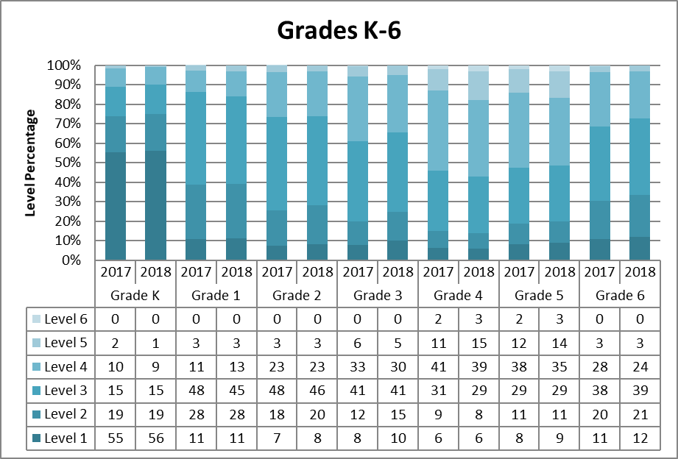

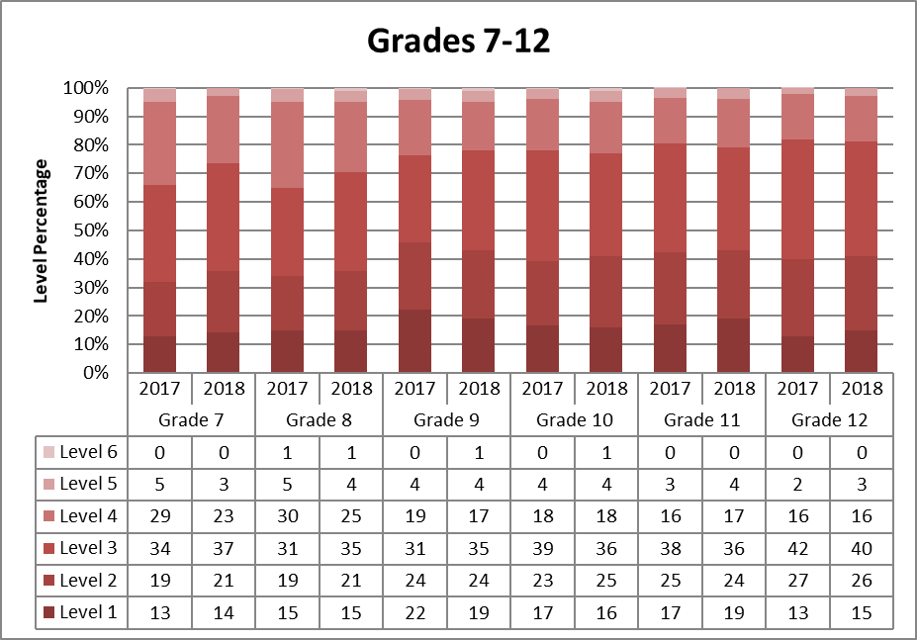

## Table 3 shows the comparative percentage of ELs who attained English proficiency as indicated by an ACCESS score of Level 4.2. The combined percentage of students attaining scores indicating their attainment of English proficiency (i.e., between *Level 4.2* and *Level 6*) in 2018 was comparable to the percentage in 2017 (22.4 percent of students in 2017 and 22 percent in 2018). However, marked decreases were noted from 2017 to 2018 in grades 3, 6, 7, and 8.

**Table 3.** **Percentage of EL Students Who Attained English Proficiency in 2017 and 2018**

**as indicated by an ACCESS test score of Level 4.2 or higher**

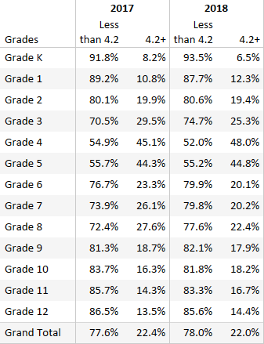

## Composite Scores

In addition to receiving an overall ACCESS proficiency level score, students receive three composite scores: oral language, comprehension, and literacy. Composite scores are derived from a combination of weighted scaled scores from the four language domains as follows:

* Overall―combining the four domain scores, as follows: Listening (15%), Speaking (15%), Reading (35%), and Writing (35%)
* Oral Language―combining equally weighted scaled scores for Listening and Speaking (50% each)
* Comprehension―combining scaled scores for Listening (30%) and Reading (70%)
* Literacy―combining equally weighted scaled scores for Reading (50%) and Writing (50%)

Median scaled scores and proficiency levels by years of enrollment for the three remaining composite scales are presented below, by grade cluster and years in Massachusetts.

**Table 4: Median Composite Scores of EL Students on the 2018 ACCESS Tests**

**by Years of Enrollment in Massachusetts and Grade Cluster**

Median Composite Scores of EL Students on the 2018 ACCESS Tests. Composite scores shown for: Oral Language (Listening and Speaking), Comprehension (Reading and Listening), and Literacy (Reading and Writing).  

## Results of the 2018 Alternate ACCESS for ELLs

The Alternate ACCESS assessment was first administered in 2014 to EL students with significant cognitive disabilities. The Alternate ACCESS results are reported at six proficiency levels: A1-Initiating, A2-Exploring, A3-Engaging, P1-Entering, P2-Emerging, and P3-Developing, and on a numerical scale from 900 to 960. Alternate ACCESS proficiency levels A1, A2, and A3 align with the ACCESS proficiency levels as shown in Figure 2 below. See Appendix D for the performance definitions of the Alternate ACCESS for ELLs proficiency levels.

**Figure 2.**

**Overlay of ACCESS and Alternate ACCESS Proficiency Levels**

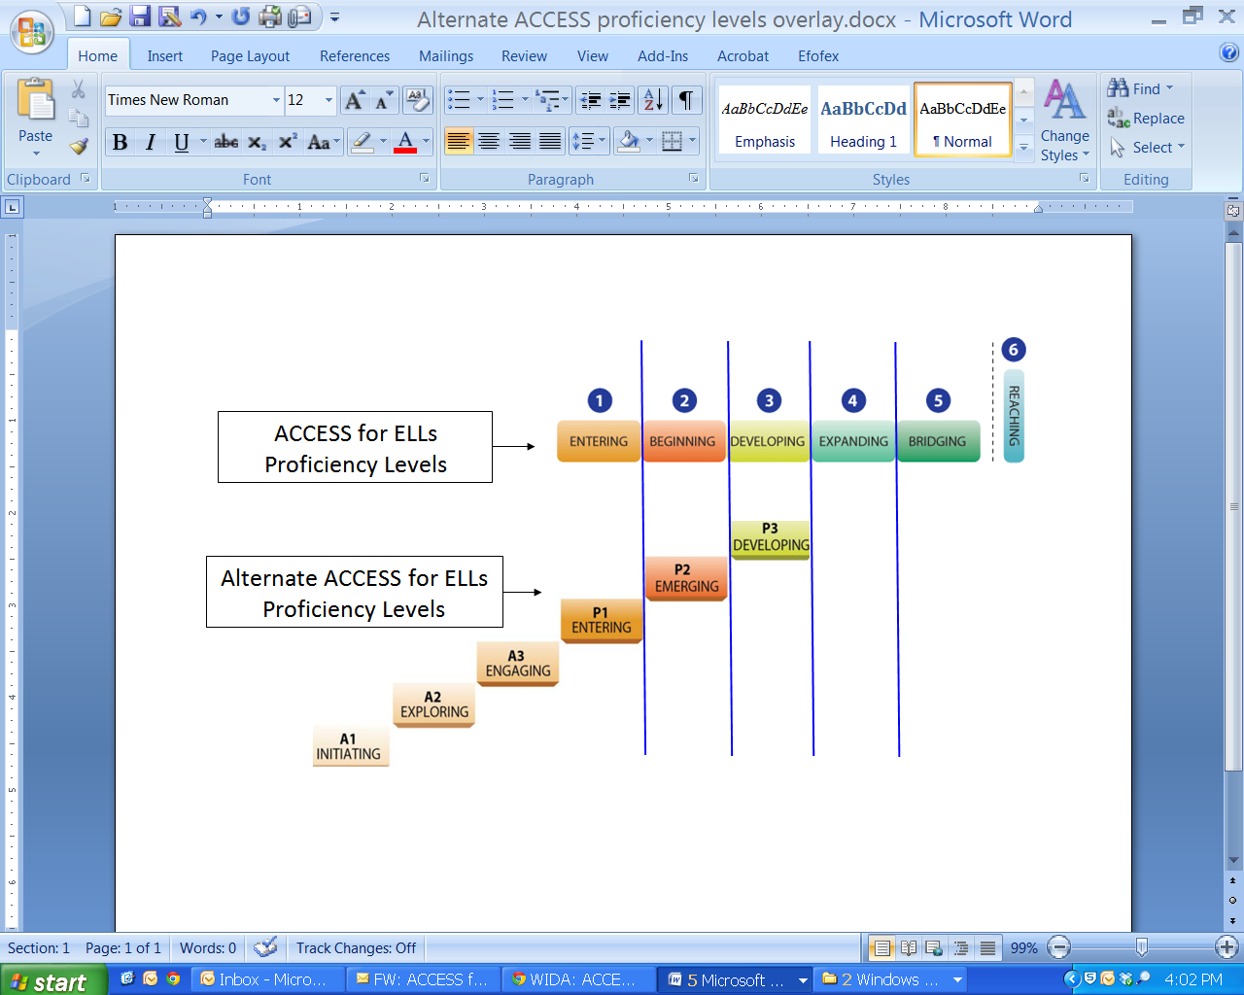

In 2018, 1,292 students participated in the Alternate ACCESS for ELLs. Results of the 2018 Alternate ACCESS test administration, disaggregated by years of enrollment for each grade cluster, are summarized in Table 5.

**Table 5: Median Composite Scores of EL Students on the 2018 Alternate ACCESS for ELLs Tests by Years of Enrollment in a Massachusetts School and Grade Cluster**

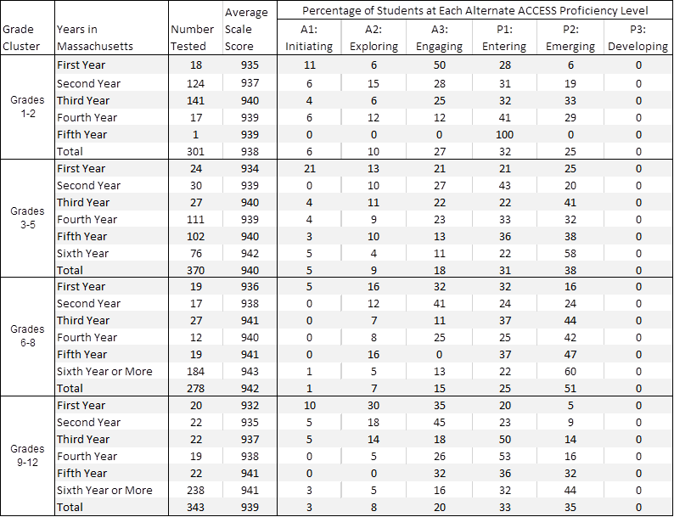

**III. New Reporting Elements**

New requirements for reporting the proficiency and progress of ELs are outlined in Title III of the federal *Every Student Succeeds Act* (ESSA) and in the *Language Opportunities for Our Kids* *Act* (LOOK), a 2017 state law. Five required reporting elements are summarized below.

* Reporting Element #1: The number and percentage of ELs making progress toward achieving English language proficiency, disaggregated for ELs with disabilities
* Reporting Element #2: The number and percentage of ELs attaining English proficiency
* Reporting Element #3: The number and percentage of ELs exiting EL status based on their attainment of English proficiency
* Reporting Element #4: The number and percentage of former ELs meeting challenging State academic standards for each of the four years after such children are no longer receiving EL services, disaggregated for ELs with disabilities
* Reporting Element #5: The number and percentage of ELs who have not attained EL proficiency within 6 years of initial classification as an English learner (i.e., within 5 years after the first baseline year, or within 6 years), disaggregated for ELs with disabilities

This report has been updated to include results on the five reporting elements described above. Results for the five reporting elements are based on the overall state results on the ACCESS tests combined with results for students taking the Alternate ACCESS. Reporting on the five elements is intended to provide districts with important instructional feedback to promote and accelerate the achievement of EL students, and to provide a basis for additional oversight of EL programming by the Department.

**Reporting Element #1: EL Students Making Progress Toward EL Proficiency (disaggregated for students with and without disabilities)**

In 2018, a new method for establishing student progress was used that provided the following information for each EL student:

1. **Future Progress Target** representing the minimum ACCESS proficiency level score needed on the following year’s ACCESS test to remain on track to reach English proficiency (i.e., growth-to-proficiency) within a total of six years in a Massachusetts school. Future progress targets are reported as an ACCESS proficiency level, ranging from Levels 1.0 to 4.2. Individual student targets will be provided in the fall of each year. Further clarification of Future Progress Targets is provided in Appendix C.
2. **Difficulty Index** showing an estimate of how difficult it will be to reach next year’s target, relative to the student’s current proficiency level. The difficulty index ranges from 1–99, with one being the lowest difficulty (i.e., least difficult to achieve the target) and 99 the highest (i.e., most difficult to achieve the target). Students with difficulty indices greater than 60 have a high difficulty index. Educators were directed to use the difficulty index as an indicator of which students may need additional instructional assistance in order to succeed. Further clarification of Difficulty Indices is provided in Appendix C.
3. **Student Growth Percentile for ACCESS** **(SGPA)** indicating the amount of progress made by a student on the ACCESS test from one year to the next, relative to other EL grade-level students who earned similar ACCESS scores the prior year. In general, SGPA indicates whether a student has made low, moderate, or high gains in their ACCESS test scores from one year to the next compared with other ELs in the same grade level who took the ACCESS test in two consecutive years. Like the difficulty index, the SGPA is a number from 1−99, with 40−59 representing *average* growth. Unlike the difficulty index, however, higher numbers of SGPA indicate *more* growth, whereas higher numbers on the difficulty index indicate greater difficulty in reaching the following year’s target. SGPA allows each student a nearly equal opportunity with other ELs in their grade level to demonstrate their progress in learning English.
4. **Progress Indicator**, either “Yes” or “No,” showing whether the student has met last year’s future progress target in the current year. Students who meet or exceed their future target for that year will be designated as having “made progress.” Students who do not meet their targets will not make progress for that year. Students taking the Alternate ACCESS will make progress if they increase the Alternate ACCESS achievement level in any subdomain by one level.

**Table 6. Number and Percentage of EL Students Meeting Growth-to-Proficiency Targets**

**by Grade for 2017 and 2018**

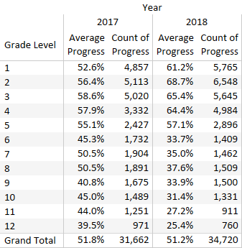

Across Massachusetts, 51.2 percent of EL students made progress in 2018 (as shown in Table 5). Approximately two-thirds of students in grades 1–5 made progress, while a third or fewer students made progress in grades 6–12. However, a large proportion of middle school ELs (52 percent) and high school ELs (33 percent) have been enrolled in the state for six or more years (as shown in Table 7). Only 23 percent of those students made progress in middle school, and only 17.5 percent of those students made progress in high school.

**Table 7. Number and Percentage of EL Students Meeting Growth-to-Proficiency Targets**

**by Grade Cluster and Years Enrolled in a Massachusetts School**

Number and Percentage of EL Students Meeting Growth-to-Proficiency Targets: 51.2

ESSA, Title III also requires reporting of growth-to-proficiency results by disability status. Table 8 disaggregates the results shown in Table 7 by students in special education versus not in special education. Overall, 57 percent students without a disability made progress while only about 30 percent of students with a disability made progress. In middle and high school, the rate of students with disabilities making progress was less than 15 percent. In those grade ranges, a large proportion of students with disabilities were enrolled in the state for six or more years (78 percent in middle school and 76 percent in high school), suggesting that middle and high schools are retaining students with disabilities in EL programming much longer than they are retaining students without disabilities.

**Table 8: Number and Percentage of EL Students Meeting Growth-to-Proficiency Targets**

**by Grade Cluster, Years Enrolled in Massachusetts, and Disability Status**

Number and Percentage of EL Students Meeting Growth-to-Proficiency Targets 
by Disability Status: 57.1% for nondisabled students and 29.6% for students with disabilities


**Reporting Element #2: EL Students Attaining English Language Proficiency**

The method of identifying EL proficiency in 2018 is the same as it was in 2017. Students who obtain an overall ACCESS score of *Level 4.2* and *Level 3.9* Literacy composite will be designated as having met English language proficiency. The proficiency rates shown in Table 9 indicate that approximately the same percentage of students had attained EL proficiency in both years (19.5 percent in 2017 and 19.8 percent in 2018). However, the distribution of proficient students in 2018 changed such that more students were deemed proficient in the lower grades and fewer in the higher grades, likely as a consequence of using individual progress targets in 2018, rather than average targets for all grades in 2017.

**Table 9. Number and Percentage of EL Students Attaining English Proficiency**

**by Grade in 2017 and 2018**

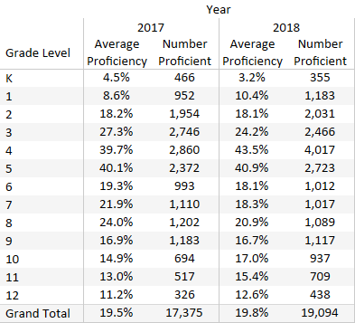

As shown in Table 10, the proportion of students attaining EL proficiency is highest in grades 3−5 (35.3 percent). In most grade clusters, the proportion of students attaining proficiency increases with years of enrollment in a Massachusetts school; however, the proportion decreases slightly for students enrolled for 6 or more years.

**Table 10. Percent of EL Students Attaining EL Proficiency**

**by Grade Cluster and Years Enrolled in Massachusetts**

Percent of EL Students Attaining EL Proficiency: 19.8%


**Reporting Element #3: EL Students Who Exited English Learner (EL) Status as a Result of Their Attainment of EL Proficiency**

This element reports the number and percentage of students who exited EL status once they had attained English proficiency on the ACCESS tests. The number of students reaching proficiency in 2017 and 2018 is shown in Table 10 and the top row of Table 11. The number of students exiting EL status by the fall of the following year is shown in row 2 of Table 11. The percentage of EL students who attained proficiency and exited EL status by the following fall as a result of their attainment of proficiency is shown in row 3 of Table 11. The overall percent of proficient EL students who exited EL status after reaching proficiency was 48.4 percent in 2017 and 62.4 percent in 2018.

**Table 11. Number and Percentage of EL Students Who Attained English Proficiency and Exited EL Status in 2017 and 2018**

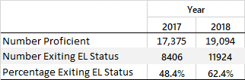

Table 12 indicates the number and percentage of students exiting EL status based on attaining proficiency in 2017 and 2018 by grade cluster. The first number in each grade cluster row is the number of students attaining proficiency. The second number identifies the number of those students exiting EL status by fall of the following year. The third row shows the percentage of students exiting EL status, based on their attainment of EL proficiency. A comparison of percentages in 2017 and 2018 shows an increase in students exiting EL status based on proficiency in 2018 across all grade clusters. Overall, 62.4 percent of English proficient students exited EL status in 2018, an increase from 48.4 percent in 2017.

**Table 12. Percent of Massachusetts Students Exiting EL Status After Attaining English Proficiency by Grade Cluster in 2017 and 2018**

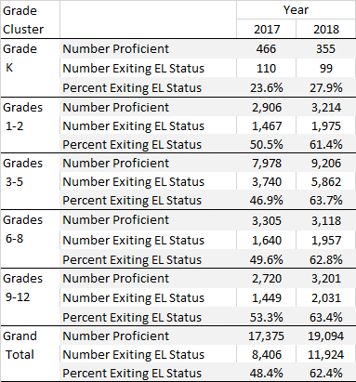

**Reporting Element #4: Former ELs (FELs) Meeting Challenging State Academic Standards (disaggregated for students with and without disabilities)**

Reporting Element #4 describes the number and percentage of former English learners (FELs) who have met challenging state standards, as indicated by a score of *Meeting* *Expectations* or *Exceeding* *Expectations* on the next-generation MCAS ELA and Mathematics tests. For this reporting element, FELs are considered to be students who exited EL status up to four years prior to taking the MCAS tests. Reporting Element #4 is also reported by disability status (i.e., EL students in special education versus ELs not in special education).

In 2018, the results of all FEL students (i.e, students who have exited EL status during 1−4 prior years) were reported together. In subsequent years, statewide FEL results will be indicated by each year since the students were exited from EL status (e.g., FEL year 1, FEL year 2, etc.).

Note: 2018 results are reported in grades 3–8 for FELs and non-FELs who took the next-generation MCAS tests (i.e., ELA and Mathematics only). Results on the legacy grade 10 MCAS tests were *not* included, but will be included in subsequent years, once students have taken the next-generation ELA and Mathematics MCAS tests in grade 10. It is also important to note that the non-FEL group includes students who are current ELs, as well as those who were “never ELs;” while the FEL group does not include current ELs.

As shown in Table 13, a majority of FELs met challenging standards in grades 3 and 4 in both subjects, and in grade 5 in ELA. In grades 3 and 4, FELs outperformed students who are not FELs. FEL performance tended to decrease as students’ grades increased, except for grade 8 mathematics, which shows higher performance for FELs than grade 7 math.

Results shown in Table 13 indicate that FELs outperformed the Not FELs group in grades 3 and 4, for both subjects, with 62 percent of grade 3 FELs meeting challenging standards in both subjects, and 63 percent and 59 percent of grade 4 FELs meeting challenging standards in ELA and Math, respectively. FEL results in grade 5 are comparable to the Not FEL group. After grade 5, the comparison group performs better than the FEL group in both subjects. Across all grades, the comparison group slightly outperforms the FEL group (51 percent to 49 percent in ELA and 48 percent to 46 percent in Math).

**Table 13. Number and Percentage of Former ELs (FELs) and Not FELs Meeting Challenging State Academic Standards in 2018**

Former ELs (FELs) Meeting Challenging State Academic Standards Compared with not-FELs: 46% of FELs and 48% of not-FELs met academic standards on MCAS tests in ELA and Mathematics

Student percentages shown in Table 13 are subdivided by disability (i.e., special education) status in Table 14. FEL students without disabilities have higher rates of meeting challenging academic standards in ELA and Mathematics in grades 3 and 4. In grade 5, FELs have a lower rate of meeting challenging standards, and the discrepancies between FEL and Not FEL achievement increases as grade levels increase.

With respect to student with disabilities, the average rate of meeting challenging standards across grades is 13 percent in ELA and Mathematics for FEL students with disabilities, and 14 percent in ELA and Math for nondisabled FEL students. In summary, students with disabilities perform similarly regardless of FEL status.

**Table 14. Percentage of FELs and Not FELs Meeting State Academic Standards on MCAS ELA and Mathematics by Grade and Disability Status**

Percentage of FELs and Not FELs Meeting State Academic Standards on MCAS ELA and Mathematics by Disability Status

**Reporting Element #5:** **EL Students Who Have Not Attained English Proficiency within Six Years (disaggregated for students with and without disabilities)**

ELs in Massachusetts are expected to reach proficiency on ACCESS tests within a total of 6 years after being classified as an English learner in a Massachusetts school (one baseline year, plus five years to demonstrate growth toward proficiency). An EL student is considered to have attained English proficiency when he or she earns ACCESS scores of at least Level 4.2 overall and Level 3.9 Literacy composite.

As shown in Table 15, approximately 15 percent of all EL students did *not* reach proficiency in 2017 and 2018 within 6 years of entering a Massachusetts school.

**Table 15. Number and Percentage of ELs Not Attaining English Proficiency Within Six Years**

**in 2017 and 2018**

Number and Percentage of ELs Not Attaining English Proficiency Within Six Years: 165.2% in 2017 and 15.0% in 2018


Table 16 indicates this information by grade cluster for EL students with and without disabilities in grades 3–12, omitting students in K–2 due to the reporting requirement that a student be enrolled in a Massachusetts school for at least six years. While about 15 percent of students in both 2017 and 2018 are not meeting proficiency standards within six years, the percentage of students with disabilities not attaining proficiency in six years approaches 37 percent in both years. For students with disabilities in grades 6–12, the percentages of students not attaining proficiency within six years is greater than 70 percent.

**Table 16. Number and Percentage of EL Students Not Attaining English Proficiency Within Six Years by Grade Cluster and Disability Status (2017 and 2018)**

EL Students Not Attaining English Proficiency Within Six Years

# IV. ACCESS Results for EL Students from the State’s Highest Incidence First-Language Groups

Table 17 shows the number and percentage of students in the highest incidence language groups enrolled in a Massachusetts school in 2017 and 2018. Spanish is the largest native language group with just under 55 percent of students, followed by Portuguese, the native language of about 10 percent of the EL population.

**Table 17. Number and Percentage of Enrolled EL Students by Highest-Incidence**

**First (Native) Languages (2017 and 2018)**

Number and Percentage of Enrolled EL Students by Highest-Incidence 
First (Native) Languages 

The ACCESS achievement of students speaking the ten highest-incidence languages is summarized in Table 18 and Figures 3, 4, and 5.

Both tables show the percent of students scoring at each ACCESS level, by native language. The language groups with the highest percentages of students in the highest performance levels are Chinese and Vietnamese.

**Table 18. Percentage at each ACCESS Proficiency Level**

**for EL Students Speaking the Ten Highest-Incidence Languages**

**Percentage at each ACCESS Proficiency Level for EL Students Speaking the Ten Highest-Incidence Languages 
**

Figure 3 depicts the percentage of students in each ACCESS proficiency level by native language.

**Figure 3. Percentage of EL Students by ACCESS Proficiency Level for the Ten Highest-Incidence Languages**

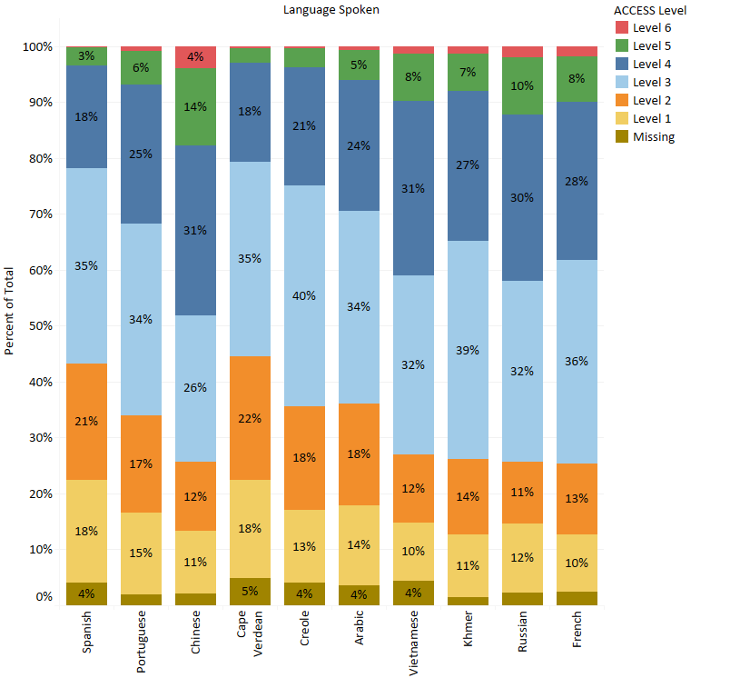

Figure 4 shows the average ACCESS proficiency level by grade cluster for the ten highest-incidence native languages. Figure 5 shows the average ACCESS proficiency level by native language and number of years in a Massachusetts school. For Figures 4 and 5, the bar widths represent the proportion of students with an economic disadvantage, as shown in the key.

**Figure 4. Average 2018 ACCESS Scores for EL Students Speaking the Ten Highest-Incidence Languages by Grade Cluster\***

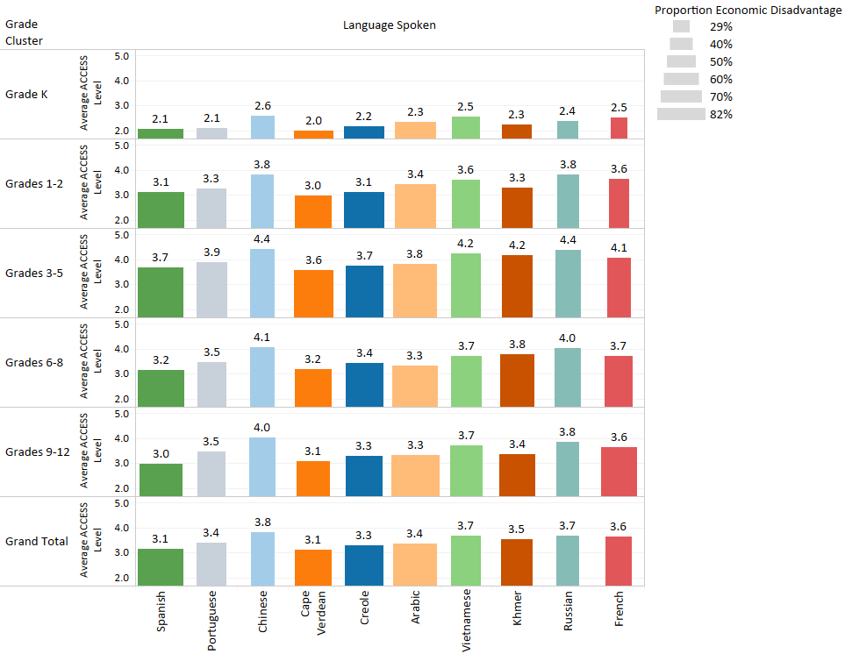

*Bar widths denote the proportion of students with an economic disadvantage.

**Figure 5: Average 2018 ACCESS Scores for EL Students Speaking the Ten Highest-Incidence Languages by Number of Years in a Massachusetts School\***

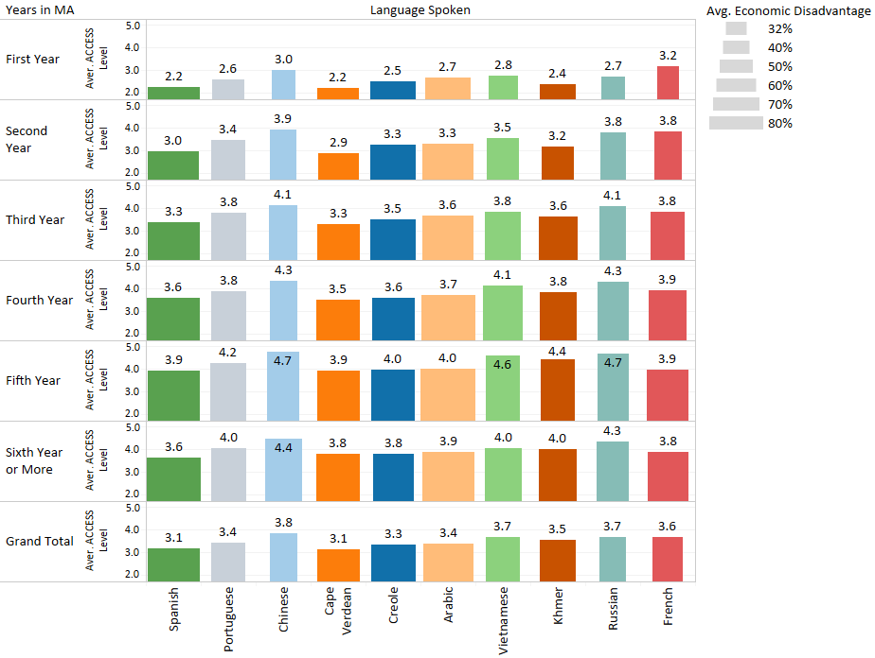*Bar widths denote the proportion of students with an economic disadvantage.

# 

# Appendix A. Performance Definitions for the ACCESS for ELLs Levels of English Language Proficiency

WIDA Performance Definitions for the ACCESS for ELLs Levels of English Language Proficiency - Listening and Reading Grades K-12.

The Performance Definitions are the interpretations of the six ACCESS proficiency levels (Entering, Emerging, Developing, Expanding, Bridging and Reaching) and are articulated under the headings of linguistic complexity, language forms and conventions, and vocabulary usage.

WIDA Performance Definitions for the ACCESS for ELLs Levels of English Language Proficiency - Speaking and Writing Grades K-12.

The Performance Definitions are the interpretations of the six ACCESS proficiency levels (Entering, Emerging, Developing, Expanding, Bridging, and Reaching) and are articulated under the headings of linguistic complexity, language forms and conventions, and vocabulary usage.

# Appendix B. Alternate ACCESS for ELLs Performance Definitions

WIDA Alternate ACESS for ELLs - Performance Definitions

The Performance Definitions are the interpretations of the six Alternate ACCESS proficiency levels (Initiating, Exploring, Engaging, Entering, Emerging, and Developing) and articulate the language that English language learner students with  significant cognitive disabilities will produce and process.

**Appendix C: Further Clarification of Future Progress Targets and Difficulty Indices**

Graph C1 provides clarification of Future Progress Targets based on the following variables for ELs. Future Progress Targets for EL students in grade 6 are provided as an example:

* Future Progress Targets (2019)
* Difficulty Index for the future Progress Targets
* Current ACCESS level
* Years enrolled in MA

In Graph C1, the ACCESS proficiency level is shown on the y-axis for each category of Years in MA. The 2019 Future Progress Target is displayed on the x-axis. The shading depicts the Difficulty Index from easiest (green) to moderate difficulty (yellow) to very difficult (red). The nonlinear growth trajectory observed in the actual student population is illustrated in the curved graph lines.

For EL students in their first year in a Massachusetts school, students who scored lowest on the ACCESS test will have the lowest targets, ranging from 1.9 to 2.0 for students scoring between 1.4 to 1.7 on the current year’s ACCESS test. As students’ current year ACCESS scores increase, their Future Progress Targets will also increase. Students who score above ACCESS level 2.0 will have targets that are higher than 2.9. The highest target assigned is 4.2 (Since Level 4.2 is considered English proficient), depicted by the straight vertical line in each graph panel. A similar growth trajectory is observed for students enrolled in MA for two years.

For students enrolled for three and four years, the trajectories are shortened to denote the reduced time frame for attaining proficiency. For example, the lowest-scoring students enrolled for three years begin with Future Progress Targets of 2.4 (compared with a target of 1.9 for students enrolled in MA for fewer years). For the lowest-scoring students enrolled in MA for four years, the targets start at 2.8. The higher level of difficulty in meeting these targets is denoted by the orange shading, which is especially evident for lower-scoring students enrolled in MA for four and five years. For high-scoring students, the relative ease of reaching their targets is denoted by the green shading.

**Graph C1: 2019 Grade 6 Students’ Future Targets Relative to Years in MA, Current ACCESS Proficiency Level, and Difficulty Index**

