ACCESS for ELLs

2022 Statewide Results
February 2024

Massachusetts Department of Elementary and Secondary Education
135 Santilli Highway, Everett, MA 02149
Phone 781-338-3000 TTY: N.E.T. Relay 800-439-2370
www.doe.mass.edu

This document was prepared by the
Massachusetts Department of Elementary and Secondary Education
Jeffrey C. Riley
Commissioner

The Massachusetts Department of Elementary and Secondary Education, an affirmative action employer, is committed to ensuring that all of its programs and facilities are accessible to all members of the public.
We do not discriminate on the basis of age, color, disability, gender identity, national origin, race, religion,
sex, or sexual orientation.
Inquiries regarding the Department’s compliance with Title IX and other civil rights laws may be directed to the
Human Resources Director, 135 Santilli Highway, Everett, MA 02149 781-338-6105.

© 2024 Massachusetts Department of Elementary and Secondary Education
Permission is hereby granted to copy any or all parts of this document for non-commercial educational purposes. Please credit the “Massachusetts Department of Elementary and Secondary Education.”

Massachusetts Department of Elementary and Secondary Education
135 Santilli Highway, Everett, MA 02149
Phone 781-338-3000 TTY: N.E.T. Relay 800-439-2370
http://www.doe.mass.edu/

Table of Contents

Overview of 2022 Participation and Achievement 1
I. Background 2
Reclassification of ELs 3
Alternate ACCESS 3
II. Summary of 2022 ACCESS for ELLs Participation and Achievement 3
Student Participation 3
Student Achievement 7
Composite Proficiency Levels 9
Results of the 2022 Alternate ACCESS for ELLs 11
III. Reporting Elements 11
Reporting Element #1: ELs Making Progress toward English Language Proficiency (disaggregated for students with and without disabilities) 12
Reporting Element #2: ELs Attaining English Language Proficiency 17
Reporting Element #3: ELs Who Exited English Learner (EL) Status as a Result of Their Attainment of English Proficiency 20
Reporting Element #4: Former ELs (FELs) Meeting Challenging State Academic Standards (disaggregated for students with and without disabilities) 21
Reporting Element #5: ELs Who Have Not Attained English Proficiency within Six Years (disaggregated for students with and without disabilities) 23
IV. ACCESS Results for ELs from the State’s Highest Incidence Non-English Language Groups 24
Appendix A. Performance Definitions for the ACCESS Levels of English Language Proficiency 27
Appendix B. Alternate ACCESS Performance Definitions 29

Overview of 2022 Participation and Achievement
The ACCESS for ELLs (ACCESS) is an assessment of English language proficiency administered through the WIDA consortium to students who have been reported to the Massachusetts Department of Elementary and Secondary Education (the “Department” or “DESE”) as English learners (ELs). ACCESS assesses student achievement of the WIDA English Language Development Standards in reading, writing, listening, and speaking and is administered to all publicly-funded ELs in grades K−12. In addition, the Alternate ACCESS for ELLs (Alternate ACCESS) is administered to ELs in grades 1−12 who have the most significant cognitive disabilities and are unable to take the regular ACCESS tests, even when accommodations are provided.

Participation Rates
During the 2021–2022 school year, there was a significant rebound in Massachusetts ACCESS participation rates compared to the 2020–2021 school year, when the COVID-19 pandemic disrupted educational programming statewide. In total, 101,004 ELs (97% ) who were enrolled in grades K–12 in 2022 participated in all four domains of the ACCESS tests, including 1,551 students who participated in the Alternate ACCESS. This was an overall increase of 21 percentage points from the previous year. Participation rates were lower for students in high school; about 99% of ELs in grades K–8 participated in the ACCESS tests in 2022, whereas only 91% of students in grades 9–12 participated in the test. For more information on participation, see the Student Participation section of this report.
Overall Achievement
ACCESS results in 2021–2022 were mixed and reveal an incremental decrease in overall student proficiency and growth compared to 2020–2021. Achievement results, shown in detail in table 5 indicate that the combined percentage of students attaining proficiency on the ACCESS tests (i.e., Level 4.2 through Level 6) in 2022 (14.1%) was 1.2 percentage points lower than in 2021 (15.3%). While continuing impacts of the pandemic may have contributed to the decrease in 2022, overall achievement has declined in each year since 2017, when 22.4% of students attained proficiency. These declines indicate that ELs will need significant support in classrooms and at home to accelerate English proficiency so that they may rebound to previous levels and take advantage of learning opportunities within both EL programs as well as in inclusive general education settings.
Reporting Requirements
Since 2019, this report has been revised to include reporting elements described in Title III of the federal Every Student Succeeds Act (ESSA) and in the Language Opportunities for Our Kids (LOOK) Act, a 2017 state law. The five required reporting elements described in ESSA are defined and described in detail beginning in section III, Reporting Elements. The purpose of the reporting elements is to aid in the improvement of programs and to support activities designed to enhance student outcomes.

I. Background
This report summarizes the test results of 101,004 ELs in Massachusetts who participated in all four test domains of the 2022 ACCESS and Alternate ACCESS tests, which were developed by the WIDA consortium and are intended to measure the English language proficiency of ELs in 41 consortium member states, territories, and federal agencies. Massachusetts joined the WIDA consortium in May 2012 and has administered the ACCESS tests since the 2012–2013 school year.

The ACCESS tests are available in paper-based and online versions for grades 1−12. Kindergarten tests are available on paper only, as is the Alternate ACCESS. Large print and Braille formats of the ACCESS tests are also available only on paper.

ACCESS tests measure how well ELs have met the English Language Development (ELD) Standards developed by the WIDA consortium. The WIDA ELD Standards describe English language literacy in four academic subjects (English language arts, mathematics, social studies, and science), plus social and instructional language in four separate domains (listening, reading, speaking, and writing). The WIDA ELD Standards are aligned with the Massachusetts Curriculum Frameworks. Only students who participate in all four domains, or those who are assigned overall scores for missing domains as described in the Guide to Assigning Scores for Missing Domains on ACCESS for ELLs Tests (for English Learners with Disabilities), receive overall scores. Students are required to participate in tests designed for the grade or grade-level cluster in which they are enrolled, as follows:

ACCESS Tests
Format | Grade-Level Cluster Tests
Online | 1, 2–3, 4–5, 6–8, 9–12
Paper | K, 1, 2, 3, 4–5, 6–8, 9–12; and Alternate ACCESS 1–2, 3–5, 6–8, 9–12

In 2016, WIDA introduced a new, computer-based test, with the expectation that the state would gradually transition virtually all ELs to computer-based testing. Paper-based testing is available for use as an accommodation for students with disabilities and for first-year ELs who lack familiarity with or the ability to use a computer. Of the students who participated in the ACCESS in 2022, 88.1% took the test online, and 11.9% took the test on paper.

The computer-based listening and reading tests are adaptive, with students directed to questions of equal, lesser, or greater difficulty depending on how they responded to a previous cluster of questions. Based on listening and reading results, students are routed to the appropriately-tiered speaking and writing tests. For paper-based testing, students in grades 1–12 take either Tier A or B/C of the designated grade-cluster test, as determined by their teachers, depending on their level of English language proficiency.

Students taking the ACCESS test receive scaled scores between 100−600 overall, in each domain, and several composite scores. Proficiency level scores are reported as a whole number followed by a decimal (e.g., Level 3.4), indicating the student’s overall language proficiency level, and the relative position within the proficiency level of the student’s scaled score, rounded to the nearest tenth. English proficiency is reported in one of six English language proficiency levels: 1-Entering, 2-Emerging, 3-Developing, 4-Expanding, 5-Bridging, and 6-Reaching (see Appendix A).

Composite scores are also reported using the same scaled scores and proficiency levels in the four domains of listening, speaking, reading, and writing and are reported in the following combined areas:
- Overall composite score combining scaled scores in all four domain scores
- Oral Language composite score, combining scaled scores in listening and speaking
- Literacy composite score, combining scaled scores in reading and writing
- Comprehension composite score, combining scaled scores in listening and reading

Reclassification of ELs
The minimum criteria districts use to exit students from EL status is an overall ACCESS score of Level 4.2 and a Literacy composite score of Level 3.9. The Department recommends that districts also consider other relevant data before exiting students from EL status, including the following:
- student scores on locally administered reading, language, and other academic assessments
- written observations and the recommendations of classroom teachers
- student’s classroom work and academic grades
- student’s achievement and growth on MCAS tests

Alternate ACCESS
The Alternate ACCESS is administered to Massachusetts ELs with the most significant cognitive disabilities. The Alternate ACCESS is given to students in grades 1–12 whose disabilities prevent participation in the ACCESS general assessment, even with the use of accommodations. It is recommended for students who also participate in the state’s academic alternate assessment, the MCAS-Alt, or who would be designated by their IEP teams to participate if the test were offered in their grade). It is administered individually by trained and certified educators in four grade-level clusters: Grades 1–2, 3–5, 6–8, and 9–12. Students are assessed in the four domains of reading, writing, listening, and speaking. Results are reported at six proficiency levels (Levels A1, A2, A3, P1, P2, and P3; see Appendix B for descriptors for each proficiency level) and on a numerical scale from 900 to 960. In all, 1,551 Massachusetts students in grades 1–12 participated in the Alternate ACCESS test in 2022.

II. Summary of 2022 ACCESS for ELLs Participation and Achievement

Student Participation
As noted above, the 2021–2022 school year saw a significant increase in Massachusetts ACCESS participation rates compared to the 2020–2021 school year, when the COVID-19 pandemic disrupted educational programming statewide. Table 1 below shows the ACCESS participation rates in districts with the highest numbers of enrolled ELs in 2022. Of the 19 districts with more than 1,000 ELs, 15 were urban districts.

Table 1. Districts with Highest Numbers of ELs including their ACCESS Participation Rates

Organization | Org Type | Rank | Total ELs | Participated in ACCESS | % ACCESS Participation
State | -- |  | 104,150 | 101,004 | 97
Boston | Urban | 1 | 13,118 | 12,382 | 94
Worcester | Urban | 2 | 7,369 | 7,166 | 97
Lynn | Urban | 3 | 5,866 | 5,720 | 98
Lawrence | Urban | 4 | 4,798 | 4,587 | 96
Brockton | Urban | 5 | 4,199 | 4,075 | 97
Lowell | Urban | 6 | 3,923 | 3,861 | 98
Springfield | Urban | 7 | 3,819 | 3,713 | 97
New Bedford | Urban | 8 | 3,152 | 3,007 | 95
Framingham | Non-Urban | 9 | 3,041 | 2,987 | 98
Chelsea | Urban | 10 | 2,502 | 2,431 | 97
Everett | Urban | 11 | 2,425 | 2,392 | 99
Fall River | Urban | 12 | 2,110 | 2,059 | 98
Revere | Urban | 13 | 1,945 | 1,929 | 99
Quincy | Urban | 14 | 1,588 | 1,576 | 99
Marlborough | Non-Urban | 15 | 1,416 | 1,395 | 99
Waltham | Urban | 16 | 1,392 | 1,346 | 97
Milford | Non-Urban | 17 | 1,270 | 1,259 | 99
Malden | Non-Urban | 18 | 1,241 | 1,218 | 98
Somerville | Urban | 19 | 1,083 | 1,074 | 99

Participation numbers and rates in the 2021 and 2022 ACCESS and Alternate ACCESS by grade cluster and years of enrollment in Massachusetts are summarized in table 2 below. “Participation” means that a student participated in all four sections of the ACCESS or Alternate ACCESS test–reading, writing, listening, and speaking, or received an overall assigned score due to a disability for which there is no accommodation on the ACCESS tests.

In 2022, 101,004 ELs in Massachusetts enrolled in grades K–12 completed the ACCESS tests, including 1,551 students who participated in the Alternate ACCESS. This was an overall participation rate of 97%, which is 21 percentage points higher than in 2021. Absent students in 2022 totaled 3,146, compared to 21,686 absent students in 2021. On average, 99% of students in grades K–8 participated in the test compared to 91% of students in high school. In 2022, participation rates (shown in the % columns for each grade cluster) decreased marginally for each year a student was enrolled in Massachusetts; this was an improvement over 2021, when participation rates decreased significantly for each year of enrollment, as shown in table 2.

Table 2. Participation by Grade Cluster and Years of Enrollment in MA (2021 and 2022)

Grade cluster
Year | Years in MA | K |  | 1–2 |  | 3–5 |  | 6–8 |  | 9–12 |  | Grand Total
 |  | # | % | # | % | # | % | # | % | # | % | # | %
2021 | First Year | 8,140 | 82 | 1,153 | 93 | 1,164 | 93 | 1,046 | 95 | 1,168 | 88 | 12,671 | 85
 | Second Year | 165 | 85 | 9,403 | 82 | 2,764 | 88 | 2,377 | 88 | 2,986 | 69 | 17,695 | 81
 | Third Year |  |  | 7,266 | 80 | 1,896 | 83 | 1,487 | 84 | 1,869 | 66 | 12,518 | 79
 | Fourth Year |  |  | 502 | 80 | 6,266 | 79 | 1,240 | 80 | 1,437 | 60 | 9,445 | 76
 | Fifth Year |  |  | 1 | - | 4,529 | 77 | 990 | 79 | 1,028 | 55 | 6,548 | 73
 | Sixth+ Year |  |  |  |  | 2,755 | 78 | 4,942 | 71 | 3,273 | 47 | 10,970 | 63
 | Total | 8,305 | 82 | 18,325 | 82 | 19,374 | 81 | 12,082 | 79 | 11,761 | 60 | 69,847 | 76
2022 | First Year | 11,350 | 99 | 3,891 | 99 | 3,809 | 100 | 3,472 | 99 | 5,136 | 98 | 27,658 | 99
 | Second Year | 195 | 98 | 9,906 | 99 | 1,083 | 99 | 951 | 99 | 1,188 | 94 | 13,323 | 98
 | Third Year |  |  | 9,139 | 99 | 3,139 | 99 | 2,351 | 98 | 3,444 | 93 | 18,073 | 98
 | Fourth Year |  |  | 499 | 98 | 8,597 | 99 | 1,463 | 98 | 2,185 | 91 | 12,744 | 97
 | Fifth Year |  |  | 3 | - | 6,723 | 99 | 1,253 | 98 | 1,774 | 92 | 9,753 | 97
 | Sixth+ Year |  |  |  |  | 4,522 | 98 | 7,660 | 97 | 7,271 | 86 | 19,453 | 93
 | Total | 11,545 | 99 | 23,438 | 99 | 27,873 | 99 | 17,150 | 98 | 20,998 | 91 | 101,004 | 97

Table 3 represents the changes in ACCESS participation rates between 2021 and 2022 by grade span. The participation rates rebounded in 2022 by 17–19 percentage points from 2021 rates for students in grades K–8 and by 31 percentage points for students in grades 9–12.

Table 3. ACCESS Participation Rates and Change in Percentage Points
by Grade Cluster between 2021, 2022

Grade Cluster | Participation Rate 2021 | Participation Rate 2022 | Change in Percentage Points
Kindergarten | 82% | 99% | 17
Grades 1–2 | 82% | 99% | 17
Grades 3–5 | 81% | 99% | 18
Grades 6–8 | 79% | 98% | 19
Grades 9–12 | 60% | 91% | 31
TOTAL | 76% | 97% | 21

Table 4 represents the changes in ACCESS participation rates between 2021 and 2022 by student group. In 2022, participation rates among students with disabilities, low-income students, and students in urban districts all showed marked increases compared to that of their counterparts in 2021.

Table 4. ACCESS Participation Rates and Change in Percentage Points
by Student Group between 2021 and 2022

Student Group | Participation Rate 2021 | Participation Rate 2022 | Change in Percentage Points
Low Income | 75% | 97% | 22
Non-Low Income | 81% | 98% | 17
Students with Disabilities | 72% | 95% | 23
Non-Disabled | 78% | 98% | 20
Urban | 69% | 97% | 27
Non-Urban | 88% | 97% | 9

Student Achievement
Table 5 summarizes overall ACCESS proficiency level results including the number of students tested and percent of students scoring at each ACCESS proficiency level, disaggregated by grade cluster and years of enrollment in Massachusetts. Results for students who took the Alternate ACCESS are summarized in table 8.

Table 5. Percent of Students at Each Proficiency Level
by Grade Cluster and Years of Enrollment in MA (2022)

Grade Cluster | Years in MA | # Tested | %  Level 1 | % Level 2 | % Level 3 | % Level 4 | % Level 5 | %  Level 6
K | First Year | 11,350 | 66 | 15 | 11 | 7 | 1 | 0
 | Second Year | 195 | 63 | 17 | 11 | 8 | 1 | 0
 | Total | 11,545 | 66 | 15 | 11 | 7 | 1 | 0
1–2 | First Year | 3,873 | 61 | 21 | 13 | 4 | 1 | 0
 | Second Year | 9,732 | 17 | 38 | 35 | 7 | 2 | 0
 | Third Year | 8,978 | 8 | 28 | 47 | 16 | 2 | 0
 | Fourth Year | 493 | 10 | 35 | 44 | 10 | 1 | 0
 | Fifth Year | 3 | - | - | - | - | - | -
 | Total | 23,079 | 21 | 31 | 36 | 10 | 2 | 0
3–5 | First Year | 3,793 | 61 | 14 | 12 | 10 | 2 | 1
 | Second Year | 1,074 | 16 | 19 | 33 | 24 | 7 | 1
 | Third Year | 3,104 | 13 | 22 | 35 | 23 | 6 | 1
 | Fourth Year | 8,432 | 5 | 17 | 48 | 26 | 3 | 0
 | Fifth Year | 6,608 | 3 | 8 | 35 | 41 | 11 | 2
 | Sixth+ Year | 4,416 | 2 | 8 | 38 | 41 | 9 | 1
 | Total | 27,427 | 13 | 14 | 36 | 29 | 6 | 1
6–8 | First Year | 3,466 | 61 | 17 | 13 | 6 | 2 | 0
 | Second Year | 948 | 23 | 27 | 33 | 14 | 3 | 0
 | Third Year | 2,325 | 19 | 28 | 36 | 14 | 2 | 0
 | Fourth Year | 1,448 | 8 | 24 | 48 | 18 | 2 | 0
 | Fifth Year | 1,221 | 6 | 24 | 52 | 17 | 1 | 0
 | Sixth+ Year | 7,364 | 4 | 23 | 57 | 15 | 1 | 0
 | Total | 16,772 | 19 | 23 | 42 | 14 | 2 | 0
9–12 | First Year | 5,123 | 54 | 25 | 13 | 6 | 1 | 0
 | Second Year | 1,182 | 23 | 29 | 32 | 13 | 3 | 0
 | Third Year | 3,420 | 24 | 31 | 33 | 10 | 2 | 0
 | Fourth Year | 2,159 | 15 | 28 | 42 | 13 | 2 | 0
 | Fifth Year | 1,737 | 8 | 29 | 47 | 14 | 1 | 0
 | Sixth+ Year | 7,009 | 6 | 24 | 56 | 14 | 1 | 0
 | Total | 20,630 | 23 | 26 | 38 | 11 | 1 | 0
Grand Total |  | 99,453 | 23,979 | 24 | 22 | 35 | 16 | 3
Figures 1 and 2 show the percentage of students in each ACCESS proficiency level in 2021 and 2022, by grade. The percentage of students at Level 4 decreased in 2022 in every grade except 4, 5, 6, 10, and 12.

Figure 1. Percentage of Students in each Proficiency Level, Grades K–6

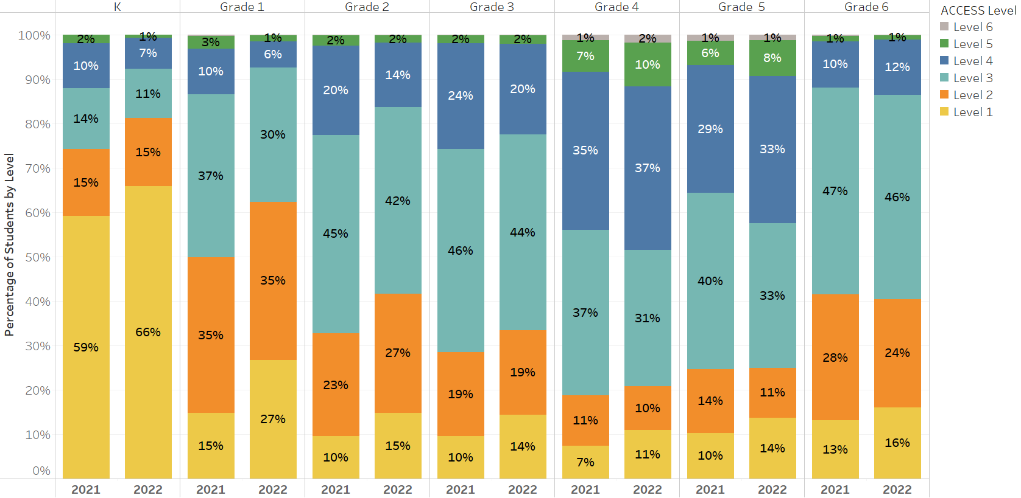

Figure 2. Percentage of Students in each Proficiency Level, Grades 7–12

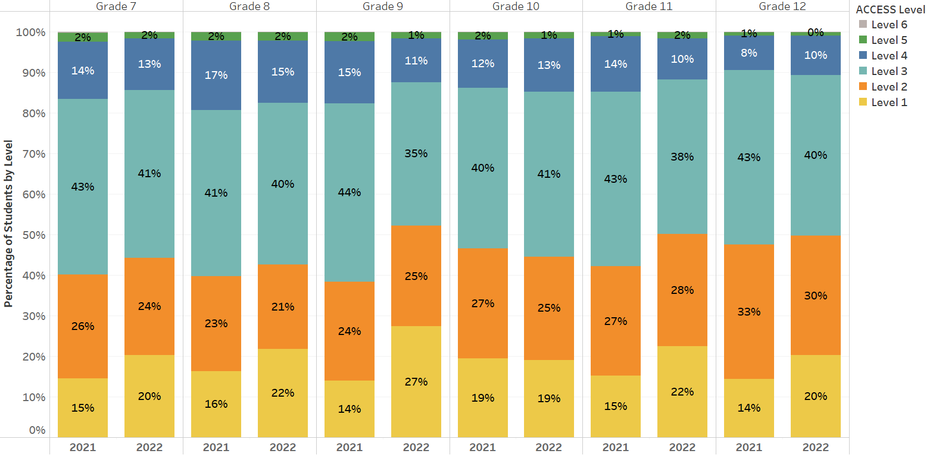

Table 6 shows the comparative percentage of ELs who performed at an overall composite ACCESS score of Level 4.2 or higher. The percentage of students attaining scores indicating their attainment of English proficiency (i.e., between Level 4.2 and Level 6 Overall) in 2022 (14.1%) was 1.2 percentage points lower than the percentage in 2021 (15.3%).

Table 6. Percentage of Students Who Attained Level 4.2 or Above by Grade (2020 to 2022)

Grade | 2020 | 2021 | 2022 | Percentage Change 2020–2022
 | 4.2 or Above | 4.2 or Above | 4.2 or Above | 4.2 or Above
K | 7.3 | 8.9 | 5.4 | -1.9
1 | 8.3 | 10.7 | 5.8 | -2.5
2 | 20.8 | 16.3 | 11.8 | -9.0
3 | 25.6 | 17.3 | 15.7 | -9.9
4 | 45.3 | 33.9 | 39.5 | -5.8
5 | 39.7 | 27.3 | 33.8 | -5.9
6 | 13.1 | 7.8 | 8.9 | -4.2
7 | 15.0 | 12.3 | 10.0 | -5.0
8 | 16.4 | 13.4 | 12.6 | -3.8
9 | 11.9 | 12.7 | 9.0 | -2.9
10 | 12.4 | 9.9 | 10.0 | -2.4
11 | 10.3 | 9.6 | 8.2 | -2.1
12 | 8.3 | 5.8 | 6.6 | -1.8
Total | 18.7 | 15.3 | 14.1 | -4.6

Composite Proficiency Levels
In addition to receiving a composite overall ACCESS proficiency level score, students receive three additional composite scores: oral language, comprehension, and literacy. Composite scores are derived from a combination of weighted scaled scores in the four language domains as follows:
- Overall―combining the four domain scores, as follows: listening (15%), speaking (15%), reading (35%), and writing (35%)
- Oral Language―combining equally weighted scaled scores for listening and speaking (50% each)
- Comprehension―combining scaled scores for listening (30%) and reading (70%)
- Literacy―combining equally weighted scaled scores for reading (50%) and writing (50%)

Average proficiency levels for the Oral Language, Comprehension, and Literacy composite scales are presented in table 7, by grade cluster and years in Massachusetts.

Table 7. Average Composite Proficiency Level
by Grade Cluster and Years of Enrollment in MA (2022)

Grade Cluster | Years in MA | # Included | Average Oral Level | Average Comprehension Level | Average Literacy  Level
K | First Year | 11,350 | 3.5 | 2.1 | 1.7
 | Second Year | 195 | 4.3 | 2.2 | 1.7
 | Total | 11,545 | 3.6 | 2.1 | 1.7
1–2 | First Year | 3,873 | 2.4 | 2.8 | 2.1
 | Second Year | 9,731 | 3.6 | 3.8 | 2.5
 | Third Year | 8,978 | 3.5 | 4.0 | 3.1
 | Fourth Year | 493 | 3.4 | 3.7 | 2.9
 | Fifth Year | 3 | - | - | -
 | Total | 23,078 | 3.4 | 3.7 | 2.7
3–5 | First Year | 3,793 | 2.4 | 2.7 | 2.4
 | Second Year | 1,074 | 3.7 | 3.9 | 3.3
 | Third Year | 3,103 | 3.8 | 3.9 | 3.2
 | Fourth Year | 8,432 | 3.8 | 4.1 | 3.5
 | Fifth Year | 6,608 | 4.5 | 4.8 | 3.8
 | Sixth+ Year | 4,416 | 4.4 | 4.6 | 3.8
 | Total | 27,426 | 3.9 | 4.1 | 3.4
6–8 | First Year | 3,466 | 2.5 | 2.6 | 2.2
 | Second Year | 948 | 3.5 | 3.3 | 2.8
 | Third Year | 2,325 | 3.5 | 3.3 | 2.8
 | Fourth Year | 1,447 | 3.8 | 3.7 | 3.0
 | Fifth Year | 1,221 | 3.9 | 3.7 | 3.0
 | Sixth+ Year | 7,364 | 3.9 | 3.6 | 3.1
 | Total | 16,771 | 3.5 | 3.3 | 2.8
9–12 | First Year | 5,123 | 2.3 | 2.7 | 2.4
 | Second Year | 1,182 | 2.9 | 3.4 | 3.0
 | Third Year | 3,419 | 2.8 | 3.3 | 2.9
 | Fourth Year | 2,159 | 3.1 | 3.5 | 3.1
 | Fifth Year | 1,737 | 3.2 | 3.7 | 3.2
 | Sixth+ Year | 7,006 | 3.3 | 3.8 | 3.3
 | Total | 20,626 | 2.9 | 3.3 | 3.0
Grand Total |  | 99,446 | 3.5 | 3.5 | 2.8

Results of the 2022 Alternate ACCESS for ELLs
The Alternate ACCESS for ELLs assessment was first administered in 2014 to ELs with the most significant cognitive disabilities. The Alternate ACCESS results are reported at six proficiency levels: A1-Initiating, A2-Exploring, A3-Engaging, P1-Entering, P2-Emerging, and P3-Developing (for Writing only), and on a numerical scale from 900 to 960. See Appendix B for the performance definitions of the Alternate ACCESS proficiency levels.

Overall, 1,551 students participated in the 2022 Alternate ACCESS, compared with 999 students in 2021. The percentage of students in each Alternate ACCESS proficiency level is shown by grade in table 8.

Table 8. Percentage of Students Taking Alternate ACCESS in Each Proficiency Level and Grade (2022)

Grade | # Tested | % A1 | % A2 | % A3 | % P1 | % P2
1 | 194 | 30 | 12 | 24 | 22 | 12
2 | 165 | 19 | 17 | 22 | 22 | 21
3 | 180 | 18 | 12 | 21 | 28 | 21
4 | 138 | 14 | 6 | 19 | 32 | 30
5 | 128 | 13 | 9 | 18 | 21 | 39
6 | 132 | 12 | 8 | 23 | 29 | 28
7 | 120 | 9 | 5 | 19 | 32 | 35
8 | 126 | 17 | 8 | 11 | 28 | 36
9 | 103 | 9 | 11 | 23 | 24 | 33
10 | 72 | 14 | 14 | 22 | 25 | 25
11 | 89 | 9 | 4 | 20 | 27 | 39
12 | 104 | 19 | 5 | 11 | 26 | 39
Grand Total | 1,551 | 16 | 10 | 20 | 26 | 28

III. Reporting Elements
Requirements for reporting the proficiency and progress of ELs are outlined in Title III of the federal Every Student Succeeds Act (ESSA) and in the Language Opportunities for Our Kids Act (LOOK), a 2017 state law. The five reporting elements required by ESSA are summarized below.
- Reporting Element #1: The number and percent of ELs making progress toward achieving English language proficiency, disaggregated for ELs with disabilities (EL SWD). A student who is making progress is on track to achieve English proficiency (i.e., for Reporting Element #1, overall Level 4.2 on ACCESS is considered English proficient) within one baseline year plus 5 years, or a total of six years.
- Reporting Element #2: The number and percent of ELs attaining English proficiency (i.e., for Reporting Element #2, overall Level 4.2 and composite literacy Level 3.9 on ACCESS is considered English proficient)
- Reporting Element #3: The number and percent of ELs exiting EL status based on their attainment of English proficiency
- Reporting Element #4: The number and percent of former ELs (FELs) meeting challenging state academic standards on the next-generation MCAS tests for English language arts (ELA), mathematics, and science and technology/engineering (STE) for each of the four years after such students are no longer receiving EL services, disaggregated for FELs with disabilities (FELSWD)
- Reporting Element #5: The number and percent of ELs who have not attained English language proficiency within six years of initial classification as an EL (i.e., five years after the first baseline year), disaggregated for ELs with disabilities
This report includes the results based on the five reporting elements described above. Results for the five reporting elements are based on the overall state results on the ACCESS tests combined with results for students taking the Alternate ACCESS, as well as the results of FEL students on the MCAS tests. Reporting on the five elements is intended to provide districts with important instructional feedback to promote and accelerate the achievement of EL and FEL students, and to provide a basis for additional oversight of EL programming by districts and the Department.

Reporting Element #1: ELs Making Progress toward English Language Proficiency (disaggregated for students with and without disabilities)
In 2018, a method was established to indicate progress in learning English that provided the following information for each EL student:
- Future Progress Target representing the minimum ACCESS proficiency level score needed on the following year’s ACCESS test to remain on track to reach English proficiency (i.e., attain overall Level 4.2) within a total of six years in a Massachusetts school. Future progress targets are reported as an ACCESS proficiency level, ranging from Levels 1.0 to 4.2. Individual student targets are provided in the summer of each year.
- Difficulty Index showing an estimate of how difficult it will be to reach next year’s target, relative to the student’s current proficiency level. The difficulty index ranges from 1–99, with one being the lowest difficulty (i.e., least difficult to achieve the target) and 99 the highest (i.e., most difficult to achieve the target). Students with difficulty indices greater than 60 are considered to have a high difficulty index. Educators are directed to use the difficulty index as an indicator of which students may need additional instructional assistance in order to succeed.
- Student Growth Percentile for ACCESS (SGPA) indicates the amount of progress made by a student on the ACCESS test from one year to the next, relative to other ELs in the same grade who earned similar ACCESS scores the prior year. The SGPAs in 2022 are calculated using the same baseline and scale as those produced from 2017 to 2021.
SGPA indicates whether a student has made low, moderate, or high gains in their ACCESS test scores from one year to the next compared with other ELs in the same grade who took the ACCESS test in two consecutive years. Like the difficulty index, the SGPA is a number from 1–99, with 40–59 representing average growth. Higher SGPA numbers (i.e., above 60) indicate more growth and lower SGPA numbers (i.e., below 40) show less growth. In 2021, the average SGPAs by grade are below 50, indicating overall lower growth rates than in prior years among students who took the test.
- Progress Indicator, either “Yes” or “No,” showing whether the student has met last year’s future progress target in the current year. Students who meet or exceed their future target for that year will be designated as having “made progress.” Students who do not meet their targets will not make progress for that year. Students taking the Alternate ACCESS will make progress if they increase the Alternate ACCESS achievement level in any domain by one level and do not lower their score in any other domain.
Students who were eligible to take the ACCESS test but did not participate because they were absent received a progress indicator of “0.” Table 9 and figure 3 indicate progress indicator data for students by grade and grade span who tested in 2021 and 2022. Overall, the percentage of students making progress in 2022 increased by 14% compared to 2021.

Table 9. Students Making Progress by Grade in 2021 and 2022

 | 2021 |  |  | 2022
Grade | % Making Progress | # Making Progress | #  Incl. in Progress | % Making Progress | # Making Progress | #  Incl. in Progress
1 | 44 | 4,525 | 10,265 | 52 | 4,698 | 9,110
2 | 47 | 4,940 | 10,441 | 61 | 6,090 | 9,938
3 | 39 | 3,517 | 9,081 | 58 | 5,465 | 9,482
4 | 37 | 2,959 | 7,894 | 63 | 5,282 | 8,341
5 | 28 | 1,511 | 5,472 | 48 | 3,076 | 6,438
6 | 16 | 697 | 4,308 | 25 | 1,176 | 4,687
7 | 20 | 975 | 4,787 | 27 | 1,213 | 4,413
8 | 20 | 941 | 4,761 | 28 | 1,304 | 4,662
9 | 16 | 764 | 4,800 | 25 | 1,228 | 4,943
10 | 11 | 557 | 5,248 | 24 | 1,048 | 4,285
11 | 10 | 398 | 4,013 | 21 | 880 | 4,237
12 | 6 | 233 | 3,700 | 19 | 733 | 3,858
Total | 29 | 22,017 | 74,770 | 43 | 32,193 | 74,394

Figure 3. Students Making Progress by Grade Span

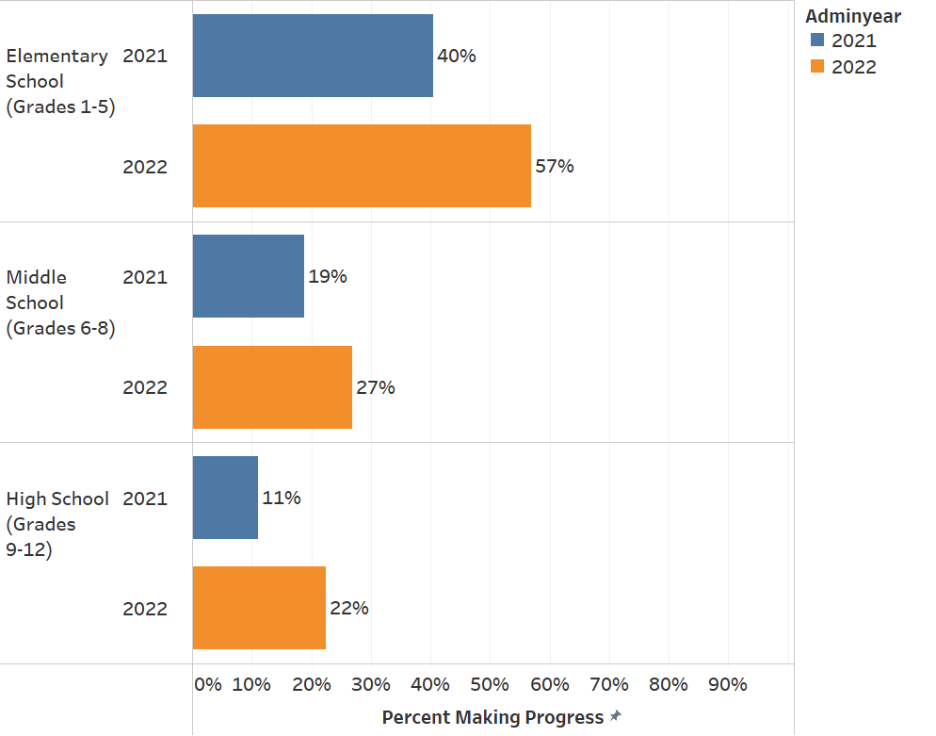

Table 10 indicates progress indicator data for students who tested in 2021 and 2022 by grade cluster and years in school. Across Massachusetts, 43% of all ELs made progress in 2022, an increase of 14 percentage points from 2021 when approximately 29% of all students did so. The increase in progress in 2022 should be interpreted with caution since participation in 2022 was significantly higher compared to 2021. Since participation calculations consider untested students as “not making progress,” 2021 resulted in markedly lower percentage of students making progress, while in 2022 both progress and participation rates increased significantly. In 2022, the highest rates of progress were in grades 2−5 and grades 10−12, where approximately 11−26% of all students made progress. Rates of progress in other grades showed positive but more modest increases.

Table 10. Students Making Progress
by Grade Cluster and Years of Enrollment in MA (2021 and 2022)

Grade Cluster | Years in MA | 2021 |  | 2022
 |  | # Included in Progress | % Making Progress | # Included in Progress | % Making Progress
1–2 | First Year | 210 | 76 | 419 | 58
 | Second Year | 10,939 | 44 | 9,137 | 52
 | Third Year | 8,939 | 47 | 8,995 | 62
 | Fourth Year | 618 | 33 | 494 | 47
 | Fifth Year | - | - | 3 | -
 | Total | 20,706 | 46 | 19,048 | 57
3–5 | First Year | 224 | 88 | 536 | 80
 | Second Year | 2,913 | 39 | 945 | 55
 | Third Year | 2,220 | 39 | 3,041 | 53
 | Fourth Year | 7,797 | 38 | 8,508 | 60
 | Fifth Year | 5,791 | 35 | 6,724 | 63
 | Sixth+ Year | 3,502 | 23 | 4,507 | 44
 | Total | 22,447 | 36 | 24,261 | 57
6–8 | First Year | 140 | 86 | 373 | 75
 | Second Year | 2,467 | 32 | 815 | 49
 | Third Year | 1,729 | 31 | 2,319 | 44
 | Fourth Year | 1,526 | 25 | 1,438 | 45
 | Fifth Year | 1,227 | 20 | 1,230 | 33
 | Sixth+ Year | 6,767 | 8 | 7,587 | 12
 | Total | 13,856 | 19 | 13,762 | 27
9–12 | First Year | 169 | 76 | 497 | 65
 | Second Year | 3,957 | 14 | 1,057 | 27
 | Third Year | 2,755 | 14 | 3,574 | 31
 | Fourth Year | 2,340 | 12 | 2,294 | 35
 | Fifth Year | 1,811 | 11 | 1,873 | 29
 | Sixth+ Year | 6,729 | 6 | 8,028 | 11
 | Total | 17,761 | 11 | 17,323 | 22
Grand Total |  | 74,770 | 29 | 74,394 | 43

Title III of ESSA also requires reporting of progress results by disability status, presented in table 11. Overall, in 2022, 50% of students without a disability made progress while 24% with a disability made progress.

Comparisons between grade clusters reveal significant differences in the percentage of students making progress. In clusters 1–2 and 3–5, 60% and 64% of non-disabled students (respectively) made progress, while 36% and 27% of students (respectively) in clusters 6–8 and 9–12 made progress. Among students with disabilities, only 9% of students in grade clusters 6–8 and 9–12 made progress, compared to 39% and 38% of students (respectively) in clusters 1–2 and 3–5 who did so.

Table 11. Students Making Progress in 2022
by Grade Cluster, Years of Enrollment in MA, and Disability Status

Grade Cluster | Years in MA | non-SWD |  | SWD |  | Total
 |  | # Included in Progress | % Making Progress | # Included in Progress | % Making Progress | # Included in Progress | % Making Progress
1–2 | First Year | 389 | 61 | 30 | 30 | 419 | 58
 | Second Year | 7,655 | 56 | 1,482 | 32 | 9,137 | 52
 | Third Year | 7,339 | 65 | 1,656 | 46 | 8,995 | 62
 | Fourth Year | 280 | 55 | 214 | 37 | 494 | 47
 | Fifth Year | 1 | - | 2 | - | 3 | -
 | Total | 15,664 | 60 | 3,384 | 39 | 19,048 | 57
3–5 | First Year | 516 | 81 | 20 | 55 | 536 | 80
 | Second Year | 871 | 57 | 74 | 31 | 945 | 55
 | Third Year | 2,743 | 55 | 298 | 34 | 3,041 | 53
 | Fourth Year | 6,585 | 65 | 1,923 | 43 | 8,508 | 60
 | Fifth Year | 4,627 | 71 | 2,097 | 45 | 6,724 | 63
 | Sixth+ Year | 2,547 | 56 | 1,960 | 27 | 4,507 | 44
 | Total | 17,889 | 64 | 6,372 | 38 | 24,261 | 57
6–8 | First Year | 368 | 75 | 5 | 60 | 373 | 75
 | Second Year | 760 | 50 | 55 | 29 | 815 | 49
 | Third Year | 2,135 | 45 | 184 | 24 | 2,319 | 44
 | Fourth Year | 1,247 | 48 | 191 | 24 | 1,438 | 45
 | Fifth Year | 874 | 40 | 356 | 17 | 1,230 | 33
 | Sixth+ Year | 3,535 | 19 | 4,052 | 7 | 7,587 | 12
 | Total | 8,919 | 36 | 4,843 | 9 | 13,762 | 27
9–12 | First Year | 490 | 66 | 7 | 29 | 497 | 65
 | Second Year | 1,027 | 27 | 30 | 13 | 1,057 | 27
 | Third Year | 3,438 | 31 | 136 | 17 | 3,574 | 31
 | Fourth Year | 2,115 | 35 | 179 | 28 | 2,294 | 35
 | Fifth Year | 1,561 | 32 | 312 | 17 | 1,873 | 29
 | Sixth+ Year | 4,478 | 14 | 3,550 | 7 | 8,028 | 11
 | Total | 13,109 | 27 | 4,214 | 9 | 17,323 | 22
Grand Total |  | 55,581 | 50 | 18,813 | 24 | 74,394 | 43

Reporting Element #2: ELs Attaining English Language Proficiency
Students who attained an overall score of at least Level 4.2 and a literacy composite score of at least Level 3.9 were designated as having attained English language proficiency. Students who did not test received a score of “0” and were considered not proficient. The overall rates of proficiency shown in table 12 indicate an increase in attainment of approximately two percentage points in 2022 compared to 2021, but an overall decrease in attainment of approximately four percentage points in 2022 compared to 2020.
Table 12. Students Attaining English Proficiency by Grade (2020–2022)

Grade | 2020 |  | 2021 |  | 2022 |  | 2020–2022
 | % Proficient | # Included | % Proficient | # Included | % Proficient | # Included | Percentage Change 2020–2022
K | 3 | 11,386 | 4 | 10,157 | 2 | 11,716 | -1
1 | 7 | 11,994 | 7 | 11,259 | 5 | 12,012 | -2
2 | 19 | 11,676 | 12 | 11,116 | 11 | 11,658 | -8
3 | 24 | 10,527 | 13 | 9,657 | 15 | 10,955 | -9
4 | 41 | 9,085 | 25 | 8,409 | 35 | 9,583 | -6
5 | 36 | 6,733 | 20 | 5,891 | 31 | 7,668 | -5
6 | 11 | 5,748 | 5 | 4,862 | 7 | 5,954 | -4
7 | 13 | 5,775 | 9 | 5,292 | 8 | 5,670 | -5
8 | 15 | 5,538 | 10 | 5,205 | 11 | 5,920 | -4
9 | 11 | 7,633 | 8 | 5,578 | 8 | 7,906 | -3
10 | 12 | 5,643 | 6 | 5,731 | 9 | 5,482 | -3
11 | 9 | 4,542 | 6 | 4,399 | 7 | 5,213 | -2
12 | 7 | 3,725 | 3 | 3,976 | 5 | 4,405 | -2
Total | 17 | 100,005 | 10 | 91,532 | 12 | 104,142 | -5

Figure 4 shows that proficiency rates in 2022 increased marginally by 1–2 percentage points in all grade spans in 2022 compared to 2021 but remained between 2–5 percentage points below 2020 proficiency rates.

Figure 4. Students Attaining Proficiency by Grade Span, 2020–2022
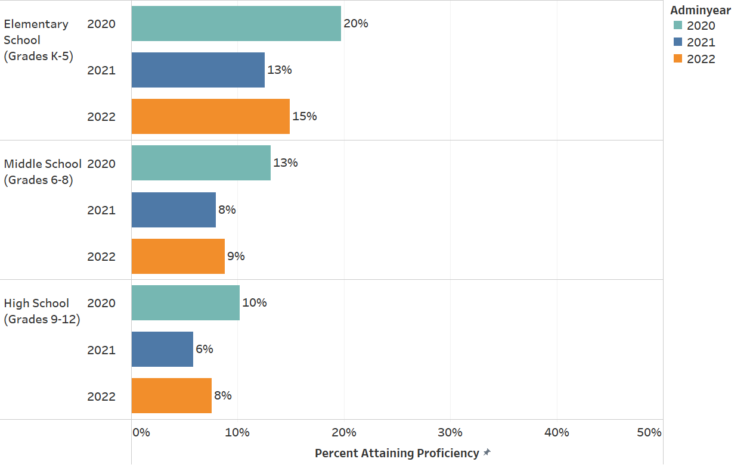

Table 13 below indicates that the percentage of students attaining proficiency was highest in grades 3−5 (26% in 2022), but much lower in other clusters. Students in grades 6−8 attained a proficiency rate of 9%, while students in grades 1−2 and 9−12 attained a proficiency rate of 8%.

Table 13. Students Attaining English Proficiency by Grade Cluster and Years of Enrollment in MA
(2020–2022)

Grade | Years in MA | 2020 |  | 2021 |  | 2022 |  | 2020–2022
 |  | % Proficient | # Included | % Proficient | # Included | % Proficient | # Included | Percentage Change
K | First Year | 3 | 11,019 | 4 | 9,964 | 2 | 11,517 | -1
 | Second Year | 4 | 367 | 4 | 193 | 2 | 199 | -2
 | Total | 3 | 11,386 | 4 | 10,157 | 2 | 11,716 | -1
1–2 | First Year | 6 | 3,046 | 9 | 1,246 | 3 | 3,920 | -2
 | Second Year | 9 | 10,913 | 8 | 11,432 | 6 | 10,013 | -2
 | Third Year | 21 | 9,041 | 12 | 9,068 | 12 | 9,227 | -9
 | Fourth Year | 12 | 669 | 5 | 628 | 6 | 507 | -6
 | Fifth Year | - | 1 | - | 1 | - | 3 | -
 | Total | 13 | 23,670 | 10 | 22,375 | 8 | 23,670 | -5
3–5 | First Year | 13 | 3,621 | 15 | 1,253 | 9 | 3,826 | -3
 | Second Year | 26 | 2,607 | 16 | 3,154 | 24 | 1,091 | -2
 | Third Year | 34 | 2,540 | 20 | 2,290 | 21 | 3,155 | -12
 | Fourth Year | 31 | 7,900 | 16 | 7,882 | 20 | 8,708 | -11
 | Fifth Year | 45 | 5,898 | 24 | 5,847 | 38 | 6,824 | -6
 | Sixth+ Year | 41 | 3,779 | 20 | 3,531 | 36 | 4,602 | -5
 | Total | 33 | 26,345 | 19 | 23,957 | 26 | 28,206 | -7
6–8 | First Year | 10 | 3,190 | 10 | 1,104 | 6 | 3,496 | -3
 | Second Year | 15 | 2,185 | 8 | 2,716 | 13 | 963 | -2
 | Third Year | 14 | 1,990 | 11 | 1,766 | 10 | 2,392 | -4
 | Fourth Year | 15 | 1,631 | 10 | 1,558 | 12 | 1,495 | -3
 | Fifth Year | 15 | 1,046 | 9 | 1,249 | 9 | 1,276 | -6
 | Sixth+ Year | 13 | 7,019 | 6 | 6,966 | 8 | 7,922 | -5
 | Total | 13 | 17,061 | 8 | 15,359 | 9 | 17,544 | -4
9–12 | First Year | 8 | 4,766 | 9 | 1,333 | 6 | 5,221 | -3
 | Second Year | 12 | 3,507 | 6 | 4,298 | 10 | 1,270 | -1
 | Third Year | 10 | 2,876 | 6 | 2,816 | 8 | 3,707 | -2
 | Fourth Year | 10 | 2,603 | 5 | 2,413 | 9 | 2,395 | -1
 | Fifth Year | 11 | 1,489 | 6 | 1,855 | 9 | 1,936 | -2
 | Sixth+ Year | 11 | 6,302 | 5 | 6,969 | 7 | 8,477 | -3
 | Total | 10 | 21,543 | 6 | 19,684 | 8 | 23,006 | -3
Grand Total |  | 17 | 100,005 | 10 | 91,532 | 12 | 104,142 | -4

Reporting Element #3: ELs Who Exited English Learner (EL) Status as a Result of Their Attainment of English Proficiency
This element reports the number and percentage of students who exited EL status once they had attained English proficiency on the ACCESS tests, based on districts’ reporting of students in the October 2021 Student Information Management System (SIMS). The number of students reaching proficiency who exited EL status in 2020, 2021, and 2022 is shown in table 14. The overall percentage of proficient students who exited EL status after reaching proficiency was 75.1% in 2020, 73.8% in 2021, and 85% in 2022.
Table 14. Students Who Attained English Proficiency and Exited EL Status (2020 to 2022)

Grade Cluster |  | Year
 |  | 2020 | 2021 | 2022
K | Number Proficient | 394 | 422 | 291
 | RE3 Exit | 173 | 304 | 208
 | Percent Proficient Who Exited | 44% | 72% | 71%
1–2 | Number Proficient | 3,059 | 2,176 | 1,861
 | RE3 Exit | 2,166 | 1,584 | 1,509
 | Percent Proficient Who Exited | 71% | 73% | 81%
3–5 | Number Proficient | 8651 | 4511 | 7,316
 | RE3 Exit | 6751 | 3325 | 6,313
 | Percent Proficient Who Exited | 78% | 74% | 86%
6–8 | Number Proficient | 2,235 | 1,223 | 1,541
 | RE3 Exit | 1,610 | 874 | 1,279
 | Percent Proficient Who Exited | 72% | 72% | 83%
9–12 | Number Proficient | 2198 | 1149 | 1,750
 | RE3 Exit | 1726 | 908 | 1,541
 | Percent Proficient Who Exited | 79% | 79% | 88%
Grand Total | Number Proficient | 16,537 | 9,481 | 12,759
 | RE3 Exit | 12,426 | 6,995 | 10,850
 | Percent Proficient Who Exited | 75% | 74% | 85%
A Note about RE3: Each year RE3 is re-evaluated based on the most current FEL year. This results in a small increase in the numbers and percentages reported for the previous year(s). The method for calculating RE3 is consistent across years.

Reporting Element #4: Former ELs (FELs) Meeting Challenging State Academic Standards (disaggregated for students with and without disabilities)
Reporting Element #4 describes the number and percent of former English learners (FELs) and former English learners with disabilities (FEL & SWD) who met challenging state standards, as indicated by a score of Meeting Expectations or Exceeding Expectations on the next-generation MCAS tests. For this reporting element, FELs are considered to be students who exited EL status up to four years prior to taking the MCAS tests. Results for students who took grades 3−8 MCAS in ELA, mathematics, and science and technology/engineering (STE) are reported in table 15, and results for grade 10 ELA and mathematics are presented in table 16. Results on the legacy high school STE MCAS tests were not included because students in the class of 2023 were not required to take the MCAS tests.

As shown in table 15, 36% of FELs in grades 3−8 performed at Meeting Expectations or Exceeding Expectations in ELA; 35% performed at these levels in mathematics; and 31% performed at these levels in STE. In all subjects and grade clusters, FELs who exited an EL program 4 years prior to taking the tests performed better than those who exited the program more recently.

Table 16 shows that 43% of FELs in grade 10 performed at Meeting Expectations or Exceeding Expectations in ELA, and 32% of FELs performed at those levels in mathematics. As with FELs with and without disabilities in grades 3–8, FELs with and without disabilities who exited an EL program 3–4 years prior to taking the tests performed better than those who exited 1–2 years prior.

FELs with disabilities consistently performed below the level of FELs without disabilities. The percentage of FELs with disabilities in grades 3−8 meeting academic standards is about one-third that of the overall FEL group across in ELA and mathematics. In grade 10, the percentage of FELs with disabilities meeting academic standards is about one-fourth that of the overall FEL group in those subjects.

Table 15. Former ELs (FEL) Meeting Challenging State Academic Standards,
Disaggregated for FELs with Disabilities (FEL & SWD) in Grades 3–8 (2022)

Student Group | FEL Year | Grades  3–8  ELA  Tested # | Grades  3–8  ELA  E+M # | Grades  3–8  ELA  E+M % | Grades  3–8  Math  Tested # | Grades  3–8  Math  E+M # | Grades  3–8  Math  E+M % | Grades  5 & 8  STE  Tested # | Grades  5 & 8  STE  E+M # | Grades  5 & 8  STE  E+M %
FEL | 1 | 13,214 | 4,059 | 31 | 13,193 | 4,347 | 33 | 4,116 | 1,072 | 26
FEL | 2 | 10,084 | 3,515 | 35 | 10,061 | 3,337 | 33 | 3,318 | 1,054 | 32
FEL | 3 | 8,254 | 3,525 | 43 | 8,253 | 3,212 | 39 | 3,647 | 1,238 | 34
FEL | 4 | 2,756 | 1,319 | 48 | 2,753 | 1,198 | 44 | 971 | 398 | 41
FEL | Total | 34,308 | 12,418 | 36 | 34,260 | 12,094 | 35 | 12,052 | 3,762 | 31
FEL & SWD | 1 | 1,832 | 187 | 10 | 1,830 | 236 | 13 | 564 | 74 | 13
FEL & SWD | 2 | 1,240 | 139 | 11 | 1,231 | 155 | 13 | 419 | 48 | 11
FEL & SWD | 3 | 861 | 99 | 11 | 860 | 108 | 13 | 404 | 46 | 11
FEL & SWD | 4 | 332 | 54 | 16 | 334 | 52 | 16 | 105 | 19 | 18
FEL & SWD | Total | 4,265 | 479 | 11 | 4,255 | 551 | 13 | 1,492 | 187 | 13

Table 16. Former ELs (FELs) Meeting Challenging State Academic Standards,
Disaggregated for FELs with Disabilities (FEL & SWD) in Grade 10 (2022)

Student Group | FEL Year | Grade 10  ELA  Tested # | Grade 10  ELA  E+M # | Grade 10  ELA  E+M % | Grade 10  Math  Tested # | Grade 10  Math  E+M # | Grade10  Math  E+M %
FEL | 1 | 1,032 | 324 | 31 | 1,031 | 230 | 22
FEL | 2 | 834 | 386 | 46 | 832 | 286 | 34
FEL | 3 | 669 | 350 | 52 | 667 | 265 | 40
FEL | 4 | 380 | 192 | 51 | 382 | 150 | 39
FEL | Total | 2,915 | 1,252 | 43 | 2,912 | 931 | 32
FEL & SWD | 1 | 184 | 14 | 8 | 184 | 5 | 3
FEL & SWD | 2 | 116 | 14 | 12 | 114 | 8 | 7
FEL & SWD | 3 | 93 | 18 | 19 | 91 | 7 | 8
FEL & SWD | 4 | 56 | 9 | 16 | 57 | 8 | 14
FEL & SWD | Total | 449 | 55 | 12 | 446 | 28 | 6

Reporting Element #5: ELs Who Have Not Attained English Proficiency within Six Years (disaggregated for students with and without disabilities)

ELs in Massachusetts are anticipated to reach proficiency on ACCESS tests within a total of six years after being classified as an English learner (one baseline year, plus five years to demonstrate growth toward proficiency). ELs are considered to have attained English proficiency when they achieve the minimum state exit criteria of an ACCESS scores of at least Level 4.2 overall and Level 3.9 literacy composite.
As shown in table 17, 18% of all ELs did not reach proficiency in 2022 within six years of entering a Massachusetts school, which was unchanged from the previous year. Students in grades K–4 are omitted from the table due to the reporting requirement that a student be enrolled in a Massachusetts school for at least six years. The percent of students with disabilities not attaining proficiency within six years increased by 4 percentage points over the previous year (41% in 2021 and 45% in 2022). For students without disabilities, the percent not attaining proficiency within six years increased by 1 percentage point over the previous year (11% in 2021 and 12% in 2022).

Table 17. Students in Grades K‒12 with at least Six Years in MA Not Attaining English Proficiency
by Grade Cluster and Disability Status (2021 and 2022)

Grade Cluster |  | 2021 |  |  | 2022
 |  | non-SWD | SWD | Total | non-SWD | SWD | Total
3–5 | # Not Meeting | 1,241 | 1,643 | 2,884 | 1,395 | 1,680 | 3,075
 | % Not Meeting | 7% | 25% | 12% | 6% | 25% | 11%
 | # Included | 17,403 | 6,554 | 23,957 | 21,535 | 6,671 | 28,206
6–8 | # Not Meeting | 3,072 | 3,839 | 6,911 | 3,641 | 4,164 | 7,805
 | % Not Meeting | 29% | 79% | 45% | 29% | 82% | 44%
 | # Included | 10,486 | 4,873 | 15,359 | 12,450 | 5,094 | 17,544
9–12 | # Not Meeting | 3,689 | 3,221 | 6,910 | 4,575 | 3,755 | 8,330
 | % Not Meeting | 24% | 79% | 35% | 25% | 83% | 36%
 | # Included | 15,615 | 4,069 | 19,684 | 18,482 | 4,524 | 23,006
Grand Total* | # Not Meeting | 8,002 | 8,703 | 16,705 | 9,611 | 9,599 | 19,210
 | % Not Meeting | 11% | 41% | 18% | 12% | 45% | 18%
 | # Included | 70,556 | 20,976 | 91,532 | 82,600 | 21,542 | 104,142
* The Grand Total includes the count of students in grades K–4, but these students are not considered eligible to be included in the “meets” or “does not meet” proficiency status within six years due to the number of years they have been enrolled in school.

IV. ACCESS Results for ELs from the State’s Highest Incidence Non-English Language Groups
Table 18 shows the number and percent of ELs in the highest incidence non-English language groups enrolled in a Massachusetts school in 2021 and 2022. Spanish is the largest native language group with 53% of ELs, followed by Portuguese, the native language of 18% of the EL population and the group with the largest increase (4% from 2021).
Table 18. Enrollment by Highest-Incidence Non-English Languages (2021 and 2022)

Language Spoken and  Ranking by Enrollment # |  | 2021 |  | 2022
 |  | # of ELs | % of ELs | # of ELs | % of ELs
1 | Spanish | 50,153 | 54 | 55,385 | 53
2 | Portuguese | 12,691 | 14 | 18,277 | 18
3 | Creole | 3,707 | 4 | 3,852 | 4
4 | Cape Verdean | 3,869 | 4 | 3,829 | 4
5 | Chinese | 2,925 | 3 | 3,038 | 3
6 | Arabic | 2,652 | 3 | 2,809 | 3
7 | Vietnamese | 1,862 | 2 | 1,805 | 2
8 | Khmer | 1,507 | 2 | 1,542 | 1
9 | Russian | 1,114 | 1 | 1,128 | 1
10 | French | 702 | 1 | 689 | 1

The ACCESS achievement, by proficiency level, of students speaking the ten highest-incidence non-English languages is summarized in table 19 and in figures 5, 6, and 7. Table 19 and figure 5 show the percentage of students scoring at each ACCESS level, by native language. The language group with the highest percentages of students in the highest proficiency levels (Levels 4–6) is Chinese, followed closely by Russian. Both figures 6 and 7 illustrate higher proficiency levels among students in higher grade clusters and among students with more years in school.

Table 19. Proficiency Level by Students Who Speak the Ten Highest-Incidence
Non-English Languages (2022)

Language Spoken | % in  Level 6 | % in  Level 5 | % in  Level 4 | % in  Level 3 | % in  Level 2 | % in  Level 1 | # Included
Spanish | 0 | 2 | 13 | 35 | 25 | 25 | 52,434
Portuguese | 0 | 2 | 13 | 27 | 20 | 39 | 17,852
Cape Verdean | 0 | 1 | 13 | 43 | 28 | 15 | 3,619
Creole | 0 | 2 | 18 | 43 | 23 | 14 | 3,671
Chinese | 2 | 11 | 29 | 33 | 13 | 12 | 2,953
Arabic | 1 | 4 | 22 | 41 | 19 | 13 | 2,688
Vietnamese | 1 | 6 | 25 | 39 | 17 | 12 | 1,703
Khmer | 1 | 5 | 22 | 42 | 19 | 12 | 1,500
Russian | 2 | 9 | 28 | 34 | 15 | 13 | 1,097
French | 1 | 5 | 27 | 39 | 17 | 11 | 659

Figure 5. Percent of Students at Each Proficiency Level Who Speak the Ten Highest-Incidence
Non-English Languages

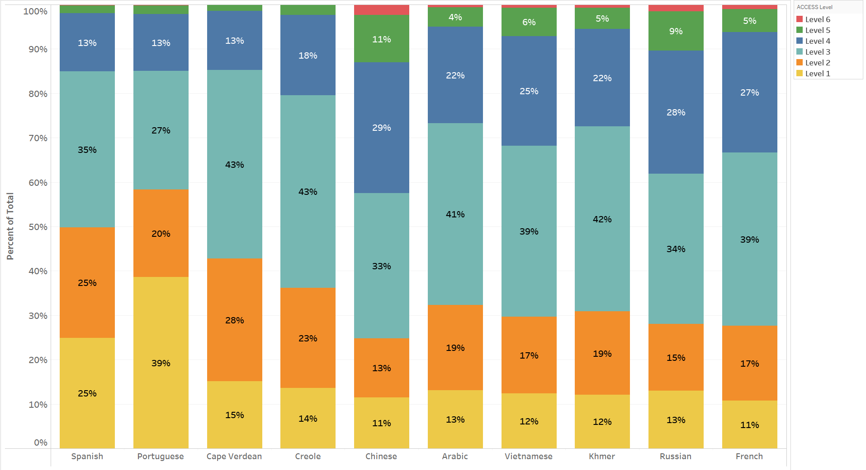

Figure 6. Average Proficiency Level of Students Who Speak the Ten Highest-Incidence
Non-English Languages by Grade Cluster

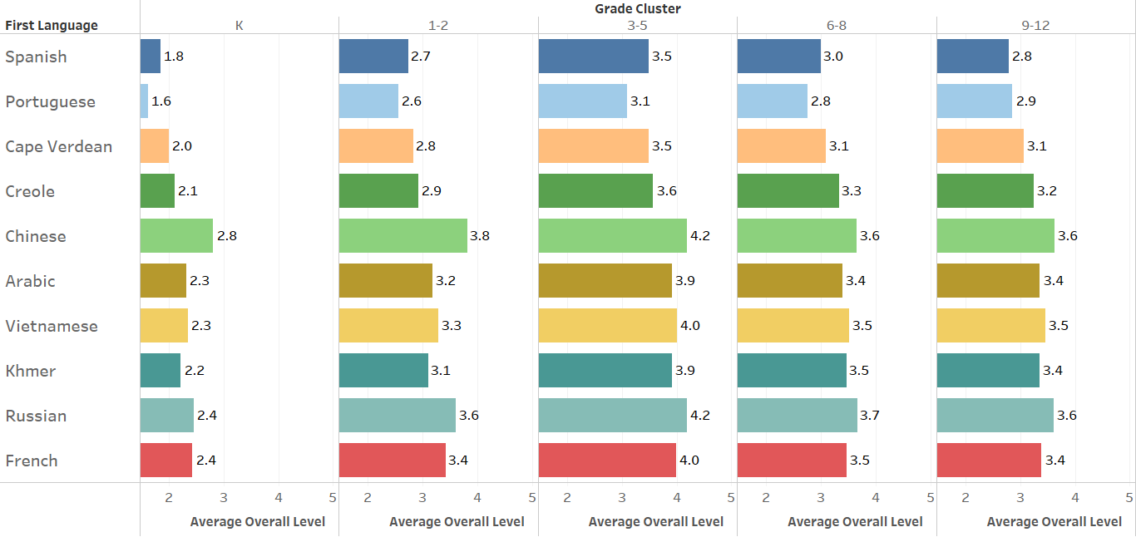

Figure 7. Average Proficiency Level of Students Who Speak the Ten Highest-Incidence
Non-English Languages by Years in Massachusetts

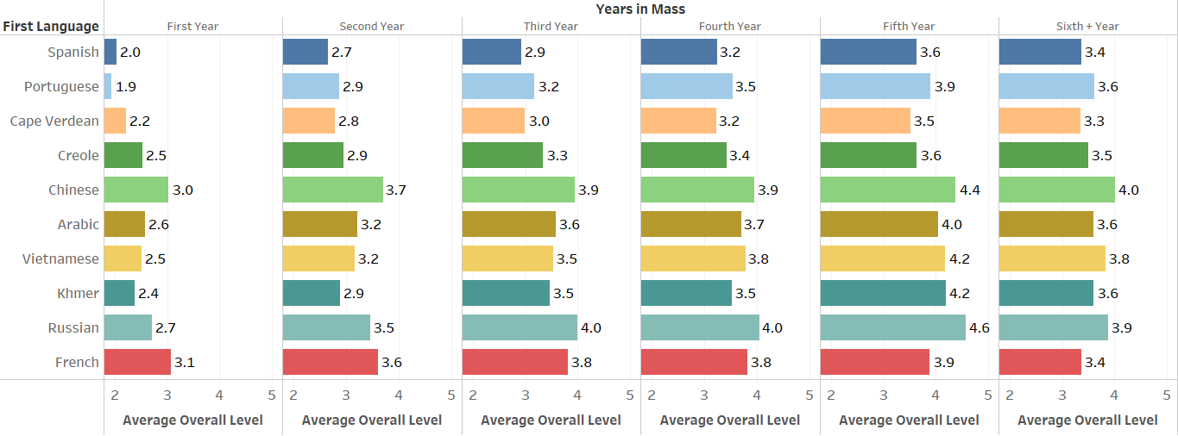

Appendix A. Performance Definitions for the ACCESS Levels of English Language Proficiency

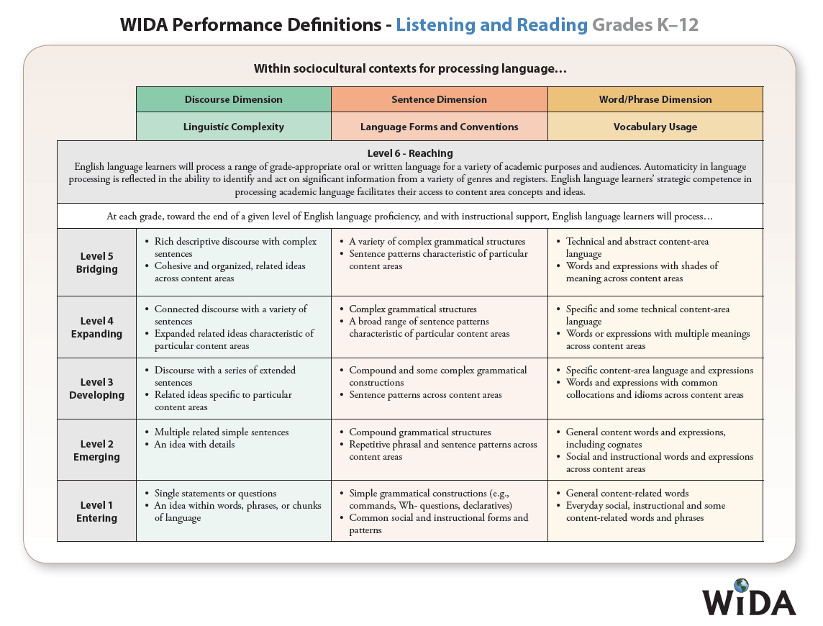
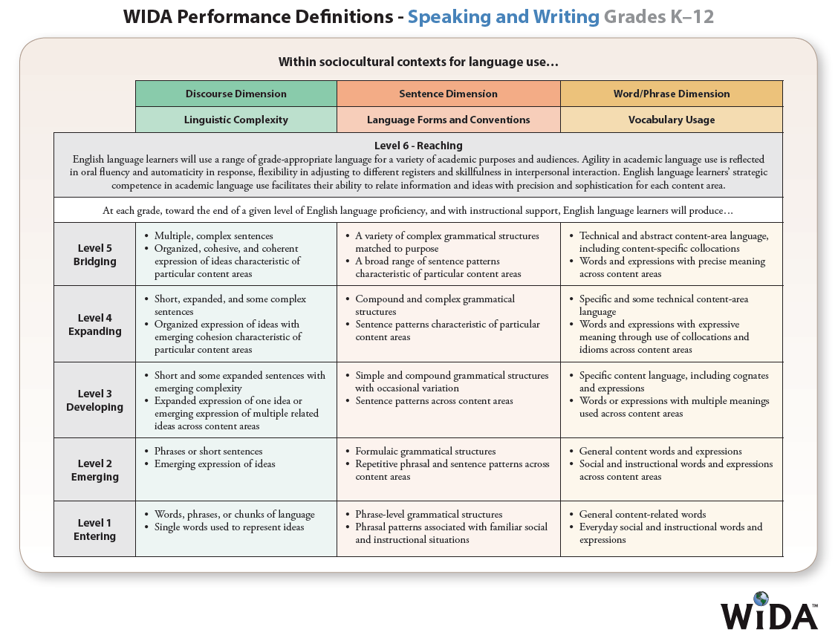

Appendix B. Alternate ACCESS Performance Definitions

