Approved Supplemental Mathematics Reference Sheet—Grade 6
ONLY for use by students on the MCAS Mathematics test who have this accommodation listed in their IEP or 504 plan
Note: Students may NOT use a reference sheet on which the table has already been completed prior to the beginning of the test administration, and test administrators MUST check to confirm that they are providing students with blank sheets.

General Problem-Solving Process | Order of Operations
- Read/reread the problem for understanding.  - Identify what the question is asking.  - Make a plan to solve the problem. (Choose at least one strategy.)  - Draw a picture.  - Create a table, chart, or list.  - Look for a pattern.  - Work backwards.  - Write a number sentence or an equation.  - Solve the problem.  - Reread the problem to see if your solution makes sense. | PEMDAS  - Parentheses (brackets, etc.)  - Exponents  - Multiplication or Division (left to right)  - Addition or Subtraction (left to right)
GEMA
- Grouping
- Exponents
- Multiplicative operations (multiplication or division – left to right)
- Additive operations (addition or subtraction – left to right)
Hundreds Charts
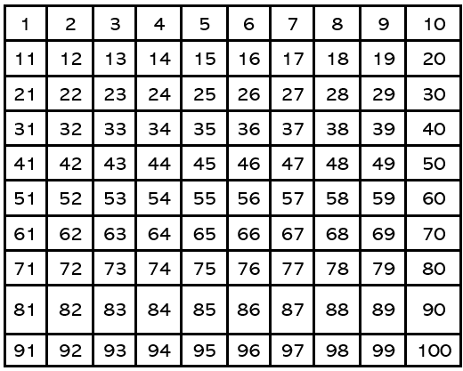 | 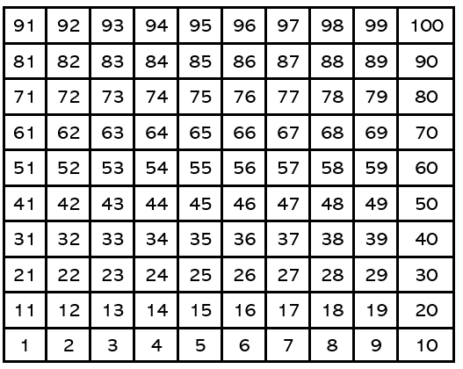
Properties | Fractions
- $a\left(b+c\right)=ab+ac$  - $a+\left(b+c\right)=\left(a+b\right)+ c$  - $a∙\left(b ∙ c\right)=\left(a ∙ b\right) ∙ c$  - $a ∙ b=b ∙ a$  - $a+b=b+a$ | - $\frac{a}{b}+\frac{c}{d}=\frac{ad+bc}{bd}$  - $\frac{a}{b}-\frac{c}{d}=\frac{ad-bc}{bd}$  - $\frac{a}{b}∙ \frac{c}{d}=\frac{ac}{bd}$  - $\frac{a}{b}÷\frac{c}{d}=\frac{ad}{bc}$

Place Value
Whole Numbers |  |  |  |  |  |  | Decimals
Hundred-  thousands | Ten- thousands | Thousands | Hundreds | Tens | Ones | . | Tenths | Hundredths

Number Line
Symbols | Divisibility Rules
- > is greater than  - $<$ is less than  - $=$ is equal to  - $| x |$ = absolute value of x | 2 If the last digit is even  3 If the sum of the digits can be divided by 3  5 If the last digit is 0 or 5  6 If the number is divisible by both 2 and 3  9 If the sum of the digits can be divided by 9  10 If the last digit is 0
Geometric Measurement
P = perimeter; $l=length;w=width$

Perimeter of Rectangle: P = 2$l$ + 2w

Statistics | Coordinate Plane
- Mean - Average  - Median - Middle  - Mode – Most often  - Range – Least to Greatest | 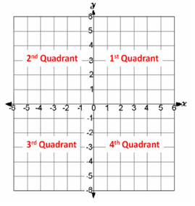
Percentages and Proportions | Ratios
- $\frac{is}{of}=\frac{\%}{100}$  - $x\%=\frac{x}{100}$  - if $\frac{a}{b}=\frac{c}{d}$ , then $ad=bc$ | - Part:Part  - Part:Whole

Multiplication Table (NOTE: DO NOT COMPLETE THIS TABLE FOR THE STUDENT.)
X | 1 | 2 | 3 | 4 | 5 | 6 | 7 | 8 | 9 | 10 | 11 | 12
1
2
3
4
5
6
7
8
9
10
11
12

