|  |
| --- |
| 2025 Educator’s Manual for MCAS-Alt |
|  |
| Alternate Assessment Based on Alternate Achievement Standards for  Students with the Most Significant Cognitive Disabilities  Fall 2024 |
|  |

This document was prepared by the Massachusetts Department of Elementary and Secondary Education

Russell D. Johnston, Acting Commissioner

Board of Elementary and Secondary Education Members

Ms. Katherine Craven, Chair, Brookline

Mr. Matt Hills, Vice-Chair, Newton

Dr. Ericka Fisher, Worcester

Ms. Ela Hopple Gardiner, Wellesley, Student Member

Ms. Dálida Rocha, Worcester

Ms. Farzana Mohamed, Newton

Mr. Michael Moriarty, Holyoke

Mr. Paymon Rouhanifard, Brookline

Ms. Mary Ann Stewart, Lexington

Dr. Patrick Tutwiler, Secretary of Education, Andover

Dr. Martin West, Newton

Russell D. Johnston, Acting Commissioner

Secretary to the Board

The Massachusetts Department of Elementary and Secondary Education, an affirmative action employer, is committed to ensuring that all of its programs and facilities are accessible to all members of the public.

We do not discriminate on the basis of age, color, disability, national origin, race, religion, sex, gender identity, or sexual orientation.

Inquiries regarding the Department’s compliance with Title IX and other civil rights laws may be directed to the Human Resources Director, 135 Santilli Highway, Everett, MA 02149. Phone: 781-338-6105.

© 2024 Massachusetts Department of Elementary and Secondary Education

Permission is hereby granted to copy any or all parts of this document for non-commercial educational purposes. Please credit the “Massachusetts Department of Elementary and Secondary Education.”

This document printed on recycled paper

Massachusetts Department of Elementary and Secondary Education

135 Santilli Highway, Everett, MA 02149

Phone 781-338-3000 TTY: N.E.T. Relay 800-439-2370

[www.doe.mass.edu](http://www.doe.mass.edu)

###### Overview

The *2025 Educator’s Manual for MCAS-Alt* provides guidelines and instructions for educators who are preparing alternate assessments for students with the most significant cognitive disabilities who are designated on their IEP as being unable to participate in the standard MCAS tests. Determination of participation eligibility may be found on the [MCAS-Alt ESSA website](https://www.doe.mass.edu/mcas/alt/essa/default.html) and on page 6 of this manual. The knowledge and skills assessed by the MCAS-Alt are aligned with the same content assessed for other students on the MCAS tests based on the most current versions of the state’s curriculum frameworks. The *2025 Educator’s Manual for MCAS-Alt* should be used in conjunction with *The Alternate Academic Achievement Standards to the Massachusetts Curriculum Frameworks for Students with Disabilities (Resource Guide)* to identify challenging measurable outcomes for students with the most significant cognitive disabilities*.* Both publications are available on the [Department’s website](http://www.doe.mass.edu/mcas/alt/resources.html).

**Contact Information**

For further information on the MCAS-Alt, please contact:

|  |  |
| --- | --- |
| Student Assessment Services  Department of Elementary and Secondary Education  135 Santilli Hwy  Everett, MA 02149  Telephone: 781-338-3625  Email: [mcas@doe.mass.edu](mailto:mcas@doe.mass.edu) |  |

MCAS Service Center: 800-737-5103

**TABLE OF CONTENTS**

Overview

PART I Introduction

1. Recommended Timeline and Important Dates for 2024–20251
2. Updated and New for the 2025 MCAS-Alt2
3. Rationale and Purpose of the MCAS-Alt3
4. Administrative Responsibilities and Security Requirements4

PART II Assessment Participation Guidelines5

1. Statewide Assessment Participation Requirements5
2. Decision-Making Tool for MCAS Participation by Students with Disabilities5
3. **Requirements of the Every Student Succeeds Act (ESSA)** 6

PART III Required Assessments in Each Grade7

PART IV Compiling MCAS-Alt Evidence15

1. Content Checklist for Required Forms15
2. MCAS-Alt Skills Survey16
3. Selecting an Entry Point (Skill) for MCAS-Alt17
4. Submission for ELA—Reading, ELA—Language, and Mathematics19
5. Guidelines to Create a Data Chart19
6. Primary Evidence22
7. Strand Specific Requirements: ELA—Reading24
8. Strand Specific Requirements: Mathematics24
9. Strand Specific Requirements: ELA—Writing24
10. Strand Specific Requirements: Science and Technology/Engineering 26
11. Strand Specific Requirements: Civics28

PART V Scoring the MCAS-Alt and Reporting Results 30

1. Scoring the MCAS-Alt30
2. MCAS-Alt Rubric for Scoring Each Strand30
3. Calculating the Overall Achievement Level in the Content Area38
4. Including MCAS-Alt Results in Reporting and Accountability39
5. Policy on Storage and Destruction of Returned MCAS-Alt Materials41

APPENDICES

A. Examples of Completed Forms for the MCAS-Alt43

B. Scoring Rubric for ELA—Writing48

# Introduction

## Recommended Timeline and Important Dates for 2024–2025

**Summer 2024**

* Educators may begin collecting evidence on July 1, 2024, for students taking the 2025 MCAS-Alt.

**Fall 2024**

* Identify students who are eligible to participate in MCAS-Alt.
* Register for [Forms and Graphs](https://profile.measuredprogress.org/MCAS-Alt/login.aspx), the Department’s web-based secure MCAS-Alt application. For technical assistance using Forms and Graphs, call (866) 834-8880.
* Complete the MCAS-Alt Skills Survey required for assessment determined by student grade.
* Obtain signed *Consent Form*(s) *to Photograph or Video Student*,as needed, and keep on file at school. Do not substitute a “blanket” consent form for this purpose.
* Consult the DESE [website](http://www.doe.mass.edu/mcas/alt/resources.html) for information on MCAS-Alt training sessions for teachers and administrators.
  + Identify prospective entry points for each student and develop appropriate measurable outcomes based on *current* versions ofthe Resource Guide and the results of the MCAS-Alt Skills Survey.
  + Plan instruction in collaboration with general educators, as needed.
* Begin collecting work samples and data on student performance noting accuracy and independence.

Stay apprised of current information by reading the [MCAS-Alt Newsletter](http://www.mcas-alt.org/news/register.htm) (including tips and strategies, training, logistics, and resources), which is emailed to educators and posted on the DESE website.

**Winter/Spring 2025**

**January/February**

* + **January 2-17**: Principals order MCAS-Alt materials on the Cognia [website](http://www.mcasservicecenter.com/).
  + Consult the DESE [website](http://www.doe.mass.edu/mcas/alt/resources.html) for registration information for MCAS-Alt review sessions.
  + Open MCAS-Alt materials shipment to schools and review instructions.

**March**

* + Finish collecting, organizing, labeling, and selecting student evidence.
  + Complete required forms, including Student Information Booklet (SIB).
* Label all materials (photographs, videos, etc.).
* Invite parents to view the final assessment(s) and sign the Verification Form *or* document attempts made.
* Review the binder for completeness.
* Remind the building administrator to schedule a pickup of completed binders through MCAS Service Center by **2:30 p.m., Thursday, March 27**. The administrator verifies assessments are complete, accurate, and authentic (PCPA).
* Ensure pickup of all MCAS-Alt materials from school by UPS no later than **Friday, March 28**. (Do not transport boxes to UPS.)

**June**

* Preliminary results are reported electronically to schools and districts in mid-June.
* File MCAS-Alt Score Appeals, if warranted, by 5:00 p.m. on **Friday, June 20**.

**July**

* Results of MCAS-Alt Score Appeals emailed to principals end of July.

## Updated and New for the 2025 MCAS-Alt

**MCAS-Alt Spring Submission Date**

Assessments must be completed and prepared for submission in time for pick-up from schools no later than **Friday, March 28, 2025**. All assessments must be submitted on or before this date—no extensions will be granted. Assessments may not be amended, nor materials added, after the March 28 date.

School administrators must order materials online within the **January 2–17, 2025,** window. Materials will be sent to each school in late February 2025.

**Civics Alternate Assessment for Grade 8**

Civics is now part of the *Alternate Academic Achievement Standards to the Massachusetts Curriculum Frameworks* (Resource Guide) available on the [Forms and Graphs](https://profile.measuredprogress.org/MCAS-Alt/login.aspx) application. The new Civics alternate assessment is for Grade 8 only and includes a Civics Skills survey; three Civics summary sheets, one for each Core Idea (see below); and three pieces of student evidence (see pages 28–29 for specific requirements).

Core Ideas (Topics):

* + 1. Foundation and development of the U.S. political system & government
    2. Institutions and structures of U.S. government & Massachusetts state and local governments
    3. Rights and responsibilities, the U.S. Constitution, and news & media literacy
* Civic Practices: Encourages a range of instructional approaches for each core idea. Each core idea integrates specific civic practices. Entry points have practices embedded (see Civics Summary Sheet).
* Civics Curriculum: Allows educators to teach and assess a cohesive civics unit, rather than assessing single skills in isolation. Resources will be made available.
* Cross-curriculum opportunities occur and encourage assessment of multiple entry points (or access skills) in a single-strand (i.e., informational text, vocabulary acquisition, writing).

**Participation in MCAS-Alt**

The U.S. Department of Education requires that each state define which students have the most significant cognitive disabilities and therefore which students are eligible to participate in the alternate assessments**.** To be eligible, students must meet all four of the criteria listed on Review the [MCAS-Alt ESSA website](https://www.doe.mass.edu/mcas/alt/essa/default.html). If the student is determined eligible for the alternate assessment, all content areas must be assessed. A companion form (the Participation Tool) will be completed and submitted to DESE when a student is found eligible to participate in the MCAS-Alt. (Available on the [MCAS-Alt ESSA website](https://www.doe.mass.edu/mcas/alt/essa/).)

**Educator Materials** for 2025 MCAS-Alt are in a new location. [Completeness Questions](https://profile.measuredprogress.org/MCAS-Alt/login.aspx) and other resources have been added to the login page on the online[Forms and Graphs](https://profile.measuredprogress.org/MCAS-Alt/login.aspx) application for the MCAS-Alt. An account is **not** necessary to utilize the materials site.

**MCAS-Alt Skills Survey**

Submission of a completed skills survey is required for *each* assessed strand. The omission of a completed skills survey will result in a score of *Incomplete*. See page 16 in this manual for details on the skills survey.

The Fall 2024 *Alternate Academic Achievement Standards to the Massachusetts Curriculum Frameworks for Students with Disabilities* (“Resource Guide”)has the same format, but the entry points and access skills have been updated, and Civics for grade 8 has been added.

###### Data and Evidence Collection

All data points, evidence, and the MCAS-Alt Skills Survey must be completed and compiled during the current school year (i.e., between July 1, 2024, and March 28, 2025) for the 2025 MCAS-Alt. Science and Technology/Engineering (STE) may include evidence collected during **two consecutive school years** (i.e., the current and prior school years, between July 1, 2023, and March 28, 2025).

###### ****Sheet Protectors and Staples****

**We continue to request that teachers *not* use sheet protectors or staples with assessment evidence. Instead, we encourage the use of dividers (tabs) between each strand to improve the organization of materials and the efficiency of the scoring process.**

###### ****Forms and Graphs Application****

Use the [Forms and Graphs](http://www.doe.mass.edu/mcas/alt/resources.html) application to complete all r**equired forms, data charts, and work sample description labels** for students’ alternate assessments. All users must register each year.

###### MCAS-Alt Score Appeals

For all 2024 requests for a score appeal, the strand in question was reviewed by DESE and, if needed, rescored. Appeals findings were returned to schools by mail in late July; see your administrator for the 2024 results.

## Rationale and Purpose of the MCAS-Alt

When done correctly, the MCAS-Alt provides educators, parents, and the state with the following:

* information on academic performance and progress
* data for the IEP team to identify challenging academic goals
* visibility in the school community
* consistency among staff
* resources for special education classrooms
* students' abilities, not disabilities
* best practices for integrating assessment and instruction
* increased inclusion opportunities

## MCAS-Alt Administrative and Security Requirements

Principals are responsible for ensuring that all educators administering the MCAS-Alt, including other administrators and staff within the school and district, comply with the requirements and instructions detailed in this manual. Staff members who violate the test security requirements are subject to the sanctions and penalties outlined in this section. The purpose of the MCAS-Alt security requirements is to protect the validity of the statewide results, maintain the integrity of individual assessments, and provide every student with the opportunity to show growth.

###### Educators’ Responsibilities for Conducting the MCAS-Alt

Educators who conduct the MCAS-Alt are responsible for ensuring that information is complete and accurate for each student participating in the MCAS-Alt. They are also responsible for ensuring that student work samples and other evidence are not duplicated, altered, or fabricated in a way that provides false information or portrays the student’s performance inaccurately. Evidence for each student, regardless of the similarity of classroom instruction or participation in similar classroom activities, must reflect the individual student’s authentic abilities and performance. The student’s teacher is responsible for the timely submission of student assessments with all required forms and information to their principal for review and sign-off on the *Principal’s Certification of Proper MCAS-Alt Administration* (PCPA) before the submission of binders to the Department.

Intentional disregard for MCAS testing and security protocols may constitute misconduct or other good cause for which an educator may face license discipline under Department regulations. If misconduct by a licensed educator is found, the Commissioner, as the Massachusetts educator licensing authority, may further investigate possible license consequences.

Penalties for testing irregularities and/or misconduct may include the following:

* delay in reporting the district, school, and/or student results
* invalidation or nullification of the district, school, and/or student results
* removal of school personnel from any future role in MCAS and/or MCAS-Alt administrations
* possible employment and/or licensure sanctions for licensed educators

###### Reporting MCAS-Alt Irregularities

Educators or administrators who become aware of any irregularities in preparing or submitting MCAS-Alts must contact DESE at 781-338-3625 to report the issue. DESE may then request that the school or district investigate the matter and submit a written investigative report and may also perform its own independent investigation.

Once DESE has determined whether an irregularity has taken place, it will notify the school and district of any consequences that follow from this determination. This may include invalidation of student assessment, licensure sanctions, or other limitations for licensed educators. Consequences imposed by DESE do not limit a local district’s authority to impose its own sanctions up to and including termination.

# Participation Guidelines

## Statewide Assessment Participation Requirements

All students must participate in MCAS testing for their grade level. It is not a question of **whether** students with disabilities participate but **how** they will participate.

All students who are educated with Massachusetts public funds, including students with disabilities, English learners, and English learners with disabilities, are required by state and federal laws to participate in statewide assessments. A student participates in the alternate assessment in all grades and subjects for which the standard MCAS tests are required. The student’s grade is determined by information found in the Student Information Management System (SIMS) sent to DESE.

## Decision-Making Guide for Participation in MCAS for Students with Disabilities

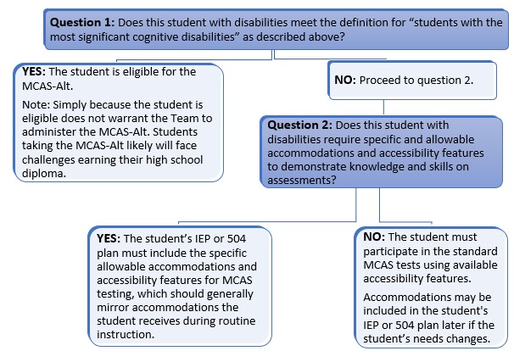

## ****Requirements of the Every Student Succeeds Act (ESSA) Regarding MCAS-Alt Participation****

The ESSA Act has made significant changes regarding student participation rates in the alternate assessment:

* The number of students who may take the alternate assessment is limited to no more than 1.0% of the total number of all students in the state who are assessed in any of the given subjects.
* ESSA further requires that a school district exceeding the 1% cap in any subject area must submit a justification to DESE, and DESE must provide appropriate guidance to those districts. Previously, there was no cap on participation rates until 2017.

**The** [MCAS-Alt ESSA website](https://www.doe.mass.edu/mcas/alt/essa/default.html) **provides resources about the requirements outlined in ESSA, including a training PowerPoint for IEP teams and a sample parent notification letter required for all parents whose child is eligible to participate in the alternate assessment.**

In order to be eligible for the alternate assessment, students must demonstrate *all* four of the following criteria:

1. have cognitive disabilities evidenced by significant delays in attaining age-level academic achievement standards, even with systematic, extensive individually designed instruction, related services, and modifications; **and**
2. have cognitive disabilities that significantly impact their educational performance and ability to apply learning from one setting to another; **and**
3. require extensive, direct individualized instruction and substantial support to achieve measurable gains on the challenging State academic content standards for the grade in which the student is enrolled; **and**
4. perform significantly below average in general cognitive functioning and adaptive behavior. This is defined as a student functioning two or more standard deviations below the mean on commonly accepted norm-referenced assessments in both cognitive functioning and adaptive behavior (e.g., two or more adaptive skill areas such as daily living skills, communication, self-care, social skills, and academic skills).

IEP teams should **not** designate a student for an alternate assessment solely because the student

* is frequently absent from school,
* has not received instruction in the general curriculum,
* has a particular disability (e.g., all students with intellectual disabilities should not automatically be designated for the MCAS-Alt),
* is placed in a program or classroom where it is expected that students will take the MCAS-Alt,
* has taken an alternate assessment in the past (since this is an annual decision),
* has previously failed the MCAS test,
* is an English learner,
* is from a low-income family or is a child in foster care,
* requires assistive technology or an augmentative communication system that has not been provided.

# Required Assessments in Each Grade

## Required MCAS-Alt Assessments in Each Grade

The information in table 1 below and on the following pages outlines the assessment requirements in each grade for students participating in the 2025 MCAS-Alt. The [Fall 2024 Resource Guides](http://www.doe.mass.edu/mcas/alt/resources.html) are based on the current editions of the Massachusetts Curriculum Frameworks and must be used as the basis for developing measurable outcomes that will be assessed on the 2025 MCAS-Alt.

Blank forms and samples can be found in the appendices of this document. Educators should use [Forms and Graphs](https://profile.measuredprogress.org/MCAS-Alt/login.aspx) web-based application to digitally create all necessary documentation.

**Note:** The [MCAS-Alt Skills Survey](http://www.doe.mass.edu/mcas/alt/skills-survey.docx) must be completed for *each* strand submitted.

**Table 1. Requirements for Grade 3**

|  |  |
| --- | --- |
| **ELA** | **Required Evidence** |
| Language  (based on standards in the “Vocabulary Acquisition and Use” cluster) | * One data chart measuring the student’s achievement of the measurable outcome on at least eight different dates, based on **one** standard in the Vocabulary Acquisition and Use cluster of the ELA—Language strand * Two additional pieces of primary evidence, plus work description forms, showing the student’s achievement of the measurable outcome identified on the data chart |
| Reading:   * Literature   *or*   * Informational Text | * One data chart measuring the student’s achievement of the measurable outcome on at least eight different dates, based on one text type: **either** the Literature **or** Informational ELA—Reading strand * Two additional pieces of primary evidence, plus work description forms, showing the student’s achievement of the measurable outcome identified on the data chart   **Note:** The title of the text must be included; see page 24 for more details. |
| Writing (based on standards in the “Text Type and Purposes” cluster) | * Three **different** final writing samples in any text type * One baseline writing sample in any text type * Work description labels for each writing sample * Three pre-scored writing rubrics, one for each final writing sample |
| **Mathematics** | **Required Evidence** |
| Operations and Algebraic Thinking (OA) | * One data chart measuring the student’s achievement of the measurable outcome, on at least eight different dates, based on one entry point or access skill in the Operations and Algebraic Thinking domain * Two additional pieces of primary evidence, plus work description forms, showing the student’s achievement of the measurable outcome identified on the data chart |
| Measurement and Data (MD) | * One data chart measuring the student’s achievement of the measurable outcome on at least eight different dates, based on one entry point or access skill in the Measurement and Data domain * Two additional pieces of primary evidence, plus work description forms, showing the student’s achievement of the measurable outcome identified on the data chart |

**Table 2. Requirements for Grade 4**

|  |  |
| --- | --- |
| **ELA** | **Required Evidence** |
| Language  (based on standards in the “Vocabulary Acquisition and Use” cluster) | * One data chart measuring the student’s achievement of the measurable outcome on at least eight different dates, based on **one** standard in the Vocabulary Acquisition and Use cluster of the ELA—Language strand * Two additional pieces of primary evidence, plus work description forms, showing the student’s achievement of the measurable outcome identified on the data chart |
| Reading:   * Literature,   *or*   * Informational Text | * One data chart measuring the student’s achievement of the measurable outcome on at least eight different dates, based on one text type: **either** the Literature **or** Informational ELA—Reading strand * Two additional pieces of primary evidence, plus work description forms, showing the student’s achievement of the measurable outcome identified on the data chart   **Note:** The **title of the text** must be included; see page 24 for more details. |
| Writing  (based on standards from the “Text Type and Purposes” cluster) | * Three **different** final writing samples in any text type * One baseline writing sample in any text type * Work description labels for each writing sample * Three pre-scored writing rubrics, one for each final writing sample |
| **Mathematics** | **Required Evidence** |
| Operations and Algebraic Thinking (OA) | * One data chart measuring the student’s achievement of the measurable outcome on at least eight different dates, based on one entry point or access skill in the Operations and Algebraic Thinking domain * Two additional pieces of primary evidence, plus work description forms, showing the student’s achievement of the measurable outcome identified on the data chart |
| Number and Operations—Fractions (NF) | * One data chart measuring the student’s achievement of the measurable outcome on at least eight different dates, based on one entry point or access skill in the Number and Operations—နနFractions domain * Two additional pieces of primary evidence, plus work description forms, showing the student’s achievement of the measurable outcome identified on the data chart |

**Table 3. Requirements for Grade 5**

|  |  |
| --- | --- |
| **ELA** | **Required Evidence** |
| Language  (based on standards in the “Vocabulary Acquisition and Use” cluster) | * One data chart measuring the student’s achievement of the measurable outcome on at least eight different dates, based on **one** standard in the Vocabulary Acquisition and Use cluster of the ELA—Language strand * Two additional pieces of primary evidence, plus work description forms, showing the student’s achievement of the measurable outcome identified on the data chart |
| Reading:   * Literature   or   * Informational Text | * One data chart measuring the student’s achievement of the measurable outcome on at least eight different dates, based on one text type: either the Literature or Informational ELA—Reading strand * Two additional pieces of primary evidence, plus work description forms, showing the student’s achievement of the measurable outcome identified on the data chart   **Note:** The **title of the text** must be included; see page 24 for more details. |
| Writing  (based on standards from the “Text Type and Purposes” cluster) | * Three **different** final writing samples in any text type * One baseline writing sample in any text type * Work description labels for each writing sample * Three pre-scored writing rubrics, one for each final writing sample |
| **Mathematics** | **Required Evidence** |
| Number and Operations in Base Ten (NBT) | * One data chart measuring the student’s achievement of the measurable outcome, on at least eight different dates, based on one entry point or access skill in the Number and Operations in Base Ten domain * Two additional pieces of primary evidence, plus work description forms, showing the student’s achievement of the measurable outcome identified on the data chart |
| Number and Operations—  Fractions (NF) | * One data chart measuring the student’s achievement of the measurable outcome, on at least eight different dates, based on one entry point or access skill in the Number and Operations—Fractions domain * Two additional pieces of primary evidence, plus work description forms, showing the student’s achievement of the measurable outcome identified on the data chart |
| **Science and Technology/**  **Engineering (STE)** | **Required Evidence**  Evidence may be compiled over two consecutive school years in this subject.  (Dated 7/1/22 to 3/28/24) |
| STE disciplines:   * Life Science * Earth and Space Sciences * Physical Science * Technology/ Engineering | Choose three STE disciplines. For **each discipline**, select **one core idea**:  For ***each*** Core Idea:   * Choose three pieces of primary evidence (work samples) based on an entry point or access skill and attach each piece to its corresponding STE Summary Sheet.   + Each piece of primary evidence must address a different science practice. |

**Table 4. Requirements for Grade 6**

|  |  |
| --- | --- |
| **ELA** | **Required Evidence** |
| Language  (based on standards from the “Vocabulary Acquisition and Use” cluster) | * One data chart measuring the student’s achievement of the measurable outcome on at least eight different dates, based on **one** standard in the Vocabulary Acquisition and Use cluster of the ELA—Language strand * Two additional pieces of primary evidence, plus work description forms, showing the student’s achievement of the measurable outcome identified on the data chart |
| Reading: (only one)   * + Literature,   + Informational Text,   + Literacy in Science and Technical Subjects, *or*   + Literacy in History/Social Studies | * One data chart measuring the student’s achievement of the measurable outcome on at least eight different dates, based on one text type: **either** the Literature **or** Informational ELA—Reading strand * Two additional pieces of primary evidence, plus work description forms, showing the student’s achievement of the measurable outcome identified on the data chart   **Note:** The **title of the text** must be included; see page 24 for more details. |
| Writing  (based on standards from the “Text Type and Purposes” cluster) | * Three **different** final writing samples in any text type * One baseline writing sample in any text type * Work description labels for each writing sample * Three pre-scored writing rubrics, one for each final writing sample |
| **Mathematics** | **Required Evidence** |
| Statistics and Probability (SP) | * One data chart measuring the student’s achievement of the measurable outcome on at least eight different dates, based on one entry point or access skill in the Statistics and Probability domain * Two additional pieces of primary evidence, plus work description forms, showing the student’s achievement of the measurable outcome identified on the data chart |
| The Number System (NS) | * One data chart measuring the student’s achievement of the measurable outcome on at least eight different dates, based on one entry point or access skill in the Number System domain * Two additional pieces of primary evidence, plus work description forms, showing the student’s achievement of the measurable outcome identified on the data chart |

**Table 5. Requirements for Grade 7**

|  |  |
| --- | --- |
| **ELA** | **Required Evidence** |
| Language  (based on standards from the “Vocabulary Acquisition and Use” cluster) | * One data chart measuring the student’s achievement of the measurable outcome on at least eight different dates, based on **one** standard in the Vocabulary Acquisition and Use cluster of the ELA—Language strand * Two additional pieces of primary evidence, plus work description forms, showing the student’s achievement of the measurable outcome identified on the data chart |
| Reading: (only one)   * + Literature,   + Informational Text,   + Literacy in Science and Technical Subjects, *or*   + Literacy in History/Social Studies | * One data chart measuring the student’s achievement of the measurable outcome on at least eight different dates, based on one text type: **either** the Literature, Informational, or Literacy strand * Two additional pieces of primary evidence, plus work description forms, showing the student’s achievement of the measurable outcome identified on the data chart   **Note:** The **title of the text** must be included; see page 24 for more details. |
| Writing  (based on standards from the “Text Type and Purposes” cluster) | * Three **different** final writing samples in any text type * One baseline writing sample in any text type * Work description labels for each writing sample * Three pre-scored writing rubrics, one for each final writing sample |
| **Mathematics** | **Required Evidence** |
| Ratios and Proportional Relationships (RP) | * One data chart measuring the student’s achievement of the measurable outcome, on at least eight different dates, based on one entry point or access skill in the Ratios and Proportional Relationships domain * Two additional pieces of primary evidence, plus work description forms, showing the student’s achievement of the measurable outcome identified on the data chart |
| Geometry (G) | * One data chart measuring the student’s achievement of the measurable outcome, on at least eight different dates, based on one entry point or access skill in the geometry domain * Two additional pieces of primary evidence, plus work description forms, showing the student’s achievement of the measurable outcome identified on the data chart |

**Table 6. Requirements for Grade 8**

|  |  |
| --- | --- |
| **ELA** | **Required Evidence** |
| Language  (based on standards from the “Vocabulary Acquisition and Use” cluster) | * One data chart measuring the student’s achievement of the measurable outcome on at least eight different dates, based on **one** standard in the Vocabulary Acquisition and Use cluster of the ELA—Language strand * Two additional pieces of primary evidence, plus work description forms, showing the student’s achievement of the measurable outcome identified on the data chart |
| Reading: (only one)   * + Literature,   + Informational Text,   + Literacy in Science and Technical Subjects, *or*   + Literacy in History/Social Studies | * One data chart measuring the student’s achievement of the measurable outcome on at least eight different dates, based on one text type: **either** the Literature, Informational, or Literacy ELA—Reading strand * Two additional pieces of primary evidence, plus work description forms, showing the student’s achievement of the measurable outcome identified on the data chart   **Note:** The **title of the text** must be included; see page 24 for more details. |
| Writing  (based on standards from the “Text Type and Purposes” cluster) | * Three **different** final writing samples in any text type * One baseline writing sample in any text type * Work description labels for each writing sample * Three pre-scored writing rubrics, one for each final writing sample |
| **Mathematics** | **Required Evidence** |
| Expressions and Equations (EE) | * One data chart measuring the student’s achievement of the measurable outcome, on at least eight different dates, based on one entry point or access skill in the Expressions and Equations domain * Two additional pieces of primary evidence, plus work description forms, showing the student’s achievement of the measurable outcome identified on the data chart |
| Geometry (G) | * One data chart measuring the student’s achievement of the measurable outcome, on at least eight different dates, based on one entry point or access skill in the geometry domain * Two additional pieces of primary evidence, plus work description forms, showing the student’s achievement of the measurable outcome identified on the data chart |
| **Science and Tech/Eng** | **Required Evidence** (Dated 7/1/23 to 3/28/25) Evidence may be compiled over two consecutive school years in this subject |
| STE disciplines:   * Life Science * Earth and Space Sciences * Physical Science * Technology/ Engineering | Choose three STE disciplines. For **each discipline**, select **one core idea**:  For **each** Core Idea:   * Choose three pieces of primary evidence (work samples) based on an entry point or access skill and attach each piece to its corresponding STE Summary Sheet. * Each piece of primary evidence must address a *different* science practice. |
| **History and Social Science (Civics)** | **Required Evidence** |
| Core Ideas:  **A**: Foundations and development of the U.S. . . . **B:** Institutions and structure of U.S. government & MA . . .  **C:** Rights and responsibilities . . . | **Three** Civics Summary Sheets, one for each Core Idea (**A, B, and C**)   * Detailed description of the Civics-based activity * Entry point or access skill * Accuracy and independence * Completed pre-scored state-provided civic rubric * Completed state-provided rubric (on summary sheet) |

**Table 7. High School Grade 10 Requirements**

|  |  |
| --- | --- |
| **ELA** | **Required Evidence** |
| Language  (based on standards from the “Vocabulary Acquisition and Use” cluster) | * One data chart measuring the student’s achievement of the measurable outcome on at least eight different dates, based on **one** standard in the “Vocabulary Acquisition and Use” cluster of the ELA—Language strand; plus * Two additional pieces of primary evidence, plus work description forms, showing the student’s achievement of the measurable outcome identified on the data chart |
| Reading: (only one)   * + Literature,   + Informational Text,   + Literacy in Science and Technical Subjects, *or*   + Literacy in History/Social Studies | * One data chart measuring the student’s achievement of the measurable outcome on at least eight different dates, based on one text type: **either** the Literature, Informational, or Literacy ELA—Reading strand * Two additional pieces of primary evidence, plus work description forms, showing the student’s achievement of the measurable outcome identified on the data chart   **Note:** The **title of the text** must be included; see page 24 for more details. |
| Writing  (based on standards from the “Text Type and Purposes” cluster) | * Three **different** final writing samples in any text type * One baseline writing sample in any text type * Work description labels for each writing sample * Three pre-scored writing rubrics, one for each final writing sample |
| **Mathematics** | **Required Evidence** |
| Any **three** of five conceptual categories inHigh SchoolMathematics (see Fall 2022 Resource Guide)   * Number and Quantity * Algebra * Functions * Geometry * Statistics and Probability | Select three different conceptual categories. For each conceptual category, submit:   * One data chart measuring the student’s achievement of the measurable outcome on at least eight different dates, based on onestandard in the selectedMathematicsconceptual category * Two additional pieces of primary evidence, plus work description forms, showing the student’s achievement of the measurable outcome identified on the data chart   Measurable outcomesmay bebased on entry points selected either from high school or from lower grade levels in related domains, according to figure 4. |
| **Science** | **Required Evidence** (Dated 7/1/23 to 3/28/25) Evidence may be compiled over two consecutive school years in this subject | |
| Grade 9 or 10 may  Choose *either*:   * Biology * Introductory Physics | Select **one STE discipline**:  If selecting either ***Biology*** OR***Introductory Physics***, use the STE Resource Guide and select **three core ideas** in the selected discipline**.**  For ***each*** core idea:   * Choose three pieces of primary evidence (work samples) and attach each piece to its corresponding STE Summary Sheet. * Each piece of primary evidence must address a *different* science practice. | |

# Compiling MCAS-Alt Evidence

### Content Checklist for Required Forms

This checklist will assist in submitting a complete assessment along with the [*Checking for Completeness Questions*](https://profile.measuredprogress.org/MCAS-Alt/login.aspx) document. The required forms listed below (unless noted otherwise), may be found in the [Forms and Graphs](https://profile.measuredprogress.org/MCAS-Alt/login.aspx) application. All requirements for each strand are listed in this manual.

* **Artistic cover** (recommended) designed and produced by the student, inserted in the front window of the three-ring binder.
* **MCAS-Alt Cover Sheet** containing important demographic information about the student, inserted as the first page of the binder.
* **Student’s Introduction** **to the Assessment** produced by the student using his or her primary mode of communication describing “what I want others to know about me as a learner and about my work.”
* **Consent Form to Photograph and/or Video a student**,kept on file at the student’s school, if images or recordings of the student are included in the assessment. This consent form gives permission only for the student to be recorded digitally in photographs or video for the MCAS-Alt and is **not** a consent form for the student to participate in an alternate assessment. Please do not substitute a “blanket” consent form for this purpose. Consent forms are available in English and Spanish.
* **School calendar** placed in the left inside pocket of the binder.
* **MCAS-Alt Skills Survey** completed for each strand/domain/discipline submitted. Place a completed print version of the survey just after the Strand Cover Sheet in each strand.
* **Strand Cover Sheet** placed at the beginning of each strand submitted. Each strand includes a set of evidence that addresses a specific measurable outcome.
* **Data Chart** choice of one bar, line, or field data chart for ELA—Language, Reading, and Math.
* **Work Sample Descriptions** attached to each piece of primary evidence for ELA—Language, Reading, and Math.If work description labels are not used, all required information must be written directly on each piece of evidence.
* **ELA**—**Writing Work Description** labels for 1 Baseline and 3 Finals, 3 State-provided Writing rubrics attached to each final writing sample.
* **Science Technology/Engineering Summary Sheet** for each piece of evidence.
* **Civics Summary Sheet** for *each* Core Idea (A, B, and C).
* **Verification Form** signed by the parent(s), guardian, or primary care provider signifying that they have reviewed their child’s assessment or were invited to do so. In the event no signature was obtained, the school must include a record of attempts to invite the parent(s), guardian, or primary care provider to view the assessment. Forms are available in English and Spanish.

## MCAS-Alt Skills Survey

The MCAS-Alt Skills Survey should be completed using the [Forms and Graphs](https://profile.measuredprogress.org/MCAS-Alt/login.aspx) application. It is a standardized component of the MCAS-Alt that **must be completed by the teacher for each student BEFORE selecting an entry point or access skill in the subject required for assessment.** The survey will help determine a student’s current level of knowledge, skills, and abilities so that challenging entry points or access skills can be selected in each strand. The survey will also familiarize teachers with the range of entry points in a strand/domain that may be selected for the assessment. Although the skills survey is not required as a follow-up after teaching the skill, it may be helpful to conduct the survey after the skill has been taught to note the student’s progress.

The survey lists the important skills in each strand/domain/conceptual category/discipline from least to more complex. To complete the skills survey, teachers may use the sample tasks provided on the survey, design their own simple tasks, and use classroom observations, class assignments, progress reports, or locally administered assessments to determine the degree to which the student can perform each skill listed in the survey.

**Submission of a completed skills survey is required for each strand being assessed.**

**Note:** The **Science and Technology/Engineering** Skills Survey must be conducted once for the entire STE content area, not for each discipline, and must include all eight science practices.

**Strands that do not include a completed skills survey** will receive a score of *Incomplete.* Instructions for administering the skills survey and applying the results are available [here](http://www.doe.mass.edu/mcas/alt/skills-survey.docx). A sample skills survey from the ELA—Reading strand is shown in figure 1.

**Figure 1. 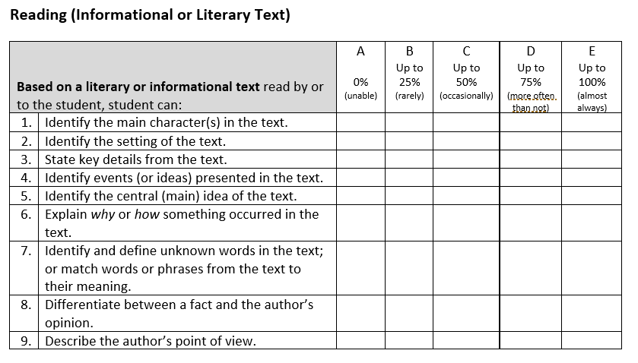Excerpt from the MCAS-Alt Skills Survey in ELA**—**Reading (for all grades)**

Once the skills survey has been completed for each student in the required strands/domains/conceptual categories, teachers should review the results and select an entry point from the Resource Guide based on a skill (or a related skill) that has been checked in columns A, B, or C (i.e., that the student cannot yet perform independently most of the time).

If columns D and/or E are checked for most of the skills in the strand/domain, then the IEP team should consider whether the standard MCAS test (paper or online) or grade-level/competency portfolio would be more appropriate for the student**.**

If the student is unable to perform any of the skills in the survey due to their disability (i.e., column A above), then the student could be considered for access skills, rather than entry points.

###### How to Create a Strand for ELA—Language, Reading, and Mathematics

1. **Review the section on Required Assessments in Each Grade (see pages 7**–14**) to determine the strands and subjects required for assessment in the student’s grade.**
2. **Administer the MCAS-Alt Skills Survey (see Section C below) for each student in the required strands/domains/conceptual categories/disciplines.**
3. **Refer to the**[**Fall 2024 Resource Guide**](http://www.doe.mass.edu/mcas/alt/resources.html) **in the content area being assessed and select a learning standard in the student’s grade for the strand/domain/conceptual category required for assessment in the student’s grade.**
4. Determine the appropriate level of complexity for the student based on the results of the MCAS-Alt Skills Survey and s**elect a specific entry point or access skill from the Resource Guide** (see figure 2) **that is challenging for the student.**
   * Entry point: grade-level academic content addressed at a lower level of complexity.

Teachers can select an entry point in the student’s grade or reduce the complexity by selecting an entry point from an earlier grade in the same topic or cluster.

* + Access skill*:* address earliest developmental milestones within the context of an academic activity; for example, grasping or releasing objects during a science activity.

1. Develop a measurable outcome based on the entry point or access skill (see pages 17–19).
2. Begin assessing the student on the acquisition of the skill. Collect evidence, including work samples and performance information for a data chart (see Guidelines to Create a Data Chart on pages 19–22). Document the percentage of accuracy and independence for each date on which the skill is assessed.

## Selecting an Entry Point (Skill) for MCAS-Alt

The Resource Guide is organized into **strands (ELA), domains/conceptual categories (mathematics), or disciplines (STE)** for each grade or grade span in STE.

Standards in each grade are grouped into clusters or core ideas of related standards within each strand/domain, conceptual category, or discipline. Following the standards are entry points in each grade or grade span that describe outcomes at successively lower levels of complexity, see Excerpt from the Resource Guide below.

Access skills are available in the lowest grade or grade span listed for each strand, domain, conceptual category, or discipline except for STE separate section designated.

Review the entry points based on the level determined in the completed MCAS-Alt Skills Survey. Educators may select entry points from an earlier grade level, but they are encouraged to address the most challenging and appropriate entry point tomeet the needs of the student.

**Figure 2. Excerpt from the Resource Guide in ELA**—**Language**

Excerpt from ELA-Language Resource Guide showing entry points and
access skills in Language Acquisition and Use in Pre-K - grade 1.

**Teachers may select entry points for assessment either**

* **as written in the Fall 2024 Resource Guide** in the subject being assessed**,** without making any changes.
* with minor modifications, for Reading, Language, and Math only, provided the essential meaning and intent of the entry point is maintained. For example, for the entry point “Solve word problems involving the addition of fractions using manipulatives”, the words “using manipulatives” may be removed, since manipulatives are not the only way to perform the skill. However, “addition of fractions” must be included.
  + **When two or more related skills in an entry point are connected only by “and,” the teacher may select both skills for assessment; *or* isolate a single skill within the entry point.**
  + **For example, if the entry point says“solve single-digit addition and subtraction problems”**
    - **If *both* skills are selected, both skills must be assessed during *each* activity and documented in the brief description for each activity and in the evidence.**
    - **If only *one* skill is selected, the measurable outcome must be edited to reflect only the selected skill, and onlythat skill will be documented in the brief description for each activity and in the evidence.**
  + **Entry points containing “and” may not be changed to “or,” since this is considered excessively modifying the entry point and will result in a score of *Incomplete*.**
  + **If more than one skill is listed in an entry point connected by “and/or”, “/”, “ or” then *any or all* skills may be assessed on each date. (e.g., “Identify the meaning of words, phrases, or sentences.”)**

Entry points should be used as they appear in the Resource Guide and may not be excessively modified by the teacher unless approval was previously obtained in writing from DESE before the submission date. Overly modified entry points will result in a score of *Incomplete*. If in doubt as to whether a modification of an entry point is acceptable, please contact DESE at [mcas@mass.gov](mailto:mcas@doe.mass.edu).

###### Developing and Assessing a Measurable Outcome for ELA—Language, Reading, and Math

**For entry and access skills:**

* Using the MCAS-Alt Skills Survey as a guide, select either an entry point or access skill from the Resource Guide that is challenging and appropriate for the student (i.e., from columns A, B, or C in figure 1).
* Select the desired percent of accuracy and independence that would constitute reasonable mastery of the skill. These criteria are selected by the teacher for instructional purposes *only* and need not be attained before the MCAS-Alt is submitted.

**Entry points:**

* Review the examples below to see how the entry points (bolded) have been transformed into measurable outcomes by adding the student’s name and percent accuracy and independence:
* Example 1: Pasquale will**record measurement data for multiple objects using a single unit scale** with 75 percent accuracy and 90 percent independence.
* Example 2: Naila will**identify angles of geometric shapes as either obtuse, acute, or right** with 80 percent accuracy and 100 percent independence*.*
* Instructional activities should assess *only* the skill(s) listed in the measurable outcome which is then documented on the data chart and the primary evidence.
* If the teacher changes the measurable outcome because the student has attained the prior measurable outcome, then a new data chart and strand cover sheet must be started.

**Access skills:**

* A measurable outcome based on an **access skill** requires somewhat different criteria to determine accuracy, such as in the following example where the student’s ability to respond within a specific time frame (i.e., latency) is being measured. Latency may not always be necessary depending on the access skill and/or student goals. Educators should ask themselves, what makes this skill right or wrong? Can accuracy be measured across evaluators?
  + Example: Jamal will**respond to material related to key details in a literary text****within 15 seconds of the directive**with 75 percent accuracy and 100 percent independence.

## Submission for ELA—Reading, ELA—Language, and Mathematics

Each strand requires the submission of a minimum of **a completed skills survey, a Strand Cover Sheet, one data chart, and two pieces of primary evidence** (produced by the student or teacher-documented.)

However, teachers are strongly encouraged to include more than the minimum amount of data and/or evidence to reduce the chances of a content area being scored *Incomplete*.

## Guidelines to Create a Data Chart

A data chart is required in the strands **of ELA**—**Reading, ELA**—**Language, and Mathematics.** Data charts provide evidence of a student’s progress over time in mastering the skill described in the measurable outcome. Use only the Data Chart formats available in the Forms and Graphs [application](https://profile.measuredprogress.org/MCAS-Alt/login.aspx).

Each strand must include one of the following formats to collect data on the student’s performance and submit it in the binder.

* **Field data charts** are most effective for collecting response-by-response data on several repeated tasks, trials, or activities conducted during a single session. This allows relevant information for each response to be collected while the activity is ongoing. Field data charts are also effective for tasks that do not yield tangible work samples.
* **Bar graphs** and/or **line graphs** are effective for documenting a student’s performance over a period of time and visually portray the student’s trend and overall performance “at a glance.”

Each data chart must include these elements:

* **the student’s name, content area, grade-level standard, and measurable outcome being assessed**
* **accuracy and independence percentages on a minimum of 8 different dates o**n which school is in session
* a brief description beneath each data point that clearly describes what skill the student performed and how the student addressed the skill, taking care to document only the specific skill(s) listed in the measurable outcome. For example:
  + *(Student) determined the meaning of ten synonyms from the context of a story* **(What)** *by completing 8 answers on a worksheet* **(****How)**.
  + *…answered six comprehension questions* **(What)** *orally* **(How)** *after reading Missing* *Links.*
  + *…completed ten 2-digit-by-1-digit multiplication problems* **(What)** *on the computer* **(How)**.
  + *……retold a birthday party story in chronological order* **(What)** *using a topic board* **(How)**.

Or the following brief descriptions of an activity assessing an **access skill**:

* *(Student) moved* **(What)** *10 plastic coins into a piggy bank* **(How)** *as they were counted* **(link to academic activity)**.
* *…. imitates the action* ***(*What)** *required to divide objects in half* (**link to academic activity)** *using foam balls* **(How)**.
* *…activates a device within 3 seconds* **(What)** *to turn to the next page* ***(How)*** *for The Cat in the Hat* **(link to academic activity)**.

###### Calculating Accuracy and Independence

Collecting data on a student’s performance is an essential part of good instruction and ongoing assessment. Instructional data can help educators make valid and objective decisions about what to teach based on what the student has or has not already learned and documents vital information on the effectiveness of the instruction provided.

Data can be collected either during routine classroom instruction, during tasks and activities set up specifically for assessing the student, or during naturally occurring activities in the school or community. Even if similar activities are taught in a group setting, the resulting data should be unique to the student. Record data only for skill(s) that are based directly on the measurable outcome. More than one question/task/trial should be collected for one day.

When unrelated or additional skills are included on the same data chart, the data will be skewed or inconclusive, and cannot be included in the calculation of the final score, resulting in a score of *Incomplete* (‘*M’- Missing or insufficient information)*.

The percentage of accuracy for each activity must indicate the percentage of correct responses in relation to the number of total responses (e.g., 8/10 correct = 80%). Teachers must score each activity by marking responses on the work samples that are incorrect so scorers can verify the overall percentage of accuracy.

The percentage of independence for each activity must indicate the number of independent responses in relation to the number of total responses (e.g., 8/ 10 unprompted, independent responses = 80%). An independent response occurs when the student responds to an instructional demand without the use of prompts or assistance that would guide them to a response. Teachers should mark all prompted responses on the work samples to assist in verifying and calculating the overall percentage of independence.

###### Cues and Prompts versus Accommodations

Accommodations provided to the student are *not* considered “prompts” for calculating independence (e.g., use of a text reader, scribe, or calculator) because they allow the student to respond independently during the activity. Directives that refocus the student on a task (e.g., “pick up your pencil” or “focus on your work”) should also not be considered prompts in the calculation of independence.

Prompts that guide or assist the student to give a correct response are considered non-independent responses in the calculation of independence. Any prompted response is therefore 0 percent independent, regardless of the type of prompt used with the student during an activity. The use of a “weighted scale” or “prompt hierarchy” that bases the percentage of independence on the kind of prompt given (e.g., visual versus gestural) may not be used for calculating the percentage of independence. Errorless teaching strategies will result in a score of zero until the student can perform the skill independently. Hand-over-hand assistance is alwaysconsidered a prompted, non-independent response.

Figure 3 illustrates the method used to calculate accuracy and independence for an instructional activity where a student is answering questions orally. After each response, the teacher indicates whether the student’s response was correct or incorrect (accuracy) and whether the response was independent or prompted (independence). This information can be used to determine the final accuracy and independence of this activity. The information could be used as a data point on the graph with a completed brief description.

**Figure 3. How to Calculate Accuracy and Independence for a Series of Responses**

|  |  |  |
| --- | --- | --- |
| **Question Number** | **Accurate or Inaccurate** | **Independent or Prompted** |
| **Question 1** | Correct response (accurate) (+) | Verbal prompt (-) (not independent) |
| **Question 2** | Incorrect response (inaccurate) (-) | Verbal prompt (-) (not independent) |
| **Question 3** | Correct response (accurate) (+) | Gestural prompt (-) (not independent) |
| **Question 4** | Incorrect response (inaccurate) (-) | Verbal prompt (-) (not independent) |
| **Question 5** | Correct response (accurate) (+) | No prompt (+) (independent) |
| **Overall Percent** | (3/5 correct)  60% accurate | (1/5 independent)  20% independent |

**Important Notes for Data Charts**:

* Activities on the first recorded date of the data chart must begin below 80 percent accuracy *or* 80 percentindependence to indicate that the student is being taught a skill that he or she has not already mastered.
* Percentages for multiple activities conducted on a single date must be combined and averaged for the data chart.
* Do not include activities on the data chart during which the student performed zero percent accuracy and zero percent independence.
* Do not include evidence that does not demonstrate student participation in the activity (e.g., refusal).

###### Interpreting Data on the Student’s Performance

Instructional approachesshould be individualized and based on the strengths of the student. When designing instruction for data and evidence collection, consider the following:

* Which accommodations and accessibility features would support the student to perform as independently as possible? (e.g., frequent breaks)
* Which instructional adaptations or modifications are needed? (e.g., access to assistive technology for responses)
* Does the data change depending on *where* and *when* the instruction occurs? (e.g., before lunch/after lunch, in the classroom/outdoors)
* Does the data change based on *who* is delivering the instruction? (e.g., Teacher, Paraeducator, Speech Therapist)
* Does the level of student engagement change with the use of varied materials during instruction? (e.g., preferred materials, textures, or topics)

If the student’s data chart indicates that the studentis notmaking effective progress toward meeting the original measurable outcome, or the student has quickly reached mastery of the skill, consider the following:

* The complexity of the skill may need to be altered, a new measurable outcome established, and a new strand cover sheet and data chart created. Each data chart must reflect data collected on only one measurable outcome.
* The activity format or materials may need to be altered.
* Themethod of instructionmay need to be altered.

## Primary Evidence

In addition to a data chart, at least two additional pieces of primary evidence must be included thatdocument the student’s performance of the skill (measurable outcome) selected for assessment. The pieces of primary evidence (work samples) may be included as data points on the chart or may be submitted separately and not included on the data chart, at the teacher’s discretion. Primary evidence should provide tangible documentation of the student’s performance of only the skill(s) listed in the measurable outcome.

**Each piece of primary evidence must include the following information, either on a w**ork sample description attached to the evidence application or written directly on the evidence**:**

* student’s name
* date of completion of the activity
* percentage of accuracy of the student’s performance of the skill(s) identified in the measurable outcome (i.e., percent of correct versus incorrect responses)
* percentage of independence for the student’s performance of the skill(s) identified in the measurable outcome (i.e., percent of independent non-prompted versus non-independent prompted responses)
* a brief description of the task or activity in which the student demonstrated performance of the specified skill in the measurable outcome

Percentages of accuracy and independence must be mathematically possible based on the evidence submitted.

The following types of primary evidence may be included in the assessment:

* **Work samples** produced by the student must show
* the student’s authentic performance
* verifiable percentages of accuracy and independence based on the total number of tasks
* a brief description of the activity on an attached work sample description
* participation by the student must be evident (blank worksheet not accepted).
* **Photographs\*** thatdocument the skill listed in the measurable outcome that clearly show an image of the final product of instruction, including
  + a summary of the percentages of accuracy and independence
  + a clear photograph of an actual work sample that is either
* three-dimensional
  + - temporary in nature (e.g., a model or presentation)
    - too large, fragile, or perishable
      * a sequence of steps leading to a final product that cannot be included in the binder

(e.g., a pattern of shapes created by a student using manipulatives)

* **Video samples[1]** that
* document the student performing the skill in the measurable outcome
* demonstrate verifiable accuracy and independence during the viewing
* are no more than three minutesin length
* if difficult to understand, include a transcription of the audio portion.
* are submitted on a clearly labeled flash drive with a completed Video Description form (see Appendix B)
* are securely attached within the binder (one flash drive per student).
* **Digital evidence** on a flash drivein any of the following formats: Word, PowerPoint, .pdf, .txt, .jpg (JPEG), .mp4, or .mov.
* **Teacher-documented work samples** (formerly labeled as teacher-scribed work samples**)** (see the example on page 47).
* a series of trials conducted during a single session
* the student’s responses (i.e., levels of accuracy and independence) for *each* item/trial
* detailed information describing the materials, the context of the activity, and expected responses

## Strand-Specific Requirement for ELA—Reading

The ELA—Reading strandfocuses onthe comprehension of text, including the understanding of words, phrases, and sentences in the context of a text,rather than in isolation. Evidence in this strand must be based eitheronaninformational or literarytext, at the teacher’s discretion, but should not include both. For the purpose of assessment, a reading text must consist of at least one grammatically complete sentence.

The title of the text must be in each brief description and on pieces of primary evidence; submit a brief excerpt of the text if it is

* + an untitled worksheet,
  + teacher-created,
  + taken from a digital source (e.g., a website such as *TeacherspayTeachers or EdHelper*),
  + a leveled reader (e.g., Reading A-Z), or
  + titled in a way that does not make clear whether the text is informational or literary.

Do not submit the entire booklet or only the cover.

## Strand-Specific Requirement for Mathematics Grades 3–8, and 10

**Using Entry Points from Earlier Grades in Related Domains**

The teacher may select entry points from lower grade levels in related domains according to figure 4; see pages 7–14 for grade-specific domain requirements and the [Mathematics Resource Guide](https://www.doe.mass.edu/mcas/alt/rg/math.docx) for more information.

**Figure 4. Moving from High School Conceptual Categories to Grades 3**–**8 Domains**

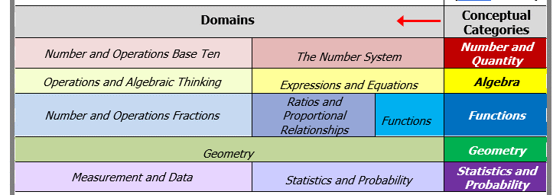

## Strand-Specific Requirements for ELA—Writing

ELA—Writing assesses expressive communication by the student.

**Writing samples must reflect the student’s expressive communication. Samples that document only motor skills (e.g., letter formation, tracing, scribbling) will not be scored.**

**Writing samples may *not* include bathroom-related activities, which** will not be scored nor included in the minimum required three final writing samples.

In preparing writing samples, students should use their primary mode(s) of communicationtoconvey thoughts, express ideas, and demonstrate knowledge and skills, which may include any of the following formats:

* dictating to a scribe (with verbatim transcription, assume capital letters, spelling, and basic punctuation, but may *not* change or embellish what was dictated)
* assistive technology, such as an augmentative and alternative communication (AAC) device or other symbol-based communication systems, voice output device (with supporting documentation to show the context of the activity and choices made by the student), or use of word prediction, speech-to-text, or text-to-speech
* Braille writer, notetaker, ASL, translated into English for submission
* handwritten
* using a word processor or similar device

Engage students through the following activities:

* sharing experiences
* opinions, preferences
* ideas, and/or facts
* discussing books, articles, stories, videos
* poetry, imagery
* sharing knowledge with an audience (e.g., peers)

The ELA—Writing strand must include the following components:

* A completed ELA—Writing Skills Survey (no data charts are required in the ELA—Writing strand)
* One baseline writing sample with an attached *work sample description* that is dated *prior* to the final writing samples.
* Three final writing samples with attached work sample descriptions in any text type, each based on a different topic, picture, or assignment that demonstrates the student’s expressive communication skills and uses the student’s primary mode of communication(see below).

Note: when changing text types (e.g., from narrative to opinion) a new Strand Cover Sheet will be generated in the Forms and Graphs application.

* Three state-provided ELA—Writing pre-scored rubrics corresponding to each final writing sample. Rubrics must be completed by the teacher according to the descriptions listed for each rubric area. The date of each writing sample must be matched to the date listed on the pre-scored Writing rubric.

Any combinationof the following text types may be submitted:

* + - 1. **Opinion/Argument:** Stating a claim, opinion, preference, or analysis based on a text or topic, citing reasons and evidence from a text. (Educators are encouraged but not required to link expressive language to a reading they have encountered.)
      2. **Informative/Explanatory text:** conveying or explaining facts, information, or ideas on a topic, including descriptions from a text. (Educators are encouraged but not required to link expressive language to a reading they have encountered.)
      3. **Narrative:** Prose that tells a story based on real or imagined events from a text or personal experience. The narrative can be fiction, drama (script), a personal reflection, an event sequence; OR poetry that uses figurative language (e.g., similes, metaphors), imagery, sounds of words (e.g., rhyme), meter, and/or repetition to express emotion or tell a story.

Writing samples will be based on either of the following:

* An entry point: “*Use the student's primary mode of communication to express or create a writing sample*….” (only one entry point available)

or

* An access skill selected from the dropdown menu in the Forms and Graphs application

Students who communicate at a pre-symbolic language level should be assessed based on one of the access skills listed in the [ELA Resource Guide](https://www.doe.mass.edu/mcas/alt/rg/ela.docx).

For a student working on access skills, the writing sample must be a tangible (i.e., permanent) product created by the teacher, paraprofessionals, related service provider, or peer(s) that documents the student’s expressive response including the percent of independence during the creation of the writing sample. Please review the fall training for Access skills for ELA—Writing.

**Pre-scoring Each Final Writing Sample**

Be aware that the scores submitted on the writing rubrics must reflect the responses generated by the student, not the corrections or text provided by the teacher. MCAS-Alt scorers will verify the scores submitted by the teacher and will only change a score if it does not accurately reflect the work of the student.

Edits or corrections made by the teacher should be reflected in the percentage of independence. Base the percentage independence for each final sample either on the number of prompts per word, per sentence, or per paragraph, at the teacher’s discretion, depending on the length and complexity of the writing sample (see example in figure 3).

Consider submitting evidence from other content areas as ELA—Writing samples, such as the student’s open responses to comprehension questions in the ELA—Reading or STE strands.

## Strand-Specific Requirements for Science and Technology/Engineering (STE)

The STE MCAS-Alt for students in grades 5 and 8 (all disciplines) and high school (Biology and Introductory Physics) requirements are described below.

The structure and format of the STE assessment encourages instruction using high-quality curriculum units, rather than isolated science skills*.* The format described on the following pages is intended to encourage the teaching of a high-quality unit of science based on the core idea. High-quality curriculum units along with topics related to each core idea can be found in the table of contents in the Forms and Graphs application. The use of a unit also allows for cross-curriculum skills to be addressed.

The 2016 framework emphasizes the application of science practices that promote student engagement in scientific inquiry and engineering design skills, in addition to the content in each discipline. Science Practices are numbered for reference purposes only, there is no order of how they should be used.

* The following are the eight science practices are:

1. Asking (Scientific) Questions and Defining Problems
2. Planning and Carrying Out Investigations (to gather data and perform experiments to answer a scientific question)
3. Using Mathematical and Computational Thinking (to answer scientific questions)
4. Analyzing and Interpreting Data (to recognize patterns and analyze and organize data)
5. Developing and Using Models (to think about and make sense of an experience and make predictions, using 2-D and 3-D representations, constructions, displays, illustrations, and simulations)
6. Constructing Explanations and Designing Solutions (to explain phenomena and use evidence to support explanations)
7. Engaging in Argument from Evidence (to support a claim and critique competing arguments)
8. Obtaining, Evaluating, and Communicating Information (to research, record, evaluate, and present information from scientific texts and digital sources)

* Science practices are grouped in the STE Resource Guide according to the following scheme:
* Practices #1-2 are included under the heading “Investigations and Questioning.”
* Practices #3-4 are included under the heading “Mathematics and Data.”
* Practices #5-8 are included under the heading “Evidence, Reasoning, and Modeling.”
* Each STE entry point and access skill in the Resource Guide combines science content with science practice.
* Entry point or access skills cannot be modified, all changes must be approved by DESE.

**STE Assessment Format and Structure: Grades 5 and 8**

**1.** Conduct the STE Skills Survey to determine the optimal grade span at which to select entry points for the student. NOTE: The STE Skills Survey must be conducted once for the entire STE content area, not for each discipline, and must include all eight science practices.

**2.** Choose any three (3) of the following disciplines for each student’s STE assessment:

* Earth and Space
* Life Science
* Physical Science
* Technology/Engineering

**3.** In each discipline, select one core idea that engages the student. Review the topics related to each core idea, then choose entry points/access skills found in each core idea to relate to a unit of study.

**Tip**: When using the STE units, plan the lessons first and then review entry points to determine the practices that will be covered.

**For each core idea:**

**4.** **Select three (3) entry points or access skills that are each from a different science practice.** Use the completed Skills Survey to assist in determining the grade span from which to choose the entry point. Submit evidence (e.g., work samples, photographs, or video) aligned with the selected science practice/entry point.

**5.** **Attach one** ***STE Summary Sheet* for each piece of evidence documenting the selected entry points or access skills** (three total).Include the following information on each *STE Summary Sheet*.

* student’s name and grade
* core idea (one for each discipline)
* entry point or access skill addressed
* the science practice number for each entry point or access skill
* date of completion of assignment or activity
* percent of accuracy and independence for each activity
* detailed description of the activity (material, instructional approach, activity)
* self-evaluation either described or attached

**STE Assessment Format and Structure: High School (Grade 9 or 10)**

**1.** **Choose one** of the following STE disciplines: Biology **OR** Introductory Physics

**2. Conduct one MCAS-Alt STE Skills Survey** to determine the grade span at which to select entry points in each science practice for the student. Only one STE Skills Survey is required for high school Biology or Introductory Physics.

**3.** **Select three core ideas within the chosen discipline** **from the STE Resource Guide** that engage and challenge the student. See the tips above for high-quality units.

**For each core idea:**

Follow steps 4 and 5 above for each of the three core ideas.

* Evidencefor STE MCAS-Alt in grades 5, 8, and high schoolmust be submitted in the required grade.
* Evidence for STE may be collected over two school years (i.e., the current and one prior school year).

## Strand-Specific Requirements for Civics (Only Students in Grade 8)

The Civics MCAS-Alt for students in grade 8 is described below.

All students in grade 8 are required to participate in an assessment of their knowledge in the Civics discipline. The structure and format of the Civics alternate assessment provides educators with measurable alternate achievement standards for students with skills and abilities that are significantly delayed compared to their age-level peers. The format described below is similar to the STE alternate assessment, and has a focus on the assessment of units, as opposed to specific skills.

The 2018 *History and Social Science Framework* emphasizes that students understand their role in a democratic society and its institutions. The eight topics of the framework are grouped into three core ideas to provide educators with a manageable and clear alternate assessment.

* Core Idea A: Foundations and development of the U.S. political system & government
* Core Idea B: Institutions and structures of U.S. government & Massachusetts state and local governments
* Core Idea C: Rights and responsibilities, the US Constitution, news and media literacy

The Civics Alternate Academic Achievement Standards (Resource Guide) will be available Fall 2024.

The requirements for completing the alternate assessment in Civics are as follows:

1. Complete one **Civics Skills Survey** (available on the [MCAS-Alt Manuals and Training Sessions](https://www.doe.mass.edu/mcas/alt/resources.html) website).
2. Complete three **Civics Summary Sheets** (one for each Core Idea, A, B, and C). Each Civics Summary Sheet includes:

* entry point/access skill
* student evidence that documents the entry point/access skill
* accuracy and independence percentages
* **completion of the state-provided rubric** based on student’s knowledge of the civics concept

###### Evidence of Self-Evaluation

Self-evaluationactivitiesdocument the student’s choices, decisions, and preferences before, during, and after instruction, including evidence that the student performed any of the following activities:

* reflecting on his or her performance; for example, the teacher can ask the student:
  + *What did you do during this activity? What did you learn?*
  + *What did you do well? What are you good at? Was this too easy?*
  + *How could you do better? Where do you need help?*
  + *What should I work on next? What would I like to learn?*
* planning and goal setting
* using a “K-W-L” chart or questionnaire (What I know, what I want to learn, what I learned)
* choosing an activity, materials to use, or next steps in an activity
* selecting a problem-solving strategy (requesting help, selecting resources)
* self-monitoring own progress or use of a strategy (e.g., by checking off each step as completed)
* deciding when to continue or end participation in an activity (e.g., “more” or “all done”)
* identifying and correcting (or editing) their own responses
* selecting data/graphing their performance or progress on a chart, table, or graph
* determining their score using a rubric
* selecting work for their assessment

**Note:** Simply placing a sticker or stampon the primary evidence or on the work description label (in the sectionmarked self-evaluation*)* does notconstitute self-evaluation. Similarly, selecting a “motivator” or reward does not constitute self-evaluation. Self-evaluation must reflect the student’s “voice.”

###### Evidence of Generalized Performance

Generalized performance reflects the student’s application of knowledge and/or skills in other learning situations, and using different **instructional approaches, variations of materials, student responses, and** **activity formats**. Scores for generalized performance are determined by evidence and/or *how* the student addressed the measurable outcome in the brief description of the activity provided on the data chart.

###### Optional Supporting Documentation

Supporting documentation is not required, but it is helpful in showing or describing the *context* of the learning activity. Supporting documentation may include templates, organizers, screenshots from a computer program or AAC device, photographs, or videos that show the setting, instructional approach, or materials.

# Scoring the MCAS-Alt and Reporting Results

## Scoring the MCAS-Alt

###### Scoring Student Assessments

MCAS-Alt is scored by trained and qualified scorers whose performance is closely monitored by the Department to ensure that the score of each assessment is accurate. All strands with missing or incomplete information; with evidence that is determined to be unmatched to the required Massachusetts curriculum framework standards for a student in that grade; will be reviewed by Massachusetts expert scorers.

By verifying the standards being assessed using a universal scoring rubric, and through the rigorous training, qualification, and monitoring of scorers, the evidence of a student’s performance is evaluated and scored using research-based criteria on how students with significant cognitive disabilities learn (*National Alternate Assessment Center*, 2005).

The MCAS-Alt Rubric for Scoring Each Strand was developed with assistance and feedback from hundreds of teachers and a statewide advisory committee. The criteria for scoring are described on the following pages and are detailed in the annual Guidelines for Scoring the MCAS-Alt document, available on the [Scoring and Reporting MCAS-Alt website](https://www.doe.mass.edu/mcas/alt/results.html).

The scoring of the MCAS-Alt reflects the level at which a student has learned and demonstrated the knowledge and skills outlined in the Massachusetts Curriculum Frameworks. The MCAS-Alt measures progress over time, as well as the highest achievement attained by the student on the assessed standards and incorporates the frequency of prompts provided to the student in determining the overall score.

## MCAS-Alt Rubric for Scoring Each Strand

The MCAS-Alt Rubric for Scoring Each Strand is shown on page 32, with an explanation of each rubric area on pages 33-37.

The rubric is used to generate scores in each strand based on each rubric area: Level of Complexity (1–5), Demonstration of Skills and Concepts (M or 1–4), and Independence (M or 1–4). Scores are also generated for Self-Evaluation (M, 1, or 2) and Generalized Performance (1 or 2). A score of “M” means there was insufficient evidence or information to generate a numerical score in a rubric area.

Trained and qualified scorers examine each strand and apply the following criteria to produce a score in each rubric area, based on the evidence found in the assessment:

* **level of complexity** at which the student addresses standards in the Massachusetts curriculum framework in the subject being assessed, through entry points, or through access skills based on alternate academic achievement standards, and the alignment of the assessment activities with the required learning standards
* **completeness** of all assessment materials
* **demonstration of skills and concepts (accuracy)** of the student’s responses to questions, or of his or her performance of specific tasks
* **independence** of the student in responding to questions, demonstrating knowledge and skills, or performing tasks
* **self-evaluation** during or after each task or activity (e.g., reflection, self-correcting, goal setting)
* **generalized performance** ofthe skill or the application of knowledge using different formats and instructional contexts

###### Using the Scoring Rubric to Guide the Development of the MCAS-Alt

Each student’s assessment must include evidence that the student has learned challenging academic skills and is able to perform those skills as accurately and independently as possible. Evidence taken together should address all areas of the MCAS-Alt Rubric for Scoring Each Strand, including self-evaluation and generalized performance. A variety of products must be submitted that support and complement one another. A single piece of evidence cannot, by itself, provide evidence of student learning in every rubric category. DESE encourages submission of additional products beyond the minimum required for the “core set of evidence,” in case some evidence is not scorable.

The MCAS-Alt Rubric for Scoring Each Strand (see following pages) serves several purposes:

* to inform educators and parents of the criteria that will be used to evaluate student work
* to score the assessment
* to guide teachers in planning and designing standards-based instruction that yields high-quality products for the student’s assessment and engages each student

|  |
| --- |
| MCAS-Alt Rubric for Scoring Each Strand |

|  |  |  |  |  |  |
| --- | --- | --- | --- | --- | --- |
|  | 1 | 2 | 3 | 4 | 5 |
| **Level**  **of**  **Complexity** | Strand reflects little or no basis in, or is unmatched to, curriculum framework learning standard(s) required for assessment. | Student primarily addresses motor and communication “access skills” during instruction based on curriculum framework standards in this strand. | Student addresses curriculum framework standards that have been modified below grade-level expectations in this strand. | Student addresses a narrow sample of curriculum framework standards (1 or 2) at grade-level expectations in this strand. | Student addresses a broad range of curriculum framework standards (3 or more) at grade-level expectations in this strand. |

|  |  |  |  |  |  |
| --- | --- | --- | --- | --- | --- |
|  | M | 1 | 2 | 3 | 4 |
| **Demonstration of Skills**  **and Concepts**  **(Accuracy)** | The strand contains insufficient information to determine a score. | Student’s performance is primarily inaccurate and demonstrates minimal understanding in this strand (0–25% accurate). | Student’s performance is limited and inconsistent with regard to accuracy and demonstrates limited understanding in this strand (26–50% accurate). | Student’s performance is mostly accurate and demonstrates some understanding in this strand (51–75% accurate). | Student’s performance is accurate and is of consistently high quality in this strand (76–100% accurate). |
| **Independence** | The strand contains insufficient information to determine a score. | Student requires extensive verbal, visual, and physical assistance to demonstrate skills and concepts in this strand (0–25% independent). | Student requires frequent verbal, visual, and physical assistance to demonstrate skills and concepts in this strand (26–50% independent). | Student requires some verbal, visual, and physical assistance to demonstrate skills and concepts in this strand (51–75% independent). | Student requires minimal verbal, visual, and physical assistance to demonstrate skills and concepts in this strand (76–100% independent). |
| **Self-Evaluation** | Evidence of planning, self-correction, task- monitoring, goal-setting, and reflection was not found in this strand. | Student infrequently plans, self-corrects monitors, sets goals, and reflects in this content area — only one example of self-evaluation was found in this strand. | Student plans, self-corrects monitors, sets goals, and reflects in this content area — multiple examples of self-evaluation were found in this strand. |  |  |
| **Generalized Performance** |  | Student demonstrates knowledge and skills in one context or uses one approach and/or method of response and participation in this strand. | Student demonstrates knowledge and skills in multiple contexts or uses multiple approaches and/or methods of response and participation in this strand. |  |  |

**Expanded Version of the MCAS-Alt Rubric for Scoring Each Strand**

1. **LEVEL OF COMPLEXITY**

To what extent is the evidence aligned with the standards required for assessment in this subject?

|  |  |  |  |  |
| --- | --- | --- | --- | --- |
| 1 | 2 | 3 | 4 | 5 |
| Strand reflects little or no basis in, or is unmatched to, curriculum framework learning standard(s) required for assessment. | Student primarily addresses motor, and communication “access skills” during instruction based on curriculum framework standards in this strand. | Student addresses curriculum framework standards that have been modified below grade-level expectations in this strand. | Student addresses a narrow sample of curriculum framework standards (1 or 2) at grade-level expectations in this strand. | Student addresses a broad range of curriculum framework standards (3 or more) at grade-level expectations in this strand. |

**What each score means in this rubric area:**

1. The evidence in this strand documents instruction that is either **unrelated or unmatched to the Massachusetts curriculum framework standards required for assessment**. Either the standards being assessed were not required of a student enrolled in the grade or the evidence does not document the student’s participation in a standards-based activity. If a score of 1 is given in Level of Complexity, other rubric areas will not receive a score.
2. The evidence indicates that the student is being exposed to the academic curriculum but is **not yet addressing academic content and skills** in this subject. The student is working on early developmental milestones (“access skills”) **during** instructional activities based on curriculum frameworks assessed in that grade, which may include exploring methods, tools, and materials in the content area.
3. The evidence indicates that the student is addressing academic content and skills based on curriculum framework standards in this strand, but **standards have been modified to a lower level of complexity** (i.e., below grade-level expectations) compared with standards addressed by a typical student in this grade. Modified standards are called “entry points” and are described in detail in the DESE publication *Resource Guide to the* *Massachusetts Curriculum Frameworks for Students with Disabilities*.
4. The evidence indicates that the student is addressing academic content and skills based on **a small number of curriculum framework** **standards (1** **or** **2) at grade-level expectations, either in a grade level or competency.** A student submitting an alternate assessment based on alternate achievement standards *cannot score* LOC=4.
5. The evidence indicates that the student is addressing academic content based on **a broad range of curriculum framework standards (3 or more) at grade-level expectations, either in a grade level or competency.** A student submitting an alternate assessment based on alternate achievement standards *cannot score* LOC=5.

**NOTE:** A score of 5 in this rubric area is required for a student to be considered for a score of *Partially Meets Expectations* or higher; and in high school, for a student to earn a Competency Determination. The student must submit evidence according to the guidelines described in the [*MCAS Grade-Level and Competency Portfolio Manual*](http://www.doe.mass.edu/mcas/accessibility/).

1. **DEMONSTRATION OF SKILLS AND CONCEPTS**

How accurate was the student’s performance of the skills and concepts being assessed?

|  |  |  |  |  |
| --- | --- | --- | --- | --- |
| M | 1 | 2 | 3 | 4 |
| The strand contains insufficient information to determine a score. | Student’s performance is primarily inaccurate and demonstrates minimal understanding in this strand **(0–25% accurate)**. | Student’s performance is limited and inconsistent with regard to accuracy and demonstrates limited understanding in this strand **(26–50% accurate)**. | Student’s performance is mostly accurate and demonstrates some understanding in this strand **(51–75% accurate)**. | Student’s performance is accurate and is of consistently high quality in this strand **(76–100% accurate)**. |

**Summary:**

This rubric area measures the degree to which the student gave the **correct or desired response(s)** during a task or activity. Teachers must provide the student’s percentage of accuracy on (or attached to) each piece of primary evidence, and for each data point on the data chart. The percentage of accuracy for points on the data chart is calculated by averaging the percentage(s) of accuracy on all tasks and activities performed by the student in the assessed strand or standard on a single date.

**What each score means in this rubric area: the “final 1/3-time frame.”**

Each strand, **except for ELA**—**Writing and STE**, will be scored for *Demonstration of Skills and Concepts* by first identifying the “final 1/3-time frame” on the data chart. If fewer than twelve data points are listed on the data chart the final three points will be calculated. An overall average accuracy percentage will be calculated by the scorer based on the percentage of accuracy for all data points during or after the final 1/3-time frame of the data chart. Based on the average percentage of the data points and evidence in the final 1/3-time frame, the overall score for Demonstration of Skills and Concepts (i.e., 1-4) in the strand is determined using the scoring rubric above.

A score of **“**M**”** (missing or insufficient evidence) will be given in both *Demonstration of Skills and Concepts* and in *Independence* when the following primary evidence is not included in the strand:

* **one data chart** (labeled correctly) documenting the student’s performance of the measurable outcome on **at least eight different dates** that show the student’s overall (i.e., average) accuracy and independence for each date; the percentage must begin **below 80 percent** for either accuracy or independence or both. A data point reflecting 0% accuracy and independence will not be included as one of the eight data points. A **brief description** must be provided for each data point describing **what** the student was asked to do and **how** they addressed the measurable outcome.

A score of **“**M**”** will also be given for **primary evidence** that is not labeled properly or when the evidence does not document the measurable outcome.

See comments on the *MCAS-Alt Feedback Form* available in mid-June, based on scoring rules.

NOTE: See the ELA—Writing Rubric on page 48 for information on the *Demonstration of Skills and Concepts* for the Writing strand*.*

1. **INDEPENDENCE**

How much support and direct assistance does the student require to demonstrate knowledge and skills?

|  |  |  |  |  |
| --- | --- | --- | --- | --- |
| M | 1 | 2 | 3 | 4 |
| The strand contains insufficient information to determine a score. | Student requires extensive verbal, visual, and physical assistance to demonstrate skills and concepts in this strand (**0–25% independent**). | Student requires frequent verbal, visual, and physical assistance to demonstrate skills and concepts in this strand (**26–50%** **independent**). | Student requires some verbal, visual, and physical assistance to demonstrate skills and concepts in this strand (**51–75%** **independent**). | Student requires minimal verbal, visual, and physical assistance to demonstrate skills and concepts in this strand (**76–100% independent**). |

**Summary:**

This rubric area measures the frequency with which cues and prompts (either verbal, visual, gestural, or physical)were used to assist the student in responding to a task, activity, or assignment. The percentage of independence for a single point on a data chart is calculated by averaging the percentage(s) of independent responses on all tasks and activities performed by the student on a single date based on the measurable outcome. ***Any* prompt given to the student during an instructional activity will count as a** **non-independent response** and the percentage of independence will be calculated as 0%.

**Scoring in this rubric area**: **the “final 1/3-time frame”**

Each strand will be reviewed by the scorer for *Independence* who will identify the “final 1/3-time frame” on the data chart (or the final three points, if fewer than twelve points are listed on the chart). An average score will be calculated for independence based on the percentage of independence for all data points during or after the final 1/3-time frame of the data chart. Based on the average of the data points and evidence, the overall score in the strand is then determined using the scoring rubric above.

A score of **“**M**”** (missing or insufficient evidence) will be given in both *Demonstration of Skills and Concepts* and in *Independence* when the following primary evidence is not included in the strand:

* **one data chart** (labeled correctly) documenting the student’s performance of the measurable outcome on **at least eight different dates** that show the student’s overall (i.e., average) accuracy and independence for each date; the percentage must begin **below 80 percent** for either accuracy or independence or both. A data point reflecting 0% accuracy and independence will not be included as one of the eight data points. A **brief description** must be provided for each data point describing **what** the student was asked to do and **how** they addressed the measurable outcome.

A score of **“**M**”** will also be given for **primary evidence** that is not labeled properly or when the evidence does not document the measurable outcome.

See comments on the *MCAS-Alt Feedback Form* available in mid-June, based on scoring rules.

**4) SELF-EVALUATION**

How aware is the student of his or her performance, and how often does he or she make decisions or choices that affect the performance?

|  |  |  |
| --- | --- | --- |
| M | 1 | 2 |
| Evidence of planning, self-correction, task-monitoring, goal-setting, and reflection was **not found** in this strand. | Student infrequently plans, self-corrects monitors, sets goals, and reflects in this content area — only **one example** of self-evaluation was found in this strand. | Student frequently plans, self-corrects monitors, sets goals, and reflects in this content area — **multiple examples** of self-evaluation were found in this strand. |

**Summary:**

Self-evaluation, or “thinking about learning,” measures how well and how frequently the student:

* reflects on his or her performance
* plans and sets goals
* chooses an academic/standard-based activity or next steps in the activity
* selects a problem-solving strategy
* uses a “K-W-L” chart or questionnaire (What I know, what I want to learn, what I learned)
* monitors his or her progress or use of a strategy (e.g., checks off steps as each is completed)
* decides when to continue or end participation in an activity
* self-corrects as necessary
* determines own score using a rubric

Evidence of **self-evaluation** must be clearly labeled with the student’s name and date and may be included on the work description label. If it is included on a piece of primary evidence directly, then it should be briefly described by the teacher (for example, “student corrected his/her incorrect answer,” or “student chose this piece of work”).

**5) GENERALIZED PERFORMANCE**

How frequently does the student demonstrate knowledge and skills in different contexts, and during instruction that uses multiple approaches and formats?

|  |  |
| --- | --- |
| 1 | 2 |
| Student demonstrates knowledge and skills in **one** context or uses **one** approach and/or method of response and participation in this strand. | Student demonstrates knowledge and skills in **multiple** contexts or uses **multiple** approaches and/or methods of response and participation in this strand. |

**Summary:**

Students with significant cognitive disabilities often have difficulty **generalizing** skills in new settings and situations. This area measures the use of effective classroom strategies for ensuring that students can retain and transfer what they have learned (*National Alternate Assessment Center*, 2005).

Generalized Performance reflects the number of **instructional approaches and** **activity formats** through which the student acquires and demonstrates knowledge and skills, including any of the following elements of instruction:

* *media and materials* (using art materials, written text, manipulatives, and computer)
* *activity formats* (classroom projects, small group discussions, paired research, experiments)
* *presentation formats* (oral, written, multimedia)
* *method of response* (handwritten, word-processed, oral, creation of a visual display, on a video)
* *application of skills and/or knowledge* in community settings

**Scoring Information:**

The score for Generalized Performance will not be increased based on changes in the *setting* or *people* who assist the student.

The score in Generalized Performance will always be at least 1 since evidence will always demonstrate at least **one** approach or context.

**Age-appropriate instructional materials:** When the evidence indicates that materials used during instruction were inappropriate to the student’s chronological age, the Generalized Performance score in the strand will be lowered to1.

## Calculating the Overall Achievement Level in the Content Area

To determine the overall achievement level in a content area, each strand is scored separately using the Rubric for Scoring Each Strand (see page 32). A strand score is assigned by applying the score combinations shown in table 2 below. An **overall** **achievement level** is then determined based on calculating the average of all strand scores in the content area and rounding to the nearest achievement level. Scores in Self-Evaluation and Generalized Performanceare not included in the calculation of the overall achievement level.

**Table 2. Calculating a Strand Score**

A subscore is calculated for each strand based on the score combinations shown below using the Rubric for Scoring Each Strand. Then, each strand score is combined and averaged to yield an overall score in the content area.

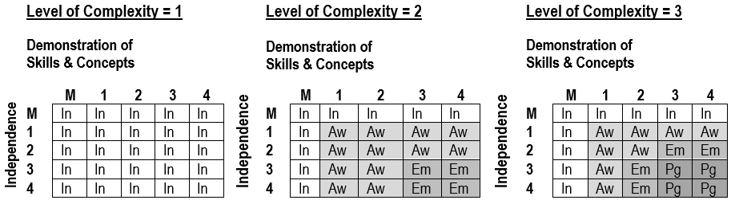

***NOTE:***

“M” means that required information was either missing or insufficient to determine a score.

**Level of Complexity = 4 or 5** refers to grade-level and competency portfolios, which are detailed in the *MCAS Grade-Level and Competency Portfolio Manual* available online [here](http://www.doe.mass.edu/mcas/accessibility/).

|  |  |
| --- | --- |
| In | Incomplete |
| Aw | Awareness |
| Em | Emerging |
| Pg | Progressing |

## Including MCAS-Alt Results in Reporting and Accountability

###### Achievement Levels

For each student who takes the MCAS-Alt, one of the following achievement levels will be reported in each content area:

**Grades 3-10 (Alternate Assessments Based on Alternate Achievement Standards)**

* ***Incomplete***—Sufficient evidence and information was not included to allow an achievement level to be determined in the content area.
* ***Awareness***—Students demonstrate very little understandingof standards and core knowledge topics contained in the Massachusetts curriculum framework for the content area. Students require extensive prompting and assistance, and their performance is mostly inaccurate.
* ***Emerging***—Students demonstrate a simple understanding that is below grade-level expectations of a limited number of standards and core knowledge topics contained in the Massachusettscurriculum framework for the content area.Students require frequent prompting and assistance, and their performance is limited and inconsistent.
* ***Progressing***—Students demonstrate a partial understanding that is below grade-level expectations of selected standards and core knowledge topics contained in the Massachusettscurriculum framework for the content area.Students are steadily learning new knowledge, skills, and concepts. Students require minimal prompting and assistance, and their performance is basically accurate.

**Grades 3-10 (MCAS Grade-Level Achievement Standards for ELA, Mathematics, and High School Biology and Introductory Physics):**

* **Not Meeting Expectations*—***Students performing at this level did not meet grade-level expectations in this subject. The school, in consultation with the student's parent/guardian, should determine the coordinated academic assistance and/or additional instruction the student needs to succeed in this subject.
* **Partially Meets Expectations**—Students performing at this level partially meet grade-level expectations for knowledge, skills, and understanding. These students may need coordinated assistance and/or additional instruction to succeed at the next grade level.
* **Meeting Expectations**—Students performing at this level meet grade-level expectations for knowledge, skills, and understanding, and are academically prepared to succeed at the next grade level.
* **Exceeding Expectations**—Students performing at this level exceed grade-level expectations for knowledge, skills, and understanding, and are academically well-prepared to succeed at the next grade level.

###### Alternate Achievement Performance Levels

The alternate academic achievement performance levels (*Awareness, Emerging, Progressing*) and their descriptors reflect the collaboration, input, and professional judgment of stakeholders who have affirmed that these performance levels represent the highest possible standards achievable by students taking the MCAS-Alt.

###### School and District Results

Feedback Forms containing preliminary school and district performance-level results are posted to DropBox Central on the Department’s [Security Portal](https://gateway.edu.state.ma.us/) in mid-June. Results are available online in the fall and reflect changes made due to discrepancies reported to the Department and the findings of MCAS-Alt score appeals filed in late June. Students’ alternate assessments are returned to schools in the fall after they have been scored.

MCAS-Alt school and district reports include an achievement level for each student attending a school or program in a district, as well as for those students who reside in the district and attend publicly funded out-of-districtplacements, such as educational collaboratives or approved and unapproved private special education schools.

To meet federal requirements for reporting aggregated and disaggregated results of statewide assessments for *all* students, the results of MCAS-Alt are included in school, district, and statewide reports of MCAS results as achievement levels only. The alternate achievement performance levelsof *Incomplete, Awareness, Emerging*, and *Progressing* will be included in the lowestMCASachievement level for school and district reporting.

###### Parent/Guardian Reports

In the fall, districts receive shipments of MCAS-Alt Parent/Guardian Reports that provide a detailed description of a child’s score in each area of the scoring rubric and an overall achievement level in each subject.

Districts are responsible for sending a parent/guardian report to the home of each student who took the MCAS-Alt. If the student is also reported as an English learner, a copy of the report in the student’s home language must also be sent. Print copies of the translations of the report “shell” in the state’s ten most frequently spoken languages are provided in the shipment of MCAS-Alt Parent/Guardian Reports. The translated report templates are also available [online](http://www.doe.mass.edu/mcas/alt/results.html) in ten languages. Districts may request copies of the Parent/Guardian Report template in alternate formats, including Braille and large print.

###### Including MCAS-Alt Results in School and District Accountability

MCAS-Alt results will be included in the accountability system, together with the results of students who took the standard MCAS tests. Details on the state’s accountability system are available [here](http://www.doe.mass.edu/accountability/). Accountability determinations for schools that administer MCAS tests in grades 3–8 and 10 will be based on a combination of indicators, including:

* average scaled MCAS scores in ELA, mathematics, and science and technology/engineering (this replaces Composite Performance Index points used previously)
* an assigned MCAS-Alt scaled score equivalent (see following page)
* average student growth percentile (SGP) in ELA and mathematics
* progress toward attaining English language proficiency for students reported as English learners
* percentage of chronically absent students

Table 3 shows the score scale for MCAS tests.

**Table 3. MCAS Tests Scaled Score Ranges**

|  |  |
| --- | --- |
| **Standard MCAS**  **Achievement level** | **Scaled Scores** |
| Not Meeting Expectations (NM) | 440-469 |
| Partially Meeting Expectations (PM) | 470-499 |
| Meeting  Expectations (M) | 500-529 |
| Exceeding Expectations (E) | 530-560 |

Table 4 shows the average equivalent MCAS scaled score to the results of students who took the MCAS-Alt in each subject as shown in table 4. The MCAS-Alt equivalent scaled score is only used for the purpose of making accountability determinations.

**Table 4. MCAS Scaled Score Equivalents Assigned to MCAS-Alt Scores**

|  |  |
| --- | --- |
| **MCAS-Alt achievement level, based on alternate achievement standards** | **Assigned MCAS scaled score equivalent** |
| Incomplete (INP) | 455 |
| Awareness (AWR) | 470 |
| Emerging (EMG) | 485 |
| Progressing (PRG) | 500 |

## Policy on Storage and Destruction of Returned MCAS-Alt Materials

In September of each year, DESE returns MCAS-Alt assessments to schools. Once returned, an MCAS-Alt becomes part of a student’s temporary record *and* must be kept by the school in a secure location. Under the [Massachusetts Student Records Regulations](http://www.doe.mass.edu/lawsregs/603cmr23.html?section=06), a temporary record contains everything that is not in the transcript and that is “clearly of importance to the educational process.” Principals or their designees are required periodically to review temporary student records and to destroy portions that are “misleading, dated, or irrelevant.” Prior to destroying these records, **schools must give parents and eligible students written notice of the intent to destroy records, and of parents’ right to receive copies of these records before they are destroyed** (603 CMR 23.06(2)).

Regardless of the obligation to review and periodically purge temporary records of “misleading, dated, or irrelevant” documents, schools must destroy students’ temporary records no later than seven years after the student transfers, graduates, or withdraws from public school (i.e., a student’s temporary records *must* be destroyed *within* seven years after the student exits). However,schools may destroy “misleading, dated, or irrelevant” documents prior to this time by providing written notice to the student and his/her parentof the approximate date of the destruction of the record and of their right to receive these materials in whole or in part prior to their destruction.

DESE recommends the following time periods for schools to retain MCAS-Alt assessments once they have been returned to the school, based on the general view that, over time, the importance of the assessment to the educational process diminishes:

* grades 3-8 ELA and Mathematics binders: two years
* grade 5 Science and Technology/Engineering (STE) binders: three years
* grade 8 Science and Technology/Engineering (STE) binders: two years
* high school ELA, Mathematics, and STE binders: after the student exits public education

After the recommended time, if the student is no longer in the district, or if the parent doesn’t want the assessment after receiving notice of the approximate date of destruction and the parent’s right to receive these materials, the school may destroy the assessment.

Despite these recommendations, schools, and districts should be aware of circumstances in which it may be prudent to retain a student’s MCAS-Alt *longer* than the recommended time periods and treat the destruction of MCAS-Alt for specific students on a case-by-case basis. However, in all cases, records must be destroyed within the seven-year period described above.

Districts are reminded that the district must furnish a copy of the assessment to the eligible student or parent upon request, per (603 CMR 23.07(2)).

Additionally, when a student is transferring from one Massachusetts district to another, the Department requests that the previous district send the student’s current and/or most recent MCAS-Alt to the new district.

### Bottom of Form

#### Appendix A. Examples of Completed Forms

###### Data Charts: Line Graph, Bar Graph, and Field Data Chart

###### Teacher-Documented Work Sample

###### Sample Completed Strands (available online [here](http://www.doe.mass.edu/mcas/alt/samples.html))

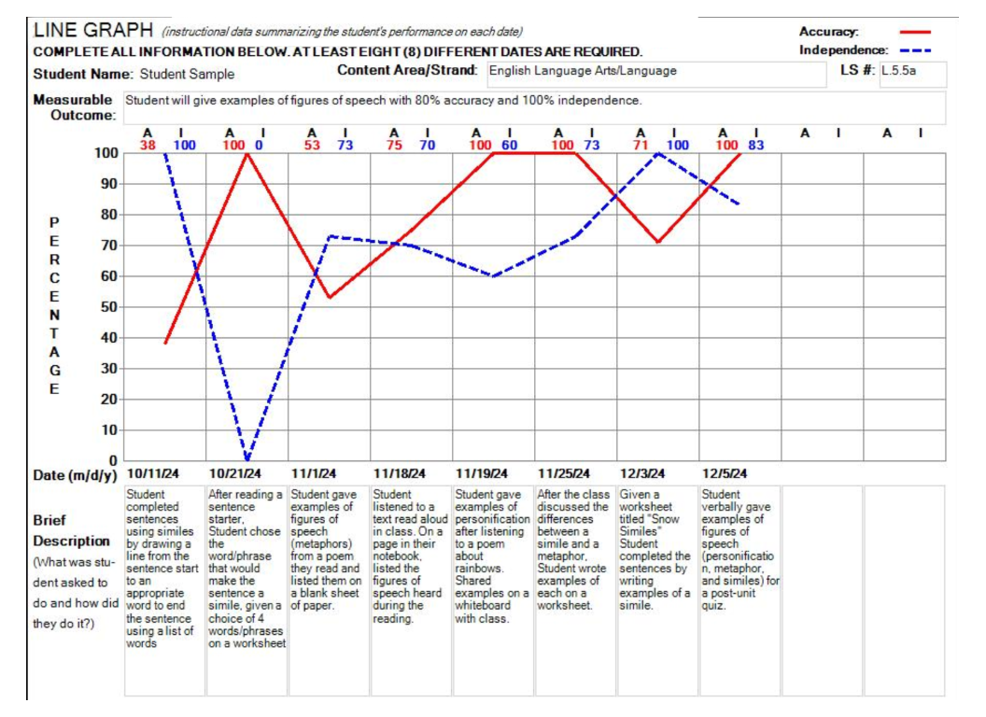

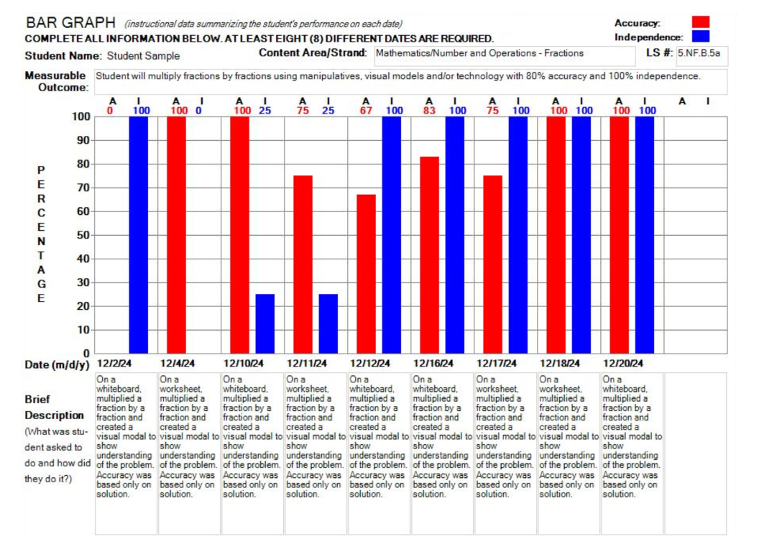

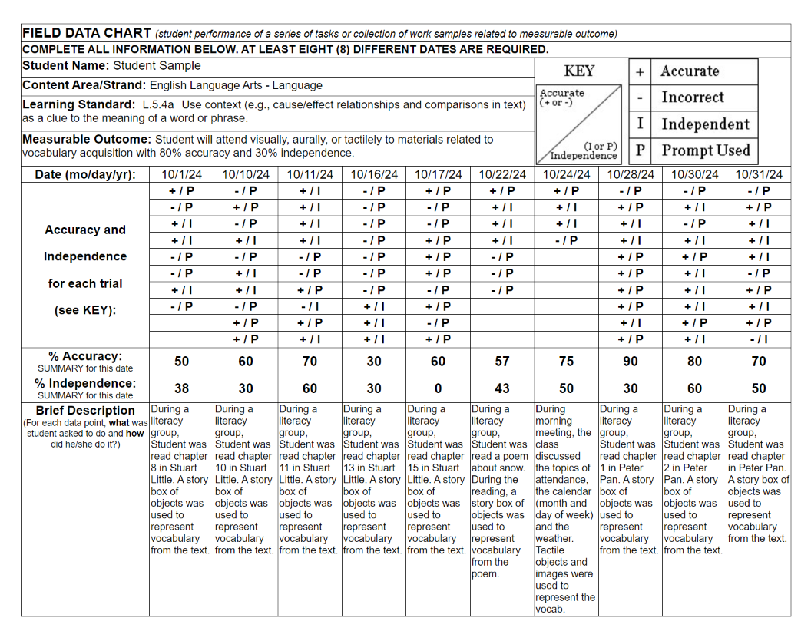

###### Example: Teacher Sample *(Additional examples are available at* [*Educator Materials*](https://profile.measuredprogress.org/MCAS-Alt/Materials/Default.aspx)*)* —Documented WorkTeacher-scribed work sample for a student who cannot produce written work. Typically used for students who address access skills, it documents a series of trials or activities conducted during a single session, with a record of the student’s responses (i.e., levels of accuracy and independence) for each item/trial, plus detailed information describing the materials, context of the activity, anticipated responses, and actual responses during each task.

### Appendix B. SCORING RUBRIC for ELA—Writing

**Student’s Name:**

**Date:**

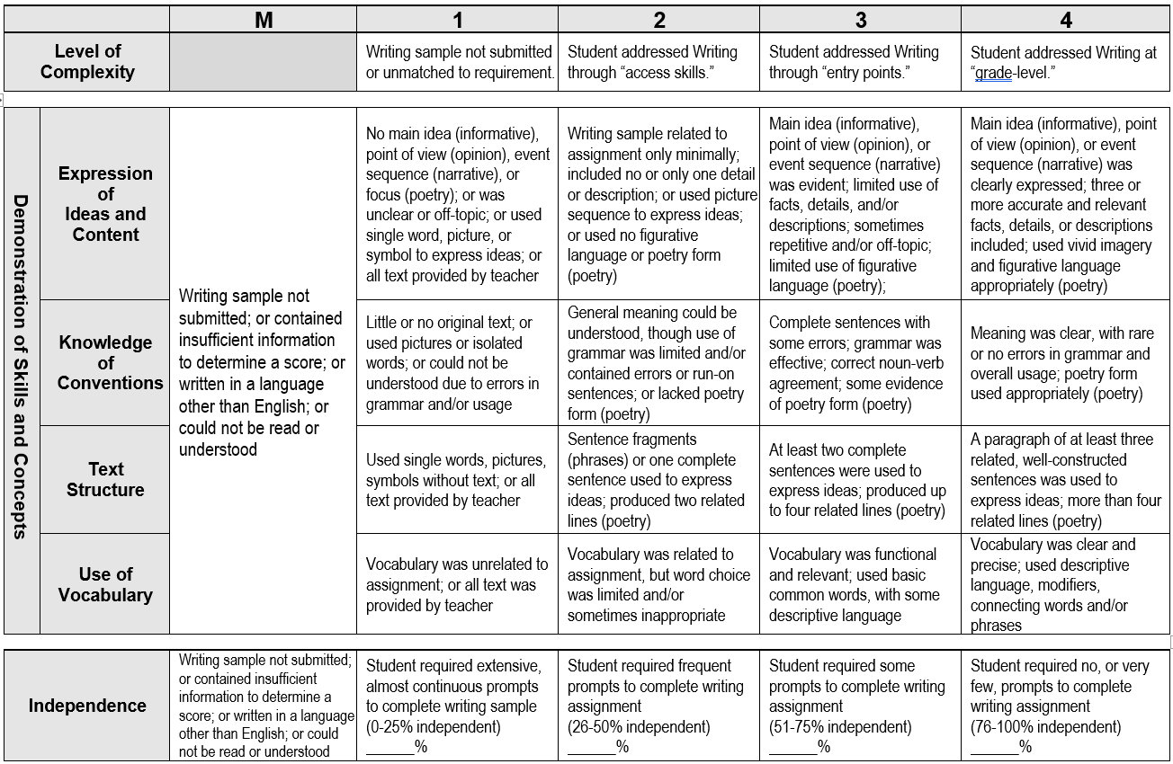

1. Written consent must be obtained from the parent, guardian, or student (if 18 years or older) before including photographic or video images of the student in the MCAS-Alt. If a student’s peers are shown in an image or video, consent must also be obtained for those “incidental” images of students. Consent forms for these purposes are provided in [Forms and Graphs](https://profile.measuredprogress.org/MCAS-Alt/login.aspx) and must be kept on file at the school.