2020 Strand Cover Sheet
Student: Robert Flack
Grade: 10
Content: English Language Arts
Strand: Writing Narrative
Skill: Create a writing sample
MCAS-Alt Skills Survey for Grade 10
Skills survey demonstrates student needs more practice responding to questions or writing prompts .
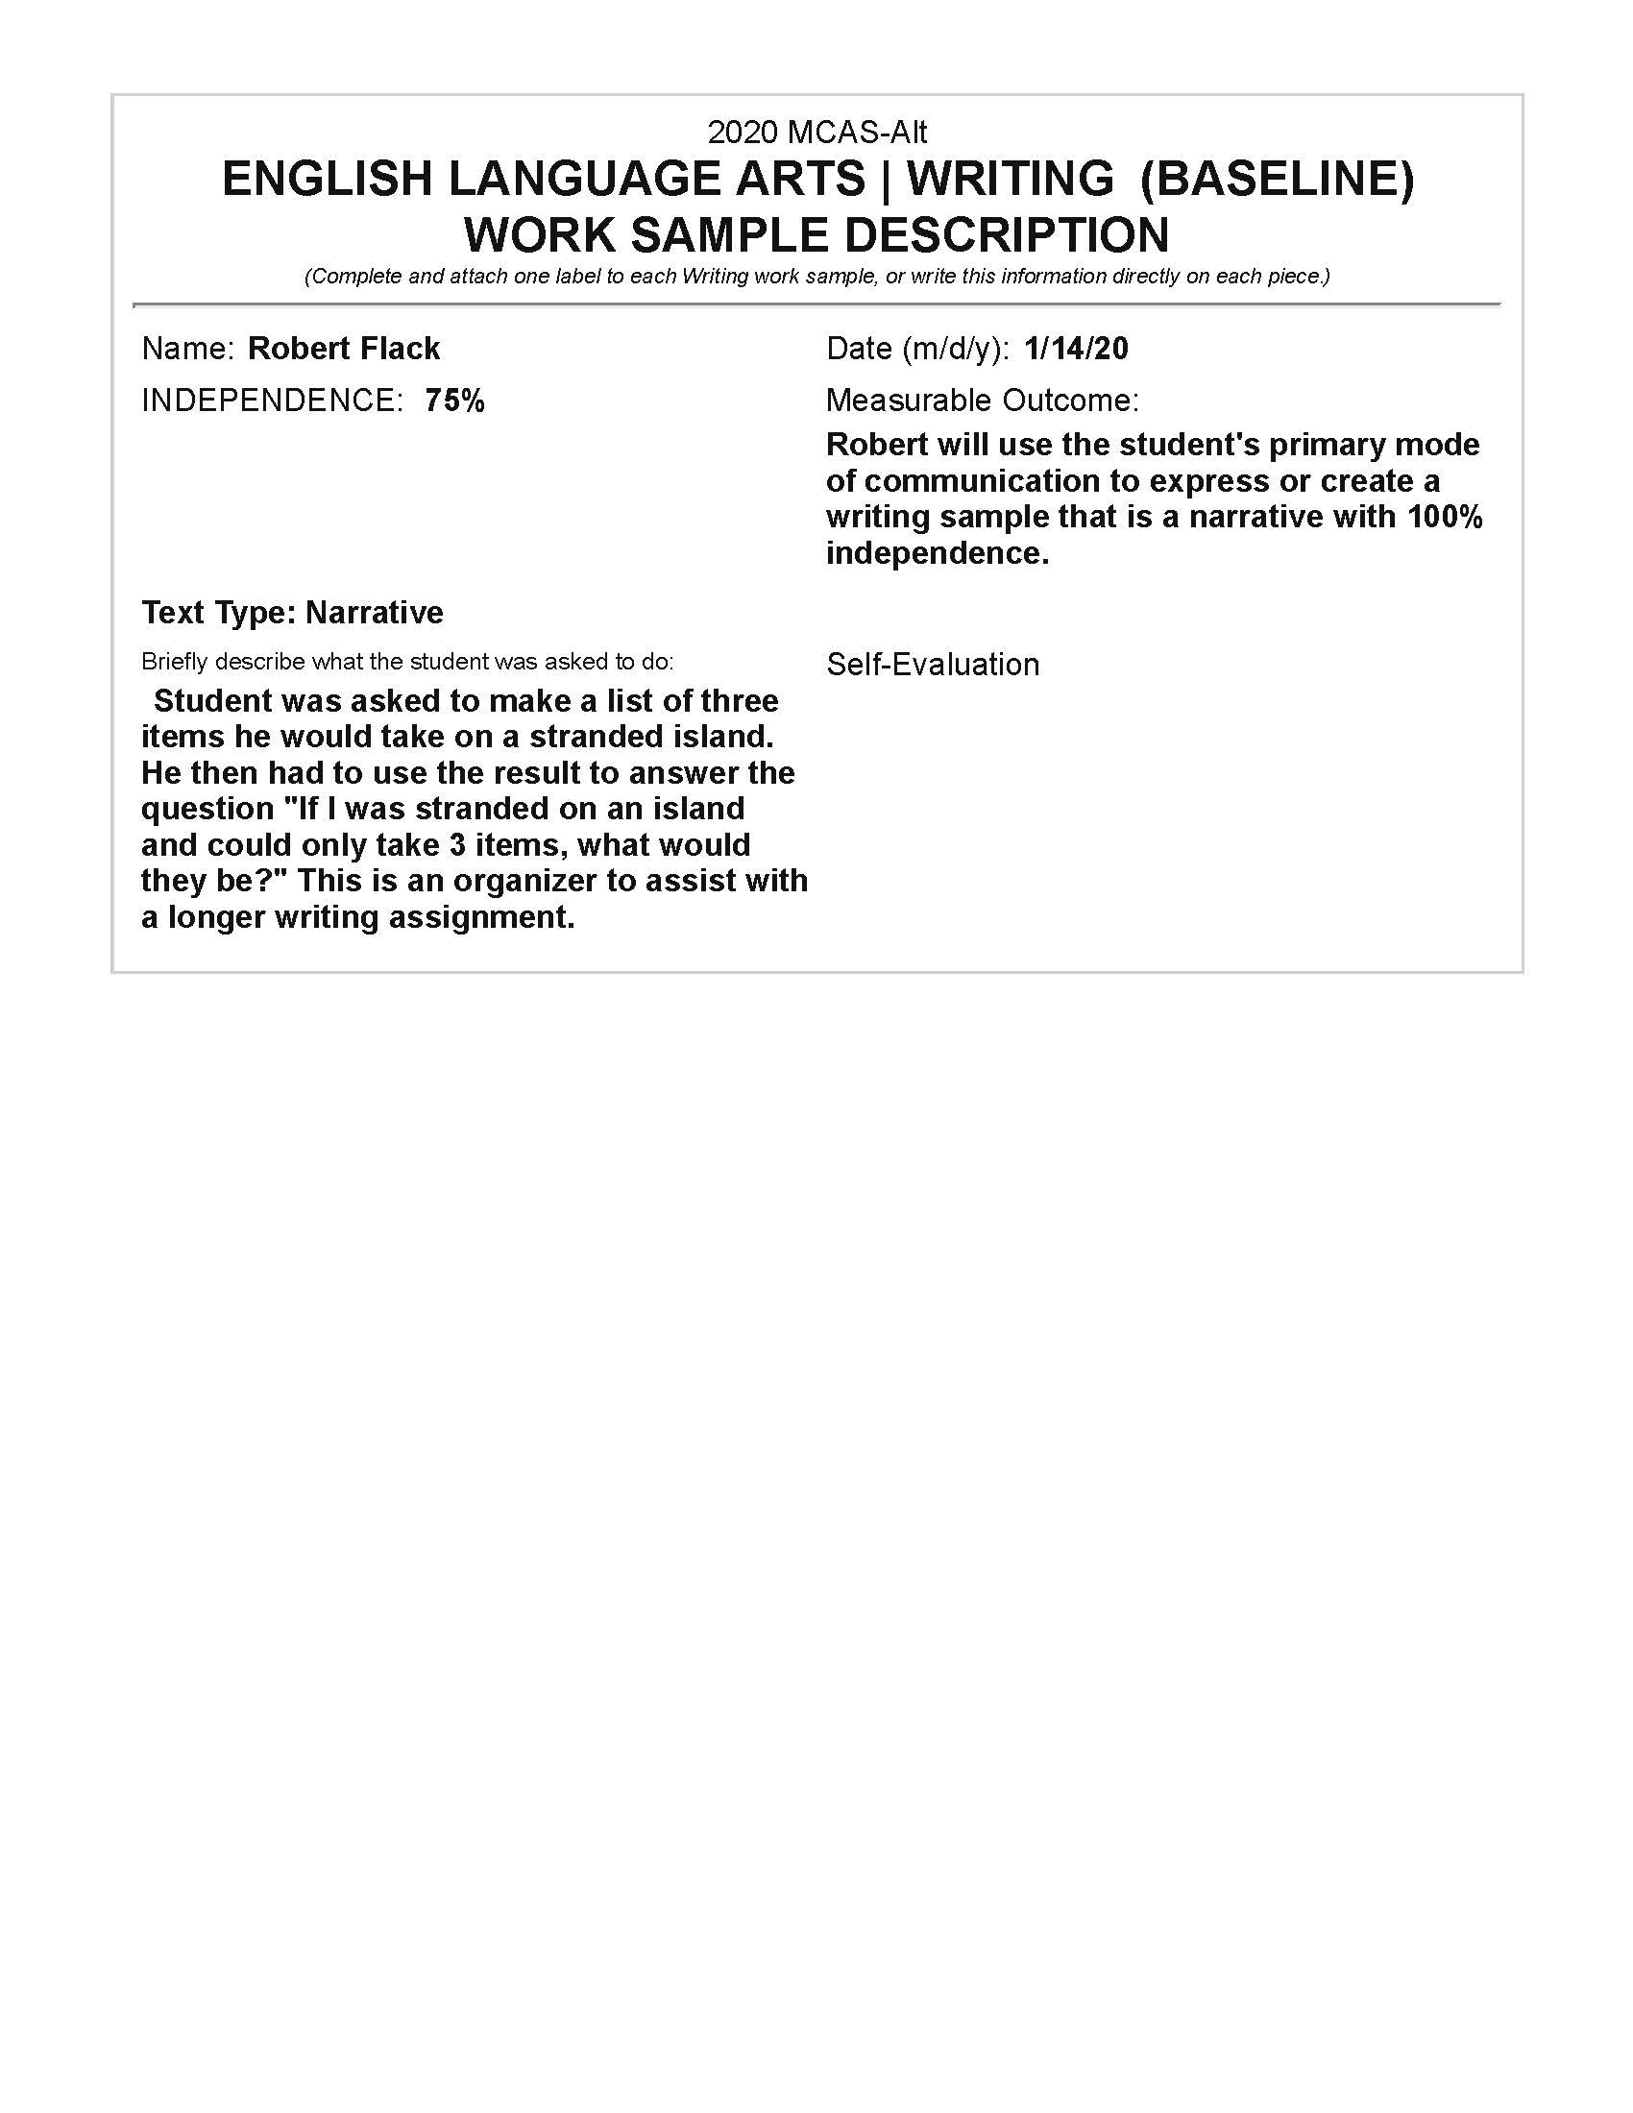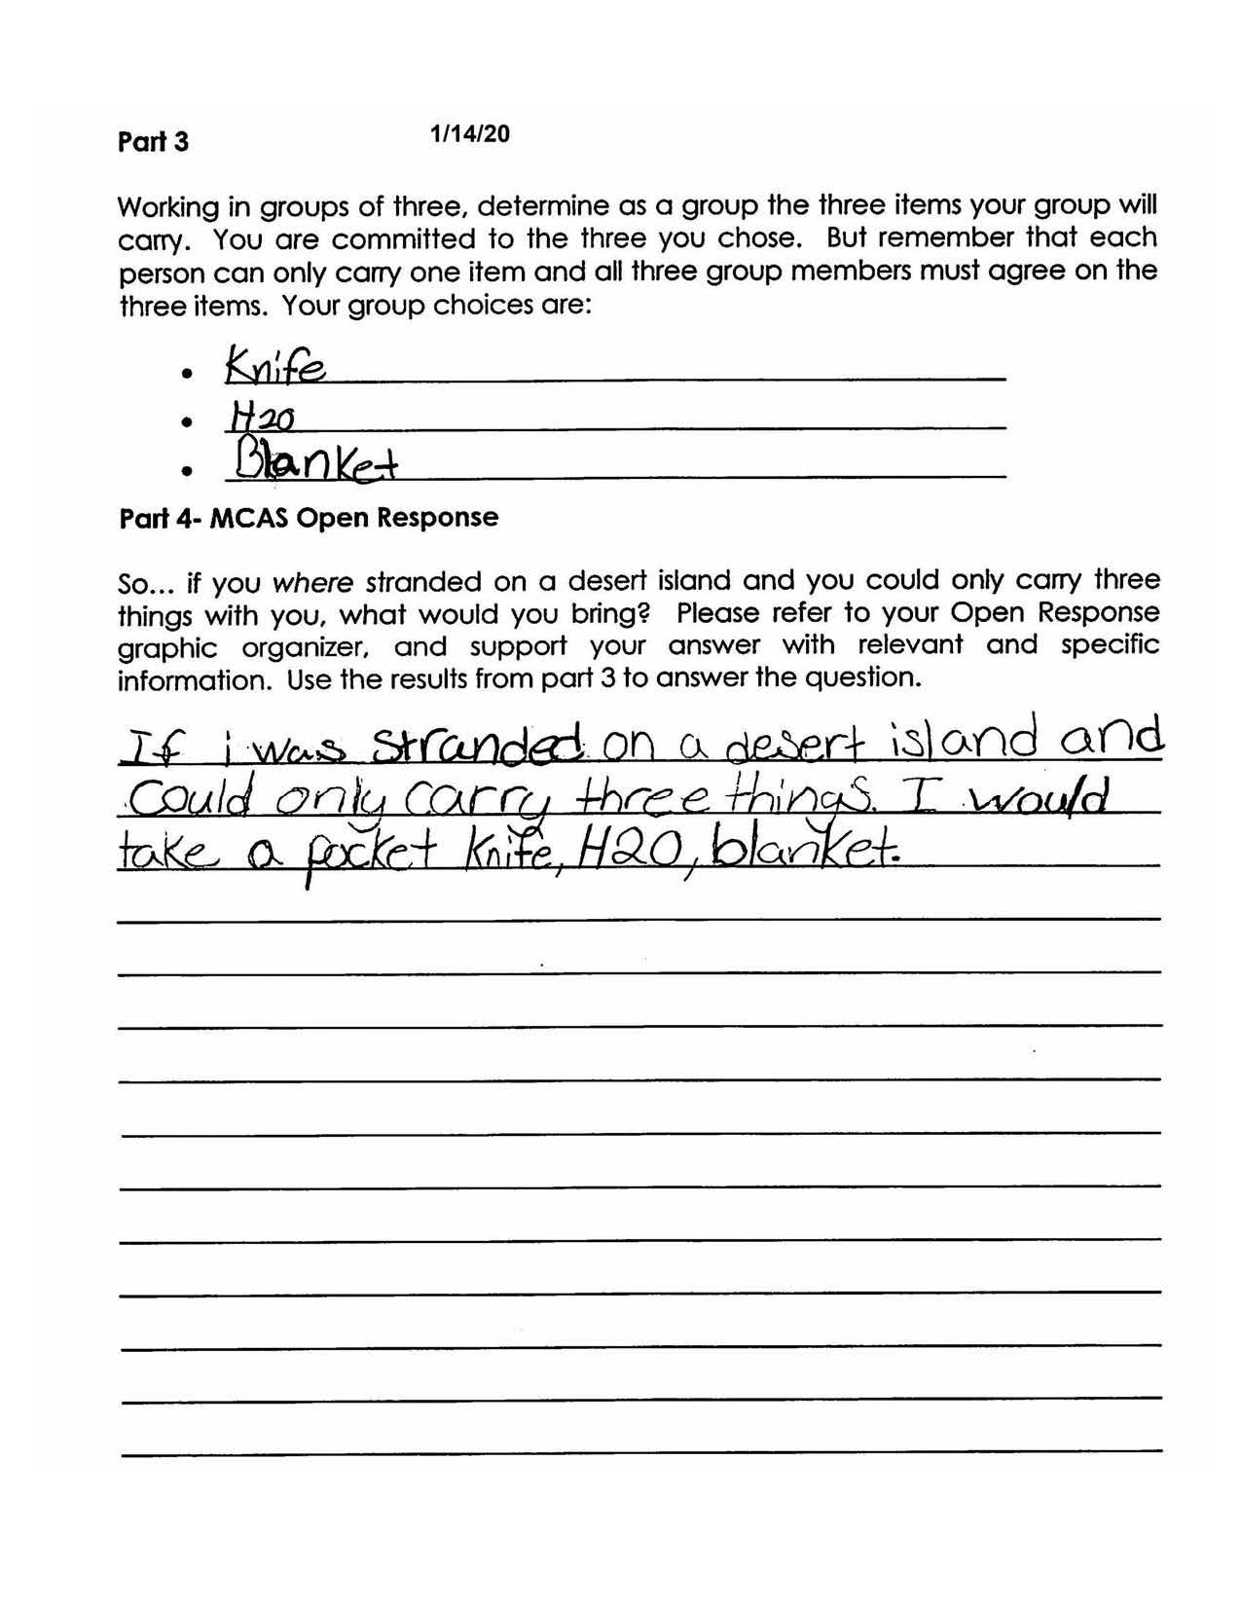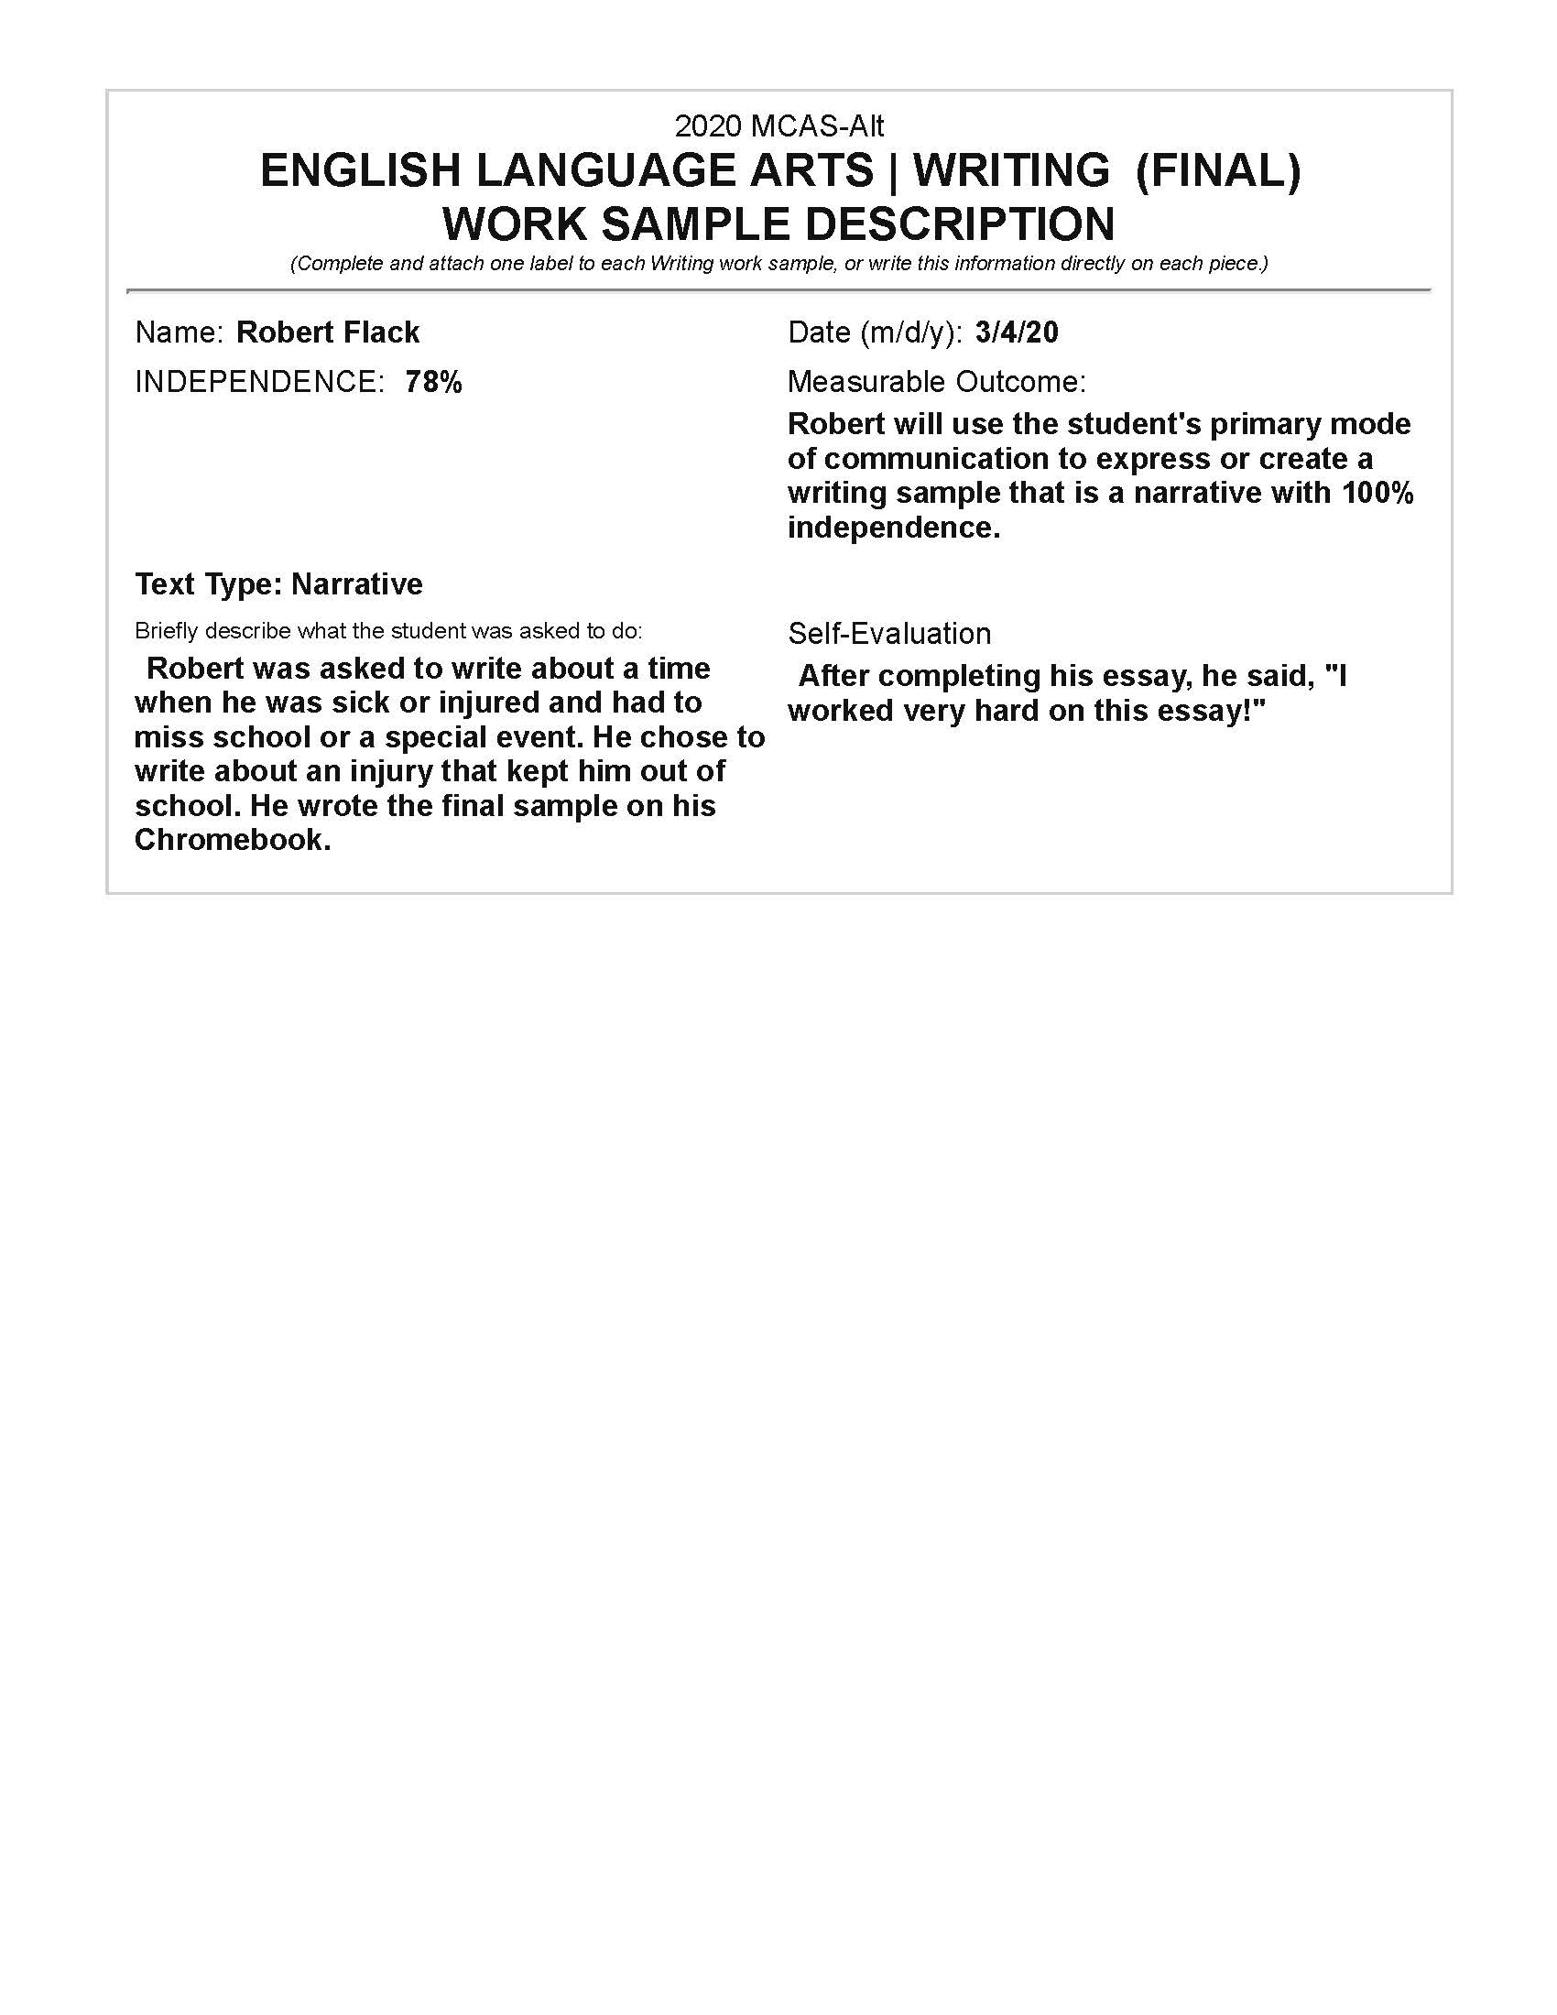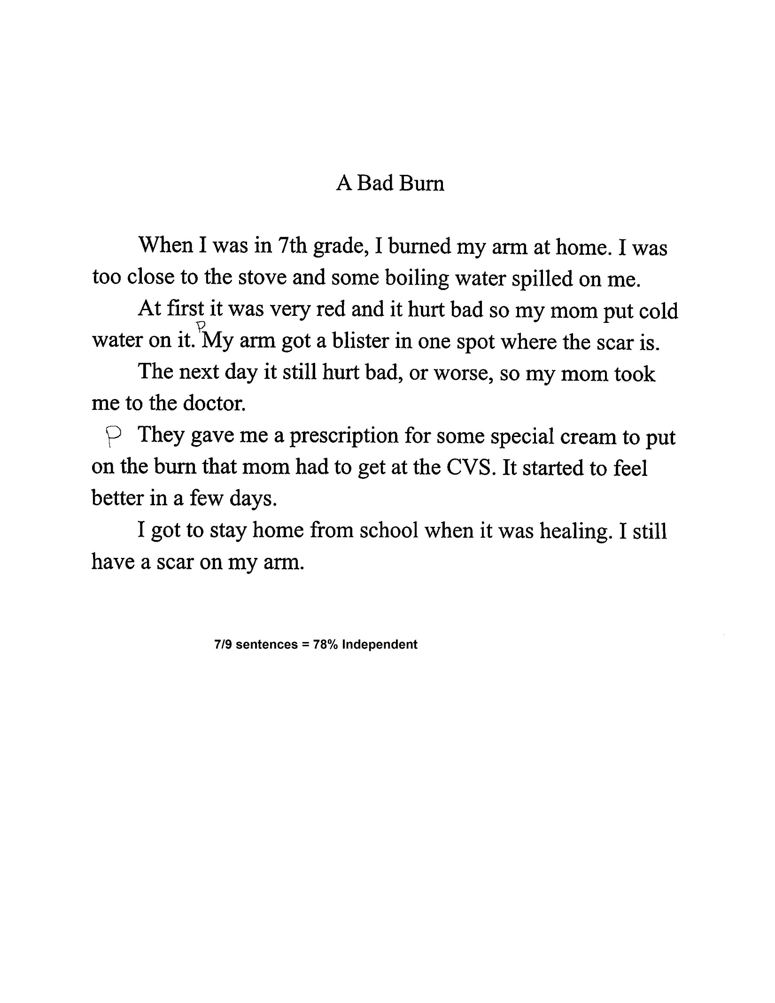

Writing Scoring Rubric: 1-4
Level of Complexity = Entry point
Expression of Ideas and Content =3
Knowledge of Conventions=4
Text Structure=4
Use of Vocabulary = 3
Independence = 78%=4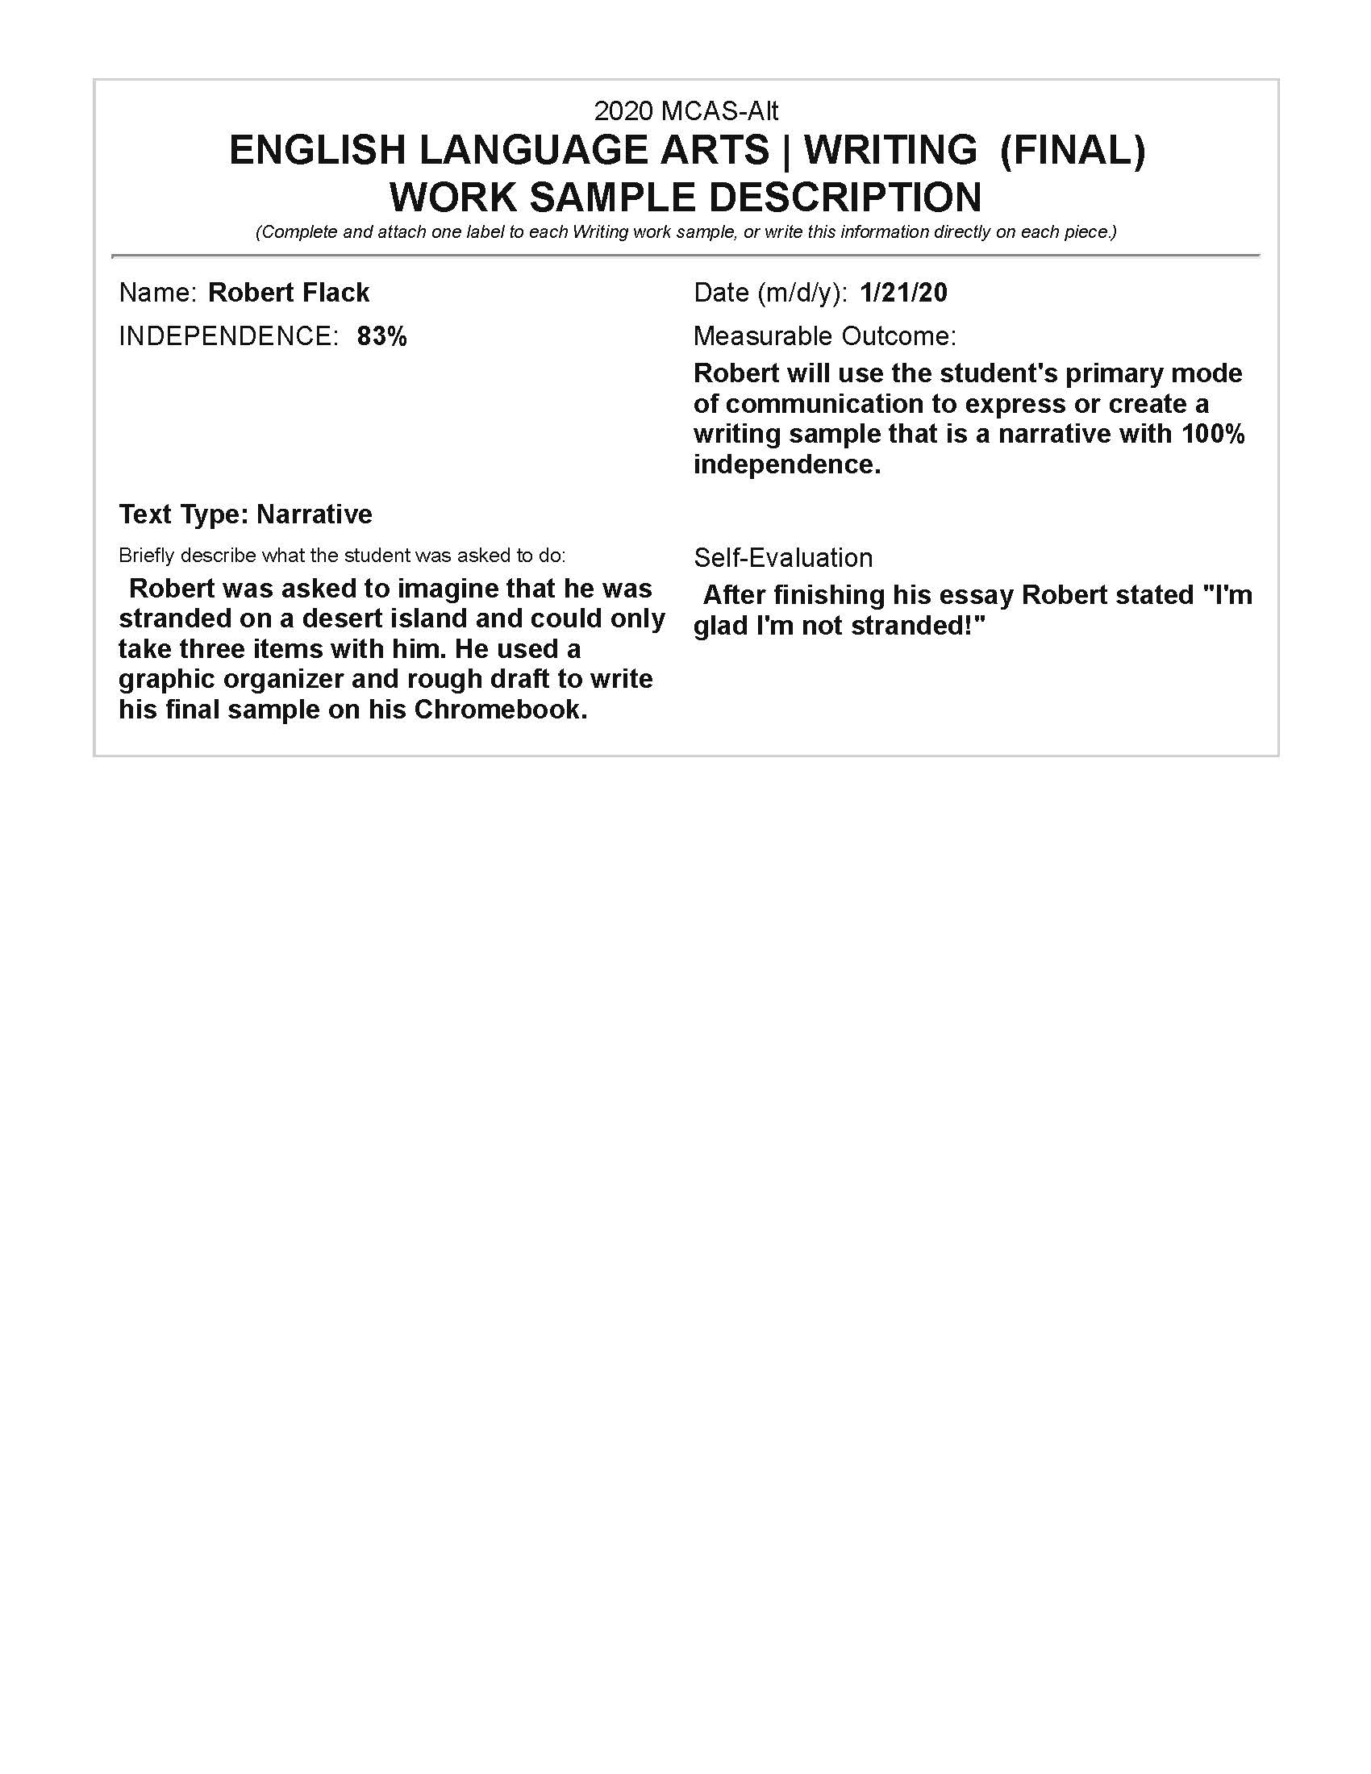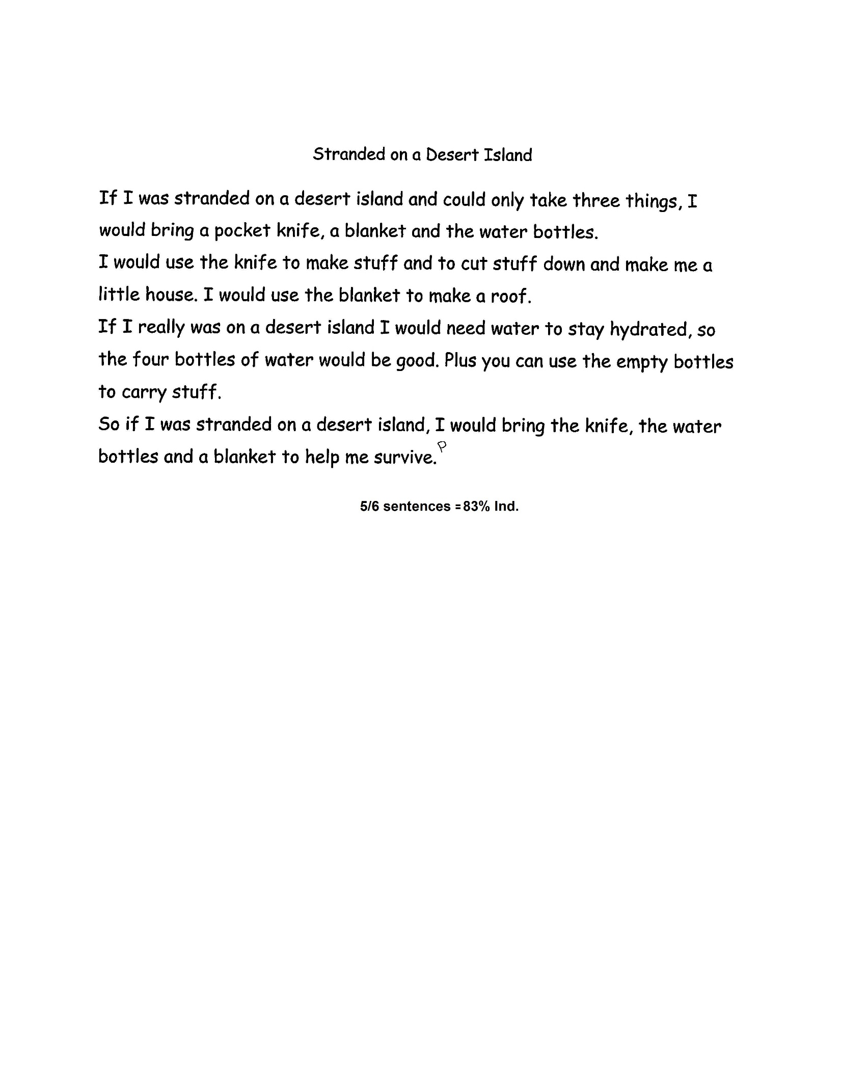

Writing Scoring Rubric: 1-4
Level of Complexity = Entry point
Expression of Ideas and Content =3
Knowledge of Conventions=4
Text Structure=4
Use of Vocabulary = 3
Independence = 83%=4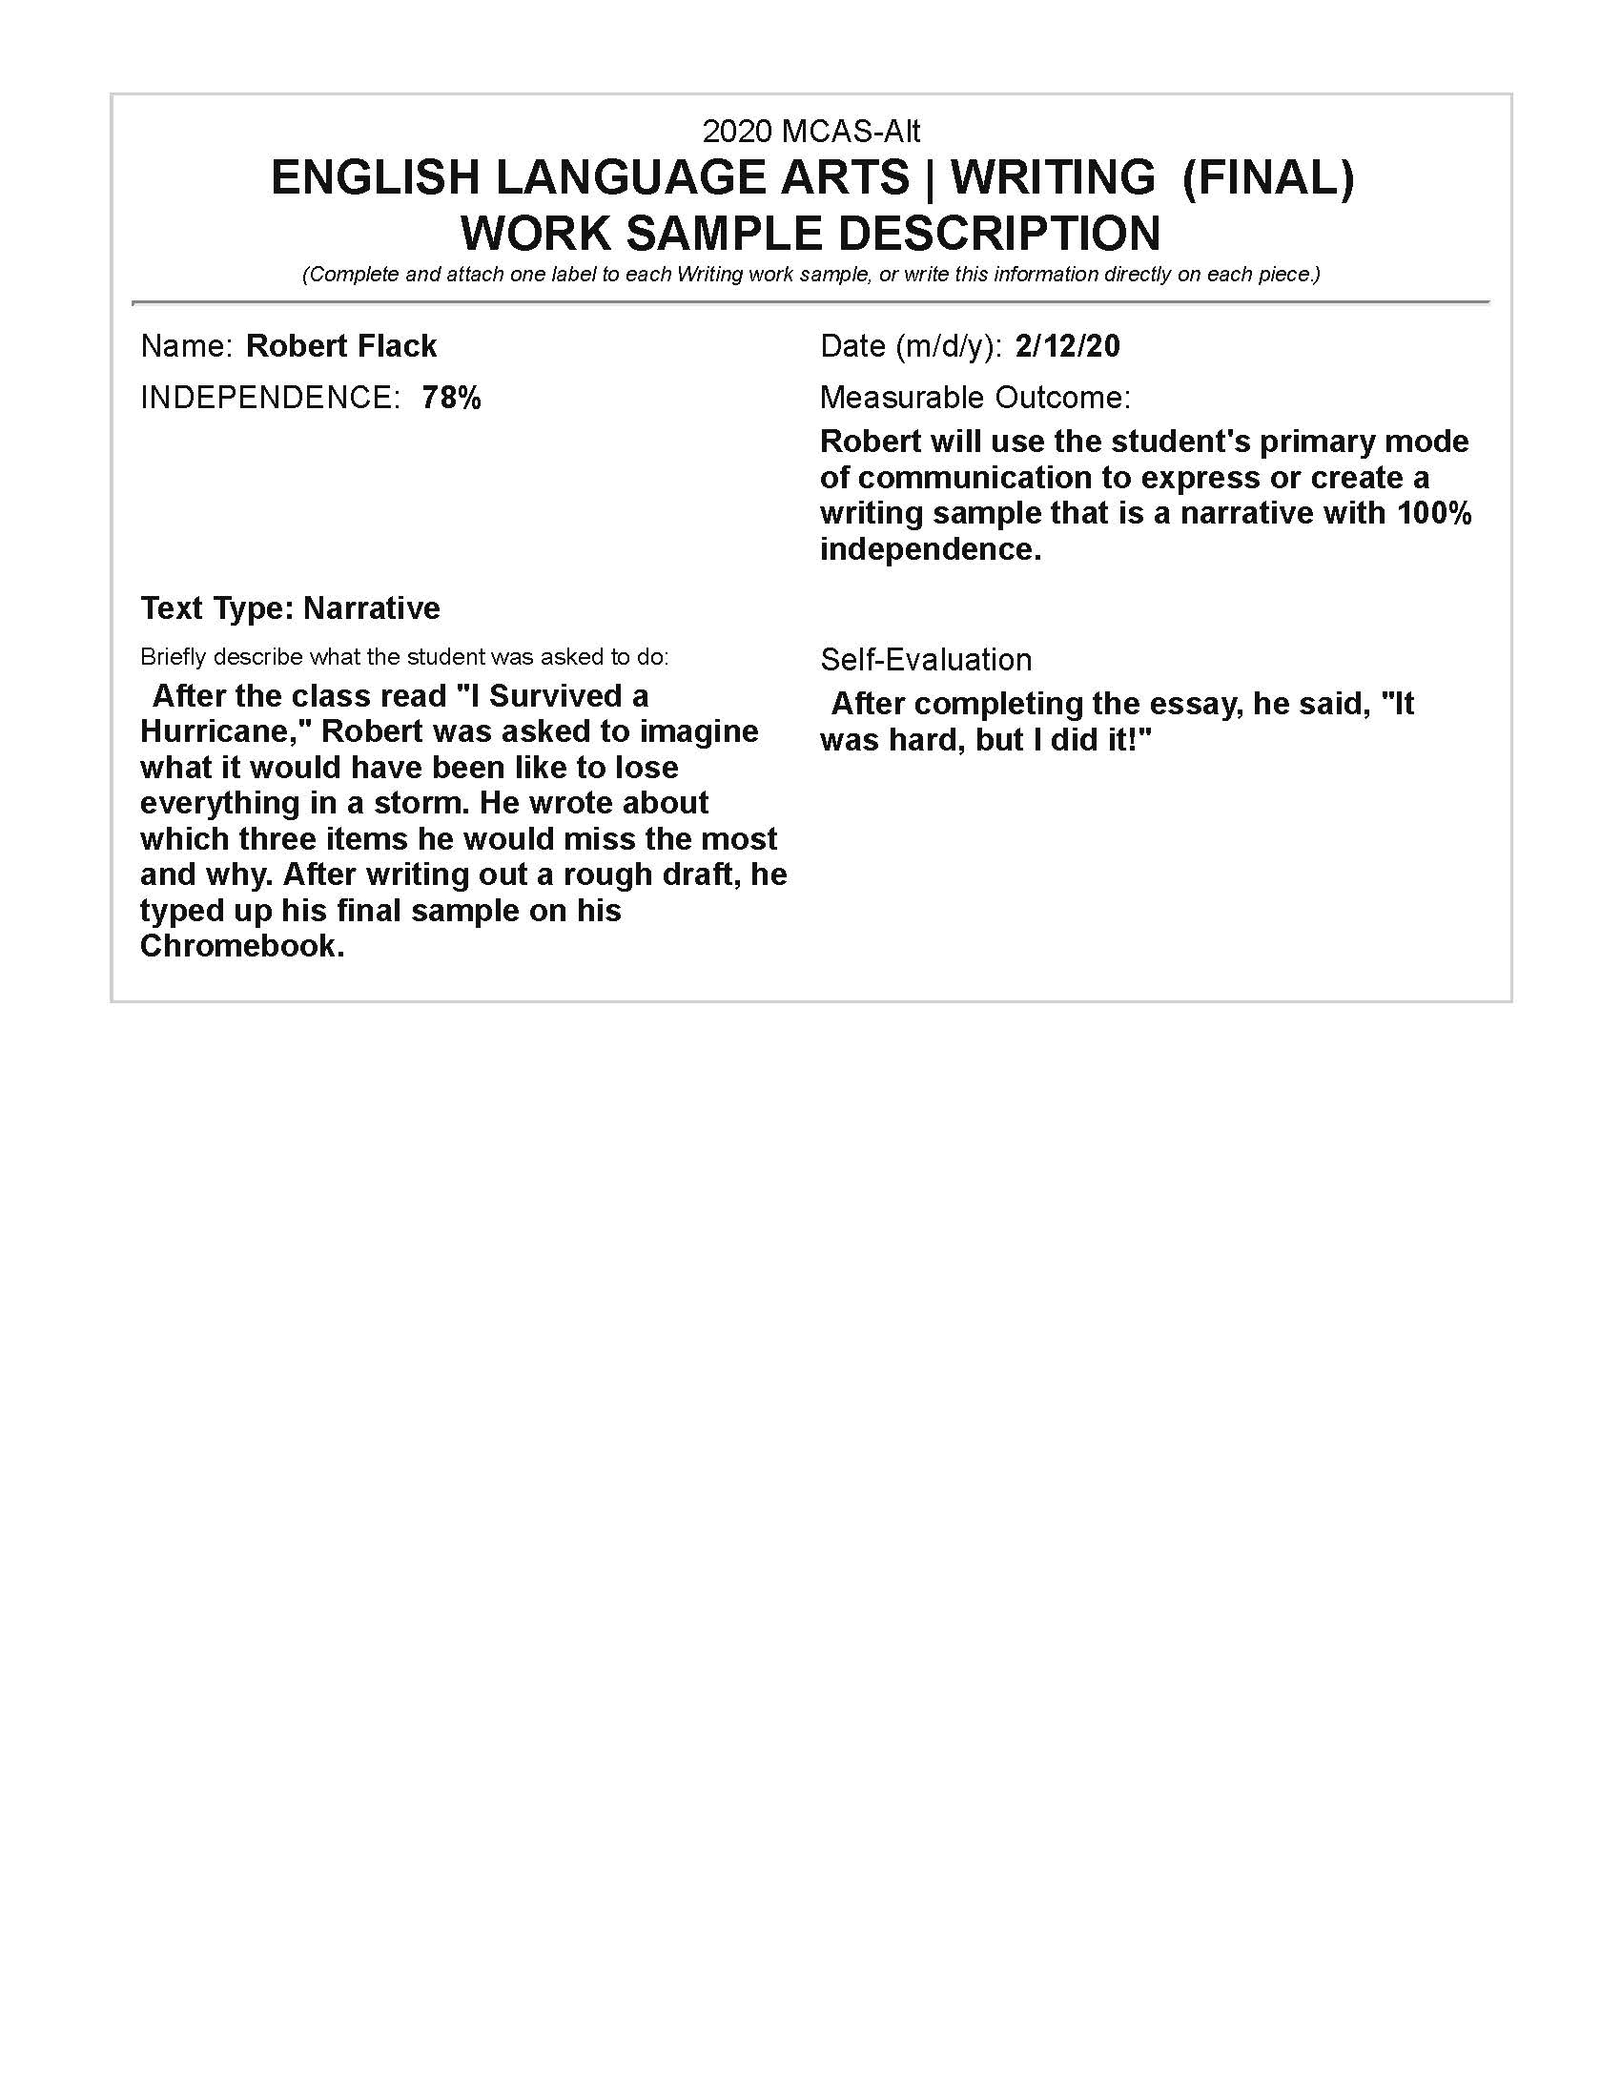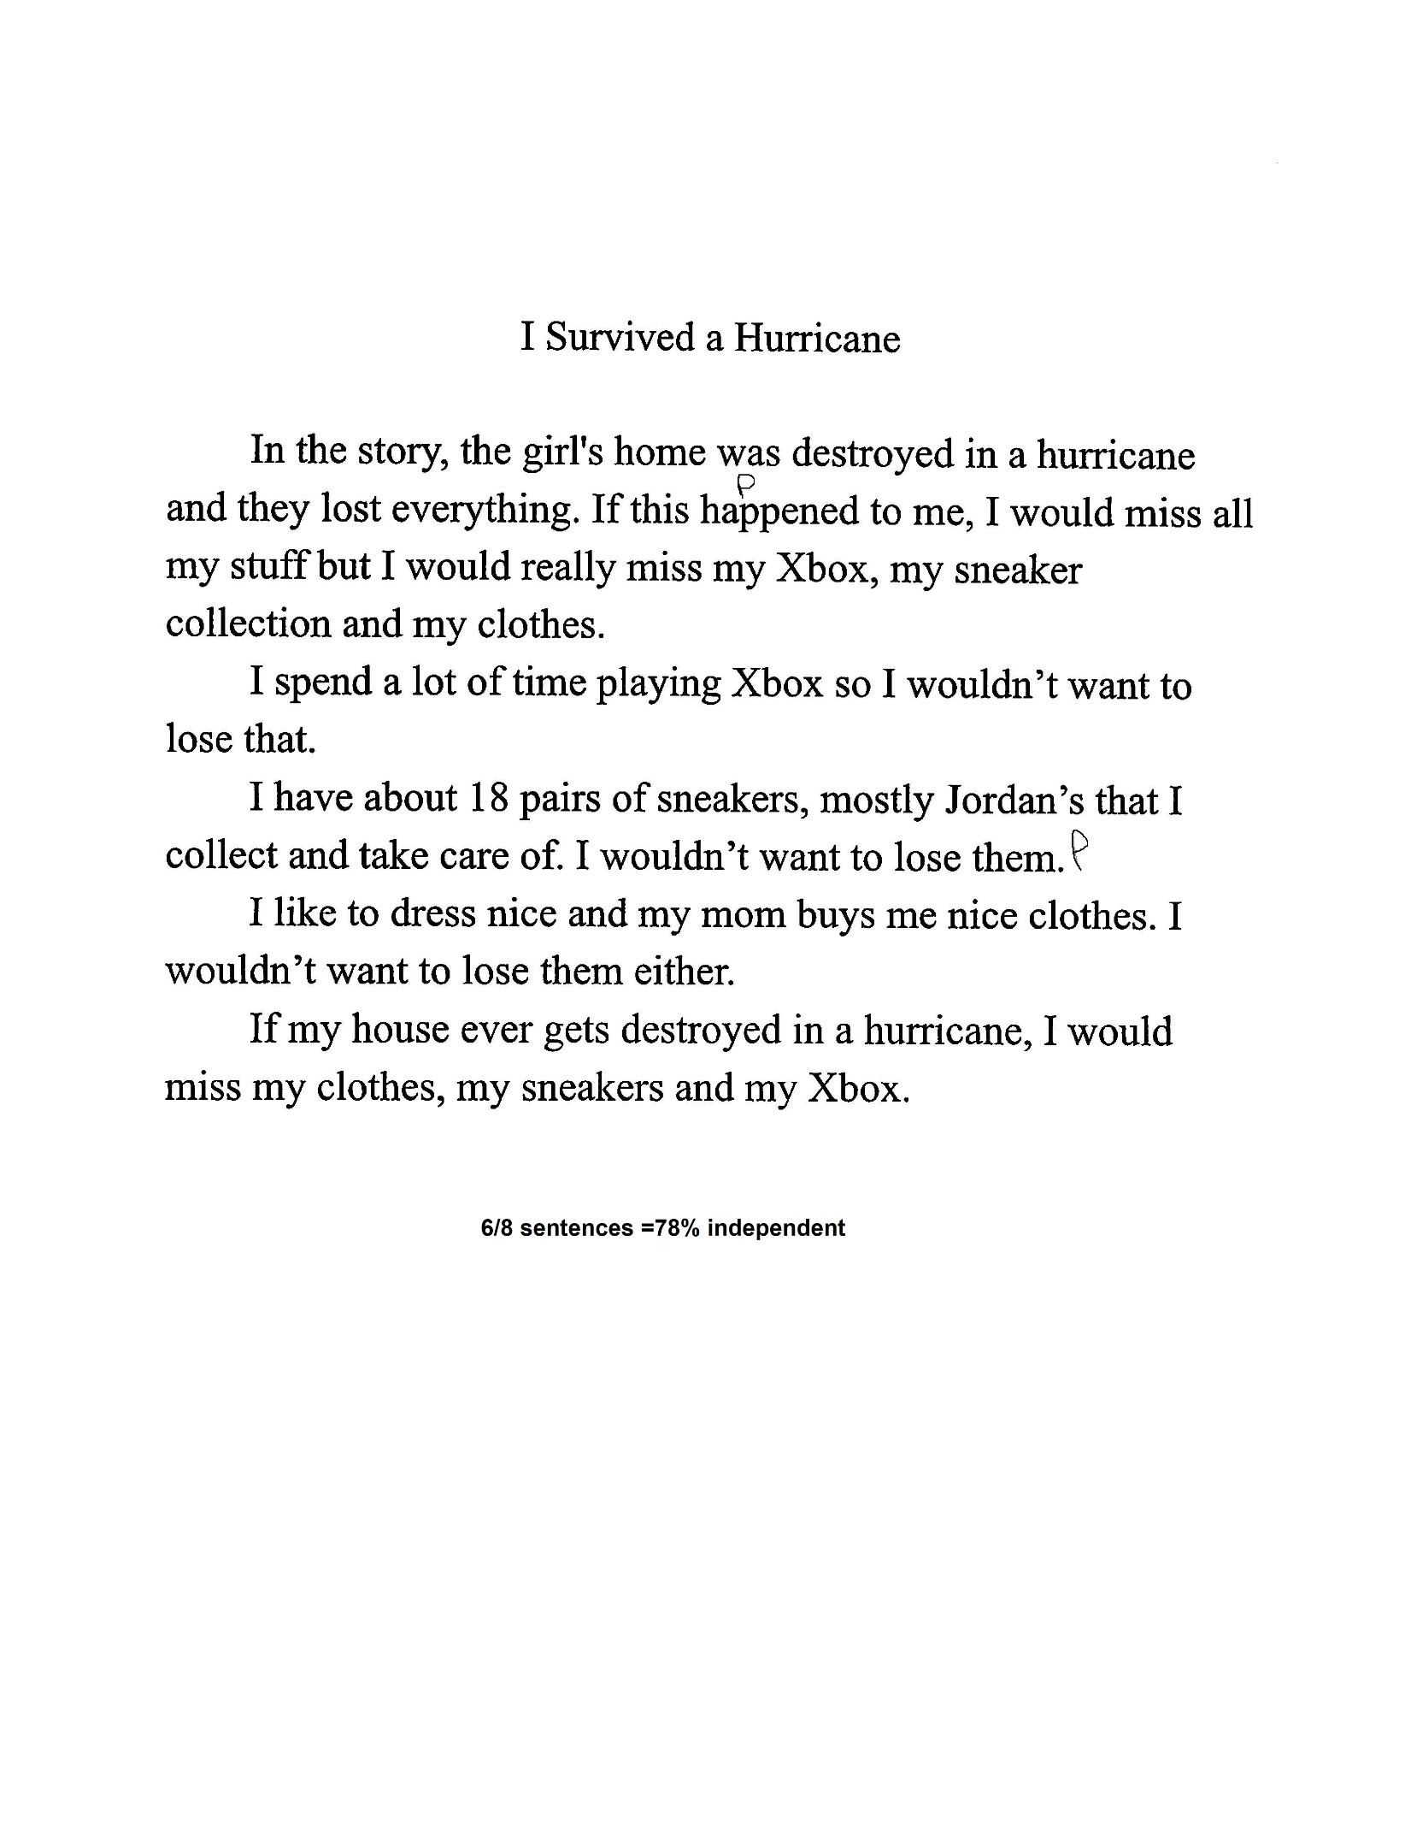

Writing Scoring Rubric: 1-4
Level of Complexity = Entry point
Expression of Ideas and Content =3
Knowledge of Conventions=3
Text Structure=4
Use of Vocabulary = 2
Independence = 78%=4