2020 Strand Cover Sheet
Student: 
Grade: 10
Content: Mathematics
Strand: Geometry
Skill: Calculate the volume of a rectangular prism given dimensions.
MCAS-Alt Skills Survey for Grade 10
Skills survey demonstrates student lacks the skill to calculate area.


MCAS-Alt Bar Graph
Demonstrates progress in learning the skill of calculating the volume of rectangular prisms. Karlee made progress in both accuracy and independence. On 10 different dates starting 12/3/19 ending 3/25/20 she was given multiple opportunities to calculate the volume of rectangular prisms. On the last day of the data chart student was 90% accurate and 100% independent.
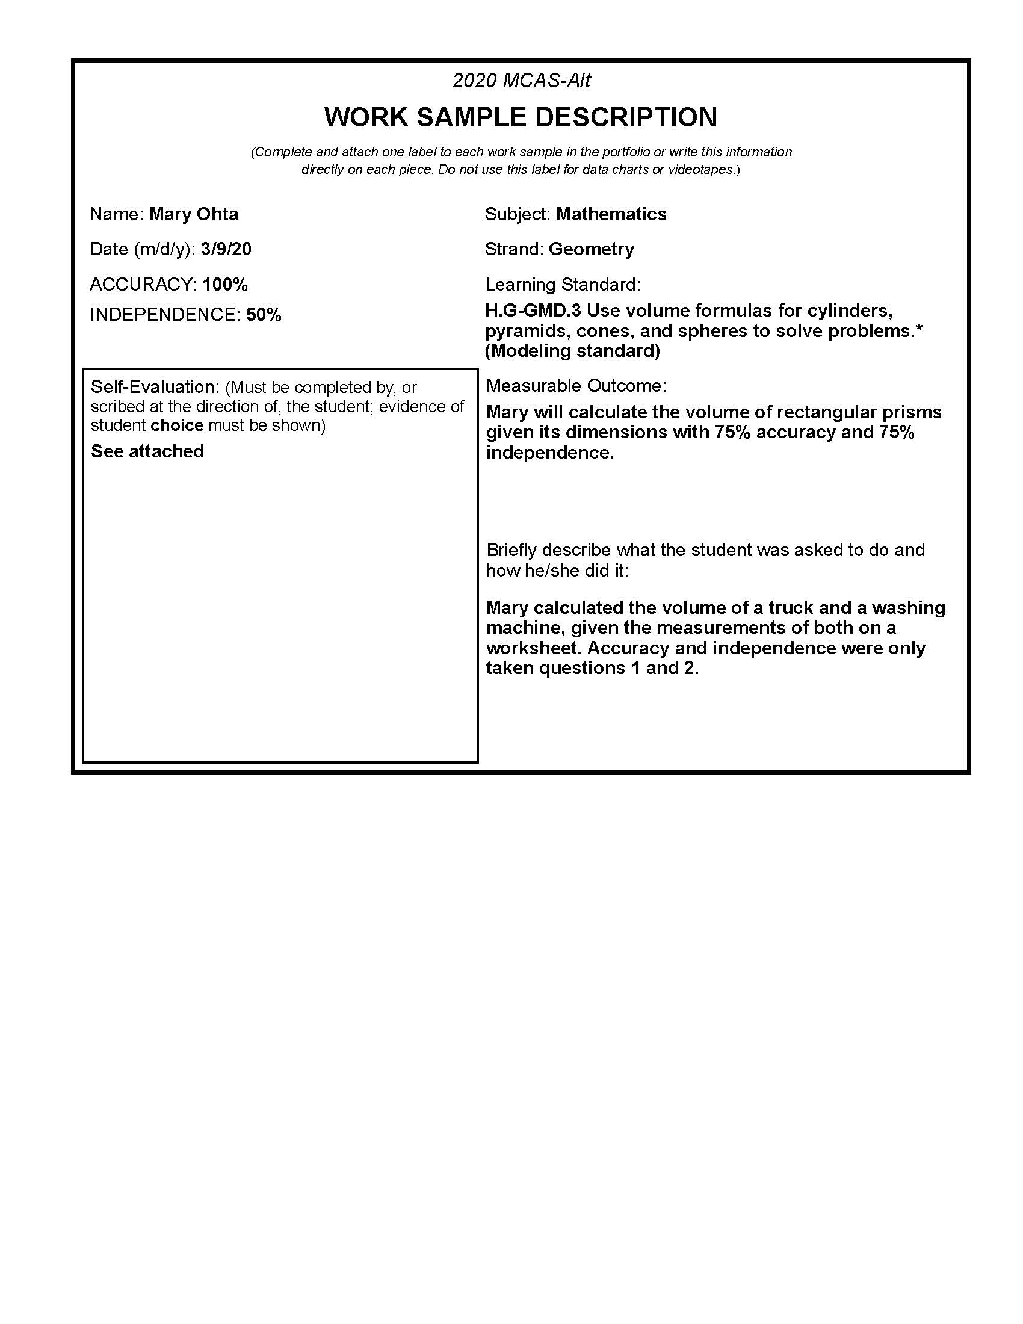 Student-created work sample dated //2019. Student was 100% accurate and independent.

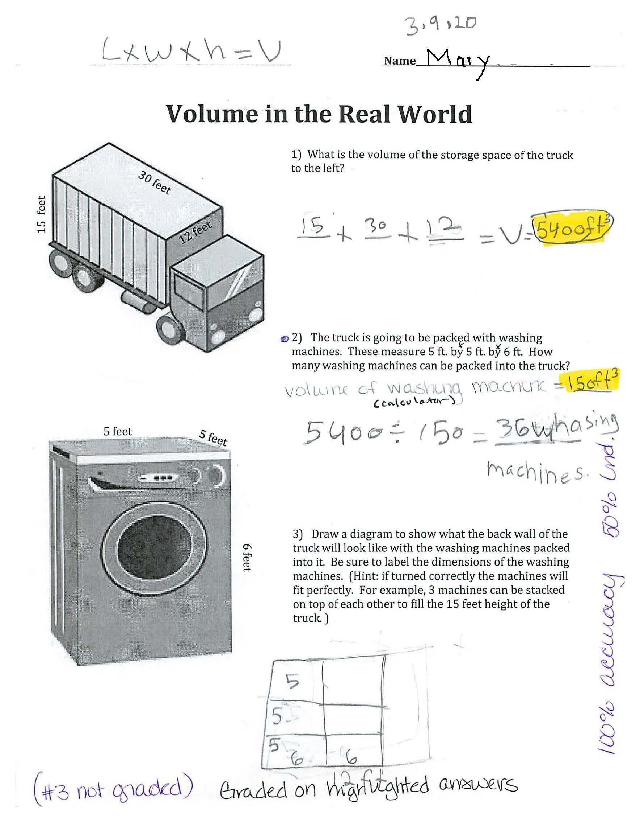Student's self-evaluation:
Student thought the assignment was medium in difficulty, she worked carefully and didn't need any help. She did her best work.