PISA 2012 Results
2012 Program for International Student Assessment (PISA)
January 2014
Massachusetts Department of Elementary and Secondary Education
75 Pleasant Street, Malden, MA 02148-4906
Phone 781-338-3000 TTY: N.E.T. Relay 800-439-2370
www.doe.mass.edu

This document was prepared by the
Massachusetts Department of Elementary and Secondary Education
Mitchell D. Chester, Ed.D.
Commissioner

The Massachusetts Department of Elementary and Secondary Education, an affirmative action employer, is committed to ensuring that all of its programs and facilities are accessible to all members of the public. We do not discriminate on the basis of age, color, disability, national origin, race, religion, sex, gender identity, or sexual orientation.

Inquiries regarding the Department’s compliance with Title IX and other civil rights laws may be directed to the
Human Resources Director, 75 Pleasant St., Malden, MA 02148-4906. Phone: 781-338-6105.

© 2013 Massachusetts Department of Elementary and Secondary Education
Permission is hereby granted to copy any or all parts of this document for non-commercial educational purposes. Please credit the “Massachusetts Department of Elementary and Secondary Education.”

This document printed on recycled paper

Massachusetts Department of Elementary and Secondary Education
75 Pleasant Street, Malden, MA 02148-4906
Phone 781-338-3000 TTY: N.E.T. Relay 800-439-2370
www.doe.mass.edu

Table of Contents

Executive Summary….………………………………………………………………………….……..2

Background on the PISA Assessment………………………………………………….……….....4

PISA 2012 Mathematics Literacy Results………………………………………………………….6

PISA 2012 Mathematics Performance by Subgroup……………………………………….……9

PISA 2012 Science Literacy Results………………………………………………………………10

PISA 2012 Science Literacy Performance by Subgroup………………………………………13

PISA 2012 Reading Literacy Results ……………………………………………………………..14

PISA 2012 Reading Literacy Performance by Subgroup……………………………………...17

Additional List of Resources……………………………………………………………………….18

Executive Summary

PISA is a system of international assessments that allows countries to compare outcomes of learning as students near the end of compulsory schooling. PISA has measured the performance of 15-year-old students in mathematics, science, and reading literacy every three years since 2000. In 2012, PISA was administered in 65 education systems, including all 34 member countries of the Organization for Economic Cooperation and Development (OECD) and 31 other countries and subnational education systems. Some countries also oversampled students at the subnational level to augment their national results with state or other regional results.

In the United States, Connecticut, Florida, and Massachusetts opted to have separate samples of public schools and public-school students included in PISA in order to obtain state-level results. Massachusetts’s average scores were higher than the U.S. and OECD average scores in all three subjects, and Connecticut’s average scores were higher than the OECD average scores in science and reading. In each participating education system, probability sampling was used to obtain a representative sample of all 15-year-old students, regardless of grade, educational track, or school program type.
PISA’s goal is to assess students’ preparation for the challenges of life as young adults. PISA assesses the application of knowledge in mathematics, science, and reading literacy to problems within a real-life context. PISA does not focus explicitly on curricular outcomes and uses the term “literacy” in each subject area to indicate its broad focus on the application of knowledge and skills.
PISA results are presented in terms of average scale scores and the percentage of 15-year-old students reaching selected proficiency levels, comparing the United States with other participating education systems. Results for the three U.S. states are also reported. For proficiency levels, results are reported in terms of the percentage reaching level 5 or above and the percentage below level 2. Higher proficiency levels represent the knowledge, skills, and capabilities needed to perform tasks of greater complexity. At levels 5 and 6, students demonstrate higher-level skills and are referred to as “top performers” in the subject. Conversely, students performing below level 2 are referred to as “low performers.”
All differences described here using PISA data are statistically significant at the .05 level. Differences that are not statistically significant are referred to as being “similar” or “not measurably different.”
Following are some highlights of the PISA 2012 assessment:
- Average scores in mathematics literacy ranged from 613 in Shanghai-China to 368 in Peru. Massachusetts’ average was higher than the OECD and U.S. averages and Connecticut’s was higher than the U.S. average but not measurably different than the OECD average. Florida’s average score (467) was lower than the OECD and U.S. averages.
- Average scores in science literacy ranged from 580 in Shanghai-China to 373 in Peru. Massachusetts and Connecticut science literacy average scores were higher than the OECD and U.S. averages. Florida’s average score (485) was lower than the OECD average and not measurably different than the U.S. average.
- Average scores in in reading literacy ranged from 570 in Shanghai-China to 384 in Peru. Massachusetts and Connecticut reading literacy average scores were higher than the OECD and U.S. averages. Massachusetts was outperformed by only three education systems and Connecticut by four. Florida’s average score (492) was not measurably different than the OECD or U.S. average

Background on the PISA Assessment

“What is important for citizens to know and be able to do?” That is the question that underlies the triennial survey of 15-year-old students around the world known as the Programme for International Student Assessment (PISA). PISA assesses the extent to which students near the end of compulsory education have acquired key knowledge and skills that are essential for full participation in modern societies. The assessment, which focuses on reading, mathematics, science and problem solving, does not just ascertain whether students can reproduce knowledge; it also examines how well students can extrapolate from what they have learned and apply that knowledge in unfamiliar settings, both in and outside of school. This approach reflects the fact that modern economies reward individuals not for what they know, but for what they can do with what they know.

PISA is an ongoing program that offers insights for education policy and practice, and that helps monitor trends in students’ acquisition of knowledge and skills across countries and economies and in different demographic subgroups within each country. PISA results reveal what is possible in education by showing what students in the highest-performing and most rapidly improving school systems can do. The findings allow policy makers around the world to gauge the knowledge and skills of students in their own countries in comparison with those in other countries, set policy targets against measurable goals achieved by other school systems, and learn from policies and practices applied elsewhere.

While PISA cannot identify cause-and-effect relationships between policies/practices and student outcomes, it can show educators, policy makers and the interested public how education systems are similar and different – and what that means for students.

Differences between countries in the nature and extent of pre-primary education and care, in the age of entry into formal schooling, in the structure of the school system, and in the prevalence of grade repetition mean that school grade levels are often not good indicators of where students are in their cognitive development. To better compare student performance internationally, PISA targets a specific age of students. PISA students are aged between 15 years 3 months and 16 years 2 months at the time of the assessment, and have completed at least 6 years of formal schooling.

The population of participating students is defined by strict technical standards, as are the students who are excluded from participating. The overall exclusion rate within a country was required to be below 5% to ensure that, under reasonable assumptions, any distortions in national mean scores would remain within plus or minus 5 score points, i.e., typically within the order of magnitude of 2 standard errors of sampling. Exclusion could take place either through the schools that participated or the students who participated within schools. There are several reasons why a school or a student could be excluded from PISA. Schools might be excluded because they are situated in remote regions and are inaccessible, because they are very small, or because of organizational or operational factors that precluded participation. Students might be excluded because of intellectual disability or limited proficiency in the language of the assessment.

Paper-based tests were used, with assessments lasting a total of two hours for each student. Test items were a mixture of multiple-choice items and questions requiring students to construct their own responses. The items were organized in groups based on a passage setting out a real-life situation. A total of about 390 minutes of test items were covered, with different students taking different combinations of test items.

In addition, students answered a background questionnaire that sought information about themselves, their homes and their school and learning experiences, which took 30 minutes to complete. School principals were given a questionnaire, which covered the school system and the learning environment.

PISA results are reported in the following methods: average scale scores ranging from 1-1000 for all domains; proficiency levels which report the percentages of students scoring in 6 levels in mathematics and science literacy and 7 levels in reading literacy; trends which illustrated the change between average scores from previous years; and sub-group scores based on international (e.g., gender and economic, social and cultural status (ESCS) and U.S. specific variables ( e.g., race/ethnicity and income).

The year 2012 was the first time that Massachusetts chose to participate as a separate educational entity; therefore no trend data are available. Following are additional resources for in-depth investigation: http://nces.ed.gov/surveys/pisa/ and http://www.oecd.org/pisa/.

PISA 2012 Mathematics Literacy Results

Table 1. Average scores of 15-year-old students on PISA mathematics literacy scale, by education system: 2012

Education system | Average score |  |  |  |  | s.e.* |  |  |  |  |  |  |  | Education system |  |  |  | Average score |  |  |  |  |  |  | s.e.*
OECD average |  | 494 |  |  |  |  |  |  | 0.5
Shanghai-China |  | 613 |  |  |  |  |  |  | 3.3 |  |  |  |  |  |  |  | Lithuania |  |  |  | 479 |  |  |  |  | 2.6
Singapore |  | 573 |  |  |  |  |  |  | 1.3 |  |  |  |  |  |  |  | Sweden |  |  |  | 478 |  |  |  |  | 2.3
Hong Kong-China |  | 561 |  |  |  |  |  |  | 3.2 |  |  |  |  |  |  |  | Hungary |  |  |  | 477 |  |  |  |  | 3.2
Chinese Taipei |  | 560 |  |  |  |  |  |  | 3.3 |  |  |  |  |  |  |  | Croatia |  |  |  | 471 |  |  |  |  | 3.5
Korea, Republic of |  | 554 |  |  |  |  |  |  | 4.6 |  |  |  |  |  |  |  | Israel |  |  |  | 466 |  |  |  |  | 4.7
Macao-China |  | 538 |  |  |  |  |  |  | 1.0 |  |  |  |  |  |  |  | Greece |  |  |  | 453 |  |  |  |  | 2.5
Japan |  | 536 |  |  |  |  |  |  | 3.6 |  |  |  |  |  |  |  | Serbia, Republic of |  |  |  | 449 |  |  |  |  | 3.4
Liechtenstein |  | 535 |  |  |  |  |  |  | 4.0 |  |  |  |  |  |  |  | Turkey |  |  |  | 448 |  |  |  |  | 4.8
Switzerland |  | 531 |  |  |  |  |  |  | 3.0 |  |  |  |  |  |  |  | Romania |  |  |  | 445 |  |  |  |  | 3.8
Netherlands |  | 523 |  |  |  |  |  |  | 3.5 |  |  |  |  |  |  |  | Cyprus |  |  |  | 440 |  |  |  |  | 1.1
Estonia |  | 521 |  |  |  |  |  |  | 2.0 |  |  |  |  |  |  |  | Bulgaria |  |  |  | 439 |  |  |  |  | 4.0
Finland |  | 519 |  |  |  |  |  |  | 1.9 |  |  |  |  |  |  |  | United Arab Emirates |  |  |  | 434 |  |  |  |  | 2.4
Canada |  | 518 |  |  |  |  |  |  | 1.8 |  |  |  |  |  |  |  | Kazakhstan |  |  |  | 432 |  |  |  |  | 3.0
Poland |  | 518 |  |  |  |  |  |  | 3.6 |  |  |  |  |  |  |  | Thailand |  |  |  | 427 |  |  |  |  | 3.4
Belgium |  | 515 |  |  |  |  |  |  | 2.1 |  |  |  |  |  |  |  | Chile |  |  |  | 423 |  |  |  |  | 3.1
Germany |  | 514 |  |  |  |  |  |  | 2.9 |  |  |  |  |  |  |  | Malaysia |  |  |  | 421 |  |  |  |  | 3.2
Vietnam |  | 511 |  |  |  |  |  |  | 4.8 |  |  |  |  |  |  |  | Mexico |  |  |  | 413 |  |  |  |  | 1.4
Austria |  | 506 |  |  |  |  |  |  | 2.7 |  |  |  |  |  |  |  | Montenegro, Republic of |  |  |  | 410 |  |  |  |  | 1.1
Australia |  | 504 |  |  |  |  |  |  | 1.6 |  |  |  |  |  |  |  | Uruguay |  |  |  | 409 |  |  |  |  | 2.8
Ireland |  | 501 |  |  |  |  |  |  | 2.2 |  |  |  |  |  |  |  | Costa Rica |  |  |  | 407 |  |  |  |  | 3.0
Slovenia |  | 501 |  |  |  |  |  |  | 1.2 |  |  |  |  |  |  |  | Albania |  |  |  | 394 |  |  |  |  | 2.0
Denmark |  | 500 |  |  |  |  |  |  | 2.3 |  |  |  |  |  |  |  | Brazil |  |  |  | 391 |  |  |  |  | 2.1
New Zealand |  | 500 |  |  |  |  |  |  | 2.2 |  |  |  |  |  |  |  | Argentina |  |  |  | 388 |  |  |  |  | 3.5
Czech Republic |  | 499 |  |  |  |  |  |  | 2.9 |  |  |  |  |  |  |  | Tunisia |  |  |  | 388 |  |  |  |  | 3.9
France |  | 495 |  |  |  |  |  |  | 2.5 |  |  |  |  |  |  |  | Jordan |  |  |  | 386 |  |  |  |  | 3.1
United Kingdom |  | 494 |  |  |  |  |  |  | 3.3 |  |  |  |  |  |  |  | Colombia |  |  |  | 376 |  |  |  |  | 2.9
Iceland |  | 493 |  |  |  |  |  |  | 1.7 |  |  |  |  |  |  |  | Qatar |  |  |  | 376 |  |  |  |  | 0.8
Latvia |  | 491 |  |  |  |  |  |  | 2.8 |  |  |  |  |  |  |  | Indonesia |  |  |  | 375 |  |  |  |  | 4.0
Luxembourg |  | 490 |  |  |  |  |  |  | 1.1 |  |  |  |  |  |  |  | Peru |  |  |  | 368 |  |  |  |  | 3.7
Norway |  | 489 |  |  |  |  |  |  | 2.7
Portugal |  | 487 |  |  |  |  |  |  | 3.8 |  |  |  |  |  |  |  | U.S. state education systems
Italy |  | 485 |  |  |  |  |  |  | 2.0
Spain |  | 484 |  |  |  |  |  |  | 1.9
Russian Federation |  | 482 |  |  |  |  |  |  | 3.0 |  |  |  |  |  |  |  | Massachusetts |  |  |  | 514 |  |  |  |  | 6.2
Slovak Republic |  | 482 |  |  |  |  |  |  | 3.4 |  |  |  |  |  |  |  | Connecticut |  |  |  | 506 |  |  |  |  | 6.2
United States |  | 481 |  |  |  |  |  |  | 3.6 |  |  |  |  |  |  |  | Florida |  |  |  | 467 |  |  |  |  | 5.8
* standard of error

In 2012, Massachusetts’ mathematics literacy average scale score of 514 was lower than nine education systems and statistically tied with 13.

Table 2. Average scores of 15-year-old students on PISA mathematics literacy scale in Massachusetts public schools compared with other participating education systems: 2012

Education systems higher than Massachusetts
Shanghai-China |  |  |  |  | Macao-China
Singapore |  |  |  |  | Japan
Hong Kong-China |  |  |  |  | Liechtenstein
Chinese Taipei |  |  |  |  | Switzerland
Korea, Republic of
Education systems not measurably different from Massachusetts
Netherlands |  |  |  |  | Vietnam
Estonia |  |  |  |  | Connecticut
Finland |  |  |  |  | Austria
Canada |  |  |  |  | Australia
Poland |  |  |  |  | Ireland
Belgium |  |  |  |  | Slovenia
Germany
Education systems lower than Massachusetts
Denmark |  |  |  |  | Serbia, Republic of
New Zealand |  |  |  |  | Turkey
Czech Republic |  |  |  |  | Romania
France |  |  |  |  | Cyprus
OECD average |  |  |  |  | Bulgaria
United Kingdom |  |  |  |  | United Arab Emirates
Iceland |  |  |  |  | Kazakhstan
Latvia |  |  |  |  | Thailand
Luxembourg |  |  |  |  | Chile
Norway |  |  |  |  | Malaysia
Portugal |  |  |  |  | Mexico
Italy |  |  |  |  | Montenegro, Republic of
Spain |  |  |  |  | Uruguay
Russian Federation |  |  |  |  | Costa Rica
Slovak Republic |  |  |  |  | Albania
United States |  |  |  |  | Brazil
Lithuania |  |  |  |  | Argentina
Sweden |  |  |  |  | Tunisia
Hungary |  |  |  |  | Jordan
Croatia |  |  |  |  | Colombia
Florida |  |  |  |  | Qatar
Israel |  |  |  |  | Indonesia
Greece |  |  |  |  | Peru
NOTE: All average scores reported as higher or lower than the Massachusetts average score are different at the .05 level of statistical significance. The OECD average is the average of the national averages of the OECD member countries, with each country weighted equally. Italics indicate non-OECD countries and education systems.

Figure 1. Percentage of 15-year-old students performing at PISA mathematics literacy
proficiency levels 5 and above and below level 2, by education system: 2012
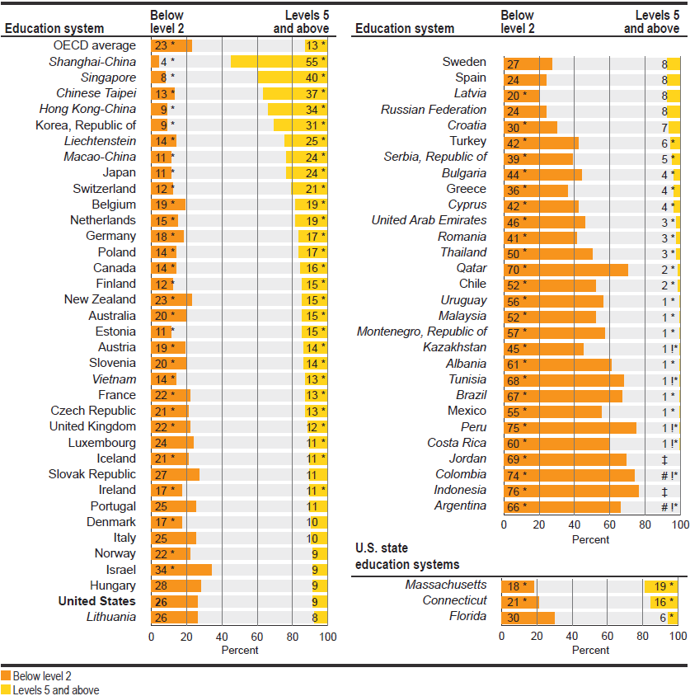

# Rounds to zero.
! Interpret data with caution. Estimate is unstable due to high coefficient of variation.
‡ Reporting standards not met.
PISA 2012 Mathematics Performance by Sub-Group and School-Wide Low Income Level

Table 3. Average scores of 15-year-old students on PISA mathematics literacy scale in Massachusetts public schools, by various subgroups: 2012

Reporting groups | Average score
Massachusetts average | 514 | *
U.S. average | 481 | **
OECD average | 494 | ***
Sex
Female | 509 | *
Male | 518 | *
Race/ethnicity
White | 530 | *
Black | 458 | **
Hispanic | 446 | *
Asian | 569 | *
Percentage of students in enrolled schools eligible for free or reduced-price lunch
Less than 10 percent | 583 | *
10 to 24.9 percent | 514 | *
25 to 49.9 percent | 493 | ***
50 to 74.9 percent | 465 | **
75 percent or more | 457 | **
* p<.05. Significantly different from both the U.S. and OECD averages at the .05 level of statistical significance.
** p<.05. Significantly different from the OECD average at the .05 level of statistical significance.
*** p<.05. Significantly different from the U.S. average at the .05 level of statistical significance.

PISA 2012 Science Literacy Results
Table 4. Average scores of 15-year-old students on PISA science literacy scale, by education system: 2012

Education system | Average  score |  | s.e.* |  | Education system | Average score |  | s.e.*
OECD average | 501 |  | 0.5
Shanghai-China | 580 |  | 3.0 |  | Russian Federation | 486 |  | 2.9
Hong Kong-China | 555 |  | 2.6 |  | Sweden | 485 |  | 3.0
Singapore | 551 |  | 1.5 |  | Iceland | 478 |  | 2.1
Japan | 547 |  | 3.6 |  | Slovak Republic | 471 |  | 3.6
Finland | 545 |  | 2.2 |  | Israel | 470 |  | 5.0
Estonia | 541 |  | 1.9 |  | Greece | 467 |  | 3.1
Korea, Republic of | 538 |  | 3.7 |  | Turkey | 463 |  | 3.9
Vietnam | 528 |  | 4.3 |  | United Arab Emirates | 448 |  | 2.8
Poland | 526 |  | 3.1 |  | Bulgaria | 446 |  | 4.8
Canada | 525 |  | 1.9 |  | Chile | 445 |  | 2.9
Liechtenstein | 525 |  | 3.5 |  | Serbia, Republic of | 445 |  | 3.4
Germany | 524 |  | 3.0 |  | Thailand | 444 |  | 2.9
Chinese Taipei | 523 |  | 2.3 |  | Romania | 439 |  | 3.3
Netherlands | 522 |  | 3.5 |  | Cyprus | 438 |  | 1.2
Ireland | 522 |  | 2.5 |  | Costa Rica | 429 |  | 2.9
Australia | 521 |  | 1.8 |  | Kazakhstan | 425 |  | 3.0
Macao-China | 521 |  | 0.8 |  | Malaysia | 420 |  | 3.0
New Zealand | 516 |  | 2.1 |  | Uruguay | 416 |  | 2.8
Switzerland | 515 |  | 2.7 |  | Mexico | 415 |  | 1.3
Slovenia | 514 |  | 1.3 |  | Montenegro, Republic o | 410 |  | 1.1
United Kingdom | 514 |  | 3.4 |  | Jordan | 409 |  | 3.1
Czech Republic | 508 |  | 3.0 |  | Argentina | 406 |  | 3.9
Austria | 506 |  | 2.7 |  | Brazil | 405 |  | 2.1
Belgium | 505 |  | 2.1 |  | Colombia | 399 |  | 3.1
Latvia | 502 |  | 2.8 |  | Tunisia | 398 |  | 3.5
France | 499 |  | 2.6 |  | Albania | 397 |  | 2.4
Denmark | 498 |  | 2.7 |  | Qatar | 384 |  | 0.7
United States | 497 |  | 3.8 |  | Indonesia | 382 |  | 3.8
Spain | 496 |  | 1.8 |  | Peru | 373 |  | 3.6
Lithuania | 496 |  | 2.6
Norway | 495 |  | 3.1
Hungary | 494 |  | 2.9 |  | U.S. state education systems
Italy | 494 |  | 1.9
Croatia | 491 |  | 3.1 |  | Massachusetts | 527 |  | 6.0
Luxembourg | 491 |  | 1.3 |  | Connecticut | 521 |  | 5.7
Portugal | 489 |  | 3.7 |  | Florida | 485 |  | 6.4

* standard of error

In 2012, Massachusetts’s science literacy average scale score of 527 was lower than six education systems and statistically tied with 15.

Table 5. Average scores of 15-year-old students on PISA science literacy scale in Massachusetts public schools compared with other participating education systems: 2012

Education systems higher than Massachusetts
Shanghai-China | Japan
Hong Kong-China | Finland
Singapore | Estonia
Education systems not measurably different from Massachusetts
Korea, Republic of | Ireland
Vietnam | Australia
Poland | Connecticut
Canada | Macao-China
Liechtenstein | New Zealand
Germany | Switzerland
Chinese Taipei | United Kingdom
Netherlands
Education systems lower than Massachusetts
Slovenia | Turkey
Czech Republic | United Arab Emirates
Austria | Bulgaria
Belgium | Chile
Latvia | Serbia, Republic of
OECD average | Thailand
France | Romania
Denmark | Cyprus
United States | Costa Rica
Spain | Kazakhstan
Lithuania | Malaysia
Norway | Uruguay
Hungary | Mexico
Italy | Montenegro, Republic of
Croatia | Jordan
Luxembourg | Argentina
Portugal | Brazil
Russian Federation | Colombia
Florida | Tunisia
Sweden | Albania
Iceland | Qatar
Slovak Republic | Indonesia
Israel | Peru
Greece
NOTE: All average scores reported as higher or lower than the Massachusetts average score are different at the .05 level of statistical significance. The OECD average is the average of the national averages of the OECD member countries, with each country weighted equally. Italics indicate non-OECD countries and education systems.

Figure 2. Percentage of 15-year-old students performing at PISA science literacy proficiency levels 5 and above and below level 2, by education system: 2012

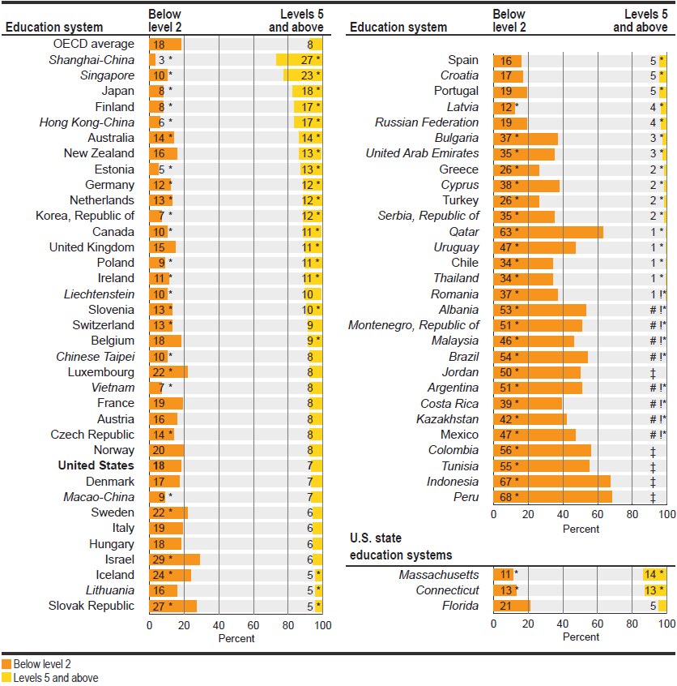

# Rounds to zero.
! Interpret data with caution. Estimate is unstable due to high coefficient of variation.
‡ Reporting standards not met.

PISA 2012 Science Performance by Sub-Group and School-Wide Low Income Level

Table 6. Average scores of 15-year-old students on PISA science literacy scale in Massachusetts public schools, by various subgroups: 2012

Reporting groups | Average score
Massachusetts average | 527 | *
U.S. average | 497
OECD average | 501
Sex
Female | 526 | *
Male | 529 | *
Race/ethnicity
White | 545 | *
Black | 466 | **
Hispanic | 460 | *
Asian | 580 | *
Percentage of students in enrolled schools eligible for free or reduced-price lunch
Less than 10 percent | 596 | *
10 to 24.9 percent | 531 | *
25 to 49.9 percent | 510
50 to 74.9 percent | 481
75 percent or more | 461 | *
* p<.05. Significantly different from both the U.S. and OECD averages at the .05 level of statistical significance.
** p<.05. Significantly different from the OECD average at the .05 level of statistical significance.

PISA 2012 Reading Literacy Results

Table 7. Average scores of 15-year-old students on PISA reading literacy scale, by education system: 2012

Education system | Average score | s.e.* |  |  |  |  | Education system |  | Average score |  | s.e.*
OECD average | 496 |  |  | 0.5
Shanghai-China | 570 |  |  | 2.9 |  |  |  | Iceland |  | 483 |  |  |  | 1.8
Hong Kong-China | 545 |  |  | 2.8 |  |  |  | Slovenia |  | 481 |  |  |  | 1.2
Singapore | 542 |  |  | 1.4 |  |  |  | Lithuania |  | 477 |  |  |  | 2.5
Japan | 538 |  |  | 3.7 |  |  |  | Greece |  | 477 |  |  |  | 3.3
Korea, Republic of | 536 |  |  | 3.9 |  |  |  | Turkey |  | 475 |  |  |  | 4.2
Finland | 524 |  |  | 2.4 |  |  |  | Russian Federation |  | 475 |  |  |  | 3.0
Ireland | 523 |  |  | 2.6 |  |  |  | Slovak Republic |  | 463 |  |  |  | 4.2
Chinese Taipei | 523 |  |  | 3.0 |  |  |  | Cyprus |  | 449 |  |  |  | 1.2
Canada | 523 |  |  | 1.9 |  |  |  | Serbia, Republic of |  | 446 |  |  |  | 3.4
Poland | 518 |  |  | 3.1 |  |  |  | United Arab Emirates |  | 442 |  |  |  | 2.5
Estonia | 516 |  |  | 2.0 |  |  |  | Chile |  | 441 |  |  |  | 2.9
Liechtenstein | 516 |  |  | 4.1 |  |  |  | Thailand |  | 441 |  |  |  | 3.1
New Zealand | 512 |  |  | 2.4 |  |  |  | Costa Rica |  | 441 |  |  |  | 3.5
Australia | 512 |  |  | 1.6 |  |  |  | Romania |  | 438 |  |  |  | 4.0
Netherlands | 511 |  |  | 3.5 |  |  |  | Bulgaria |  | 436 |  |  |  | 6.0
Belgium | 509 |  |  | 2.2 |  |  |  | Mexico |  | 424 |  |  |  | 1.5
Switzerland | 509 |  |  | 2.6 |  |  |  | Montenegro, Republic of |  | 422 |  |  |  | 1.2
Macao-China | 509 |  |  | 0.9 |  |  |  | Uruguay |  | 411 |  |  |  | 3.2
Vietnam | 508 |  |  | 4.4 |  |  |  | Brazil |  | 410 |  |  |  | 2.1
Germany | 508 |  |  | 2.8 |  |  |  | Tunisia |  | 404 |  |  |  | 4.5
France | 505 |  |  | 2.8 |  |  |  | Colombia |  | 403 |  |  |  | 3.4
Norway | 504 |  |  | 3.2 |  |  |  | Jordan |  | 399 |  |  |  | 3.6
United Kingdom | 499 |  |  | 3.5 |  |  |  | Malaysia |  | 398 |  |  |  | 3.3
United States | 498 |  |  | 3.7 |  |  |  | Indonesia |  | 396 |  |  |  | 4.2
Denmark | 496 |  |  | 2.6 |  |  |  | Argentina |  | 396 |  |  |  | 3.7
Czech Republic | 493 |  |  | 2.9 |  |  |  | Albania |  | 394 |  |  |  | 3.2
Italy | 490 |  |  | 2.0 |  |  |  | Kazakhstan |  | 393 |  |  |  | 2.7
Austria | 490 |  |  | 2.8 |  |  |  | Qatar |  | 388 |  |  |  | 0.8
Latvia | 489 |  |  | 2.4 |  |  |  | Peru |  | 384 |  |  |  | 4.3
Hungary | 488 |  |  | 3.2
Spain | 488 |  |  | 1.9
Luxembourg | 488 |  |  | 1.5 |  |  |  | U.S. state education systems
Portugal | 488 |  |  | 3.8
Israel | 486 |  |  | 5.0 |  |  |  | Massachusetts |  | 527 |  |  |  | 6.1
Croatia | 485 |  |  | 3.3 |  |  |  | Connecticut |  | 521 |  |  |  | 6.5
Sweden | 483 |  |  | 3.0 |  |  |  | Florida |  | 492 |  |  |  | 6.1
* standard of error

In 2012, Massachusetts’s reading literacy average scale score of 527 was lower than three education systems and statistically tied with 15.

Table 8. Average scores of 15-year-old students on PISA reading literacy scale in Massachusetts public schools compared with other participating education systems: 2012
Education systems higher than Massachusetts
Shanghai-China | Singapore
Hong Kong-China
Education systems not measurably different from Massachusetts
Japan | Canada
Korea, Republic of | Connecticut
Finland | Poland
Ireland | Estonia
Chinese Taipei | Liechtenstein
Education systems lower than Massachusetts
New Zealand | Lithuania
Australia | Greece
Netherlands | Turkey
Belgium | Russian Federation
Switzerland | Slovak Republic
Macao-China | Cyprus
Vietnam | Serbia, Republic of
Germany | United Arab Emirates
France | Chile
Norway | Thailand
United Kingdom | Costa Rica
United States | Romania
OECD average | Bulgaria
Denmark | Mexico
Czech Republic | Montenegro, Republic of
Florida | Uruguay
Italy | Brazil
Austria | Tunisia
Latvia | Colombia
Hungary | Jordan
Spain | Malaysia
Luxembourg | Indonesia
Portugal | Argentina
Israel | Albania
Croatia | Kazakhstan
Sweden | Qatar
Iceland | Peru
Slovenia
NOTE: All average scores reported as higher or lower than the Massachusetts average score are different at the .05 level of statistical significance. The OECD average is the average of the national averages of the OECD member countries, with each country weighted equally. Italics indicate
non-OECD countries and education systems.

Figure 3. Percentage of 15-year-old students performing at PISA reading literacy
proficiency levels 5 and above and below level 2, by education system: 2012

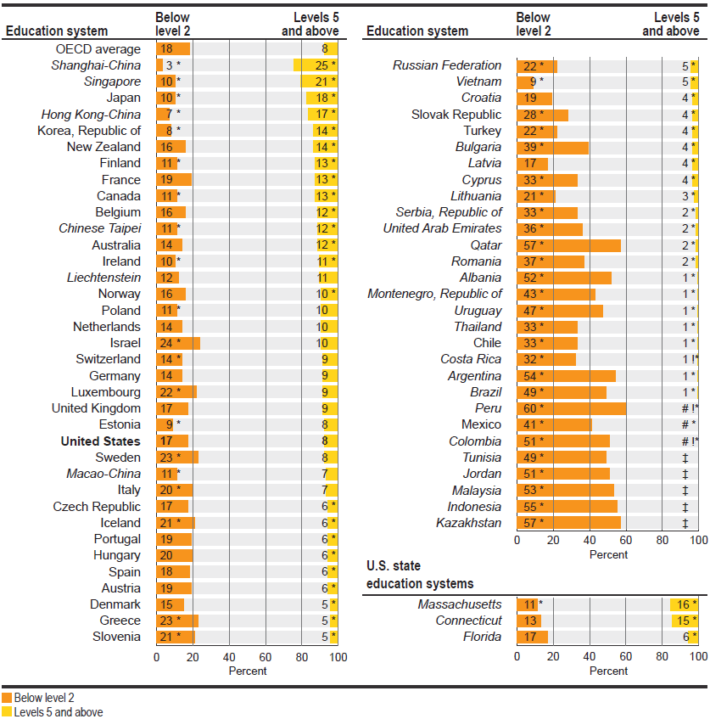

# Rounds to zero.
! Interpret data with caution. Estimate is unstable due to high coefficient of variation.
‡ Reporting standards not met.

PISA 2012 Reading Performance by Sub-Group and School-Wide Low Income Level

Table 9. Average scores of 15-year-old students on PISA reading literacy scale in Massachusetts public schools, by various subgroups: 2012

Reporting groups | Average score
Massachusetts average | 527 | *
U.S. average | 498
OECD average | 496
Sex
Female | 542 | *
Male | 511 | **
Race/ethnicity
White | 540 | *
Black | 476
Hispanic | 475
Asian | 584 | *
Percentage of students in enrolled schools eligible for free or reduced-price lunch
Less than 10 percent | 590 | *
10 to 24.9 percent | 527 | *
25 to 49.9 percent | 507
50 to 74.9 percent | 488
75 percent or more | 477
* p<.05. Significantly different from both the U.S. and OECD averages at the .05 level of statistical significance.
** p<.05. Significantly different from the OECD average at the .05 level of statistical significance.

Additional Resources

http://nces.ed.gov/surveys/international/

http://nces.ed.gov/surveys/pisa/

http://nces.ed.gov/surveys/pisa/idepisa/

http://www.oecd.org/pisa/

http://www.youtube.com/watch?v=q1I9tuScLUA

