Burlington Public Schools
MCAS - Test Administrator Handout

START HERE

The following document explains steps the Test Administrator should take BEFORE starting to read the script from the Test Administrator Manual and contains important reminders.

Login to Pearson Access Next (PAN):
Dress Rehearsal Screen

Live Testing Screen

Test Administrator Login ID: [your email address]

Test Administrator Password: [set by you]
*If you need a password reset, try using the “I forgot my password” link on the Pearson Access Next login screen.

MCAS Pearson Access Next Tutorial

Steps before testing starts and before you read the script:
- Distribute student iPads and instruct students to open the TestNav app. If there are any iPads that do not have TestNav, or students whose iPads are not working properly, please connect with a member of your building’s IT Support Team before moving on.
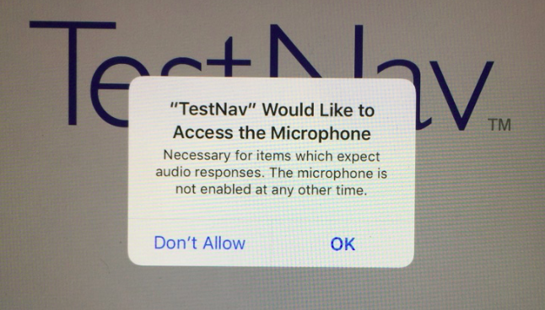
- A student may be prompted with a request for TestNav to access the iPads microphone. Please instruct the students to click OK.

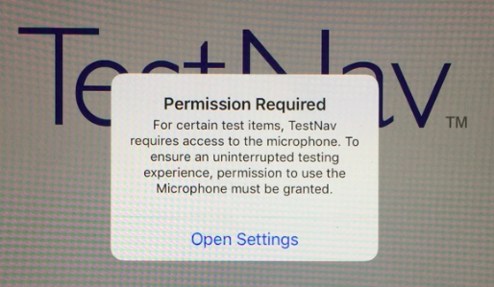
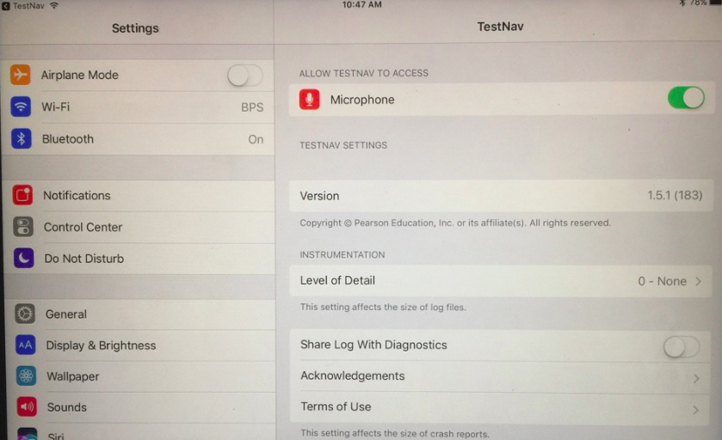
If the students click Don’t Allow, then they will see the screen on the lower left. They need to click Open Settings and then enable the microphone as shown in the lower right.

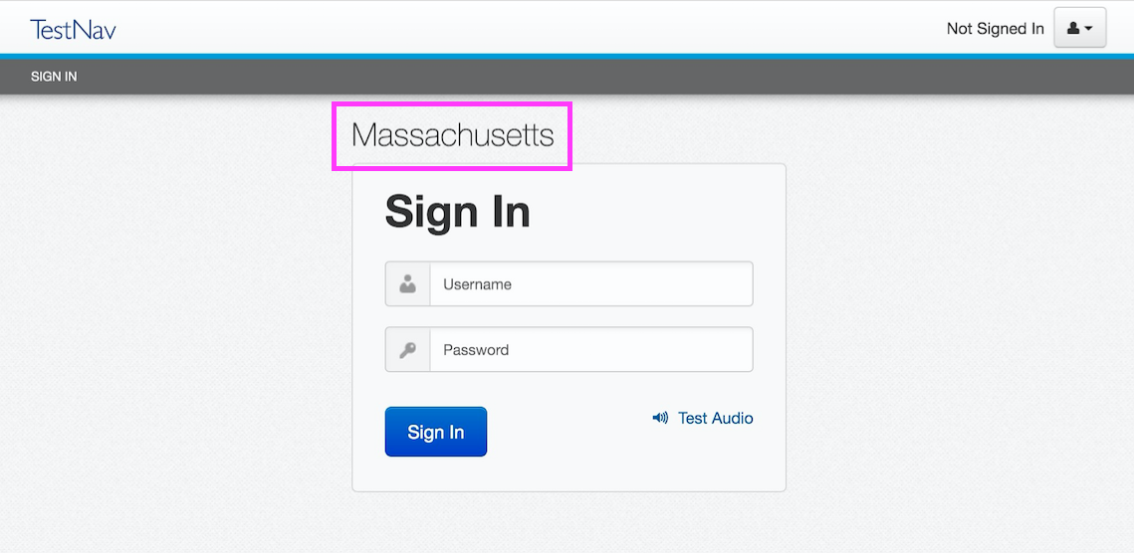
- The first time the students use TestNav they’ll be prompted to choose a testing location. They need to choose Massachusetts. If they do, then they should see the word Massachusetts above the Sign In area.

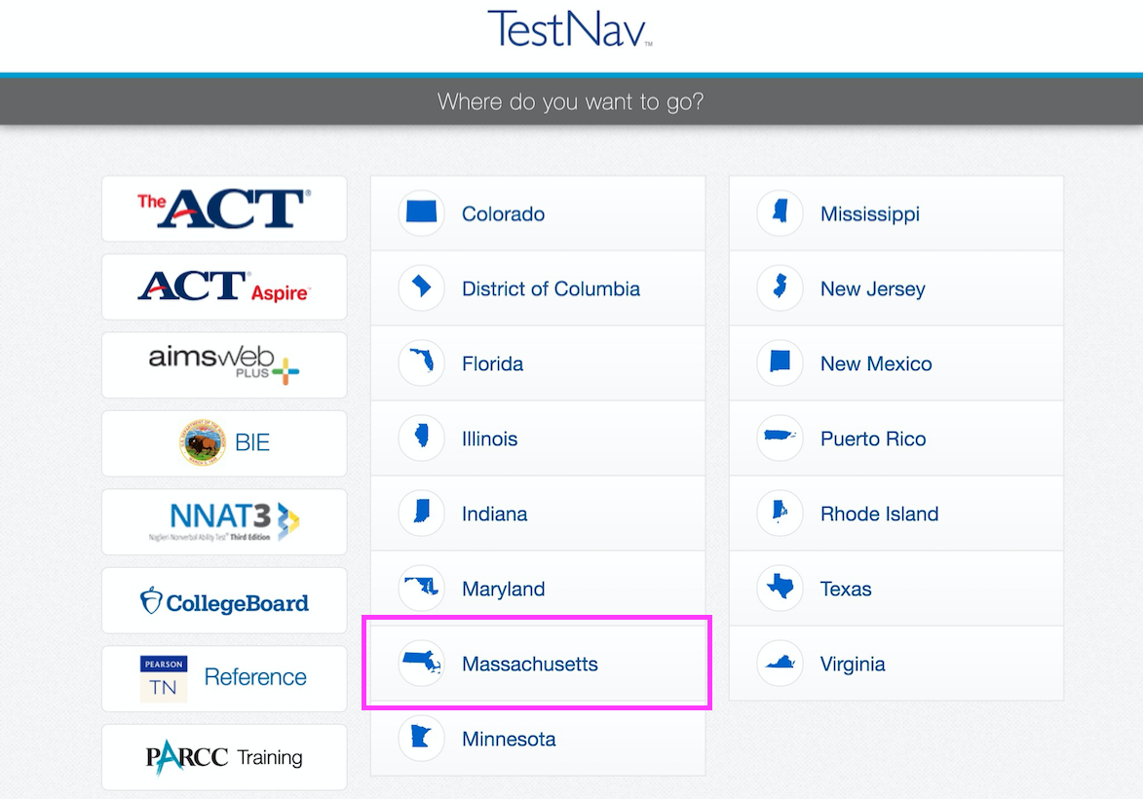
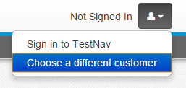
If it shows something other than Massachusetts, students can switch to the MA sign in screen by clicking the button in the top right corner of the screen and selecting Choose a different customer. When asked where they want to go, they will select Massachusetts.
- Now that the students are all on the MA sign in screen, you should login to PAN. Once logged in, you will navigate to the session control page add today’s session.
(If you do not know how to navigate to the Students In Sessions section and pull up your
sessions, please refer to the PAN Tutorial which contains the step-by-step instructions. The tutorial is linked at the top of this page)

- Once you have navigated to the session control screen and added your session, you may now click the green start button if this is the first day of testing. You will see the screen refresh and the session lock / unlock icons will appear. Unlock all students and then lock the individual students that are absent.
(If you do not know how to lock/unlock sessions or resume students, please refer to the PAN Tutorial which contains the step-by-step instructions. The tutorial is linked at the top of this page)

- Review the following Test Administrator Notes before starting the script…

  - We are only testing one session per day, so be sure only unlock one testing session at a time.

  - The manual mentions stopping ½ way through the session to take a break. The break is not required and is at the Test Administrator’s discretion.

  - At the end of the session, if there are students who need additional time, make sure they logout of TestNav. Make sure they do not submit answers for the session they will continue working on.

  - At the conclusion of the session, make sure all students who have finished the session show a status of Completed and all students who require extra time show a status of Exited. Once you have confirmed that all students have logged out of TestNav, lock all students in PAN. You do not need to click the stop button. We will click that centrally after all sessions have been completed and all makeups are completed.

  - Troubleshooting and Support Reminder
    - If a student is experiencing a technology issue with the test, please follow the three troubleshooting steps before contacting the support team.
      - Change Questions: Instruct the student to visit the previous or next question, and then return the question they were working.
      - Logout and Login: Instruct the student to logout of Testnav. This is done by clicking the icon in upper right corner of the application and selecting sign out of TestNav. You will need to resume the student in PAN before they can login.
      - Reboot the device: Instruct the student to logout of Testnav. Then ask them to reboot the device. One the devices restarts, have the student log back into the session. You will need to resume the student in PAN before they can login.
    - If the steps above do not resolve the problem, contact one of the building’s support members.

- You can now begin the script from the Test Administrator Manual.

