Burlington Public Schools
MCAS - Pearson Access Next Tutorial
The following tutorial showcases how to login to Pearson Access Next (PAN), pull up your session on the screen, and control student tests during testing.

Part 1 - Login to PAN
Dress Rehearsal Screen (Brown Site)

Live Testing (Blue Site)

Click the Sign In button
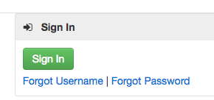
You will be brought to a screen asking for your username and password.
Reminder: Your Login ID for both systems is your BPS email address
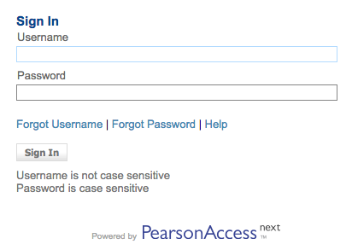

Once logged in, look at the bar across the top of the screen and make sure it has the following window selected.

Part 2 - Pull Up and Prepare Your Session
Once you are logged into PAN, click Select an action under the Testing icon.
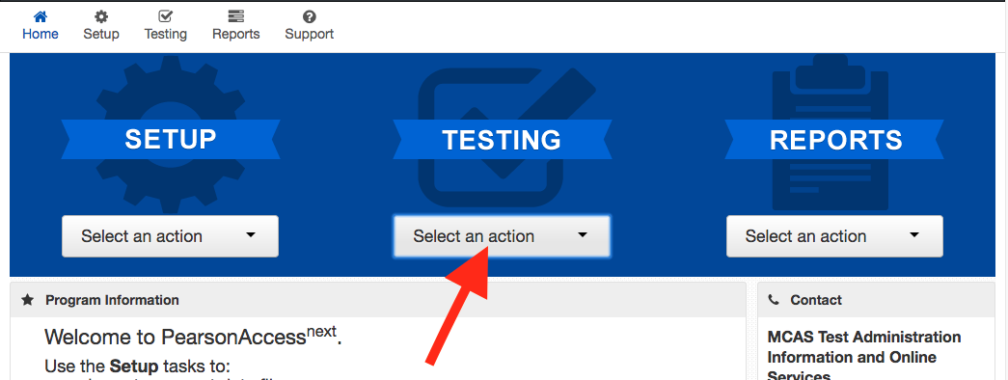
Click Students in Sessions
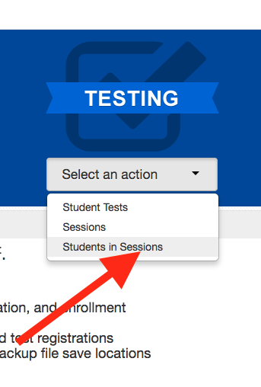

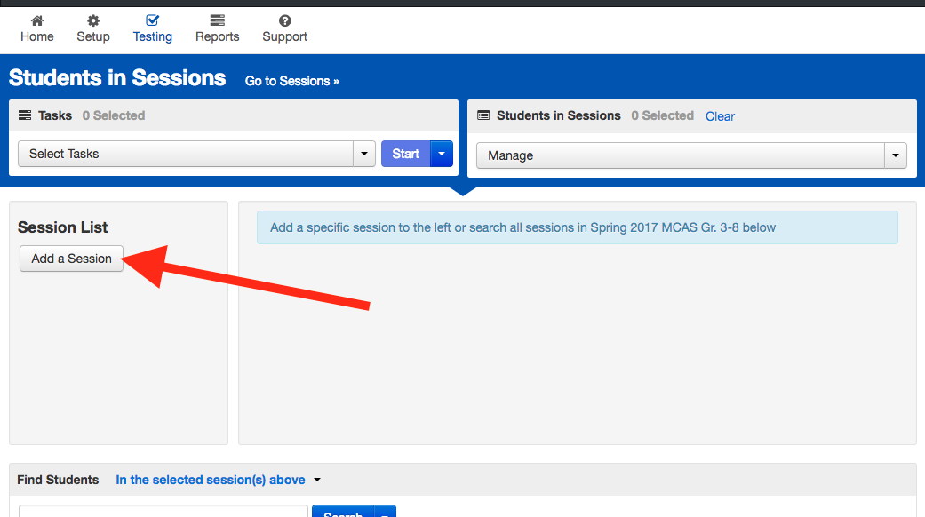
Click the Add a Session button

Type your session’s name. The name of your session can be found in your MCAS Packet. As you type, the lists of sessions below will begin to fill in. Select your session and click the Add Selected button.
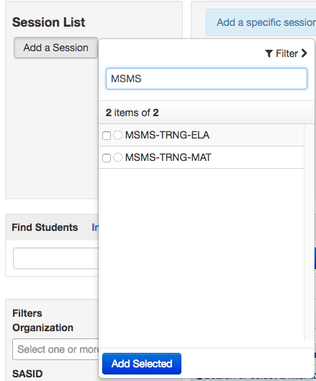
You should see the screen refresh and look similar to the following image.
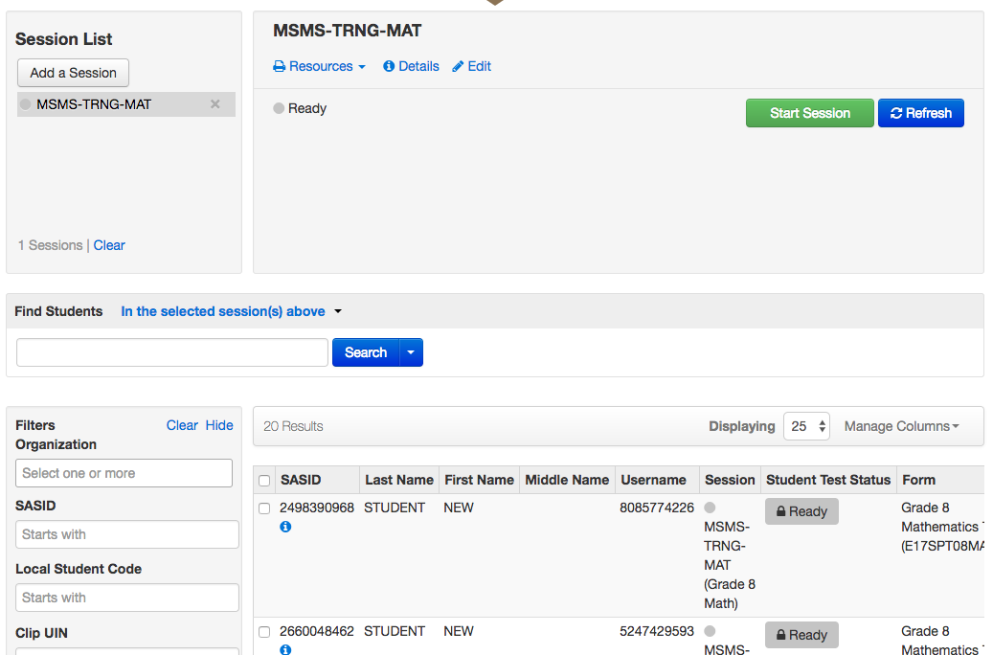
The first day of testing for a subject, you’ll need to click the green Start Session button. You will never click the grey Stop Session button. Stopping sessions will be taken care of centrally after all testing has been completed.

Once a session has been started, the screen will refresh again and should look similar to the following.
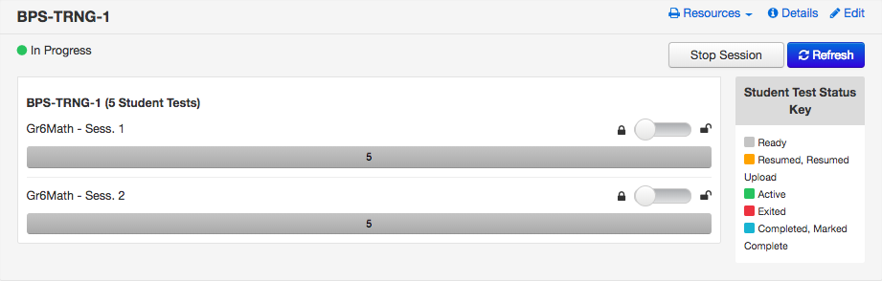

To begin testing you will need to unlock student tests by clicking the toggle button between the two lock icons. Only unlock one session at a time. You will see the icons in the Student Test Status column update.
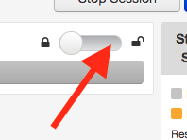

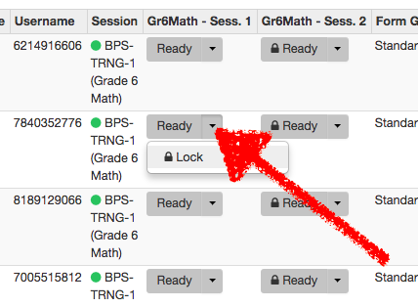
If there are any students absent for a session, make sure to lock the individual students by clicking the down arrow in the Student Test Status icon and selecting Lock.
Your session is now ready to begin testing. At this point you can begin reading the scripts from the manual.

Since we are only testing one session a day,
only one session should be unlocked at a time.

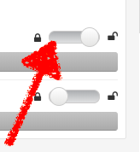
When testing is done for the day, you should lock ALL students even if a student is going to receive Extended Time. The proctor facilitating the additional time will unlock and resume the student.

If all students are unlocked, the lock controls will look like a slide button. Simply click the slider near the locked lock icon.

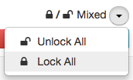

If there is a mix of locked and unlocked students, there will button with an arrow. Click the arrow and select Lock All.

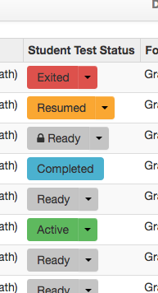
Part 3 - Controlling Student Tests
There will be a status column for each test session. To change a student’s status, you click on the down arrow in the Student Test Status icon.

For a student to be able to login to TestNav, they need to be unlocked and their status needs to be Ready or Resumed.

A student will show as Exited…
- when they log out after a session has been completed, but has not submitted final answers.
- when they log out to take a break.
- when some sort of error occurs and they are kicked out of the test.

An Exited student needs their status changed to Resumed before they can log in again. This should be done...
- when the student returns from break and is ready to continue testing.
- when they are attempting to continue after an error has occurred.

When a student has successfully submitted a session, their student status will show as Completed.

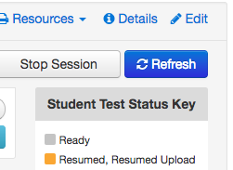
If the status shown in the Student Test Status column, does not display as expected, try clicking the Refresh Button in the upper right corner of the session control screen.

Important Note: To avoid the Test Administrator being timed out of Pearson Access Next, it is recommended that they click the refresh button every couple minutes to keep the session active.

THIS PAGE IS INTENTIONALLY BLANK

