Introduction
E-rate 2.0 refers to the Federal Communications Commission’s (FCC) E-rate Modernization Order that sets “Ensuring Affordable Access to High-Speed Broadband” to the classroom as its top priority. To accomplish this goal, the FCC has:
- increased the overall funding cap for all schools and eliminated or begun phasing out support for non-priority services such as email, web hosting, phone lines and cell phones
- set broadband speed goals for schools and libraries
- established “predictable” funding for internal Wi-Fi connections
Other goals of E-rate 2.0 include “Maximizing the Cost-Effectiveness of E-rate Spending” and “Making the E-rate Application Process and Other E-rate Processes Fast, Simple and Efficient.” The FCC rule changes are intended to support the attainment of these goals. E-rate 2.0 revises rules on discount rates, eligible services, competitive bidding, contracts, electronic filing, technology plans, and more.
The deadline for filing a Form 471 request for E-rate funding for the 2017-2018 year is Thursday, May 11, 2017 at 11:59 PM EDT.
For 2017-2018, you are only allowed to make changes to school profiles from 2/3/2017 through 2/26/2017. Changes to enrollment and free and reduced counts, school names and addresses, and addition/deletions of schools and other profile information must be made during this period.
If you have questions that these FAQs do not address or would like additional information, please refer to the last section in this document for links to “Additional Resources.”
These FAQs were developed by TECedge, The Education Consultants, in partnership with the MA Department of Elementary and Secondary Education for Massachusetts districts.
The following questions and answers focus primarily on changes that have occurred as a result of the E-rate Modernization Order. Click on the links below to go to the desired section.

Frequently Asked Questions
Click on one of the links below to jump to the answer. Hint: To return back from the answer, enter Alt+Left arrow (Windows). Using Adobe Reader on the Mac, enter +Left arrow (command+left arrow). In Preview, the equivalent is +[ (command + open square bracket).
Overview
Where does E-rate funding come from?

Eligibility
Who is eligible and what kinds of services are eligible for discounts?
The complete list of eligible services for FY2017 can be found at https://apps.fcc.gov/edocs_public/attachmatch/DA-16-1023A1.pdf.
How do the changes finally allow all districts receive Category 2 funding?
Discounts
How has the discount calculation changed in E–rate 2.0?
How is the discount calculated?
How do I tell if my district is urban or rural?
How does participation in the Community Eligibility Provision (CEP) affect the way that I calculate my school district discount?
How do Pre-K students impact district discounts and Category 2 applications?
Timeline
Are the state fiscal year and the E-rate funding year the same?
What is the E-rate process?
How do E-rate filing deadlines work?
What is the approximate E-rate timeline?
This seems incredibly complicated. Is there any support for this process?
Phase Out of Voice Services
What voice services are being phased out?
How are phone/voice over Internet/cell phone discounts being phased out?
What do I do if my vendor bundles voice and data services together?
Even though E-rate discounts on phones and cell phones are going away, we still need these services! What can we do?
Are data plans and air cards still eligible?
Local Funding
Category 2 sounds great, but it requires money that we don’t have. How can we get our share?
Competitive bidding process
How can we ensure that we purchase from an eligible contract?
Must the award always be made to the lowest bidder?
What procurement documents must I keep for E-rate?
I just filed a Form 470 but now I realize it does not include everything. What should I do?

How to purchase off of state contracts
What state contracts can I use for E-rate?
What are the rules for purchasing off a state contract?
It looks like ITC47 ends 3/31/17. What do I do if I want to install in the summer of 2017?
Equipment Tracking
Do we have to keep track of all the equipment installed?
Can I move the equipment after it is installed?
Changes during Wi-Fi Installation
What do I do if changes are needed during Wi-Fi installation?
Using E-rate reimbursements to fund 1 to 1
Can I receive E-rate discounts on devices such as laptops, iPads and Chromebooks?
If the school files a Form 472 Billed Entity Applicant Reimbursement (BEAR) and receives funds from E-rate, can it be used for 1 to 1 purchases?

Overview
- Where does E-rate funding come from?
The Universal Service Fund (USF) comes from a small percentage of telecommunication service providers’ interstate and international end-user telecommunications revenues. Some providers add a "Universal Service" fee on their telephone bills to recover their USF contributions directly from their customers. E-rate is one of four programs supported by the USF.
The Universal Services Administration Corporation (USAC) administers the USF program for the FCC. Its Schools and Libraries Division (SLD) administers the E-rate program.

Eligibility
- Who is eligible and what kinds of services are eligible for discounts?
All public schools are eligible to receive discounts on eligible Category 1 services (Internet/broadband and for a limited time, voice) and Category 2 services (internal connections, managed internal broadband services, and basic maintenance of internal connections), but only if the services are purchased from eligible contracts (see Question 20) and the application is approved by the E-rate program. The table below outlines basic services that are new or can still be funded () and those services that are being eliminated or phased out ().
Category 1  Connections to schools | Category 2  Connections within schools
- Internet access | - Wi-Fi Wireless, caching devices
- Fiber (dark and lit) | - Managed Wi-Fi (owned or leased)
- Digital transmission | - Switches, routers, cabling, racks & UPS
- Email services, Webhosting | - Software required for network
- Text messages, voicemail, paging | - Installation, configuration
- Cell phones, land lines, and VoIP (phasing out 20% per year) | - Basic network maintenance  - Gateways, servers, storage devices
The complete list of eligible services for FY2017 can be found at https://apps.fcc.gov/edocs_public/attachmatch/DA-16-1023A1.pdf.
- How do the changes finally allow all districts receive Category 2 funding?
In the past, only the poorest schools received funding for Category 2 internal infrastructure such as Wi-Fi. No schools have received Category 2 funds in the last two years. With E-rate 2.0, the FCC seeks to ensure Wi-Fi in all schools by:
- increased funding from $2.4 billion to $3.9 billion and will adjust for inflation.
- committing an additional $2 billion of unspent funds from prior years
- giving all schools a budget of $150 per student for Wi-Fi over a 5-year period (4 years remainng)
- dropping the requirement for an approved Technology Plan
Discounts on Category 2 Wi-Fi range from 20% to 85% based upon poverty level and whether the district is rural or urban. Rural districts and districts with higher poverty receive greater discounts. Almost all Massachusetts public schools receive at least a 40% discount.

Discounts
- How has the discount calculation changed in E–rate 2.0?
The new rules require the E-rate discount to be calculated for the entire district rather than for individual schools. In the past, schools in the same district could have different discount rates based on each school’s percentage of students eligible for free and reduced meals. Now all schools in the district have the same district discount.
- How is the discount calculated?
To calculate a district’s discount rate, determine the percentage of students eligible for free and reduced price meals by dividing the “number of students eligible for free and reduced-price meals” in the district by the district’s “total enrollment.” Using this percentage, look up the E-rate Program discount in the matrix below based on whether the district is urban or rural:

INCOME Measured by % of students eligible for the National School Lunch Program | URBAN LOCATION  Discount | RURAL LOCATION  Discount
If the % of students in your school that qualifies for the National School Lunch Program is... | ...and you are in an  URBAN area, your  discount will be... | ...and you are in a  RURAL area, your  discount will be...
Less than 1% | 20% | 25%
1% to 19% | 40% | 50%
20% to 34% | 50% | 60%
35% to 49% | 60% | 70%
50% to 74% | 80% | 80%
75% to 100% | 90% | 90%
This discount applies to both Category 1 and Category 2 services, with the following exceptions:
- discounts for voice services are being reduced by 20% each year (see Question 15)
- category 2 services are capped at 85%
- How do I tell if my district is urban or rural?
E-rate 2.0 changes the definition of urban and rural. To determine whether a school is urban or rural, use the USAC Urban/Rural Lookup Tool.
To determine if the district is urban or rural, if more than half of the schools are rural then the district is rural, otherwise it is urban. Non-Instructional Facilities (NIFs), such as the district office or a technology center, are not counted in the urban/rural calculation.
- How does participation in the Community Eligibility Provision (CEP) affect the way that I calculate my school district discount?
E-rate 2.0 allows the Community Eligibility Provision (CEP) to be used in determining discounts rates. Convert the number of directly certified students into the equivalent number of students eligible for the National School Lunch Program (NSLP) as follows:
Formula: number of students eligible for free and reduced-price meals = number of enrolled students x Identified Student Percentage (ISP) x 1.6*
* The 1.6 is the current CEP multiplier used to determine who is actually living in poverty, because not all eligible families apply for free or reduced-price lunch. Use the “total enrollment” and the calculated “number of students eligible for free and reduced-price meals” in the normal discount calculation as described in the answer to Question 5.
- How do Pre-K students impact district discounts and Category 2 applications?
In Massachusetts, Pre-K students are not eligible for E-rate - only K-12 students are eligible. As a result, Pre-K students must be removed from school enrollment and the number of students eligible for free and reduced meals when calculating the district’s discount. Even if Pre-K students receive no meals, they are often counted in the school’s overall students eligible for free and reduced meals due to their inclusion in family applications.
If your school or district participates in the Community Eligibility Provision (CEP), remove the Pre-K students prior to calculating your equivalent number of students eligible for the NSLP described in 7 above.
Pre-K students can also impact your Category 2 application. Remember only K-12 students can count towards your Category 2 school budget. If your Category 2 Wi-Fi project includes Pre-K classrooms, the cost of such infrastructure must be cost allocated out of your Category 2 request.

Timeline
- Are the state fiscal year and the E-rate funding year the same?
Although the time period is the same, the terminology describing fiscal years differs, which can be confusing. E-rate calls the period between July 1, 2015-June 30, 2016 Funding Year 2015 (FY2015). The State refers to the same time period as Fiscal Year 2016 (FY2016). To make things more confusing, the federal fiscal year runs from October 1– September 30.
E-Rate Funding Year 2016 (FY2016) | July 1, 2016-June 30, 2017
State Fiscal Year 2017 (FY2017) | July 1, 2016-June 30, 2017
Federal Fiscal Year 2016 (FY2016) | October 1, 2016-September 30, 2017
- What is the E-rate process?
The following graphic provides an overview of the E-rate process.
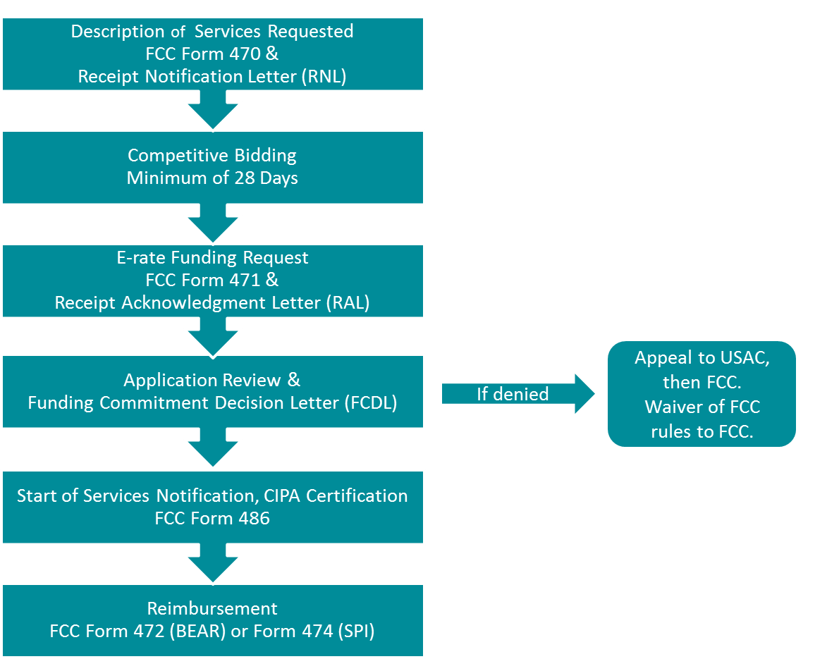
- How do E-rate filing deadlines work?
There are many deadlines to meet in order to receive E-rate funding. Missing a deadline can result in loss of funding.
Recently, the deadline for filing the application (Form 471) has been in March for the next fiscal year. This deadline is set in the fall each year by the FCC and is subject to change. Other dates are relative to this date.
Form 470, the notice that you are seeking services, must be filed no later than 28 days before the Form 471 application is submitted, although it is recommended that it be filed earlier. Some forms cannot be filed until after USAC makes a decision on the application. For example, you must file Form 486, the start of services, no later than 120 days after the funding commitment decision letter is generated or the service start date, whichever is later. Invoices for services provided in the previous funding year must be submitted before October 28th for Category 1 and by January 28th for Category 2 services unless you have requested and received permission for a one-time 120 day extension.
- What is the approximate E-rate timeline?
The following graphic illustrates the timeline for major E-rate events. Since one E-rate year takes almost two years to prepare and complete, districts typically are dealing with three applications during any one fiscal year, as shown below.
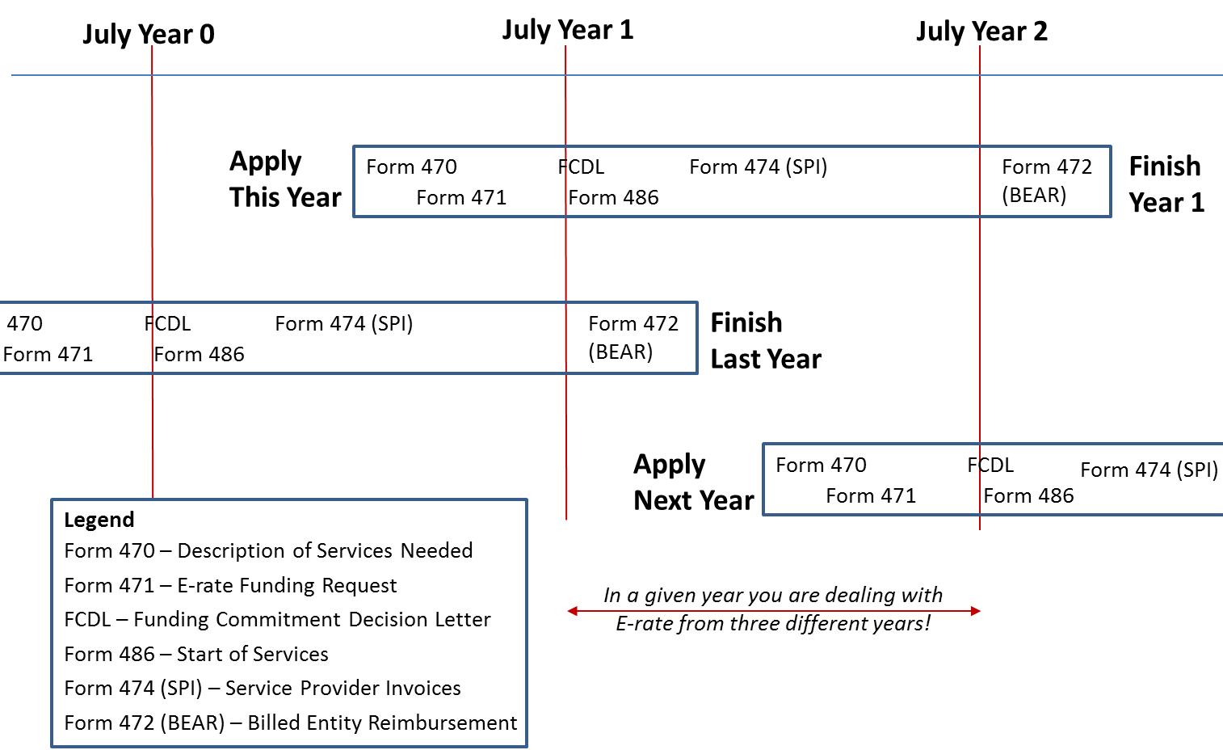
- This seems incredibly complicated. Is there any support for this process?
The E-rate Productivity Center (EPC) is the newly created portal for the Schools and Libraries (E-rate) Program. Applicants, consultants, and service providers participating in the E-rate Program will use this tool to manage program processes and to submit questions. Account administrators can add other users and set user permissions (full rights to submit applications, partial rights to edit application prior to submission, or view-only rights). EPC can be used to file Form 470s, Form 471s, Form 486s, Form 498s, and Form 500s. Only the Form 472 still uses a legacy web application.

Phase-out of Voice Discounts
- What voice services are being phased out?
Local and long distance phone service, POTS (plain old telephone service), Centrex, PRI lines (primary rate interface), wireless telephone service such as cellular, and Voice over Internet Protocol (VoIP) are being phased out over five years. Although VoIP is implemented through data, it is being phased out because VoIP is dedicated to voice.
- How are phone/voice over Internet/cell phone discounts being phased out?
Voice services are being phased out by 20% each year over a five year period. For example, a 40% district will see its voice discount drop to 20% in 2015-2016 and drop to zero in 2016-2017, as shown in the table below.

E-rate Discount for Other  Category One Services | Voice Phase Down Discount by Year
 | FY2015 | FY2016 | FY2017 | FY2018 | FY2019
20% | 0% | 0% | 0% | 0% | 0%
25% | 5% | 0% | 0% | 0% | 0%
30% | 10% | 0% | 0% | 0% | 0%
40% | 20% | 0% | 0% | 0% | 0%
50% | 30% | 10% | 0% | 0% | 0%
60% | 40% | 20% | 0% | 0% | 0%
70% | 50% | 30% | 10% | 0% | 0%
80% | 60% | 40% | 20% | 0% | 0%
90% | 70% | 50% | 30% | 10% | 0%
- What do I do if my vendor bundles voice and data services together?
For cell phones with bundled voice and data plans and cable connections that include data and voice services, the ineligible voice services must be removed from the E-rate request.
- Even though E-rate discounts on phones and cell phones are going away, we still need these services! What can we do?
Explore reducing costs in the following ways:
- reduce the number of phones and cell phones.
- explore alternative technologies such as Voice over IP (VoIP) that are often cheaper.
- re-examine phone and cell phone contracts
- ensureyou are receiving the best prices by conducting “mini-bids” for land line and cell phones under state contract ITT46 and use price as the primary award factor
A mini-bid usually consists of a scope of work and specifications, a request for pricing based on the state contract, and other evaluation criteria, if required.
Ultimately, the district may have to increase its budget for phones and cell phones (telecommunications) as the E-rate discounts are phased out.
- Are data plans and air cards still eligible?
Yes, but only if you can demonstrate that the data plans and air cards are the most cost-effective option for providing Internet broadband access to a school. While this might be possible for schools that serve a very small number of students, they will not be the most cost effective option for most districts.

Local Funding
- Category 2 sounds great, but it requires money that we don’t have. How can we get our share?
Category 2 funds to add/expand Wi-Fi to all schools provides a tremendous bang for the buck! The FCC has committed funding only for the next 4 years, so the funds may not be available later.
You need to work with the school committee and town/city to identify the additional local funds needed. If you cannot identify enough local funds to add/expand Wi-Fi in all the schools, remember you do not have to spend your budget all in one year. If limited local funds are available:
- implement over several years
- consider Managed Wi-Fi, which minimizes a one-time cost through leasing

Competitive bidding process
- How can we ensure that we purchase from an eligible contract?
All eligible contracts must result from a competitive bid that starts with the filing of the Form 470 that describes the services needed. Think of it as advertising in the Goods and Services Bulletin, except that E-rate requires the posting of a Form 470 for all services regardless of dollar amount.
Tariff or month-to-month services such as basic telephone service or Internet access may not require a contract, but they still require a Form 470.
If you receive services under a contract, the contract with the vendor must be signed and dated before the submission of the district’s Form 471 application.
If you post a Form 470 and sign a multi-year contract resulting from that posting, you do not have to post an FCC Form 470 or open a competitive bidding process again for the life of that contract.
If you are using a state contract, you do not need to file a Form 470 (that was done when the state contract was bid), but you do need to conduct a “mini-bid” (see “How to purchase off state contracts for E-rate” below).
The only exception to the Form 470 and competitive bidding requirement is for commercially available Internet service that does not exceed $3,600 per year per school and whose speed is at least 100 Mbps downstream and 10 Mbps upstream.
- Must the award always be made to the lowest bidder?
Although E-rate rules do not require going with the lowest bidder, the price of the eligible products and services must be the primary factor in the bid evaluation.
- If the cost of eligible products and services is the only evaluation criterion the vendor with the most cost-effective bid for eligible services or equipment must be selected.
- If additional evaluation criteria are used, the cost of eligible products and services must be weighted higher than other evaluation factors. See guidance on multiple evaluation criteria at the USAC website.
For E-rate, it is the price of the eligible products and services that must be most heavily weighted, NOT THE ENTIRE COST OF THE PROJECT. Some districts make the cost of the ineligible items a separate evaluation criterion that is weighted lower than the price of eligible products.
Whichever strategy you use, E-rate requires that you document evaluation criteria and vendor selection rating for all responses in an evaluation matrix that shows how each vendor scored against the evaluation criteria. See additional guidance on documenting vendor selection on the USAC website.
Please be sure to comply with district or municipality rules on bid awards.
- What procurement documents must I keep for E-rate?
E-rate requires that all documents used to prepare the application as well as invoices for discounted services be kept for at least 10 years after the last day of service delivered.
For the competitive bidding process, we recommend that you retain the following documents (this list is not exhaustive):
- the FCC Form 470
- the RFP, if one is issued
- questions from potential bidders and your answers
- copies of winning and losing bids
- the final bid evaluation matrix and any supporting documentation
- the contract, if one is signed
- I just filed a Form 470 but now I realize it does not include everything. What should I do?
If you make significant changes to the descriptions in the Form 470 or to the scope of services requested, you need to file a new FCC Form 470. Posting a new Form 470 re-starts the 28-day waiting period. Cancel the incomplete Form 470 to avoid confusion.
Remember, applicants must also be in compliance with all applicable state or local competitive bidding rules and regulations.

How to purchase off state contracts for E-rate
- What state contracts can I use for E-rate?
Several state contracts with E-rate eligible items have posted a Form 470 and are an eligible contract under E-rate. The major contracts are:
- ITT46 - Telecommunication Network Services
- ITC47 - Information Technology Hardware, Project Management, Integration, and Maintenance. Note that Category 6 (Project Management, Maintenance, Integration, Incidental Hardware, Goods and Services from other Statewide Contracts) includes a “one-stop shopping” provision.
- ITT50 - Converged Voice and Data Communications Systems, Services and Equipment
- ITC54 - Data Cable Products and Services
Category 2 purchases typically use ITC47, although ITT50 and ITC54 can also be used.
- What are the rules for purchasing off a state contract?
Since the state contracts are awarded to multiple vendors, special E-rate rules apply. You must conduct a “mini-bid” for the services you require, sending the bid out to all vendors on the list able to provide the services.
- All vendors on a State contract must have an “equal opportunity” to bid.
E-rate rules require that all vendors on a state contract have an equal opportunity to bid to avoid potential denial based on violation of E-rate procurement rules.
You can satisfy the “equal opportunity” requirement by one of two ways:
post your request for quote (RFQ) on CommBuys to vendors on a specific state contract, such as ITC47.
Email your request for quote (RFQ) to the email addresses listed in the most recent vendor list on CommBuys.
We recommend that you document the fact that you have done one of the above.
For E-rate, it is acceptable if just one vendor ultimately responds.
- The price of the eligible products and services must be the primary factor in the “mini-bid” evaluation.
- Sign and date the agreement.
We recommend that you execute a signed state contract agreement with the vendor using the state contract or purchase order form.
- Include the required state contract language when placing the order.
If you are not using OSD’s (Massachusetts Operational Services Division) standard order form, the Contract Users’ Guides (for each of the State contracts listed in Question 24) instructs you to include the following statement on your purchase order: “This order is placed under Statewide Contract <enter state contract number>.” Otherwise, the state may not considered the purchase a “use of a Statewide Contract” for procurement purposes.
- Include recommended language if E-rate does not fund the project.
Include language in the purchase order that gives you the sole right to cancel, reduce quantities and hours, or eliminate line items in the agreement, with the price adjusted accordingly, if the E-rate program does not fund the request. This allows you to continue with the project if you have other funds or to cancel it or scale it back to something you can afford.
- It looks like ITC47 ends 3/31/17. What do I do if I want to install in the summer of 2017?
The ITC47 Strategic Sourcing Team announced on 2/3/2017 that they have elected to exercise the renewal option for ITC47 through 3/31/2019. Vendors in good standing will have their contracts renewed through this date. For more information, see the Contract User Guide.

Equipment Tracking
- Do we have to keep track of all the equipment installed?
Definitely! The E-rate program requires asset tracking of equipment purchased with E-rate funds. Should USAC’s on-site auditors arrive, they will ask to see the installed equipment.
When the equipment arrives, label each piece of equipment with "FY 2015, FRN xxx" using the FRN number from the Form 471. FRN is a Funding Request Number.
Also record each piece of equipment in your district’s inventory system or create an E-rate asset inventory register list. USAC provides a Sample Asset Inventory worksheet to create an Excel file that lists the required data for the E-rate funded equipment. The asset inventory register list should contain the following information:
- make & model
- serial number (if available)
- physical location of equipment (building/room number)
- date installed
- funding Year
- funding Request Number
- purchase order #
Detailed records of the purchase, installation, and payment of the equipment avoid the need to gather the information after-the-fact when the USAC auditors request it. Timely data input also avoids errors.
- Can I move the equipment after it is installed?
Equipment must stay at the location indicated on the Form 471 for a period of three years after the date of purchase. After that, the equipment can be transferred to other eligible entities. If a location closes within the first three years, equipment from that closed location can be transferred to another eligible entity; however, USAC must be notified of such equipment transfers. After five years from the date of installation, equipment can be disposed of, sold, transferred, or traded with no notification required to USAC. If equipment is sold after 5 years, no funding is required to be returned to USAC.

Changes During Wi-Fi Installation
- What do I do if changes are needed during Wi-Fi installation?
It is not unusual to need changes made to the original Wi-Fi plan. You may find you need more access points to get adequate coverage in some areas or find that you can get by with fewer. Sometimes the manufacturer discontinues the model you ordered. All changes must go through the new online Form 500 process.
The impact on E-rate reimbursements depends upon the type of change needed:
- Additions/Increases
You cannot add new products or services or increase the line item quantities on any E-rate request. Your district will have to pay the full amount of the additional cost as E-rate will not cover additions/increases to the application.
- Reductions in Quantity
Reductions in quantity are allowed if there is no change in the make/model (see next if this is not true). You must file a Form 500 to notify USAC of the change and to free up the difference in cost. This filing can be done at the end of installation as part of the “as built” reimbursement process.
- Changes in Make/Model (Substitution of Equipment)
The rules for changing or substituting equipment are more complex. The E-rate application includes the make and model of the equipment and any change in make/model is treated as a “substitution.” This even applies to a no-cost swap of one wireless access point model for another from the same manufacturer. The FCC allows changes only if the substituted services or products:
have the same functionality as the services or products contained in the original proposal
do not violate any contract provisions or state or local procurement laws .
do not result in an increase in the percentage of ineligible services or functions
are within the scope of the controlling FCC Form 470, including any Requests for Proposal (RFP), for the original service
If a change in make or model is required, you must ask approval for the change. The substitution request must describe the original product, the new product, the financial impact, and a certification that the 4 bullets above are true. If there is also a change in quantity, it needs to be noted here. Detailed guidance on substitution is available on the USAC website.
In the event that a service substitution results in a change in the pre-discount price for the supported service, E-rate funding will be based on the lower of either the pre-discount price of the service for which support was originally requested or the pre-discount price of the new, substituted service. In other words, the discount amount will either remain the same or go down – it can never increase.
USAC will respond to the online submission of the Form 500 request, either approving the request or indicating the reason(s) why the request cannot be approved. The approvals can take some time.

Using E-rate reimbursements to fund 1:1 programs
- Can I receive E-rate discounts on devices such as laptops, iPads and Chromebooks?
No. End user devices are not eligible for E-rate.
- If the school files a Form 472 Billed Entity Applicant Reimbursement (BEAR) and receives funds from E-rate, can it be used for 1 to 1 purchases?
Yes, E-rate places no restriction on how the reimbursement funds can be used. Many districts have establish agreements with their town/city to ensure that all funds from E-rate are available for use by the schools.

Additional Resources
Schools and Libraries E-rate Glossary of Acronyms & Terms, USAC, 8 pages.
Summary of the E-Rate Modernization Order, FCC.
Eligible Services List, FCC.
Phasing Down Support for Voice and Eliminating Support for Other Legacy Services, USAC.
Competitive Bidding Process, Schools and Libraries News Brief of February 13, 2015.
E-rate Modernization Order - Relevant News Brief Topics, USAC.
Latest [E-rate] News, USAC.
Subscription Center (newsletters, Twitter, RSS Feeds, Facebook, etc.), USAC.
MA Dept. of Elementary and Secondary Education E-rate page, ESE.

