The proposed course title: Exploring Standards Based Assessment
Instructor: Dr. Avon Lewis
Target Audience: 6-12 classroom teachers – teachers who share a prep are encouraged to do this as a team
Number of sessions/hours: 15 hours – 2 5 hour sessions during the summer; 2 2.5 hour sessions in the fall
Course objectives and rationale: Conventional grading allows students to average skills they are very good at with skills that are poor. It also allows them to combine “participation” based assignments that do not actually demonstrate what they know with assignments that do show what they know. This allows students to get “good” grades, even when they do not know the material.
Students need to master all the skills a course is teaching in order to be prepared for future coursework. Standards based assessment gives students and teachers a much more precise understanding of what students have learned and what they are struggling with and it allows teachers to target interventions and support appropriately.
Standards based assessment becomes an even more powerful tool when combined with mastery grading. In mastery grading, students who fail to demonstrate proficiency on a standard on the first pass are given more chances to demonstrate their proficiency.
This course will introduce teachers to the reasons for standards based assessment, especially when combined with a mastery grading model. We will discuss the creation of standards for assessment. We will explore some different methods of implementing standards based assessment and then teachers will have time to work on developing some standards based assessments of their own, for us in their classes.
General outline of proposed syllabus:
Day 1 – 5 hours – Background. Reading from Hattie, Dweck, Grant Wiggins, and others about mindset, feedback, standards based assessment, etc. Probably do a mix of short lecture, excerpted readings, small group discussions I have not selected the readings yet, but if I find enough good ones I will spread these out and do a few on each of the subsequent days.
Day 2 – 5 hours – Models of assessment – I will present things that I and others have done and intersperse it with work time/discussion time for them to start to create an assessment or assignment for use in their class. Readings from O’Shea, Schmoker and others.
Day 3 – 2.5 hours – Small group coaching/discussions/project development – Participants will discuss their projects with other participants and work on their projects. I will help them and suggest resources for them to use.
Day 4 – 2.5 hours – Presentations – each participant will present what they tried and discuss the pros and cons of that approach.
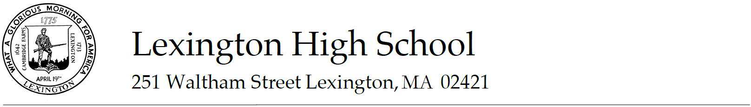
Jacalyn Crowe, Ph.D., Science Department Head jcrowe@sch.ci.lexington.ma.us
781-861-2320 ext. 3040
March 10, 2015
To: Len Swanton
Carol Pilarski
From: Jackie Crowe
Re: Letter in support of Avon Lewis’ course proposal
Dear Len and Carol,
I was excited to hear that Avon Lewis will be developing a professional learning course related to her work in Standards Based Assessment. Avon has been developing and adapting her method of assessment over the past several years and she has much to offer in terms of considering the practical application of this method of assessment.
Avon’s presentation during the “Lexington Learns Together” event was well-received and I know that there is interest among the LHS Science faculty to learn more. Avon has generously offered to share her experience with us in an upcoming department meeting. A course in the Professional Learning catalog would provide a wider audience that sharing.
I enthusiastically support this offering for the Professional Learning catalog. Please contact me if you need any additional information.
Sincerely,
Jacalyn Crowe

