Charter School Data Annual Report
2013 Charter School Enrollment Data (G.L. c. 71, § 89(kk))
December 2013
Massachusetts Department of Elementary and Secondary Education
75 Pleasant Street, Malden, MA 02148-4906
Phone 781-338-3000 TTY: N.E.T. Relay 800-439-2370
www.doe.mass.edu

This document was prepared by the
Massachusetts Department of Elementary and Secondary Education
Mitchell D. Chester, Ed.D.
Commissioner

Board of Elementary and Secondary Education Members
Ms. Maura Banta, Chair, Melrose
Mr. Daniel Brogan, Chair, Student Advisory Council, Dennis
Dr. Vanessa Calderón-Rosado, Milton
Ms. Harneen Chernow, Jamaica Plain
Ms. Karen Daniels, Milton
Ms. Ruth Kaplan, Brookline
Mr. Matthew Malone, Secretary of Education, Roslindale
Mr. James Morton, Springfield
Dr. Pendred Noyce, Weston
Mr. David Roach, Sutton

Mitchell D. Chester, Ed.D., Commissioner and Secretary to the Board

The Massachusetts Department of Elementary and Secondary Education, an affirmative action employer, is committed to ensuring that all of its programs and facilities are accessible to all members of the public.
We do not discriminate on the basis of age, color, disability, national origin, race, religion, sex or sexual orientation.
Inquiries regarding the Department’s compliance with Title IX and other civil rights laws may be directed to the
Human Resources Director, 75 Pleasant St., Malden, MA 02148-4906. Phone: 781-338-6105.

© 2013 Massachusetts Department of Elementary and Secondary Education
Permission is hereby granted to copy any or all parts of this document for non-commercial educational purposes. Please credit the “Massachusetts Department of Elementary and Secondary Education.”

This document printed on recycled paper

Massachusetts Department of Elementary and Secondary Education
75 Pleasant Street, Malden, MA 02148-4906
Phone 781-338-3000 TTY: N.E.T. Relay 800-439-2370
www.doe.mass.edu

Massachusetts Department of

Elementary and Secondary Education

75 Pleasant Street, Malden, Massachusetts 02148-4906 Telephone: (781) 338-3000

TTY: N.E.T. Relay 1-800-439-2370

Mitchell D. Chester, Ed.D.
Commissioner

December 2013

Dear Members of the General Court:

I am pleased to submit this Report to the Legislature: Charter School Data Annual Report for 2012-2013. The charter school enrollment data provided in this report was compiled from the Department’s Student Information Management System (SIMS). Data profiles of each charter school for 2012-2013 and prior years are available on the Department’s School and District Profiles website at http://profiles.doe.mass.edu/search/search.aspx?leftNavId. This is also where updated data for 2013-2014 will be posted.

If you have any questions about this report, please feel free to contact Cliff Chuang, Associate Commissioner of the Office of Charter Schools and School Redesign at cchuang@doe.mass.edu or at 781-338-3227.

Sincerely,

Mitchell D. Chester, Ed.D.
Commissioner of Elementary and Secondary Education
Table of Contents

Introduction 1
Subgroup Percentages 2

Introduction

The Department of Elementary and Secondary Education (“the Department”) respectfully submits this Report to the Legislature: Charter School Data Annual Report for FY2013 pursuant to the requirement under G.L. c. 71, s. 89 (kk) that states:

The commissioner shall collect data on the racial, ethnic and socio-economic make-up of the student enrollment of each charter school in the commonwealth. The commissioner shall also collect data on the number of students enrolled in each charter school who have individual education plans pursuant to chapter 71B and those requiring English language learners programs under chapter 71A. The commissioner shall file said data annually with the clerks of the house and senate and the joint committee on education not later than December 1.

The charter school enrollment data for FY2013, compiled from the Department’s Student Information Management System (SIMS) information collection, is provided in the following table. Data profiles of each charter school for FY2013 and prior years are available at District and School Profiles on the Department’s website.

Subgroup Percentages
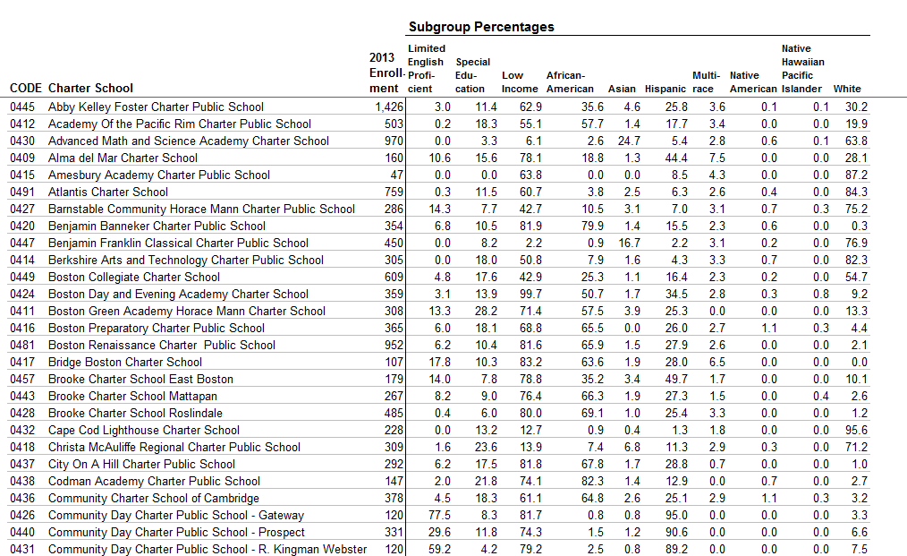

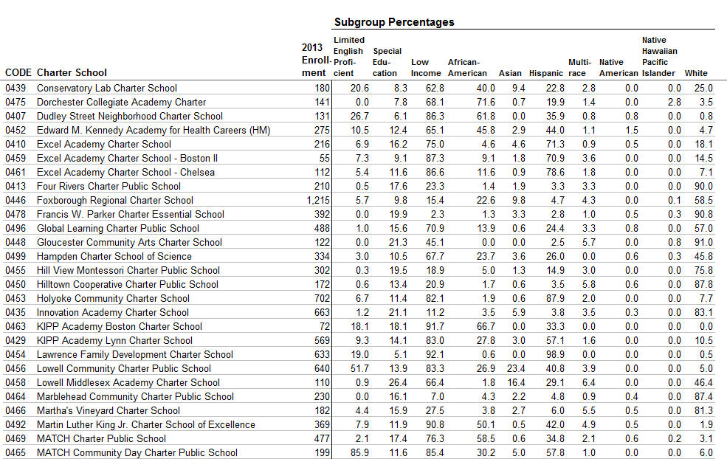

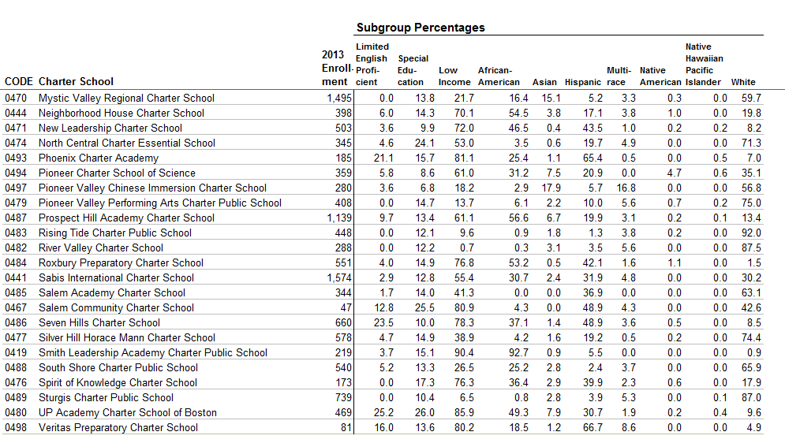

http://profiles.doe.mass.edu/search/search.aspx?leftNavId=

