Report to the Legislature: Mathematics and Science Teacher Content-Based Professional Development – FY13
This report summarizes activities funded by the State Budget, Chapter 139 of the Acts of 2012, line item 7061-9804
March 2014
Massachusetts Department of Elementary and Secondary Education
75 Pleasant Street, Malden, MA 02148-4906
Phone 781-338-3000 TTY: N.E.T. Relay 800-439-2370
www.doe.mass.edu

This document was prepared by the
Massachusetts Department of Elementary and Secondary Education
Mitchell D. Chester, Ed.D.
Commissioner

Board of Elementary and Secondary Education Members
Ms. Maura Banta, Chair, Melrose
Ms. Harneen Chernow, Vice Chair, Jamaica Plain
Mr. Daniel Brogan, Chair, Student Advisory Council, Dennis
Dr. Vanessa Calderón-Rosado, Milton
Ms. Karen Daniels, Milton
Ms. Ruth Kaplan, Brookline
Dr. Matthew Malone, Secretary of Education, Roslindale
Mr. James O'S. Morton, Springfield
Dr. Pendred E. Noyce, Weston
Mr. David Roach, Sutton

Mitchell D. Chester, Ed.D., Commissioner and Secretary to the Board

The Massachusetts Department of Elementary and Secondary Education, an affirmative action employer, is committed to ensuring that all of its programs and facilities are accessible to all members of the public.
We do not discriminate on the basis of age, color, disability, national origin, race, religion, sex, gender identity, or sexual orientation.
Inquiries regarding the Department’s compliance with Title IX and other civil rights laws may be directed to the
Human Resources Director, 75 Pleasant St., Malden, MA 02148-4906. Phone: 781-338-6105.

© 2014 Massachusetts Department of Elementary and Secondary Education
Permission is hereby granted to copy any or all parts of this document for non-commercial educational purposes. Please credit the “Massachusetts Department of Elementary and Secondary Education.”

This document printed on recycled paper

Massachusetts Department of Elementary and Secondary Education
75 Pleasant Street, Malden, MA 02148-4906
Phone 781-338-3000 TTY: N.E.T. Relay 800-439-2370
www.doe.mass.edu

Massachusetts Department of
Elementary & Secondary Education

75 Pleasant Street, Malden, Massachusetts 02148-4906 Telephone: (781) 338-3000
TTY: N.E.T. Relay 1-800-439-2370

March 2014

Dear Members of the General Court:

I am pleased to provide a progress report on the ongoing work of the Department of Elementary and Secondary Education (Department) to provide mathematics and science content professional development to teachers from high-need schools and districts across the Commonwealth pursuant to Chapter 139 of the Acts of 2012, line item 7061-9804:

“For teacher content training in math and science; provided, that such training shall include the math specialist and Massachusetts test for educator licensure preparation; provided further, that funds from this item shall be expended on content based professional development in math and science, with a focus on elementary and middle school math and science teachers in districts with a high percentage of students scoring in level 1 or 2 on the math or science Massachusetts comprehensive assessment system exams, or in districts which are at risk of or determined to be underperforming …”

This represents the only state-funded line item dedicated to science, technology, engineering and mathematics (STEM) professional development. The Department has designated STEM fields as critical teacher shortage areas and the Board of Elementary and Secondary Education has identified improvement in mathematics achievement as a high priority goal for the Department. The Department also supports the efforts of the Governor’s STEM Advisory Council’s State Plan to improve the STEM pipeline by engaging students throughout their educational career.

Key to all these efforts is high quality content-based professional development. Teacher quality is a key determinant of student achievement and strong content knowledge is crucial to effective teaching. Successfully teaching all students to reach our state’s high standards of mathematics and science learning requires a depth of content knowledge, conceptual understanding, and facility with pedagogical skills that exceeds the level of many current teachers.

With the continued attention placed on STEM education in the Commonwealth and nationally, state funding is a critical component in our efforts to strengthen STEM teaching and learning.
Please let me know if I may provide you with any further information. I appreciate your support for mathematics and science professional development.

Sincerely,

Mitchell D. Chester, Ed.D.
Commissioner of Elementary and Secondary Education

Table of Contents
I. Introduction 1
II. Major Initiatives and Programs 2
Mathematics and Science Teacher Professional Development Institutes 2
Background and Accomplishments 2
Professional Development Courses Funded 3
Fund Use 6
Professional Development Networks for Mathematics and Science Leaders 6
Background and Accomplishments 6
Fund Use 7
Visualizations of Student Thinking: Professional Development (PD) Resources for New Science Standards 7
Background and Accomplishments 7
Fund Use 10
III. FY13 Budget 10

I. Introduction

The Department of Elementary and Secondary Education respectfully submits this report to the Legislature: Mathematics and Science Teacher Content-Based Professional Development pursuant to Chapter 139 of the Acts of 2012, line item 7061-9804:

Teacher Content Training
“For teacher content training in math and science; provided, that such training shall include the math specialist and Massachusetts test for educator licensure preparation; provided further, that funds from this item shall be expended on content based professional development in math and science, with a focus on elementary and middle school math and science teachers in districts with a high percentage of students scoring in level 1 or 2 on the math or science Massachusetts comprehensive assessment system exams, or in districts which are at risk of or determined to be underperforming under sections 1J and 1K of chapter 69 of the General Laws; provided further, that such professional development courses shall demonstrate proven, replicable results in improving teacher and student performance and shall demonstrate the use of best practices, as determined by the department, including data comparing pre-training and post-training content knowledge; provided further, that for the purposes of this item, appropriated funds may be expended through August 31, 2013; and provided further, that the department shall deliver to the general court an evaluation of the program and its impact on student achievement, particularly as it relates to closing achievement gaps”
The budget language for this line item states that the funds support professional development to increase the content knowledge of elementary and middle school mathematics and science teachers, particularly those in high-need districts.

Teacher quality is a key determinant of student achievement and strong content knowledge is crucial to effective teaching. Successfully teaching all students to reach our state’s high standards of mathematics and science learning requires a depth of content knowledge, conceptual understanding, and facility with core skills that exceeds the level of many current elementary and middle school teachers.

This line item represents the only state line item dedicated to support professional development to increase the content knowledge of elementary and middle school mathematics and science teachers, particularly those teaching in high needs districts. The Department has designated STEM fields as critical teacher shortage areas and the Board of Elementary and Secondary Education has identified improvement in mathematics achievement as a high priority goal for the Department.

The state economic downturn has resulted in a decline in the STEM line item since the initial funding in FY07. In the first year, $1 million provided high quality effective content-based professional development courses for 1000 STEM teachers through 8 Massachusetts Intel Math Initiative courses (80-hour courses, serving 400 elementary and middle mathematics teachers) and 25 STEM Professional Development Institutes (PDIs; 45-hour courses serving 600 STEM teachers. In FY13 this line item funded 12 STEM PDI courses, serving approximately 275 teachers.
With the continued attention placed on mathematics and science education nationally, state funding is a critical component in state efforts to strengthen mathematics and science education across the Commonwealth.

II. Major Initiatives and Programs

Mathematics and Science Teacher Professional Development Institutes

Background and Accomplishments
The Professional Development Institutes are sponsored by the Department in partnership with non-profit organizations, professional development organizations, educational collaboratives, cultural institutions, school districts, charter schools, colleges, and universities. The purpose of the institutes is to increase the content and pedagogical knowledge of Massachusetts educators necessary to provide effective, standards-based classroom instruction. The institutes are selected specifically to address achievement gaps, particularly for students with disabilities and English language learners. The Professional Development Institutes have been providing coursework during the summer for 19 years to educators throughout the Commonwealth in all subject areas.

Teachers from across the state participated in the summer 2013 Professional Development Institute program; funds from this line item funded nine mathematics and three science institutes. These courses engaged teachers, coaches, paraprofessionals, and administrators in subject-specific mathematics and science courses, including foundational courses, as well as courses designed to continue to improve teachers' classroom practice through advanced study. Institutes are required to administer pre- and post-tests of content knowledge. The participants completed the institute participant survey, providing detailed information about their teaching positions and credentials.

A preliminary summary of the survey data shows:

- Participation of teachers serving high-need populations
- Approximately 250 mathematics and science teachers participated, with approximately 55 percent from high-need districts.
- Teacher participants worked with key student populations – approximately 60 percent of participants teach students with disabilities and 30 percent teach English language learners.

- Increased content knowledge
- Over 90 percent of participants showed gains on pre-post content exams.

- Improved pedagogy
- Each institute included a pedagogy component which participants need to effectively translate content learning to classroom instruction. Institutes also include a range of content-relevant resources and materials for classroom use.

Professional Development Courses Funded

Course  Title | Subject Area | Number of Sections | Course Description
Developing Proportional Thinking | Math | 1 | This course is designed for teachers in grades six to eight with a focus on fractions, decimals, percents, and ratios and the overall development of proportional reasoning. Specific topics include a study of rational numbers, division of fractions with an understanding of the traditional algorithm, equivalent ratios using the support of visual models, and ratio and percent problems. This course balances content and pedagogy, including elements and strategies of effective instruction and application of the Standards for Mathematical Practice. Teachers will engage with learning activities that strengthen their own conceptual knowledge. This course is aligned to the 2011 Massachusetts Curriculum Frameworks for Mathematics.
Foundations in Mathematics: Number | Math | 2 | This course is designed to explore early childhood mathematics concepts with a focus on number. Participants will explore critical learning experiences necessary to build a strong foundation in mathematical understanding. Specific topics to be covered include counting and cardinal meaning of number, number relationships, place value, and additive thinking. Throughout the course, teachers will engage with learning activities that build conceptual knowledge. Furthermore, teachers will work with problem solving and assessment tasks that reveal common student misconceptions. Through the examination of videotapes, articles, and student work, teachers will create solutions to reveal misconceptions and design appropriate instructional plans for moving children to a deeper level of understanding. This course is aligned to the 2011 Massachusetts Curriculum Framework for Mathematics.
Teaching Advanced Mathematical Decision Making | Math | 1 | This institute will prepare teachers to implement Advanced Mathematical Decision Making (AMDM) during the 2013-14 school year. AMDM is a mathematics course designed to follow Algebra I, Geometry, and Algebra II. It involves the use of algebra, geometry, trigonometry, and discrete mathematics to model a range of situations and solve problems in diverse areas such as statistics and financial mathematics. The institute facilitators, including experienced AMDM teachers, will help participants to develop the unique combination of mathematical content, as well as pedagogical skills required for implementing AMDM. Although the mathematical content of the course is rigorous, teachers enthusiastic about learning contextual mathematical ideas using the standards of mathematical practice aligned with the newly adopted Common Core Mathematics Frameworks, are encouraged to enroll. Participants will be expected to attend two follow-up days, participate in a facilitated online community, and have access to a wide range of web resources.
Increasing Accessibility to Algebra and Geometry for ALL Students | Math | 1 | This course offers foundational mathematical content and pedagogical strategies for general education, inclusion and special education teachers of grades 5 through 10. It strengthens teachers’ understanding of relationships between concepts in geometry and algebra. Teachers will learn universal design strategies and techniques to increase accessibility of rigorous mathematics to a broad range of learners.
Developing Mathematical Practices for Number, Operations and Algebraic Reasoning: Grades K-5 | Math | 2 | Participants will experience and reflect upon the Standards for Mathematical Practice found in the new Massachusetts Curriculum Frameworks Incorporating the Common Core, and, more specifically, on making sense of problems and persevering in solving them; reasoning abstractly and quantitatively, and looking for and making use of structure. The course will enhance and deepen participants’ mathematics pedagogical content knowledge in fundamental domains such as representing and operating on whole numbers, linking operations to algebraic thinking, place value in base ten, developing an understanding of fractions and operations with fractions and decimals, as well as writing and interpreting numerical expressions. Emphasis is placed on the importance of multiple solution methods and on various representations in organizing and displaying information. The course will provide information regarding online and other classroom instructional tools that can be used to support students' mathematical reasoning.
Developing Mathematical Practices for Geometry, Algebra II and Beyond: Grades 10-12 | Math | 1 | The Standards for Mathematical Practice capture the style of work, the ways of thinking, and the habits of mind employed by proficient users of mathematics. This course provides high school teachers with the opportunity to experience and reflect upon how the Standards for Mathematical Practice bring rigor and coherence to the overall mathematics program through purposefully selected examples and applications representative of major topics in post-Algebra I courses. Participants learn to identify specific “habits of mind” for the Standards for Mathematical Practice that are the focus of the course, explore classroom strategies that can be used to nurture students in their development of the Practices, experience a variety of pedagogy models that encourage collaboration and communication, and examine lesson planning ideas based on end-of-course projects.
Developing Mathematical Practices for Algebra: Grades 6-10 | Math | 1 | Developing Mathematical Practices for Algebra is an eight-day experience for teachers in grades 6-10 that addresses both the content and pedagogy of Algebra. Through shared mathematical experiences, participants will deepen their own understanding of Algebra and examine their own and their colleagues’ solution strategies to broaden their concept of Algebraic reasoning. They will collect and analyze student work samples for evidence of and opportunities to promote students’ algebraic thinking. The mathematical practice standards found in the Common Core State Standards and the new 2011 Massachusetts Mathematics Curriculum Framework will serve as a touchstone for this work. Participants will not only gain a clear understanding of the mathematical practice indicators, they will learn how to develop these practices in their students. By examining their own thinking and examples of student work, teachers will learn to recognize the seeds of mathematical practices that can be nurtured in their students to lead to success in Algebra 1. Participants will learn how to set up the kinds of high-cognitive demand Algebraic tasks that promote mathematical practices and how to use questioning to advance student understanding.
Student Conceptions in Physical Science (Gr. 3-8) | Science | 1 | This course will focus on identifying and developing students' conceptual thinking about physical science, whether concrete, emerging, or misconstructed. Participating teachers will see how to support the connection and development of concepts across and within grade spans by actively engaging with colleagues in investigations. They will learn about tools, strategies and approaches to assess students' initial ideas, including possible misconceptions. Course participants will learn how to plan for and support student learning to advance student conceptual thinking in productive ways as they learn science. Multiple resources will be used for effective planning and instruction, including the Massachusetts Science Curriculum Standards, formative assessments, differentiation strategies, models of student work, learning progressions and strand maps. Through this course, participating teachers will also deepen their fundamental knowledge in physical science concepts and learn how students’ conceptual thinking develops in: Force and Motion, Properties of Matter, and Energy Transformation.
Laboratory-Based Physics II: Electricity & Magnetism, and Waves | Science | 1 | This is a laboratory-based course especially relevant to teachers in grades 9 through 12. This physics course will help participants develop more competencies in physics and is designed to support scientific practices, concepts and content related to the Massachusetts Science and Technology/Engineering Framework standards in physics. Investigations will involve the study of electricity, magnetism and waves. Technology resources will be used to facilitate “learning from nature”, and strategies for interactive learning will be modeled throughout the institute.
Connecting Science and Literacy: Investigate it, Read it, Write it, Talk it! | Science | 1 | This institute will model how science and literacy teaching and learning can be conducted in an elementary classroom to deepen all students’ science thinking and reasoning, and to build the skills needed to conduct inquiry. Topics addressed will include: the role of talk in elementary science teaching and learning; authentic uses of science notebooks; science journaling, and the role of books and reading in inquiry-based science. Participants will conduct investigations and have field experiences at various locations within the Berkshires region. Ultimately, teachers will build on their experiences by designing inquiry-based investigations to be implemented in their classrooms over the upcoming academic year. Teachers will be led through a series of activities to reinforce the inclusion of literacy. Participants will prepare and test their lesson plan concepts with their peers as they add literacy and science reading activities to their inquiry-based investigations.

Fund Use

FY13 funds from this line item funded 12 45-hour institutes during summer 2013. The average cost for an institute is $24,000, with a total of $291,390 for the Summer 2013 Institutes.

Professional Development Networks for Mathematics and Science Leaders

Background and Accomplishments
For the past 8 years, the superintendent of each of the 24 urban districts in the Commonwealth has annually appointed a liaison to the statewide networks in both mathematics and science. Liaisons act as the bridge between statewide programs and local STEM initiatives. They are responsible for integrating statewide opportunities and professional development into district activities, as well as scaling up local efforts to improve student achievement in STEM and close achievement gaps, particularly for students with disabilities. Both the mathematics and science networks collaborate around shared issues to problem-solve, build capacity, provide feedback on STEM initiatives and Department policy, and assess the need and subject areas for content-focused professional development programs.

The networks produce resources and recommendations to inform future Department initiatives and professional development programs that address achievement gaps in mathematics and science. The Science Network, for example, spent significant time considering the implications and implementation of the new educator evaluation system. Particular attention was paid to the creation of what assessments districts already have in place, may adapt, or may share with each other, to serve as District Determined Measures (DDMs) for science teacher evaluation. The Math Network, for example, spent significant time considering how to best support high-need student populations, including English Language Learner (ELL) students and students with disabilities, in Level 3 and 4 schools. The resources districts shared during these meetings are consistently reported as being a critical benefit to participants. They also provided Department staff important insight into, and examples of, how state policy is being interpreted and acted on in the state’s urban districts.

Fund Use
The line item has supported monthly meeting expenses for these professional development networks during the 2012-2013 school year. There were approximately 8 meetings this year for 40 participants.

Visualizations of Student Thinking: Professional Development (PD) Resources for New Science Standards

Background and Accomplishments
The development of eight visualizations of student thinking produced representations of how students think about key science concepts that can be used in future professional development on soon-to-be-revised public draft state science standards. These visualizations will help teachers and professional development providers to see variations in how students often think about or understand the science concepts in standards prior to instruction. Research has shown that understanding common student conceptions leads to more effective teaching and learning. State science standards present a progression of, or outcomes for, science concepts for teachers to help students achieve. For that scientific understanding, it is important for the teachers to recognize that: 1. Students have prior understandings and ideas about the science concept; and 2. There is likely variation in student thinking about the concept that needs to be accounted for in instruction.

Students come to learning about standards with different understandings, different ways of viewing the world, and/or different conceptions about science in the standards. The developed products illustrate different ways to visualize student thinking and the variation that different students may exhibit in their thinking about particular science concepts (standards). The example below illustrates how students often think about molecules during a phase change (right side) as compared to how that should be viewed from a scientific perspective (left side). The text below the image summarizes the common student conception and the text on the following page summarizes research on student thinking about this phenomena.

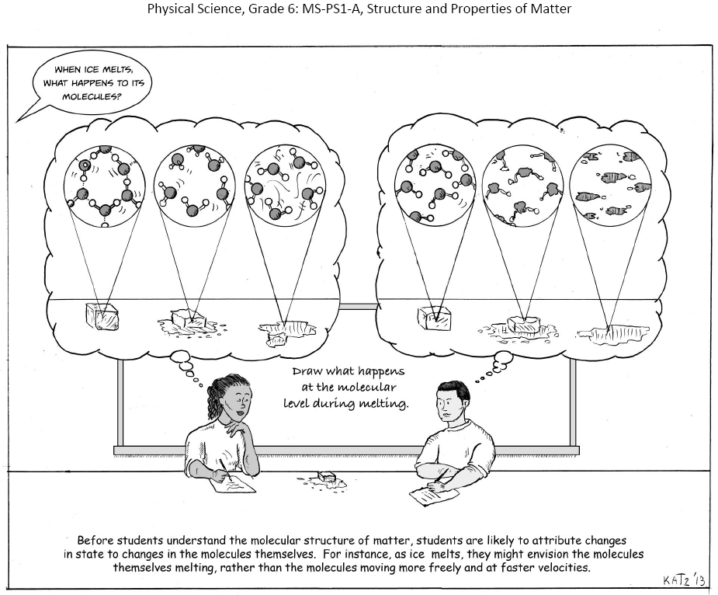

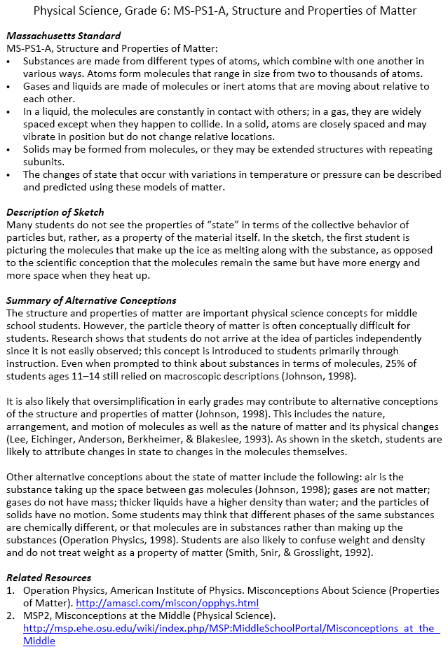

Nine visualizations, each with a related research summary, were developed through this funding. These visualizations will be used by teachers and professional development providers to emphasize the importance of eliciting student thinking prior to teaching particular standards and to differentiate instruction for those differences to effectively move students toward scientific understanding of the standards.

Fund Use
The line item supported the creation of visualization of student thinking resources that will be integrated into future professional development for revised state science standards.

III. FY13 Budget

Program or Initiative | Amount
12 Summer 2013 Math and Science Professional Development Institutes | $291,390
Professional Development Networks for Mathematics and Science Leaders | $15,169
Visualizations of Student Thinking: PD Resources for New Science Standards | $39,603

TOTAL | $346,162

Sadler, P., Sonnert, G., Coyle, H., Cook-Smith, N., and Miller, J., (2013). The Influence of Teachers’ Knowledge on Student Learning in Middle School Physical Science Classrooms. American Educational Research Journal, Vol. 50:5, p. 1020-1049.

