2011 Massachusetts Curriculum Frameworks for English Language Arts and Mathematics Implementation Study: Final Report

October 2014

Julia Marchand
Matthew Welch
Mary Nistler
Janet Levings
Christine Paulson

Contents
Page
Executive Summary 1
Key Findings Related to Implementation 1
Key Findings Related to Supports 2
Key Findings Related to Observations of Higher Implementing Classrooms 3
Key Findings Related to Implementation as a Change Process 3
Recommendations 4
Section 1: Introduction 6
Background 6
The Massachusetts Context 6
Study Overview 8
Limitations 14
Report Structure 15
Section 2: Implementation of the 2011 Frameworks 16
Teacher Awareness 16
Teacher Endorsement 17
Implementation Status 20
Section 3: An Examination of Classroom Implementation of the 2011 Frameworks 24
ELA and Humanities Classrooms 24
Mathematics Classrooms 30
Observed Differences Among Elementary, Middle, and High School Classrooms 34
Reported Shifts in Teaching Practices 35
Section 4: District and School Support for Implementation of the 2011 Frameworks 40
Leadership 40
Critical Supports 41
Main Sources of Information 44
Challenges 45
Section 5: Implementation as a Change Process 48
Change Model 49
Frameworks Implementation as a Change Process 50
Section 6: Recommendations 60
Give Teachers a Role and Voice 60
Engaged Leadership Is Critical 61
Start Gradually and Stay Focused 61
Consider School Culture and Structures 62
References 64
Appendix A. Data Collection Instruments 65

Tables
Table 1. Participating Districts and Schools 10
Table 2. Data Collection Methods 10
Table 3. Study Questions and Data Sources 11
Table 4. Data Collection 11
Table 5. Reasons Teachers Believed 2011 Frameworks Would Benefit Students 19
Table 6. Reasons Teachers Believed 2011 Frameworks Would Not Benefit Students 20
Table 7. Strong Alignment Versus Weak Alignment: Middle School ELA 27
Table 8. Strong Alignment Versus Weak Alignment: High School ELA 29
Table 9. Strong Alignment Versus Weak Alignment: Elementary School Mathematics 33
Table 10. Changes Made to Teaching Practices: ELA 37
Table 11. Changes Made to Teaching Practices: Mathematics 38
Table 12. Critical Activities and Resources 42
Table 13. Teachers’ Main Sources of Information 45
Table 14. Challenges to Implementation 46
Table 15. Frameworks Implementation Within the Change Model 57

Figures
Figure 1. Timeline of Frameworks and Assessment Adoption in Massachusetts 8
Figure 2. Teachers’ Self-Reported Knowledge of the 2011 Frameworks 17
Figure 3. Teachers’ Endorsement of the 2011 Frameworks 18
Figure 4. Implementation of 2011 ELA Framework 21
Figure 5. Implementation of 2011 Mathematics Frameworks 22
Figure 6. Model for Change 49

Executive Summary

In January 2013, the Massachusetts Department of Elementary and Secondary Education (ESE) partnered with American Institutes for Research (AIR) to conduct a study of the implementation of the 2011 Massachusetts Curriculum Frameworks for English Language Arts and Literacy (ELA) and mathematics. The study aimed to provide relevant and applicable information to ESE to inform the department’s support of implementation of the frameworks. Employing a mixed-methods approach and a combination of qualitative and quantitative data collected from multiple sources, the main objectives of the study were as follows:
- To examine what a higher implementing classroom looks like in terms of instructional practices, teacher–student interactions, and resources
- To examine the relationship between classroom practice and school supports
- To generate a model of implementation along with a framework for understanding the transition at an individual or group level

A total of 10 schools from five districts participated in the study: four elementary schools, three middle schools, and three high schools. Multiple methods were used to collect both qualitative and quantitative data. These included observations of mathematics and ELA/humanities classrooms, district- and school-level key informant interviews, and a teacher survey. A concerted effort was made to collect data from multiple sources and from as many teachers as possible, as their perceptions of the 2011 frameworks and the change process are an important piece of this implementation study.

Key Findings Related to Implementation

Most surveyed teachers reported that they were knowledgeable about the 2011 frameworks, and that they believe they will lead to improved student learning. Elementary and middle school teachers were generally more positive about the benefits that the frameworks might bring than their high school peers. The most common reason for teachers’ enthusiasm was a belief that the frameworks would help the district to ensure that standards are vertically aligned across grades. Among respondents who did not consider the frameworks beneficial for their students, the primary reason cited was that the frameworks do not provide teachers with enough flexibility, particularly with students who are not performing at grade level.

The majority of surveyed teachers reported that they had at least partially incorporated the frameworks in their classrooms, with implementation in elementary schools further along than in middle and high schools. Elementary school teachers were far more likely than other teachers to report full incorporation of the frameworks into their teaching expectations and practice. Elementary school teachers also were more likely to report adopting the core instructional shifts aligned with the Common Core. District and school respondents suggested that the pace and depth of implementation were impacted by a number of factors—notably the availability of aligned and high-quality instructional materials, such as lesson plans and textbooks.

Implementation of the ELA and mathematics frameworks was on a similar trajectory within the sample of schools. Teachers and administrators reported active efforts to implement both sets of frameworks, although elementary teachers appeared to be outpacing their peers in other schools in implementing both frameworks. There was also some indication that teachers perceived implementation of the ELA framework to be more challenging.

Key Findings Related to Supports

District leaders emphasized a gradual process of transitioning to the frameworks and provided time for teachers to learn and share with each other. Districts effectively communicated to schools the role and importance of teamwork, the potential benefits of the 2011 frameworks for all students, and that the transition will be a gradual process.

High school teachers felt less supported in implementing the 2011 frameworks than their elementary and middle school colleagues. One third of surveyed high school teachers were unsure that the frameworks would lead to improved student learning for their students. Compared with surveyed high school teachers, elementary educators reported having more supports available to them. In addition, elementary and middle school teachers were more likely to identify multiple sources of information about the frameworks—notably instructional coaches. In contrast, outside of their teaching peers and occasionally principals and online or print news media, high school teachers typically relied on few other sources of information about the 2011 frameworks.

High school teachers perceived different challenges than their elementary and middle school colleagues. Surveyed elementary and middle school teachers were more likely to report students’ prior knowledge, the need for more time to collaborate, and the need for more aligned materials as major challenges. High school teachers were far more likely to identify a need for more general information about the 2011 framework. High school teachers also expressed a need for more professional development to strengthen or expand their academic content knowledge, as well as their pedagogical knowledge of instructional strategies aligned with the frameworks.

Teachers in higher implementing schools were more deeply engaged in collaborating and consulting with other teachers to support their transition to the 2011 frameworks. Compared with their colleagues in lower implementing schools, teachers in schools that consistently demonstrated a higher level of frameworks-aligned instructional practices in observed classrooms were more likely to cite several essential supports and activities. These included collaborative planning time with other teachers, participation in PLCs, resources on research and best practice in CCSS implementation, and support from fellow teachers as well as district and school leaders. Teachers in lower implementing schools were somewhat more likely to cite online and print news media as a key source of information on the 2011 frameworks or the Common Core.

Key Findings Related to Observations of Higher Implementing Classrooms

Classroom observations revealed a number of common characteristics and practices in higher implementing classrooms:
- Authentic Academic Content: Lessons focused on rich, subject-specific concepts, and were distinguished by the frequent use of academic and disciplinary vocabulary.
- Multiple Modalities: Teachers used multiple strategies within a lesson to present a concept or to engage student learners.
- Attention to Student Thinking and Understanding: Teachers thoroughly accessed students’ thinking by asking them to explain their answers or illustrate their thinking.
- Student Voice: Teachers actively facilitated peer-to-peer conversations throughout the class period.

An ELA classroom that was considered higher implementing was one in which the teacher designed a text-focused lesson that also connected to a previously taught text. The text, rather than being supplemented by the presentation of content, was the key tool to convey content. Students were asked to use examples from the focal text to substantiate answers and to respond to peers’ comments.

Similarly, teachers leading higher implementing mathematics classes presented lessons that reinforced conceptual understanding, promoted procedural fluency, and offered opportunities for the application of mathematics skills. Teachers operationalized these guiding principles by focusing lessons on mathematics concepts using academic and discipline-specific vocabulary; using manipulatives, games, and technology to offer multiple representations of problems and concepts; pushing students to articulate and to deepen their thinking through discussion and illustration; and promoting peer-to-peer discussion aimed at enhancing understanding as well as speaking and listening skills.

Key Findings Related to Implementation as a Change Process

The transition to the 2011 frameworks can be described as a large-scale change process to new standards that has the potential to transform what is taught and how students learn in Massachusetts schools. Thus, it is instructive to view and assess frameworks implementation within a practical model for understanding, managing, and sustaining change. The model of change developed by Hiatt (2006) views change as a dynamic process that moves individuals along a continuum. According to the model, five core elements must be in place for change to be successfully implemented and sustained: (1) an awareness of the need for change, (2) a desire to support and participate in the change, (3) knowledge of how to change, (4) the ability to implement the required skills and behaviors, and (5) reinforcement to sustain the change.

Building Awareness of the Change and the Reasons for the Change. All districts in the sample began the implementation of the frameworks with awareness sessions designed to inform school staff about the frameworks and the district’s broad strategy and timeline for reaching full implementation. The most successful districts communicated clearly, and in multiple ways, about the 2011 frameworks and were attentive to consistent messaging. Furthermore, leaders were actively involved in making school staff aware of what the 2011 frameworks entailed and what the new standards meant for teachers and students.

Creating a Desire to Support and Participate in the Change. In districts and schools where implementation of the 2011 frameworks was most effective, leaders were knowledgeable, visible, and engaged in the change process. More successful districts and schools also relied on teachers to communicate to other teachers that the new standards were a desired and viable shift. In addition, several districts explicitly connected implementation of the 2011 frameworks with the state’s new educator evaluation system to incentivize adoption of the new standards.

Developing Knowledge to Make the Change. Most district and school participants in this study indicated that building knowledge has been a gradual process, and has been fairly well supported and addressed. Resources and supports to build and strengthen knowledge included model units developed by the state or districts, curriculum guides, professional development during the school year and in the summer, and job-embedded supports such as coaching and mentoring. Nearly all respondents discussed the value of collaborative teams and PLCs within schools to build collective knowledge.

Fostering the Ability to Apply New Knowledge and Skills. Participating districts and schools attempted to foster an ability to implement the 2011 frameworks by providing opportunities to plan and collaborate together, sometimes with the guidance of instructional coaches. Model instructional units with concrete examples of effective classroom instruction were also provided to teachers (although fewer were provided at the high school level). In schools that had instructional coaches, these individuals were seen as key players in helping teachers to continuously hone their skills and stay abreast of new developments to improve their practice.

Reinforcing and Sustaining Change. Like other elements of the change process, reinforcing and sustaining change requires time, collaboration, ongoing communication, and a persistent focus on goals and key principles. Showcasing success, student work, and exemplary teacher practices has helped schools and teacher to celebrate change. Finally, open conversations about the frameworks and implementation were cited as a useful strategy to reinforce and sustain change. Through candid dialogue, the frameworks—as well as the expectations for and practices associated with implementation—became part of the curriculum, language, and culture of the school.

Recommendations

Based on data collected throughout this study, and with the understanding that change is a process made up of interrelated building blocks, the following are key points to consider when implementing the 2011 frameworks in districts and schools.

Give Teachers a Role and Voice

District and school leaders alike stressed the importance of teacher involvement in the implementation process. One important role for teachers is to be a member of district- or school-level planning or design committees responsible for analyzing the frameworks and creating curricular maps, modules, guides, and other resources and supports. Teachers also play an important role in clarifying the standards and materials when they are back in their schools.

Another way to engage teachers and give them a voice in the transition process is to convene school-level collaborative opportunities (e.g., professional learning communities, data teams, or leadership teams) to facilitate teachers’ collective learning about the frameworks, foster collaboration on lesson planning, allow for debriefing on new lessons taught, and help school staff understand new teaching approaches. The more engaged teachers are, the greater their desire to participate in the change and, for some, to also lead the change among their peers.

Engaged Leadership Is Critical

Although teachers are on the frontlines of implementation, district and school leaders play a critical role in initiating the change and maintaining focus and momentum. In schools where implementation of the frameworks was most effective, district leaders were visible and actively engaged. They led the transition process and provided vision, direction, and support.

Just as vital as district leadership in providing an overall plan for implementation of the frameworks, school leaders play a critical role in communicating a vision for teachers and students, ensuring that the frameworks remain a priority, and promoting consistency across classrooms.

Start Gradually and Stay Focused

Nearly all district and school respondents referred in some way to implementation of the 2011 frameworks as a gradual—even methodical—transition. Teachers in higher implementing schools received a supportive and collaborative message from their district and school leaders that emphasized teamwork and steady process. In addition to a gradual yet focused approach, district and school respondents also emphasized the need to revise instructional materials and assessments as a deeper understanding of (and comfort with) the frameworks develops and more is known about the district’s adoption of new assessments aligned with the CCSS.

Consider School Culture and Structures

It is important to consider the differences in culture, communication channels, and organizational and leadership structures in schools—particularly schools at different grade levels—and to not assume that a singular transition approach will work across all schools. Findings from this study suggest that teachers in elementary schools experienced implementation of the 2011 frameworks differently than their colleagues in other schools (particularly high schools) and had more supports available to them. To develop strategies that effectively drive and support implementation of the frameworks, it is necessary to first understand how schools at different grade levels function, and to identify the supports that are available, or can be made available, to teachers within those schools so that implementation of the frameworks can be appropriately communicated, supported, and sustained.

Section 1: Introduction

Background

In the last quarter century, there have been numerous calls to raise academic standards in American schools. They have ranged in scope from the 1983 report A Nation at Risk, national discussions convened by two presidents—one Republican and one Democrat—in the 1990s, the standards and accountability movement at the state level, and, finally, the reauthorization of the Elementary and Secondary Education Act known as No Child Left Behind (NCLB) in 2002. Each of these endeavors, from national calls to action to federal legislation, has attempted to frame for educators and parents what students should know and be able to do.

Although NCLB called for all states to create standards, as well as assessments to test those standards, the quality and rigor of standards varied greatly across states, and the United States as a whole lagged behind other countries in academic performance (Bandeira de Mello, 2011; Bandeira de Mello, Blankenship, & McLaughlin, 2009; Phillips, 2010). Consequently, some observers and researchers argued that ensuring international and economic competitiveness demanded new standards that were more comprehensive, coherent, and challenging than those adopted by many U.S. states.

The Common Core State Standards Initiative—led by governors and state superintendents across the country through the National Governors Association and the Council of Chief State School Officers—was launched in 2009. This initiative sought to raise academic standards—and, subsequently, achievement—for all students, regardless of their place of residence, level of mobility, or socioeconomic status, and to prepare them more effectively for life after graduation from high school: “One of the most important goals of the Common Core State Standards (CCSS) is that they provide the knowledge and skills necessary to succeed in college, career, and life” (Conley, 2014, p.4). As Conley (2014) further notes, the CCSS have been validated in a number of ways, including review by college-level instructors and comparison with other sets of rigorous standards from high-performing states as well as high-scoring nations on international tests. Schmidt and Houang (2012) found that the CCSS in mathematics compared favorably with the standards used by nations with high mathematics achievement on international assessments. In addition, national surveys have revealed that most educators find the CCSS more rigorous than their previous state standards (Center for Educational Policy, 2012).

The Massachusetts Context

In 2007, the Massachusetts Department of Elementary and Secondary Education (ESE) began revising its existing standards for mathematics and English Language Arts (which were published in 2000 and 2001). Preliminary drafts of the revised standards were completed by spring 2009, when the Common Core State Standards Initiative began. The Commonwealth participated in this effort, with ESE staff serving on the writing teams for the Common Core Initiative.

Massachusetts adopted the CCSS—with its own unique additions—in 2010. As of 2014, 43 states and the District of Columbia have adopted the standards. The competitive federal grant program known as Race to the Top (RTTT) provided an incentive for the adoption of “college and career ready” standards (although without specifically mentioning the Common Core). In 2010, Massachusetts was awarded $250 million in RTTT funding from the U.S. Department of Education to accelerate the state’s education reform efforts, which include the following:

- Strengthening curriculum, instruction, and assessment
- Improving educator effectiveness
- Turning around the lowest performing schools
- Using data and technology to support student performance
The award recognized the Commonwealth’s commitment to quality education for all students and provided the state with the funds and momentum to launch new strategies and initiatives. One of these initiatives was implementation of the 2011 Massachusetts Curriculum Frameworks for English Language Arts and Literacy (ELA) and mathematics.

With RTTT funding, ESE has also engaged in a major effort to integrate key initiatives into a coherent and strategic approach to reform that focuses on achieving college and career readiness for students. As a result, Massachusetts is committed to aligning its statewide assessments in ELA and mathematics with the new standards it has adopted in those subjects. By coupling implementation of new standards with the adoption of new assessments, the state has provided districts with a powerful reason for making a smooth transition to the new standards over the next three years—students will soon be assessed on how well they meet the standards and educators therefore need to understand both the content and the philosophy of the new frameworks.

In spring 2014, more than 81,000 students in 1,050 Massachusetts public schools participated in a field test of assessments developed by the Partnership for Assessment of Readiness for College and Careers (PARCC). For the spring 2015 statewide assessments, districts will choose to administer either PARCC or the Massachusetts Comprehensive Assessment System (MCAS)—a choice that must be made by October 2014. In fall 2015, the Board of Elementary and Secondary Education is scheduled to vote on whether the Commonwealth’s statewide assessments in mathematics and ELA will be designed by PARCC or the state through an individual state assessment contract. Figure 1 shows a timeline of the key events and activities related to adoption of the frameworks and their associated assessments.
Figure 1. Timeline of Frameworks and Assessment Adoption in Massachusetts

Study Overview

First used by districts in the 2011–12 school year, the Massachusetts Curriculum Frameworks in ELA and mathematics were developed to explicitly define the knowledge and skills that students must master by the end of high school to become college and career ready. The goal has been to achieve full implementation of the 2011 frameworks by the end of the 2013–2014 school year.
In January 2013, ESE partnered with American Institutes for Research (AIR) to conduct a study on the implementation of the 2011 frameworks. The goal of the study was to provide relevant and applicable information to ESE that could inform the department’s support of implementation of the frameworks. Specifically, the study was designed to go beyond identifying the factors that contribute to successful implementation; therefore, the study also examined how the 2011 curriculum frameworks were being applied in higher implementing ELA and mathematics classrooms and described the structures and supports that districts and schools have in place to support the transition to new standards. The main objectives of the study were as follows:
- To examine what a higher implementing classroom looks like in terms of instructional practices, teacher–student interactions, and resources
- To examine the relationship between classroom practice and school supports
- To generate a model of implementation along with a framework for understanding the transition at an individual or group level

Questions
In alignment with the first two objectives, three study questions guided data collection and analysis:
- What are the characteristics and practices of districts, schools, and classrooms that have effectively transitioned to the 2011 frameworks?
- How is successful transition to the 2011 frameworks led and supported?
- What are the key lessons learned in implementing the 2011 frameworks for districts and schools?
The study employed a cross-case analytical framework that conveyed similarities and differences in implementation across districts, schools, and classrooms. It used a multi-method design, incorporating interviews, observations, and surveys (described below).

Organization
The study’s initial exploratory phase—which focused on identifying organizational supports and infrastructure at the district level—commenced in spring 2013. The intended purpose was to identify structures and organizational practices that respondents believed were supportive of implementation of the frameworks. Information was collected from selected districts that were actively implementing the frameworks during this initial phase, and this information was used to inform data collection in schools.
In the 2013–14 school year, AIR researchers turned their attention to the classroom—the point of service—in schools implementing the frameworks. The purpose was to learn what higher implementing classrooms look like in terms of teacher practices, student engagement strategies, the resources employed, and the types of supports teachers have been provided to help them understand and implement the new standards. Data was collected from schools in districts that participated in the exploratory phase of the study, and data collection occurred over several months, from winter 2013 into spring 2014.

Sample
In fall 2012, ESE developed and administered surveys designed to gather annual feedback from district-level curriculum directors or coordinators across the state regarding their current level of implementation of the 2011 Massachusetts Curriculum Framework for English Language Arts and Literacy and the Massachusetts Curriculum Framework for Mathematics. ESE and AIR identified five districts that were implementing the curriculum frameworks at a higher level than most other Massachusetts districts, as determined by data from these surveys. ESE staff who were familiar with the districts were also consulted about the districts’ progress in implementing the curriculum frameworks. At a minimum, districts had to have structures and supports for implementation in place and had to have made progress in developing curriculum guides in at least one subject area. In addition, districts were selected so that different geographic areas of the state were represented. This selection also ensured that districts of different size were included in the sample.
Districts were invited, but not required, to participate in the implementation study. If district administrators agreed to participate, then the district was asked to nominate two district schools that were furthest along in implementing the frameworks. Table 1 shows the districts and schools that participated in the study and their enrollment in the 2013–14 school year (when data collection took place).

Table 1. Participating Districts and Schools
District | School | Grades Served | School Enrollment 2013–14ª
Cambridge | Middle School | 6–8 | 267
 | High School | 9–12 | 1,741
Chicopee | Elementary School | K–5 | 453
 | High School | 9–12 | 1,432
Lowell | Elementary School | PK–4 | 506
 | Elementary School | PK–4 | 545
Pittsfield | Middle School | 6–8 | 529
 | High School | 9–12 | 959
West Springfield | Elementary School | K–5 | 482
 | Middle School | 6–8 | 886
ª Based on data provided at http://profiles.doe.mass.edu/

Data Collection

As Table 2 shows, multiple methods were used to collect both qualitative and quantitative data throughout the study. A concerted effort was made to collect data from multiple sources and from as many teachers as possible because their perceptions of the 2011 frameworks and the change process are an important piece of the implementation study. Table 3 identifies the primary source(s) of data for each study question.
Table 2. Data Collection Methods
Method | Description | Data Source
Classroom Observations | Using specially designed protocols aligned with the instructional shifts required by the Common Core State Standards, observational data informed narrative descriptions of classrooms, including instructional approaches, resources and technology used, and student activities and levels of engagement. | Per school: Minimum of three ELA and humanities classes and three mathematics classes
Key Informant Interviews | Interviews collected information from key district and school staff about the benefits and challenges of the 2011 frameworks, the level and consistency of implementation, the types of support and collaborative structures available to teachers, and the contextual conditions that support or hinder implementation. | Per district:  Two to five district leaders or coordinators  Per school:  Two to five key instructional leaders
Teacher Survey | An online survey gathered feedback from teachers about the following:  - Awareness of and support for the  2011 curriculum frameworks  - Resources and supports provided  - Communication and outreach mechanisms  - Challenges to implementation  - Changes in classroom practices | Per school:  Open to all teachers
Table 3. Study Questions and Data Sources
 | Classroom Observations | Key Informant Interviews | Teacher Surveys
- What are the characteristics and practices of classrooms that are implementing the  2011 frameworks at a high level? | X | X | X
- How is successful transition to the  2011 frameworks led and supported? |  | X | X
- What are the key lessons learned in implementing the 2011 frameworks for districts and schools? | X | X | X
Classroom observations were conducted during one- to two-day site visits at each school. Interviews took place either in person or by telephone when key staff members were available, and the teacher survey was administered online and open to all instructional staff in participating schools. Table 4 shows the number of observations, interviews, and surveys completed for this study.
Table 4. Data Collection
 | Observations |  | Interviews |  | Surveys
 | Number ELA/  Humanities | Number Mathematics | Number of Interviews | Number of Individuals Interviewed |  | Number Submitted
Total | 30 | 26 | 60 | 77 |  | 228

Across the 10 schools in the study, 30 observations occurred in ELA or humanities classes (i.e., text-based classes such as reading, history, or social studies) and 26 observations took place in mathematics classrooms. A total of 60 interviews were conducted with 77 individuals. At the district level, interviews were conducted with key district administrators (e.g., the superintendent or an assistant superintendent) and the staff member or members charged with implementing the frameworks and working with schools (e.g., curriculum coordinators, district coaches, or assistant superintendents). At the school level, interview respondents included principals and the school staff member or members who were most responsible for supporting teachers in learning about and implementing the frameworks (e.g., instructional coaches, lead teachers, department chairs). In addition, nearly 230 teachers responded to the online teacher survey. The following sections describe each data collection approach. All protocols developed and used in this study are provided in Appendix A.

Classroom Observation
Classroom observations—which provided a firsthand look at how teachers were putting into practice the key instructional shifts required by the Common Core State Standards—were a critical component of the data collection. For ELA, the instructional shifts are as follows:
- Building knowledge through content-rich nonfiction
- Reading, writing, and speaking grounded in evidence from text, both literary and informational
- Regular practice with complex text and its academic language

For mathematics, the core shifts are as follows:
- Focusing strongly on the core concepts in each grade
- Creating coherence by connecting learning across grades and major topics within grades
- Increasing rigor by attending to conceptual understanding, procedural skill and fluency, and application of mathematics concepts with equal intensity

The primary goals of the observations were (1) to determine the prevalence of key instructional shifts in text-based ELA/humanities and mathematics classrooms and (2) to describe specific practices associated with higher implementing classrooms. Classes were observed in their entirety using observation tools developed internally by AIR that were aligned with the core instructional shifts. Separate protocols for ELA and mathematics were used, each addressing the following aspects of classroom instruction and teacher–student interactions:
- Lesson objectives and activities
- Mode of instruction
- Grouping format
- Instructional materials
- Design of instructional tasks
- Instructional strategies
- Student engagement strategies
- Strategies to gauge student understanding
Most observation items were scored on a three-point scale of frequency or intensity. Other items used a checklist (e.g., mode of instruction and instructional materials used) that recorded the presence (or absence if not checked) of an instructional practice or resource. Based on the range of observation ratings across the classrooms observed, elementary and middle schools were identified as higher or lower implementing. Higher implementing schools were those in which average classroom ratings were higher relative to other schools in the sample. School classification as either higher implementing or lower implementing was used to cross-tabulate survey data (described later) and uncover differences in teacher-reported practices and supports between the two groups of schools.

Key Informant Interviews
Interviews with key district- and school-level staff members who were most knowledgeable about the transition to the 2011 frameworks were conducted using semistructured interview protocols. At the district level, interviews were conducted with key district administrators and the staff member or members charged with implementing the frameworks and working with schools (e.g., curriculum coordinators, district coaches, or assistant superintendents). At the school level, interview respondents included principals and the school staff member or members who were most responsible for supporting teachers in learning about and implementing the frameworks. Each interview lasted approximately 45–60 minutes. Topics covered in interviews included the following:
- Status of implementation at the school
- Infrastructure to support implementation, including communication, and teacher supports and professional development
- Alignment with other key initiatives
- District support
- Challenges to implementation
- Lessons learned regarding implementation

Interviews were audio-recorded and professionally transcribed. Transcriptions were coded according to major categories and subcategories aligned with the interview questions. Similarities and differences across districts and schools and recurrent themes were then identified, as were the illustrative quotes included in this report.

Teacher Survey
The teacher survey provided a chance for all teachers—regardless of grade or subject area taught—in the sample of schools to share their views about the transition to the 2011 frameworks and associated supports, as well as their experience implementing them in their classrooms. The survey was administered online through SurveyMonkey, and participation was voluntary and anonymous. Topics covered in the survey were as follows:
- Teachers’ awareness of and support for the frameworks
- Teachers’ use of and satisfaction with resources and supports
- Effective communication and outreach mechanisms
- Challenges to implementation
- Changes in classroom practices

Survey data were analyzed descriptively and cross-tabulated to identify differences by grade level, subject area, and level of implementation.

Limitations

As noted, districts in the sample were selected by ESE based on the results of a statewide district-level survey administered in fall 2012. Within these districts, schools were selected in part by attempting to create a stratified sample of schools representing at least two of the three grade levels (i.e., elementary, middle, and secondary) and in part by relying on a convenience sample of those schools that agreed to engage in the study. Classrooms for observations and participants for interviews were identified with the help of principals. Selected teachers had to be teaching a typical lesson that day (rather than giving an assessment or otherwise engaging students in special programming or activities), and ELA and humanities classrooms had to be working with a text as their focal activity. Interview participants also had to be knowledgeable about the transition to the 2011 frameworks in their schools. These criteria may contribute to some bias in the sample toward those participants who were more engaged in the adoption of frameworks-aligned practices. However, because the focus of the study was to identify promising practices in higher implementing districts, schools, and classrooms, there was less of a need to fully represent the complete range of teachers’ attitudes. Moreover, the online survey was distributed to all teachers in each participating school, offering the opportunity to collect additional (and opposing) viewpoints on the transition to the 2011 frameworks.

Report Structure

The core of the report consists of the following sections:
- Implementation of the 2011 Frameworks. Based on key informant interviews and teacher surveys, this section describes the support for and extent of ELA and mathematics frameworks implementation in the sample of schools, primarily from the perspective of classroom teachers.
- An Examination of Classroom Implementation of the 2011 Frameworks. This section summarizes findings from observations in a subset of classrooms in each school, identifies common characteristics and practices observed in higher implementing classrooms, and highlights exemplary classroom practices and strategies that not only closely align with the 2011 frameworks but also provide an effective learning experience for students.
- District and School Support for Implementation of the 2011 Frameworks. This section explores leadership and supports for implementation from the perspective of school staff.
- Implementation as a Change Process. The section considers the transition to the 2011 frameworks within a research-based framework for understanding essential components of the change process. The model may be useful when considering and framing implementation in districts and as well as other education initiatives.
- Recommendations. The report closes with key lessons learned in implementing the 2011 frameworks.

Section 2: Implementation of the 2011 Frameworks
Drawing on school-level interview and survey data, this section provides a snapshot of the schools in the sample, focusing specifically on teachers’ awareness and endorsement of the 2011 frameworks and the status of implementation from the perspective of teachers and instructional leaders. Key findings include the following:
- Most surveyed teachers reported that they were knowledgeable about the 2011 frameworks, and that they believe they will lead to improved student learning. Elementary and middle school teachers were generally more positive about the benefits the frameworks may bring than high school teachers. The most common reason for teachers’ enthusiasm was a belief that the frameworks will help the district to ensure that standards are vertically aligned across grades.

- The majority of surveyed teachers reported that they had at least partially incorporated the frameworks in their classrooms, with implementation in elementary schools further along than in middle and high schools. Elementary school teachers were far more likely to report full incorporation of the frameworks into their teaching expectations and practice than other teachers. District and school respondents suggested that the pace and depth of implementation were impacted by a number of factors—notably the availability of aligned and high-quality instructional materials, such as lesson plans and textbooks.

- Implementation of the ELA and mathematics frameworks was on a similar trajectory within the sample of schools. Teachers reported active efforts to implement both sets of frameworks, although elementary teachers appeared to be outpacing their peers in other schools in implementing both frameworks. There was also some indication that teachers perceived the implementation of the ELA framework to be more challenging.

Teacher Awareness

The first step to enable any significant change is to create awareness of the change and the need for it among key individuals. In the transition to the 2011 frameworks, teachers were the pivotal actors; thus they were asked about their level of knowledge of the 2011 frameworks. As Figure 2 shows, the majority of teachers across the sample of schools claimed “some” (38 percent) or “comprehensive” (42 percent) knowledge about the 2011 frameworks; only 5 percent reported no knowledge. When respondents were disaggregated by grade level, high school teachers were less likely to report that they were knowledgeable about the 2011 frameworks than elementary and middle school teachers—nearly all elementary (99 percent) and the majority of middle school teachers (87 percent) reported some or comprehensive knowledge, compared with about two thirds of high school teachers (65 percent). When teachers were separated by subject area—ELA and mathematics—levels of awareness about the 2011 frameworks were similar.
Figure 2. Teachers’ Self-Reported Knowledge of the 2011 Frameworks

Note. Percentages may not total 100 percent due to rounding.
Exhibit Reads: Among all surveyed teachers, 38 percent reported comprehensive knowledge about the
2011 frameworks.
Source: Online teacher survey—How much do you know about the 2011 curriculum frameworks for English language arts/literacy and/or mathematics?

Teacher Endorsement
For the transition to be successful, participants must also support the change. To gauge teachers’ support for the 2011 frameworks, survey respondents were asked if they believed the 2011 frameworks would lead to improved student learning for the majority of their students. Figure 3 shows that at least half of the teachers at all grade levels agreed or strongly agreed that the frameworks would lead to improved learning for the majority of their students. Elementary school teachers were most positive about the potential benefits to their students (84 percent agreed or strongly agreed), while a quarter to a third of middle and high school teachers were unsure if the 2011 frameworks would lead to improved student learning. There was minimal difference in support among ELA and mathematics teachers; the majority of surveyed teachers in both groups were positive about the impact of the 2011 frameworks on student learning.

Figure 3. Teachers’ Endorsement of the 2011 Frameworks

Note. Percentages may not total 100 percent due to rounding.
Exhibit Reads: Among all surveyed teachers, 10 percent strongly agreed that the 2011 frameworks would lead to improved student learning for the majority of students they teach.
Source: Online teacher survey—Choose the answer that most closely reflects your opinion: I believe that the
2011 frameworks will lead to improved student learning for the majority of students I teach.

Surveyed teachers who believed the 2011 frameworks would help their students were then asked to identify the reasons for this opinion. Table 5 shows that elementary and middle teachers were generally more positive about the benefits that the frameworks might bring, while high school teachers were more cautious in their assessment of the benefits for their students. For example, although the top reason provided by elementary, middle, and high school teachers was the same—that the 2011 frameworks would help the district to ensure that standards are vertically aligned across grades—responses differed widely in magnitude. Over 80 percent of elementary and middle school teachers agreed with this statement, compared with only 54 percent of their high school peers. Similarly, while 6 out of 10 elementary and middle school teachers believed that the frameworks would provide students a clearer understanding of what they must know to succeed, less than a third of high school teachers (31 percent) shared this opinion. Among elementary and middle school teachers, several notable differences also emerged: Elementary school teachers were more likely to think that the 2011 frameworks would help educators focus on what is most important compared with their middle school colleagues (71 percent and 48 percent, respectively), and they were more than twice as likely to believe that the frameworks would help educators differentiate instruction to meet the unique needs of students compared with middle school peers (38 percent and 14 percent, respectively). When teachers were disaggregated by subject, differences were minor; the largest difference was that ELA teachers were more likely to think that the 2011 frameworks would give students the opportunity to master key competencies.
“I believe instruction has become much more organized and consistent across the school and city as well as state. I believe the vertical progression for all students has improved in terms of content and overall rigor.”
—Elementary school teacher
Table 5. Reasons Teachers Believed 2011 Frameworks Would Benefit Students
 | All  (N = 141) | Grade Level |  |  | Subject
 |  | ES  (n = 61) | MS  (n = 21) | HS  (n = 59) | ELA  (n = 113) | Math  (n = 89)
They will help my school system ensure that our standards are vertically aligned from kindergarten through Grade 12. | 70.9% | 83.6% | 81.0% | 54.2% | 73.5% | 77.5%
They will help educators focus on what is most important. | 56.0% | 70.5% | 47.6% | 44.1% | 60.2% | 65.2%
They will give students the opportunity to master key competencies. | 49.6% | 52.5% | 61.9% | 42.4% | 56.6% | 48.3%
They will provide students a clearer understanding of what they must know in order to succeed. | 48.2% | 62.3% | 57.1% | 30.5% | 52.2% | 57.3%
They will help educators better prepare students for college. | 41.8% | 24.6% | 61.9% | 52.5% | 38.9% | 37.1%
They will help educators better prepare students for careers. | 31.9% | 24.6% | 33.3% | 39.0% | 31.0% | 32.6%
They will provide educators a manageable amount of curriculum to teach in a school year. | 29.1% | 27.9% | 19.0% | 33.9% | 29.2% | 25.8%
They will help educators differentiate instruction to meet the unique needs of students. | 27.0% | 37.7% | 14.3% | 20.3% | 28.3% | 31.5%
They will ensure that a high school diploma has meaning. | 24.1% | 14.8% | 19.0% | 35.6% | 20.4% | 24.7%
Exhibit Reads: Among all teachers, 71 percent believe that the 2011 frameworks will help their school system ensure that the school’s standards are vertically aligned from kindergarten through Grade 12.
Source: Online teacher survey—Please identify the reasons you believe that the 2011 frameworks will benefit the majority of students you teach. (Check all that apply.)

Far fewer respondents believed that the 2011 frameworks would not benefit the majority of their students (Table 6); however, nearly three quarters of respondents who believed the frameworks would not benefit their students were high school teachers. Among teachers who reported they were skeptical about the frameworks, the primary reason was that the frameworks do not provide teachers with enough flexibility, particularly when teaching students who are not performing at grade level. Teachers perceived that the frameworks embraced a “one size fits all” approach. As one surveyed ELA teacher explained, “We need to be given the freedom to teach modern texts as well as any text that fits for the skills. We shouldn’t all be teaching the same things at the same time.”
“The pace is rapid and does not consider how different students learn.”
—High school teacher

Elementary and high school teachers were more likely to believe that the 2011 frameworks did not provide educators with enough flexibility to support struggling students, while middle school teachers were more concerned that the 2011 frameworks embraced a “one size fits all” approach. Elementary school teachers were also worried that the frameworks excluded important concepts they believed all students should learn. Mathematics teachers were more likely to indicate that the frameworks did not provide enough flexibility and were too rigorous for their students, while their ELA counterparts were more likely to believe the old standards were better than the current frameworks.
Table 6. Reasons Teachers Believed 2011 Frameworks Would Not Benefit Students
 | All  (N = 31) | Grade Level |  |  | Subject
 |  | ES  (n = 5) | MS  (n = 4) | HS  (n = 22) | ELA  (n = 21) | Math  (n = 16)
They do not provide educators the flexibility needed to help students who are not on grade level. | 64.5% | 80.0% | 25.0% | 68.2% | 57.1% | 75.0%
They embrace a “one size fits all” approach that will not help many students I teach. | 58.1% | 60.0% | 100.0% | 50.0% | 52.4% | 50.0%
They are too rigorous for many students I teach. | 32.3% | 40.0% | 25.0% | 31.8% | 23.8% | 43.8%
They exclude important concepts that students should learn. | 25.8% | 80.0% | 25.0% | 13.6% | 33.3% | 37.5%
Our previous state standards were better than the 2011 frameworks | 16.1% | 0.0% | 25.0% | 18.2% | 23.8% | 0.0%
Exhibit Reads: Among all teachers, 65 percent believe that the 2011 frameworks do not provide educators the flexibility needed to help students who are not on grade level.
Source: Online teacher survey—Please identify the reasons you believe that the 2011 frameworks will not benefit the majority of students you teach. (Check all that apply.)

Implementation Status

According to teacher survey data, overall implementation of the ELA and mathematics frameworks was on a similar trajectory within the sample of schools. Surveyed teachers reported active efforts to implement both sets of frameworks, although elementary and middle school teachers appeared to be outpacing their peers in high schools. The following provides a detailed examination of ELA and mathematics frameworks implementation.

ELA. Among teachers who responded to the online survey, 71 percent indicated that the 2011 ELA framework was applicable to the subject(s) they taught. As Figure 4 shows, of these respondents, the majority had either fully (56 percent) or partially (36 percent) incorporated the ELA framework into their teaching expectations and practice. When surveyed teachers are disaggregated by grade level, ELA teachers in elementary schools were almost twice as likely to report full incorporation of the framework into their teaching as their middle school peers (82 percent and 43 percent, respectively) and far more likely to do so than high school teachers (34 percent). Still, among middle and high school ELA teachers, over 80 percent reported at least partial incorporation of the 2011 ELA framework into their teaching.
Figure 4. Implementation of 2011 ELA Framework

Note. Percentages may not total 100 percent due to rounding.
Exhibit Reads: Among all surveyed ELA teachers, 56 percent reported that they have fully incorporated the
2011 ELA frameworks into their teaching expectations and practice.
Source: Online teacher survey—To what extent have you incorporated the 2011 ELA frameworks into your teaching expectations and practice?

Mathematics. Slightly more than half of the surveyed teachers (54 percent) indicated that the mathematics framework was applicable to the subject(s) they teach. Among these teachers who indicated applicability of the mathematics framework, 61 percent reported that they had fully incorporated the standards into their teaching expectations and practice, and 33 percent reported that they had partially incorporated the standards (Figure 5). Similar to ELA framework implementation, mathematics teachers in elementary schools were far more likely to report full implementation than their middle and high school peers (84 percent, 56 percent, and 28 percent, respectively).

Figure 5. Implementation of 2011 Mathematics Frameworks

Note. Percentages may not total 100 percent due to rounding.
Exhibit Reads: Among all surveyed mathematics teachers, 61 percent reported that they had fully incorporated the 2011 mathematics frameworks into their teaching expectations and practice.
Source: Online teacher survey—To what extent have you incorporated the 2011 mathematics frameworks into your teaching expectations and practice?

Status of implementation was also explored in key informant interviews. Based on these conversations with school leaders and staff, all schools are at or near full implementation of the 2011 frameworks, although several qualified this by reporting that some teachers had made significantly more changes to their teaching practices (to align with the frameworks) than others. Several respondents also reported that implementation had been more challenging for the ELA than the mathematics frameworks because expectations for student writing are much higher and mathematics is “not as gray as reading and writing.”

Those interviewed suggested that the pace and depth of implementation were impacted by a number of factors, notably the availability of aligned and high-quality instructional materials, such as lesson plans and textbooks. As one elementary school interviewee shared:
It’s been easier in mathematics because the district has purchased new curriculum to go along with it. It’s been a little more difficult in ELA just because the teachers have had to do a lot of the legwork to change the wording of questions or comprehension or whatever it is to meet the higher standards.

The availability of instructional coaches also had an effect on the pace of the transition. For example, in some schools, while ELA coaches are working with teachers every day, mathematics coaches are only present in the school on a part-time basis. This situation is summarized by one elementary school respondent:
Most of the emphasis, particularly in the primary grades, was on the literacy aspect of it, not on the mathematics aspect of it. And, then there was a bit of focus on mathematics, but our mathematics coach is only in the building every other week this year. It’s running every two weeks and then off two weeks for half the month. So if you think about it, there were two leading [literacy] coaches in the building all day, every day. And there was one mathematics person in the building half of the month. So just by the sheer number, you’re looking at an uneven amount of support that’s been given over a prolonged period of time.

High school respondents also pointed out that when transitioning to the 2011 frameworks in high schools, they faced the additional challenge of incoming ninth-grade students lacking the requisite content knowledge required by the new standards. Interviewees described a need for “pushing them and jumping them up to the new frameworks” and more rigorous content. As one high school teacher shared: “We’re supposed to be starting at a certain point, and it’s very hard when there is a huge deficit between what they are coming out of eighth grade with and what they need to be successful in high school.” To further complicate matters, high school respondents also noted that the “amount of content has not decreased but the depth of exploration has increased.” Both of these factors, they believe, have influenced the pace of implementation and resulted in a notable struggle for some high school teachers.
“I do think we have one more year where we’ll see lots of gaps in learning. We’ll have to start a subject, go back, and then re-teach something and then get back into it”
—High school teacher

Section 3: An Examination of Classroom Implementation of the 2011 Frameworks

As stated earlier, across the 10 schools in the study, 30 observations occurred in ELA or humanities classes (i.e., text-based classes such as reading, history, or social studies) and 26 observations were in mathematics classrooms. The primary goals of the observations were to determine the prevalence of key instructional shifts in text-based ELA/humanities and mathematics classrooms and to describe specific teaching and learning practices associated with higher implementing schools and districts.

Observation tools for this study included framework-aligned dimensions and indicators that were subject-specific. That is, ELA principles differed from mathematics principles and, accordingly, instructional approaches for meeting the principles differed between the two subject areas that were examined. Most observation items were scored on a three-point scale of frequency or intensity. Based on the range of observation ratings across the classrooms observed, elementary and middle schools were identified as higher or lower implementing. Higher implementing schools were those in which average classroom ratings were higher relative to other schools in the sample.

A number of common characteristics and practices were observed in both ELA and mathematics classrooms that had more positive ratings on the observation tools (indicating strong alignment with the 2011 frameworks). The principles these classrooms consistently demonstrated at a high level were as follows:
- Authentic Academic Content: Lessons focused on rich, subject-specific concepts and were distinguished by the frequent use of academic and disciplinary vocabulary.
- Multiple Modalities: Teachers used multiple strategies within a lesson to present a concept or to engage their students.
- Attention to Student Thinking and Understanding: Teachers thoroughly accessed students’ thinking by asking them to explain their answers or illustrate their thinking.
- Student Voice: Teachers actively facilitated peer-to-peer conversations throughout the class.

ELA and Humanities Classrooms

ELA and humanities classrooms that were rated high on the observation tool were those that demonstrated qualities consistent with Common Core–aligned instruction: focusing on a high-quality text, presenting challenging and interpretive questions, pushing students to substantiate answers with textual evidence, and directing students to peers’ comments and observations. In higher implementing ELA or humanities classrooms, teachers addressed the four principles by using the following instructional approaches and tools:
- Grade-Appropriate Text. Teachers presented lessons that were focused on a grade-appropriate text, but these texts were presented in different ways. In some cases, the observed lessons were parts of multi-lesson units focused on multiple texts, including a focal piece of literature and supplemental nonfiction texts. For example, in one elementary class, a fictional story about a family trip to a beach was supplemented with an article about tides; students engaged with this supplemental text as they rotated through learning centers set in the classroom. Another approach to text observed in high-implementing classrooms was for students to deeply engage with a single text by discussing specific features of the text, such as literary qualities, context, or meaning.
- Multiple Modalities. Teachers in higher implementing classrooms used multiple modalities for engaging learners and presenting materials. In some of the classrooms, teachers and students used technology to create visual representations of key lesson concepts. For example, in one classroom, students viewed works of art that were related to historical periods or based on works of literature. In another classroom, students were provided audio books as well as videos and recordings of historical speeches. In numerous classrooms, teachers used graphic organizers or visual aids to help students connect arguments with evidence, highlight key text segments, or work through other types of learning processes.
- Higher Level Thinking and Engagement. Teachers in the higher implementing classrooms encouraged higher level thinking among students in different ways, such as through discussions, written assignments, and in large- and small-group settings. In large-group discussions, teachers followed up students’ answers with probing questions, asking them to clarify responses. Frequently, teachers in ELA classrooms directed students to examine the text and provide evidence for their interpretation. In one high school English class, students wrote responses to a discussion and kept structured notes as they read a novel. In another secondary English classroom, students discussed a historical speech in small groups and then summarized their discussions by e-mailing a written response to their teacher, using their iPads. The teacher frequently facilitated discussions in which half the class actively participated in discussions and the other half observed the discussion while taking notes (e.g., in a Google Doc) on their peers’ interpretation of the text and their own interpretations of the text. The teacher said the techniques put pressure to participate on students, held them accountable, and also made them feel “their comments were validated” by teachers and classmates.
- Facilitation of Discussion. In a large-group format, teachers effectively facilitated discussions while directing students to comments made by peers or arranging students into smaller groups and prompting their discussions with engaging tasks and discussion prompts. For example, in one secondary English classroom, the teacher divided students into small groups based on their performance on the previous night’s homework assignment. She encouraged them to use their reading notes and the text to discuss and answer questions about their early impressions of a character in a novel.

Vignette 1: Elementary Reading
The class was divided into four groups; one was working with the teacher, and two of the other three groups were working with specialists. The class was focused on a short story the students had recently finished reading.

The student group working with the classroom teacher was focused on pictures they had drawn of a character from the story. They were gluing strips of paper to these pictures, all with adjectives written on them that described character traits. All words were from their vocabulary list for this story. As students selected an adjective for their character, the teacher asked them to explain that choice to the group (“Why was that character greedy? Can you give an example that happened in the story?”). She further directed students to discuss one another’s choices by prompting the group (“Does everyone else agree with her?”). The other two staff worked with their groups in a similar fashion. After this activity, the conversation continued, and the teacher began circulating between her initial group and the group that began the lesson working alone. All of the students were discussing the same story and characters. As the teacher circulated, she was offering students explicit suggestions about how to engage in productive academic conversation and to disagree with one another. She pointed students to a series of laminated cards, bound together, that offered explicit prompts for starting or directing a peer-to-peer conversation (e.g., “Maybe we should try…” or “I have another way of looking at this”).

The class described in Vignette 1 illustrates several of the instructional shifts associated with the 2011 ELA framework and observed in higher implementing classrooms. The lesson included a central focus on a grade-appropriate, fictional text (the observation tool did not assess the overall balance between fiction and nonfiction texts in the curriculum) and discussions that required students to interpret that text while substantiating their interpretations with evidence. The teacher had students present their interpretations verbally and in pictures, all the while encouraging students to use discipline-specific and academic language. Although a paraprofessional in the classroom made it easier for the teacher to plan and manage small groups and peer-to-peer discussions, the teacher still circulated among the groups and encouraged students to think deeply. Most importantly, the cognitive effort of the activity was placed on the students rather than the teacher.

To illustrate further the features of a higher implementing text-focused lesson, Table 7 contrasts two middle school lessons. The social studies classroom demonstrated strong pedagogical alignment to the ELA framework, whereas the reading lesson was weakly aligned. Note that in the more aligned social studies class, the teacher centered the lesson on a text, used multiple modalities to present information, regularly engaged students in discussions and other activities, and encouraged higher order thinking. The class that was not as aligned with the framework was less rigorous and engaging. Specifically, there was a text at the center of the lesson but there were not necessarily requirements for students to engage with that text in a way that was cognitively demanding. In this classroom, the teacher did most of the reading and talking, and students were not asked, expected, or given opportunities to think critically either in writing or discussion.
Table 7. Strong Alignment Versus Weak Alignment: Middle School ELA
Strong Alignment | Weak Alignment
Social studies lesson focused on informational text about Islam | Reading lesson focused on character development
- Objectives and “students will be able to” statements displayed on the board  - Teacher used audio, visual, and textual representations during the lesson  - During lesson, teacher stopped at regular intervals and asked questions or gave students a chance to answer questions on an answer sheet  - Teacher regularly pressed students to justify their responses with examples and evidence from the text and to “back up” their arguments with text-based justifications or prior knowledge gained from earlier lessons on the related topics | - Lesson focused on writing an essay about character development  - Teacher read portions of the story aloud, explained note-taking strategies; teacher did the vast majority of reading and talking  - Teacher asked several questions, but these were not written down. Students didn’t write in response to these questions. Some questions were interpretive, some were not. Students gave verbal answers but were not asked to substantiate them with textual evidence  - Some students wrote in reading journals, but teacher did no follow-up to ensure all students were doing this

As noted in the 2011 ELA framework, the focus on texts was meant to extend beyond literature and reading lessons. As the table above illustrates, a high-quality lesson can be focused on a literary text or informational text meant to convey content as well as various text structures and elements.

Vignette 2 also illustrates key principles present in the higher implementing ELA classrooms observed, this one in a high school. The teacher designed a text-focused lesson that connected to a previously taught text, and the text, rather than being supplemented by the presentation of content, was the key tool used to convey content. That is, students were asked to use examples from the focal text to substantiate their answers and to respond to peers’ comments. The lesson reinforced an intellectual process for engaging with content and supported use of both background knowledge and discipline-specific vocabulary. Collectively, these practices were meant to offer students a more rigorous experience with authentic academic content in their ELA and humanities classes.

Vignette 2: High School History
The lesson focused on the Judiciary Act of 1789, which established federal courts. The teacher began the lesson by distributing a handout containing a portion of the text of the Act as well as a section of Article III of the Constitution of the United States. The lesson came in the midst of a unit on the Constitution and the framework of American government.

Students began the lesson by reading the Act and circling words that were unknown to them. This was followed by a discussion of these words using a vocabulary list that the teacher had prepared in advance. Students added words to this list and the class defined them together. Students and the teacher then discussed the Act as a large group using two frameworks. The first was a Primary Source Analysis Tool, available for free from the Library of Congress. This tool allowed students to note their initial observations and reflections about a document and to record their questions. The teacher then asked students to follow a protocol their class had developed for discussing primary sources, which considers the following:
- Author(s)
- Author’s purpose
- Intended audience
- Intended message
- Context/time when the source was written
- Historical impact or significance of the document
The last portion of class was devoted to a discussion of students’ interpretations of the impact of the Act and the relationship between the two documents—the Act and the section from the Constitution. The teacher asked students to support their answers with evidence from the text (e.g., “Where does it say that in the Act?”) and directed students to address responses given by their peers (“How does that relate to what she said?”). The teacher framed the discussion by continually using language from the document, including words that students noted as unfamiliar. Class concluded with the teacher collecting the graphic organizer to gauge student understanding.

Table 8 below is a comparison of two high school English lessons—one that demonstrated almost all of the desired instructional shifts, and one that displayed far fewer. Both lessons were described by the teachers as being designed for more advanced students in their respective grades, but the level of cognitive demand on students differed.
Table 8. Strong Alignment Versus Weak Alignment: High School ELA
Strong Alignment | Weak Alignment
Lesson focused on discussion and interpretation of a passage from Macbeth | Lesson focused on Kant text and discussion of ethics
- Lesson centered on soliloquy from Macbeth  - Focus was for students to understand first the meaning, then the arc of the character, and finally the connection between the soliloquy and the main themes in the play  - Students seated in horseshoe to allow quick transition from “pair talks” to large-group discussion  - Teacher distributed the soliloquy separately from the larger text, allowing and encouraging students to write on it  - Students also all had list of typed, interpretive questions that might be used to explore meaning in any text (e.g., contextualize, summarize, etc.)  - Periodic discussions in pairs, focused on interpretive questions  - Teacher called on multiple students after “pair talks” and asked students to write answers. All students accountable for participation by writing and reporting out, with teacher monitoring for engagement  - Students were to write additional responses to the text before the next day’s class | - Lesson was centered on ethics using short segment from Kant, but students had not read any portion of this text and were not provided with an excerpt  - Focus was for students to evaluate series of actions as potential “acts of moral worth” based on Kant’s definition  - Students seated in rows, but expected to “turn and talk” and then shift back to large-group discussion  - Teacher summarized segment from Kant, but it was not distributed to students  - Teacher wrote summary in bullet points on the board, asking questions orally  - Periodic discussions in pairs, focused on hypothetical ethical scenarios  - Only a few students volunteered to share out after “pair talks,” no writing done, several students with cellphones out or not discussing class topic  - Next lesson is focused on ethics but will not continue discussion of Kant text

In the strongly aligned lesson, the classroom was arranged to facilitate discussion and flexible grouping (moving from pair work to whole-class discussion). The classroom also had a higher level of accountability and cognitive demand, and the teacher communicated more clearly what students should be doing at all times—beyond listening to the teacher or others—and what they would be expected to produce. In addition, the lesson was tightly focused on a smaller selection of a larger text; this facilitated deeper discussion and selection of evidence by students, allowing the teacher to focus intensively on the development of students’ interpretive skills. Students were asked not to summarize the common text that they had read but to offer arguments about the character’s traits, to make predictions about future actions, and then to draw specific evidence from that common text to support their claims. Finally, student participation was a major element in this lesson, as students were asked to be more active mentally and physically. At some point—during the large group, the peer-to-peer discussion, or the writing—students were all asked to take active part in the lesson and to be accountable for their engagement with the material.

Mathematics Classrooms

The 2011 mathematics framework promotes three principles as key to instruction: (1) conceptual understanding, (2) fluency and accuracy with mathematical algorithms and procedures, and (3) application to real-world problems. Higher implementing mathematics classrooms tried to accomplish these principles concurrently. In practice, these lessons displayed similar qualities to their high-scoring ELA and humanities counterparts: rigorous content, multiple modalities of instruction, extensive discussion of concepts and students’ thinking, and peer-to-peer interaction and discussion. In mathematics, however, teachers achieved these qualities in ways different from those used in ELA classrooms. In higher implementing mathematics classrooms, the following principles were observed:
- Focus on Age-Appropriate Concepts. Teachers emphasized the use of discipline-specific vocabulary and focused lessons on depth of understanding of a small number of ideas and examples. In one sixth-grade classroom, the teacher spent a lesson having students place integers on number lines and coordinate planes as part of her instruction on positive and negative numbers. In a high school algebra lesson, the teacher spent the entire lesson having students work in small groups on a 12-part problem on rockets (students calculated height, time in flight, and other aspects). She supported students in using various methods to graph and represent the data, and emphasized the connection between terminology and mathematical notation in their work. In these cases, students got the opportunity to see a mathematical concept from several angles to strengthen their understanding of the underlying mathematics concepts.
- Multiple Modalities. Manipulatives, games, and whole-class technology were common ways that teachers presented mathematics concepts for students. Manipulatives and games were more common in elementary school classrooms. Teachers used these as opportunities to help students understand number sense, to track accuracy in practice problems, and to let students view examples in an applied context. In one first-grade classroom, students gathered around an interactive whiteboard and manipulated virtual counting chips in and out of “10 frames,” practicing basic addition and being introduced to place value. This lesson was indicative of the use of technology in high-scoring mathematics lessons, where teachers used various tools to offer visual representations of example problems and ideas.
Another key aspect of this concept was the extensive use of examples and practice problems, which gave students several opportunities to solve different kinds of problems related to the same concept. The same first-grade lesson previously mentioned provided students with several related examples of using 10 frames on the interactive whiteboard, and then several additional examples at their desks with paper frames and counting chips. A high school algebra teacher placed 10 example problems on linear equations around the room and students circulated, solving them in pairs.
- Exploration of Students’ Thinking. Most often, this manifested itself as opportunities for students to present their work on a problem and to discuss their work with teachers and peers. This included demonstrating and discussing several correct solutions to a given problem. For example, one high school teacher presented several different methods for solving problems related to linear equations, naming the methods and offering examples suited to each method. An elementary mathematics lesson focused on two-digit addition alternated between students explaining answers to the large group, solving problems together, answering each other’s questions, and representing groupings of 10 in different ways. Teachers reinforced conceptual understanding as well as procedural fluency in these cases by showing multiple ways to solve problems.
- Peer-to-Peer Interaction. Like their counterparts in the humanities, mathematics teachers facilitated this kind of communication both by directing students to their peers’ comments during large-group discussions as well as by putting students into small groups and giving them problems to solve together. In one sixth-grade lesson, the teacher prompted students to answer questions from classmates. In a third-grade classroom, students were divided into groups and asked to use bowls of candy to discuss early division concepts. In these cases, students were asked to articulate their ideas and to practice speaking and listening with peers.

In the higher implementing elementary mathematics lesson described in Vignette 3, the teacher structured the lesson around a grade-appropriate mathematical concept. Although the class focused exclusively on that concept—principles of multiplication—the teacher supported students’ growing conceptual understanding by using visual representations with the interactive whiteboard as well as manipulatives. Students were asked to complete several practice problems, supporting their fluency with multiplicative operations, but these problems emphasized both applications (e.g., pairs of socks) as well as proficiency and accuracy with problem solving. Finally, students were asked to practice peer-to-peer discussion and articulate their thinking about the concept during small-group discussions.

Vignette 3: Elementary Mathematics
This mathematics lesson focused on properties of multiplication, and students were divided into three groups. One group sat in two paired rows, facing each other, seated near the front of the room, working with the classroom teacher and an interactive whiteboard. A second group was seated at the rear of the room, also in paired rows facing each other, working with a paraprofessional who was using flipchart paper and an easel. The third and smallest group of students was seated at a rear table working individually on problems from a textbook.

The teacher’s group was working with two sets of materials. First, each student had an individual whiteboard. Second, each student had a sheet of paper with wide gridlines on it and a set of counting chips. The teacher first asked students to solve a word problem, displaying nine pairs of socks using two adjacent rows of chips on their chipboards. Students explained the number of pairs and total number of “socks” (or chips) to their partners, and then one student was asked to explain her solution to the entire group. The group then worked on several examples of simple multiplication problems. Some were word problems that asked for visual representation or the creation of a number sentence, while others were written numerically and asked for a numerical answer. These were displayed on the interactive whiteboard; each was solved by a student who was trying to beat a timer. Each student discussed his or her answer, and other students offered their own solutions for solving similar problems. The teacher asked students to explain their answers to each other and the group. (“Can you tell us how you came up with that?” or “If she was stuck, what could she have done?”)

The paraprofessional’s group in the back of the room was working with mostly numerical problems and number sentences written horizontally and vertically. He and the students reviewed rules for several sets of multiplication tables and applied these to various examples that the teacher had written on the tablet. Students solved these individually and then discussed their answers as a group. The rules and “tricks” that the paraprofessional demonstrated applied to different sets of multiplication facts and were a review for them. For example, he reviewed skip counting by fives and what he called the “nines trick” using his hands and fingers.

The last portion of the lesson was devoted to students completing practice problems with their partners. Both staff continued to circulate through their respective groups and assist students who were having difficulty, largely by asking guiding questions.

Table 9 contrasts an elementary mathematics lesson characterized by strong alignment with another elementary mathematics lesson characterized by weak alignment. Note that elements like the presence of technology or the use of small groups are not, in themselves, signs of strong alignment with core instructional shifts; their pedagogical approaches are what separate them. That is, the teacher in the strongly aligned lesson led a class marked partly by a large-group lesson and in part by small-group work. This teacher also did some leading of the discussion, but also effectively explored students’ thinking as they offered answers to problems and supported students in actively engaging classmates in discussion of solutions and methods. Students were required to represent their thinking, were accountable for being active in the lesson, and were engaged in a variety of ways to demonstrate understanding, such as being asked to participate in a rigorous discussion using academic vocabulary.

Table 9. Strong Alignment Versus Weak Alignment: Elementary School Mathematics
Strong Alignment | Weak Alignment
Lesson focused on writing numbers in standard and expanded notation and word form | Lesson focused on algebraic expressions and equations
- Teacher used a combination of video, interactive whiteboard, and large-group discussion, and had students lead classroom discussions  - Walls contained posters with sentence starters, supporting respectful peer-to-peer conversation  - Students worked in pairs, small groups, and independently, discussing possible solutions  - Teacher encouraged students to discuss, define, explain, and provide rationales for their responses  - Learning was student-driven; students led discussions at the board and asked questions and challenged each other while the teacher acted as a facilitator of these discussions  - Teacher emphasized use of mathematics vocabulary, such as “expanded and standard notation”  - Teacher explained concept to students, had students demonstrate this concept for each other, and asked them to represent their understanding using words, graphic organizers, and real-world example problems | - Students were seated in rows, facing an interactive whiteboard; teacher stood at the interactive whiteboard presenting slides while students took notes  - Lesson was large-group, teacher-led explanation and question and answer, followed by large-group guided practice  - Teacher involved students by calling on them to answer, but only a small portion called on and only one kind of solution presented, and students generally only offered opportunity to represent ideas verbally  - Few opportunities to apply concepts to real-world situations

Vignette 4: Middle School Mathematics
The class was seated in small groups of three to four students each, with the teacher initially moving around the room. A slide on the SMART Board read that the focus for the day was on “The Counting Principle,” a concept to which students had previously been only minimally exposed.
As students filed in, the teacher distributed a warm-up word problem, which asked students to calculate the number of different combination options available to customers at a pizza shop given the number toppings and other choices available. Students worked through the problem individually, and then two students were asked to share answers with the class. Sharing responses meant speaking in front of their peers, illustrating their answers using “tree diagrams,” and responding to questions from peers. The teacher then pointed out to the class critical components of the students’ answers, focusing on the procedures they used to arrive at their conclusions.
The class then moved to the main activity for the day: completing four of eight problems listed on a sheet distributed by the teacher. The problems all focused on the rule of products. Students completed these problems in small groups. Some groups created trees, others created diagrams, and others wrote their answers using number sentences. At the end of this small-group work period, a representative from each group shared their solutions as well as methods and diagrams for solving the problems with the rest of the class.
As the strongly aligned ELA lesson in Table 8 and the mathematics vignettes describe, teachers leading higher implementing mathematics classes provided instruction that reinforced conceptual understanding, promoted procedural fluency, and offered opportunities for the application of mathematics skills. Teachers made these guiding principles operational by focusing lessons on mathematics concepts using academic and discipline-specific vocabulary; using manipulatives, games, and technology to offer multiple representations of problems and concepts; pushing students to articulate and to deepen their thinking through discussion and illustration; and promoting peer-to-peer discussion aimed at enhancing understanding as well as speaking and listening skills. Although the grouping format and the number of adults in the classroom differed, all of the strongly aligned classrooms offered multiple ways of presenting procedures and concepts. Classes were also often divided into multiple segments, allowing for whole group, small-group, and individual work in the same class session. Students were provided with practice problems to hone their skills, but this work was always varied, rigorous, and done with an eye toward enhancing conceptual understanding.

Observed Differences Among Elementary, Middle, and High School Classrooms

In general, classrooms in elementary schools received higher ratings on the observation tools than did classrooms at the high school level. On average, elementary classrooms were rated higher than secondary (middle and high school) classrooms on all three observation dimensions: lesson design, instruction, and strategies to engage students. High school and middle school lessons, especially in ELA, were more likely to be teacher-centric than their elementary school counterparts and more focused on delivering content.

ELA and Humanities. Elementary, middle, and high school classrooms did not differ greatly on lesson design, but there were observed differences in instruction and student engagement strategies. That is, classrooms at all levels focused lessons on reading and understanding a grade-appropriate text. Elementary and secondary teachers also asked students to substantiate answers with textual evidence (a key Common Core–aligned practice), facilitated peer-to-peer interactions, and used small groups as part of their instruction. High school teachers, however, offered more opportunities for students to write from text and to use summarizing or rephrasing as part of delivering lessons.

High school and middle school classrooms did not use multiple modalities of instruction (e.g., visual aids, alternate representations of students’ thinking or work) as much as elementary classrooms. High schools and middle schools, compared with elementary classrooms, did not offer multiple ways for students of varying abilities to engage with the content or push students to use high-level academic vocabulary. Even when lessons displayed the desired shifts in instruction, the lessons were far more likely to be teacher-centered discussions or presentations of material.

At the elementary level, discussions were often peer to peer or, when teacher-led, designed to direct students to the responses of their peers. The multiple means of engagement included use of graphic organizers, flexible groups that change during the course of the lesson, and more frequent technology use by students (as opposed to the presence of technology used only by teachers, such as a SMART Board). Elementary classrooms were also more likely to feature teachers offering explicit instruction in substantiating answers with textual evidence and support in acquiring new vocabulary (e.g., reviewing words, having a posted word wall). This is not to say that no high school ELA lessons placed high demands on students in terms of critical thinking and participation. Vignette 2 and Table 8 highlight high school lessons that, like elementary classrooms, also featured cognitively demanding practices.

Mathematics. Observations in mathematics classrooms revealed a less glaring contrast between elementary, middle, and high school levels than was seen in ELA classrooms. Instruction and the level of student engagement proved to be the most varied, while lesson design was more similar among grade levels. All observed teachers framed lessons to help students understand mathematics concepts and to achieve procedural fluency. High school teachers, however, did not use methods that required active participation and engagement from students. For example, high school mathematics instruction was characterized by a teacher-led review of procedures, with few opportunities for application of the mathematics concepts at the heart of the lessons. Furthermore, high school students were seldom asked to express their ideas about complex problems in writing for which they would be held accountable (i.e., it would be submitted to the teacher), and they worked less with peers on solving problems than students in elementary grades.

In terms of instruction and engagement, elementary teachers were more likely to use technology, offer multiple representations of concepts and points of engagement (e.g., manipulatives or graphic organizers), ask students to answer complex problems in writing, and facilitate discussion among peers. High school mathematics teachers were somewhat more likely, however, to ask students to deepen their thinking by discussing solutions. Teachers across grade levels were highly likely to offer opportunities for students to practice skills through completing example problems.

Reported Shifts in Teaching Practices

The previous sections described key characteristics and practices observed in a sample of classrooms transitioning to 2011 frameworks. The study was also designed to examine how teachers were experiencing the transition and adapting to the new standards. Thus, teachers responding to the online survey were asked to identify the instructional changes they had made in their classrooms as a result of the transition to the 2011 frameworks. Although all the practices listed in the following two tables are important, the practices or shifts most closely associated with implementation of the Common Core State Standards are bolded in Tables 10 and 11.

ELA and Humanities. As shown in Table 10, among all ELA teachers across the sample of schools, the most commonly reported instructional changes they made were asking students more questions and encouraging student independence in answering them (71 percent) and incorporating new curricular materials aligned with the 2011 frameworks (69 percent). This held true across grade levels. Compared with their middle and high school peers, however, elementary ELA teachers were more likely to have made these shifts as well as additional changes to their practice, such as increasing collaboration with colleagues (84 percent) and incorporating new curricular materials and instructional strategies (85 percent). High school ELA teachers lagged behind in changing their teaching practices, with collaboration among colleagues (30 percent) and diversifying the ways they evaluate student learning (33 percent) the changes least likely to be implemented in high school classrooms. When teacher responses from higher implementing schools were compared with those from lower implementing ones at the same grade level, ELA teachers in the former were more likely to report changes in their practices (substantiating observation findings that these schools are higher implementing).
“The biggest shift is to think about what [we are] doing in terms of a progression of skills rather than like a series of texts…with a sort of multilayer thinking about the curriculum.”
—ELA teacher

Looking specifically at core instructional shifts aligned with the Common Core (Table 10, in bold), the majority of teachers reported asking students more questions (71 percent) and structuring opportunities for students to independently problem solve (60 percent), but diversifying evaluation techniques to assess student learning was a change undertaken by less than half of all ELA teachers surveyed (48 percent). When teachers were disaggregated by grade level, an average of 73 percent of elementary school ELA teachers reported changing their practices to align with all three core shifts, compared with 55 percent of middle school teachers and 46 percent of high school teachers. High school ELA teachers had been slower to make these adaptations in their teaching, particularly diversifying how they evaluate their students and provide feedback. Among ELA teachers in higher implementing versus lower implementing schools, the most notable difference was in the percentage of teachers asking students more questions and encouraging them to develop answers independently—nearly all teachers in higher implementing schools (95 percent) reported doing this, compared with less than two thirds of their colleagues in lower implementing buildings (64 percent).

Table 10. Changes Made to Teaching Practices: ELA
 | All  (N = 147) | Grade Level |  |  | Implementation Level
 |  | ES  (n = 67) | MS  (n = 20) | HS  (n = 60) | Higher  (n = 42) | Lower  (n = 42)
I am asking students more questions and encouraging them to develop answers independently. | 70.7% | 86.6% | 60.0% | 56.7% | 95.2% | 64.3%
I am incorporating new curricular materials and instructional strategies in my teaching. | 68.7% | 85.1% | 55.0% | 55.0% | 85.7% | 71.4%
I am structuring opportunities for students to develop and solve their own problems. | 59.9% | 71.6% | 60.0% | 46.7% | 73.8% | 64.3%
I am increasing my collaboration with colleagues within my school and in other schools. | 57.8% | 83.6% | 55.0% | 30.0% | 85.7% | 69.0%
I am increasing the use of technology in my teaching. | 49.0% | 58.2% | 45.0% | 40.0% | 64.3% | 42.9%
I am diversifying the ways I evaluate student learning and provide feedback. | 47.6% | 61.2% | 45.0% | 33.3% | 64.3% | 50.0%
Exhibit Reads: Among all surveyed ELA teachers, 71 percent report that they are asking students more questions and encouraging them to develop answers independently.
Source: Online teacher survey—What changes are you making to your teaching practice as a result of the transition to the 2011 ELA frameworks? (Check all that apply.)

Mathematics. Table 11 shows that the most common changes in instructional practices reported by mathematics teachers were the same as for ELA and humanities teachers—incorporating new curricular materials and instructional strategies (75 percent) and asking students more questions and encouraging their independence in answering them (68 percent). As with their ELA colleagues, elementary school mathematics teachers were more likely to undertake these and additional changes compared with their middle and high school counterparts. The biggest difference was in collaboration with colleagues—86 percent of elementary school teachers reported adopting this change in their practice while only half of middle school teachers and less than a third of high school teachers reported doing so. Mathematics teachers in higher implementing schools were also more likely to report changes to their practice compared with their colleagues from lower implementing schools—particularly asking their students more questions and the increased use of technology in their teaching.
“The emphasis has been more on getting students to the point where they can explain their thinking thoroughly on paper.”
—Math teacher

Of the three instructional shifts (Table 11, in bold), teachers most frequently reported asking their students more questions and encouraging them to respond independently (68 percent). However, there was a difference in magnitude among teachers in schools at different grade levels—83 percent of elementary and school teachers noted they had made this change, compared with 63 percent of their middle school peers and 46 percent of high school teachers. High school mathematics teachers were slower to adopt the core shifts than their elementary and middle school counterparts. On average, 75 percent of elementary mathematics teachers reported changing their practices to align with all three core shifts, compared with 59 percent of middle school teachers and 40 percent of high school teachers. When disaggregated by implementation level, mathematics teachers from higher implementing schools were considerably more likely to report that they ask more questions of their students and encourage them to develop their own answers (93 percent and 64 percent, respectively). Finally, mathematics teachers across all grade levels were more likely than their ELA colleagues to report that they had diversified the ways they evaluate student learning and provide feedback.
Table 11. Changes Made to Teaching Practices: Mathematics
 | All  (N = 114) | Grade Level |  |  | Implementation Level
 |  | ES  (n = 63) | MS  (n = 16) | HS  (n = 35) | Higher  (n = 40) | Lower  (n = 36)
I am incorporating new curricular materials and instructional strategies in my teaching. | 74.6% | 88.9% | 62.5% | 54.3% | 92.5% | 75.0%
I am asking students more questions and encouraging them to develop answers independently. | 68.4% | 82.5% | 62.5% | 45.7% | 92.5% | 63.9%
I am increasing my collaboration with colleagues within my school and in other schools. | 64.0% | 85.7% | 50.0% | 31.4% | 87.5% | 69.4%
I am structuring opportunities for students to develop and solve their own problems. | 59.6% | 73.0% | 62.5% | 34.3% | 77.5% | 61.1%
I am diversifying the ways I evaluate student learning and provide feedback. | 57.0% | 68.3% | 50.0% | 40.0% | 72.5% | 55.6%
I am increasing the use of technology in my teaching. | 46.5% | 58.7% | 37.5% | 28.6% | 67.5% | 38.9%
Exhibit Reads: Among all surveyed mathematics teachers, 75 percent report that they are incorporating new curricular materials and instructional strategies in their teaching.
Source: Online teacher survey—What changes are you making to your teaching practice as a result of the transition to the 2011 ELA frameworks? (Check all that apply.)

Specific changes in teaching practices and classroom environment also were mentioned in interviews with key school-level informants. Interviewees described an increased use of various instructional strategies to engage students more, such as small-group work and oral discussion driven by student participation rather than teacher-led whole-group instruction. Respondents with knowledge of ELA framework implementation also reported that teachers were intentionally infusing lessons with more informational or historical texts, connecting them with literary texts when possible to deepen understanding of topics and themes. Regarding changes in mathematics instruction, one instructional coach made the following comment: “We’ve been doing a lot more journals and just working on improving our ability to ask the right questions to get to the heart of the mathematics and the big ideas.” School staff interviewed also explained that mathematics teachers were diversifying the ways they evaluate their students by creating formative assessments featuring word problems to check for conceptual understanding of principles and application of knowledge, rather than focusing purely on mathematical skills. In both mathematics and ELA classrooms, interviewees shared, writing has become a much more prevalent practice to encourage critical thinking in their students.

Section 4: District and School Support for Implementation of the 2011 Frameworks

Drawing on interview and survey data, the study addressed the following question: How is successful transition to the 2011 frameworks led and supported? Leadership and supports for implementation from the perspective of school-level staff were a particular focus. Remaining or persistent challenges to implementation were also identified. Several key findings emerged:

- District leaders emphasized a gradual process of transitioning to the frameworks and provided time for teachers to learn and share with each other. Districts also effectively communicated to schools the role and importance of teamwork, the potential benefits of the 2011 frameworks for all students, and that the transition would be a gradual process.
- High school teachers reported fewer available supports in implementing the 2011 frameworks than their elementary and middle school colleagues. Compared with surveyed high school teachers, elementary educators reported having more supports available to them and were more likely to participate in collaborative groups with other teachers.
- High school teachers perceived different challenges than their elementary and middle school colleagues. Surveyed elementary and middle school teachers were more likely to report gaps in students’ prior knowledge, the need for more time to collaborate, and the lack of aligned materials as major challenges. High school teachers were more likely to identify a need for more general information about the 2011 framework.

- Teachers in higher implementing schools were more deeply engaged in collaborating and consulting with other teachers to support their transition to the 2011 frameworks. Teachers in schools that consistently demonstrated a higher level of frameworks-aligned instructional practices were more likely to cite several essential supports and activities. These included collaborative planning time with other teachers, participation in PLCs, resources on research and best practice in CCSS implementation, and support from fellow teachers as well as district and school leaders.

Leadership

Although implementation of the standards was often driven by the district, interviews with district and school leaders revealed that leadership did not rest with a single individual but typically was distributed among several individuals or across a team, which commonly included curriculum coordinators, other administrators, and teachers. Furthermore, school-level leaders played an important role by ensuring that the frameworks were implemented consistently, and by establishing teams in a way that gave teachers a voice in the implementation process in their schools. As such, strong and distributed leadership in districts and schools was an effective facilitator of the transition to the 2011 frameworks. Other significant facilitators included a collaborative culture that allowed for partnership based on mutual trust and ongoing support and professional development for teachers.

A key message delivered by district leaders was that transitioning to the frameworks is difficult, will take time, and will be a major shift from what schools do currently. At the same time, district leaders recognized that allowing teachers to have time to learn and avoiding “panic mode” were essential for implementation to progress.

School staff interviewed suggested that how and what school leaders communicate to teachers can go a long way toward easing teachers’ level of opposition and apprehension and motivating staff to commit to the frameworks. Emphasizing teamwork, the potential benefits of the 2011 frameworks for all students, and that the transition will be a gradual process have been effective messages. As one respondent said:
That’s been the key here, is that these are all of our students, this is all of our responsibility and we’re going to do it together. So I think that’s been the key message of the school… It’s taken some time to pull people out of their classrooms and say, we’re going to do this together, but once they saw the benefits of it and the power of it, I think they bought into it and they realized hey, it’s better to do it together.

Another interviewee talked about the benefits of a gradual and flexible transition process, which allowed time for staff to understand and feel comfortable with the new frameworks:
Our goal is to do this over the next couple of months. And then we’ll need to, you know, [do] this, this, and this. But it wasn’t as though the entire thing was lockstep, because there were things that we thought that they would do with ease that took much longer. And there were other things that we thought would take forever and they didn’t. So it was flexible…it’s very much like teaching your students. You put it out there until they have it. You’re not going to go on to the next part until they feel comfortable and fairly confident with what they have.

As schools travel further along the road to full implementation, transition gradually focuses more intentionally on ways to increase rigor. As one interviewee stated:
I don’t know if we talk much about transitioning so much as we’re far enough into it that’s it really not about transition any more. I think the biggest message we’re getting is just about—it’s more between teacher and teacher, and is about how to increase the rigor.

The following sections discuss critical supports and sources of information to help teachers transition to and implement the 2011 frameworks with the intended rigor, as well as perceived challenges related to implementation.

Critical Supports

To identify the factors that led to effective implementation, the survey asked teachers to select the most essential supports that have been made available to them. Table 12 shows that collaborative planning time dedicated to aligning curriculum with the 2011 frameworks was the most frequently identified activity or support (44 percent), followed by collaborative time to understand and deconstruct the 2011 frameworks (41 percent).

By grade level, elementary school educators reported having more supports available to them; 23 percent of middle school teachers and 31 percent of high school teachers reported that none of the supports listed in the survey were available to them, compared with less than 2 percent of elementary school teachers. Elementary school teachers were also generally more likely to identify supports as being essential for the successful implementation of the frameworks. For example, at least 30 percent of elementary school teachers regarded five of the eight supports listed as critical, compared with three out of eight middle school teachers and no high school respondents. Most notably, although 51 percent of elementary school teachers regarded PLCs as essential, only 14 percent of their middle school colleagues and 5 percent of high school teachers agreed with this assessment. Middle school teachers were slightly more likely than their elementary and high school colleagues to identify content-focused training and training on the required instructional shifts as critical for the transition.

When respondents were disaggregated by level of frameworks implementation, teachers in higher implementing schools were more likely to cite collaborative planning time dedicated to aligning curricula and PLCs as important activities and resources, compared with teachers in lower implementing schools. Teachers in lower implementing schools were more likely to identify job-embedded training and coaching focusing on classroom implementation of the frameworks as essential.
Table 12. Critical Activities and Resources
 | All  (N = 174) | Grade Level |  |  | Implementation Level
 |  | ES  (n = 70) | MS  (n = 21) | HS  (n = 83) | Higher  (n = 45) | Lower  (n = 42)
Collaborative planning time dedicated to aligning curriculum to the 2011 frameworks | 44.3% | 65.7% | 47.6% | 25.3% | 71.1% | 50.0%
Collaborative planning time dedicated to understanding and deconstructing the 2011 frameworks | 41.4% | 55.7% | 61.9% | 24.1% | 55.6% | 54.8%
Lesson plans aligned with the 2011 frameworks | 25.9% | 31.4% | 19.0% | 22.9% | 26.7% | 31.0%
PLC focused on 2011 frameworks implementation | 24.7% | 51.4% | 14.3% | 4.8% | 53.3% | 33.3%
Content-focused training on the 2011 frameworks | 24.1% | 20.0% | 33.3% | 25.3% | 20.0% | 21.4%
Job-embedded training or coaching focused on classroom implementation of the 2011 frameworks | 19.5% | 31.4% | 19.0% | 9.6% | 20.0% | 35.7%
Resources on research and best practice in Common Core State Standards implementation | 14.9% | 17.1% | 4.8% | 15.7% | 20.0% | 9.5%
Training focused on the instructional shifts required by the 2011 frameworks | 14.4% | 11.4% | 19.0% | 15.7% | 11.1% | 14.3%
Exhibit Reads: Among all surveyed teachers, 44 percent identified collaborative planning time dedicated to aligning curriculum to the 2011 frameworks as a critical activity.
Source: Online teacher survey—Of the activities and resources that you selected in the previous question, which have been the most critical in helping you transition to the 2011 frameworks? (Check up to three responses.)

Key school informants were also asked about significant resources, supports, and collaborative opportunities provided to teachers as they transitioned to the 2011 frameworks. As with surveyed teachers, most identified collaborative opportunities with other teachers, including those with teachers from other district schools, as helpful for aligning instruction vertically and horizontally across grades and schools. Formal collaborative opportunities, however, were not consistently available across the sample of schools. Organizing collaborative opportunities was particularly difficult in high schools, as this comment from a high school teacher illustrates:
In school, we actually don’t have any time built in to collaborate over standards in our classes at all…. Furthermore, our classes are very spread apart. So there may be days in which many of us don’t see each other at all. Not during the regular school day... Plus, as a mathematics department, we only have an opportunity once a month for an hour after school to get together. And that opportunity is very jam-packed. As you can imagine there’s a lot to be done in one hour.

According to some high school respondents, the lack of collaborative opportunities was an issue, although a desire to collaborate may also be lacking among high school teachers. For example, one high school teacher reported a low level of interest in working on collaborative teams to align curricula with the frameworks among colleagues: “I think a lot of the teachers feel like, just tell me what to do and I’ll teach it. I don’t want to write curriculum documents... I think in the elementary school, there have been lots of people willing to do it, but not as many in the high school level.”

Nevertheless, nearly all interviewees mentioned the value of well-designed Common Core–aligned and vertically aligned curricular materials, including model lessons and textbooks:
The modules are…what’s really making some of the growth, because the first graders are learning about characters, and they’re also learning about it in second, third, and fourth [grades]. But they’re all aligned to the Common Core at that grade level. But again, standing on each other’s shoulders, because we all are using modules that have the same goals, same focuses, and using the same language. So when we get to third grade, we’re not reintroducing this new language to these kids. They started hearing some of this language around characters, around informational text, around talking about texts back in kindergarten. So we’re building and building and building so teachers aren’t having to back up so far each year.

Main Sources of Information

To further understand the factors that effectively support the transition to the 2011 frameworks, surveyed teachers were asked to identify their most relied-upon sources of information about the frameworks. As Table 13 shows, the majority of surveyed teachers (60 percent) cited fellow teachers as their primary sources of information. About a third also named instructional coaches, principals, and online or print news media as important sources of information.

Among elementary school teachers, the majority identified fellow teachers (74 percent) and instructional coaches (65 percent) as important sources of information on the 2011 frameworks, followed by school principals (54 percent). Online or print news media (52 percent) and fellow teachers (44 percent) were high on the list for middle school teachers. Outside of their teaching peers (55 percent) and occasionally principals (31 percent) and online or print news media (26 percent), high school teachers as a whole relied on few other sources for information about the 2011 frameworks.

When we look specifically at teachers in higher or lower implementing schools, educators in the higher implementing schools were more likely to report a reliance on fellow teachers for information about the frameworks than teachers in lower implementing schools (81 percent and 52 percent, respectively), and slightly more likely to rely on principals and district communications. Teachers in lower implementing schools were somewhat more likely to cite online and print news media as a key source of information on the 2011 frameworks or the Common Core (44 percent and 34 percent, respectively).

Table 13. Teachers’ Main Sources of Information
 | All  (N = 207) | Grade Level |  |  | Implementation Level
 |  | ES  (n = 72) | MS  (n = 27) | HS  (n = 108) | Higher  (n = 47) | Lower  (n = 48)
Fellow teachers | 59.9% | 73.6% | 44.4% | 54.6% | 80.9% | 52.1%
Instructional coaches | 36.7% | 65.3% | 40.7% | 16.7% | 59.6% | 62.5%
School principal | 35.7% | 54.2% | 7.4% | 30.6% | 51.1% | 35.4%
Online or print news media | 32.4% | 34.7% | 51.9% | 25.9% | 34.0% | 43.8%
School district newsletter, website, or e-mail | 21.7% | 27.8% | 18.5% | 18.5% | 31.9% | 18.8%
Professional associations | 16.9% | 18.1% | 22.2% | 14.8% | 19.1% | 20.8%
National organizations or websites | 13.5% | 13.9% | 18.5% | 12.0% | 14.9% | 16.7%
ESE newsletter, website, or e-mail | 8.7% | 4.2% | 18.5% | 9.3% | 6.4% | 8.3%
Exhibit Reads: Among all surveyed teachers, 60 percent reported relying on fellow teachers to provide information on the 2011 frameworks or the Common Core.
Source: Online teacher survey—Of the following sources that provide information on the 2011 frameworks or the Common Core State Standards, which do you rely on most? (Check all that apply.)

Challenges

Early in the study, district and school leaders identified several challenges impacting the transition to the 2011 frameworks in classrooms, including not enough time for teachers to carefully plan and refine lessons, develop assessments, and make connections to other major initiatives; the difficulty among some teachers of shifting to standards-based instruction; and inconsistencies in teachers’ content and pedagogical knowledge.

To further understand the teachers’ perspective on implementation challenges, teachers were asked, in the online survey, to identify what they saw as major challenges. Among all surveyed teachers, students’ prior knowledge (56 percent) and the need for more collaboration time with other teachers (51 percent) were the most frequently cited challenges to implementation (Table 14). Notable differences between elementary and middle school teachers and their high school colleagues were also apparent. For example, elementary and middle school teachers were more likely to report that students’ prior knowledge, the need for more time to collaborate, and the need for more aligned materials were major challenges. Elementary school respondents in particular also cited a need for more student exemplars. Conversely, high school teachers were far more likely to report the need for more information about the 2011 frameworks as a major challenge. High school teachers were also more likely to indicate a need for additional professional development on instructional strategies and academic content.

When teachers were disaggregated by their schools’ level of frameworks implementation, students’ prior knowledge, the need for more time to work with students, and the need for professional development on academic content were more likely to be identified as challenges by teachers in lower implementing schools. Teachers in higher implementing schools more often named the lack of time to collaborate with colleagues and the need for more student exemplars and aligned instructional materials as challenges.
Table 14. Challenges to Implementation
 | All  (N = 207) | Grade Level |  |  | Implementation Level
 |  | ES  (n = 70) | MS  (n = 27) | HS  (n = 110) | Higher  (n = 45) | Lower  (n = 47)
Students’ prior knowledge | 55.6% | 64.3% | 59.3% | 49.1% | 60.0% | 70.2%
Need more time to collaborate with my colleagues | 50.7% | 50.0% | 37.0% | 54.5% | 57.8% | 40.4%
Need more aligned instructional materials | 33.3% | 41.4% | 40.7% | 26.4% | 48.9% | 36.2%
Need more professional development on academic content | 28.5% | 20.0% | 25.9% | 34.5% | 15.6% | 29.8%
Need more professional development on instructional methods | 26.1% | 17.1% | 29.6% | 30.9% | 17.8% | 21.3%
Need more time to help all students learn what the 2011 frameworks require | 25.6% | 32.9% | 29.6% | 20.0% | 22.2% | 42.6%
Need more parental involvement | 25.1% | 32.9% | 22.2% | 20.9% | 35.6% | 21.3%
Need more student exemplars | 20.3% | 35.7% | 11.1% | 12.7% | 35.6% | 25.5%
Need more information about the 2011 frameworks | 17.4% | 4.3% | 11.1% | 27.3% | 4.4% | 8.5%
Need more formative assessments aligned to the 2011 frameworks | 15.9% | 17.1% | 18.5% | 14.5% | 20.0% | 14.9%
Exhibit Reads: Among all surveyed teachers, 56 percent identified students’ prior knowledge as a top challenge to implementing the 2011 frameworks in their schools.
Source: Online teacher survey—What do you believe are the top three challenges to implementing the 2011 frameworks in your school? (Check up to three responses.)

In interviews, key school informants reiterated the difficulty of going to full implementation in the timeframe mandated and with other major statewide initiatives also underway, including new testing tied to the frameworks. As one high school interviewee shared:
It was just too much happening at once. It would have been nice to have a year in between to just take a breath, but it was Common Core with the new curriculum—well, mathematics and ELA had curriculum, but everybody was also implementing. Then the following year now, you are teaching me about this new evaluation tool which is attached to my livelihood. They [the teachers] are just exhausted. It’s just too much happening at once. If it could have been every other year—and then this year, RETELL. They feel like they are in the weeds, they can’t get out and get their head above water.

Echoing the survey—which showed that students’ backgrounds were regarded by some respondents as a key challenge—a number of educators, particularly those from high schools, discussed the challenge of teaching students who have fallen behind academically at the level required by the frameworks. As one teacher described:
More than 50 percent of our kids have free and reduced lunch. And their home lives are, you know, up and down and left and right and every direction. And trying to sit down and be consistent day in, day out for 183 days is not always easy. So what happens is that every year that occurs, according to the standards, a student would fall further and further behind. And, by the time they come to high school, they’re very far behind at that point.

Several respondents also reported that there is no time to re-teach concepts despite the significant gaps in learning among some students. One high school teacher provided a glimpse of the pressures teachers faced as they began the transition:
It was very different because typically our teachers would take the first two weeks of the school year to set up their classroom rules and do review and make sure everybody is on the same page, but we didn’t do that this year. We were told to just hit the ground running.

Other challenges mentioned included the lack of high-quality aligned instructional material, particularly inclusion and intervention resources, and the resistance of some teachers to change. Regarding the latter point, one respondent said:
I think it would be the same no matter what was being changed. Sometimes it’s hard to get teachers to change their thinking. So, there’s always—not in general, but there are always a few people who—here it’s a little harder to get them to see the value in changing a few things. So, they kind of drag their feet. But, the support of other teachers and the principal and, you know, seeing changes in other kids, in other classes, has been helpful. That’s a challenge in any job, in any district or any profession, some people, they just don’t want to change.

Section 5: Implementation as a Change Process

The transition to the 2011 frameworks can be described as a large-scale change process to new standards that has the potential to transform what is taught and how students learn in Massachusetts schools (i.e., curriculum, instruction, and assessment). Thus, it is instructive to view and assess frameworks implementation within a practical model for understanding, managing, and sustaining change. Within such a change model, key findings include:

- Building Awareness of the Change and the Reasons for the Change. All districts in the sample began implementation of the frameworks with awareness sessions designed to inform school staff about the frameworks and the district’s broad strategy and timeline for reaching full implementation. The most successful districts clearly communicated about the 2011 frameworks in multiple ways and were attentive to consistent messaging. Furthermore, leaders were actively involved in making school staff aware of what the 2011 frameworks entailed and what the new standards meant for teachers and students.

- Creating a Desire to Support and Participate in the Change. In districts and schools where implementation of the 2011 frameworks was most effective, leaders were knowledgeable, visible, and engaged in the change process. More successful districts and schools also relied on teachers to communicate to other teachers that the new standards were a desired and viable shift. In addition, several districts explicitly connected implementation of the 2011 frameworks with the state’s new educator evaluation system to incentivize adoption of the new standards.

- Developing Knowledge to Make the Change. Most district and school participants in this study indicated that building knowledge has been a gradual process, and has been fairly well supported and addressed. Resources and supports to build and strengthen knowledge included model units developed by the state or districts, curriculum guides, professional development during the school year and in the summer, and job-embedded supports (such as coaching and mentoring). Nearly all respondents discussed the value of collaborative teams and PLCs within schools to build collective knowledge.

- Fostering the Ability to Apply New Knowledge and Skills. Participating districts and schools attempted to foster an ability to implement the 2011 frameworks by providing opportunities to plan and collaborate together, sometimes with the guidance of instructional coaches. Model instructional units with concrete examples of effective classroom instruction were also provided to teachers. In schools with instructional coaches, these individuals were seen as key players in helping teachers to continuously hone their skills and stay abreast of new developments to improve their practice.

- Reinforcing and Sustaining Change. Like other elements of the change process, reinforcing and sustaining change requires time, collaboration, ongoing communication, and a persistent focus on goals and key principles. Showcasing success, student work, and exemplary teacher practices helped schools and teachers to celebrate change. Open conversations about the frameworks and implementation were also cited as a useful strategy to reinforce and sustain change. Through candid dialogue, the frameworks—and the expectations for and practices associated with implementation—became part of the curriculum, language, and culture of the school.

Change Model
In this section of the report, we consider the transition to the 2011 frameworks within a specific model of change (the ADKAR model developed by Hiatt, 2006), which is a research-based and results-oriented framework for understanding change at an individual or group level. We do this to emphasize that any change, including one as significant as the transition to new learning standards, is a process that can be understood and managed within a real-world model that defines the essential elements for change to occur.

The model employed for this study features five core elements (Hiatt also refers to the elements as objectives), each of which must be in place for change to be successfully implemented and sustained (Figure 6).
Figure 6. Model for Change

Although there is some overlap among the strategies at each level of change (i.e., some strategies serve multiple purposes), the elements of the model fall into a natural order of how an individual experiences change. As Hiatt explains:
Desire cannot come before awareness because it is awareness of the need for change that stimulates our desire or triggers our resistance to that change. Knowledge cannot come before desire because we do not seek to know how to do something that we do not want to do. Ability cannot come before knowledge because we cannot implement what we do not know. Reinforcement cannot come before ability because we can only recognize and appreciate what has been achieved (2006, p. 3).

The life cycle of the change model begins after a change has been identified. From this starting point, the model provides a framework and sequence for understanding, managing, documenting, and assessing the people side of change (i.e., how individuals or groups experience change).

Frameworks Implementation as a Change Process

The following sections describe district and school strategies and actions to facilitate the transition to the 2011 frameworks within the change model. We also discuss opportunities for improvement at each level of the change process.

Building Awareness

As a lever of change, awareness involves not only communicating clear messages about the change to potential participants but also conveying a sense of urgency about the need for change.

Reported Activities and Strategies. All districts in the sample began the implementation of the frameworks with awareness sessions designed to inform school staff about the frameworks and the district’s broad strategy and timeline for reaching full implementation. The most successful districts clearly communicated about the 2011 frameworks in multiple ways (e.g., in person, video, slide presentation) and were attentive to consistent messaging. As one respondent pointed out, “clarity is important to people,” especially against the swirling backdrop of multiple initiatives underway in the district and the state. Just as important to communicate was the message that “this is where we are going, and you have got to be on board.” Leaders were actively involved in making school staff aware of what the 2011 frameworks entailed and what the new standards mean for teachers and students. In one district, the superintendent and principals made clear at the beginning of each school year the expectations regarding implementation of the frameworks and urged everyone “to be part of this journey.”
“This is expected, and that’s kind of the culture of our building. This is what’s expected of us, this is why. It’s good for our kids, and this is how we’re going to get there.”
—School ELA coach

A key strategy in some districts and schools, particularly higher implementing ones, was empowering instructional coaches to convey and reinforce key messages with teachers during PLCs as well as in other collaborative opportunities, and through doing so help manage change at the school, grade, and classroom levels. One district coach described the initial process:
We started with everyone having professional development around the new standards at the time they were new. And, just kind of talking, really kind of looking deeply, you know, at the different standards at their different grade levels and trying to kind of tease out, you know, what do these actually mean, what is it going to look like in the classroom.

Higher implementing districts and schools also engaged teachers as members of design teams and advocates for the transition to the 2011 frameworks in their schools. Engaging coaches and teachers in this way contributed to the district and school capacity to disseminate credible, accurate information to staff and prepare them for the coming shifts in their work.

Opportunities for Improvement. To more effectively build awareness, district and school leaders might consider more intentionally and deeply focusing on first explaining why the change is needed or, as one teacher put it, “why the [old] Massachusetts ELA frameworks are being abandoned.” Also important is communicating the timeline for change and the potential risks and benefits associated with the change, as is communicating frequently, using multiple strategies to reach all relevant stakeholders and, if necessary, tailoring messages for the intended audience. As Hiatt writes, “A common assumption is that awareness building is equal to communications” (2006, p. 63). He continues, “Building awareness is a process; you cannot assume that a single message or event will result in uniform awareness of the need for change” (2006, p. 64).

Creating Desire
Desire refers to the intrinsic motivation of individuals not only to see the need for change but to want to support and participate in that change. This is a necessary element in the change process because many factors influence an individual’s decision to participate fully.
Reported Activities and Strategies. In districts and schools where implementation of the 2011 frameworks was most effective, leaders were knowledgeable, visible, and engaged in the change process. They led implementation efforts and provided vision, direction, and supports—essentially encouraging others to participate in change and making it feel safe and collaborative. The main message in one district was one of teamwork so that no one, especially individual teachers, felt as if he or she had to shoulder the burden alone. A district respondent said:
So when we come to them and we say, “Look, these are mandates. In some cases, they’re unfunded mandates, but we are going to work at this as a team together,” they believe that we’re working at it together, not that we’re telling them that they have to do something. In today’s day and age, that makes all the difference in the world.

More successful districts and schools also relied on teachers to communicate to other teachers that the new standards were a desired and viable shift; multiple respondents pointed out that “teachers listen to teachers.” In some cases, teachers actively participated in district- or school-level committees engaged in cross-walking old and new standards and helping their colleagues to identify areas of overlap. Thus, they were in the thick of unpacking the standards, creating understanding, and taking responsibility for change not only in their classrooms but in their schools and among their colleagues. One respondent from a high-implementing district said the teachers who do the work on these teams are a “great asset” because they are able to clarify the standards and materials when they are back in the schools.
“Being able to take responsibility for our students and where we’re going with it gives us a bit more motivation, because it’s our choice.”
—School coach/teacher

Much of the work of changing “hearts and minds” began with one-on-one conversations or small groups. For many school-level respondents, “being able to get together and talk about it [the transition] through our PLC” was the “motivating part.” This sentiment is reflected in the following comment from a teacher/coach:
Having teachers have the time during the day to work together and talk about their practice and have them focus on something that they create together and use in their classroom, I think, has been sort of the most effective way to change hearts and minds, so to speak. It is all informed by teachers working with each other.

Individual support from instructional coaches was also an important mechanism for motivating teachers and demystifying the new standards. As one school-level coach shared:
A lot of times, [I am] just working with the teacher, giving her examples, ideas, things to try. She comes out at the end of, you know, [after] working with me over a period of time, period of sessions, they’re like, okay, I can do this. It’s not as hard or confusing as I thought it was going to be.
This individual went on to say that “keeping them [teachers] comfortable and familiar and kind of unthreatened with the changes” was an important priority, and served to build confidence and momentum in the school.
In addition, to create incentive (if not desire) for teachers to adopt the new standards, several districts explicitly connected implementation of the 2011 frameworks with the state’s new educator evaluation system. For example, some districts suggested that teachers adopt a goal related to the frameworks. In one district, teachers were asked to consider developing a SMART goal that addressed framework adoption and implementation:
We simply said, “We are going to give you this goal as a way of getting started in the educator evaluation, using what you’re already doing in this other initiative to be a part of it. If you choose to do something else, then that’s between you and your building principal to negotiate.” I would say that there was a large percentage of teachers that were so thankful and said, “That’s one thing I don’t have to think about for this year. We’ll take that district goal and build that in as one of our professional goals or team goals.”

Despite these efforts, desire was one of the least understood and addressed ADKAR elements. Many personal and professional factors might impinge on an individual’s willingness to adopt change. For example, the willingness of some teachers was tempered by fear that the 2011 frameworks were just another in a long line of fleeting changes. A number of teachers expressed anxiety about how new state assessments might again change the teaching and classroom environment. As one surveyed teacher stated, “We have not received definitive information on how, and to what extent, these standards will be presented on standardized tests.” The perception of losing professional freedom to teach their students in the way they think best was a cause of resistance among some teachers, evidenced by this teacher comment: “Curriculum has changed and become dictated, which removes some individual teaching strategies and freedoms that could well be used to teach several of the required framework skills.”

Opportunities for Improvement. Desire is often overlooked or underestimated as an important consideration. Frequently, those who advocate and lead change leapfrog from awareness to building knowledge, wrongly assuming that with awareness of change comes a willingness to change. To avoid this fallacy, district and school leaders should be more intentional about creating the desire or providing incentives to change. One way to do this is to ensure that other related initiatives promote the kind of pedagogical changes that are most desired in teachers. The next step is to clearly and frequently communicate the alignment of different initiatives, allaying teachers’ fears about the lack of cohesiveness among initiatives and about the burden of individual initiatives. In addition, districts and schools might consider providing opportunities for teachers to lead change in a meaningful way.

It is also important for district and school leaders to clearly identify the major reasons for staff resistance to change and address them directly before resistance becomes entrenched or widespread. It is helpful to keep in mind, as noted earlier in the report, that elementary and middle school teachers perceive different benefits and challenges to implementation of the 2011 frameworks than their high school colleagues. Thus, strategies to create desire in teachers and overcome their resistance may need to be differentiated depending on grade level. It cannot be overstated that the success of the transition to the 2011 frameworks rests on teachers’ commitment to, and engagement in, the change process.

Developing Knowledge

Knowledge represents how to implement change; it is essentially the mental building blocks of change. Knowledge-building most often is accomplished through training or professional development on content, skills, strategies, processes, or systems. It also may include disseminating resources and supports that help educators gain a comprehensive and concrete understanding about what they must do to make desired changes.

Reported Activities and Strategies. Most district and school participants in this study indicated that building knowledge has been a gradual process, and has been fairly well supported and addressed. Resources and supports to build and strengthen knowledge included model units developed by the state or districts, curriculum guides, professional development during the school year and in the summer, and job-embedded supports such as coaching and mentoring. Realizing the need for an easily accessible centralized repository to hold all resources developed by their alignment committees (e.g., curriculum maps, guides, and modules), one district created a password-protected online site that teachers can access whenever and wherever they choose. The site is self-contained, and all materials and resources are hyperlinked and downloadable. In terms of professional development outside of the district, district coordinators played an important role to “help teachers be aware of what’s out there, because there are so many opportunities with all the universities that we have.”
“Sometimes it’s like bits and pieces. Sometimes they’re very positive and other time they’re not so positive, but I think that they’re all feeling, actually—even if they’re not willing to admit it—they’re feeling much stronger in their teaching. I’ve noticed a difference in attitude.”
—School math coach

Also discussed by nearly all respondents was the value of collaborative teams and PLCs, or what Hiatt calls “user groups,” within schools to build collective knowledge. In all districts, particularly in the early stages of implementation, collaborative “design teams,” composed largely of teachers working together across schools and grade levels, were an essential feature of successful planning and implementation. The critical tasks of analyzing the frameworks and creating curricular maps, modules, guides, and other resources occurred within these teams. In current stages of implementation, collaborative school teams were cited by many respondents across districts and schools as the most effective means of ongoing knowledge building among teachers. A respondent noted that it is in these teams that teachers delve into the data and answer important questions, such as “where we are, where do we need to be, what standards are we missing, and what do we need to brush up on.” A district coordinator referred to PLCs in schools as “the most powerful venue” for professional learning and implementation, adding, “The collaborative model of planning lessons and creating assessments and doing everything in a collaborative manner is absolutely necessary for this [initiative] to take effect.”

Regardless of the knowledge building resources and opportunities made available to teachers, an important consideration is being “strategic” in rolling them out so that teachers are not overwhelmed, and “figuring out a way to make it easy for teachers” to process or integrate them into their classroom practices.

Opportunities for Improvement. Along with awareness, knowledge was one of the most thoroughly addressed elements of the change process. Nevertheless, there are several ways to improve the learning opportunities provided to teachers. To develop appropriate knowledge, learning opportunities should be based on assessment of teachers’ knowledge gaps—what they know and what they need to know to successfully implement the frameworks. Knowledge development should also include frequent hands-on and interactive activities to increase teachers’ practical knowledge, as well as job-embedded one-on-one coaching. Because experiential learning is more effective with adult learners than passive forms of learning (e.g., listening, reading), districts and school leaders might consider providing teachers with opportunities to demonstrate and share experiences with one another as they transition to the 2011 frameworks (this also helps to foster ability, discussed next). It is especially important for teachers who are successfully implementing to share their experiences with new teachers and with teachers who are having difficulty implementing the frameworks.

Fostering Ability

Ability is the visible act of doing, of being able to take knowledge and information and enact it in daily practice. The development of knowledge does not necessarily result in a demonstrated capacity to implement the change. As Hiatt writes, “Awareness, desire, and knowledge are all essential building blocks, but fall short of realizing change if ability is absent” (2006, p. 31).

Reported Activities and Strategies. Participating districts and schools attempted to foster ability to implement the 2011 frameworks by providing opportunities to plan and collaborate together, sometimes with the guidance of instructional coaches. PLCs were mentioned as prime opportunities for teachers to “really push our students and figure out ways to do that, but we’re allowed… to choose where we go with it within our time.” Model instructional units with concrete examples of effective classroom instruction were also provided to teachers (although fewer were provided at the high school level). Furthermore (as mentioned earlier), in at least one district, a comprehensive online repository was developed to house extensive and teacher-vetted online and print instructional materials and resources.

In one district, respondents described a “peer observation model” in which grade-level teams observe a teacher who is recognized for doing something exceptionally well. After observing this teacher, the team would discuss what they saw and learned and how it might “benefit their own work.” In the same vein of learning from each other, in another district, teachers had opportunities to present on “something they are good at” to other teachers:
There have also been times where a teacher has been very successful in something, some area, and we’ll have in-house [professional development] on that during a staff meeting. Or a group of teachers have done really well with something, and they’ll share what they’ve been doing.

These strategies foster learning by teachers from their peers in the school community, and are effective ways to encourage teachers to adopt new practices supportive of frameworks implementation.

In schools that have instructional coaches, these individuals were seen as key players in helping teachers to continuously hone their skills and stay abreast of new developments to improve their practice. They served on school- and district-level implementation teams to develop materials and guidance, worked with individual teachers based on need, delivered professional development, and were recognized as instructional leaders in their schools. As one district respondent said, “Coaches are particularly important in the implementation of initiatives like the frameworks because district coordinators are stretched too thin to provide the immediate support that teachers often need.” The added advantage of coaches is that they were seen by teachers not as administrators or evaluators but as colleagues. The following comment from an instructional coach is typical of how coaches worked with teachers to make them feel “comfortable, familiar, and unthreatened with the changes” called for by the new frameworks:
I kept saying things like, you know, this is your first time through this book, so we don’t expect perfection here. Just do the best you can and do some of the essential lessons to start a chapter or a section. So it’s been gradual, but I think they’ve been surprised that the kids are right with them. The kids can do a lot more than they expected of them in past situations.

Even with adequate professional development, coaching, and curricular resources, teachers still need time to process new content and practice new strategies, and this was often in short supply. The most significant need identified by teachers was more time to “study the 2011 frameworks and decide how to incorporate them” as well as more time to teach rather than assess students and respond to myriad district directives.

Opportunities for Improvement. It is important to understand that ability is not equal to knowledge and is not an automatic outcome of training and professional development. Ongoing access to expertise is invaluable in effectively building capacity. The extent to which districts provide such expertise (in the form of instructional coaches and expert consultants), coupled with more hands-on and one-on-one approaches to professional learning, will influence teachers’ ability and confidence to implement the frameworks. As with building knowledge, creating opportunities for teachers to share their promising and best practices and learn from each other also would develop abilities. Lastly, districts and schools should consider different, nonthreatening ways to monitor classroom practices to determine if teachers are developing the right pedagogical skills to teach in the ways required by the frameworks.

Reinforcing Change

Reinforcement is the final element of the model and includes any effort to strengthen and reinforce the change, preventing individuals from slipping back into old habits and the loss of momentum. According to Hiatt, “If change is reinforced and celebrated, then the readiness and capacity for change increases” (2006, p. 41).
“It’s very motivating for a teacher to see students really excited in what they’re learning and to see students a little bit more engaged and a little more successful with this new way that they’re teaching.”
—School coach

Reported Activities and Strategies. Like other elements of the change process, reinforcing and sustaining change require time, collaboration, ongoing communication, and a persistent focus on goals and key principles. These strategies are evident in the following comment from an instructional coach:
I think that because we have—because the teachers spend one planning period together a day and they have one complete hour with me once a week on Fridays, I think that that’s what sustains us. I think we make a point, I make a point, of recording what we’re doing all the time. We have a very specific agenda that comes from me and from them. So I think we’re able to keep a common focus 99 percent of the time.

To maintain focus, in one school, the grade-level standards are posted in every classroom for teachers, students, and parents to see. Respondents from another district talked about the continuous attention to high-quality implementation from the superintendent and principals to prevent slippage and maintain momentum:
Our superintendent and our principals really keep those curriculum guides in mind which are aligned with the new standards. And, as they’re doing their walkthroughs, they’re really looking for those lessons that are right from the curriculum guide, that are aligned with the standards. So they’re looking for those things.

Showcasing success, student work, and teacher practices have also helped to reinforce and celebrate change. In one school, improvements in test scores over several years were “really invigorating”; “people started to feel better about it [the transition].” Another respondent said, “I think the sharing of the successes and the struggles are really important. People get heard. Like I said, at every faculty meeting there’s a different department that does the report out, and we really make that a focus.” An administrator from a different school noted that one of the most successful ways to maintain momentum is through open conversations. That is, to let “people have conversations about these things everywhere, anywhere, with everybody.” In this way, the frameworks, as well as expectations for and practices associated with implementation, become part of the curriculum, language, and how the school functions.

Although not a prevailing opinion, a final point made by a school coach suggested that, as hard as the work of transitioning to the 2011 frameworks was and is, the future looks bright as long as “enough young people enter this field.” In this respondent’s thinking, as older teachers retire, young educators who are enthusiastic about the frameworks and know no other way of teaching will replace them and “sustain everything.”

Opportunities for Improvement. Once the preceding elements are addressed, districts and schools face the challenge of maintaining focus and continuing messages and efforts related to the transition to the 2011 frameworks. Ways to do this include employing processes to collect regular teacher feedback to understand where change is taking hold and where it is struggling, as well as celebrating and communicating successes and effective teaching strategies to other teachers. Districts and schools should also consider maintaining collaborative teams with members who were initially engaged with unpacking the frameworks and developing instructional resources. At this stage of the change process, their responsibilities might shift to helping manage change, developing reinforcement mechanisms, and communicating success stories to their peers within their schools and across the district.

Table 15 situates the primary strategies and activities that districts and schools in this study have undertaken in their transition to the 2011 frameworks within the model of change (first column). The table also summarizes key factors influencing an individual’s readiness for change (according to Hiatt) as well as opportunities for improving or enhancing each element of the model (e.g., opportunities for building greater awareness).
Table 15. Frameworks Implementation Within the Change Model
Reported Activities and Strategies | Influential Factors | Opportunities for Leadership Team
Building Awareness of the Change and the Reasons for the Change
Communication  - Districts held awareness sessions with school staff.  - Districts conducted whisper campaign with school leaders.  - Districts provided school leaders with talking points and presentation materials to ensure consistent communication with school staff.  - Teachers and instructional leaders conveyed and reinforced key messages.  Leadership  - District and school leaders were actively involved in developing awareness among teachers. | - Individual view of the current situation  - Individual perceptions of problems  - Contestability of the reasons for change  - Credibility of the sender/messenger  - Circulation of misinformation | - Focus on why the change is taking place before explaining how to make the change.  - Create a formal communication plan that involves principals and teachers, describing change and how it aligns with the vision of the district or school, timeline, and potential impact.  - Describe risk of not changing.  - Communicate frequently and consistently.
Creating Desire to Support and Participate in the Change
Leadership  - Leaders were active and visible.  - Leadership was distributed on both district and school teams.  Teacher Involvement  - Teachers were given an active role on design and planning teams.  Initiative Alignment  - Frameworks implementation was aligned with other key initiatives (e.g., educator evaluation). | - Intrinsic or personal motivators of individual staff  - Personal situations of individual staff  - Nature of the change (i.e., “What is in it for me?”)  - Organizational context, culture, and history | - Participate actively and visibly throughout the change process.  - Assess risks and manage resistance.  - Equip key staff to lead change.  - Engage more staff in the change process.  - Clarify and communicate alignment with other initiatives and how they will support each other (and not increase burden on teachers).
Developing the Knowledge to Make the Change
Teacher Learning  - Teachers were provided professional development on content and instructional shifts.  - On-site coaches were available in schools.  Instructional Resources  - Districts led coordinated, vertical curriculum planning across schools.  - Model instructional units were provided to teachers.  - Districts created curriculum maps and other aligned materials.  - Districts developed repositories of high-quality resources and materials. | - Current knowledge base of individuals  - Capability of individuals to gain additional knowledge  - Available resources for education and training  - Existence of and access to required knowledge | - Assess knowledge gaps in teachers.  - Provide hands-on, interactive learning opportunities.  - Provide one-on-one coaching.  - Create forums for teachers within a school or across a district to share their experiences and how they handled challenges.
Fostering the Ability to Apply New Knowledge and Skills
Teacher Collaboration and Learning  - Teachers were given common planning/prep time.  - Schools formed teacher- or coach-led PLCs.  - Teachers participated in peer observations.  - Teachers presented best practices to other teachers.  Instructional Resources  - Model instructional units were provided to teachers.  - Districts developed repositories of high-quality resources and materials. | - Psychological blocks  - Physical and intellectual limitations  - Time needed to develop the needed skills  - Availability of ongoing support for the development of new abilities | - Provide hands-on opportunities during training.  - Make coaches and expert consultants available to teachers.  - Monitor performance to determine knowledge gaps and information needs.
Reinforcing and Sustaining Change
- Collaborative meetings continued to maintain common focus.  - Schools publicized student work and successful teacher practices.  - Grade-level standards were posted in each classroom.  - District and school leaders looked for high-quality implementation during walkthroughs.  - Schools leaders held open conversations about the frameworks and implementation. | - Association between reinforcement and accomplishment  - Absence of negative consequences  - Accountability system  - Meaningful rewards and incentives | - Collect regular feedback from teachers to understand where change is taking hold and where there are challenges.  - Celebrate successes, exemplary classroom practices, and innovative teaching.  - Continue leadership/planning team(s) with broad representation to sustain momentum.

Section 6: Recommendations

This section answers the following question: What are the key lessons learned in implementing the 2011 frameworks for districts and schools? Based on data collected throughout this study, and with the understanding that change is a process composed of interrelated building blocks, the following are key points to consider when implementing the 2011 frameworks in districts and schools.

Give Teachers a Role and Voice

District and school leaders alike stressed the importance of teacher involvement in the implementation process, “because they’re out there every day, and they know what needs to be taught. They know the students they have,” and they are ultimately the individuals responsible for making the frameworks come alive in classrooms. As noted by one respondent, “That definitely eased the implementation—the fact that the teachers had choice and voice and they had involvement.”

One important role for teachers is to be a member of district- or school-level planning or design committees responsible for analyzing the frameworks and creating curricular maps, modules, guides, and other resources and supports. The teachers on these teams are a “great asset” because they are able to clarify the standards and materials when they are back in their schools. Also, pride of ownership can be a powerful driver, as is evident in this comment from an instructional leader:
I think we have a pretty good understanding of the Common Core, of the practices, more so than most people because we’ve been unburying it and pulling it apart ourselves and not having someone else tell us what it’s supposed to mean…. The benefit of doing it ourselves is that it’s our work and we own it and we know it inside and out because we created it. So, I think, when teachers come together and create a piece of work, there’s pride in it, and if it doesn’t work okay, then what do we do to make it work?

This was echoed by a teacher who said, “Being able to take responsibility for our students and where we’re going with it gives us a little bit more motivation, because it’s our choice.”

Another way to engage teachers and give them a voice in the transition process is to convene school-level collaborative opportunities (e.g., professional learning communities, data teams, or leadership teams) to facilitate teachers’ collective learning about the frameworks, foster collaboration on lesson planning, allow for debriefing on new lessons taught, and help school staff understand the “new mechanisms for teaching.” A district coordinator referred to professional learning communities in schools as “the most powerful venue” for professional learning and implementation, adding, “The collaborative model of planning lessons and creating assessments and doing everything in a collaborative manner is absolutely necessary for this [initiative] to take effect.” Another respondent said:
For me the biggest lesson learned is that teachers listen to teachers, as they should, because these are the folks that are really doing it every day. They’re teaching those lessons. They’re teaching those students every single day. So for me that’s key. And I just think that being respectful to teachers and helping them help everyone is important.

Giving teachers opportunities to participate is critical in gaining their acceptance and commitment. The more engaged teachers are, the greater their desire to participate in the change and, for some, to also lead the change among their peers.

Engaged Leadership Is Critical

Although teachers are on the frontlines of implementation, district and school leaders play a critical role in initiating the change and maintaining focus and momentum. In schools where implementation of the frameworks was most effective, district leaders were visible and actively engaged. They led the transition process and provided vision, direction, and support. As one interviewee shared:
I think it’s just easier for teachers when the district is pushing it more and, you know, they’re investing in programs that are aligned to Common Core because I think it makes it a little easier for the teachers and it also gives them what they need. And I think without the district kind of pushing it and saying this has to be done, teachers aren’t going to do it, you know. They don’t have the materials and everything that they need, so it’s definitely something.

For some districts, the “key was to have a superintendent [who is] forward moving and thinking” but also skilled in “helping us [school staff] see how it was all connected and making it a little easier.” Because of the dedication and passion of these individuals, in the eyes of some respondents, they are the driving force for the change and “the proud parent you don’t want to disappoint.”

Just as vital as district leadership in providing an overall plan for implementation of the frameworks, school leaders play an important role in communicating a vision for teachers and students, ensuring that the frameworks remain a priority, and promoting consistency across classrooms. One middle school principal said, “It’s about being present, being in the classrooms, having people see you, talking to people about their own experiences.” Another interviewee described the role of an effective school leader in this way:
You need to support teachers in getting them comfortable with the materials. You have to be present as an administrator in the conversations around curriculum and in classrooms, so that teachers feel validated when it’s going well and supported when it’s not. You can’t leave it to your coaches…. You have to know the frameworks as well as your teachers, so you can go in and have a conversation with them about implementation and objectives and things like that.

Start Gradually and Stay Focused

Nearly all district and school respondents referred in some way to implementation of the 2011 frameworks as a gradual, even methodical, transition. A respondent from one school referenced a three-year rollout of the frameworks, with new standards added to the implementation schedule each year. In addition to being gradual, this approach was described as going “deep and steady” and “easy for teachers.” A district leader made the following comment about the district’s overall goal and measured approach:
It was never the goal just to say we’re implemented. It was our goal of implementing with quality, and hopefully, thereby creating quality results. That is the focus. That’s the message that goes out, along with this idea that I do not expect perfection in a given year, that I do see this as a process, that I totally understand the vast amount of work that teachers are asked to do on a daily basis.

This is an important message to communicate to teachers, who often feel besieged with other initiatives, priorities, and responsibilities.

According to key informant interviews, schools that have experienced more hardship with implementation have heard a different message from the district: “It’s been a very hard transition just to flip the switch in one year or two years for our classrooms. Which, I don’t know if that was the expectation, but that was the expectation, I think, brought upon us from the district.” In contrast, teachers in higher implementing schools received a more supportive message from their district and school leaders:
We were going to continue teaching what we were doing, but we were going to merge it with the new Common Core standards. And that—there was overlap on those and we would be not adding to but checking what we were doing and gradually withdrawing some of the things from the Massachusetts frameworks that were no longer a key focus, and building on the standards every year.

In addition to a gradual yet focused approach, district and school respondents also emphasized the need to revise instructional materials and assessments as a deeper understanding of and comfort with the frameworks develops and more is known about the district’s adoption of new assessments aligned with the CCSS. An instructional coach said, “I honestly constantly check those new PARC release questions, and we try to make our assessments at least, you know, a little bit aligned with PARC because it makes sense.” Attention to data also informs relevant revisions in curricula and teaching strategies: “the numbers [can] show us… it was or wasn’t working the way it needed to work for everybody.”

Consider School Culture and Structures

Finally, it is important to consider the differences in culture, communication channels, and organizational and leadership structures in schools—particularly schools at different grade levels—and to not assume that a singular transition approach will work across all schools. Data from this study suggest that teachers in elementary schools experienced implementation of the 2011 frameworks differently than their colleagues in other schools, particularly those in high schools. Several high school respondents described communication and planning challenges within their schools that were not commonly mentioned by their elementary and middle school colleagues:
I think next year teachers will still be trying to get their feet under them in understanding exactly what the standards encompass. We’ve spent some time breaking down each standard. Some of us have, but that information and that breakdown hasn’t been given to all of the English teachers.
Common planning has been a very difficult thing, especially at a comprehensive high school like this, to be able to afford and do that. What I’ve done is I’ve given up a faculty meeting every other month so we can do common planning, so departments can work together.

Surveyed high school teachers reported that they were less knowledgeable about and supportive of the frameworks, and they also noted fewer available supports and more fundamental challenges (related to a lack of information about the frameworks, curricular resources, and professional development focused on instructional shifts and academic content aligned to the frameworks). To develop strategies that effectively drive and support implementation of the frameworks, it is necessary to first understand how schools at different grade levels function (e.g., the collaborative bodies in place, the leadership roles, and the time allocated for shared planning and learning) and the supports that are available, or can be made available, to teachers within those schools so that implementation of the frameworks (or other major initiatives) can be appropriately communicated, supported, and sustained.

References

Bandeira de Mello, V. (2011). Mapping state proficiency standards onto the NAEP Scales: Variation and change in state standards for reading and mathematics, 2005–2009 (NCES 2011-458). National Center for Education Statistics, Institute of Education Sciences, U.S. Department of Education, Washington, DC: Government Printing Office.

Bandeira de Mello, V., Blankenship, C., & McLaughlin, D. H. (2009). Mapping state proficiency standards onto NAEP scales: 2005–2007 (NCES 2010-456). National Center for Education Statistics, Institute of Education Sciences, U.S. Department of Education. Washington, DC.

Conley, D. T. (2014). The Common Core State Standards: Insight into their development and purpose. Council of Chief State School Officers.

Henderson, M. B., Peterson, P. E., & West, M. R. (2014). No common opinion on the Common Core. Retrieved from http://educationnext.org/2014-ednext-poll-no-common-opinion-on-the-common-core/.

Hiatt, J. M. (2006). ADKAR: A model for change in business, government and our community. Loveland, CO: Prosci Learning Center Publications.

Phillips, G. W. (2010). International benchmarking: State education performance standards. Washington, DC: American Institutes for Research.

Schmidt, W. H., & Houang, R. T. (2012). Challenging the research base of the Common Core State Standards: A historical reanalysis of text complexity. Educational Researcher October 1, 2013 42: 381–39.

Appendix A. Data Collection Instruments

This section contains the data collection instruments developed for this study. Districts and schools may consider using or adapting these instruments to help them gauge the extent to which the frameworks have been implemented in the district or within specific schools.
MA Curriculum Frameworks Instructional Shifts Observation Protocol—English Language Arts and
Text-Based Humanities Lessons

Grade: | Date:
Subject: | Topic/Standard:
School (District): | Observer:

General Observer Guidelines:
- Be punctual. When entering the classroom, adopt a friendly manner with both the teacher and students
- While in the classroom, try to be unobtrusive and remain at a distance (in the back of the room or another area away from student focus) so both students and teacher will behave “naturally,” without feeling overly self-conscious about your presence
- Determine ratings based on what is observed rather than what is perceived to be the intention of the teacher or students.
- Take detailed notes and capture examples of strategies and practices (if necessary, use a separate notepad)

Describe the lesson objective and the standard being addressed:
Objective was clearly stated, connected to specific standards, and apparent to students

Primary mode of instruction and primary grouping format (check at least 1 from each column): | Notes
 | Lecture |  |  | Large group
 | Discussion (Socratic dialogue, Q&A) |  |  | Small groups
 | Inquiry-based assignment / project |  |  | Pairs
 | Student presentations |  |  | Individuals
 | Other: ____________________________ |  |  | Flexible

Materials/resources used in the lesson (check all that apply): | Notes
 | Slides (PowerPoint, Prezi) |  |  | State-provided Curriculum Unit/Lesson
 | Narrative or fictional texts |  |  | Technology: ________________________
 | Non-fiction/technical texts |  |  | Graphic organizers
 | Anchor charts |  |  | List of teacher-generated questions
 | Collection, basal, textbook |  |  | Other: __________________________

This section focuses on the design of the primary instructional task being observed. In ELA and humanities, tasks should focus on texts, including ensuring that students can grapple with a complex text, engage in interpretation and rigorous discussion (where they respond to peers and substantiate arguments with evidence from the text). There should be a clear learning objective (e.g., reading a poem that represents a historical event and responding to challenging, interpretive questions about that text). Teachers may do this by incorporating historical texts or primary sources into lessons, or ELA teachers may include non-fiction pieces to complement literature.  To what extent is the teacher observed doing the following? (Rate for each item)  3-Teacher does this consistently and effectively throughout the lesson  2-Teacher does this effectively but sporadically or consistently but with mixed effectiveness during the lesson  1-Teacher rarely or never does this |  | Notes
3 | 2 | 1 | Focus on a sufficiently complex, grade-appropriate text
3 | 2 | 1 | Provide background information, context, or build disciplinary knowledge
3 | 2 | 1 | Promote close reading (i.e., interpretation of meaning, examination of evidence)

This section focusses on the teacher’s instruction of the lesson. Tasks should be presented in a way that engages students and builds on materials covered in prior lessons or grades; students should be asked challenging, interpretive questions that require the formation of an argumentative thesis, careful re-reading of texts, and the use of evidence from the text; teacher should provide multiple modes of communicating information and for allowing students to demonstrate mastery (e.g., visual, verbal, graphical). Students should be asked to use academic language specific to the lesson (e.g., metaphor or hyperbole in an ELA lesson) and formal language more generally.  To what extent is the teacher observed doing the following? (Rate for each item)  3-Teacher does this consistently and effectively throughout the lesson  2-Teacher does this effectively but sporadically or consistently but with mixed effectiveness during the lesson  1-Teacher rarely or never does this | Notes
3 | 2 | 1 | Push students to substantiate answers with evidence from focal text
3 | 2 | 1 | Push students to respond to text-dependent questions with arguments and interpretations
3 | 2 | 1 | Provide opportunity for writing from and in response to texts (i.e., interpreting, forming an argument, providing text-based evidence, re-reading)
3 | 2 | 1 | Attempt to access students’ background knowledge or make connections to prior concepts
3 | 2 | 1 | Employ multiple modalities of instruction (i.e., verbal and visual representations)
3 | 2 | 1 | Develop and show application of academic language

These items focus on the teachers’ strategies to promote student engagement. Teacher should strive to shift the cognitive “heavy lifting” of the lesson to the students, offering opportunities for students to engage with the teacher and respectfully challenge the thinking of other students. Students should be encouraged to grapple with the text, interpretations of the text, and to cite the text in discussions. Students should also be asked to write interpretively about texts, substantiating their answers (e.g., literary interpretation, recommendations from technical texts, or data- or document-based questions).  To what extent is the teacher observed doing the following? (Rate for each item)  3-Teacher does this consistently and effectively throughout the lesson  2-Teacher does this effectively but sporadically or consistently but with mixed effectiveness during the lesson  1-Teacher rarely or never does this | Notes
3 | 2 | 1 | Provide all students with opportunities to engage, regardless of ability level
3 | 2 | 1 | Facilitate discussion among students (i.e., directing students to previous answers by peers)
3 | 2 | 1 | Use rephrasing, redirecting, or summarizing to reinforce ideas and concepts
3 | 2 | 1 | Employ open-ended questions encouraging interpretation and focus on a selection of text
3 | 2 | 1 | Encourage student responders to deepen their thinking (i.e., explain ideas, offer examples)
3 | 2 | 1 | Promote independent reading and thinking by increasing complexity

Describe efforts the teacher made to gauge understanding and evidence of students’ grasp of the text or skill
Follow-up Questions for ELA/Humanities Teachers (if teacher is willing and time permits)
- How has lesson planning changed for you because of the transition to the 2011 Frameworks?
- Did you use teaching strategies to teach today’s lesson that are different from what you have done in the past (before the 2011 Frameworks)?
- What resource or support has been most critical in helping you to transition to the 2011 Frameworks?

MA Curriculum Frameworks Instructional Shifts Observation Protocol—Mathematics

Grade: | Date:
Subject: | Topic/Standard:
School (District): | Observer:

General Observer Guidelines:
- Be punctual. When entering the classroom, adopt a friendly manner with both the teacher and students
- While in the classroom, try to be unobtrusive and remain at a distance (in the back of the room or another area away from student focus) so both students and teacher will behave “naturally,” without feeling overly self-conscious about your presence
- Determine ratings based on what is observed rather than what is perceived to be the intention of the teacher or students.
- Take detailed notes and capture examples of strategies and practices (if necessary, use a separate notepad)

Describe the lesson objective and the standard being addressed:
Objective was clearly stated/written, connected to specific standards, and apparent to students
Objective was coherent, connected to prior lessons or concepts

Primary mode of instruction and primary grouping format (check at least 1 from each column): | Notes
 | Lecture |  |  | Large group
 | Discussion (Socratic dialogue, Q&A) |  |  | Small groups
 | Inquiry-based assignment / project |  |  | Pairs
 | Student presentations |  |  | Individuals
 | Other: ____________________________ |  |  | Flexible

Materials/resources used in the lesson (check all that apply): | Notes
 | Slides (PowerPoint, Prezi) |  |  | State-provided Model Curriculum Unit/Lesson
 | Narrative or fictional texts |  |  | Technology: __________________________
 | Non-fiction/technical texts |  |  | Graphic organizers
 | Anchor charts |  |  | Manipulatives
 | Text book |  |  | Other: __________________________

This section focuses on the design of the primary instructional task being observed. In math lessons, tasks should focus on a narrow set of concepts (e.g., absolute value of fractions, adding negative numbers) and attempt to achieve depth rather than breadth by promoting familiarity and accuracy with operations (e.g., memorization or fluency through repetition), promote an understanding of the mathematical concepts behind procedures, and offer opportunities to learn about applying the concept, including in unfamiliar scenarios (e.g., word problems not specifying an operation).  To what extent is the teacher observed doing the following? (Rate for each item)  3-Teacher does this consistently and effectively throughout the lesson  2-Teacher does this effectively but sporadically OR consistently but with mixed effectiveness during the lesson  1-Teacher rarely or never does this | Notes
3 | 2 | 1 | Encourage conceptual understanding of a single, focused mathematical concept
3 | 2 | 1 | Lay out a step-by-step procedure for solving a type of problem and encourage fluency
3 | 2 | 1 | Discuss the application of math operations and strategies to real and novel problems

This section focusses on the teacher’s instruction of the lesson. Instruction should focus on the principal topics in each grade level, with growing fluency and skill in the application of mathematical concepts. Tasks should fit within concepts that students have studied and tap existing knowledge (“coherence”) and present the key concept of the lesson in several ways (e.g., tactile like colored chips or manipulatives, verbal through metaphors, or visual through charts or number lines). The lesson should engage students on several levels of ability and push all students through examples from a rote procedure (e.g., simple algorithms) to new applications of operations and understandings (e.g., more complicated word problems). Discussions and explanations include academic terminology and mathematical language.  To what extent is the teacher observed doing the following? (Rate for each item)  3-Teacher does this consistently and effectively throughout the lesson  2-Teacher does this effectively but sporadically OR consistently but with mixed effectiveness during the lesson  1-Teacher rarely or never does this | Notes
3 | 2 | 1 | Provide practice problems of escalating levels of difficulty (i.e., rote to applied)
3 | 2 | 1 | Ground concepts in real-world problems, encourage application and perseverance
3 | 2 | 1 | Push students to illustrate thinking of problems through discussion, illustration, and other means
3 | 2 | 1 | Attempt to access students’ background knowledge or make connections to prior concepts
3 | 2 | 1 | Employ multiple modalities of instruction (i.e., verbal and visual representations)
3 | 2 | 1 | Develop and show application of academic language and mathematical vocabulary

These items focus on the teachers’ strategies to promote student engagement. Teacher should strive to shift the cognitive “heavy lifting” of the lesson to the students, especially in soliciting possible solutions, discussing applications of strategies or procedures, or asking students to explain why an operation is appropriate or a solution is correct. Discussion includes the teacher engaging students and facilitating discussion of ideas between students. Students are given ample opportunity to practice procedures and show fluency as well as understand concepts/applications.  To what extent is the teacher observed doing the following? (Rate for each item)  3-Teacher does this consistently and effectively throughout the lesson  2-Teacher does this effectively but sporadically OR consistently but with mixed effectiveness during the lesson  1-Teacher rarely or never does this | Notes
3 | 2 | 1 | Solicit varied strategies and solutions from students
3 | 2 | 1 | Facilitate discussion among students (e.g., directing students to previous answers by peers)
3 | 2 | 1 | Use rephrasing, redirecting, or summarizing to reinforce ideas and concepts
3 | 2 | 1 | Employ open-ended questions to encourage deep thinking and participation
3 | 2 | 1 | Encourage student responders to deepen their thinking (e.g., explain ideas, offer examples)
3 | 2 | 1 | Provide opportunity for small-group or guided practice of skill
3 | 2 | 1 | Provide opportunity for individual practice of skill

Describe efforts the teacher made to gauge understanding and evidence of students’ grasp of the text or skill
Follow-up Questions for Math Teachers (if teacher is willing and time permits)
- How has lesson planning changed for you because of the transition to the 2011 Frameworks?
- Did you use teaching strategies to teach today’s lesson that are different from what you have done in the past (before the 2011 Frameworks)?
- What resource or support has been most critical in helping you to transition to the 2011 Frameworks?

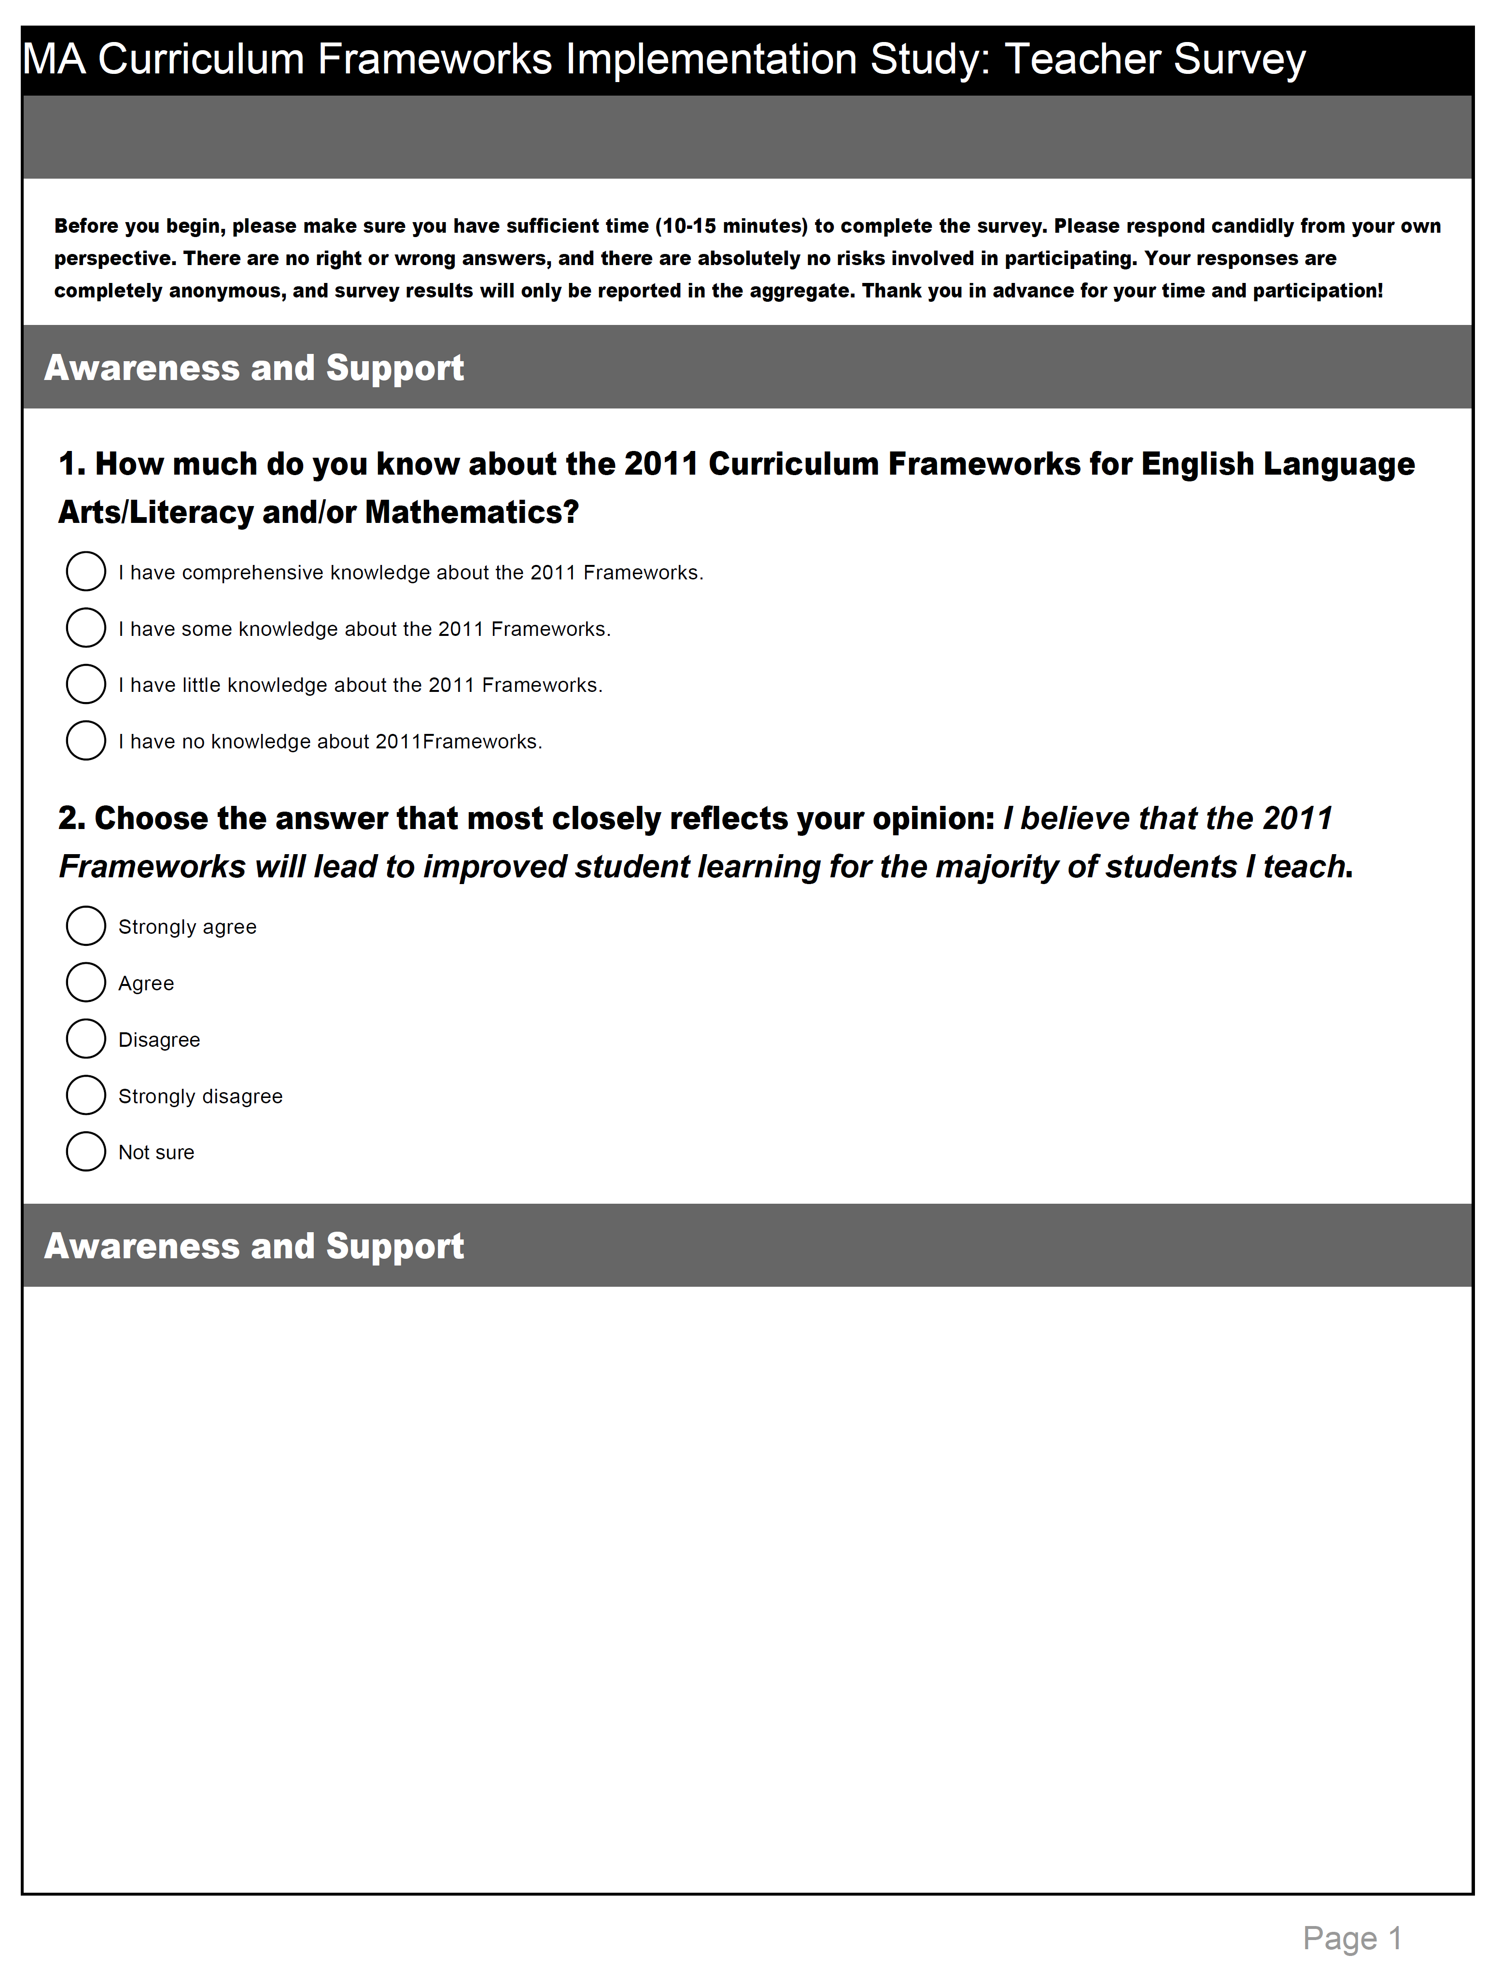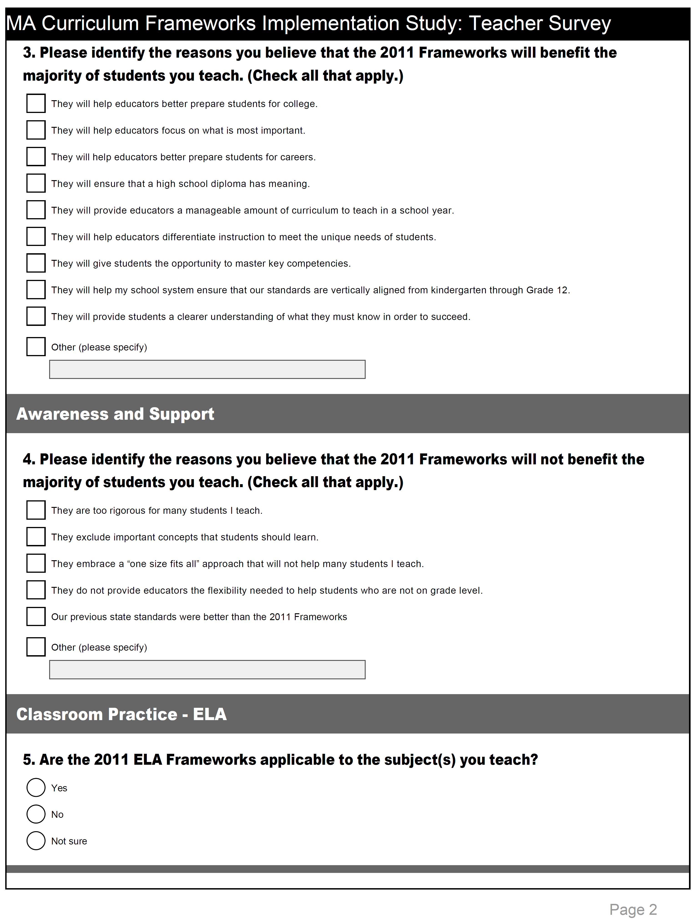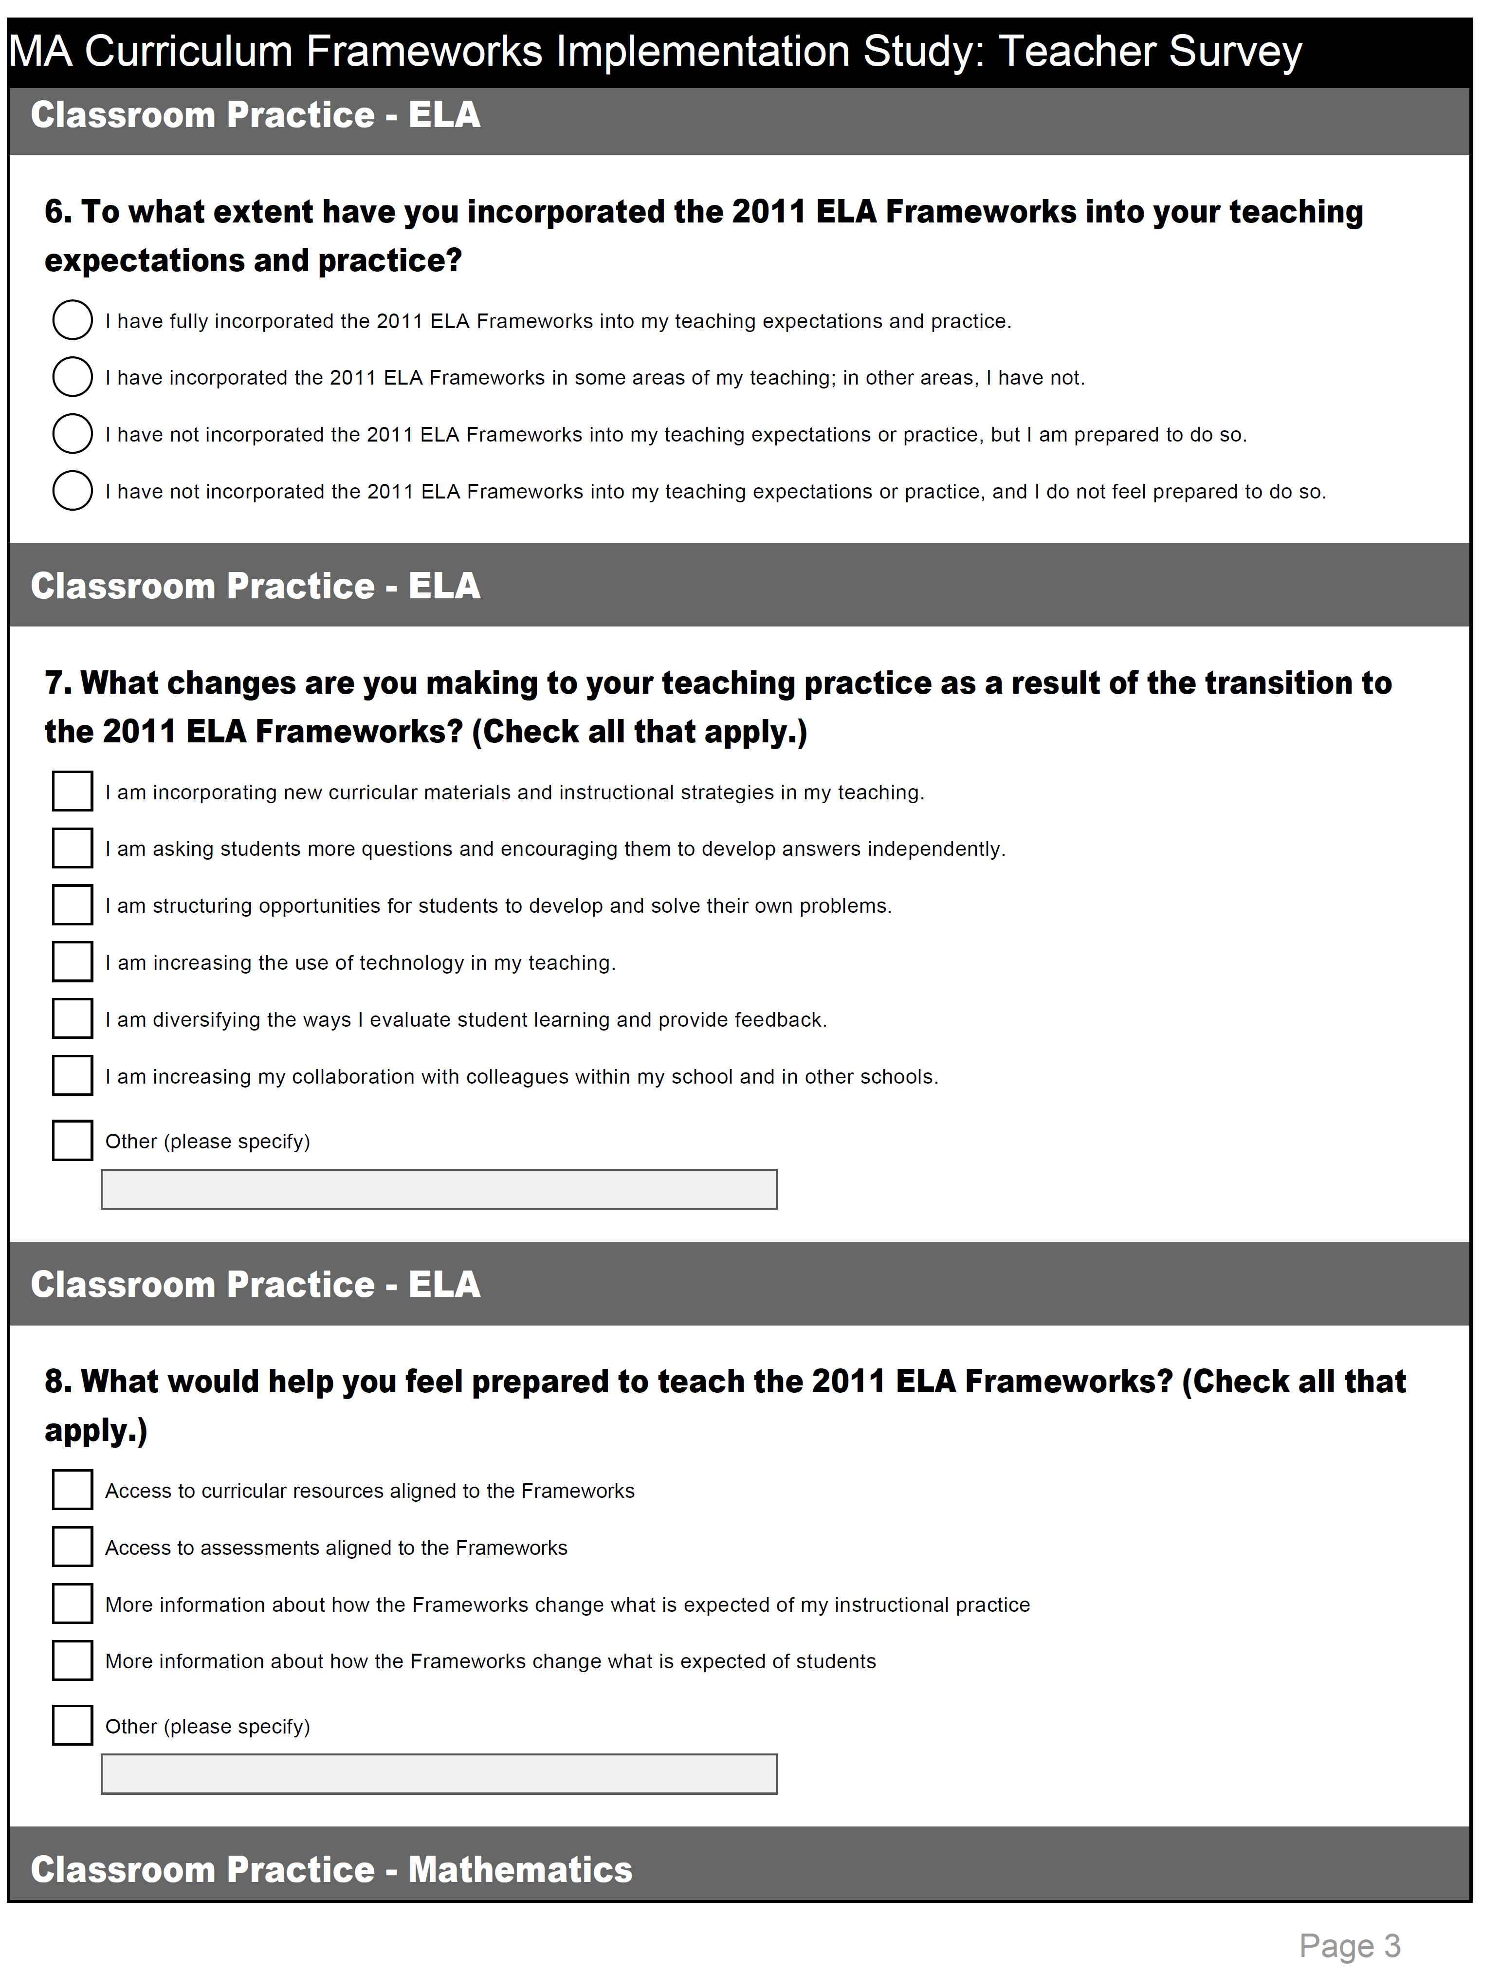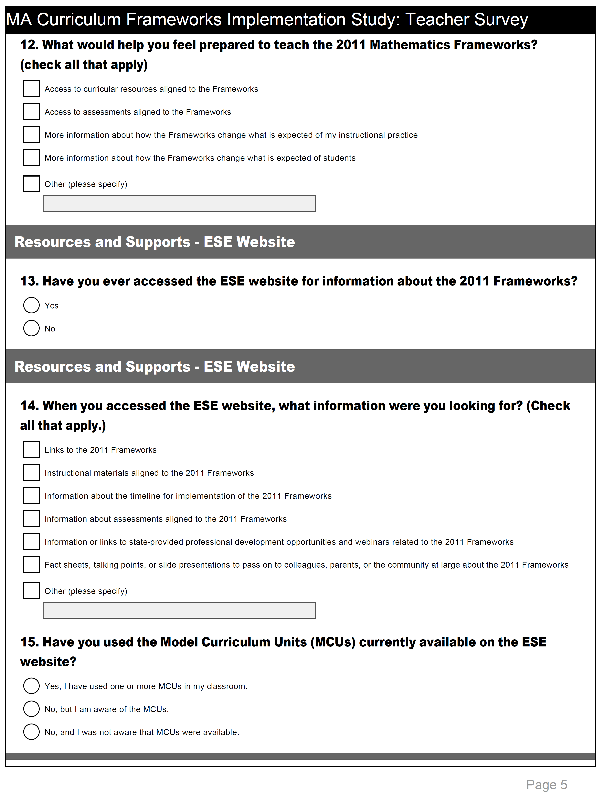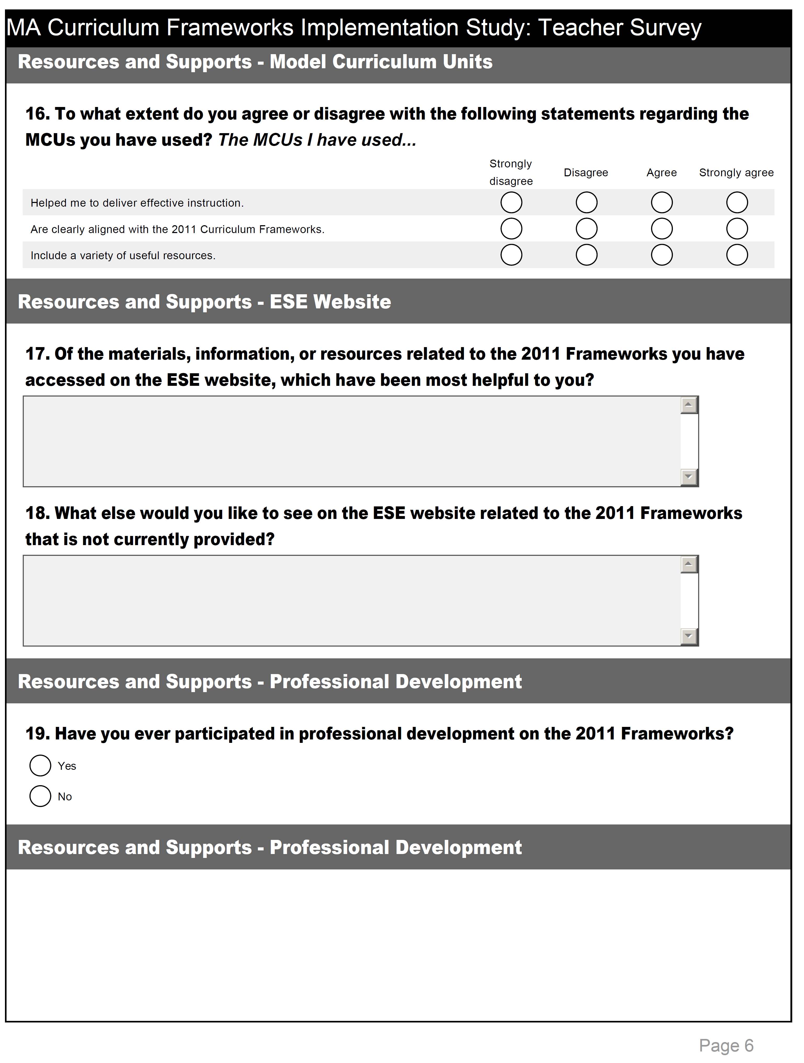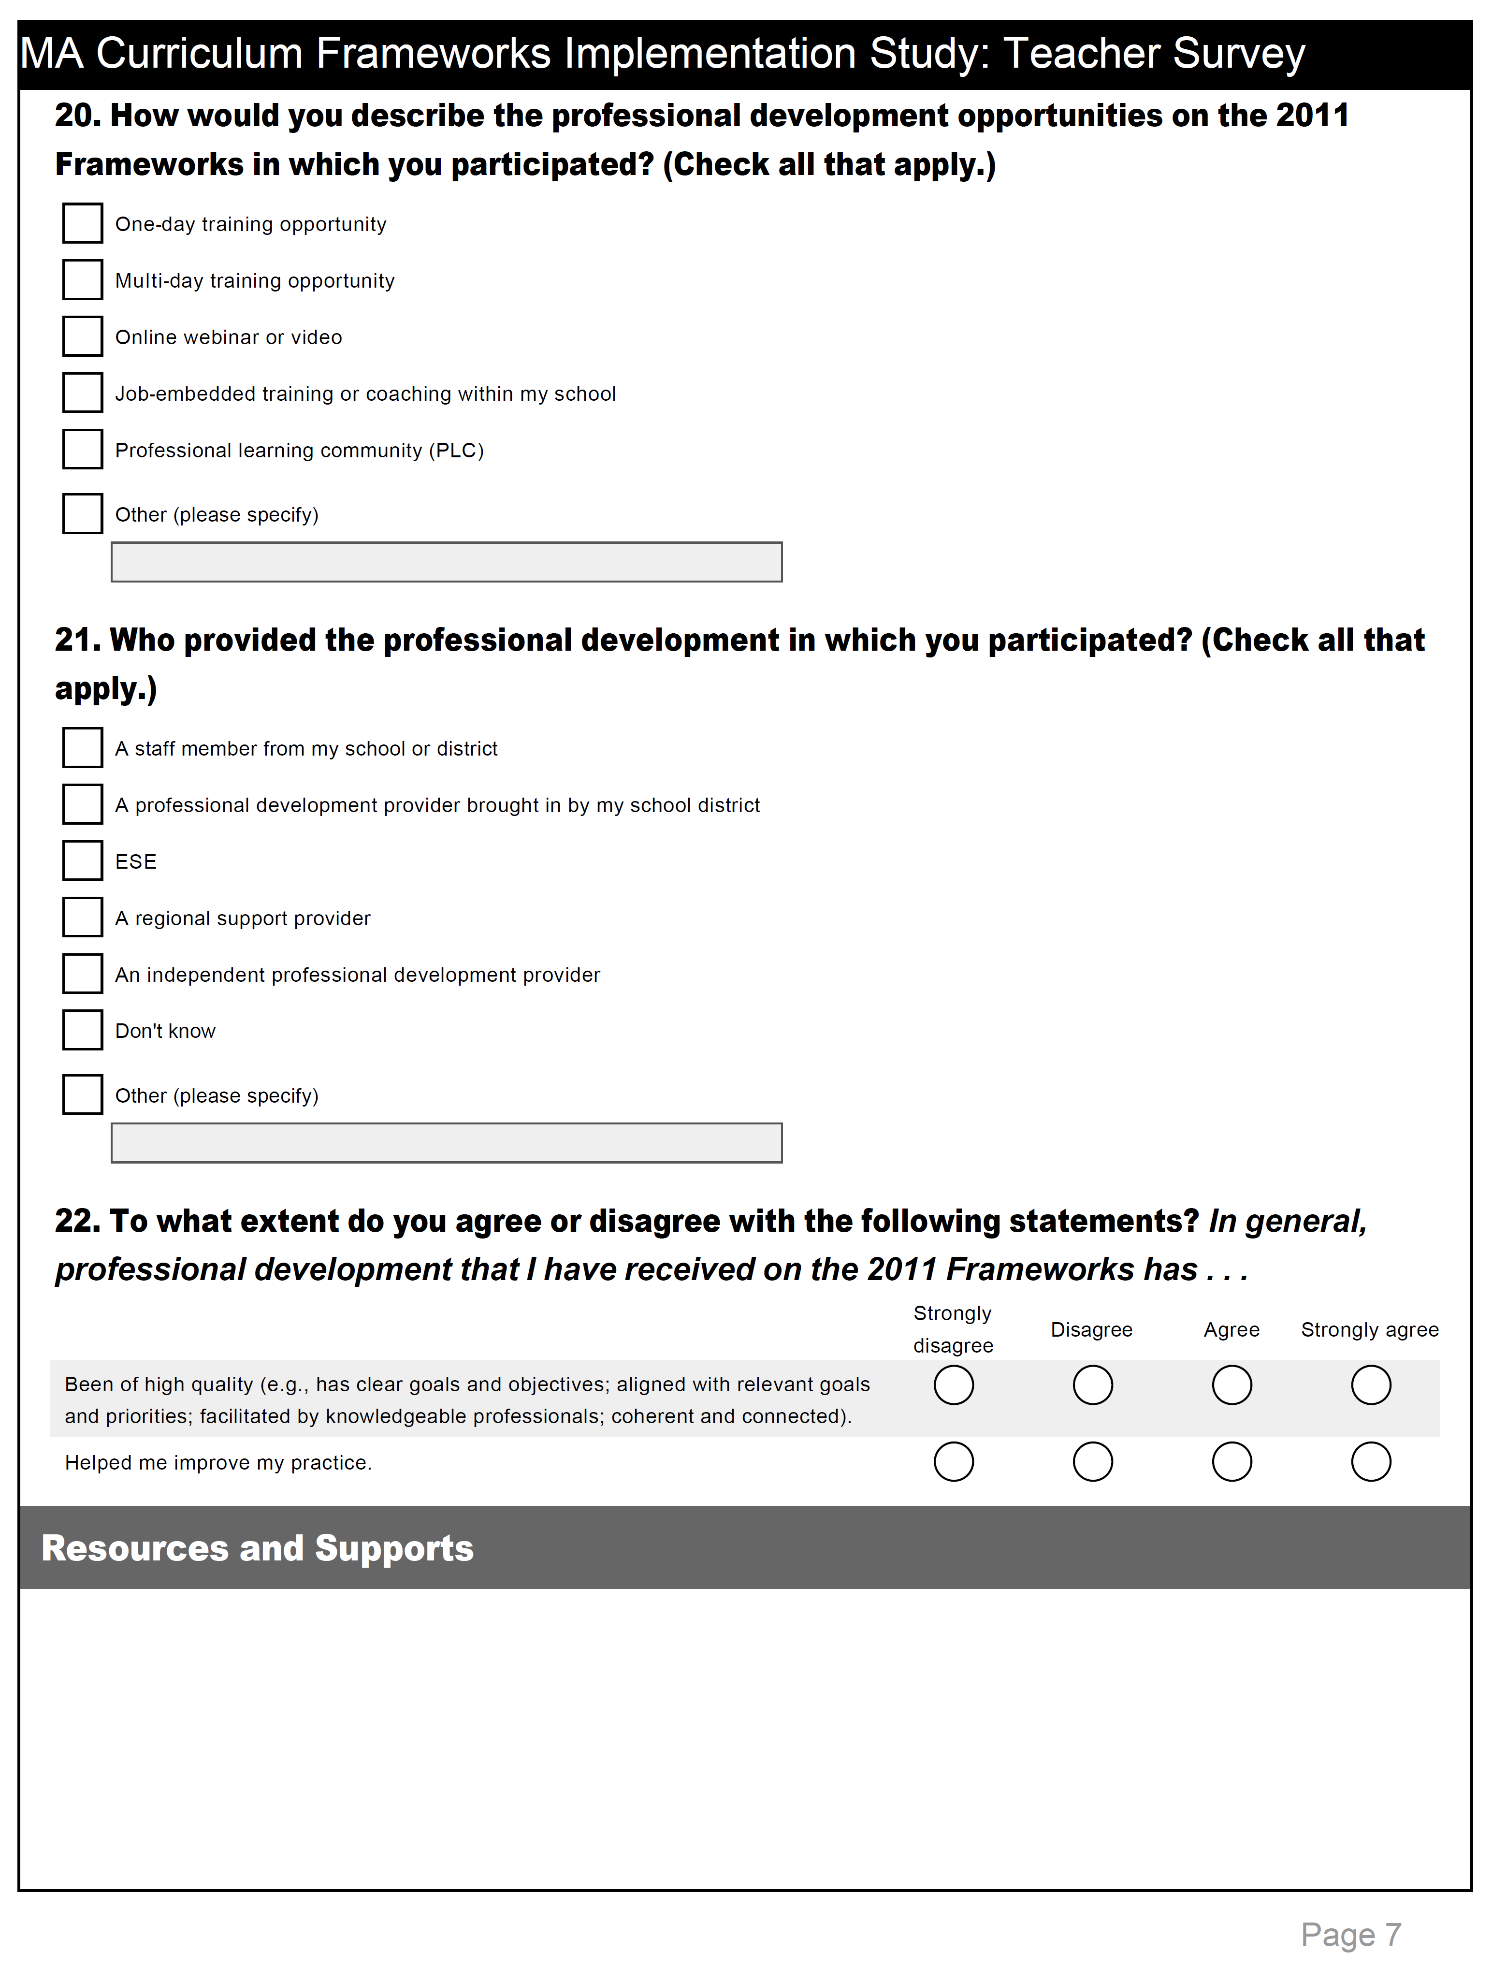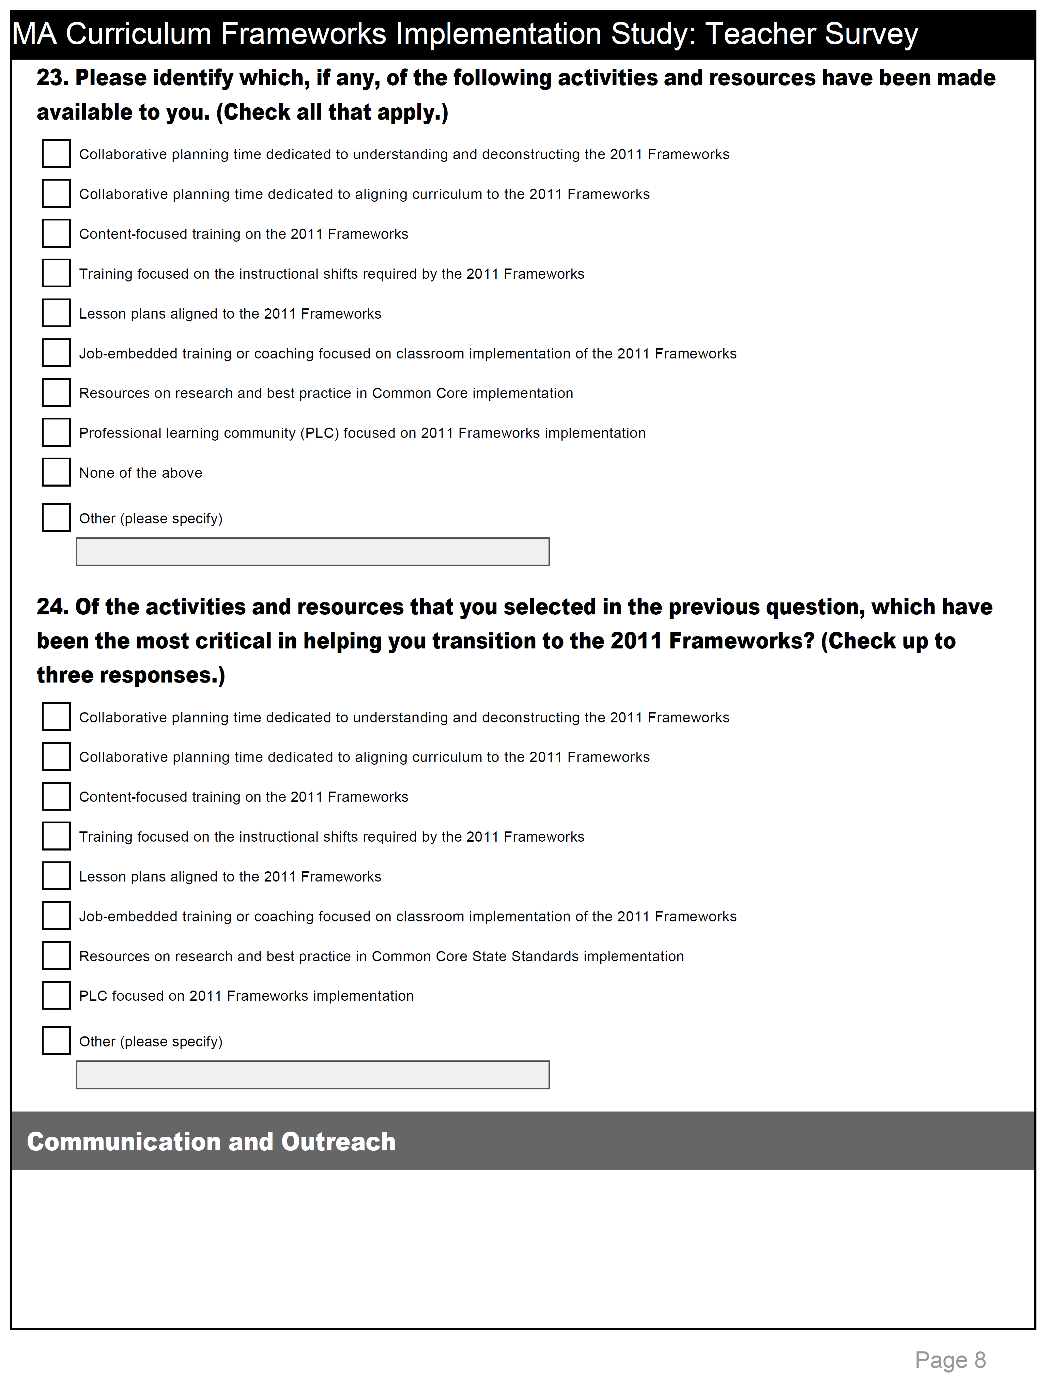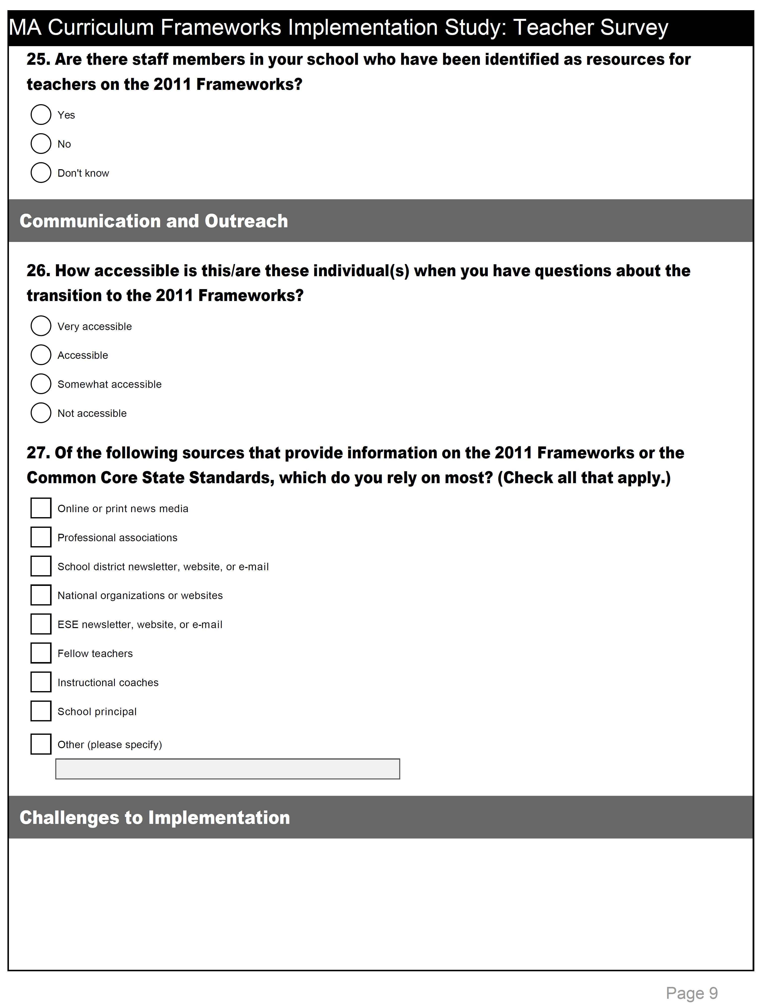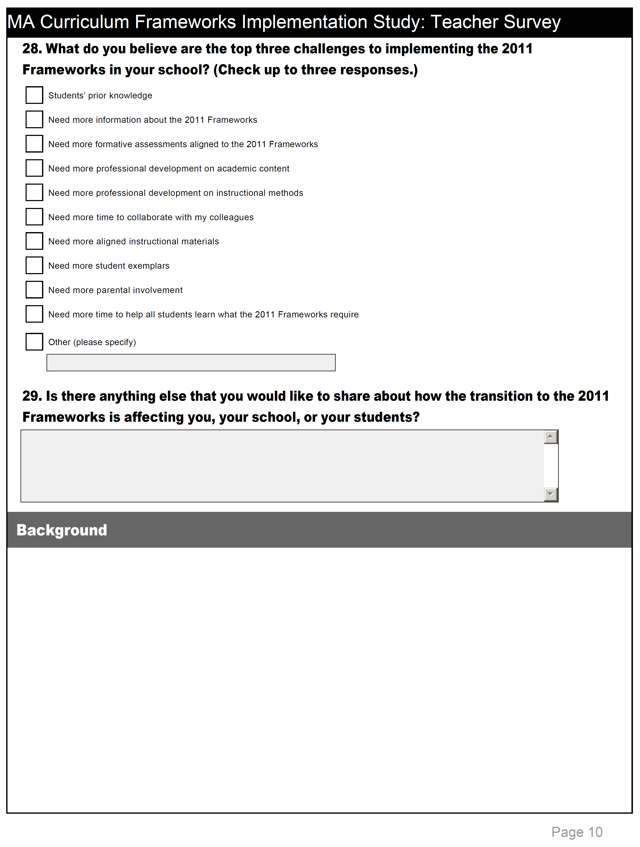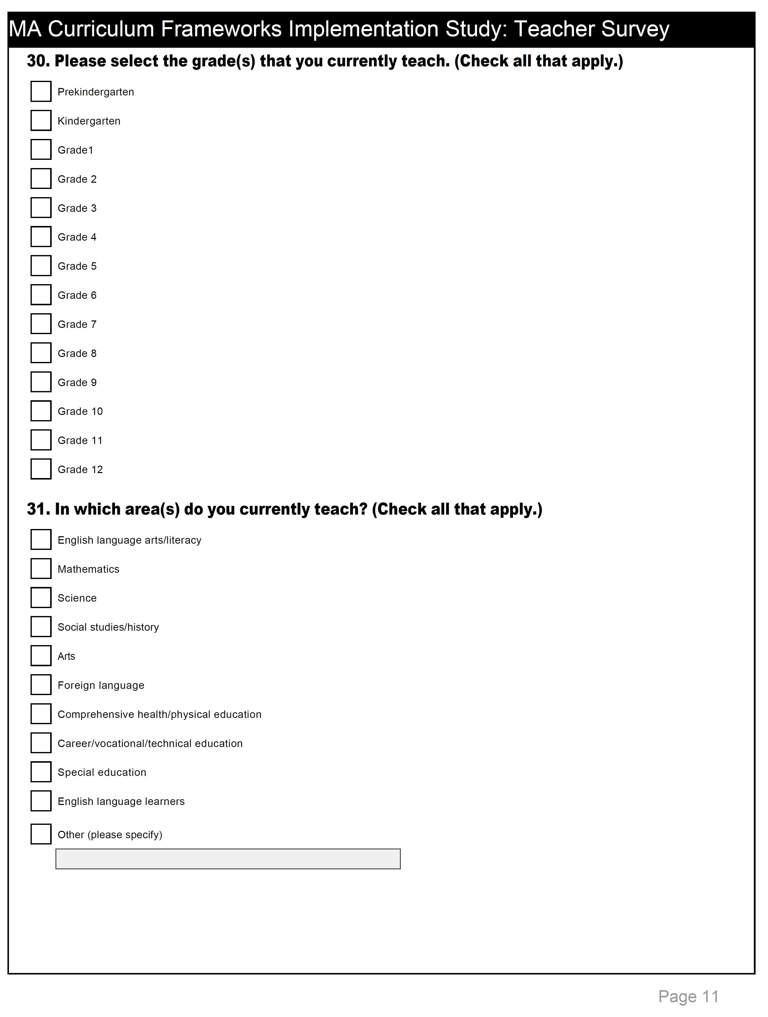

INSTRUCTIONAL LEADER INTERVIEW QUESTIONS

Status of Implementation

- To what extent have teachers in this school incorporated the 2011 Frameworks into their teaching expectations and practice?
  - How close is the school to full implementation?
  - Are there differences in the transition to the ELA versus the Math Frameworks?
  - Is the transition more or less difficult depending on grade and/or subject area?
Communication About Implementation

- In this school year, what are the key messages so far from school leaders to teachers regarding the transition to the 2011 Frameworks?
  - What is emphasized?
  - How are teachers reacting to these messages?

- Did this school have a plan for transitioning to the 2011 Frameworks that was shared with staff?
  - Has a timeline or benchmarks for full implementation been communicated to staff?
Student Assessment

- How have the ways in which students are assessed in this school changed because of the transition to the 2011 Frameworks?
  - Has the focus or emphasis of school-mandated assessments changed?
  - Has the focus or emphasis of district-mandated assessments changed?
  - To what extent are assessments being used to drive or encourage implementation of the frameworks in this school?
Support for Teachers

- Do teachers in this school have collaborative opportunities to work with other teachers (in the school or in the district) regarding implementation of the 2011 Frameworks?
  - Who participates?
  - How often do they meet?
  - What is the focus of these collaborative sessions?

- What professional learning opportunities have teachers in this school participated in to help them transition to the 2011 Frameworks? (PD can be from the state, district, or regional providers and pedagogy or content focused.)
  - Which have been most helpful?
  - What additional professional learning opportunities will teachers have in this school year to help them transition to the frameworks?

- What Instructional materials (developed by the state, district, school, regional providers, or commercial vendors) are made available to teachers in this school to support or facilitate the transition to the 2011 Frameworks (e.g., curriculum guides, model units)?
  - Which have been most helpful?
Alignment With Other Initiatives
- In what ways, if at all, does the transition to the 2011 Frameworks align with other key initiatives currently underway in the school?
- What are these initiatives?
- How do they support each other in terms of implementation and/or meeting initiative objectives?
District Support
- In what ways is the district supporting the transition to the 2011 Frameworks in schools?
- What has been most helpful?
- What more is needed from the district?

- In what ways, if at all, has the district’s involvement with your school changed with the transition to the 2011 Frameworks?
  - In what ways, if at all, are teachers in this school involved with teachers in other district schools?
Challenges to Implementation

- What do you are think are the major challenges to implementing the 2011 Frameworks in this school?

- What tools, resources, or information would be helpful in addressing these challenges?
Lessons Learned

- What are the major lessons learned in transitioning to the 2011 Frameworks in this school?
  - Is there anything at the school, district, or state levels that you think could have been done differently?
Final Thoughts

- Is there anything you would like to add about the transition to the 2011 Frameworks in this school?
SCHOOL-LEVEL INTERVIEW QUESTIONS

Building Awareness about the 2011 Frameworks and Reasons for the Change
- In what ways has the school tried to build teachers’ awareness about the 2011 Frameworks and the reasons for the transition to them?
  - What processes, strategies, or activities have been used?
- To what extent do teachers in this school have a clear understanding of the following:
  - Why the change is necessary and is happening now
  - The impact on their instructional practices
  - The consequences of not transitioning
  - How the new frameworks align with the school’s vision for success
- What has been the district’s role in creating awareness about the transition to the 2011 Frameworks and the need for it among school staff?
Creating Desire to Support and Implement the 2011 Frameworks
- In what ways has the school tried to motivate teachers to support and participate in the transition to the 2011 Frameworks?
  - What processes, strategies, activities, or messages have been used to motivate and engage teachers?
- Has the school tried to identify and address teachers’ concerns about the transition?
  - If so, what are teachers’ primary concerns and how is the school addressing them?
- What has been the district’s role in motivating school staff to support and participate in the transition to the 2011 Frameworks?
Developing the Knowledge to Implement the 2011 Frameworks
- In what ways has the school helped teachers to develop or strengthen the appropriate knowledge and skills to effectively implement the 2011 Frameworks?
  - What kinds of learning opportunities and/or resources have been provided to teachers?
  - Do teachers in this school have ready access to needed information and materials about the frameworks?
- What has been the district’s role in developing teachers’ knowledge to effectively implement the 2011 Frameworks?
Fostering the Ability to Implement the 2011 Frameworks
- In what ways has the school helped teachers to develop, practice, and hone the abilities, skills and behaviors required by the 2011 Frameworks?
  - What processes, strategies, or activities have been used (e.g., professional learning communities, common planning/prep time, coaching)?
- What has been the district’s role in developing and strengthening teachers’ ability to apply new knowledge and skills to effectively implement the 2011 Frameworks?
Reinforcing and Sustaining the Transition to the 2011 Frameworks
- In what ways has the school tried to reinforce the changes teachers are making in their practice to avoid losing momentum?
  - What processes, strategies, activities or incentives have been used?
- What has been the district’s role in reinforcing the changes teachers and schools have made to reach the goal of full implementation districtwide?
Alignment of the 2011 Frameworks with Other Initiatives
- What is the relationship between the implementation of the 2011 Frameworks and other major policy initiatives right now, such as Educator Evaluation and PARCC? How do they align if at all?
Major Challenges to Implementation
- What have been the major challenges to implementing the 2011 Frameworks in this school?
Lessons Learned about Implementation
- What are the major lessons learned in transitioning to the 2011 Frameworks in this school?
  - Is there anything at the school, district, or state levels that you think could have been done differently?
Final Thoughts
- Is there anything you would like to add about the transition to the 2011 Frameworks in this school or district?

Thank you very much for your comments and time.

However, a recent study found that support for the Common Core among teachers is slipping—76 percent backed the standards in 2013, but only 46 percent did so in the most recent poll (Henderson et al., 2014)
These unique elements include standards for pre-kindergarteners and an expansion of the Common Core’s glossary and bibliography.
In a number of states, however, there is growing resistance to the standards, fuelled largely by debate about who drove their adoption and about the testing and accountability procedures connected with them. Lawmakers in roughly 15 states have introduced or passed legislation during recent sessions to repeal or replace the standards.
Work on aligning the Massachusetts Comprehensive Assessment System (MCAS) Grade 3–8 tests in ELA and mathematics began in 2011, with aligned items appearing on the tests in the 2013–14 school year.
Between 2011 and 2014, Massachusetts was also a governing state in PARCC—a multistate consortium formed to design common assessments based on the CCSS.
One district originally selected, Stoughton, declined to participate in the study. In consultation with ESE, the research team chose West Springfield instead.
The development of the observation tools was informed by a number of primary sources, including the 2011 Massachusetts Curriculum Framework for English Language Arts and Literacy and the 2011 Massachusetts Curriculum Framework for Mathematics, as well as materials from Achieve the Core, the National Education Association, and Engage NY, including the video series with New York Commissioner John King and David Coleman (a contributing author for the Common Core).
Although an overall “score” was calculated for each classroom observed, it should be noted that the observations were not intended to evaluate the teachers observed.
Only elementary and middle schools were considered in this classification scheme, as these schools are fundamentally more similar than high schools
The use of illustrative quotes in this report is consistent with qualitative methodology and purposes. The quotes that are included in this report were selected carefully. They may be representative of a shared viewpoint; that is, representing other respondents who had similar remarks. In some cases, quotes were selected because they present a substantial, relevant, and specific observation or issue brought up by a single, informed respondent. Quotes that represent different reasons for a general assessment are also included. For example, although multiple respondents may agree that they support the 2011 frameworks, their reasons may differ.
This survey was adapted from the Common Core implementation survey developed by Achieve, the U.S. Education Delivery Institute, and Education First. This tool was designed for voluntary use by state education agencies as they create feedback loops to monitor Common Core implementation efforts. Additional topics relevant to the 2011 frameworks implementation were added in consultation with ESE.
As noted earlier, whether a school was identified as higher implementing or lower implementing was based on composite ratings from observations in a subset of mathematics and ELA/humanities classrooms in each school.
Teachers self-reported whether the 2011 ELA and mathematics frameworks were applicable to the subject(s) they teach.
While the ELA framework makes recommendations about progressively increasing text complexity, it is not meant to constrain or dictate teachers’ choice of texts.
In this section and the ones that follow reporting teacher survey results, elementary and middle schools in the sample were identified as higher or lower implementing based on an average composite score across observed classrooms in this phase. Higher implementing schools were those in which the average classroom score on the observations tools was higher relative to other schools in the sample. Only elementary and middle schools were considered in this classification scheme.
Massachusetts Model Curriculum Units (MCUs) are curricular units of study that align with the frameworks. In October 2012, ESE released 36 Model Curriculum Units for piloting in Race to the Top districts. In April 2013, 60 additional units were added. In July 2013, all units were revised according to feedback from the pilot and external review and made available to all districts and schools. For the 2014–15 school year, ESE will release over 80 MCUs on a rolling basis. MCUs span Grades PK–12 in mathematics, ELA, history and social science, and science, technology and engineering. Each unit includes a curriculum-embedded performance assessment, lesson plans, and digital resources.
It is important to note that although the implementation of new standards, new statewide assessments, and the educator evaluation system were all conceived together by ESE as a comprehensive system in the state’s Race to the Top application, the RETELL initiative was a separate entity, funded through a state legislative line item beginning in fiscal year 2013.

