About This Brief
This brief highlights Lawrence Public Schools’ guidance materials for developing and implementing educator plans under the Massachusetts’ Educator Evaluation Framework.

Since 2012, the Massachusetts Department of Elementary and Secondary Education has contracted with SRI International, Abt Associates, Nancy Brigham Associates, and J. Koppich and Associates to study the implementation of the Educator Evaluation Framework. The Artifact Brief Series highlights promising strategies for evaluation system implementation in districts across the Commonwealth.

For more information on the study, please visit http://www.doe.mass.edu/edeval/resources/study/default.html.

Educator Evaluation Implementation Artifact Brief Series – Issue 2
Lawrence Public Schools: Guidance for Developing and Supporting Educator Plans

As part of an evaluation of the Massachusetts Educator Evaluation Framework (EEF), SRI and its partners (Abt Associates, Nancy Brigham Associates, and J. Koppich and Associates) issued a statewide invitation to districts for examples of successful artifacts, practices, materials, and tools used to support EEF implementation. The purpose of this effort is broader dissemination of promising examples of specific district-developed EEF artifacts and implementation strategies that may be useful to other districts.
This brief describes a set of materials and supports created by Lawrence Public Schools (LPS) to help evaluators develop and implement educator plans under EEF, especially Directed Growth and Improvement Plans. Goal setting or refinement and educator plan development typically take place early in the year and in the evaluation cycle. For the duration of the evaluation cycle, educators work to pursue these goals and demonstrate evidence of practice, and evaluators provide educators with feedback and access to supports while using multiple sources to measure progress toward goals. The materials created by LPS provide evaluators with guidance about how to work with educators to develop a well-rounded plan that (1) articulates clear professional practice and student learning goals; (2) builds in opportunities for feedback and professional growth; (3) identifies key action steps for implementing each type of educator plan; and (4) identifies the types of evidence to be collected in support of educator plan progress or completion. The materials are designed to complement mentoring and professional development for evaluators on how to prepare and implement meaningful and well-specified plans for the educators they evaluate.
According to ESE, educator plans should be “designed to provide educators with opportunities for feedback, professional growth, and leadership; and to ensure educator effectiveness and overall system accountability” (603 CMR 35.06(3)).
http://www.doe.mass.edu/edeval/
resources/QRG-EducatorPlans.pdf

The brief describes the context in which the guidance materials were developed, key content from the materials, how they are used, and key takeaways about the implementation process. The brief also outlines how the guidance materials might be adapted for use in other districts. Note that this brief describes district perspectives on providing guidance to principals and other evaluators about the educator plan portion of the EEF’s five-step cycle; it does not reflect educators’ perspectives or experiences.

Context and Development of the Guidance Materials
In late 2011, Lawrence Public Schools (LPS), a mid-sized urban school district, was the first district in the Commonwealth to enter state receivership status due to low student achievement. When LPS began implementing the EEF in 2011-12, the district was beginning an aggressive turnaround effort. LPS recognized the need to provide evaluators with targeted training and resources on how to conduct evaluations, provide feedback, and make decisions about educator plans. Evaluators expressed concerns about their capacity to implement Directed Growth and Improvement Plans consistently. As a result, the district hired external evaluation support to focus explicitly on educator evaluation (referred to in this brief as an EE specialist) and work closely with central office administrators.
The EE specialist, in close collaboration with the district’s HR director, developed guidance materials for evaluators that included a checklist of steps for assessing the type of plan that was appropriate for educators. As noted by the EE specialist, “these documents were a way of providing a shorthand or synthesis of the regulations so that each principal would feel confident that he or she was doing things according to the way the district had negotiated them. Principals appreciated this shorthand approach.”
The key purposes of the educator plan guidance materials were to
- create a systematic process for placing educators on appropriate plans and then implementing those plans;
- increase evaluators’ capacity to conduct observations and provide high-quality feedback;
- promote consistency of EEF implementation across the district and calibrate evaluators; and
- help evaluators use the EEF to improve teaching practices and ultimately student learning.

The guidance materials are among multiple supports LPS has made available to its evaluators to help clarify the educator plan development and implementation process. The guidance materials—which are intended to monitor and improve instructional practice—reflect the district’s efforts to (1) help calibrate evaluators’ work with teachers to directly target improvement and (2) offer supports that can improve educators’ practice.
Overview of Guidance Materials
The guidance materials provided to evaluators include the following:
- Two concise documents that articulate criteria for placing educators on different plans (Guidance on which plans to place Educators on for 2014-2015 and Guidance on Directed Growth Plans).
- Two checklists that outline the steps required to place an educator on an Improvement Plan or Directed Growth Plan (Putting an Educator on a Directed Growth Plan Checklist and Putting an Educator on an Improvement Plan Checklist).
- One document that outlines how evaluators should work with and provide effective feedback to educators placed on Improvement Plans (Guidance for Working with an Educator on an Improvement Plan).

As a group, the guidance materials delineate the steps and processes evaluators should follow when selecting and implementing educator plans (see below). Step 1 applies to all educators; subsequent steps apply primarily to Directed Growth and Improvement Plans.
- Choosing an educator plan. The materials provide an overview of both the specific criteria used (e.g., summative rating from previous year, Professional Teaching Status) to determine educator plan assignments, particularly Directed Growth and Improvement Plans, and the evaluator’s process for using those criteria.
- Placing educator on a plan. Two checklists outline all required documentation (e.g., Self-Assessment form, Teacher/Specialized Instructional Support Personnel Formative Assessment/Evaluation form) that must be completed and activities that must take place throughout the evaluation cycle prior to formally placing a teacher on a Directed Growth or Improvement Plan.
- Working with an educator on a Directed Growth or Improvement Plan. The guidance materials provide plan-specific instructions for working with educators. For example, in Lawrence, evaluators are expected to observe educators on Improvement Plans weekly and to observe educators on Directed Growth Plans at least every two weeks.
- Conducting observations and providing feedback. The guidance materials stress the importance of providing specific and actionable feedback to educators. To supplement the guidance materials, the EE specialist created sample observation write-ups of high school and elementary school teachers at each performance level–from exemplary to unsatisfactory. These write-ups, also available in the district’s online evaluation platform (TeachPoint), serve as a reference for evaluators as they conduct and write up their observations. Because the write-ups are in TeachPoint, educators can access them as well, so they know what to expect during and after an observation.

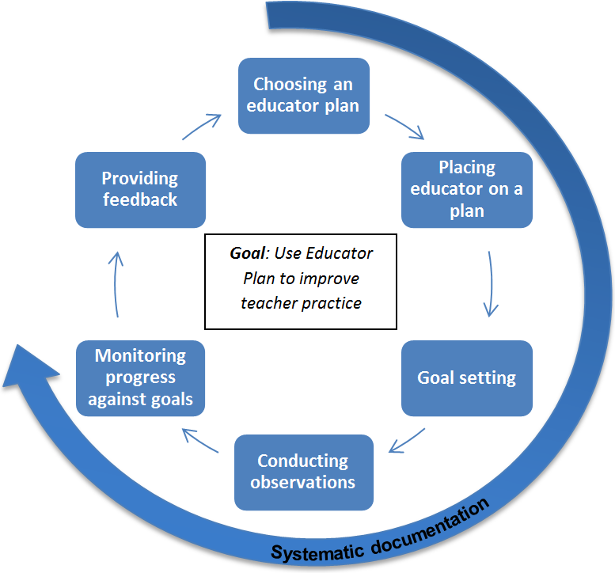
- Optional co-observations with EE specialist. LPS provides optional support to evaluators to help them understand what to look for during their observations and how to provide more meaningful feedback. The EE specialist will co-observe and then debrief with the evaluator about the observation and feedback. The EE specialist also works with evaluators to calibrate observation techniques. These supports are offered both to individual evaluators and to small groups of evaluators.
- Systematic documentation. The guidance materials highlight key steps that need to be documented throughout implementation of an educator plan. Evaluators in Lawrence received training about how to use the district’s online platform to document their activities and interactions.
Evaluators’ Reactions to the Guidance Materials
Multiple evaluators from Lawrence reported that they found the guidance materials to be extremely useful. These administrators were appreciative of the range of supports provided that increase their understanding of and comfort with the educator plan implementation process. The administrators also commented that these materials help them, as evaluators, provide more meaningful and effective feedback to educators.
- As noted by one evaluator, the guidance materials provide clear and easy-to-follow instructions on how to approach the educator plan process; these materials, coupled with coaching from a more experienced evaluator, help to ensure that evaluators can implement this important process with precision and provide feedback that helps improve practice.
- A different evaluator reflected that since evaluators serve as a conduit for communicating information about plans and the EEF to educators, they therefore need to fully understand both the process and reasons for putting an educator on a specific plan. The value of the guidance materials is in providing a clear roadmap that evaluators can communicate to educators.
- Both veteran and less experienced principals reported that use of the guidance materials and accompanying professional development has resulted in improved evaluation processes, particularly related to documentation and avoiding procedural errors during the plan implementation process.

In addition, evaluators also expressed appreciation for the district’s broader commitment to increasing evaluator capacity through professional development. As an example, one evaluator reported having a positive experience during LPS’s summer instructional leadership institute, during which evaluators were introduced to the guidance materials and discussed the evaluation process as a group.
Supports for Evaluators Implementing Educator Plans
The guidance materials represent an effort to systematize the correct steps for putting an educator on a plan, with a particular focus on Directed Growth and Improvement Plans. Furthermore, the materials also represent a larger commitment by LPS to increase evaluator capacity. Returning and new evaluators benefit from other related mentoring and training resources throughout the school year. See below for some examples.
- More experienced evaluators (e.g., EE specialist, headmaster of the Lawrence High School) meet with less experienced evaluators regularly to focus on how to conduct high-quality observations. Videos are used to highlight the types of instructional behaviors to look for during observations. For example, the EE specialist has worked closely with all seven administrators at the Lawrence High School campus (the Headmaster and six principals) to help them refine their observation skills and to calibrate and improve feedback. The EE specialist also reviews and suggests improvements to evaluators’ write-ups of completed observations.
- The EE specialist visits new evaluators at least twice during the school year to discuss the educator evaluation process and provides support to new evaluators as they begin to conduct evaluations in their buildings. This enables a customized approach where support is tailored to the evaluators’ specific needs.
- During the initial implementation period, the assistant superintendent hosted drop-in sessions during which evaluators have informal opportunities to ask questions about the EEF generally and discuss the guidance materials. Such sessions remain available on demand.
- When an evaluator identifies an educator in need of specific supports—especially individuals who may be placed on or are already on an Improvement Plan—he or she may work with a more experienced evaluator to provide instructional strategies and guidance to the educator.
- Evaluators also receive training about how to have difficult conversations so that they can be more comfortable providing critical feedback to educators about areas needing improvement.

Key Takeaways and Considerations for Adapting Educator Plan Guidance in Other Districts
LPS continues to learn from and make adjustments to the supports available to evaluators and educators. The guidance materials developed by LPS offer one type of support for evaluators who want to navigate the educator plan development and implementation process more efficiently. Districts interested in adapting the guidance materials may benefit from considering the following recommendations from the LPS experience, some of which would require resources on top of in-house expertise:
- In LPS, clear communication, focused professional development for evaluators, and district-developed documents about the process for placing educators on various plans strengthened the consistency of plan assignments districtwide. As noted by one district administrator, “There has to be a clear process. If you don’t have a process that everyone is following, the system will fail. You have to find a way to calibrate the system…and these guidance materials are our baseline.”
- LPS benefits from having a dedicated point person to support evaluators as they use the guidance materials and implement different types of educator plans. Evaluators from LPS reported that having a more experienced evaluator (i.e., EE specialist, high school headmaster) as a “thought partner” was very helpful for learning how to fit supports to teachers’ needs and how to provide meaningful feedback. For other districts, this approach could be adapted by identifying individuals (e.g., veteran evaluators, district staff) from within the district who could serve as “thought partners” or evaluation mentors for less experienced evaluators as they conduct observations and make decisions about educator plans.
- Districts may want to establish ongoing mechanisms and/or processes to ensure that evaluators receive both initial and as-needed training and support as they conduct observations and provide feedback to educators. LPS makes all guidance materials available on demand to evaluators through the district’s online system and incorporates training related to the guidance materials into the district’s annual summer leadership institute. Additional training and discussion about educator plans can be integrated into other professional development sessions for principals.
- Districts may find it useful to provide specific tools and supports for evaluators who are working with educators on Directed Growth or Improvement Plans. Clear training and support for evaluators helps them communicate more effectively about goals and about using the educator plan to improve practice.
- Districts may want to designate multiple staff, whether district office staff or experienced school administrators, who can consult with evaluators and help address questions about the guidance materials or educator plan implementation process. Reliance upon only one individual may limit evaluators’ capacity, and evaluators may benefit from the opportunity to receive guidance or support from multiple perspectives.

Additional Information
For more details about this resource, please contact: EducatorEvaluation@doe.mass.edu

To see this brief and the full series, please visit http://www.doe.mass.edu/edeval/resources/study/.

The information in this brief is based on interviews with Lawrence central office staff and a small number of school leaders about the guidance materials and the research team’s review of the materials.
This status was created under a new law enacted the previous year that enabled the Board of Elementary and Secondary Education to take over “chronically underperforming” districts.
Districts with Level 4 schools were required to implement EEF a year earlier than Race to the Top districts (and two years earlier than non-Race to the Top districts).

