Massachusetts English Language Learners’ Profiles and Progress: A Report for the Massachusetts Department of Elementary and Secondary Education

October 2015

Rachel Slama, Ed.D.

Erin Haynes, Ph.D.

Lynne Sacks, Ed.D.

Dong Hoon Lee

Diane August, Ph.D.

**Acknowledgments**

We wish to thank several individuals who made significant contributions to this report. Ayrin Molefe (AIR) provided substantial analytic support and Sidney Wilkinson-Flicker (AIR) provided excellent research assistance. Diane Staehr Fenner and Sydney Snyder of DSF Consulting also provided research support. Lien Hoang in the Office of Planning and Research at the Massachusetts Department of Elementary and Secondary Education provided data management assistance. The authors are grateful for the thoughtful reviewer comments from Sergio Páez, consultant to Holyoke Public Schools and former superintendent, and Michael Garet of AIR. We would also like to thank the state officials who generously donated their time to participate in conversations about reclassification practices in Massachusetts. Any errors in judgment or fact are the responsibility of the authors.

Contents

**Page**

Executive Summary i

Introduction 1

Study Questions 2

ELL Policy Context 3

Research Methods 5

Phase 1 Methods 5

Phase 2 Methods 6

Phase 1 Findings 9

RQ1a. ELL Key Demographics 9

RQ1b. Distribution of ELLs in Schools 14

RQ1c. ELL Academic and Nonacademic Profiles 16

RQ1d. District Guidelines for Making Reclassification Decisions 33

Phase 1 Conclusion 34

Phase 2 Findings 35

RQ2a. Average Time to First Reaching Key Academic Milestones for the 2003 Kindergarten ELL Cohort 36

RQ2b. Relationship Between English Language Proficiency Attainment and Reclassification 43

RQ2c. Classified ELLs Scoring *Proficient* on MCAS 45

RQ2d. ELLs’ English Language Proficiency and Content-Area Performance 46

RQ2e. On-Time Fifth- and Eighth-Grade Promotion 47

RQ2f: Average Time to Key Educational Milestones by District 48

Phase 2 Conclusion 49

Discussion 51

Language Instructional Services 51

Time to Proficiency and Reclassification 55

Data Collection 56

Conclusion 57

References 58

Appendix A. Research Methods Detail A–1

Appendix B. Data Tables B–1

Tables

Table 1. Prototypical Districts Representing Various Concentrations of Students From Low-Income Households and ELL Growth in English Language Proficiency 6

Table 2. Key Outcomes and School Years Included in the Analysis 7

Table 3. First and Second Most Common Languages Spoken by Massachusetts ELLs in Sampled Districts and Statewide (2013–14) 11

Table 4. First and Second Most Common Countries of Origin of Massachusetts ELLs in Sampled Districts and Statewide (2013–14) 11

Table 5. Enrollment of ELLs in Language Learning Programs, by District (2013–14) 17

Table 6. Teachers Classified as Providing Language Support to ELLs, by Sampled Districts (2013–14) 18

Table 7. Information Districts Report Using to Make ELL Reclassification Decisions 33

Table 8. Characteristics of the Fall 2003 Massachusetts Kindergarten Cohort, by ELL Status at Kindergarten Enrollment (2003–04) 36

Table 9. Nature of Primary Disability for Students Who Remained Classified as ELL During the 10-Year Period of Analysis (n = 175; based on 2013–14 data) 41

Table 10. Level of Need for Special Education Services for Students Who Remained Classified as ELL During the 10-Year Period of Analysis (*n* = 175; based on 2013–14 data) 42

Table 11. Number and Percentage of Nonreclassified ELLs Reaching English Language Proficiency, by School Year 43

Table 12. Percentage of ELLs (E) and FELLs (F) Scoring *Proficient* or Above on the English Language Arts and Mathematics MCAS, by School Year 46

Table 13. Correlations Between Scaled Language Assessments (MEPA/ACCESS) and Scaled MCAS Mathematics and English Language Arts Scores, by School Year 46

Table 14. Number of Years at Which 50 Percent of ELLs Were Reclassified, by Selected Districts 48

Table A1. Display of the Four Bins of Potential Prototypical ELL Districts in Massachusetts A–2

Table A2. Selection of the Final Four Prototypical Districts on the Basis of: (1) Average Percentage of Students From Low-Income Families; (2) Average Student Growth Percentile on ACCESS (SGPA); (3) Average Number of ELL Students Included in SGPA; (4) Average Percentage of ELL Students; (5) Median Percentage of Students From Low-Income Families; (6) Median SGPA; (7) Median Number of Students Included in SGPA; and (8) Median Percentage of ELL Students in the District A–3

Table A3. Phase 2 Research Questions and Corresponding Outcome Variables (With Data Sources in Brackets) A–7

Table A4. Cohort Structure and Testing Map A–8

Table B1. Percentage of ELLs Scoring *Proficient* or Higher, or Making Progress on ACCESS for ELLs, and Percentage of ELLs Performing at Each Level of ACCESS for ELLs, by District and Number of Years in Massachusetts Schools (2013–14) B–1

Table B2. Percentage of ELLs Scoring *Proficient* or Higher on the MCAS, by District, ACCESS for ELLs Assessment Level, and Subject Area (2013–14) B–2

Table B3. Median Student Growth Percentile (SGP), by District, Number of Years in Massachusetts Schools, and MCAS Subject (2013–14) B–4

Table B4. MCAS Composite Score Index for ELLs, Former ELLs, and Students Who Were Never ELLs in English Language Arts, Mathematics, and Science, by District (2013–14) B–5

Table B5. Sample Sizes Included in Group Composite Score Index Reports by ELL Status and MCAS Subject Area for Each Sampled District and Massachusetts B–6

Table B6. Results of Fitting Discrete-Time Hazard Models to the Time-to-First-English Language Proficiency for the 2003–04 Kindergarten English Language Learner (ELL) Cohort, for the Polynomial Specifications of Time(Standard Error in Parentheses) B–7

Table B7. Results of Fitting Discrete-Time Hazard Models to the Time-to-first-Reclassification for the 2003–04 Kindergarten English Language Learner (ELL) Cohort, for the Polynomial Specifications of Time (Standard Error in Parentheses) B–8

Figures

Figure 1. Percentage of ELLs in Sampled Districts (2003–04 and 2013–14) 10

Figure 2. Percentage of ELLs in Grades 2–12 Who Are in the First or Second Year in Massachusetts Public Schools in Sampled Districts (2013–14) 12

Figure 3. Percentage of Students From Low-Income Households Among ELLs in Sampled Districts, All Students in Sampled Districts, and ELLs Statewide (2013–14) 13

Figure 4. Percentage of ELLs Receiving Special Education Services in Sampled Districts Compared With Percentage of All Students Receiving Special Education Services in Massachusetts (2013–14) 14

Figure 5. Percentage of ELL Students at Each School Level (Elementary, Middle, Secondary) in Massachusetts (2013–14) 15

Figure 6. Demographic Characteristics of Schools Attended by Non-ELL and ELL Students in Sampled Districts, by Characteristic (2013–14) 16

Figure 7. Percentage of ELLs Scoring *Proficient* or Higher and Making Progress on the ACCESS for ELLs Assessment (2013–14), by Sampled District 20

Figure 8. Percentage of ELLs Scoring *Proficient* or Higher on the ACCESS for ELLs, by Number of Years in Massachusetts Schools (2013–14) 21

Figure 9. Percentage of ELL Students Scoring *Proficient* or Higher on the MCAS in English Language Arts, Mathematics, and Science, by District, With Percentage of All Massachusetts ELLs and All Massachusetts Students Scoring *Proficient* or Higher Overlaid (2013–14) 23

Figure 10. ELL Median Student Growth Percentile (SGP) in English Language Arts and Mathematics, by Sampled District, With Statewide ELL SGPs Overlaid (2013–14) 24

Figure 11. MCAS Composite Performance Index for ELLs, Former ELLs (FELLs), and Students Who Were Never ELLs in English Language Arts, Mathematics, and Science, by Selected Districts and Statewide (2013–14) 25

Figure 12. Retention Rate of ELLs in Massachusetts by Selected Districts, With Statewide Retention Rates for ELLs and All Students Overlaid (2013–14) 26

Figure 13. Dropout Rate of ELLs in Massachusetts, by Selected Districts, With Statewide Overall Dropout Rate and Statewide ELL Dropout Rate Overlaid (2013–14) 27

Figure 14. Four-Year and Five-Year ELL Graduation Rates, by Selected Districts, With State ELL Four- and Five-Year Graduation Rates and Overall State Four- and Five-Year Graduation Rates Overlaid (2013–14) 28

Figure 15. ELLs’ Chronic Absenteeism Rate, by Selected Districts, With State ELL Chronic Absenteeism Rate and Overall State Chronic Absenteeism Rate Overlaid (2013–14) 30

Figure 16. ELLs’ Stability Rate, by Selected Districts, With State ELL Stability Rate and Overall State Stability Rate Overlaid (2013–14) 31

Figure 17. ELLs’ In-School and Out-of-School Suspension Rates, by Selected Districts, With State ELL In- and Out-of-School Suspension Rates and Overall State In- and Out-of-School Suspension Rates Overlaid (2013–14) 32

Figure 18. Estimated Hazard and Survivor Functions for Time-to-English Language Proficiency for the 2,566 ELLs in the 2003 Kindergarten Cohort, by Years in School, With Median Lifetime Overlaid on Plot of Survivor Function 38

Figure 19. Estimated Hazard and Survivor Functions for Time-to-Reclassification for the 4,997 ELLs in the 2003 Kindergarten Cohort, by Years in School, With Median Lifetime Overlaid on Plot of Survivor Function 40

Figure 20. Characteristics of Students From the 2003–04 Kindergarten Cohort Who Remained Classified as ELLs in 2013–14 (*n* = 296) 42

Figure 21. Percentage of Students First Reclassified the Year After Reaching Proficiency, by School Year (2008–09 to 2013–14) 44

Figure 22. Proportion of ELLs and Former ELLs Experiencing On-Time Fifth- and Eighth-Grade Promotion 47

# Executive Summary

The present study was commissioned by the Massachusetts Department of Elementary and Secondary Education (ESE) to provide a profile of Massachusetts English Language Learners (ELLs) and policy recommendations for improving their outcomes. ESE was concerned about previous study findings that most of these learners exited ELL instructional programs at relatively fast rates—within three years of school entry as kindergartners—but struggled academically following exit. Furthermore, the State was concerned about the numbers of students who never exited ELL instructional services at all. The purpose of this report is to update and expand these findings to reflect changes in the standards and assessments for ELLs and a major statewide initiative to improve the training of core academic teachers of ELLs.

We performed in-depth statistical analyses using district-level data for a sample of 10 select districts (“Phase 1” of the report) and State student demographic and assessment data (“Phase 2” of the report). In Phase 1, we looked at a rich set of academic indicators such as graduation rates as well as performance on statewide content assessments (the Massachusetts Comprehensive Assessment System [MCAS]) and the relevant statewide English language proficiency assessments (Massachusetts English Proficiency Assessment[MEPA] and ACCESS for ELLs). Nonacademic indicators examined include retention, dropout, chronic absenteeism, stability, and suspension rates. In Phase 2, we followed a kindergarten ELL cohort across most of their schooling trajectory (from kindergarten through 10th grade) in Massachusetts public schools to look at whether and when they were exited from ELL programs, when they became English proficient and how they fared on the MCAS both while still classified as ELL and after exit. In both phases of this study, we looked at variability among districts serving these learners.

Phase 1 key findings include the following:

* **Growth in ELL population:** All sampled districts experienced substantial growth in their ELL population over the last decade, with the highest growth districts also among those with the highest concentrations of ELLs in the State.
* **Distribution of ELLs:** The average ELL student in Massachusetts attended “triply segregated” schools—those with high proportions of minority students, ELL students and students from low-income households—compared to the average non-ELL student.
* **Clustering of students from common language groups:** In six of the 10 districts, more than 50 percent of ELLs spoke a common language whereas in those same districts, the second most common language was spoken by fewer than 2 percent of ELLs in the district.
* **Dual identification as ELL with disabilities:** ELLs are typically identified for special education services at comparable rates as in the general student population. However, identification rates vary by district—we highlight a district in which ELLs are identified at rates higher than those in the overall population and one in which ELLs are identified at rates lower than those in the general population.
* **Academic indicators of current ELLs:** Overall performance on the State’s language proficiency assessment, ACCESS for ELLs, was low in many of the sampled districts, with 25 percent or fewer ELLs scoring *proficient* in nine of the 10 districts in 2013–14. The percentage of ELLs performing at *proficient* or higher on the English language arts (ELA), mathematics, and science Massachusetts Comprehensive Assessment System (MCAS) in all 10 districts fell below the State average for all students in 2013–14.
* **Nonacademic indicators:** ELLs in most of the sampled districts had higher grade retention, dropout, chronic absenteeism, and suspension rates than the State averages. ELLs in most sampled districts have lower stability and four-year graduation rates than the State averages.

Phase 2 key findings include the following:

* **Time to English language proficiency:** The average ELL in the sample takes 3.3 years after kindergarten entry to perform at the *proficient* level on the statewide English language proficiency assessment. ELL students who also receive special education `services and Spanish-speaking ELLs take longer to become proficient.
* **Time to reclassification:** The average ELL in the sample is reclassified after 2.7 years in Massachusetts schools. However, by eighth grade, more than 30 percent of former ELLs were not proficient in English language arts, and more than 60 percent were not proficient in mathematics.
* **Long-term ELLs:** Statewide, approximately 12 percent of students who began as ELLs in kindergarten did not achieve English proficiency by the end of the study period. The majority of these students were also identified as needing special education services, while only 7.3 percent of the initial samples were classified as needing special education services.

Educating ELLs to college- and career-ready standards poses a challenge to Massachusetts, partially due to the rapid growth of this population in many districts across the State. In addition, this study shows that many long-term ELLs require specialized support because they are dual-identified as needing both special education and English language instructional support services. Moreover, ELLs tend to be clustered in the highest need districts in the State (including two Level 5 districts) with large proportions of other ELLs as well as minority students and students from low-income households who are also some of the State’s highest need learners.

Large numbers of former ELLs also merit attention: many ELLs are outperformed by mainstream peers statewide (i.e., “never-ELL”) after exit: only 55 and 46 percent score proficient or above in ELA and mathematics, respectively, in fifth grade (compared to 66 and 56 percent of never-ELLs), and 68 and 39 percent are proficient in eighth-grade ELA and mathematics (compared to 83 and 55 percent of never-ELLs). Addressing the academic and nonacademic needs of ELLs across their entire schooling trajectory including after exit is critical to ensuring that these learners are provided with their federally guaranteed right to “participate meaningfully” in public school education programs (Office for Civil Rights [OCR], 2015).

Nonetheless, Massachusetts ELLs should be considered a resource to the State. They bring a wealth of linguistic and cultural diversity to the State’s districts. Academic proficiency in more than one language is no longer simply an asset but a requirement to be competitive in our increasingly global workplace and world. At the end of the report, we provide detailed recommendations to promote ELLs’ outcomes.

# Introduction

English language learners (ELLs)[1]—students who speak a non-English language at home and who have not acquired sufficient academic English to perform ordinary classroom work in English—represent a substantial and growing population of students in Massachusetts. Over the 10-year period from 2003–04 to 2013–14, K–12 ELL enrollment increased nearly 54 percent, from 49,297 students to 75,947 students; as a result, ELLs made up 7.8 percent of the State’s total student body in the 2013–14 school year.[2] This trend is not unusual. U.S. Grade PK–12 ELL enrollment grew nationwide by more than 51 percent between the 1998–99 school year and the 2008–09 school year, while the growth of total student enrollment increased by only 7 percent (National Clearinghouse for English Language Acquisition and Language Instruction Educational Programs [NCELA], 2011). ELLs are clustered in the state’s most high need urban districts, several of which have been identified as Level 4 and 5 districts—defined by the State as struggling academically based on an analysis of four-year trends in absolute achievement, student growth, and improvement trends as measured by MCAS.[3] A recent Massachusetts study (Slama, 2014) found that 78 percent of the students who were identified as ELL at kindergarten entry in 2002 attended school in an urban district.

Studies by the MBESE (2009), Owens (2010), and Slama (2014) have found that Massachusetts reflects another national ELL trend: ELLs in the United States tend to fare worse academically (NCES, 2010, 2011) and in other achievement areas, such as graduation rates (Rumberger, 2006), than their non-ELL peers. Owens (2010) found that ELLs in Massachusetts were more likely than English-proficient students to repeat a grade and were 25 percent more likely to be suspended. The MBESE (2009) reported that although ELLs in Massachusetts fare better than other ELLs nationwide, they have a larger achievement gap and graduation rate gap with their non-ELL peers than in most other states. The achievement gap is not limited to students who remain classified as ELLs; Slama (2014) found that large percentages of ELLs struggled to keep up with mainstream classwork even several years after reclassification as English proficient into those classrooms. By fifth grade, fewer than half of the kindergarten ELL cohort who had been reclassified scored at the *proficient* or above level on the ELA and mathematics Massachusetts Comprehensive Assessment System (MCAS).

The present study, sponsored by the Massachusetts Department of Elementary and Secondary Education (ESE), capitalizes on Massachusetts’ rich district- and student-level data sets to provide an updated profile of Massachusetts ELLs and recommendations for improving their outcomes. We begin in Phase 1 of the study with a description of ELL demographic trends and instructional and reclassification practices in 10 selectively sampled Massachusetts districts. Then, in Phase 2, we expand on Slama’s (2014) longitudinal study of Massachusetts ELL achievement, reproducing her analysis with a cohort of students that began kindergarten in 2003–04 and following them through Grade 10.[4] The selection of the 2003–04 cohort of ELLs is significant because it corresponds with the statewide shift to English-only programs following the 2002 passage of Question 2, a ballot initiative that made Massachusetts one of only three states that mandate English-only instruction.[5]

## Study Questions

The study is organized into two phases. The first phase provides an aggregate district-level analysis of ELL student demographic, geographic, and academic program profiles across a purposive sample of 10 Massachusetts districts, with a focus on documenting key trends. The second phase is an in-depth investigation of a kindergarten cohort of ELLs, drawing on statewide data, to examine students’ academic trajectories over time from initial identification as ELL until 10th grade when they may or may not have been reclassified as fluent English proficient. Research questions and key findings are listed in the following sections.

In this section we include an overview of our research questions (RQs) by study phase. Key findings are highlighted in text boxes in the body of the report.

### Research Questions

### Phase 1: ELL Student Demographic, Geographic, and Academic Program Profile

* **RQ1a.** What are the key demographic characteristics of Massachusetts ELLs in the 10 selected districts?
* **RQ1b.** What is the distribution of ELLs across schools within these 10 districts?
* **RQ1c.** What are the key features of ELLs’ language proficiency programs, academic profiles (e.g., MCAS performance; retention, dropout, and graduation rates), and nonacademic profiles (e.g., chronic absenteeism, stability, and in-school and out-of-school suspension rates) in these 10 districts? How do these features vary by district?
* **RQ1d.** What are district guidelines for making reclassification decisions in a purposively selected sample of 10 districts?

### Phase 2: ELL Longitudinal Student Outcomes Analysis

* **RQ2a.** After initial classification as ELL in kindergarten in 2003, what is the average time to *first* reaching the following key academic milestones:
  1. Scoring *proficient* on the statewide English language proficiency assessments (MEPA or ACCESS)
  2. Being reclassified as former ELL
* **RQ2b**. What proportion of the 2003 kindergarten ELL cohort who scored *proficient* on the statewide English language proficiency assessments (MEPA or ACCESS) is reclassified as English proficient in the following year?
* **RQ2c.** What proportion of the 2003 kindergarten ELL cohort scored *proficient* on statewide mathematics and English language arts content-area assessments (MCAS) while classified as ELL? What proportion scored *proficient* in mathematics and English language arts after first reclassification as former ELL?
* **RQ2d.** What is the relationship between the 2003 kindergarten ELL cohort’s performance on the statewide English language proficiency assessments (MEPA or ACCESS) and the cohort’s performance in mathematics and English language arts content-area assessments (MCAS)?
* **RQ2e.** What proportion of the 2003 kindergarten ELL cohort experienced on-time promotion by fifth and eighth grade?
* **RQ2f.** How does the average time to reaching the key educational milestones defined in RQ2a vary across 10 purposively selected districts?

We discuss these findings in greater detail in subsequent sections. First, in order to contextualize the study findings, we provide a brief overview of the ELL policy context in Massachusetts as situated within the larger national ELL policy landscape. Next, we provide a description of the research design and methods, followed by findings from each phase of the research. We then provide recommendations based on our findings and conclude with limitations of the current study and directions for future research.

## ELL Policy Context

Federal statute guarantees ELLs the right to “participate meaningfully” in public school education programs, and both state and local education agencies that receive federal funding are obligated to act to help ELLs overcome language barriers that might interfere with such participation (see ASPIRA Consent Decree, 1974; *Castañeda v. Pickard*, 1981; Equal Education Opportunities Act; *Lau v. Nichols*, 1974). Recently, the U.S. Department of Justice (2015) released legal guidance to remind education agencies of this obligation. Practically this statutory obligation means providing language support in addition to content area instruction, although states have latitude in how they provide such support.

In Massachusetts, Chapter 386 of the Acts of 2002, legislated in response to a public referendum popularly known as Question 2, mandates that instruction for ELLs be provided primarily in English. According to Chapter 71A of the Massachusetts General Laws (G.L. c. 71A), all students classified as ELLs must be educated in a sheltered English immersion (SEI) program, unless a program waiver is sought for another program model (dual language instruction, however, is allowed). This requirement applies to all districts that enroll ELL students, regardless of the number of students.

In Massachusetts, programs consist of two components: sheltered content instruction and English as a second language (ESL) instruction. Sheltered content instruction is defined as “approaches, strategies and methodology to make the content of lessons more comprehensible and to promote the development of academic language needed to successfully master content standards” (ESE, 2013, pp. 12–13). Sheltered content instruction must be taught by qualified teachers and be aligned to the Massachusetts Curriculum Framework and World-Class Instructional Design and Assessment Consortium English language development standards. ESL instruction is defined as that which “provides explicit, direct, and systematic instruction to learn the English language that is intended to promote second language acquisition and English language proficiency” (ESE, 2013, p. 13). ESL instruction includes instruction that is tailored specifically to ELLs’ varying proficiency levels.

This study indirectly examines these instructional policies by providing a longitudinal analysis of ELL outcomes in the cohort of students that began school in 2003, the year after the passage of Question 2. Specifically, it examines whether these practices “succeed, after a legitimate trial, in producing results indicating that students’ language barriers are actually being overcome within a reasonable period of time” (Office for Civil Rights [OCR], 2015, p. 6). The study also examines more thoroughly the policies, practices, and other factors contributing to students’ outcomes in 10 purposively selected Massachusetts districts. The findings are analyzed and recommendations made with reference to recent Office for Civil Rights (2015) guidance for providing instructional support for ELLs.

# Research Methods

This section describes our research methods by phase, including data sources used. Additional details are provided in Appendix A.

## Phase 1 Methods

### District Selection

All Phase 1 research questions refer to a purposive sample of 10 Massachusetts districts. In this section we describe the criteria used to select the 10 districts. Together, these districts represent 36,944 ELL students, or 45.5 percent of ELLs served statewide. To the extent possible, throughout the report we provide comparisons to other student subpopulations in Massachusetts where relevant (e.g., never ELLs, former ELLs, and the general student population) to contextualize our Phase 1 findings.

* ***Concentration of ELLs.*** The first five districts have the highest districtwide concentrations of ELLs statewide: Worcester (35.1 percent ELL), Lawrence (29.9 percent), Boston (29.8 percent), Holyoke (28.5 percent), and Lowell (26.6 percent).[6]
* ***Innovative ELL Programming.*** Brockton, the seventh-largest ELL district in the State (20 percent of students are ELLs), was selected for inclusion in the Phase 1 analysis because of its innovative programming for ELLs (see MBESE, 2009). Brockton serves 3,441 ELLs, or 4.2 percent of the State’s ELLs.

More specifically, in the Brockton school district,[7] elementary school ELLs performing at levels 1, 2, and 3 on the statewide English proficiency assessment are placed in a structured English immersion self-contained setting clustered by language group. These classes are taught by dual-licensed teachers who speak the home languages of the students in their class. Once ELLs reach levels 4 and 5 on the assessment, they are moved into a structured English immersion classroom in their neighborhood school, and English as a second language (ESL) instruction is provided by an ESL teacher.

At the middle and high school levels, ELL instructional models include English as a second language, structured English immersion, and transitional bilingual education classes. Students performing at levels 1, 2, and 3 on the English proficiency assessment have two to three blocks of transitional bilingual education in a self-contained setting arranged by language groups. For ELLs who have had interrupted formal education, the high school offers special courses such as literacy math, literacy social studies, and literacy science. The high school also offers a medical interpretation program for students who are proficient in their home language.

* ***Districtwide Concentration of Low-Income Households and ELL Growth in English Language Proficiency.*** The remaining four districts in the Phase 1 analysis were selected on the basis of districtwide concentrations of students from low-income households and growth in English language proficiency. Appendix A provides more information about the selection of the four prototypical districts shown in . These four districts serve an additional 2,249 ELL students, or 3 percent of the State’s ELL population.

Table . Prototypical Districts Representing Various Concentrations of Students From Low-Income Households and ELL Growth in English Language Proficiency

|  |  |  |
| --- | --- | --- |
| **District** | **Characteristics** | |
| Number of Students From  Low-Income Households | English Language Proficiency Growth |
| Weymouth | Low | High |
| Wachusett | Low | Low |
| Quincy | High | High |
| Fall River | High | Low |

### Data Analysis

For this phase of the analysis, we drew primarily from the district-level extant data maintained in the publicly available *District Analysis Review Tools (DART) Detail: ELLs* and the *School and District Profiles*, which includes aggregate Massachusetts student demographic, assessment, student support, educator, financial, and achievement gap data. We developed charts and tables of descriptive statistics to summarize information across selected districts for 2013–14, the most recent year of data available. To address research questions (RQs) 1c (language learning programs) and 1d (reclassification guidelines), we conducted short telephone interviews with an ELL administrator in each of the 10 selected districts to clarify district policies and procedures. Appendix A provides the list of questions we asked each district administrator. Finally, we conducted a review of websites and documents related to State policies and practices for ELL reclassification.

## Phase 2 Methods

### Data Construction

To address the Phase 2 research questions, we constructed a statewide longitudinal data set that followed a cohort of ELLs over time, beginning with those in kindergarten in Massachusetts public schools in the fall of 2003. Our data set consisted of student-level demographics and enrollment from the student information management systems (SIMS), standardized English language proficiency data from MEPA (fall 2004–spring 2012) and ACCESS for ELLs (spring 2013–present) assessments,[8] and content-area performance data in mathematics and ELA from the MCAS assessments (spring 2006–present).

Each student in the State has a unique student identifier that remains with him or her over time and is common across data sources even if the student changes schools or districts within the State. This identifier allowed us to link student records across multiple years, regardless of intrastate mobility or retention. In the case of the ELL cohort, tracking outcomes longitudinally over time will help ESE better understand the educational trajectories of all students who were ever classified as ELL, or “ever-ELLs.” Many students in this cohort were reclassified during the period of analysis. summarizes the school years that 2003–04 cohort ELL students entered each grade for those who progressed on time through school and the data we drew on to analyze their achievement and progress.

Table . Key Outcomes and School Years Included in the Analysis

|  | 2003 –04 | 2004 –05 | 2005 –06 | 2006 –07 | 2007 –08 | 2008 –09 | 2009 –10 | 2010 –11 | 2011 –12 | 2012 –13 | 2013 –14 |
| --- | --- | --- | --- | --- | --- | --- | --- | --- | --- | --- | --- |
| Grade | K | 1 | 2 | 3 | 4 | 5 | 6 | 7 | 8 | 9 | 10 |
| Outcome | | | | | | | | | | | |
| MEPA/ACCESS proficiency (RQ2a-1) | ⚫ | ⚫ | ⚫ | ⚫ | ⚫ | ⚫ | ⚫ | ⚫ | ⚫ | ⚫ | ⚫ |
| SIMS program exit (RQ2a-2) | ⚫ | ⚫ | ⚫ | ⚫ | ⚫ | ⚫ | ⚫ | ⚫ | ⚫ | ⚫ | ⚫ |
| MCAS proficiency (RQ2c) |  |  |  | ⚫ | ⚫ | ⚫ | ⚫ | ⚫ | ⚫ |  | ⚫ |
| On-time promotion (RQ2e) |  |  |  |  |  | ⚫ |  |  | ⚫ |  |  |

### Outcomes of Interest

*Proficiency on statewide English proficiency assessments (RQ2a-1; RQ2c).* We included students’ English language proficiency data over time in our data set as measured by the MEPA (fall 2004–spring 2012) and ACCESS for ELLs (spring 2013–present). Consistent with state guidelines over the past decade (see ESE, 2005, 2009, 2013), we considered a student to have reached proficiency at the following levels across the 10 years of our longitudinal data set: (1) Level 4 on MEPA during the 2006–2007 and 2007–2008 test administrations, (2) Level 5 on MEPA during the 2008–09 through 2011–12 school years, and (3) Level 5 or above on ACCESS during the 2012–13 and 2013–14 test administrations.

It is important to note that the standard for reaching English language proficiency as measured by the statewide English language proficiency assessment changed in several important ways during the 10-year study period. At the start of the period of analysis, language proficiency was not included on a statewide assessment for ELLs in early grades (Grades K, 1, and 2). Consequently, the 2006–07 school year—corresponding to the third grade for students who proceeded on time through school—marked the first year in which students in our study cohort could demonstrate a score of *proficient* on a statewide language assessment.

During its tenure as the statewide language proficiency assessment, the Massachusetts English Proficiency Assessment (MEPA) had two iterations. The first iteration (2006–07 and 2007–08 for our sample) classified students into four proficiency levels, with Level 4 representing proficiency. During the second iteration of MEPA (2008–09 and 2011–12), students were classified into five proficiency levels, with Level 5 representing proficiency. Beginning in 2012–13, Massachusetts began using the ACCESS for ELLs assessment, which classifies students into six levels of proficiency. We account for these changes in language proficiency assessments and corresponding benchmarks for proficiency in our analysis.

*Reclassification into mainstream classrooms (RQ2a-2).* For ELLs, the SIMS data set includes information on whether a student receives ELL instructional services (i.e., LEP = 1; reclassification = 0) or whether a student exited ELL services (i.e., LEP = 0; reclassification = 1). In our analysis, reclassification is a time-varying variable because ELLs make progress in their language development and most will reach a point at which they are considered ready to exit ELL instructional services or be reclassified as former ELL (FELL). For the purposes of this analysis, we examined only the first occurrence of reclassification and proficiency on the statewide English language proficiency assessment. In Massachusetts, reclassification reviews typically occur in the spring of each year so that any instructional changes are effective the following fall. We have coded our outcome data to reflect these instructional decision-making procedures.

*Proficiency on statewide content-area assessments (RQ2c; RQ2d)*. We relied on the State-defined proficiency levels on the statewide content-area assessment (MCAS) each year during the period of analysis in English language arts and mathematics to examine the proportion of students in the cohort that scored proficient in the respective assessments while classified as ELL and after exit.

*On-time promotion (RQ2e).* We relied on the grade-level enrollment data maintained in the SIMS database to calculate a promotion variable for each year of our longitudinal data set. Students who progressed on time from one grade to the next were counted as promoted for each respective grade transition (promoted = 1). Students whose grade level records indicated that they were in the same grade for two consecutive years were counted as retained in grade (i.e., promoted = 0) for the respective year. We relied on this variable to report the percentage of students in the 2003–04 ELL cohort who were promoted on time in fifth and eighth grades.

*District variation in time-to-reclassification and proficiency (RQ2f).* The SIMS data set tracks students’ districts and schools over time using district and school identification codes, regardless of student mobility across the State. We rely on these district and school identification codes to examine variation in time-to-reclassification and time-to-proficiency across the 10 sample districts.

### Analytic Methods

To answer RQ2a and RQ2f (please refer to the section Study Questions for a complete list of research questions), we relied on discrete time survival analysis to examine the time it takes students in the 2003–04 ELL cohort to perform at the *proficient* level on the statewide English language proficiency assessment (RQ2a-1), the time it takes to be reclassified as English proficient (RQ2a-2), and how the time-to-reclassification varies by district (RQ2f). We used correlational analyses to address the relationship between ELLs’ performance on the statewide English language proficiency assessment and the mathematics and English language arts content-area assessments, and we used descriptive statistics to examine outcomes over time (RQ2b, RQ2d). Phase 2 data and analysis methods are described in greater detail in Appendix A. In the following sections, we provide an overview of key outcome and predictor variables as they relate to each data source and research question.

# Phase 1 Findings

Phase 1 provides an aggregate district-level analysis of the ELL student demographic, geographic, and academic program profiles that aims to document key trends across a purposively selected sample of 10 Massachusetts districts. As noted in the Research Methods section, the districts were selected on the basis of three criteria: (1) districts with the highest concentrations of ELLs statewide (Worcester, Lawrence, Boston, Holyoke, and Lowell), (2) districts with innovative ELL programming (Brockton), and (3) prototypical districts representing four combinations of students from low- and high-income households and students with low and high growth in English language proficiency (see Table 1; Weymouth, Wachusett, Quincy, and Fall River). We organize the reporting of Phase 1 findings by these groupings.

We begin with a portrait of these 10 districts’ key ELL demographics (RQ1a) and the distribution of ELLs across schools in the districts (RQ1b). Next, we examine the language services for ELLs in these districts, as well as ELLs’ academic and nonacademic profiles (RQ1c). Last, we provide a description of these districts’ guidelines for making reclassification decisions (RQ1d).

## RQ1a. ELL Key Demographics

|  |
| --- |
| **Key finding 1—ELL growth:** All sampled districts experienced substantial growth in their ELL populations over the last decade, with the highest growth districts also among those with the highest concentrations of ELLs in the State—Worcester (from a student body that was 13.5 percent ELL in 2003–04 to 31.7 percent in 2013–14), Lawrence (from 16.6 percent ELL to 28.2 percent ELL), Boston (from 19 percent ELL to 29.9 percent ELL), and Brockton (from 7.4 percent ELL to 20 percent ELL).  **Key finding 2—Linguistic diversity:** The sampled districts have large clustering of speakers of a common home language: six of the 10 districts have more than 50 percent of ELLs who speak a common language (Worcester, Lawrence, Boston, Holyoke, Brockton, Fall River), whereas the second most common language in those same districts is spoken by fewer than 2 percent of ELLs in the district.  **Key finding 3—Country of origin:** In all sampled districts, the most common country of origin was the United States—the majority of ELLs in all sampled districts are U.S.-born (this figure includes Puerto Rican students). Statewide, 80 percent of ELLs are U.S.-born and in some districts, the proportion is as high as 99 percent (e.g., Holyoke).  **Key finding 4—New-to-Massachusetts students:** More than one in four ELLs are new to Massachusetts[9] across all sampled districts. The two districts with the highest proportion of new-to-Massachusetts students are both prototypical districts selected for their ELLs’ high growth in English language proficiency—Weymouth (60 percent) and Quincy (57.2 percent).  **Key finding 5—Special education representation:** Across the 10 sampled districts, we generally observe similar rates of special education identification among ELLs and the general population. However, in Holyoke, ELLs appear to be identified for special education services at rates higher than those in the general population (33.6 percent versus 25.1 percent) when compared to the discrepancy between ELL and general population special education identification in the other sampled districts. ELLs and non-ELLs in Holyoke are identified at higher rates than in the state. In Quincy, ELLs appear to be identified at rates lower than those in the overall population (4.3 percent versus 15.5 percent) as well as statewide. Lawrence, Brockton, and Weymouth also had a somewhat lower percentage of ELLs receiving special education services than in the overall student population. |

This section discusses key demographics of the ELLs in the Phase 1 district sample. shows the overall percentage of students who are ELLs in our sample of districts in 2003–04 (baseline) and in 2013–14 (the latest year of available data). The high numbers of ELLs currently enrolled in many of these districts are unsurprising given that our sample was selected purposively to include several districts with this characteristic. However, some of the districts have experienced high levels of growth in ELL enrollment since 2003–04, especially Worcester, Lawrence, Boston, and Brockton—four districts that are also among those that have the highest districtwide concentrations of ELLs.

Figure . Percentage of ELLs in Sampled Districts (2003–04 and 2013–14)

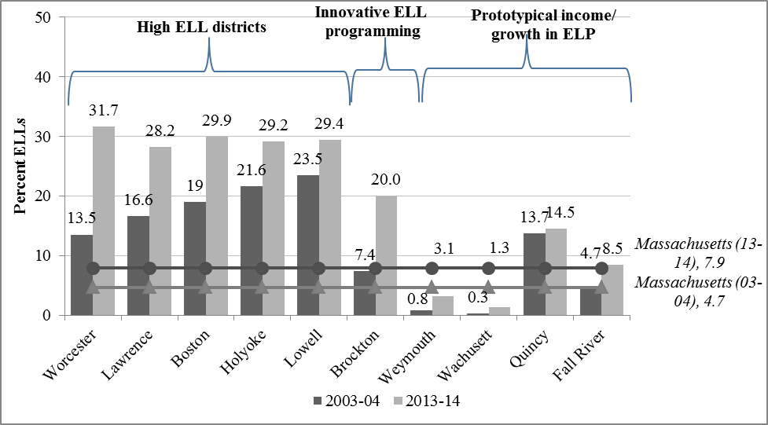

*Note.* ELP = English language proficiency.

Next, we examined home language and country of origin. displays the first and second most common non-English languages spoken by ELLs. Spanish is the most common non-English language in most districts except three of the 10 sampled districts—Brockton, Quincy, and Weymouth, whose largest language group among ELLs includes Cape Verdean (*n* = 1,893; 55.8 percent), Mandarin (*n* = 380; 28.1 percent), and Portuguese (*n* = 90; 41.9 percent), respectively. Although all the districts in the sample have speakers of multiple languages (ranging from14 languages in Holyoke to 80 languages in Worcester), in all cases the number and percentage of speakers of the most common non-English language are substantially higher than the next most common non-English language. For instance, six of the 10 districts have more than 50 percent of ELLs who speak a common language (Worcester, Lawrence, Boston, Holyoke, Brockton, Fall River), whereas the second most common language in those same districts is spoken by fewer than 2 percent of ELLs in the district. This clustering of speakers of the same home language as well as the overall linguistic diversity across districts has implications for dual language programming, as we note in the Discussionsection of the report.

Table . First and Second Most Common Languages Spoken by Massachusetts ELLs in Sampled Districts and Statewide (2013–14)

| **District** | **Total Number of Languages** | **Most Common Language (Number of Speakers; Percentage of District’s ELLs)** | **Second Most Common Language (Number of Speakers; Percentage of District’s ELLs)** |
| --- | --- | --- | --- |
| Worcester | 80 | Spanish (4,716; 61%) | Vietnamese (565; 1%) |
| Lawrence | 16 | Spanish (3,751; 98%) | Khmer/Khmai (16; 0.4%) |
| Boston | 74 | Spanish (9,592; 59%) | Haitian Creole (1,571; 1%) |
| Holyoke | 14 | Spanish (1,601; 99%) | Kirundi (5; 0.3%) |
| Lowell | 40 | Spanish (1,529; 37%) | Khmer/Khmai (1,477; 4%) |
| Brockton | 37 | Cape Verdean (1,893; 56%) | Haitian Creole (680; 2%) |
| Weymouth | 25 | Portuguese (90; 42%) | Arabic (33; 2%) |
| Wachusett | 28 | Spanish (19; 19%) | Chinese–Other (11; 1%) |
| Quincy | 50 | Mandarin (380; 28%) | Canton (300; 2%) |
| Fall River | 19 | Spanish (570; 65%) | Portuguese (199; 2%) |
| Massachusetts | 123 | Spanish (41,058; 54%) | Portuguese (5,277; 7%) |

*Note.* Percentages rounded to nearest whole number.

displays the first and second most common countries of origin for Massachusetts ELLs. The most common country of origin for ELLs is the United States for all districts in the sample, and the number and percentage of students from the United States are substantially higher than the next most common country of origin in all districts. It is likely that a portion of these students are from Puerto Rico, but we cannot determine how many; the data do not differentiate students from Massachusetts and other U.S. states or territories.

Table . First and Second Most Common Countries of Origin of Massachusetts ELLs in Sampled Districts and Statewide (2013–14)

| District | Total Number of Countries of Origin | Most Common Country of Origin (Number of Students; Percentage of District’s ELLs) | Second Most Common Country of Origin (Number of Students; Percentage of District’s ELLs) |
| --- | --- | --- | --- |
| Worcester | 25 | USA (7,404; 95%) | Ghana (140; 2%) |
| Lawrence | 20 | USA (2,277; 60%) | Dominican Republic (1,442; 38%) |
| Boston | 77 | USA (13,274; 82%) | Dominican Republic (698; 4%) |
| Holyoke | 3 | USA (1,623; 99.9%) | Dominican Republic (1; 0.1%) |
| Lowell | 55 | USA (3,583; 87%) | Cambodia (83; 2%) |
| Brockton | 31 | USA (2,227; 66%) | Cape Verde (749; 22%) |
| Weymouth | 18 | USA (159; 74%) | Brazil (13; 6%) |
| Wachusett | 5 | USA (95; 94%) | India (2; 2%) |
| Quincy | 47 | USA (900; 67%) | China (279; 21%) |
| Fall River | 23 | USA (751; 86%) | Portugal (41; 5%) |
| Massachusetts | 159 | USA (60,345; 80%) | Dominican Republic (3,142; 4%) |

In addition to collecting data on the country of origin for Massachusetts ELLs, the state also identifies students who are in their first or second year in a Massachusetts public school. In , we display the percentage of ELLs[10] in Grades 2–12 who are identified as recent arrivals. It is important to note that this statistic is not an equivalent measure to time in the United States because these figures include students who have emigrated from another country as well as students who have transferred to a Massachusetts public school from another state or a private school. Three of the districts in the sample (Lawrence, Quincy, and Weymouth) have ELL populations in which more than half of the students are in the first or second year in a Massachusetts public school. The other districts have percentages of recent ELL arrivals ranging from 27.3 percent (Lowell) to 40.7 percent (Boston).

Figure . Percentage of ELLs in Grades 2–12 Who Are in the First or Second Year in Massachusetts Public Schools in Sampled Districts (2013–14)

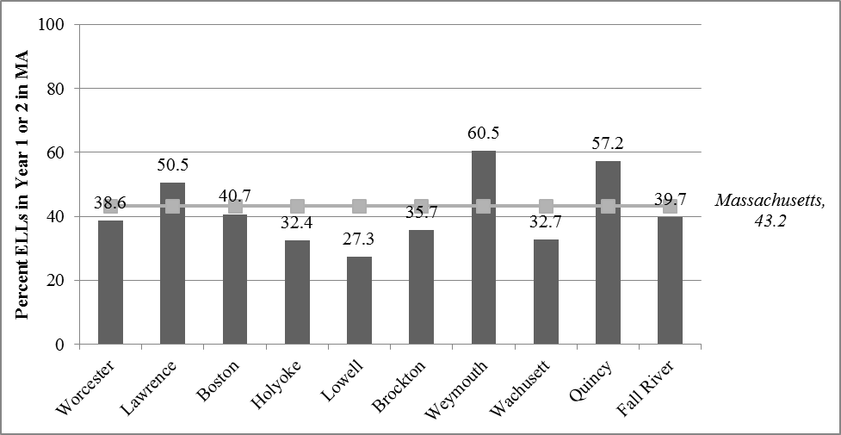

We also examined whether ELLs belong to other state-defined selected student populations, including those from low-income households and those receiving special education services. displays the percentage of ELLs in each of the 10 sampled districts who were from low-income households in 2013–14 (light gray bars). These figures are compared to the overall percentages of students from low-income households in each respective district in 2013–14 (dark gray bars). Note that ELLs from low-income households comprised part of the overall totals in these districts. Nonetheless, the percentage of ELLs who were from low-income households was higher than the overall percentage of students from low-income households in the State (overlaid line). This difference is reflected in the comparison of State percentages of ELLs from low-income households (80.5 percent) and overall percentage of students from low-income households (38.3 percent) in 2013–14, although the disparities in the selected districts are lower, likely because of the high numbers of ELLs contributing to the overall percentages of students from low-income households.

Figure . Percentage of Students From Low-Income Households Among ELLs in Sampled Districts, All Students in Sampled Districts, and ELLs Statewide (2013–14)

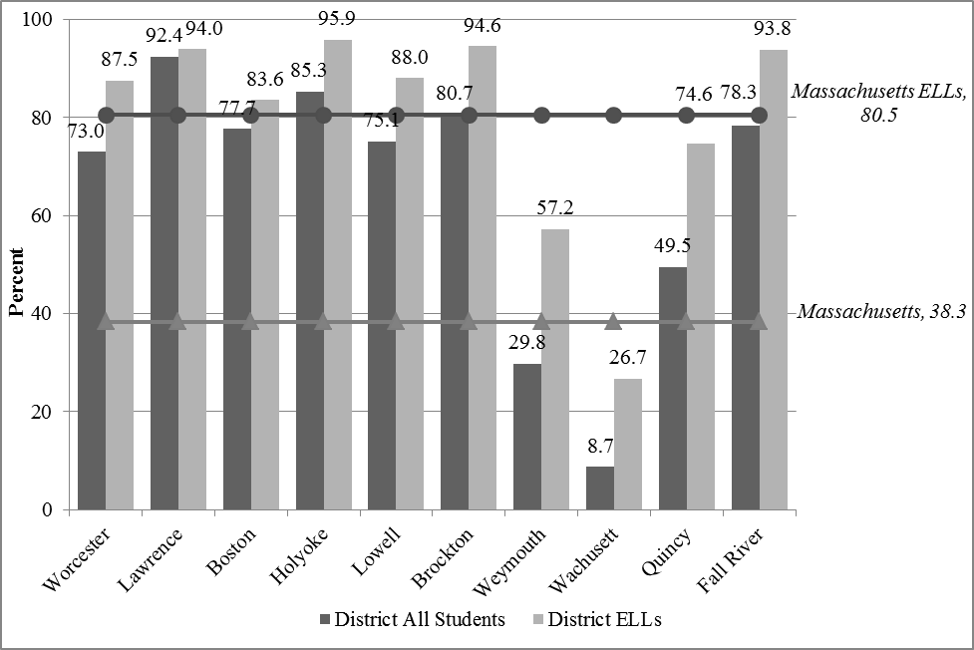

*Note.* ELLs are also included in the statewide totals.

In most of the districts in the sample, the proportion of ELLs who were from low-income households exceeded the State average of ELLs from low-income families (80.5 percent). However, in several of the sampled districts, the proportion of ELLs who were from low-income households was lower than the State average: Quincy (74.6 percent), Weymouth (57.2 percent), and Wachusett (26.7 percent).

shows the respective proportions of ELLs and students in the overall population who received special education services, both statewide (overlaid line) and in the 10 selected districts in 2013–14 (sets of gray bars). Examining the proportion of ELLs statewide receiving special education services in relation to the overall student population reveals comparable rates of services (16.5 percent compared to 16.4 percent, respectively). Across the 10 sampled districts, we generally observe similar rates of special education identification among ELLs and the general population. However, in Holyoke, ELLs appear to be identified for special education services at higher rates than in the general population (33.6 percent compared to 25.1 percent) when compared to this same difference in the other sampled districts. ELLs and non-ELLs in Holyoke are identified at higher rates than in the State. In Quincy, ELLs appear to be identified at lower rates than in the overall population (4.3 percent compared to 15.5 percent) as well as the statewide rates of identification. Lawrence, Brockton, and Weymouth also had a somewhat lower percentage of ELLs receiving special education services than in the overall student population.

Figure . Percentage of ELLs Receiving Special Education Services in Sampled Districts Compared With Percentage of All Students Receiving Special Education Services in Massachusetts (2013–14)

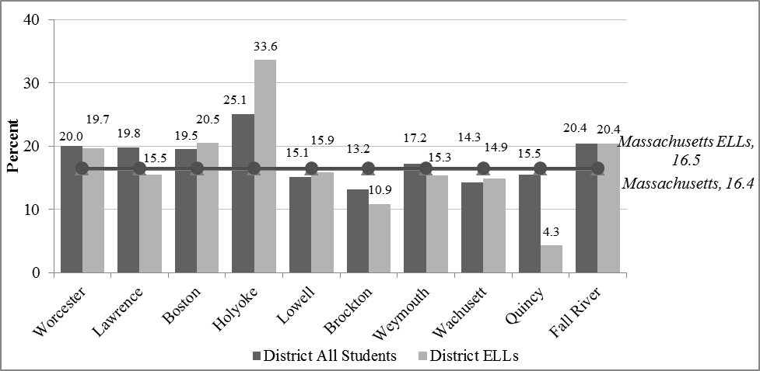

## RQ1b. Distribution of ELLs in Schools

|  |
| --- |
| **Key finding 6—Segregation:** The average ELL in Massachusetts attends “triply segregated” schools—those with high proportions of students from low-income households and minority and English language learner classmates—compared to the student composition of the average non-ELL’s school (see Figure 6). |

The previous section discussed district-level ELL demographics in a purposively selected sample of districts. To contextualize these findings further, in this section we discuss characteristics of the schools Massachusetts ELLs attend, starting with the distribution of ELLs across different school levels (e.g., elementary, middle, secondary). An extensive statewide profile of ELLs (ESE, 2012) found that ELLs tend to be clustered in the elementary grades—in the 2010–11 school year, 37.6 percent of Massachusetts ELLs were enrolled in Grades PK–2 and an additional 26.4 percent were enrolled in Grades 3–5. shows the percentage of ELL students in the State attending schools at each school level in 2013–14. Consistent with the earlier study, ELLs formed a higher proportion of elementary school students (11.8 percent) than middle school students (6.5 percent) or secondary school students (4.9 percent), with the proportion of ELLs in elementary schools more than twice as high as the proportion of ELLs in secondary schools.

Figure . Percentage of ELL Students at Each School Level (Elementary, Middle, Secondary) in Massachusetts (2013–14)

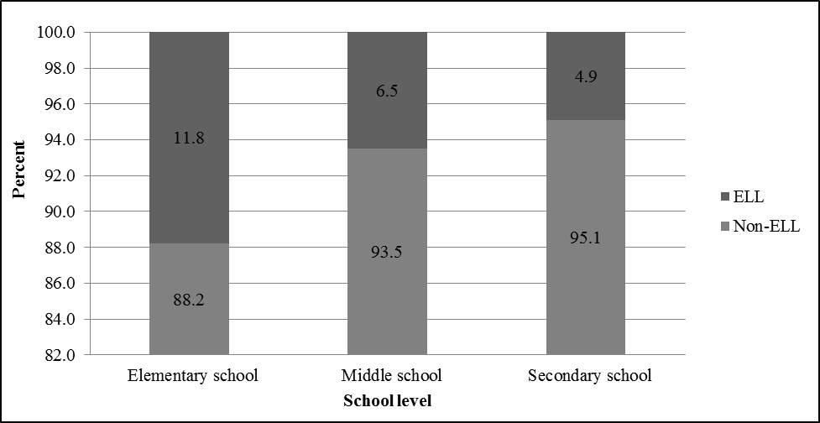

A comparison of the demographic characteristics of schools attended by non-ELLs and ELLs reveals that on average, ELLs attend schools with higher concentrations of students from low-income households, minority, and other LEP students than do non-ELLs. Figure 6 shows that the average non-ELL student attends a school that has an average of 40.1 percent of students from low-income households while the average ELL student attends a school where 74.3 percent of the students are from low-income households. The average non-ELL attends a school where, on average, 15 percent and 8 percent of the students are Hispanic and Black, respectively, compared to 39.7 percent and 16.9 percent of the respective student populations at the average school attended by ELLs. In addition, the average non-ELL attends a school where 6.3 percent of classmates are LEP compared to 26.3 percent of classmates for the ELL group. This “triple segregation” of ELL students by income, minority, and LEP status (Orfield, 2001; Orfield & Lee, 2006; Rios-Aguilar & Gándara, 2012) has been well documented across U.S. schools.

Note that on average, non-ELLs and ELLs attend schools with equivalent proportions of students receiving special education services—the average non-ELL attends a school where 17.5 percent of classmates receive services compared to 17.2 percent for ELLs.

Figure . Demographic Characteristics of Schools Attended by Non-ELL and ELL Students in Sampled Districts, by Characteristic (2013–14)

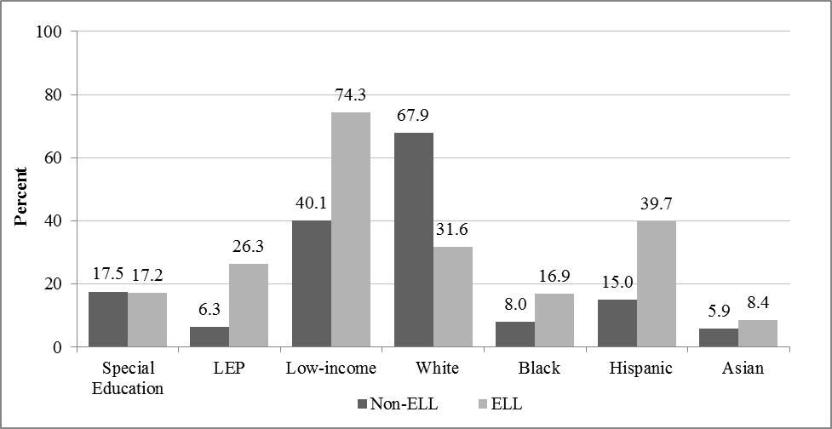

## RQ1c. ELL Academic and Nonacademic Profiles

Thus far in this report, we have focused on demographic characteristics of ELLs in 10 select districts in Massachusetts and the schools they attend. RQ1c in Phase 1 focuses on instructional services ELLs receive and descriptions of their academic and nonacademic outcomes, focusing again on the 10 purposively sampled districts.

### ELL Instructional Services

|  |
| --- |
| **Key finding 7—Teacher ELL qualifications:** Available data[11] indicate that districts lack personnel with specialized credentials to implement ELL instructional services—nearly every district in our sample has a very low ratio of teachers classified as providing support to ELLs relative to the proportion of ELLs. For example, in Worcester, 31.7 percent of students are ELL, but there are no teachers reported with ESL, bilingual or dual language certifications. |

As noted in the Introduction, Massachusetts law requires that all ELLs be educated in an SEI program, unless students are enrolled in a dual language instruction program (two-way bilingual) or the student receives a waiver. SEI is therefore the default program design for ELLs throughout the State, as reflected in , which shows reported ELL programming for 2013–14 in the study’s Phase 1 10 selected districts. Some districts, including Boston, Brockton, and Holyoke, also offer dual language instruction, but enrollment in these programs is low (less than 3 percent). According to the *DART* data, a relatively high percentage of ELLs in Weymouth opted out of ELL services (7.4 percent), and nearly one fifth of ELLs (18.2 percent) are not enrolled in any language learning program in Worcester.[12]

Table . Enrollment of ELLs in Language Learning Programs, by District (2013–14)

|  |  |  |  |  |  |  |
| --- | --- | --- | --- | --- | --- | --- |
| **District** | ***n*** | **Sheltered English Immersion** | **Dual Language Instruction** | **Opted Out** | **Other** | **No Program** |
| Worcester | 7,780 | 79.1% | 0.0% | 1.2% | 1.5% | 18.2%* |
| Lawrence | 3,813 | 100.0% | 0.0% | 0.0% | 0.0% | 0.0% |
| Boston | 16,239 | 95.6% | 3.0% | 0.0% | 1.4% | 0.0% |
| Holyoke | 1,625 | 98.7% | 0.1% | 1.2% | 0.0% | 0.1% |
| Lowell | 4,121 | 98.3% | 0.0% | 1.6% | 0.1% | 0.0% |
| Brockton | 3,395 | 79.4% | 2.1% | 1.7% | 15.4% | 1.4% |
| Weymouth | 215 | 92.6% | 0.0% | 7.4% | 0.0% | 0.0% |
| Wachusett | 101 | 99.0% | 0.0% | 0.0% | 0.0% | 1.0% |
| Quincy | 1,350 | 99.9% | 0.0% | 0.1% | 0.0% | 0.0% |
| Fall River | 872 | 98.9% | 0.0% | 1.0% | 0.1% | 0.0% |
| Massachusetts | 75,947 | 92.8% | 1.2% | 1.8% | 1.6% | 2.6% |

*Note.* The high proportion of students enrolled in “no program” in Worcester may be a result of ELL enrollment in kindergarten services where no specific program type is offered.

We also examined the numbers of teachers classified as providing SEI, ESL, and other language support to ELLs by district. These data are presented in . Staffing data are reported by districts, and districts vary in how they code teacher work assignments, so the data are not directly comparable across districts (ESE, 2014a). However, when we compare the percentage of ELL-related staffing classifications to the percentage of ELL students within each district, we find that nearly every district in our sample has a very low ratio of teachers classified as providing support to ELLs (Weymouth has the highest ratio, with 1.4 percent of its staff classified as ESL teachers and 3.1 percent ELL students). Wachusett and Worcester report no teachers providing ELL support; these districts report ELL support provided only by bilingual paraprofessionals. This staffing configuration is particularly notable for Worcester, which has 31.7 percent ELL students.

Table . Teachers Classified as Providing Language Support to ELLs, by Sampled Districts (2013–14)

|  |  |  |  |  |  |  |  |
| --- | --- | --- | --- | --- | --- | --- | --- |
| **District** | **Percent ELLs** | **ELL Directors** | **Total District Teachers (FTE)** | **Percent ESL Teachers** | **Percent Sheltered Content Teachers** | **Percent Bilingual Teachers** | **Bilingual Paraprofessionals** |
| Worcester | 31.7% | 1 | 1,413 | 0.0% | 0.0% | 0.0% | 37 |
| Lawrence | 28.2% | 1 | 1,052 | 4.7% | 0.7% | 0.0% | 13 |
| Boston | 29.9% | 1 | 4,001 | 4.4% | 0.0% | 0.0% | 0 |
| Holyoke | 29.2% | 0 | 500 | 8.3% | 0.2% | 0.0% | 0 |
| Lowell | 29.4% | 0 | 984 | 2.5% | 1.6% | 0.0% | 26 |
| Brockton | 20.0% | 4 | 1,113 | 2.4% | 0.0% | 1.1% | 31 |
| Weymouth | 3.1% | 0 | 433 | 1.4% | 0.0% | 0.0% | 1 |
| Wachusett | 1.3% | 1 | 456 | 0.0% | 0.0% | 0.0% | 1 |
| Quincy | 14.5% | 1 | 679 | 5.4% | 0.0% | 0.0% | 4 |
| Fall River | 8.5% | 1 | 717 | 0.1% | 1.7% | 0.0% | 0 |
| Massachusetts | 7.7% | 68 | 70,489 | 1.9% | 0.2% | 0.2% | 289 |

*Note.* This table only includes currently available statewide data as reported in the *DART*. Data on the RETELL initiative are not included here.

However, due to the way in which programming and teacher work assignments are reported to the State, the data in this section are likely to obscure additional supports provided to ELLs. For example, ESL-licensed teachers who provide services to ELLs for a portion of the school day would not be classified as the teachers of record and therefore may not appear in . Further, no systematic, statewide data on a major initiative launched in fall 2012 to train teachers to instruct ELLs—Rethinking Equity and Teaching for English Language Learners, or RETELL[13]—is yet available. Under this initiative, all core academic teachers in the State will be required to complete comprehensive professional development in sheltered English instruction (SEI) methods by July 1, 2016, and teachers entering the school system after that date must have the endorsement. Thus, the number of teachers with training to teach ELLs is inevitably higher.

In the following sections, we report ELL student outcomes in the 10 sampled districts on the 2013–14 English language proficiency assessment, ACCESS, as well as the most recent administration of the statewide English language arts and mathematics assessments. Whenever possible, we compare performance for students in our 10-district sample on these assessments to statewide performance for ELLs and, when relevant, to all students[14] (i.e., on content-area assessments only).

### ELL Academic Outcomes in Selected Districts

|  |
| --- |
| **Key finding 8—Language proficiency:** Overall performance on ACCESS is low in many districts, but 90 percent of the sampled districts are making progress on the State English language proficiency assessment: four of the sampled districts have less than 10 percent of ELLs who scored *proficient* on ACCESS. However, more than half of ELLs in nine out of the 10 sampled districts are making progress (by the State definition) on the ELP assessment, particularly at the lowest levels of language proficiency.  **Key finding 9—Content-area proficiency:** The percentage of ELLs performing at *proficient* or higher on the ELA, mathematics, and science MCAS in all 10 districts falls below the State average for all students. However, there are two notable exceptions to this trend: the percentage of ELLs performing at *proficient* or higher on the mathematics MCAS in Quincy and Wachusett—56 percent and 58 percent, respectively—approaches the statewide average of 60 percent. ELLs in eight out of 10 of the sampled districts showed growth that surpassed about 50 percent of ELLs statewide with similar MCAS histories.  **Key finding 10—Retention rates:** All districts except Lowell and Quincy had higher ELL retention in grade rates than the State overall average of 1.6 percent in 2013–14; Brockton, Lawrence, Holyoke, and Boston had higher retention rates than the State ELL average of 3.6 percent.  **Key finding 11—Dropout rates:** All districts had higher ELL dropout rates than the State overall average of 2.0 percent in 2013–14. Boston, Brockton, Holyoke, and Wachusett all exceeded the State ELL dropout rate of 6.5 percent.  **Key finding 12—Graduation rates:** All districts had lower ELL four-year graduation rates than the State overall rate of 86.1 percent. Weymouth, Worcester, and Quincy had higher ELL four-year graduation rates than the State ELL average of 63.9 percent. |

### ELL Performance on English Language Proficiency Assessments

We examined ELLs’ outcomes on the ACCESS for ELLs English language proficiency assessment in the 10 selected districts. Only students who are currently classified as ELL[15] would be included in these results; once students exit ELL services, they are no longer assessed on the ACCESS for ELLs. Results by number of years ELLs have been in Massachusetts schools are provided in Table B1 in Appendix B.

compares the percentage of ELLs scoring *proficient* or higher and making progress[16] on the ACCESS for ELLs assessment (2013–14) in each of the 10 selected districts. With respect to the percentage of ELLs scoring *proficient* on ACCESS, in most districts, approximately 20 percent to 25 percent of ELLs scored *proficient* or higher. Several districts stand out as falling above or below this mark. In Weymouth—included in the sample for its high proficiency growth—31 percent of ELLs scored at least *proficient* on ACCESS. Four of the sampled districts had much smaller proportions of ELLs that scored *proficient* on ACCESS—Brockton (16 percent proficient), Fall River (16 percent proficient), Lawrence (10 percent proficient), and Holyoke (11 percent proficient). With respect to progress, more than half of ELLs are making progress in all of the sampled districts with the exception of Holyoke (where 45 percent of ELLs are making progress). Weymouth also had the highest percentage of ELLs showing progress (87 percent).

Figure . Percentage of ELLs Scoring *Proficient* or Higher and Making Progress on the ACCESS for ELLs Assessment (2013–14), by Sampled District

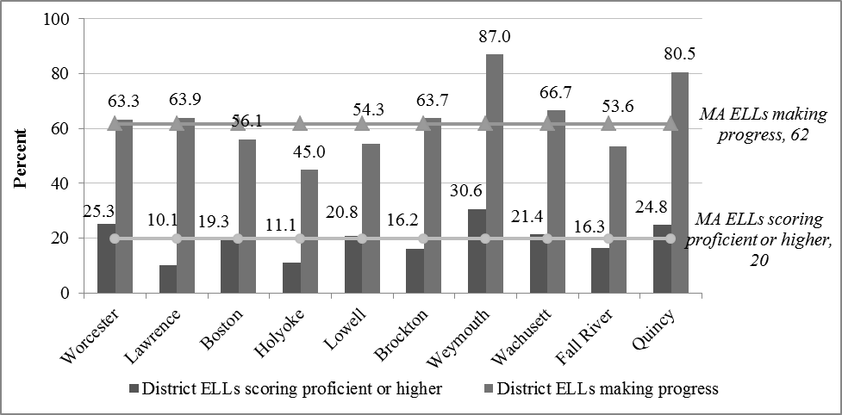

We also plotted the number of ELLs scoring *proficient* or higher on the ACCESS in 2013–14 in the 10 selected districts by the number of years ELLs had been enrolled in Massachusetts schools: 1–2 years, 3–4 years, and 5 or more years ().

Most districts show the highest average proficiency growth in the period between Years 1–2 in Massachusetts schools and Years 3–4, followed by moderate growth after students had spent five or more years in Massachusetts schools. Exceptions include Wachusett—initially selected as a prototypical low-proficiency-growth district—whose ELLs demonstrate higher rates of growth on ACCESS after three to four years in Massachusetts schools, and Weymouth—initially selected as a prototypical high-growth district—whose ELLs demonstrate higher rates of growth on ACCESS in their third and fourth years in Massachusetts schools compared to ELLs who spent five or more years in Massachusetts schools.

Several limitations related to the data presented in Figure 8 should be noted. First, data are disaggregated by time in Massachusetts schools and not by proficiency level on ACCESS. Second, enrollment in Massachusetts schools in some cases may be a proxy for time in the United States but would not be equivalent to time in the United States for students who move into Massachusetts schools from out of state. Third, these data are cross-sectional—each time “bin” (i.e., 1–2 years, 3–4 years, 5 or more years) represents different groups of students. Students who have remained in Massachusetts schools for 5 or more years without being exited from ELL programs may represent a select group of students who demonstrate lower performance on the statewide English language proficiency assessment, which prevents them from exiting ELL instructional services.

Figure . Percentage of ELLs Scoring *Proficient* or Higher on the ACCESS for ELLs, by Number of Years in Massachusetts Schools (2013–14)

**A. High ELL Districts/Innovative Program**

We also plotted the number of ELLs scoring proficient or higher on the ACCESS in 2013–14 in the 10 selected districts by the number of years ELLs had been enrolled in Massachusetts schools: 1–2 years, 3–4 years, and 5 or more years (Figure 8). 
Most districts show the highest average proficiency growth in the period between Years 1–2 in Massachusetts schools and Years 3–4, followed by moderate growth after students had spent five or more years in Massachusetts schools. Exceptions include Wachusett—initially selected as a prototypical low-proficiency-growth district—whose ELLs demonstrate higher rates of growth on ACCESS after three to four years in Massachusetts schools, and Weymouth—initially selected as a prototypical high-growth district—whose ELLs demonstrate higher rates of growth on ACCESS in their third and fourth years in Massachusetts schools compared to ELLs who spent five or more years in Massachusetts schools. 
Several limitations related to the data presented in Figure 8 should be noted. First, data are disaggregated by time in Massachusetts schools and not by proficiency level on ACCESS. Second, enrollment in Massachusetts schools in some cases may be a proxy for time in the United States but would not be equivalent to time in the United States for students who move into Massachusetts schools from out of state. Third, these data are cross-sectional—each time “bin” (i.e., 1–2 years, 3–4 years, 5 or more years) represents different groups of students. Students who have remained in Massachusetts schools for 5 or more years without being exited from ELL programs may represent a select group of students who demonstrate lower performance on the statewide English language proficiency assessment, which prevents them from exiting ELL instructional services. 


**B. Prototypical Districts**

We also plotted the number of ELLs scoring proficient or higher on the ACCESS in 2013–14 in the 10 selected districts by the number of years ELLs had been enrolled in Massachusetts schools: 1–2 years, 3–4 years, and 5 or more years (Figure 8). 
Most districts show the highest average proficiency growth in the period between Years 1–2 in Massachusetts schools and Years 3–4, followed by moderate growth after students had spent five or more years in Massachusetts schools. Exceptions include Wachusett—initially selected as a prototypical low-proficiency-growth district—whose ELLs demonstrate higher rates of growth on ACCESS after three to four years in Massachusetts schools, and Weymouth—initially selected as a prototypical high-growth district—whose ELLs demonstrate higher rates of growth on ACCESS in their third and fourth years in Massachusetts schools compared to ELLs who spent five or more years in Massachusetts schools. 
Several limitations related to the data presented in Figure 8 should be noted. First, data are disaggregated by time in Massachusetts schools and not by proficiency level on ACCESS. Second, enrollment in Massachusetts schools in some cases may be a proxy for time in the United States but would not be equivalent to time in the United States for students who move into Massachusetts schools from out of state. Third, these data are cross-sectional—each time “bin” (i.e., 1–2 years, 3–4 years, 5 or more years) represents different groups of students. Students who have remained in Massachusetts schools for 5 or more years without being exited from ELL programs may represent a select group of students who demonstrate lower performance on the statewide English language proficiency assessment, which prevents them from exiting ELL instructional services. 


### ELL Performance on Statewide English Language Arts, Mathematics, and Science Assessments

The majority of ELLs in Massachusetts participate in statewide ELA and mathematics content-area assessments—the MCAS—regardless of their enrollment in an ELL instructional program or their time in Massachusetts schools. The one exception is for ELLs who are in their first year of ELL classification and enrolled after March of the particular test administration; the ELA assessment is optional for this group, although the mathematics assessment is still required (ESE, 2015).

compares the percentage of ELLs scoring *proficient*[17] or higher on MCAS English language arts, mathematics, and science in the 10 selected districts in 2013–14 with the statewide average of all students scoring at the *proficient* level in these areas and the statewide average of ELLs scoring proficient in these areas (as overlaid lines).[18] The bars indicating ELLs rates of scoring *proficient* on the MCAS in the sampled district fall below the line denoting the State average for all students in ELA (Panel A), mathematics (Panel B), and science (Panel C). However, it should be noted that ELLs in Quincy and Wachusett surpass the State ELL average percentage proficient in all three subjects and approach the State overall average in mathematics. In addition, several of the sampled districts exceeded the State ELL average in one or more content-area assessments: Lowell (ELA and mathematics), Worcester (ELA), and Boston (mathematics). We include a full listing of proficiency rates by district and ACCESS for ELLs assessment level in Table B2 in Appendix B.

Figure 9. Percentage of ELL Students Scoring *Proficient* or Higher on the MCAS in English Language Arts, Mathematics, and Science, by District, With Percentage of All Massachusetts ELLs and All Massachusetts Students Scoring *Proficient* or Higher Overlaid (2013–14)

|  |  |
| --- | --- |
|  | Figure 9 compares the percentage of ELLs scoring proficient  or higher on MCAS English language arts, mathematics, and science in the 10 selected districts in 2013–14 with the statewide average of all students scoring at the proficient level in these areas and the statewide average of ELLs scoring proficient in these areas (as overlaid lines).  The bars indicating ELLs rates of scoring proficient on the MCAS in the sampled district fall below the line denoting the State average for all students in ELA (Panel A), mathematics (Panel B), and science (Panel C). However, it should be noted that ELLs in Quincy and Wachusett surpass the State ELL average percentage proficient in all three subjects and approach the State overall average in mathematics. In addition, several of the sampled districts exceeded the State ELL average in one or more content-area assessments: Lowell (ELA and mathematics), Worcester (ELA), and Boston (mathematics). We include a full listing of proficiency rates by district and ACCESS for ELLs assessment level in Table B2 in Appendix B. |
|  |  |
|  | Figure 9 compares the percentage of ELLs scoring proficient  or higher on MCAS English language arts, mathematics, and science in the 10 selected districts in 2013–14 with the statewide average of all students scoring at the proficient level in these areas and the statewide average of ELLs scoring proficient in these areas (as overlaid lines).  The bars indicating ELLs rates of scoring proficient on the MCAS in the sampled district fall below the line denoting the State average for all students in ELA (Panel A), mathematics (Panel B), and science (Panel C). However, it should be noted that ELLs in Quincy and Wachusett surpass the State ELL average percentage proficient in all three subjects and approach the State overall average in mathematics. In addition, several of the sampled districts exceeded the State ELL average in one or more content-area assessments: Lowell (ELA and mathematics), Worcester (ELA), and Boston (mathematics). We include a full listing of proficiency rates by district and ACCESS for ELLs assessment level in Table B2 in Appendix B. |
|  | Figure 9 compares the percentage of ELLs scoring proficient  or higher on MCAS English language arts, mathematics, and science in the 10 selected districts in 2013–14 with the statewide average of all students scoring at the proficient level in these areas and the statewide average of ELLs scoring proficient in these areas (as overlaid lines).  The bars indicating ELLs rates of scoring proficient on the MCAS in the sampled district fall below the line denoting the State average for all students in ELA (Panel A), mathematics (Panel B), and science (Panel C). However, it should be noted that ELLs in Quincy and Wachusett surpass the State ELL average percentage proficient in all three subjects and approach the State overall average in mathematics. In addition, several of the sampled districts exceeded the State ELL average in one or more content-area assessments: Lowell (ELA and mathematics), Worcester (ELA), and Boston (mathematics). We include a full listing of proficiency rates by district and ACCESS for ELLs assessment level in Table B2 in Appendix B. |

In addition to measuring student performance relative to grade-level standards, Massachusetts measures students’ progress using student growth percentiles (SGPs). SGPs compare changes in students’ MCAS scores with changes seen in groups of students with similar performance histories and take demographic characteristics into account (ESE, 2011). shows median SGPs for ELLs in the 10 selected districts in 2013–14 for English language arts and mathematics (Table B3 in Appendix B provides these data by number of years students were enrolled in Massachusetts schools). Most of the sampled districts are performing at or above the State Median ELL SGPs with the exception of Holyoke and Weymouth. For instance, ELL students in Worcester, Lawrence, Brockton, and Quincy were at or above an SGP of 50 for English language arts and mathematics, indicating that students in these districts grew more than did 50 percent of their “academic peers,” or students with similar MCAS score histories. In Boston, ELLs’ SGPs were at the 50th percentile in both ELA and mathematics, indicating that students in these districts are performing better than 50 percent of their academic peers in both content areas.

Figure . ELL Median Student Growth Percentile (SGP) in English Language Arts and Mathematics, by Sampled District, With Statewide ELL SGPs Overlaid (2013–14)

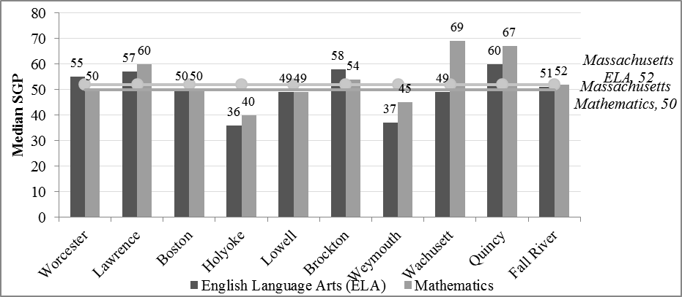

SGPs compare students’ academic growth to the growth of other students as defined by prior MCAS scores, not by student demographic data. We also sought to compare ELLs’ performance with the performance of reclassified ELLs (i.e., former ELLs [FELLs]) and students who had never been classified as ELLs. makes this comparison using the MCAS Composite Performance Index (CPI) for English language arts, mathematics, and science (2013–14); the data are also provided in Table B4 in Appendix B). The CPI is a measure of each student’s proximity to a *proficient* score on the respective assessments. Students scoring at the *proficient* level or above are assigned 100 points while students with low MCAS scores are assigned 0 points. Group CPIs provide a snapshot of how close particular subgroups are to the *proficient* mark (the total number of CPI points is summed across the group and divided by the number of students in that group; ESE, 2014b).

ELLs’ average CPI lags behind that of FELLs and students who were never ELLs in every subject area and district, with smaller gaps in mathematics than in English language arts. However, FELLs outperformed students who were never ELLs in their districts in English language arts and mathematics in Worcester, Boston, Holyoke, Lowell, Brockton, and Wachusett; in mathematics in Quincy; and in science in Worcester and Brockton.

Figure . MCAS Composite Performance Index for ELLs, Former ELLs (FELLs), and Students Who Were Never ELLs in English Language Arts, Mathematics, and Science, by Selected Districts and Statewide (2013–14)

|  |
| --- |
| Figure 11 makes this comparison using the MCAS Composite Performance Index (CPI) for English language arts, mathematics, and science (2013–14); the data are also provided in Table B4 in Appendix B). The CPI is a measure of each student’s proximity to a proficient score on the respective assessments. Students scoring at the proficient level or above are assigned 100 points while students with low MCAS scores are assigned 0 points. Group CPIs provide a snapshot of how close particular subgroups are to the proficient mark (the total number of CPI points is summed across the group and divided by the number of students in that group; ESE, 2014b).  ELLs’ average CPI lags behind that of FELLs and students who were never ELLs in every subject area and district, with smaller gaps in mathematics than in English language arts. However, FELLs outperformed students who were never ELLs in their districts in English language arts and mathematics in Worcester, Boston, Holyoke, Lowell, Brockton, and Wachusett; in mathematics in Quincy; and in science in Worcester and Brockton. |
|  |
| Figure 11 makes this comparison using the MCAS Composite Performance Index (CPI) for English language arts, mathematics, and science (2013–14); the data are also provided in Table B4 in Appendix B). The CPI is a measure of each student’s proximity to a proficient score on the respective assessments. Students scoring at the proficient level or above are assigned 100 points while students with low MCAS scores are assigned 0 points. Group CPIs provide a snapshot of how close particular subgroups are to the proficient mark (the total number of CPI points is summed across the group and divided by the number of students in that group; ESE, 2014b).  ELLs’ average CPI lags behind that of FELLs and students who were never ELLs in every subject area and district, with smaller gaps in mathematics than in English language arts. However, FELLs outperformed students who were never ELLs in their districts in English language arts and mathematics in Worcester, Boston, Holyoke, Lowell, Brockton, and Wachusett; in mathematics in Quincy; and in science in Worcester and Brockton. |
|  |

Figure 11 makes this comparison using the MCAS Composite Performance Index (CPI) for English language arts, mathematics, and science (2013–14); the data are also provided in Table B4 in Appendix B). The CPI is a measure of each student’s proximity to a proficient score on the respective assessments. Students scoring at the proficient level or above are assigned 100 points while students with low MCAS scores are assigned 0 points. Group CPIs provide a snapshot of how close particular subgroups are to the proficient mark (the total number of CPI points is summed across the group and divided by the number of students in that group; ESE, 2014b). 
ELLs’ average CPI lags behind that of FELLs and students who were never ELLs in every subject area and district, with smaller gaps in mathematics than in English language arts. However, FELLs outperformed students who were never ELLs in their districts in English language arts and mathematics in Worcester, Boston, Holyoke, Lowell, Brockton, and Wachusett; in mathematics in Quincy; and in science in Worcester and Brockton. 


In addition to standardized assessment scores, we examined a number of other indicators of student academic progress, including grade retention rates (), dropout rates (), and four- and five-year graduation rates (Figure 14). In all cases, we compared ELLs’ outcomes in the 10 selected districts to the State overall average rates and statewide ELL rates in the latest years for which data were available.[19]

In most of our sampled districts, ELLs exhibit higher grade retention and dropout rates and lower four-year graduation rates than the average student in Massachusetts. Across the retention, dropout, and graduation indicators, Boston and Holyoke stood out as having the lowest performance, underperforming the State ELL average on all three measures (i.e., higher grade retention and dropout rates, and lower four-year graduation rates). However, ELL students in Lowell and Quincy showed better outcomes across the three indicators in comparison to state average ELL rates. Quincy exhibited higher four- and five-year graduation rates for ELLs than the State average four- and five-year graduation rates for all students.

Figure . Retention Rate of ELLs in Massachusetts by Selected Districts, With Statewide Retention Rates for ELLs and All Students Overlaid (2013–14)

In addition to standardized assessment scores, we examined a number of other indicators of student academic progress, including grade retention rates (Figure 12), dropout rates (Figure 13), and four- and five-year graduation rates (Figure 14). In all cases, we compared ELLs’ outcomes in the 10 selected districts to the State overall average rates and statewide ELL rates in the latest years for which data were available.  
In most of our sampled districts, ELLs exhibit higher grade retention and dropout rates and lower four-year graduation rates than the average student in Massachusetts. Across the retention, dropout, and graduation indicators, Boston and Holyoke stood out as having the lowest performance, underperforming the State ELL average on all three measures (i.e., higher grade retention and dropout rates, and lower four-year graduation rates). However, ELL students in Lowell and Quincy showed better outcomes across the three indicators in comparison to state average ELL rates. Quincy exhibited higher four- and five-year graduation rates for ELLs than the State average four- and five-year graduation rates for all students.


Figure . Dropout Rate of ELLs in Massachusetts, by Selected Districts, With Statewide Overall Dropout Rate and Statewide ELL Dropout Rate Overlaid (2013–14)

In addition to standardized assessment scores, we examined a number of other indicators of student academic progress, including grade retention rates (Figure 12), dropout rates (Figure 13), and four- and five-year graduation rates (Figure 14). In all cases, we compared ELLs’ outcomes in the 10 selected districts to the State overall average rates and statewide ELL rates in the latest years for which data were available.  
In most of our sampled districts, ELLs exhibit higher grade retention and dropout rates and lower four-year graduation rates than the average student in Massachusetts. Across the retention, dropout, and graduation indicators, Boston and Holyoke stood out as having the lowest performance, underperforming the State ELL average on all three measures (i.e., higher grade retention and dropout rates, and lower four-year graduation rates). However, ELL students in Lowell and Quincy showed better outcomes across the three indicators in comparison to state average ELL rates. Quincy exhibited higher four- and five-year graduation rates for ELLs than the State average four- and five-year graduation rates for all students.


Figure . Four-Year and Five-Year ELL Graduation Rates, by Selected Districts, With State ELL Four- and Five-Year Graduation Rates and Overall State Four- and Five-Year Graduation Rates Overlaid (2013–14)

In addition to standardized assessment scores, we examined a number of other indicators of student academic progress, including grade retention rates (Figure 12), dropout rates (Figure 13), and four- and five-year graduation rates (Figure 14). In all cases, we compared ELLs’ outcomes in the 10 selected districts to the State overall average rates and statewide ELL rates in the latest years for which data were available.  
In most of our sampled districts, ELLs exhibit higher grade retention and dropout rates and lower four-year graduation rates than the average student in Massachusetts. Across the retention, dropout, and graduation indicators, Boston and Holyoke stood out as having the lowest performance, underperforming the State ELL average on all three measures (i.e., higher grade retention and dropout rates, and lower four-year graduation rates). However, ELL students in Lowell and Quincy showed better outcomes across the three indicators in comparison to state average ELL rates. Quincy exhibited higher four- and five-year graduation rates for ELLs than the State average four- and five-year graduation rates for all students.


*No data available.

*Note.* Graduation rates will not be publicly reported for cohort counts fewer than 6.

### ELL Nonacademic Outcomes in Selected Districts

|  |
| --- |
| **Key finding 13**—**Chronic absenteeism**: All districts except Wachusett and Quincy had higher ELL chronic absenteeism rates than the State overall average of 12.3 percent in 2013–14. Brockton’s rate of chronic absenteeism is right below the state average (12.1 percent). Boston, Holyoke and Fall River exceeded the State ELL average of 17.2 percent.  **Key finding 14**—**Stability**: All districts had lower ELL stability rates than the overall State average of 96.2 percent in 2013–14.  **Key finding 15**—**Disciplinary action**: All districts except Lawrence, Boston, and Quincy had higher in-school suspension rates than the State overall rate of 2.2 percent in 2013–14, and more than half of the districts (Worcester, Boston, Holyoke, Lowell, Brockton, and Fall River) exceeded the State overall rate of 4.3 percent out-of-school suspensions. |

We examined three nonacademic indicators of achievement in the 10 selected districts, including chronic absenteeism, stability, and disciplinary actions.

Massachusetts defines chronic absenteeism as a rate of absenteeism more than 10 percent of a student’s total days enrolled, indicating extended periods of absence. compares chronic absenteeism rates among ELLs in the 10 selected districts to the statewide ELL chronic absenteeism rate and overall State rate of chronic absenteeism in 2013–14 (the latest year for which data were available).[20] Three districts—Brockton, Quincy and Wachusett—have rates of ELL chronic absenteeism below the overall State chronic absenteeism rate, and Worcester, Lawrence, Lowell, and Weymouth are below the State ELL rate. On the other hand, Boston, Holyoke, and Fall River show rates of chronic absenteeism far above the State average for all students and for ELLs.

Figure 15. ELLs’ Chronic Absenteeism Rate, by Selected Districts, With State ELL Chronic Absenteeism Rate and Overall State Chronic Absenteeism Rate Overlaid (2013–14)

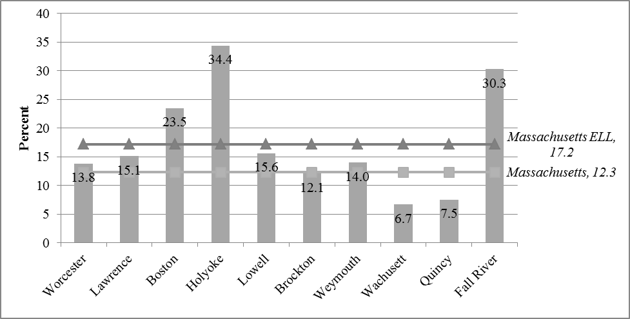

shows ELLs’ stability rates, with comparisons to State ELL and overall stability rates in 2013–14[21] The stability rate is the proportion of students who remain enrolled within a district during the course of a school year and is an indicator of student mobility (although it does not capture between-year mobility). None of the districts in our sample had an ELL stability rate above 96.2 percent, the State overall average. Only one district—Wachusett—had better stability rates than the ELL State average of 90.9 percent.

Figure . ELLs’ Stability Rate, by Selected Districts, With State ELL Stability Rate and Overall State Stability Rate Overlaid (2013–14)

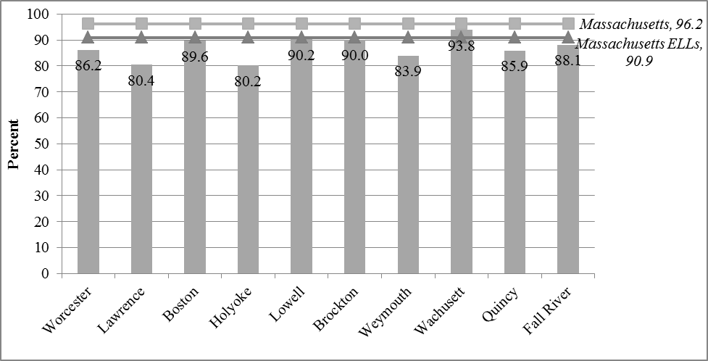

Finally, we examined in- and out-of-school suspension rates for ELLs, comparing those rates to State averages for all students and for ELLs (). These rates indicate the number of students who received in- or out-of-school suspensions but do not indicate how many incidents occurred per student nor the severity of the incidents. In general, Boston and Quincy exhibited lower rates than the State averages. Brockton and Holyoke stand out as having rates of out-of-school suspensions (11.8 percent and 20.3 percent, respectively) that are higher than the State ELL average out-of-school suspension rate. It is noteworthy that the State ELL out-of-school suspension rate (8.3 percent) is itself close to two times higher than the State overall average of 4.3 percent. In-school suspension rates tended to be lower than out-of-school suspension rates in all instances except in Lawrence, which had a slightly higher in-school suspension rate for ELLs.

Figure . ELLs’ In-School and Out-of-School Suspension Rates, by Selected Districts, With State ELL In- and Out-of-School Suspension Rates and Overall State In- and Out-of-School Suspension Rates Overlaid (2013–14)

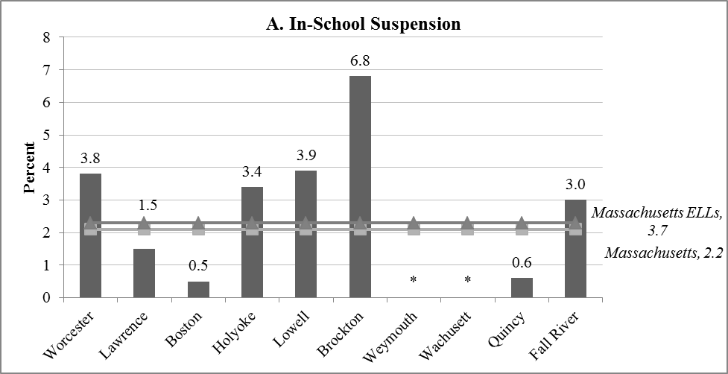

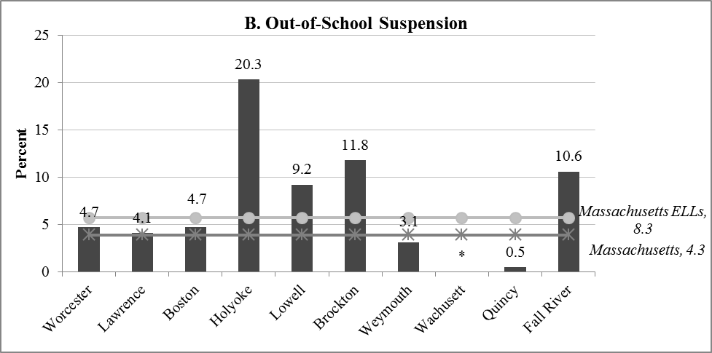

*Note:* An asterisk indicates that no students were suspended.

## RQ1d. District Guidelines for Making Reclassification Decisions

|  |
| --- |
| **Key finding 16—Reclassification procedures and decision making:** Eight of the 10 sampled districts relied most heavily on English language proficiency and content-area assessment data to reclassify students. |

Massachusetts requires districts to use ACCESS for ELLs’ data when making reclassification decisions but also recommends that school-based teams consider a range of other relevant data, including scores on other standardized and locally administered assessments, students’ grades, and student performance as documented by classroom teachers (ESE, 2013). Table 7 displays information the sampled districts report using to make reclassification decisions. Districts were asked to describe which piece of student information they relied on most heavily to make reclassification decisions. Interviewees were not provided with a set list of options to select from; rather, this question was open-ended. Selections with asterisks indicate the information the districts rely on most heavily for their decisions.

Eight of the districts rely most heavily on standardized test scores (ACCESS for ELLs and MCAS). However, most districts also use other information, including student work or writing samples, teacher input, and district benchmark assessments; only Wachusett reports relying on standardized assessment scores alone. In two of the districts, Holyoke and Lawrence, district ELL administrators did not report relying most heavily on standardized assessment scores for reclassification decisions. The finding that reclassification criteria varied across the 10 sampled districts is consistent with national studies which show that specific criteria used to reclassify students can vary across states and districts within the same state (see Ragan & Lesaux, 2006, for a review).

Table . Information Districts Report Using to Make ELL Reclassification Decisions

|  |  |  |  |  |  |  |  |
| --- | --- | --- | --- | --- | --- | --- | --- |
| **District** | **ACCESS for ELLs’ Scores** | **Student Work and Writing Samples** | **MCAS Scores** | **PARCC Scoresa** | **Teacher or Team Input** | **Benchmark and Other District Assessments** | **Other** |
| Worcester | ⚫* |  | ⚫ |  |  |  |  |
| Lawrence | ⚫ | ⚫ | ⚫ |  | ⚫* | ⚫ |  |
| Boston | ⚫* | ⚫ | ⚫ | ⚫ | ⚫ |  |  |
| Holyoke | ⚫ | ⚫* | ⚫ |  | ⚫ |  |  |
| Lowell | ⚫* | ⚫ | ⚫* |  | ⚫ |  |  |
| Brockton | ⚫* | ⚫ | ⚫* |  |  |  | Comparison to peer performance |
| Weymouth | ⚫* | ⚫ | ⚫ |  | ⚫ |  |  |
| Wachusett | ⚫* |  | ⚫* |  |  |  |  |
| Quincy | ⚫* | ⚫ | ⚫ |  | ⚫ |  |  |
| Fall River | ⚫* |  | ⚫ |  | ⚫ | ⚫ |  |

*Note.* The * indicates the information the districts reported relying on most heavily to make reclassification decisions (no set list of options was provided; this was asked as an open-ended question).

*a* Partnership for Assessment of Readiness for College and Careers. In spring 2015, 54 percent of districts in Massachusetts will administer PARCC tests to students in Grades 3–8. PARCC is administered in English language arts/literacy and mathematics.

## Phase 1 Conclusion

This section has examined demographic and descriptive outcomes data for 10 purposively selected Massachusetts districts, five of which have the top five highest concentrations of ELL students. The large majority of students in these districts are from the United States, and in most districts, the most common first language is Spanish. In all 10 districts, the top home language is spoken by a large majority of the students, indicating that most of these students could feasibly be provided instruction grouped by their first language, with first language support, through dual language instruction programs. However, although dual language instruction is allowed in Massachusetts, the findings indicate that it is rare in the 10 sample districts; dual language programs were reported in only three districts (Boston, Brockton, and Holyoke), and in these districts dual language programs make up less than 3 percent of overall ELL programs.

We also found that in Massachusetts overall, ELLs attend schools with higher concentrations of students from low-income households and minority students than do non-ELLs. ELLs tend to have lower MCAS scores (with the exception of FELLs, in some cases), lower stability and graduation rates, and higher discipline, dropout, and absenteeism rates than the overall student populations. However, there are some districts in which these trends do not hold for ELLs or that show better rates than the State ELL averages for some or many of these factors. As we note in the Discussion section, these districts (Quincy, Wachusett, Lowell, and Brockton) merit further study to understand these positive trends.

# Phase 2 Findings

The sample for Phase 2 of the study includes kindergarten students attending Massachusetts public school districts[22] in the fall of 2003 who were classified as ELLs at school entry. The passage of Question 2 legislation in fall 2002 closed the majority of bilingual programs in Massachusetts and moved students into sheltered English immersion (SEI) programs. Because the new language policy took effect in classrooms in fall 2003, the present study’s cohort represents the first kindergarten cohort of ELLs to progress through Massachusetts schools since the law went into effect. This cohort-based sample allows the study to follow students through virtually their full K–12 careers, providing they remain in Massachusetts. The data set is organized in a longitudinal “person-period format” (Singer & Willett, 2003). Students contribute one row of data for each year that they attend public school in Massachusetts.

The kindergarten analytic sample[23] for the time-to-reclassification analysis contained 4,997 ELL students at baseline after excluding students not enrolled in a traditional public school district. shows the demographic characteristics of the kindergarten sample compared to the demographic characteristics of non-ELL kindergarteners in Massachusetts in the fall of 2003. The majority of ELL students in the initial cohort are from low-income households (70.1 percent), are Hispanic (52.8 percent), and are U.S.-born (83.4 percent).[24] In comparison, only 21.5 percent of non-ELL kindergartners in the same year are from low-income households, 8.9 percent are Hispanic, and 99 percent are U.S.-born.

Table . Characteristics of the Fall 2003 Massachusetts Kindergarten Cohort, by ELL Status at Kindergarten Enrollment (2003–04)

|  |  |  |
| --- | --- | --- |
|  | **ELL Students (*n* = 4,997)** | **Non-ELL Students(*n* = 63,556)** |
| Low Income | 67.6% (*n* = 3,378) | 21.5% (*n* = 13,655) |
| Special Education | 7.3% (*n* = 364) | 9.7% (*n* = 6,130) |
| Female | 48.0% (*n* = 2,400) | 47.9% (*n* = 30,423) |
| Asian | 20.4% (*n* = 1,021) | 3.9% (*n* = 2,473) |
| Black | 7.2% (*n* = 359) | 7.7% (*n* = 4,895) |
| Hispanic | 57.2% (*n* = 2,860) | 8.9% (*n* = 5,628) |
| White | 15.0% (*n* = 750) | 79.1% (*n* = 50,191) |
| U.S. Born | 82.4% (*n* = 4,116) | 99.0% (*n* = 62,834) |
| Most common first language | Spanish (56.8%; *n* = 2,839) | English (94.3%; *n* = 59,884) |
| Portuguese (9.0%; *n* = 451) | Spanish (2.7%; *n* = 1,711) |
| Vietnamese (5.1%; *n* = 253) |  |
| Chinese (4.4%; *n* = 221) |  |
| Khmer (2.9%; *n* = 144) |  |

The following sections describe the Phase 2 research findings for this cohort of students.

## RQ2a. Average Time to First Reaching Key Academic Milestones for the 2003 Kindergarten ELL Cohort

|  |
| --- |
| **Key finding 17—English language proficiency:** The average ELL in our sample first demonstrated English proficiency (as measured by the statewide language proficiency assessment [MEPA or ACCESS]) 3.3 years after kindergarten entry.  **Key finding 18—Reclassification:** The average ELL in the 2003 kindergarten cohort was first reclassified as English proficient 2.7 years after kindergarten entry.  **Key finding 19—Reclassification procedures and decision making**: Reclassification rates for proficient students ranged from 24.4 percent to 51.5 percent, indicating that large numbers of ELLs are not reclassified the year following a proficient score on the statewide English language proficiency assessment (MEPA or ACCESS). |

This research question examines the average time it took for the cohort of ELL students who entered Massachusetts public schools as kindergartners in the 2003–04 school year to reach two academic milestones key for ELLs’ school success. Specifically, this study estimates the time it took ELL students to reach proficiency on the statewide English language proficiency assessment (RQ2a-1) and the time it takes to be reclassified as former ELL (RQ2a-2).

### RQ2a-1. Time to English Language Proficiency (MEPA and ACCESS)

To answer RQ2a-1, examining the time to reaching proficiency on the statewide language proficiency assessment, we explored a series of discrete-time hazard models to determine the best fitting model[25] (see Table B6 in Appendix B for a taxonomy of fitted hazard models). We included a two-level model with random effects for district to account for the clustering of ELL students in Massachusetts districts. Note that we measured time to proficiency for the subset of students in the 2003 ELL cohort who remained classified as ELLs until the beginning of third grade when the English language proficiency assessment was first administered.

The median time for a student in our sample to reach English language proficiency (as demonstrated on the statewide language proficiency assessment) in Massachusetts is 3.3 years (see and Table B6 in Appendix B), several years longer than the median time-to-reclassification (2.7 years). However, the actual median may be lower than our data suggest due to the lack of statewide proficiency testing for students in Grades K–2 during the time period of our study.

As shown in detail in Table B6 in Appendix B, student characteristics that had a statistically significant, negative association[26] with time to proficiency include receiving special education services, being Spanish-speaking, and being from a low-income household. This means that students with these characteristics take longer than average to reach English language proficiency (as measured by the statewide language proficiency assessment). Being female is statistically significant and positively associated with time to proficiency, indicating that girls in our sample demonstrated English proficiency, on average, sooner than boys.

Figure . Estimated Hazard and Survivor Functions for Time-to-English Language Proficiency for the 2,566 ELLs in the 2003 Kindergarten Cohort, by Years in School, With Median Lifetime Overlaid on Plot of Survivor Function

**A. Hazard Functions**

Figure 18. Estimated Hazard and Survivor Functions for Time-to-English Language Proficiency for the 2,566 ELLs in the 2003 Kindergarten Cohort, by Years in School, With Median Lifetime Overlaid on Plot of Survivor Function
A. Hazard Functions


**B. Survivor Functions**

Figure 18. Estimated Hazard and Survivor Functions for Time-to-English Language Proficiency for the 2,566 ELLs in the 2003 Kindergarten Cohort, by Years in School, With Median Lifetime Overlaid on Plot of Survivor Function
B. Survivor Functions

The average ELL first scored proficient on the ELP assessment 3.3 years since school entry


*Note:* Students were not assessed for English proficiency in years prior to 2007.

### RQ2a-2. Time to Reclassification

To answer the second part of RQ2a, examining the time to first being reclassified from ELL status to former ELL, we explored a series of discrete-time hazard models to determine the best fitting model (see Table B6 in Appendix B for a taxonomy of fitted hazard models[27] for time to reclassification). We employed a two-level model with random effects for districts to account for the clustering of ELL students within districts.[28]

The average ELL was reclassified 2.7 years after kindergarten entry. We highlight this point in time when half of the sample was exited from ELL instructional services, the “median lifetime,” in Panel B of Figure 19. In Panel A in Figure 19, the point at which the graph peaks—after seven years in Massachusetts schools—indicates when students are at greatest “risk” of being reclassified. However, this finding should be interpreted cautiously because as more students in the sample are reclassified, the *risk set*—or the pool of students eligible to be reclassified—becomes smaller and the risk of reclassification can appear greater even if the number of kids being reclassified is smaller.

Student characteristics that had a statistically significant negative association[29] with time to reclassification include low-income status. Black, Other Race, and female had a statistically significant positive association with reclassification. A negative, statistically significant association indicates that these students take longer than average to be reclassified, while a positive and statistically significant association indicates groups that exit ELL instructional programs faster than average. These results are displayed in Table B6 in the Appendix.

Figure 19. Estimated Hazard and Survivor Functions for Time-to-Reclassification for the 4,997 ELLs in the 2003 Kindergarten Cohort, by Years in School, With Median Lifetime Overlaid on Plot of Survivor Function

**A. Hazard Functions**

Figure 19. Estimated Hazard and Survivor Functions for Time-to-Reclassification for the 4,997 ELLs in the 2003 Kindergarten Cohort, by Years in School, With Median Lifetime Overlaid on Plot of Survivor Function
A. Hazard Functions 


**B. Survivor Functions**

Figure 19. Estimated Hazard and Survivor Functions for Time-to-Reclassification for the 4,997 ELLs in the 2003 Kindergarten Cohort, by Years in School, With Median Lifetime Overlaid on Plot of Survivor Function
B. Survivor Functions 

The average ELL in Massachusetts was first reclassified 2.7 years after kindergarten entry.


### Longitudinal Portrait of the 2003 Kindergarten ELL Cohort

In 2003, 5,060 students were initially identified as ELL in kindergarten. Of those students, 2,566 students were included in our sample for time-to-proficiency because they had remained in the sample until Grade 3 and consequently had language proficiency data. The 4,997 students included in our time-to-reclassification sample represent all the ELL students in kindergarten in 2003 who were enrolled in public school districts.

By the final year of the study period (2013–14), 2,787 students of the 2003 kindergarten cohort remained in Massachusetts schools.[30] Of these students, 2,491students (89.4 percent) had been reclassified or exited from ELL instructional programs. Of the 296 students who remained classified as ELL in 2013–14, more than half (59.1 percent) were also identified as receiving special-education services. Note that 7.3 percent (*n* = 364) of our analytic sample received special education services at baseline. The majority of students among this group who remained classified as ELL throughout the entire period of the study and were also receiving special education services were recorded in the state data set as having “specific learning disabilities” as the nature of primary disability (Table 9) and demonstrated a “high” level of need (Table 10 below).

Table . Nature of Primary Disability for Students Who Remained Classified as ELL During the 10-Year Period of Analysis (*n* = 175; based on 2013–14 data)

|  |  |  |
| --- | --- | --- |
| Nature of Primary Disability | *N* | Percent |
| Intellectual | 36 | 20.6 |
| Sensory/Hearing | * | * |
| Communication | 23 | 13.1 |
| Emotional | 17 | 9.7 |
| Health | 20 | 11.4 |
| Specific Learning Disabilities | 68 | 38.9 |
| Multiple Disabilities | * | * |
| Autism | * | * |
| Neurological | * | * |
| Total | 175 | 100 |

*Note.* Asterisks represent cell sizes that were too small to report.

Table . Level of Need for Special Education Services for Students Who Remained Classified as ELL During the 10-Year Period of Analysis (*n* = 175; based on 2013–14 data)

|  |  |  |
| --- | --- | --- |
| Level of Need | *N* | Percent |
| Low—less than 2 hours per week | * | * |
| Low—2 hours or more per week | 10 | 5.7 |
| Moderate | 95 | 54.3 |
| High | 68 | 38.9 |
| Total | 175 | 100 |

*Note*. Asterisks represent cell sizes that were too small to report.

With respect to demographic characteristics, the students who remained classified as ELL throughout the entire 10 years of the period of study were U.S.-born (100 percent compared to 83.4 percent at baseline), Spanish speakers (75.6 percent compared to 55.5 percent at baseline), and from low-income households (92.6 percent compared to 70.1 percent at baseline; see ).

Figure . Characteristics of Students From the 2003–04 Kindergarten Cohort Who Remained Classified as ELLs in 2013–14 (*n* = 296)

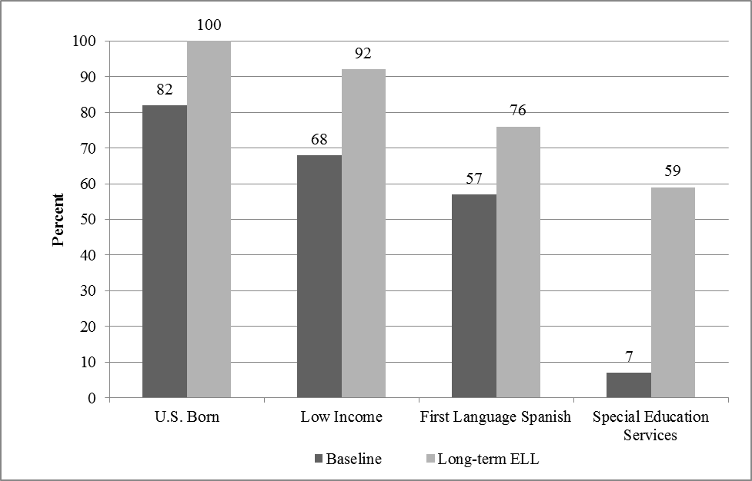

## RQ2b. Relationship Between English Language Proficiency Attainment and Reclassification

To better understand the relationship between the attainment of English proficiency as measured by the MEPA or ACCESS and reclassification, we conducted two sets of descriptive analyses. First, we examined the proportion of the 2003–04 kindergarten ELL cohort who scored at the proficient level on MEPA while still classified as ELL (i.e., they have not been reclassified as former ELL; Table 9). Second, we calculated the proportion of students who were reclassified as non-ELL for the school year immediately following attainment of first-time English language proficiency (Figure 21). Together, these statistics provide insight into the degree to which the language proficiency assessment may be used to make reclassification decisions.

We generated the subsample in Table 11 by examining the subset of the time-to-reclassification analytic sample who were still classified as ELL at the start of third grade. Then, we examined the proportion that attained English proficiency for the first time in the spring of third grade. Examining the last row in Table 9, we see that the proportion of students in our sample who reach proficiency in a given year drops precipitously between the 2007–08 and 2008–09 school years. This drop corresponds with a shift in Massachusetts from four levels of ELL proficiency to five. This may indicate that districts began using the language proficiency assessment more closely to make reclassification decisions such that those who were proficient were typically reclassified and thus fewer proportions of nonreclassified ELLs demonstrated proficient scores on the language proficiency assessment.

Table . Number and Percentage of Nonreclassified ELLs Reaching English Language Proficiency, by School Year

|  |  |  |  |  |  |  |  |  |
| --- | --- | --- | --- | --- | --- | --- | --- | --- |
| **School Year** | **2006–07** | **2007–08** | **2008–09** | **2009–10** | **2010–11** | **2011–12** | **2012–13** | **2013–14** |
| *N* Reached first proficiency | 1,054 | 569 | 38 | 50 | 73 | 53 | 16 | 15 |
| *N* Not proficient | 785 | 563 | 825 | 564 | 364 | 246 | 196 | 121 |
| *N* total | 1,839 | 1,132 | 863 | 614 | 437 | 299 | 212 | 136 |
| Percent achieving proficiency | 57.3% | 50.3% | 4.4% | 8.1% | 16.7% | 17.7% | 7.6% | 11.0% |

*Note*. School year 2006-07 was the first year the statewide English proficiency test was administered to the 2003 kindergarten cohort. English language proficiency means scoring at Level 4 on the 2006–07 and 2007–08 administrations of MEPA; at Level 5 from the 2008–09 to 2011–12 administrations of MEPA; or at Levels 5 or 6 in 2012–13 and 2013–14 on the ACCESS for ELLs.

In Figure 21, we show the percentage of the students who were first reclassified as non-ELL the year immediately following their first proficient score on the language proficiency assessment. Surprisingly few students were reclassified in the first post-proficiency year. Reclassification rates for proficient students ranged from 24.4 percent to 51.5 percent (see ). Future analysis should explore the timing of reclassification decisions—specifically, when students score *proficient* on the language proficiency assessment, when students are typically reclassified and when the change is reflected in the statewide database.[31]

Phase 1 findings indicate that currently, districts do rely heavily on statewide language proficiency assessment to make reclassification decisions. Eight out of the 10 districts in our purposive sample (with the exception of Lawrence and Holyoke) reported relying most heavily on students’ ACCESS scores to make reclassification decisions. Of those eight districts, three (Lowell, Brockton, and Wachusett) also reported using MCAS scores as the most important data point when determining whether an ELL should be exited from ELL instructional services.

Figure . Percentage of Students First Reclassified the Year After Reaching Proficiency, by School Year (2008–09 to 2013–14)

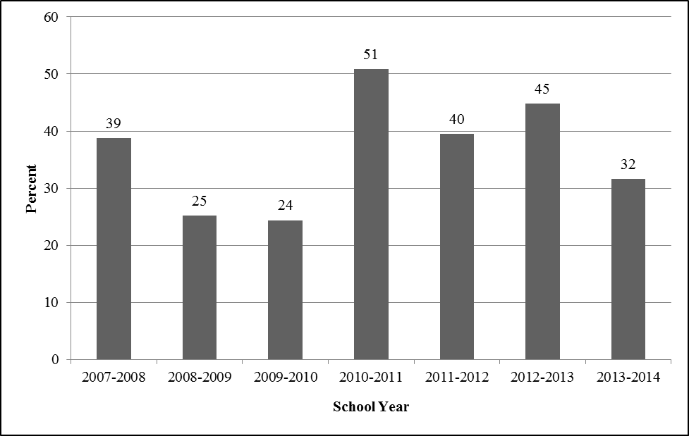

## RQ2c. Classified ELLs Scoring *Proficient* on MCAS

|  |
| --- |
| **Key finding 20—Content-area proficiency after reclassification:** Greater proportions of former ELLs scored proficient on the ELA and mathematics MCAS compared to ELLs. This result is to be expected given that MCAS scores are one of the criteria that districts use to reclassify ELLs. However, by eighth grade, only 68 percent and 40 percent of former ELLs scored *proficient* on the English language arts and mathematics MCAS assessments, respectively, compared to 83 percent and 55 percent of never-ELLs statewide. |

In this section, we calculated the percentages of ELLs and former ELLs (students who were reclassified during the period of analysis) in our sample that scored *proficient* or higher on the MCAS mathematics and English language arts exams. In Table 10, we show that in every year, greater proportions of former ELLs scored *proficient* on the ELA and mathematics assessments compared to ELLs. This result is to be expected given that MCAS performance is part of the reclassification criteria per state guidance (i.e., students with low MCAS scores are not likely to be candidates for reclassification; ESE, 2015). However, by eighth grade, only 68 percent and 39 percent of former ELLs scored at the proficient or above level in ELA and mathematics respectively, compared to 83 percent and 55 percent of never-ELL peers in that same year and grade. The proportion of former ELLs performing at the proficient or above level jumps in 10th grade to 87 percent and 74 percent in ELA and mathematics (compared to 92 and 81 percent of never-ELL 10th graders in that year). However, students who remain in school through 10th grade may, as a group, represent higher performing students.

The Phase 2 finding that former ELLs lag behind their never-ELL peers in ELA and mathematics may appear to contradict the Phase 1 finding that FELLs in many districts outperformed their never-ELL classmates on MCAS (as measured by the Composite Performance Index). However, the two phases represent two different samples of students—Phase 1 former ELLs include those students who were exited from ELL programs over the past two years. The Phase 2 former ELL group includes all students who were exited from ELL programs who were ever identified as ELL since kindergarten entry. Also, it should be noted that the comparison groups differ as well. Phase 1 never-ELLs are reported at the district level in some of the most struggling districts in the state. Never-ELLs in the Phase 2 analysis represent all students statewide who were never identified as ELL—likely a higher performing group, on average, than the Phase 1 never-ELLs.

One trend that remains the same across Phase 1 and Phase 2 analyses is that former ELLs outperformed ELLs on MCAS assessments (see Section RQ1d of the Phase 1 analysis and Table 12 below). This is not surprising, given that MCAS performance is one data point that districts rely on to make reclassification decisions—students with low MCAS performance are not likely to be candidates for exit; therefore, the former ELL group, by design, is higher performing on content assessments. It is notable, though, that there are ELLs who do score at the *proficient* level or higher; the percentage in several of the years is 20 percent or higher.

Table . Percentage of ELLs (E) and FELLs (F) Scoring Proficient or Above on the English Language Arts and Mathematics MCAS, by School Year

|  |  |  |  |  |  |  |  |  |  |  |  |  |  |  |  |  |
| --- | --- | --- | --- | --- | --- | --- | --- | --- | --- | --- | --- | --- | --- | --- | --- | --- |
|  | **2006–07** | | **2007–08** | | **2008–09** | | **2009–10** | | **2010–11** | | **2011–12** | | **2012–13** | | **2013–14** | |
|  | **E** | **F** | **E** | **F** | **E** | **F** | **E** | **F** | **E** | **F** | **E** | **F** | **E** | **F** | **E** | **F** |
| English | 25.2 | 45.2 | 13.6 | 31.9 | 13.3 | 45.0 | 21.4 | 55.2 | 20.5 | 59.7 | 23.4 | 67.9 | * | * | 42.2 | 86.6 |
| Math | 32.6 | 46.2 | 23.2 | 42.8 | 17.0 | 41.6 | 23.0 | 46.3 | 14.4 | 40.6 | 9.4 | 39.2 | * | * | 25.8 | 74.1 |

*Note.* MCAS in English Language Arts and Mathematics are administered in Grades 3–8 and 10. An asterisk indicates that the 2003 cohort of kindergartners who progressed on time through the grades would have been ninth graders in the 2012–13 school year and thus would not have taken the MCAS. We have omitted percentages for this school year because those who were assessed were likely those who were retained in grade and thus not representative of the ninth graders.

## RQ2d. ELLs’ English Language Proficiency and Content-Area Performance

|  |
| --- |
| **Key finding 21—English language proficiency and content-area proficiency:** There is a correlation between students’ English language proficiency assessment performance and their performance on the English language arts and mathematics MCAS assessments in every year of study, with a stronger relationship reported between the ELP assessment and the ELA component of the MCAS. |

RQ2d examines the relationship between ELLs’ performance on the statewide English language proficiency assessment (e.g., MEPA and ACCESS) and the mathematics and English language arts content-area assessments (e.g., MCAS). We computed the correlation between the scaled MEPA/ACCESS scores of students in our sample and their scaled scores on the mathematics and language arts MCAS exams to determine the relationship between students’ language and academic achievement.

Students’ English language proficiency assessment scores (i.e., MEPA/ACCESS) have a statistically significant relationship with their scores on both the English language arts and mathematics MCAS exams in every year of our study that students participated in both assessments. As would be expected, the correlation between the English language arts MCAS and the MEPA/ACCESS is stronger in each year than the correlation between the mathematics MCAS and the MEPA/ACCESS scores ().

Table . Correlations Between Scaled Language Assessments (MEPA/ACCESS) and Scaled MCAS Mathematics and English Language Arts Scores, by School Year

|  |  |  |  |  |  |  |  |  |
| --- | --- | --- | --- | --- | --- | --- | --- | --- |
| **School Year** | **2006–07** | **2007–08** | **2008–09** | **2009–10** | **2010–11** | **2011–12** | **2012–13** | **2013–14** |
| Mathematics MCAS | * | 0.50 | 0.49 | 0.54 | 0.52 | 0.47 | 0.37 | 0.53 |
| English Language Arts MCAS | * | 0.61 | 0.64 | 0.68 | 0.67 | 0.67 | 0.54 | 0.66 |

*We were unable to report correlations for the 2006–07 school year because there were no scaled scores reported for third graders on the 2007 MCAS administration. All correlations are significant at the .001 level.

## RQ2e. On-Time Fifth- and Eighth-Grade Promotion

|  |
| --- |
| **Key finding 22—Promotion:** Substantially greater proportions of first-time reclassified ELLs were promoted on time compared to students who remained classified as ELL. The pattern was true for fifth-grade promotion (83.3 percent of reclassified ELLs promoted on time compared to 68.2 percent of ELLs) and eighth grade (79.1 percent of reclassified ELLs experienced on-time promotion compared to 61.3 percent of ELLs). |

This section addresses RQ2e, examining the proportion of the 2003*–*04 kindergarten ELL cohort[32] who experienced on-time promotion by fifth grade and eighth grade. On-time promotion means that a student has not been retained in any grade. Students who continued to be classified as ELL in our sample experienced on-time promotion to fifth and eighth grade at lower rates than students who had been reclassified (). Although 83.3 percent of reclassified students reached fifth grade on time in 2008*–*09, the same was true for only 68.2 percent of ELLs. The rate of on-time promotion to eighth grade was 79.1 percent for reclassified students and 61.0 percent for ELLs still in the sample in 2011*–*12 (the eighth-grade year for students in the cohort who progressed on time through the grades).

Figure . Proportion of ELLs and Former ELLs Experiencing On-Time Fifth- and Eighth-Grade Promotion

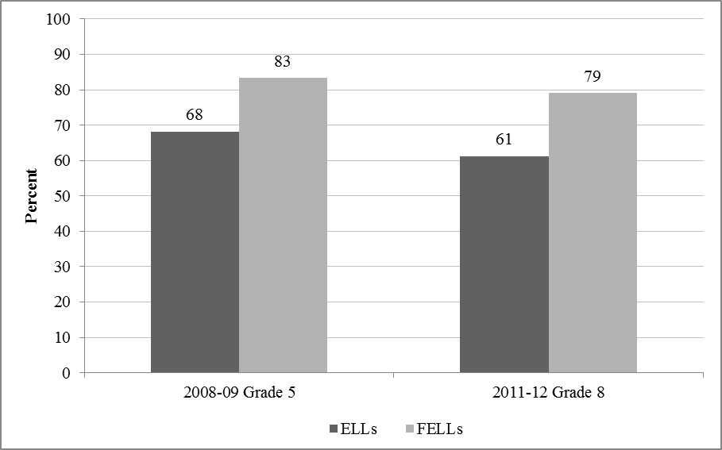

## RQ2f: Average Time to Key Educational Milestones by District

|  |
| --- |
| **Key finding 23**—**District variation in time-to-English proficiency**: In all districts in the purposive sample with sufficient sample sizes, the median time-to-scoring *proficient* on the statewide English language proficiency assessment was at least three years since kindergarten.  **Key finding 24**—**District variation in time-to-reclassification**: There was greater variation in the median time-to-reclassification across districts. In some districts, 50 percent of the sample was reclassified within three years: Lawrence (1.9 years), Fall River (2.6 years), and Quincy (2.8 years). In other districts, ELLs remained at least five years prior to reclassification: Worcester (5.4 years), Lowell (5.3 years), and Brockton (5.3 years). |

Our final research question, RQ2f, examines the average time to reaching key educational milestones (i.e., English proficiency and reclassification) in our 10 Phase 1 districts. The district-specific estimates for median time to reaching these two milestones were obtained by taking the estimated intercepts (or the overall mean across districts) from our final models (see columns denoted “final model” in Tables B5 and B6 for English proficiency and reclassification regression coefficient estimates, respectively), and adding the estimated district-specific random component.

provides the time in years at which, for each of the Phase 1 sampled districts, 50 percent of ELLs were reclassified (i.e., the median lifetime [second column]) and demonstrated English language proficiency [third column]). The last row in the table provides the median lifetime for the average time it took students in this cohort to reach each of the respective educational milestones.

Table . Number of Years at Which 50 Percent of ELLs Were Reclassified, by Selected Districts

|  |  |  |
| --- | --- | --- |
| **District** | **Median Time to Reclassification (years)** | **Median Time to English Proficiency**  **(years since third grade)** |
| Worcester | 5.4 | 3.3 |
| Lawrence | 1.9 | 3.9 |
| Boston | 4.8 | 3.0 |
| Holyoke | 3.9 | 3.7 |
| Lowell | 5.3 | 3.6 |
| Brockton | 5.3 | 3.1 |
| Weymouth | * | * |
| Wachusett | * | * |
| Quincy | 2.8 | 3.0 |
| Fall River | 2.6 | 3.6 |
| **State Average** | **2.7** | **3.3** |

In we see that in two districts—Lawrence and Fall River—the median time at which ELLs are reclassified is lower than the State average of 2.7 years. In the other districts, there is a range of times to median reclassification, from 2.8 years in Quincy to 5.4 years in Worcester. These findings are not well correlated with the time to median level of ELL English proficiency, as shown in Table 14. Examining the third column in the table shows that in all of the sampled districts that had sufficient data to estimate median lifetimes, it took students at least three years since kindergarten to account for 50 percent of students to achieve English proficiency.

### Limitations to Interpretation of Time-to-Reclassification and Time-to-English Proficiency

When interpreting the discrepancy between the median time to reclassification (2.7 years since kindergarten) and time-to proficiency (3.3 years since kindergarten), one must exercise caution based on the limitations of the data. First, it is important to emphasize that in these two sets of analyses presented in Table 14, columns one (time to reclassification) and two (time to English proficiency) use very different samples. The first one includes 2003 ELL cohort kindergartners who have reclassification data. The second analysis includes only a subset of the 2003 ELL cohort: those who remained as ELL until at least the beginning of third grade. Therefore, it is not surprising that the average time to reclassification is lower than the time to proficiency because students cannot demonstrate proficiency prior to third grade (it was not tested before this time for Grades K, 1, and 2).

Second, there is a sampling bias particularly for the time-to-proficiency statistics—we are able to measure English language proficiency beginning only in third grade when half of the sample has already exited ELL instructional services and been reclassified as former ELL. The exited students were presumably the most high performing ELLs in the sample. Consequently, ELLs who remain in the median time-to-proficiency sample are those who have the lowest MCAS scores. This is particularly salient because as we show in Table 11 of the report, MCAS scores are strongly correlated with English proficiency scores.

Although it is difficult to interpret the data across these two sets of analyses, one can examine findings about each outcome separately. For example, it is noteworthy that Lawrence has relatively fast reclassification times and is also one of two districts (along with Holyoke) that reported not relying most heavily on English language proficiency and content-area assessments to make reclassification decisions (see Table 7; RQ1d). These districts reported relying most heavily on teacher input and on work and writing samples, respectively. However, we cannot draw any sweeping conclusions given that district administrators were interviewed about reclassification practices in one period of time and the time-to-reclassification data are from a longitudinal study that spans 10 years of assessment data.

## Phase 2 Conclusion

Our longitudinal analysis of ELLs found that the median time to reach proficiency, defined in this study as achieving the highest possible level on any given year’s language proficiency exam, was 3.3 years. This figure is slightly higher than the finding for median time to reclassification (2.7 years). However, for the reasons described earlier, we cannot draw any sweeping conclusions about this discrepancy because largely they involve two slightly different samples of students.

Other important findings about reclassification included the fact that receiving special education services, coming from a low-income household, and being Spanish-speaking were all factors negatively associated with time to reclassification. In addition, approximately 12 percent of students in the 2003–04 kindergarten cohort were not reclassified by the final year of the study (2013–14). Of these students, more than 60 percent received special education services.

The longitudinal study also examined student achievement. We found that a substantial number of ELLs (20 percent or more, depending on the assessment year) scored at the *proficient* level or higher on the MCAS. Results among FELLs are mixed: on one hand, FELLs experienced higher rates of on-time promotion to fifth and eighth grade. However, as we noted in RQ2c (summarized in Table 10), large proportions of former ELLs are not proficient by eighth grade. We benchmarked these findings to the statewide percent proficient for never-ELLs[33] and there are growing gaps between former ELLs and never ELLs in ELA and mathematics from fifth to eighth grade. Based on our analysis, 55 percent and 46 percent of fifth-grade FELLs were proficient and above in ELA and mathematics compared to 66 percent and 56 percent of fifth-grade never-ELLs in the respective year. By eighth grade, 68 percent and 40 percent of FELLs were proficient in ELA and mathematics compared to 83 percent and 55 percent of never-ELLs in the respective year.

In the next section, we discuss these findings along with the Phase 1 findings and provide recommendations for improving ELL outcomes in Massachusetts.

# Discussion

Our findings reveal that Massachusetts faces some important challenges in addressing the needs of its ELLs, including gaps in achievement scores; higher grade retention, dropout, chronic absenteeism, and suspension rates; and lower stability and four-year graduation rates. Some of these challenges may be related to contextual factors; in Phase 1 of the study, we found that ELLs attend schools with higher concentrations of students from low-income households than do their non-ELL peers. This situation is not unique to Massachusetts; ELL students live disproportionately in poverty (Capps et al., 2005) and consequently often attend schools characterized by large proportions of other ELL students, minorities, and students from low-income households. Such segregated environments are associated with lower academic achievement for all students (e.g., Orfield, 2001; Orfield & Lee, 2006; Rios-Aguilar & Gándara, 2012).

Paramount to addressing these and other challenges is understanding the current context of ELL instruction and outcomes, a task made easier by Massachusetts’ extensive database of student-, school-, and district-level data. These data can be used to pinpoint areas that need improvement and to identify areas of promise, but the data themselves can also be improved to better understand the needs of the ELL population, especially at the district level. This section discusses findings from the descriptive Phase 1 of our study and the longitudinal Phase 2 of our study and makes recommendations in three key emergent areas: language instructional services for ELLs (including ELLs with disabilities), time to proficiency and reclassification, and data collection.

## Language Instructional Services

As discussed in the Introduction, ELLs have a right to equal educational opportunities, and educational agencies are tasked specifically with ensuring that language barriers do not impede these opportunities (OCR, 2015). It is therefore crucial that the State monitor and support language instructional services for ELLs, especially programs and practices that produce good academic outcomes. In this section, we discuss key findings and provide recommendations about instructional services for ELLs in the areas of dual language programming, staffing, and services for ELLs with disabilities. We also identify some districts that have exhibited better than average ELL outcomes and recommend a specific course of action to leverage these districts’ policies and programming to improve instruction for ELLs in other districts.

### Language Programming

Massachusetts is one of the nation’s three English-only states, but dual language instruction, which promotes bilingualism and biliteracy along with academic achievement (Faulkner-Bond et al., 2012), is sanctioned. Nonetheless, our examination of ELL enrollment in language learning programs in the 10 Phase 1 sample districts suggests that this type of language instruction is rare. The lack of dual language programming is unfortunate, because a long-standing and growing body of research indicates that first-language instruction promotes gains in English achievement and that bilingualism is an asset (e.g., Cummins, 1979; Dressler & Kamil, 2006; Francis, Lesaux, & August, 2006; Greene, 1997; Rolstad, Mahoney, & Glass, 2005; Willig, 1985). Our first recommendation, therefore, is to promote dual language instruction in order to draw on the home language assets of ELLs in their overall instruction.

***Recommendation 1: Develop and provide a model of language acquisition, with a focus on supporting dual language and other similarly promising programming.***

In our Phase 1 sample districts, the number and percentage of speakers of the most common non-English language are substantially higher than for the other languages, indicating that a critical mass of at least one non-English language is likely possible. Dual language instruction promotion might include the following actions:

* Educate teachers, administrators, and parents about the benefits and legality of dual language instruction.
* Provide support to districts to develop dual language programs:
* Develop and provide curricular materials and resources in multiple languages.
* Develop and provide job-embedded inservice training and preservice training for bilingual teachers, perhaps in partnership with Massachusetts colleges and universities (see MBESE, 2009).
* Monitor districts’ dual language program services to ensure that they are research based; ensure districts are evaluating students’ progress in language proficiency and content mastery and making adjustments as necessary.

The State might also consider supporting pilots of other types of language support programs, with the goal of expanding such programs if they show promising results. However, in all cases, ensure that instructional programming for ELLs does not needlessly segregate these students from English-speaking peers (see OCR, 2015).

### Human Resources to Support a Fast-Growing ELL Population

The Office for Civil Rights (OCR, 2015) is very clear in its guidance to education agencies that instructional programs for ELLs must be adequately staffed by teachers who are qualified to effectively instruct ELLs. This is a challenging task for those districts where, following a nationwide trend, ELL enrollment has grown rapidly over the past decade. Available data suggested that in all 10 of the districts selected for our Phase 1 analysis, the reported proportion of teachers providing services to ELL students was substantially lower than the ELL rates of enrollment. There are some important caveats to this finding. First, current reporting may obscure actual services provided to ELLs if those services are not provided by the students’ teachers of record. Second, as of July 2016, all Massachusetts core academic teachers of ELLs will be required to hold an SEI teacher endorsement, which means that there will be a substantial increase in the number of teachers who are trained to provide SEI to ELLs (Haynes & Paulsen, 2013). Nonetheless, the State should monitor and support ELL access to good instruction by qualified staff, our second recommendation.

***Recommendation 2: Obtain more accurate data on the credentials of teachers providing instruction to ELLs, and monitor knowledge of ELL instruction by teachers-of-record.***

Several studies have established connections between teacher knowledge and instructional effectiveness in the areas of reading and language (Foorman et al., 2006; Lane et al., 2009; Spear-Swerling & Brucker, 2004). The State could change its reporting requirements to better monitor who provides instructional services to ELLs and to ensure that they have adequate knowledge to do so. Such an approach might include the following actions:

* Monitor that there are sufficient qualified staff in districts to provide services to ELLs, including certified ESL teachers. Current reporting requirements may not make this monitoring feasible; consider streamlining the reporting requirements to ensure consistency of data across districts.
* All Massachusetts core content teachers who provide instruction to ELLs are required to participate in SEI training, but there is currently no system in place to ensure that they are knowledgeable about ELL instruction. Develop and administer an assessment of teacher knowledge (we recommend that the assessment include an observation component, if possible). Include results of the assessment in State data about teachers providing language services to ELLs.

### Special Education Services for ELLs

In our Phase 1 analysis of 10 selected districts, we generally observed similar rates of special education identification among ELLs and the general population. However, in Holyoke, ELLs appeared to be identified for special education services at higher rates than in the general population (33.6 percent compared to 25.1 percent), and in Quincy, ELLs appear to be identified at lower rates than in the overall population (4.3 percent compared to 15.5 percent). Furthermore, our Phase 2 analysis found that statewide, approximately 12 percent of students who began as ELLs in kindergarten did not achieve English proficiency by the end of the study period. The majority of these students were also identified as needing special education services, while only 7.3 percent of the initial sample were classified as needing special education services.

This finding suggests that although many districts appeared to have similar rates of identification among ELLs and other students, there may be factors related to students’ special education status impacting their achievement of English proficiency. Indeed, it is possible that in districts that appear to have similar ELL identification rates as the general population, underrepresentation in lower grades is disguised by overrepresentation in higher grades. This possibility should be further examined, as the Office for Civil Rights (2015) has made it clear that ELLs with disabilities must be identified in a timely manner. Our third recommendation therefore pertains to identifying ELLs with disabilities.

***Recommendation 3: Provide resources and support to districts to identify ELLs with disabilities in a timely manner and monitor identification rates at all grade levels.***

The English learner toolkit from the Office of Civil Rights (2015) includes five tools for identifying and serving ELLs with disabilities. These could be a useful starting point for assisting districts with this important endeavor. In addition to supporting districts, we recommend that the State monitor their success in this area. For example, the State might do the following:

* Collect data pertaining to when ELLs with disabilities are identified as needing special education services. Is this identification occurring as early as it does for non-ELLs, or are ELLs at a disadvantage for receiving special education services in the early years of school?
* Monitor the special education services provided to ELLs to determine whether those services adequately support ELLs’ language acquisition needs.

### Leverage Lessons From Higher Performing Districts

As noted previously, our findings indicate that ELLs as a group face both academic and nonacademic challenges. However, our Phase 1 analysis of 10 selected districts also revealed areas of strength. For example, three districts stood out as especially promising in the area of academic achievement. Quincy, Wachusett, and Lowell all had higher average ACCESS for ELL and MCAS assessment scores among their ELL populations than the average State ELL population. These three districts had lower than average ELL grade retention, dropout, and chronic absenteeism rates, and Lowell and Quincy had higher than average ELL four-year graduation rates. A fourth district, Brockton, showed promising nonacademic indicators, including better than average ELL stability and four-year graduation rates and lower than average rates of chronic absenteeism. Brockton also had higher than average SGPs among its ELLs in both English language arts and mathematics, indicating progress in academic achievement. Our fourth recommendation is to use this information to help districts where ELL outcomes are less robust.

***Recommendation 4: Conduct case studies in districts that exhibit higher than average ELL performance.***

Case studies such as those conducted by the Rennie Center for Education Research and Policy (2007) can help inform policies and programming that are beneficial for ELLs. We recommend that the State conduct or support case studies in districts with higher than average ELL performance, such as the districts identified in this report (Quincy, Wachusett, Lowell, and Brockton). It will be important to include districts with a variety of demographic characteristics to be able to examine the relationship among context, policies and programming, and student outcomes. For example, Quincy has a high rate of students from low-income households and relatively high ELL enrollment, as do Lowell and Brockton. Wachusett has a low rate of ELL enrollment and a relatively low rate of enrollment of students from low-income households. The State might conduct or support additional analyses to identify other districts with high ELL achievement that were not sampled for this study.

We recommend that case studies examine the following factors:

* *Staff credentials, training, and experience*: As noted in an earlier recommendation, it would be important to examine who provides services to ELLs over the course of the school week (including general education teachers, ESL specialists, and paraprofessionals), the amount of time ELLs spend with these staff, and staff certifications as well as preservice and inservice training.
* *Collaboration and coordination among educators serving ELLs, as well as among school district departments*: Collaboration and coordination among staff providing school-level services to ELLs, including ELL specialists, other specialists (e.g., reading, special education, counselors), and general education teachers, as well as among district departments providing services helps foster ELL success (August & Hakuta, 1998) and should be examined as a potential factor in districts with high rates of ELL achievement.
* *ESL specialist tasks*: It would be important to examine how district and school ESL specialists spend their time. For example, how much of their time is spent providing direct instruction to ELLs, administering assessments, modeling instruction for other teachers, or providing coaching and other professional development to mainstream teachers?
* *Resource allocation*: Districts must divide their resources among many competing needs. It would be important to examine how resources are allocated to services for ELLs, including professional development funds, curriculum and materials, and direct services to students.

We further recommend that the State use the results of case studies to develop and provide technical assistance to other districts, leveraging the support of staff from these districts whenever possible.

## Time to Proficiency and Reclassification

The average ELL in the statewide 2003–04 kindergarten cohort was reclassified relatively quickly—after 2.7 years since kindergarten entry. However large numbers of former ELLs were performing below the proficient level by eighth grade (only 68 and 39 percent were proficient in ELA and mathematics compared to 83 and 55 percent of never-ELLs in that same year and grade statewide). On the other hand, substantially greater proportions of reclassified ELLs were promoted on time compared to students who remained classified as ELL. The pattern was true for fifth-grade promotion (83.3 percent of reclassified ELLs promoted on time compared to 68.2 percent of ELLs) and eighth grade (79.1 percent of reclassified ELLs experienced on-time promotion compared to 61.3 percent of ELLs). However, we found a significant negative relationship between time to reclassification and nonacademic student characteristics, including being from a low-income household, or being Asian or Black. We were unable to ascertain the reason for these relationships as part of this study, but it is an important point for further monitoring and study. This is the basis of our recommendation about time to proficiency and reclassification.

***Recommendation 5: Conduct additional research about nonacademic factors related to reclassification and act on the findings to ensure that all students have equal opportunities to exit from ELL services regardless of background. Monitor performance of former ELLs who may face language-related difficulties as academic content becomes increasingly demanding in upper grades.***

In examining the relationship between nonacademic student characteristics and reclassification decisions, it would be important to first determine if the relationships discovered in this study are clustered in particular schools or districts.

Former ELLs also warrant attention. Our analyses indicate that there is a growing gap in performance between never-ELLs and former ELLs in the upper grades. This is particularly important given that the majority of ELLs in Massachusetts are exited in the early elementary grades. As academic content becomes increasingly demanding, former ELLs may need additional support to perform on-par with never-ELL peers.

## Data Collection

Massachusetts collects, organizes, and maintains an impressive amount of district- and student-level data. Nonetheless, both phases of this study revealed additional information that might be collected. Primary areas identified for further data collection include information about ELLs’ state or territory of origin, about the number of years they attended school in the United States, and district-level data that follow ELL cohorts. Our final recommendation is therefore related to data collection.

***Recommendation 6: Collect and analyze additional data related to ELLs.***

Additional recommended types of data collection include the following:

* Data about ELLs’ states or territories of origin in order to identify ELLs born in Puerto Rico.
* Data to track the number of years ELL students have attended school in the United States. Currently Massachusetts only measures the time ELL students attend school in the State (1–2 years; 3–4 years; 5 or more years).
* District-level longitudinal data about ELL cohorts. These data can be used as a way to continue the Phase 2 analysis presented in this report. In particular, it would be important to track students who are not reclassified and provide targeted interventions for students who are in danger of becoming long-term ELLs. In addition, these data could be useful for setting a “reasonable and realistic” timeline for ELLs to meet English language and content area proficiency goals (e.g., Cook, Linquanti, Chinen, & Jung, 2012, p. 29). This recommendation is particularly important in light of the U.S. Department of Justice’s (2015) guidance for meeting legal obligations to ELLs, which requires education agencies to evaluate the effectiveness of districts’ ESL programs.

In summary, there are some important pockets of promise for ELLs in Massachusetts, but the State could leverage additional resources in the areas of language instructional services for ELLs (including ELLs with disabilities), time to proficiency and reclassification, and data collection to help improve ELL academic outcomes. Of particular importance is ensuring that ELLs with disabilities and former ELLs who may be struggling academically in upper grades receive the services they need and that all students are considered equally in reclassification decisions. Also important is ensuring that districts acquire the resources they need, including human resources, to provide adequate services to ELLs so that they may engage meaningfully in their education, as they are guaranteed by law.

# Conclusion

This study has provided descriptive analysis of Massachusetts ELLs’ demographics and academic and nonacademic outcomes as well as a longitudinal analysis of language and content outcomes for the 2003–04 kindergarten cohort of ELLs (until 2013–14). Findings reveal that some districts are outperforming others on a range of academic and nonacademic factors. Our recommendations included further study of these districts, as well as support for dual language instruction, and further data collection and analysis. Further study is emphasized because although the analyses presented here provide important information about the state of ELL instruction and outcomes in Massachusetts, one limitation presented by the reliance on extant quantitative data is that these data could not shed any light on the effectiveness of specific programs or program characteristics, such as amount or type of ESL instruction. Another study limitation arose from the design of the Phase 2 analysis, which followed a single cohort of ELLs starting in kindergarten. This analysis allowed us to see the trajectory only of ELLs who began their formal schooling in Massachusetts, but ideally, it would be important to see the trajectories of ELLs who arrive later as well.

Future studies might therefore compare kindergarten trajectories to the trajectories of later arrivals as well as to never-ELL trajectories. Additional research might also involve collecting and analyzing data about specific subgroups of students, including those who outperform or underperform their peers, those who were shown not to be receiving ELL services (e.g., in Weymouth and Worcester), and those who belong to groups that our analysis showed tend to reach reclassification later (e.g., coming from a low-income household, or being Asian, Black, and Spanish-speaking).

Massachusetts ELLs, like their peers nationwide, tend to face additional challenges in education. It is our hope that this study and future studies will inform improved policies and practices that improve ELLs’ educational experiences and outcomes.

# References

August, D., & Hakuta, K. (Eds.). (1998). *Educating language minority children*. Washington, DC: National Academy Press.

Capps, R., Fix, M., Murray, J., Ost, J., Passel, J. S., & Herwantoro, S. (2005*). The new demography of America’s schools: Immigration and the No Child Left Behind Act* (research report). Washington, DC: Urban Institute.

Cook, G., Linquanti, R., Chinen, M., & Jung, H. (2012). National evaluation of Title III implementation supplemental report: Exploring approaches to setting English language proficiency performance criteria and monitoring English learner progress. Washington, DC: U.S. Department of Education, Office of Planning, Evaluation and Policy Development.

Cummins, J. (1979). Linguistic interdependence and the educational development of bilingual children. *Review of Educational Research*, *49*(2), 222–251.

Dressler, C., & Kamil, M. I. (2006). First and second language literacy. In D. August & T. Shanahan (Eds.), *Developing literacy in second language learners: Report of the National Literacy Panel on Language-Minority Children and Youth* (pp. 197–238). Mahwah, NJ: Erlbaum.

Faulkner-Bond, M., Waring, S., Forte, E., Crenshaw, R. L., Tindle, K., & Belknap, B. (2012). *Language instruction educational programs (LIEPs): A review of the foundational literature*. Washington, DC: U.S. Department of Education; Office of Planning, Evaluation and Policy Development; Policy and Program Studies Service.

Foorman, B. R., Schatschneider, C., Eakin, M. N., Fletcher, J. M., Moats, L. C., & Francis, D. J. (2006). The impact of instructional practices in grades 1 and 2 on reading and spelling achievement in high poverty schools. *Contemporary Educational Psychology*, *31*, 1–29.

Francis, D. J., Lesaux, N. K., & August, D. (2006). Language of instruction. In D. L. August & T. Shanahan (Eds.), *Developing literacy in a second language: Report of the National Literacy Panel* (pp. 365–410). Mahwah, NJ: Erlbaum.

Greene, J. P. (1997). A meta-analysis of the Rossell and Baker review of bilingual education research. *Bilingual Research Journal*, *21*(2/3), 1–22.

Haynes, E., & Paulsen, C. (2013). *An evaluation of the 2013 Massachusetts teachers’ SEI endorsement course*. Prepared for the Massachusetts Department of Elementary and Secondary Education*.* Washington, DC: American Institutes for Research.

Hehir, T., Grindal, T. & Eidelman, H. (April, 2012). Review of special education in the

Commonwealth of Massachusetts. Report commissioned by the Massachusetts Department of Elementary and Secondary Education. Retrieved from <http://www.doe.mass.edu/sped/hehir/>

Lane, H. B., Hudson, R. F., Leite, W. L., Kosanovich, M. L., Strout, M. T., Fenty, N. S., et al. (2009). Teacher knowledge about reading fluency and indicators of students’ fluency growth in Reading First schools. *Reading & Writing Quarterly*, *25*, 57–86.

Lindholm-Leary, K., & Block, N. (2010). Achievement in predominately low SES/Hispanic dual language schools. *International Journal of Bilingual Education and Bilingualism*, *13*(1), 43–60.

Massachusetts Board of Elementary and Secondary Education (MBESE), English Language Learners Sub-Committee. (2009). Halting the race to the bottom: Urgent interventions for the improvement of the education of English language learners in Massachusetts and selected districts. *Gastón Institute Publications* (Paper 107). Boston, MA: Gastón Institute for Latino Community Development and Public Policy Publications.

Massachusetts Department of Elementary and Secondary Education (ESE). (2005). Massachusetts English Proficiency Assessment (Technical report).Retrieved from http://iservices.measuredprogress.org/files/MCAS/MEPA_Report_Final.pdf

Massachusetts Department of Elementary and Secondary Education (ESE). (2011). *MCAS student growth percentiles: Interpretive guide*. Malden, MA: Author. Retrieved from <http://www.doe.mass.edu/mcas/growth/InterpretiveGuide.pdf>

Massachusetts Department of Elementary and Secondary Education (ESE). (2012). *Transitioning English language learners in Massachusetts: An exploratory data review.* Malden, MA: Author. Retrieved from <http://www.nciea.org/publications/Transitioning%20ELL_CD12.pdf>

Massachusetts Department of Elementary and Secondary Education (ESE). (2013). *Transitional guidance on identification, assessment, placement, and reclassification of English language learners*. Malden, MA: Author.

Massachusetts Department of Elementary and Secondary Education (ESE). (2014a). *District analysis and review tools (DART). User guide for DART detail: English language learners.* Malden, MA: Author.

Massachusetts Department of Elementary and Secondary Education (ESE). (2014b). *Glossary of 2014 accountability reporting terms.* Malden, MA: Author. Retrieved from http://www.doe.mass.edu/apa/accountability/2014/GlossaryTerms.pdf

Massachusetts Department of Elementary and Secondary Education (ESE). (2014c). *Requirements for the participation of English language learners in ACCESS for ELLs, MCAS, and PARCC.* Malden, MA: Author. Retrieved from http://www.doe.mass.edu/mcas/participation/ell.pdf

Massachusetts Department of Elementary and Secondary Education (ESE). (2014d). *Researcher’s guide to Massachusetts state education data.* Malden, MA: Author.

Massachusetts Department of Elementary and Secondary Education (ESE). (2015). *Guidance on identification, assessment, placement and reclassification of English language learners.* Retrieved from <http://www.doe.mass.edu/ell/guidance/guidance.pdf>

National Center for Education Statistics (NCES). (2010). *The nation’s report card: Grade 12 reading and mathematics 2009 national and pilot state results* (NCES 2011–455). Washington, DC: Institute of Education Sciences, U.S. Department of Education. Retrieved from <http://nces.ed.gov/nationsreportcard/pdf/main2009/2011455.pdf>

National Center for Education Statistics (NCES). (2011). *The nation’s report card: Mathematics 2011* (NCES 2012–458). Washington, DC: Institute of Education Sciences, U.S. Department of Education. Retrieved from <http://nces.ed.gov/nationsreportcard/pdf/main2011/2012458.pdf>

National Clearinghouse for English Language Acquisition and Language Instruction Educational Programs (NCELA). (2011). *The growing number of English learner students*. Washington, DC: Author. Retrieved from <http://www.ncela.us/files/uploads/9/growingLEP_0809.pdf>

Office for Civil Rights (OCR), U.S. Department of Education, & Civil Rights Division, U.S. Department of Justice (2015, January 7). *English Learner Students and Limited English Proficient Parents* (*2015 OCR Guidance*). Retrieved from http://www2.ed.gov/about/offices/list/ocr/letters/colleague-el-201501.pdf

Orfield, G. (2001). *Schools more separate: Consequences of a decade of resegregation*. Cambridge, MA: Harvard Civil Rights Project. Retrieved from http://civilrightsproject.ucla.edu/research/k-12-education/integration-and-diversity/schools-more-separate-consequences-of-a-decade-of-resegregation/?searchterm=resegregation

Orfield, G., & Lee, C. (2006). *Racial transformation and the changing nature of segregation*. Cambridge, MA: The Civil Rights Project, Harvard University.

Owens, A. (2010). *In the aftermath of Question 2: Students with limited English proficiency in Massachusetts.* Boston: Massachusetts Office for Refugees and Immigrants.

Ragan, A., & Lesaux, N. (2006). Federal, state, and district level English language learner program entry and exit requirements: Effects on the education of language minority learners. *Education Policy Analysis Archives, 14*(20). Retrieved from <http://epaa.asu.edu/ojs/article/view/91>

Rennie Center for Education Research and Policy. (2007). *Seeking effective policies and practices for English language learners.* Cambridge, MA: Author. Retrieved from <http://www.renniecenter.org/research/SeekingEffectPolicies_ELL.pdf>

Rios-Aguilar, C., & Gándara, P. (2012). *Horne v. Flores* and the future of language policies. *Teachers College Record, 114*, 1–13.

Rolstad, K., Mahoney, K., & Glass, G. (2005). The big picture: A meta-analysis of program effectiveness research on English language learners. *Educational Policy*, *19*(4), 572–594.

Rumberger, R. (2006). *Tenth grade dropout rates by native language, race/ethnicity, and socioeconomic status*. Berkeley, CA: University of California Linguistic Minority Research Institute. Retrieved from <http://escholarship.org/uc/item/2903c3p3.pdf>

Singer, J. D., & Willett, J. B. (2003). *Applied longitudinal data analysis: Modeling change and event occurrence.* New York: Oxford University Press.

Slama, R. B. (2014). Investigating whether and when English learners are reclassified into mainstream classrooms in the United States: A discrete-time survival analysis. *American Educational Research Journal,* *51*(2), 220–252.

Spear-Swerling, L., & Brucker, P. O. (2004). Preparing novice teachers to develop basic reading and spelling skills in children. *Annals of Dyslexia*, *54*, 332–364.

U.S. Department of Education. (2009). *Fact sheet: NCLB provisions ensure flexibility and accountability for limited English proficient students.* Washington, DC: Author. Retrieved from <http://www2.ed.gov/nclb/accountability/schools/factsheet-english.html>

Valentino, R. A., & Reardon, S. F. (2014). *Effectiveness of four instructional programs designed to serve English learners: Variation by ethnicity and initial English proficiency.* Unpublished manuscript, Stanford University.

Willig, A. C. (1985). A meta-analysis of selected studies on the effectiveness of bilingual education. *Review of Educational Research*, *55*, 269–267.

# Appendix A. Research Methods Detail

Selection of Four Prototypical Districts for Phase 1 Research

As noted in the main body of the text, 10 Massachusetts districts were selected for Phase 1 of the research. Five of these districts were those that had the highest concentrations of ELLs: Worcester (35.1 percent ELL), Lawrence (29.9 percent), Boston (29.8 percent), Holyoke (28.5 percent), and Lowell (26.6 percent). The sixth district, Brockton, was selected because of its high concentration of ELLs (20 percent; seventh-largest ELL district statewide) and innovative ELL programming. The remaining four districts in the Phase 1 analysis were selected on the basis of districtwide concentrations of students from low-income households and growth in English language proficiency. More specifically, we selected four prototypical districts that met the following criteria:

* One district with low numbers of students from low-income families and whose ELL population experienced lower growth in English language proficiency outcomes
* One district with low numbers of students from low-income families and whose ELL population experienced higher growth in English language proficiency outcomes
* One district with higher numbers of students from low-income families and whose ELL population experienced lower growth in English language proficiency outcomes
* One district with higher numbers of students from low-income families and whose ELL population experienced higher growth in English language proficiency outcomes

We relied on two key variables to determine the four prototypical districts—the proportion of students from low-income households and the median student growth percentile on ACCESS. With respect to the proportion of students from low-income households, we extracted this variable from ESE profiles for each district statewide and ranked the districts from the highest to lowest proportions of students from low-income households. We flagged those that fell into the top and bottom quartiles. With respect to growth in English language proficiency, we relied on data files provided by ESE that maintain the districtwide indicator of growth in English language proficiency—the median student growth percentile on ACCESS (SGPA). We ranked the districts from lowest to highest SGPA score and flagged those that fell in the top and bottom quartiles.

This process of ranking districts by quartiles on the basis of income and SGPA resulted in four bins of districts that corresponded to the four prototypical districts: (1) high income, low growth [on English language proficiency]; (2) high income, high growth; (3) low income, low growth; and (4) low income, high growth. As we display in Table A1, two districts fall into the high-income, high-growth bin, 13 districts fall into the high-income, high-growth bin, 19 districts fall into the low-income, low-growth bin, and two districts fall into the low-income, high-growth bin. In Table A1, we highlight in green the districts where SGPA fell within the high-growth benchmark, as defined by ESE. We highlight in red the districts where SGPA fell within the low-growth benchmark as defined by ESE. Notice that there are several districts in the third group—low income, low growth—that were not defined as low-growth districts by ESE standards but were in the bottom quartile of the SGPA distribution.

Table A1. Display of the Four Bins of Potential Prototypical ELL Districts in Massachusetts

(Red highlighting indicates ESE-defined low growth on ACCESS; green highlighting indicates ESE-defined high growth on ACCESS; gold highlighting indicates ESE selections.)

| (1) High Income, Low Growth | | | | | (2) High Income, High Growth | | | | | (3) Low Income, Low Growth | | | | | (4) Low Income, High Growth | | | | |
| --- | --- | --- | --- | --- | --- | --- | --- | --- | --- | --- | --- | --- | --- | --- | --- | --- | --- | --- | --- |
| District | Low Inc % | SGP % | SGP Incl # | ELL % | District | Low Inc % | SGP % | SGP Incl # | ELL % | District | Low Inc % | SGP % | SGP Incl # | ELL % | District | Low Inc % | SGP % | SGP Incl # | ELL % |
| Marblehead | 11.2 | 47.5 | 64 | 2.9 | Andover | 6.9 | 71.0 | 78 | 1.9 | Amherst | 43.6 | 42.0 | 109 | 14.0 | Quincy | 47.9 | 72.00 | 842 | 14.5 |
| Wachusett | 10.9 | 49.0 | 75 | 1.4 | Brookline | 10.7 | 82.0 | 248 | 9.0 | Attleboro | 38.8 | 39.0 | 317 | 8.2 | Tisbury | 36.5 | 71.50 | 24 | 12.9 |
|  |  |  |  |  | Chelmsford | 7.5 | 72.0 | 79 | 2.1 | Chelsea | 85.7 | 47.0 | 631 | 18.9 |  |  |  |  |  |
|  |  |  |  |  | Lexington | 6.4 | 78.0 | 209 | 5.5 | Fall River | 79.3 | 44.5 | 558 | 8.5 |  |  |  |  |  |
|  |  |  |  |  | Newton | 11.0 | 72.0 | 520 | 7.2 | Fitchburg | 76.8 | 45.0 | 528 | 15.2 |  |  |  |  |  |
|  |  |  |  |  | Southborough | 3.3 | 72.0 | 53 | 5.1 | Gill-Montague | 55.2 | 37.0 | 31 | 5.6 |  |  |  |  |  |
|  |  |  |  |  | Wayland | 6.7 | 69.0 | 22 | 1.1 | Gloucester | 41.5 | 43.0 | 59 | 2.9 |  |  |  |  |  |
|  |  |  |  |  | Wellesley | 5.6 | 82.0 | 58 | 1.7 | Greenfield | 61.0 | 39.0 | 31 | 3.5 |  |  |  |  |  |
|  |  |  |  |  | Westborough | 9.5 | 74.0 | 181 | 8.3 | Haverhill | 55.2 | 48.0 | 321 | 7.5 |  |  |  |  |  |
|  |  |  |  |  | Westford | 4.5 | 75.0 | 29 | 1.1 | Lowell | 74.3 | 43.0 | 3079 | 29.4 |  |  |  |  |  |
|  |  |  |  |  | Weston | 4.8 | 81.0 | 57 | 3.3 | Lynn | 80.8 | 50.0 | 1594 | 17.8 |  |  |  |  |  |
|  |  |  |  |  | Weymouth | 4.2 | 74.5 | 138 | 3.1 | Medford | 39.0 | 47.0 | 215 | 6.8 |  |  |  |  |  |
|  |  |  |  |  | Winchester | 6.1 | 71.0 | 106 | 3.6 | New Bedford | 79.2 | 49.0 | 312 | 5.5 |  |  |  |  |  |
|  |  |  |  |  |  |  |  |  |  | Peabody | 35.9 | 48.0 | 233 | 5.6 |  |  |  |  |  |
|  |  |  |  |  |  |  |  |  |  | Pittsfield | 59.2 | 30.5 | 142 | 4.0 |  |  |  |  |  |
|  |  |  |  |  |  |  |  |  |  | Rockland | 46.0 | 49.5 | 22 | 1.9 |  |  |  |  |  |
|  |  |  |  |  |  |  |  |  |  | Somerville | 66.0 | 47.0 | 541 | 16.8 |  |  |  |  |  |
|  |  |  |  |  |  |  |  |  |  | Southbridge | 76.3 | 33.5 | 180 | 17.0 |  |  |  |  |  |
|  |  |  |  |  |  |  |  |  |  | Springfield | 89.3 | 39.0 | 2926 | 17.0 |  |  |  |  |  |

Table A2. Selection of the Final Four Prototypical Districts on the Basis of: (1) Average Percentage of Students From Low-Income Families; (2) Average Student Growth Percentile on ACCESS (SGPA); (3) Average Number of ELL Students Included in SGPA; (4) Average Percentage of ELL Students; (5) Median Percentage of Students From Low-Income Families; (6) Median SGPA; (7) Median Number of Students Included in SGPA; and (8) Median Percentage of ELL Students in the District

| District name | Avg. Low Inc% (1) | Average SGPA (2) | Average # ELL Incl SGPA (3) | Average ELL% (4) | Median Low Inc% (5) | Median SGPA (6) | Median # Students Incl SGPA (7) | Median ELL% (8) |
| --- | --- | --- | --- | --- | --- | --- | --- | --- |
| High Income, Low Growth | N/A | N/A | N/A | N/A | N/A | N/A | N/A | N/A |
| Marblehead | ⚫ |  |  | ⚫ | ⚫ |  |  | ⚫ |
| Wachusett |  | ⚫ | ⚫ |  |  | ⚫ | ⚫ |  |
| High Income, High Growth | 6.7% | 75 | 137 | 4.1 | 6.4% | 74 | 79 | 3.3% |
| Andover |  |  |  |  |  |  |  |  |
| Brookline |  |  |  |  |  |  |  |  |
| Chelmsford |  |  |  |  |  |  | ⚫ |  |
| Lexington |  |  |  |  | ⚫ |  |  |  |
| Newton |  |  |  |  |  |  |  |  |
| Southborough |  |  |  |  |  |  |  |  |
| Wayland | ⚫ |  |  |  |  |  |  |  |
| Wellesley |  |  |  |  |  |  |  |  |
| Westborough |  |  |  |  |  | ⚫ |  |  |
| Westford |  | ⚫ |  |  |  |  |  |  |
| Weston |  |  |  |  |  |  |  | ⚫ |
| Weymouth |  |  | ⚫ |  |  |  |  |  |
| Winchester |  |  |  | ⚫ |  |  |  |  |
| Low Income, Low Growth | 62.3% | 43.2% | 623 | 10.8% | 61.1% | 44.5% | 312 | 8.2% |
| Amherst |  | ⚫ |  |  |  |  |  |  |
| Attleboro |  |  |  |  |  |  |  | ⚫ |
| Chelsea |  |  | ⚫ |  |  |  |  |  |
| Fall River |  |  |  | ⚫ |  | ⚫ |  |  |
| Fitchburg |  |  |  |  |  |  |  |  |
| Gill-Montague |  |  |  |  |  |  |  |  |
| Gloucester |  |  |  |  |  |  |  |  |
| Greenfield | ⚫ |  |  |  | ⚫ |  |  |  |
| Haverhill |  |  |  |  |  |  |  |  |
| Lowell |  |  |  |  |  |  |  |  |
| Lynn |  |  |  |  |  |  |  |  |
| Medford |  |  |  |  |  |  |  |  |
| New Bedford |  |  |  |  |  |  | ⚫ |  |
| Peabody |  |  |  |  |  |  |  |  |
| Pittsfield |  |  |  |  |  |  |  |  |
| Rockland |  |  |  |  |  |  |  |  |
| Somerville |  |  |  |  |  |  |  |  |
| Southbridge |  |  |  |  |  |  |  |  |
| Springfield |  |  |  |  |  |  |  |  |
| Low Income, High Growth | N/A | N/A | N/A | N/A | N/A | N/A | N/A | N/A |
| Quincy | ⚫ | ⚫ | ⚫ | ⚫ | ⚫ | ⚫ | ⚫ | ⚫ |
| Tisbury |  |  |  |  |  |  |  |  |

*Note:* Values of “⚫” indicate the district in each bin that was closest to the average or median value [or the highest value in the case of high-income/low-growth and low-income/high-growth bins]. Because “High Income, Low Growth” and “Low Income, High Growth” had only two districts, highest was used as the selection criterion instead of the average values of each of these indicators.

After defining the districts within each of the four prototypical bins, our next task was to determine which district to select in each bin. The goal was to select a district within each bin that was sufficiently representative of all the districts in that bin. To help determine which district to select in each bin, we generated average and median values: percentage of students from low-income families; (2) the districtwide SGPA; (3) the number of ELL students included in the SGPA calculation; and (4) the percentage of ELLs in the district.

In each column of Table A2, we display the average/median value of the eight indicators (median and average of each of the four indicators). To indicate which district has the closest average or median value for the given indicator, we add a bullet point by that prototypical bin. We highlight the districts whose average/median values are closest to the average/median for the bin. Note that, in the high-income, high-growth bin, there is no district whose average/median values are closest to the average/median for the bin more than once.

We presented these data to the Massachusetts Office of English Language Acquisition and Academic Achievement, and staff made the following district selections (highlighted gold in Table A2):

* High income, low growth: Wachusett
* High income, high growth: Weymouth
* Low income, low growth: Fall River
* Low income, high growth: Quincy

These selections were based on the districts’ general representativeness in terms of ELL population, ELL programming, and socioeconomic characteristics; none of these districts display any unusual characteristics within their respective categories.

Phase 1 Interviews: Guiding Questions for District Administrators

The following are the questions we posed to district ELL administrators regarding their districts’ ELL programming and reclassification policies and procedures.

1. Please describe the services that ELLs receive in your district for language support. How does this vary by proficiency level?
2. What information does your district rely on to make reclassification decisions (e.g., MEPA/ACCESS, MCAS, teacher recommendations, local assessments, etc.)?
3. How are the different pieces of information weighed to make a reclassification decision?
4. Who makes the reclassification decision?
5. How common is it for students to be placed back in ELL services after being reclassified as English proficient?
6. How have these reclassification procedures changed since the shift from MEPA to ACCESS?

Description of Data Used for Phase 2 Research

Phase 2 of the research drew primarily on student-level data from three sources: (1) demographic data and data on ELL programming maintained in the student information management system (SIMS); (2) English language proficiency data maintained in the Massachusetts English Proficiency Assessment (MEPA) (fall 2004–spring 2012) and Assessing Comprehension and Communication in English State-to-State (ACCESS) for ELLs (spring 2013–present); and (3) content-area performance data maintained in the Massachusetts Comprehensive Assessment System (MCAS). Each is described in greater detail in the following sections.

SIMS

SIMS provides student-level data originally collected for federal and State reporting requirements that are available for research purposes. Because SIMS provides student demographic and programmatic variables dating back to 2002, it serves as a key resource for constructing a longitudinal data set. A unique statewide identifier allows researchers to link yearly data files over time for each student within the SIMS database and across other data sources (e.g., ACCESS, MCAS). We began with the SIMS data to construct our student-level data set in Phase 2 of the proposed study. Specifically, we relied on the fall SIMS data collection to identify the proposed kindergarten ELL cohort by selecting all students whose value for “limited English proficient” (LEP) was equal to 1 in the fall of the 2003–04 school year. We relied on this same variable to determine when a student was reclassified as English proficient (when LEP = 0) and to determine whether a student was promoted on time to fifth and eighth grade across the period of analysis (by tracking on-time progression through the grades).

MEPA/ACCESS

To determine whether a given ELL has developed the language skills needed to be able to perform grade-level class work in English, the No Child Left Behind(NCLB) legislation mandates administration of an annual assessment of ELLs’ comprehension, reading, writing, speaking, and listening skills (U.S. Department of Education, 2009). In Massachusetts, all ELLs in Grades K–12 were administered the MEPA between 2005 and 2012. The 2012–13 school year marked the first administration of a new English language proficiency assessment, ACCESS for ELLs.

MCAS

Every spring, Massachusetts students in Grades[34] 3–8 and Grade 10, including most ELLs,[35] are administered the MCAS to assess their performance in mathematics, English language arts, and science and technology/engineering. MCAS can be linked with SIMS data starting with the 2002 MCAS test administration. We capitalized on the unique student identifier common to MCAS, SIMS, and MEPA/ACCESS that allowed us to link these files over time for individual students and across data sources. We relied on annual MCAS scores to examine the proportion of the ELL cohort that reached academic proficiency in English language arts and mathematics while classified as ELL and following reclassification. We also relied on the MCAS to examine the link between proficiency on the English language proficiency and content-area assessments.

Phase 2 Analysis Methods

In Table A3, we describe each of the key outcomes for the Phase 2 analysis, organized by research question. As a first step in the Phase 2 analysis, we constructed a longitudinal data set for the 2003 kindergarten ELL cohort by linking the demographic SIMS files over time for 11 years, beginning with the 2003–04 school year. We capitalized on the unique student identifier, called the State Assigned Student Identifier (SASID), to link these files over time. We then merged in the English language proficiency (MEPA and ACCESS) data and content-area assessment (MCAS) data for the respective years, such that each student in the 2003–04 kindergarten ELL cohort had demographic, English language proficiency, and content-area assessment data in one file during that student’s tenure in the Massachusetts public schools.

Table A3. Phase 2 Research Questions and Corresponding Outcome Variables (With Data Sources in Brackets)

| Research Question | Outcome Variable(s) [Data Source] |
| --- | --- |
| RQ2a. Average time to exit and proficiency  RQ2b. Proportion of students scoring at the proficient level on ACCESS who were subsequently reclassified | * **Reclassification:** Was the student exited from ELL services in the given year (1 = yes;  0 = no)? [SIMS] * **English language proficiency:** For a student scoring at the proficient level (Level 6) on ACCESS (1 = yes; 0 = no) [ACCESS], was student subsequently reclassified (1 = yes, reclassified; 0 = no, remained ELL)? [SIMS] |
| RQ2c. Proportion of the kindergarten ELL cohort that scored proficient on statewide mathematics and English language arts content-area assessments while classified as ELL and following exit from ELL services (i.e., reclassification as former ELL) | * **Content-area proficiency (English language arts):** Did the student score at the proficient level on the English language arts portion of the MCAS in the given year (1 = yes; 0 = no)? [MCAS] * **Content-area proficiency (mathematics):** Did the student score at the proficient level on the mathematics portion of the MCAS in the given year (1 = yes; 0 = no)? [MCAS] |
| RQ2d. Relationship between English language proficiency and academic proficiency | * What is the correlation between a student’s **English language proficiency** and **MCAS scores** in a given year (continuous)? [ACCESS, MCAS] |
| RQ2e. Proportion of ELLs promoted (fifth/eighth grade) | * **Promotion:** Was the student promoted on time in fifth grade (1 = yes; 0 = no)? [SIMS] * **Promotion:** Was the student promoted on time in eighth grade (1 = yes; 0 = no )? [SIMS] |
| RQ2f. District-level variation in reaching academic milestones | * What was the district-level variation in outcomes for RQ2a (**reclassification**)? |

In Table A4, we provide an overview of the cohort structure for a student who progresses on time[36] through the grades beginning in kindergarten (column 2). In columns 3–5, we display the respective English language proficiency and English language arts and mathematics content-area assessments that the student would be assigned to take in each of the given grades and years.

Table A4. Cohort Structure and Testing Map

| Measure | 2003–04 | 2004–05 | 2005–06 | 2006–07 | 2007–08 | 2008–09 | 2009–10 | 2010–11 | 2011–12 | 2012– 13 | 2013– 14 |
| --- | --- | --- | --- | --- | --- | --- | --- | --- | --- | --- | --- |
| Grade | K | 1 | 2 | 3 | 4 | 5 | 6 | 7 | 8 | 9 | 10 |
| ELP | MEPA | MEPA | MEPA | MEPA | MEPA | MEPA | MEPA | MEPA | MEPA | ACCESS | ACCESS |
| ELA | -- | -- | -- | MCAS | MCAS | MCAS | MCAS | MCAS | MCAS | -- | MCAS |
| Math | -- | -- | -- | MCAS | MCAS | MCAS | MCAS | MCAS | MCAS | -- | MCAS |

*Note.* ELP = English language proficiency.

We used the proficiency cutoff as defined by the Massachusetts Department of Education for MEPA and ACCESS from MEPA to ACCESS between 2011–12 and 2012–13 by using the highest proficiency level for each assessment as our proficiency outcome. We used this data set to answer all Phase 2 research questions and relied on three types of analyses: (1) discrete time survival analysis (RQ2a-1; RQ2e); (2) descriptive analysis (RQ2a-2; RQ2b; RQ2d); and (3) correlational analysis (RQ2c). In the following sections, we describe each set of analyses in greater detail.

Discrete Time Survival Analysis

To answer the first part of RQ2aand RQ2e, we fit a set of discrete-time hazard models using logistic regression analysis in the person-period data set (Singer & Willett, 2003). First, we organized student-level longitudinal data into a person-period format (Singer & Willett, 2003). In the data set, students contributed one row of data for each occasion of measurement that they were present—that is, one for each of the years that they attended Massachusetts public schools. The person-period format permitted us to record the values of variables that were either time-varying (e.g., ELL status) or time invariant (e.g., home language) for each participant over time.

To estimate the average time-to-proficiency or time-to-reclassification (RQ2a), we fitted a two-level (students nested within district) polynomial discrete-time hazard model(quadratic for time-to-proficiency and cubic for time-to-reclassification) for ELL student *i* enrolled in district *j* in year or time *t* after entry at kindergarten, under the assumption that the given student did not reach the respective educational milestones (proficiency on the ELP assessment or reclassification as English proficient) in the prior (*j*-1)th year.[37] A two-level model[38] was used to account for the correlations that exist among students who attended the same district. The two-level polynomial model is specified as follows:

Student-level model:

$$\left(1\right) Logit(hazard {RECLASS}_{ijt})=α_{0j}+α_{1}{YEAR}_{ijt}+α_{2}{{YEAR}^{2}}_{ijt}+{+α_{3}{{YEAR}^{3}}_{ijt}+ α}_{4}{FEMALE}_{ijt}+α_{5}{LOWINCOME}_{ijt}+α_{6}{SPED}_{ijt}+α_{7}{ASIAN}_{ijt}+α_{8}{BLACK}_{ijt}+α_{9}{OTHERRACE}_{ijt}+α_{10}{USBORN}_{ijt}+α_{11}{SPANISH}_{ijt}$$

$$where logit(a) = log(a/(1-a))$$

District-level model:

$α_{0j}=γ_{00}+u_{0j}$

where $α_{0j}$ = district-specific intercept;

$γ_{00}$ = grand-mean intercept (or the log-odds of reaching proficiency or being reclassified each year for an average student, given that the student did not reach this milestone the prior years)

$u_{0j}=$ random error associated with district *j* or how each district’s intercept deviates from the overall intercept across districts

The parameters α1 …α11 represent change in log-odds of reaching proficiency or being reclassified each year associated with a one-unit change in the value of the covariate. From the fitted hazard function, we were able to recover the corresponding fitted survivor function and estimate the median-time to proficiency or reclassification statewide.

Time-varying covariates included years in Massachusetts schools. Time invariant, or fixed, covariates included indicators for female, low family income, special education services, ethnic background (Asian, Black, other race), whether the student was U.S.- or foreign-born and whether the student was Spanish speaking.

To estimate the average time-to-proficiency or time-to-reclassification for the 10 purposively selected districts (RQ2f), we estimated the district-specific intercept from the district-level model given above. We then calculated the hazard and survival probabilities using this predicted intercept and the regression coefficients given in final model column in Tables B6 and B7, respectively, for the time-to-proficiency or time-to-reclassification, respectively.

Descriptive Analysis

We reported descriptive statistics to answer the second part of RQ2a, RQ2b, and RQ2d. More specifically, to answer the second part of RQ2a—examining the proportion of students scoring *proficient* on MEPA (2003–12) and ACCESS (2013–14) who were subsequently reclassified as English proficient—we reported the percentage of students scoring at Level 5 on MEPA or Level 6 on ACCESS who were reclassified into mainstream classrooms by fall of the following school year.

To answer RQ2b—examining the proportion of the kindergarten ELL cohort that scored *proficient* on the Massachusetts Comprehensive Assessment System (MCAS)—we reported the percentage of students in from 2006–07 (Grade 3) onward who performed at the *proficient* or *advanced-proficient* level of the respective MCAS mathematics and English language arts assessments in each of the tested grades displayed in Table A4, benchmarked to percent proficient percentages in the general population. To provide ESE with information on the content-area performance of ELLs following reclassification, we disaggregated these reports by classification status—ELL and former ELL.

To answer RQ2d**—**examining the proportion of the kindergarten ELL cohort that experienced on-time promotion by fifth and eighth grade—we relied on the grade-level enrollment data maintained in the SIMS database. Based on the baseline sample, we examined the grade distribution of students for the 2008–09 and 2011–12 school years and calculated the percentage of students in the 2003–04 cohort who were at grade level.

Correlational Analysis

We reported correlations to answer RQ2c—examining the relationship between ELLs’ performance on the statewide English language proficiency assessment (MEPA/ACCESS) and the mathematics and English language arts content-area assessments (MCAS). More specifically, we correlated each student’s English language proficiency score from the spring of a given year (MEPA) or January/February (ACCESS) with that student’s spring MCAS scores in mathematics and English language arts.

# Appendix B. Data Tables

Table B1. Percentage of ELLs Scoring *Proficient* or Higher, or Making Progress on ACCESS for ELLs, and Percentage of ELLs Performing at Each Level of ACCESS for ELLs, by District and Number of Years in Massachusetts Schools (2013–14)

|  |  |  |  |  |  |  |  |  |  |
| --- | --- | --- | --- | --- | --- | --- | --- | --- | --- |
| **District and Years in Massachusetts Schools** | ***N*** | **ELLs Scoring *Proficient* or Higher** | **ELLs Making Progress** | **ELL Students Performing at Each Level of ACCESS** | | | | | |
|  |  |  |  | **Level 1** | **Level 2** | **Level 3** | **Level 4** | **Level 5** | **Level 6** |
| **Boston (All)** | 14,400 | 19% | 56% | 12% | 15% | 28% | 26% | 15% | 5% |
| Year 1 and 2 | 5,592 | 6% | 60% | 25% | 25% | 30% | 13% | 5% | 1% |
| Year 3 and 4 | 3,965 | 25% | 58% | 3% | 9% | 30% | 33% | 18% | 7% |
| 5 or more years | 4,820 | 30% | 52% | 4% | 7% | 23% | 36% | 23% | 7% |
| **Brockton (All)** | 3,425 | 16% | 64% | 14% | 16% | 27% | 27% | 14% | 2% |
| Year 1 and 2 | 1,353 | 4% | 62% | 32% | 27% | 28% | 9% | 3% | 1% |
| Year 3 and 4 | 1,012 | 23% | 67% | 1% | 11% | 32% | 32% | 19% | 4% |
| 5 or more years | 1,060 | 26% | 61% | 2% | 6% | 22% | 44% | 24% | 2% |
| **Fall River (All)** | 848 | 16% | 54% | 15% | 19% | 29% | 21% | 12% | 4% |
| Year 1 and 2 | 376 | 7% | 60% | 30% | 27% | 27% | 10% | 6% | 1% |
| Year 3 and 4 | 279 | 19% | 51% | 4% | 18% | 33% | 27% | 14% | 5% |
| 5 or more years | 192 | 31% | 53% | 3% | 6% | 28% | 33% | 21% | 10% |
| **Holyoke (All)** | 1,515 | 11% | 45% | 15% | 18% | 30% | 27% | 9% | 2% |
| Year 1 and 2 | 458 | 3% | 51% | 37% | 24% | 27% | 10% | 2% | 1% |
| Year 3 and 4 | 436 | 11% | 46% | 5% | 17% | 32% | 34% | 9% | 3% |
| **Lawrence (All)** | 3,887 | 10% | 64% | 16% | 21% | 30% | 23% | 8% | 2% |
| Year 1 and 2 | 2,085 | 4% | 62% | 28% | 29% | 28% | 12% | 3% | 0% |
| Year 3 and 4 | 1,324 | 15% | 64% | 4% | 12% | 35% | 34% | 12% | 3% |
| 5 or more years | 478 | 24% | 67% | 3% | 12% | 24% | 38% | 19% | 4% |
| **Lowell (All)** | 4,083 | 21% | 54% | 8% | 11% | 30% | 30% | 14% | 6% |
| Year 1 and 2 | 1,236 | 5% | 56% | 24% | 23% | 35% | 13% | 4% | 1% |
| Year 3 and 4 | 1,022 | 20% | 53% | 2% | 8% | 37% | 34% | 13% | 6% |
| 5 or more years | 1,824 | 32% | 55% | 1% | 4% | 24% | 40% | 22% | 10% |
| **Quincy (All)** | 1,369 | 25% | 81% | 12% | 12% | 26% | 25% | 15% | 9% |
| Year 1 and 2 | 809 | 11% | 80% | 20% | 17% | 32% | 20% | 8% | 3% |
| Year 3 and 4 | 401 | 42% | 82% | 1% | 4% | 21% | 33% | 25% | 16% |
| 5 or more years | 159 | 53% | 78% | 1% | 3% | 11% | 32% | 28% | 26% |
| **Wachusett (All)** | 112 | 21% | 67% | 8% | 8% | 21% | 41% | 13% | 8% |
| Year 1 and 2 | 42 | 2% | 59% | 19% | 19% | 38% | 21% | 2% | 0% |
| Year 3 and 4 | 35 | 20% | 65% | 0% | 0% | 17% | 63% | 11% | 9% |
| 5 or more years | 35 | 46% | 74% | 3% | 3% | 6% | 43% | 29% | 17% |
| **Weymouth (All)** | 235 | 31% | 87% | 14% | 12% | 18% | 26% | 22% | 9% |
| Year 1 and 2 | 144 | 20% | 85% | 22% | 19% | 20% | 18% | 13% | 7% |
| Year 3 and 4 | 72 | 49% | 94% | 0% | 0% | 15% | 36% | 36% | 13% |
| 5 or more years | 19 | 42% | 67% | 0% | 0% | 11% | 47% | 37% | 5% |
| **Worcester (All)** | 7,403 | 25% | 63% | 12% | 12% | 25% | 26% | 18% | 7% |
| Year 1 and 2 | 2,653 | 8% | 68% | 29% | 23% | 28% | 13% | 5% | 2% |
| Year 3 and 4 | 2,116 | 29% | 63% | 2% | 8% | 29% | 31% | 20% | 9% |
| 5 or more years | 2,633 | 40% | 61% | 3% | 5% | 18% | 34% | 30% | 10% |

Table B2. Percentage of ELLs Scoring *Proficient* or Higher on the MCAS, by District, ACCESS for ELLs Assessment Level, and Subject Area (2013–14)

| **District and ACCESS Level** | **Percentage of ELLs Scoring *Proficient* or Higher** | | |
| --- | --- | --- | --- |
| **MCAS**  **English Language Arts** | **MCAS Mathematics** | **MCAS Science** |
| **Boston Overall** | 22.8% | 30.2% | 5.7% |
| Level 1 | 6.2% | 10.3% | 0.0% |
| Level 2 | 3.3% | 10.6% | 2.3% |
| Level 3 | 7.2% | 13.1% | 1.6% |
| Level 4 | 18.8% | 27.2% | 3.7% |
| Level 5 | 35.0% | 43.8% | 8.6% |
| Level 6 | 70.9% | 76.0% | 32.0% |
| **Brockton Overall** | 13.6% | 15.8% | 6.4% |
| Level 1 | 5.3% | 5.3% | 0.0% |
| Level 2 | 0.0% | 0.9% | 0.0% |
| Level 3 | 2.4% | 3.7% | 0.7% |
| Level 4 | 13.5% | 12.8% | 6.3% |
| Level 5 | 23.5% | 31.5% | 12.1% |
| Level 6 | 55.8% | 63.5% | 31.6% |
| **Fall River Overall** | 17.1% | 20.5% | 8.3% |
| Level 1 | 0.0% | 0.0% | 0.0% |
| Level 2 | 0.0% | 0.0% | 0.0% |
| Level 3 | 3.4% | 2.6% | 6.1% |
| Level 4 | 15.9% | 21.7% | 4.1% |
| Level 5 | 29.9% | 38.5% | 12.0% |
| Level 6 | 63.3% | 66.7% | 0.0% |
| **Holyoke Overall** | 8.7% | 10.0% | 1.2% |
| Level 1 | 0.0% | 0.0% | 0.0% |
| Level 2 | 0.0% | 0.0% | 0.0% |
| Level 3 | 0.5% | 0.9% | 0.0% |
| Level 4 | 10.0% | 10.5% | 0.0% |
| Level 5 | 22.9% | 28.8% | 6.3% |
| Level 6 | 34.8% | 40.9% | 0.0% |
| **Lawrence Overall** | 14.6% | 24.2% | 4.1% |
| Level 1 | 0.0% | 0.0% | 0.0% |
| Level 2 | 0.5% | 1.6% | 0.0% |
| Level 3 | 3.3% | 10.3% | 0.0% |
| Level 4 | 17.2% | 29.6% | 5.7% |
| Level 5 | 33.5% | 52.3% | 14.0% |
| Level 6 | 63.3% | 78.0% | 0.0% |
| **Lowell Overall** | 0.0% | 0.0% | 0.0% |
| Level 1 | 26.3% | 30.1% | 5.5% |
| Level 2 | 0.0% | 0.0% | 0.0% |
| Level 3 | 1.0% | 2.0% | 0.0% |
| Level 4 | 2.7% | 5.9% | 1.4% |
| Level 5 | 22.4% | 26.9% | 2.4% |
| Level 6 | 43.9% | 48.8% | 5.6% |
| **Quincy Overall** | 35.1% | 57.5% | 25.4% |
| Level 1 | 0.0% | 0.0% | 0.0% |
| Level 2 | 0.0% | 15.0% | 0.0% |
| Level 3 | 4.6% | 38.8% | 3.3% |
| Level 4 | 19.1% | 55.2% | 25.0% |
| Level 5 | 36.2% | 62.9% | 39.3% |
| Level 6 | 82.4% | 78.9% | 55.6% |
| **Wachusett Overall** | 55.8% | 55.8% | 41.2% |
| Level 1 | 0.0% | 0.0% | * |
| Level 2 | 0.0% | 0.0% | * |
| Level 3 | 0.0% | 0.0% | 0.0% |
| Level 4 | 43.5% | 43.5% | 0.0% |
| Level 5 | 71.4% | 71.4% | 0.0% |
| Level 6 | 0.0% | 0.0% | 0.0% |
| **Weymouth Overall** | 21.2% | 25.0% | 0.0% |
| Level 1 | 0.0% | 0.0% | 0.0% |
| Level 2 | 0.0% | 0.0% | * |
| Level 3 | 0.0% | 0.0% | 0.0% |
| Level 4 | 10.0% | 15.0% | 0.0% |
| Level 5 | 21.4% | 17.9% | 0.0% |
| Level 6 | 0.0% | 0.0% | * |
| **Worcester Overall** | 27.2% | 21.5% | 8.4% |
| Level 1 | 5.3% | 2.7% | 0.0% |
| Level 2 | 0.6% | 1.7% | 0.0% |
| Level 3 | 4.5% | 5.2% | 0.4% |
| Level 4 | 19.3% | 12.4% | 3.7% |
| Level 5 | 41.7% | 31.8% | 10.3% |
| Level 6 | 68.6% | 62.8% | 45.9% |

Table B3. Median Student Growth Percentile (SGP), by District, Number of Years in Massachusetts Schools, and MCAS Subject (2013–14)

|  |  |  |
| --- | --- | --- |
| **District and Number of Years in Massachusetts Schools** | **ELA** | **Mathematics** |
| **Boston** (All years) | 50 | 50 |
| Year 1 and 2 | 47 | 65 |
| Year 3 and 4 | 53 | 57 |
| 5 or more years | 49 | 49 |
| **Brockton** (All years) | 58 | 54 |
| Year 1 and 2 | 42 | 32 |
| Year 3 and 4 | 66 | 67 |
| 5 or more years | 57 | 51 |
| **Fall River** (All years) | 51 | 52 |
| Year 1 and 2 | 0 | 0 |
| Year 3 and 4 | 52 | 55 |
| 5 or more years | 49 | 52 |
| **Holyoke** (All years) | 36 | 40 |
| Year 1 and 2 | 0 | 0 |
| Year 3 and 4 | 30 | 49 |
| 5 or more years | 37 | 37 |
| **Lawrence** (All years) | 57 | 60 |
| Year 1 and 2 | 53 | 63 |
| Year 3 and 4 | 57 | 65 |
| 5 or more years | 57 | 52 |
| **Lowell** (All years) | 49 | 49 |
| Year 1 and 2 | 64 | 54 |
| Year 3 and 4 | 59 | 64 |
| 5 or more years | 48 | 47 |
| **Quincy** (All years) | 60 | 67 |
| Year 1 and 2 | 0 | 0 |
| Year 3 and 4 | 57 | 80 |
| 5 or more years | 63 | 64 |
| **Wachusett** (All years) | 49 | 69 |
| Year 1 and 2 | 0 | 0 |
| Year 3 and 4 | 0 | 0 |
| 5 or more years | 54 | 69 |
| **Weymouth** (All years) | 37 | 45 |
| Year 1 and 2 | 0 | 0 |
| Year 3 and 4 | 0 | 0 |
| 5 or more years | 0 | 0 |
| **Worcester** (All years) | 55 | 50 |
| Year 1 and 2 | 61 | 50 |
| Year 3 and 4 | 60 | 55 |
| 5 or more years | 53 | 49 |

Table B4. MCAS Composite Score Index for ELLs, Former ELLs, and Students Who Were Never ELLs in English Language Arts, Mathematics, and Science, by District (2013–14)

|  |  |  |  |
| --- | --- | --- | --- |
| **District** | **English Language Arts** | **Mathematics** | **Science** |
| **Boston** | | | |
| ELL | 59 | 59 | 43 |
| Former ELL | 88 | 81 | 66 |
| Never ELL | 80 | 73 | 67 |
| **Brockton** | | | |
| ELL | 54 | 48 | 42 |
| Former ELL | 88 | 77 | 71 |
| Never ELL | 81 | 71 | 69 |
| **Fall River** | | | |
| ELL | 53 | 48 | 42 |
| Former ELL | 68 | 56 | 54 |
| Never ELL | 79 | 71 | 72 |
| **Holyoke** | | | |
| ELL | 46 | 44 | 37 |
| Former ELL | 77 | 67 | 49 |
| Never ELL | 72 | 65 | 61 |
| **Lawrence** | | | |
| ELL | 50 | 54 | 39 |
| Former ELL | 71 | 69 | 53 |
| Never ELL | 80 | 74 | 64 |
| **Lowell** | | | |
| ELL | 62 | 59 | 41 |
| Former ELL | 92 | 86 | 70 |
| Never ELL | 81 | 76 | 70 |
| **Quincy** | | | |
| ELL | 67 | 80 | 56 |
| Former ELL | 85 | 85 | 76 |
| Never ELL | 88 | 79 | 80 |
| **Wachusett** | | | |
| ELL | 77 | 78 | 78 |
| Former ELL | 95 | 96 | 0 |
| Never ELL | 94 | 90 | 90 |
| **Weymouth** | | | |
| ELL | 55 | 59 | 37 |
| Former ELL | 82 | 75 | 63 |
| Never ELL | 88 | 79 | 80 |
| **Worcester** | | | |
| ELL | 62 | 52 | 46 |
| Former ELL | 92 | 80 | 74 |
| Never ELL | 83 | 71 | 73 |

Table B5. Sample Sizes Included in Group Composite Score Index Reports by ELL Status and MCAS Subject Area for Each Sampled District and Massachusetts

|  |  |  |  |  |  |  |  |
| --- | --- | --- | --- | --- | --- | --- | --- |
| **District** | **ELL Classification** | **English Language Arts** | | **Mathematics** | | **Science** | |
| ***n*** | **%** | ***n*** | **%** | ***n*** | **%** |
| **Boston** | English language learner (ELL) | 6,553 | 26 | 6,611 | 26 | 2,320 | 22 |
|  | Former English language learner (FELL) | 2,608 | 10 | 2,613 | 10 | 1,130 | 11 |
|  | Students neither ELL nor FELL | 16,299 | 64 | 16,355 | 64 | 6,991 | 67 |
| **Brockton** | ELL | 1,664 | 19 | 1,671 | 19 | 617 | 18 |
|  | FELL | 558 | 6 | 559 | 6 | 238 | 7 |
|  | Students neither ELL nor FELL | 6,537 | 75 | 6,539 | 75 | 2,625 | 75 |
| **Fall River** | ELL | 433 | 8 | 443 | 8 | 142 | 7 |
|  | FELL | 81 | 1 | 82 | 1 | 35 | 2 |
|  | Students neither ELL nor FELL | 5,034 | 91 | 5,037 | 91 | 1,988 | 92 |
| **Holyoke** | ELL | 784 | 30 | 788 | 30 | 280 | 25 |
|  | FELL | 116 | 4 | 116 | 4 | 65 | 6 |
|  | Students neither ELL nor FELL | 1,729 | 66 | 1,727 | 66 | 758 | 69 |
| **Lawrence** | ELL | 1,429 | 21 | 1,442 | 21 | 476 | 18 |
|  | FELL | 777 | 11 | 779 | 11 | 229 | 9 |
|  | Students neither ELL nor FELL | 4,727 | 68 | 4,743 | 68 | 1,970 | 74 |
| **Lowell** | ELL | 2,314 | 32 | 2,320 | 32 | 793 | 28 |
|  | FELL | 763 | 11 | 763 | 11 | 379 | 13 |
|  | Students neither ELL nor FELL | 4,086 | 57 | 4,099 | 57 | 1,684 | 59 |
| **Quincy** | ELL | 396 | 8 | 410 | 9 | 127 | 6 |
|  | FELL | 428 | 9 | 430 | 9 | 130 | 7 |
|  | Students neither ELL nor FELL | 3,864 | 82 | 3,871 | 82 | 1,704 | 87 |
| **Wachusett** | ELL | 56 | 1 | 57 | 1 | 20 | 1 |
|  | FELL | 25 | 1 | 25 | 1 | 3 | 0 |
|  | Students neither ELL nor FELL | 4,100 | 98 | 4,104 | 98 | 1,768 | 99 |
| **Weymouth** | ELL | 67 | 2 | 64 | 2 | 17 | 1 |
|  | FELL | 48 | 1 | 48 | 1 | 12 | 1 |
|  | Students neither ELL nor FELL | 3,379 | 97 | 3,377 | 97 | 1,438 | 98 |
| **Worcester** | ELL | 3,641 | 30 | 3,656 | 30 | 1,247 | 25 |
|  | FELL | 1,051 | 9 | 1,050 | 9 | 509 | 10 |
|  | Students neither ELL nor FELL | 7,405 | 61 | 7,413 | 61 | 3,296 | 65 |
| **Massachusetts** | ELL | 31,518 | 6 | 31,834 | 6 | 10,677 | 5 |
|  | FELL | 15,959 | 3 | 16,013 | 3 | 6,194 | 3 |
|  | Students neither ELL nor FELL | 441,267 | 90 | 442,441 | 90 | 194,569 | 92 |

Table B6. Results of Fitting Discrete-Time Hazard Models to the Time-to-First-English Language Proficiency for the 2003–04 Kindergarten English Language Learner (ELL) Cohort, for the Polynomial Specifications of Time(Standard Error in Parentheses)

|  |  |  |  |  |  |  |
| --- | --- | --- | --- | --- | --- | --- |
| Variable | Parameter | Model F  (Linear) | Model G  (Quadratic) | Model H  (Cubic) | Model I  (Quartic) | Model J  (Final) |
| *INTERCEPT* | β0 | 1.105*** | 2.328*** | 0.873 | -27.408*** | 2.060*** |
|  |  | (0.120) | (0.250) | (0.763) | (3.002) | (0.252) |
| *TIME* | β1 | -0.444*** | -0.968*** | -0.088 | 22.115*** | -0.893*** |
|  |  | (0.018) | (0.096) | (0.446) | (2.355) | (0.097) |
| *TIME2* | β2 |  | 0.048*** | -0.113 | -6.252*** | 0.043*** |
|  |  |  | (0.008) | (0.080) | (0.647) | (0.009) |
| *TIME3* | β3 |  |  | 0.009* | 0.716*** |  |
|  |  |  |  | (0.004) | (0.075) |  |
| *TIME4* | β4 |  |  |  | -0.029*** |  |
|  |  |  |  |  | (0.003) |  |
| *FEMALE* | β5 |  |  |  |  | 0.315*** |
|  |  |  |  |  |  | (0.059) |
| *LOW-INCOME* | β6 |  |  |  |  | -0.186* |
|  |  |  |  |  |  | (0.073) |
| *SPED* | β7 |  |  |  |  | -0.723*** |
|  |  |  |  |  |  | (0.115) |
| *ASIAN* | β8 |  |  |  |  | 0.114 |
|  |  |  |  |  |  | (0.204) |
| *BLACK* | β 9 |  |  |  |  | -0.187 |
|  |  |  |  |  |  | (0.222) |
| *OTHER RACE* | β10 |  |  |  |  | -0.040 |
|  |  |  |  |  |  | (0.207) |
| *US-BORN* | β11 |  |  |  |  | -0.104 |
|  |  |  |  |  |  | (0.086) |
| *SPANISH* | β12 |  |  |  |  | -0.559** |
|  |  |  |  |  |  | (0.195) |
| Between-district variance |  | 0.644  (0.120) | 0.612  (0.118) | 0.619  (0.118) | 0.644  (0.120) | 0.508  (0.121) |
| Goodness of fit  -2LL |  | 7672.191 | 7642.037 | 7637.9508 | 7526.662 | 7450.1686 |
| Deviance-based  hypothesis tests |  |  | Compare  MF: *H*0:  β2=0  X square (1)=3.8;  *p* < .05;  Reject *H*0 | Compare  MG: *H*0:  β3=0  X square(1)=3.8;  *p* < .05;  Reject *H*0 | Compare  MH: *H*0:  β4=0  X square(1)=3.8;  *p* < .05;  Reject *H*0 | Compare  MG: *H*0:  β5; β6; β7; β8; β9; β10; β11; β12=0  X square(8)=15.5;  *p* < .05;  Reject *H*0 |

*Note.* *n* students = 2,738; *n* observations = 7,364. M = model; H0= null hypothesis. Standard errors in parentheses. * *p* < 0.05, ** *p* < 0.01, *** *p* < 0.001. All covariates have been centered at the mean of the baseline value. SPED = students received special education services. Hispanic has been excluded as the reference category for race; therefore, all interpretations are relative to Hispanic students.

Table B7. Results of Fitting Discrete-Time Hazard Models to the Time-to-first-Reclassification for the 2003–04 Kindergarten English Language Learner (ELL) Cohort, for the Polynomial Specifications of Time (Standard Error in Parentheses)

|  |  |  |  |  |  |  |
| --- | --- | --- | --- | --- | --- | --- |
| Variable | Parameter | Model A  (Linear) | Model B  (Quadratic) | Model C  (Cubic) | Model D  (Quartic) | Model E  (Final) |
| *INTERCEPT* | α0 | -1.404*** | -1.624*** | -1.480*** | -1.483*** | -1.593*** |
|  |  | (0.076) | (0.083) | (0.083) | (0.084) | (0.081) |
| *TIME* | α1 | 0.152*** | 0.388*** | 0.050 | 0.067 | 0.058 |
|  |  | (0.008) | (0.023) | (0.047) | (0.080) | (0.047) |
| *TIME2* | α2 |  | -0.029*** | 0.081*** | 0.070 | 0.081*** |
|  |  |  | (0.003) | (0.014) | (0.041) | (0.014) |
| *TIME3* | α3 |  |  | -0.009*** | -0.007 | -0.009*** |
|  |  |  |  | (0.001) | (0.007) | (0.001) |
| *TIME4* | α4 |  |  |  | 0.000 |  |
|  |  |  |  |  | (0.000) |  |
| *FEMALE* | α5 |  |  |  |  | 0.156*** |
|  |  |  |  |  |  | (0.039) |
| *LOW-INCOME* | α6 |  |  |  |  | -0.207*** |
|  |  |  |  |  |  | (0.047) |
| *SPED* | α7 |  |  |  |  | -0.139 |
|  |  |  |  |  |  | (0.075) |
| *ASIAN* | α8 |  |  |  |  | 0.177 |
|  |  |  |  |  |  | (0.118) |
| *BLACK* | α9 |  |  |  |  | 0.315* |
|  |  |  |  |  |  | (0.134) |
| *OTHER RACE* | α10 |  |  |  |  | 0.324** |
|  |  |  |  |  |  | (0.116) |
| *US-BORN* | α11 |  |  |  |  | -0.004 |
|  |  |  |  |  |  | (0.055) |
| *SPANISH* | α12 |  |  |  |  | -0.051 |
|  |  |  |  |  |  | (0.111) |
| Between-district variance |  | .603  (.064) | 0.645  (0.069) | 0.636  (0.067) | 0.636  (0.067) | 0.597  (0.065) |
| Goodness of fit  -2LL |  | 18293.06 | 18169.23 | 18100.22 | 18100.14 | 17999.75 |
| Deviance-based  hypothesis tests |  |  | Compare  MA: *H*0:  α2=0  X square (1)=3.8;  *p* < .05;  Reject *H*0 | Compare  MB: *H*0:  α3=0  X square(1)=3.8;  *p* < .05;  Reject *H*0 | Compare  MC: *H*0:  α4=0  X square(1)=3.8;  *p* < .05;  Reject *H*0 | Compare  MC: *H*0:  α5; α6; α7; α8; α9; α10; α11  =0  X square(8)=15.5;  *p* < .05;  Reject *H*0 |

*Note.* *n* students = 4,997; *n* observations = 20,846. M = model; H0 = null hypothesis. Standard errors in parentheses.* *p* < 0.05,** *p* < 0.01, *** *p* < 0.001.All covariates have been centered at the mean of the baseline value. SPED = students received special education services. Hispanic has been excluded as the reference category for race; therefore, all interpretations are relative to Hispanic students.

1. English language learners are defined in Massachusetts as students who speak a non-English language at home, are less than proficient on the ELP assessment, and are unable to perform ordinary classwork in English. Retrieved from <http://www.doe.mass.edu/infoservices/data/sims/SIMS-DataHandbook.pdf>
2. Retrieved from <http://profiles.doe.mass.edu/state_report/selectedpopulations.aspx>
3. Retrieved from <http://www.mass.gov/edu/government/departments-and-boards/ese/programs/accountability/support-for-level-3-4-and-5-districts-and-schools/school-and-district-turnaround/>
4. Slama’s (2014) study examined students who began school in 2002–03 and followed them until Grade 7.
5. California and Arizona are the other states with English-only instruction policies.
6. These five districts and corresponding values are based on the 2014–15 Selected Populations Report from ESE Profiles, available at <http://profiles.doe.mass.edu/state_report/selectedpopulations.aspx>.
7. Personal communication with personnel at the Brockton Public Schools ESL/Bilingual services department.
8. Beginning in spring 2013, the ACCESS replaced the MEPA as the statewide English language proficiency assessment. We used the ESE-developed MEPA/ACCESS crosswalk to examine outcomes across the transition from MEPA to ACCESS during the 2011–12 and 2012–13 transition period.
9. It is not clear from the way this variable is measured whether these students are also new to the United States or have transferred from another state. We refer to these students as “new-to-Massachusetts” to differentiate from the term “newcomers”—typically referring to students who are new arrivals to the United States.
10. The *DART* includes only ELLs in Grades 2–12 in order to avoid artificially inflating the indicator, because younger students are in their first or second year of school by definition (ESE, 2014a).
11. The *DART* tool includes the total number of ESL full-time equivalents (FTEs) reported at the district and school levels and the number of teachers providing sheltered content instruction or other bilingual education instruction for ELL students. Sheltered content and other bilingual teacher FTEs include all instructional staff reported as having a job classification of teacher, co-teacher, or support content instruction teacher and whose work assignment includes Sheltered Content Teacher or Bilingual Education. The *DART* notes that ELL programming decisions vary widely district to district, and this variation may be reflected in the allocation of resources between schools. For example, some ESL teachers may be assigned at the district level and work with students across multiple schools, while in other districts, ESL teachers are assigned at the school level. Note that RETELL data are not yet included in the *DART* and thus are not reported here. Please refer to the *DART User Guide* for more information: <http://www.mass.gov/edu/docs/ese/accountability/dart/dart-user-guide.pdf>
12. The Worcester nonenrollment data may be a result of a lack of specific programs for kindergarten students.
13. For additional information on the RETELL rollout, see <http://www.doe.mass.edu/retell/2012-02-27bese.pdf>.
14. Note that ELLs in the 10 sampled districts are also included in statewide ELL and overall student averages.
15. Students who must participate in the ACCESS for ELLs test program include ELL students who were reported as LEP in October SIMS and ELL students who enroll in a Massachusetts school after the fall SIMS submission who will be reported as LEP in the March 2016 SIMS. Students who are reported as ELL in October but are exited from ELL status before the beginning of the testing window (i.e., before January of the given year) are not required to participate. Testing participation requirements are available at http://www.doe.mass.edu/mcas/participation/?section=ell.
16. The progress measure was calculated by using a student’s actual 2012 MEPA score and projected 2013 MEPA score based on an equivalent percentile linked to the student’s ACCESS scores. After translating these two scores on a common (MEPA) scale, the State determined whether a student made progress over time. More information on the State methodology for calculating progress is available at http://www.mass.gov/edu/government/departments-and-boards/ese/programs/accountability/tools-and-resources/district-analysis-review-and-assistance/.
17. *Proficient* is one of four general achievement levels on the MCAS. The four levels, from lowest to highest, are *Warning*, *Needs Improvement*, *Proficient*, and *Advanced*.
18. Note that the selected district ELLs are included in both of these averages. This feature is especially important to keep in mind for the statewide average of ELLs given that our sample includes six of the State’s seven biggest ELL districts.
19. As with assessment data, the selected districts’ ELLs’ rates were included in the overall State average rates and statewide ELL rates.
20. The ELLs included in the district rates are also included in the overall State rates.
21. The ELLs included in the district rates are also included in the overall State rates.
22. In the present study, we define “district” as the traditional, multigrade, academically focused school district (e.g., Hehr, Grindal, & Eidelman, 2012). We exclude students from our sample who were enrolled in nontraditional public school districts at baseline because they represent substantively different environments for ELLs compared to public school districts. These included students enrolled in charter schools (*n* = 63 students) as well as vocational districts, separate special education public and private schools, and collaborative schools (although no students were enrolled in these types of districts at baseline). After baseline, we excluded 768 students who moved into the above-mentioned nontraditional school districts.
23. Note that RQ2a-1 and RQ2a-2 each has its own analytic sample. To simplify reporting, we include the sample associated with the reclassification analysis. The analytic sample for the time-to-proficiency analysis includes ELL students who remained ELL as of third grade (*n* = 2,738).
24. The data do not indicate how many of the U.S.-born students were born in Spanish-speaking U.S. territories such as Puerto Rico.
25. We conducted a series of General Linear Hypothesis (GLH) tests to conclude that the best fitting model to this data was the model with a quadratic specification of time which also includes a set of covariates—indicators for female, low-income status, special education status, race (Black, Asian, and Other with Hispanic as the reference group), U.S.-born, and Spanish-speaking (see Table B5 in Appendix B, Model J).
26. Statistically significant at the *p < .*05 level.
27. We conducted a series of General Linear Hypothesis (GLH) tests to conclude that the best fitting model to these data was the model with a cubic specification of time which also includes a set of covariates—indicators for female, low-income status, special education status, race (Black, Asian, and Other, with Hispanic as the reference group), U.S.-born and Spanish-speaking (see Table B5 in the Appendix, Model E).
28. If students were associated with more than one district, we counted the student’s district as that where the student had spent the greatest number of years during the period of analysis.
29. Statistically significant at the *p < .*05 level.
30. This includes all the students from the initial sample who were enrolled in Massachusetts schools in 2013–14; some of these may have left and returned.
31. Massachusetts collects student data on October 1 and at the end of the school year. For this study, we used the October 1 data collection only.
32. Note that we do not report statewide rates of promotion because the methodology used to calculate retention does not provide equivalent comparisons.
33. We calculated these statistics in the respective years and grade levels for never ELLs using the following formula: Total number of students proficient and above - number of ELL + former ELL students proficient and above)/(Total number of students included - Total number of ELL + former ELL students included) based on the statewide data available here: <http://profiles.doe.mass.edu/state_report/mcas.aspx>
34. During 2002–05, fifth- and sixth-grade students were not administered the English language arts component of MCAS, and third- and seventh-graders were not administered the mathematics component of MCAS (ESE, 2014c).
35. ELLs who arrive in U.S. schools after March 1 may be exempt from the English language arts portion of MCAS assessment (ESE, 2014d).
36. In RQ2e, we examine the proportion of the kindergarten cohort that is promoted in fifth and eighth grade.
37. Time to reclassification was modeled from time = 0, but time to ELP was measured from time = 3 because the ELP assessment was first administered when students in our analytic sample entered third grade.
38. We also explored a three-level model with year nested within students within districts but found that the outcome variance at the student level was not statistically significantly different from zero. This indicates that after accounting for time in the model, the clustering of year-to-year observations within the same student is negligible.