METCO Program Report

Report on the impact of the grant program on student outcomes, the expenditure of funds by districts, and the extent to which the services rendered by METCO, Inc. support the goals of the grant program

February 2016

Massachusetts Department of Elementary and Secondary Education
75 Pleasant Street, Malden, MA 02148-4906
Phone 781-338-3000 TTY: N.E.T. Relay 800-439-2370
www.doe.mass.edu

This document was prepared by the
Massachusetts Department of Elementary and Secondary Education Mitchell D. Chester, Ed.D.
Commissioner

Board of Elementary and Secondary Education Members

Mr. Paul Sagan, Chair, Cambridge Mr. James Morton, Vice Chair, Boston Ms. Katherine Craven, Brookline
Dr. Edward Doherty, Hyde Park
Dr. Roland Fryer, Concord Ms. Margaret McKenna, Boston Mr. Michael Moriarty, Holyoke
Dr. Pendred Noyce, Boston
Mr. James Peyser, Secretary of Education, Milton Ms. Mary Ann Stewart, Lexington
Mr. Donald Willyard, Chair, Student Advisory Council, Revere

Mitchell D. Chester, Ed.D., Commissioner and Secretary to the Board
*

The Massachusetts Department of Elementary and Secondary Education, an affirmative action employer, is committed to ensuring that all of its programs and facilities are accessible to all members of the public.
We do not discriminate on the basis of age, color, disability, national origin, race, religion, sex, gender identity, or sexual orientation.
Inquiries regarding the Department’s compliance with Title IX and other civil rights laws may be directed to the
Human Resources Director, 75 Pleasant St., Malden, MA 02148-4906. Phone: 781-338-6105.

© 2015 Massachusetts Department of Elementary and Secondary Education
Permission is hereby granted to copy any or all parts of this document for non-commercial educational purposes. Please credit the “Massachusetts Department of Elementary and Secondary Education.”

This document printed on recycled paper

Massachusetts Department of Elementary and Secondary Education 75 Pleasant Street, Malden, MA 02148-4906
Phone 781-338-3000 TTY: N.E.T. Relay 800-439-2370
www.doe.mass.edu

Table of Contents

Introduction 1

Overview of METCO Inc 2

Student Outcomes 8

School Districts’ Expenditure of Funds 11

Introduction

The Department of Elementary and Secondary Education respectfully submits this Report to the Legislature pursuant to Chapter 182 of the Acts of 2008, line item 7010- 0012:

“For grants to cities, towns and regional school districts for payments of certain costs and related expenses for the program to eliminate racial imbalance, established under section 12A of chapter 76 of the General Laws; provided, that funds shall be made available for payment for services rendered by the Metropolitan Council for Educational Opportunity (METCO) Inc. and Springfield public schools; provided further, that all grant applications submitted to and approved by the department of elementary and secondary education shall include a detailed line item budget specifying how such funds shall be allocated and expended; and provided further, that the department of elementary and secondary education shall submit a report on the impact of the grant program on student outcomes, the expenditure of funds by districts, and the extent to which the services rendered by METCO, Inc. support the goals of the grant program to the joint committee on education and the house and senate committees on ways and means not later than December 1, 2015…..”

In order to submit this Report to the Legislature in a timely way, the Department is forwarding the annual report that Metco, Inc. submitted to the Department on its operations, number of students, and participating districts for the 2014-2015 school year.

1

Report to DESE from METCO, Inc. School Year 2014-2015
November 18, 2015

METCO, Inc. has a role in providing direct services to participating students, families and school districts. The districts provide a broad based educational program for all students, and METCO, Inc. provides additional options for tutorial programs, enrichment, remedial and referral services for METCO students in need of additional support.

We have a contract with the Department of Elementary and Secondary Education to support to the participating districts and have been the service provider for fifty years.

METCO, Inc. serves as the Boston based central office for all Boston METCO parents, students and the general public requesting information about the program. When schools are in session, we are open from 6:30AM – 8:00PM and some Saturdays from 10:00AM – 1:00PM for specific purposes.

We provide meeting space for parents groups, the MPLC (METCO Parent Legislative Committee) and the alumni association and maintain and monitor the waiting list for interested families. Currently, there are approximately 10,450 students on the waiting list.

INTAKE AND REFERRAL DEPARTMENT

We conduct information sessions for families on the waiting list to educate them about the program. We also have an annual orientation in August for new families entering the program when we distribute the METCO, Inc. parent handbook, which is also uploaded to the website (more than 100 families attended).

In its fifth year since the restructuring of the department, we continue to see significant progress in the department’s ability to manage its data, respond to district requests, project referral needs and monitor placement, graduation and student attrition.

NEW APPLICANTS ON WAITING LIST DURING THE PERIOD JULY 1, 2014 – JUNE 30, 2015

TOTAL STUDENTS – 988
African American | 592
Asian | 42
Caucasian | 8
Hispanic | 263
Native American | 1
Other | 76
Undesignated | 6

BY GRADES

GRADE | NUMBER REGISTERED | GRADE | NUMBER REGISTERED
Preschool | 498 | 6th Grade | 27
Kindergarten | 85 | 7th Grade | 22
1st Grade | 86 | 8th Grade | 17
2nd Grade | 40 | 9th Grade | 21
3rd Grade | 48 | 10th Grade | 34
4th Grade | 33 | 11th Grade | 23
5th Grade | 37 | 12th Grade | 17
2

ACTIVE WAIT LIST AS OF AUGUST 25, 2015 – BREAKDOWN BY RACE

TOTAL STUDENTS ON ACTIVE WAITING LIST – 10,451
African American | 6,535
Asian | 380
Caucasian | 85
Hispanic | 2,457
Native American | 59
Other | 648
Undesignated | 287

ACTIVE WAIT LIST AS OF AUGUST 25, 2015 – BREAKDOWN BY GRADE

GRADE | # REGISTERED | GRADE | # REGISTERED
Preschool | 3,617 | 5th Grade | 603
Kindergarten | 1,044 | 6th Grade | 565
1st Grade | 695 | 7th Grade | 453
2nd Grade | 642 | 8th Grade | 450
3rd Grade | 678 | 9th Grade | 393
4th Grade | 680 | 10th, 11th & 12th Grade | 631

2014-2015 Referral and Placement to Districts

METCO, Inc.’s placement process for the 2014-15 year began in October when parents of children who had been referred but had not been placed was asked to update their child’s referral/placement packet.

In late October, more than 2,200 parents of age eligible K2, 1st and 2nd grade students on the waiting list were invited to attend one information session. 12 sessions were conducted with over 1,500 parents attending. A total of 1064 packets were returned by parents.

As of October 19, 2015, 639 folders were referred to districts for placement. As of November 16, 2015, 369 of those students were placed.

3

2015-2016 Placed Students
 | Total | Gender
District | Active | M/F | AA | Hispanic Asian | Other | K | 1 | 2 | 3 | 4 | 5 | 6 | 7 | 8 | 9 | 10 | 11 | 12

Arlington | 11 | 7,4 | 7 | 3 |  | 1 | 2 | 2 | 2 | 2 | 1 | 1 |  | 1
Bedford | 17 | 8,9 | 9 | 7 |  | 1 | 8 |  |  | 1 | 1 |  | 2 |  | 1 | 3 |  | 1
Belmont | 11 | 3,8 | 4 | 5 |  | 2 | 2 | 2 | 1 | 3 | 2 | 1
Braintree | 0
Brookline | 27 | 13,14 | 19 | 6 | 2 |  | 23 |  | 1 | 1 |  | 1 |  |  |  | 1
Cohasset | 5 | 1,4 | 4 | 1 |  |  | 3 | 1 |  |  | 1
Concord/Carlisle | 12 | 5,7 | 8 | 3 | 1 |  | 9 |  |  |  |  |  |  |  |  | 3
Dover/Sherborn | 4 | 3,1 | 4 |  |  |  | 1 | 1 | 2
Foxborough | 5 | 4,1 | 5 |  |  |  |  |  |  |  |  | 2 |  |  | 1 | 2
Hingham | 7 | 1,6 | 6 | 1 |  |  |  | 3 |  |  | 1 | 2 |  | 1
Lexington | 33 | 14,19 | 23 | 6 |  | 4 | 15 | 14 | 3 |  |  |  | 1
Lincoln | 14 | 5,9 | 10 | 2 | 2 |  | 8 | 6
Lincoln/Sudbury | 7 | 4,3 | 5 | 1 |  | 1 |  |  |  |  |  |  |  |  |  | 6 | 1
Lynnfield | 4 | 2,2 | 3 | 1 |  |  | 4
Marblehead | 2 | 1,1 | 1 |  |  | 1 |  | 1 |  |  | 1
Melrose | 14 | 6,8 | 11 | 2 | 1 |  |  | 2 |  |  |  |  | 4 |  | 3 | 5 |  |  | I
Natick | 14 | 7,7 | 8 | 2 | 2 | 2 |  |  |  |  |  | 7 | 5 |  |  | 1 | 1
Needham | 21 | 10,11 | 10 | 7 | 3 | 1 | 15 | 6 |  |  |  |  |  |  |  |  |  |  | I
Newton | 43 | 22,21 | 19 | 12 | 6 | 6 | 17 | 17 | 9
Reading | 7 | 4,3 | 5 | 1 |  | 1 | 2 |  | 4 |  |  | 1
Scituate | 5 | 4,1 | 4 |  |  | 1 | 1 |  |  | 1 |  |  |  |  | 1 | 1 | 1
Sharon | 5 | SF | 1 | 2 | 1 | 1 |  |  |  |  | 1 | 1 |  |  | 1 | 2
Sudbury | 16 | 10,6 | 10 | 3 |  | 3 |  | 6 | 4 | 6
Swampscott | 13 | 6,7 | 9 | 1 |  | 3 |  | 1 |  | 1 | 1 | 2 | 2 | 1 | 1 | 4
Wakefield | 17 | 5,12 | 2 | 7 | 2 | 6 | 4 | 1 |  | 1 | 1 | 3 |  |  |  | 6 |  |  | 1
Walpole | 6 | 3,3 | 5 | 1 |  |  |  | 6
Wayland | 8 | 4,4 | 7 | 1 |  |  | 2 | 1 | 2 |  | 3
Wellesley | 16 | 8,8 | 10 |  |  | 6 | 9 | 2 | 2 | 2 |  | 1
Weston | 18 | 10,8 | 12 | 4 | 1 | 1 | 14 | 1 | 1 | 1 |  |  | 1
Westwood | 7 | 3,4 | 5 | 1 |  | 1 |  |  |  |  |  |  | 6 | 1
TOTALS | 369 | 0 | 226 | 80 | 21 | 42 | 139 | 73 | 31 | 19 | 13 | 22 | 21 | 4 | 8 | 34 | 3 | 1 | 1

4

STUDENT SERVICES DEPARTMENT

The Student Services Department is staffed with four fulltime employees, a manager, two social workers, and a guidance counselor. We also have temporary part-time tutors.

The priority of the SSD is to provide comprehensive services in a number of areas that often include class room observation, attending team meetings with parents, METCO Directors, district educators, support personnel and principals. This department also provides support for students who are transitioning back to Boston Public Schools or an alternative educational setting.

Each SSD staff member is assigned to 11 districts. They carry an average of 45 cases each varying from simple to complex. The challenges often multiply and can require days or weeks of involvement. The cases range in areas of concerns such as of attendance, absenteeism, inappropriate behavior with suspensions or expulsions (23 cases), low academic achievement/lack of effective progress (25), social emotional concerns (32), death / grief (5), chronic family issues (11) and school adjustments (36).

Grades 1, 4, and 5 had some issues around attendance. However, grades 4, 9 and 11 had greater concerns with issues of academic, social emotional growth, chronic family issues and school adjustments.

The number of cases still open is 12, due in part to ongoing support of children and families with outside resources such as additional academic testing, psychological evaluations and family support through social services agencies (housing, court cases, and domestic issues).

In addition, the SSD provides avenues to bring many “players” to the table to foster a better understanding of who these Boston students are as they traverse these districts on a daily basis, year in and year out, many for their entire school career.

The Guidance Counselor provides academic counseling and facilitates the following:

- Six week ISEE preparation class for students interested in taking the exam. Enrollment was 31 students as follows: nineteen 6th graders, eight 8th graders, and four 9th graders.

- The Calculus Project at Boston University

- Researched, scheduled and hosted the Black College tour conducted by Adair Johnson. 60 students attended.

- Organized a free financial aid night for students and parents. 50 families attended.

- Meets with students and their families regarding college and career planning, college applications, and provides SAT and ACT fee waivers. Thus reinforcing, supplementing and augmenting the work of the school district guidance counselor (100 students). The result is that METCO students attend college at one of the largest rates in MA.

- Facilitates SAT preparation class by Kaplan. 30 students were enrolled.

All programs provided to the students and their families are developed to support their academic and social progress, graduating on time and going on to higher education. We also find alternatives for students who do not go on to college.

AFTER SCHOOL ACADEMIC PROGRAM (ASAP)

Our planning year was more responsive to the academic needs of our students in grades 1-9. Our goal was to provide effective and sustainable academic support for METCO students. We scheduled students in grades 10- 12 on an as needed/requested basis.

This academic support program is available Monday-Thursday from 4-6pm; students did their homework and received academic instruction and support in math, ELA, reading, science and writing. The group size is 15 students in grades 1-3, 20 students in grades 4-6, 15 students in grades 7-9 and small groups of 5 students in grades 10-12. We encourage students to get academic support in their school district, however late transportation is limited.

SUMMER SCHOOL

Starting the first week in July, we provided a five week summer school for both incoming students and as remediation for students referred by the districts. We had 49 students enrolled. 20 of those students were enrolled in our extended day program.

BREAKDOWN BY GRADE

GRADE | #of Students
Kindergarten | 4
1ST Grade | 6
2nd Grade | 8
3rd Grade | 7
4th Grade | 8
5th Grade | 8
6th Grade | 8

BREAKDOWN BY RACE
African American | 85%
Latino | 10%
Other | 5%

The summer school curriculum and academic expectations were based on the Common Core Standards. We had a diverse range of learners which required tiered planning for instruction and assessment. Teachers assessed students as they entered the program and at the end. Every student made measureable academic as well as social/emotional progress.
Classes were organized in multi-grade groups – K2/1, 2/3, 4/5 and 6th. The scheduled included a morning meeting in which academic content and concepts were introduced, taught and reinforced. The classroom meeting was modeled from The Responsive Classroom and provided students a structured opportunity practice, speaking in a group, listening, commenting, sharing thoughts and ideas, asking questions and most importantly building respectful and caring relationships with peers and adults.

Students showed measurable academic progress in reading, writing and math based on the final assessment. Our expectations for teaching and for learning were high and each student was engaged in rigorous academic work. The SSD staff will monitor each student throughout the year in order to support their ongoing progress and social/emotional development.

We also developed and sent home questionnaires for families to fill out in regards to soliciting information from them about the concerns or information that they wanted us to know about their children, whether it was academic and/or social/emotional. The responses were great! Families also signed up and attended conferences with their child’s teacher. At the end of the summer school program, families shared with us that they were very satisfied with the summer school program and the progress that their child made.

Transportation Department

METCO, Inc. provides and executes administration of contracts with bus companies for fourteen school districts. Terms of the bid specifications and contracts are monitored for quality performance of the vendor to each school district.

The school districts are:

- Arlington
- Belmont
- Braintree
- Cohasset
- Dover/Sherborn
- Hingham
- Foxboro
- Lexington
- Lincoln
- Lincoln/Sudbury
- Natick
- Scituate
- Sudbury
- Walpole

The terms of the agreement with the bus vendors to supply quality service are monitored for fiscal and operational compliance. The Management Services include monitoring timely service on a daily basis for both
A.M. and P.M. trips, work with the Business Manager to review invoices for accuracy, “field” telephone inquiries and implement solutions to such or any problems identified, meet or communicate with bus company management personnel as necessary. We also enforce disciplinary codes for safe riding and meet or communicate with school district personnel and METCO Directors.

METCO, Inc., in conjunction with the superintendents and directors, monitors the logistics of transporting 3,300 students from Boston to the suburbs. We are open 6:30AM – 8:00PM to address any transportation issues before the opening of the schools and after the closing of schools. Elementary students, K-5th grade are brought to METCO, Inc. if they are not picked up at their stop. During 2014-2015, 270 students were brought to the METCO, Inc. offices.

7

METCO Student Outcomes
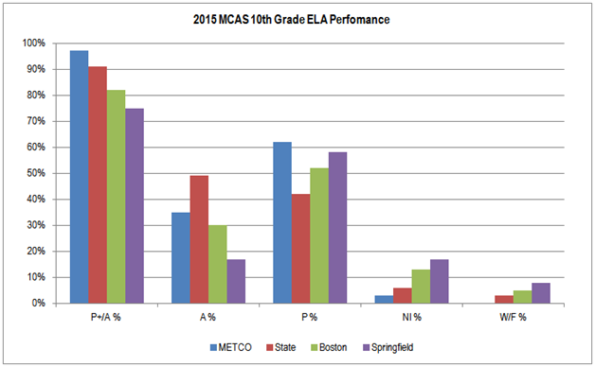
Source: Massachusetts Department of Elementary and Secondary Education, 2015 MCAS Assessment file

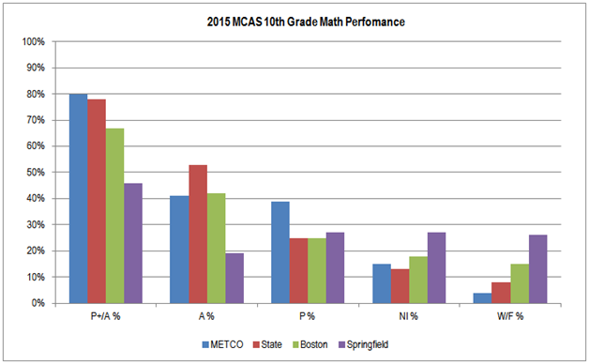
Source: Massachusetts Department of Elementary and Secondary Education, 2015 MCAS Assessment file

8

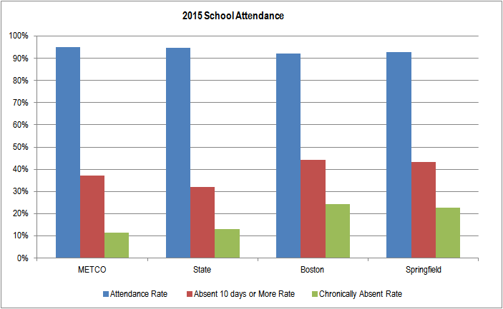
Source: Massachusetts Department of Elementary and Secondary Education, Student Information Management System (SIMS)

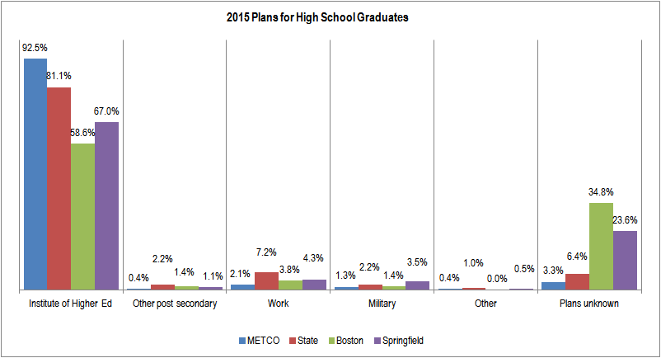
Source: Massachusetts Department of Elementary and Secondary Education, Student Information Management System (SIMS)

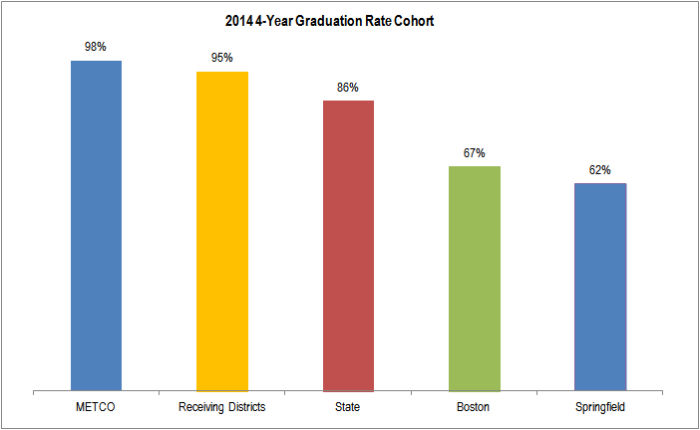
Source: Massachusetts Department of Elementary and Secondary Education, Student Information Management System (SIMS)

School District Expenditure of Funds
 | Total | Administration | Professional | Support | Other Fringe | Contractual | Supplies | Travel | Other | Indirect
 | Grant |  | Staff | Staff | Benefits | Services | Materials |  | Cost | Costs
Arlington P. S. | $361,764.00 | $73,379.00 | $64,421.00 | $51,721.00 |  | $8,744.00 | $5,525.00 | $2,073.00 | $155,901.00
Bedford P.S. | $533,162.00 | $57,846.93 | $87,931.94 | $49,918.06 |  | $45,880.03 | $1,628.94 | $1,170.00 | $288,306.00
Belmont P.S. | $497,826.00 | $88,430.04 | $152,117.00 | $68,091.00 | $47,672.88 |  | $146.75 | $585.00 | $140,783.33
Braintree P.S. | $204,179.00 | $42,361.00 | $16,629.00 | $33,898.26 | $2,769.74 |  |  | $975.00 | $107,546.00
Brookline P.S. | $1,269,296.00 | $122,538.00 | $557,690.00 | $206,853.00 | $12,000.00 | $23,550.00 | $3,500.00 | $3,300.00 | $322,430.00 | $17,435.00
Cohasset P.S. | $247,747.00 | $70,288.92 |  | $27,004.08 |  |  |  | $1,176.71 | $149,277.29
Concord P.S. | $459,613.00 | $40,376.00 | $85,327.00 | $229,397.00 |  | $3,000.00 |  |  | $101,513.00
East Longmeadow P.S. | $245,059.00 |  | $168,528.00 |  |  |  |  |  | $76,531.00
Foxboro P.S. | $238,662.00 | $41,524.00 | $70,594.00 | $41,964.98 |  |  |  |  | $84,579.02
Hingham P.S. | $196,289.00 | $53,199.90 | $16,789.10 | $15,265.89 |  | $2,292.00 | $1,497.33 | $1,205.00 | $106,039.78
Lexington P.S. | $1,285,898.00 | $183,168.00 | $313,843.00 | $243,481.00 |  | $1,006.00 | $5,000.00 | $1,500.00 | $537,900.00
Lincoln P.S. | $440,397.00 | $25,000.00 | $222,065.00 | $21,850.00 |  | $3,500.00 | $1,413.00 |  | $166,569.00
Longmeadow P.S. | $194,885.00 | $3,000.00 | $76,175.00 | $36,862.00 |  |  | $3,000.00 |  | $75,848.00
Lynnfield P.S. | $210,382.00 | $59,421.96 | $26,367.20 | $28,452.88 |  | $1,560.00 | $2,049.03 |  | $92,530.93
Marblehead P.S. | $418,671.00 | $89,438.12 | $35,534.28 | $25,427.26 | $31,268.21 | $21,684.44 | $14,284.73 | $1,417.38 | $199,616.58
Melrose P.S. | $599,255.00 | $78,079.00 | $250,000.00 | $76,807.20 |  | $4,725.00 | $70.00 | $4,439.00 | $185,134.00
Natick P.S. | $300,705.00 | $57,692.97 | $98,544.48 |  | $8,217.44 |  | $280.45 | $999.54 | $134,970.12
Needham P.S. | $797,308.00 | $103,946.82 | $172,111.83 | $183,737.97 |  | $15,103.71 | $13,717.09 | $2,410.05 | $293,162.53 | $13,118.00
Newton P.S. | $2,093,671.00 | $104,524.08 | $944,460.73 | $133,272.85 | $80,595.52 | $6,293.82 | $3,744.20 | $725.00 | $820,054.80
Reading P.S. | $358,161.00 | $70,999.95 | $93,489.67 |  |  | $6,271.15 | $1,177.10 | $3,953.03 | $182,270.10
Scituate P.S. | $366,145.00 | $81,610.88 | $50,000.00 | $21,465.92 | $6,860.20 |  | $7,920.00 |  | $198,288.00
Sharon P.S. | $383,676.00 | $90,246.26 | $60,759.11 | $29,889.96 |  | $8,263.00 | $4,037.43 | $2,145.00 | $188,335.24
Springfield P.S. | $40,000.00 | $25,502.38 |  | $3,140.65 | $5,364.97 | $2,182.50 | $1,978.22 |  | $482.00 | $1,349.28
Sudbury P.S. | $395,269.00 | $39,231.36 | $19,562.50 | $179,651.86 |  |  | $9,940.12 |  | $146,883.16
Swampscott P.S. | $359,882.00 | $55,000.00 | $156,470.00 | $28,457.00 |  |  |  |  | $119,955.00
Wakefield P.S. | $244,126.00 | $67,232.10 |  | $31,966.50 |  | $16,714.70 | $2,690.45 | $1,043.65 | $124,478.60
Walpole P.S. | $269,100.00 | $76,048.00 | $61,773.00 |  | $8,000.00 |  |  | $987.00 | $122,292.00
Wayland P.S. | $625,911.00 | $94,976.96 | $269,876.98 | $71,303.62 |  |  | $2,388.12 | $5,712.84 | $181,652.48
Wellesley P.S. | $781,066.00 | $114,205.00 | $219,418.00 | $80,155.00 | $68,746.00 |  | $5,144.00 | $200.00 | $293,198.00
Weston P.S. | $842,370.00 | $60,250.00 | $487,380.00 | $26,516.00 |  |  |  |  | $268,224.00
Westwood P.S. | $211,674.00 | $86,557.12 | $38,903.18 |  |  |  |  | $200.00 | $78,699.87
Concord-Carlisle RSD | $344,719.00 | $60,564.00 | $82,096.00 | $34,918.00 |  | $22,500.00 | $13,363.00 | $5,000.00 | $126,278.00
Dover-Sherborn RSD | $186,883.00 | $72,828.00 |  | $17,402.01 | $1,029.36 |  | $491.63 |  | $95,132.00
Hampden-Wilbraham  RSD | $128,030.00 | $2,757.06 | $77,496.94 |  |  |  |  |  | $47,776.00
Lincoln-Sudbury RSD | $433,856.00 | $39,232.00 | $87,582.00 | $5,000.00 |  | $32,420.00 | $38,470.00 | $3,500.00 | $206,152.00 | $21,500.00
Southwick/Tolland RSD | $123,172.00 |  | $71,420.00 |  |  |  |  |  | $51,752.00
 | $16,688,809.00 | $2,331,455.81 | $5,135,355.94 | $2,003,870.95 | $272,524.32 | $225,690.35 | $143,456.59 | $44,717.20 | $6,470,540.83 | $53,402.28
Source: Massachusetts Department of Elementary and Secondary Education
11

