Low-Income Student Calculation Study
Pursuant to Section 165 of Chapter 133 of the Acts of 2016
February 2017
Massachusetts Department of Elementary and Secondary Education
75 Pleasant Street, Malden, MA 02148-4906
Phone 781-338-3000 TTY: N.E.T. Relay 800-439-2370
www.doe.mass.edu

This document was prepared by the
Massachusetts Department of Elementary and Secondary Education
Mitchell D. Chester, Ed.D.
Commissioner

Board of Elementary and Secondary Education Members
Mr. Paul Sagan, Chair, Cambridge
Mr. James Morton, Vice Chair, Boston
Ms. Katherine Craven, Brookline
Dr. Edward Doherty, Hyde Park
Dr. Roland Fryer, Concord
Ms. Margaret McKenna, Boston
Mr. Michael Moriarty, Holyoke
Dr. Pendred Noyce, Boston
Mr. James Peyser, Secretary of Education, Milton
Ms. Mary Ann Stewart, Lexington
Mr. Nathan Moore, Chair, Student Advisory Council, Scituate

Mitchell D. Chester, Commissioner
Secretary to the Board

The Massachusetts Department of Elementary and Secondary Education, an affirmative action employer, is committed to ensuring that all of its programs and facilities are accessible to all members of the public.
We do not discriminate on the basis of age, color, disability, national origin, race, religion, sex, gender identity, or sexual orientation.

Inquiries regarding the Department’s compliance with Title IX and other civil rights laws may be directed to the
Human Resources Director, 75 Pleasant St., Malden, MA 02148-4906. Phone: 781-338-6105.

© 2017 Massachusetts Department of Elementary and Secondary Education
Permission is hereby granted to copy any or all parts of this document for non-commercial educational purposes. Please credit the “Massachusetts Department of Elementary and Secondary Education.”

This document printed on recycled paper

Massachusetts Department of Elementary and Secondary Education
75 Pleasant Street, Malden, MA 02148-4906
Phone 781-338-3000 TTY: N.E.T. Relay 800-439-2370
www.doe.mass.edu

Table of Contents
Legislative Charge 1
Acknowledgements 1
Background 2
The New Economically Disadvantaged Metric 3
Statistical comparisons 7
Other programmatic impacts 12
Alternative approaches in other states 14
Recommendations 16
Endnotes 18

Legislative Charge
The Department of Elementary and Secondary Education (ESE) respectfully submits this Report to the Legislature pursuant to section 165 of chapter 133 of the acts of 2016 (the FY17 general appropriations act):
“SECTION 165. The department of elementary and secondary education, in consultation with the executive office for administration and finance and the executive office of health and human services, shall conduct a study on the calculation of low-income students within public school districts as it relates to determining the number of low-income students in the distribution of funding pursuant to chapters 70 and 76 of the General Laws. The study may include, but not be limited to:
(i) the current methodology for determining low-income students and alternatives for adjusting the methodology based on best practices in other states;
(ii) the possible effects of adjusting the methodology, including overall low-income student counts, projected low-income counts for school districts and both foundation budget and state funding level impacts for school districts;
(iii) measures to identify eligible low-income students who qualify under the current methodology but who would not qualify under any proposed alternatives;
(iv) the effects of adjusting the methodology on school building authority reimbursement rates;
(v) data that is currently collected that could be used to identify low-income students;
(vi) considerations of eligible low-income students identified through programs such as the Supplemental Nutrition Assistance Program, transitional assistance for families with dependent children, the department of children and families' foster care program and the MassHealth program;
(vii) identification of all relevant data fields currently collected within each of the applicable databases in the commonwealth and determine additional data needed in each of the databases that would improve the ability of the systems to generate successful direct certification matches including, but not limited to, expanded use of the State Assigned Student Identifier and additional name fields and recommendations for implementing any necessary changes to data fields included in the databases;
(viii) recommended methods to ensure that direct certification shall include all applicable commonwealth programs;
(ix) determination of the steps necessary to identify matches within the Medicaid database;
(x) analysis of the format in which data are received and reviewed by schools and school districts and the procedures used by schools and school districts to review the data to determine ways to simplify procedures for direct certification and the resolution of partial matches at the local level; and
(xi) policies adopted by other states in the implementation of the Community Eligibility Provision of the Healthy, Hunger-Free Kids Act of 2010, Public Law 111-296, as it relates to the calculation of low-income or economically-disadvantaged students in a state funding formula.
The report, and any accompanying recommendations, shall be filed with the house and senate committees on ways and means not later than December 19, 2016.”

Acknowledgements

We gratefully acknowledge the assistance and advice of our colleagues at the Executive Office of Education and the Executive Office of Health and Human Services. Sincere thanks, too, to the many public school administrators and other stakeholders who have given of their time and expertise in helping us to work through the challenges of this project. Finally, we express our appreciation to the Massachusetts Budget and Policy Center for their in-depth analyses of this issue, which have helped to inform our work.

Background

The National School Lunch Program (NSLP) was enacted by Congress in 1946 to provide free or subsidized school meals to low income students. Students from families with a household income of less than 133% of the federal poverty level qualify for free meals; students from families with a household income between 133% and 185% of the federal poverty level qualify for reduced price meals. For many students, eligibility is established via application forms submitted by parents. In recent years, school districts have been able to establish eligibility for some students based on their families’ participation in other social support programs, such as the Supplemental Nutrition Assistance Program (SNAP, formerly known as “food stamps”).

Because of the widespread adoption and popularity of the NSLP, eligibility for free and reduced price school meals (FRP) has become the de facto measure of the number of “low income” students enrolled in each school. Over many years it has provided a consistent and uniform metric across the nation, and for that reason it has been widely used in research studies and other reports.

This measure took on added importance for Massachusetts schools in 1993, with the enactment of the Education Reform Act. This legislation established a new system for funding schools, designed to ensure that every district received adequate funding regardless of the city or town’s wealth. A foundation budget is established annually for each district, based in large part on the demographics of the students in that district. As part of this calculation, districts receive additional funding based on the number of low income students they serve, recognizing that these students typically require additional resources and support to succeed. For the poorer cities and towns in the Commonwealth, this low income increment – based on the number of FRP students – has resulted in significant increases in education funding.

We would still be using FRP as our low income measure today if it weren’t for the enactment of the Healthy, Hunger-Free Kids Act by Congress in 2010. Under this legislation, if a school, group of schools, or district could identify at least 40% of its students as eligible for free meals, then it could elect to provide free meals to all of its students, without the need to verify every individual student’s eligibility. This new program, known as the Community Eligibility Provision (CEP), offers many benefits to participating schools: it eliminates the need to collect and process paper applications, it eliminates the need to collect and account for lunch money, it speeds up cafeteria service, and most importantly, it has been shown to significantly increase student participation in the school breakfast and school lunch programs.

We know that students learn better when they have access to nutritious meals, so ESE has encouraged eligible schools to participate in the CEP program. Since its inception, the number of participating Massachusetts schools has increased steadily. This year, nearly 240,000 students in 500 schools – roughly one quarter of our statewide enrollment – are receiving free school meals through CEP. Not all eligible schools are participating yet, so this number may continue to rise in future years.

But CEP’s success created an unintended consequence. With so many students participating, eligibility for free and reduced price lunches was no longer an accurate measure of low income status. The next section discusses the new metric developed to replace FRP.

The New Economically Disadvantaged Metric

In developing recommendations for a new metric in response to federal changes, ESE evaluated several alternative approaches to measuring poverty. Factors considered included the degree to which each approach could be measured accurately; whether it could be consistently applied across both CEP and non-CEP districts; whether it increased or decreased district reporting requirements; and whether it provided data at the student and school level as well as the district level.

Beginning with the 2014-15 school year, ESE began electronically matching student names and birthdates in its Student Information Management System (SIMS) with databases maintained by the Executive Office of Health and Human Services (EOHHS) for SNAP, the Transitional Aid for Families with Dependent Children program (TAFDC), and certain Medicaid programs within the broader MassHealth system. The match process also includes children who are in guardianship or foster care through the Department of Children and Families, are under the custody of the Department of Youth Services, or are severely disabled and receiving Supplemental Security Income through the Social Security Administration. Those students who were successfully matched are identified in SIMS as “economically disadvantaged.”

This process is similar to the direct certification process used by districts to establish FRP eligibility under NSLP. But in this case the matching process is conducted by ESE staff for the entire state. In effect, it relies on the income verifications conducted by the social service agencies, rather than asking school districts to duplicate that work.

The matching process conducted during the 2014-15 school year identified 251,026 students as economically disadvantaged, representing 26.3% of total state enrollment. This compared with 365,885 students (38.3%) identified the previous year as low income, using the FRP standard. This decrease had been anticipated and was the result of several factors:

- The assistance programs selected for this matching process have an eligibility threshold at or near 133% of the federal poverty level, corresponding to the free lunch eligibility standard under NSLP. This was the primary factor and is discussed further, below.
- Some low income families are not eligible for social assistance programs, due to their immigration status.
- Some low income families that are eligible for social assistance programs do not apply, because they are not familiar with the programs or for other reasons.
- Transcription and data entry errors can prevent the matching of names between databases.

The FY15 economically disadvantaged data was not used for any programmatic purposes. Over the next two years, work was done to improve the process:

- ESE and EOHHS staff worked to improve the matching algorithms. For example, the search process now accounts for more variations in students’ names across state systems, such as last names with hyphens in one system (“Davis-Smith”) but not in another (“Davis Smith”); variations in date of birth, such as the month and year being transposed (e.g., May 6, 2005 coded as 5/6/05 or as 6/5/05); or variations in spelling, such as the letter s substituting for letter z.
- The matching process was repeated four times over the course of a year, to avoid missing students who might have dropped off of program eligibility for short periods of time.
- Many districts also began exploring ways to help families sign up for the assistance programs for which they were eligible.

Using FY16 school enrollment data and the new metric, ESE calculated the economically disadvantaged component of the statewide foundation enrollment at 312,203. This figure was used in the FY17 Chapter 70 calculations. It has further increased to 314,776 in the preliminary FY18 Chapter 70 calculations, based on FY17 school enrollment data.

Even with these improvements, the economically disadvantaged metric still identified fewer students than the old low income metric. In response, the FY17 budgets filed by both the Governor and the Legislature adjusted the Chapter 70 foundation budget rates for FY17 to significantly increase the per pupil low income increments. This rate adjustment was made to ensure that the foundation budget measure of the additional resources needed to educate poor children did not shift downward simply because of a change in the metric used to count the overall number of such children.

In FY16, the last year before this change, the low income increment was $3,474 for each elementary student and $2809 for each secondary student. FY17 saw the introduction of a progressive set of rates, which assigned more weight to students attending districts with higher concentrations of poverty. These increments ranged from $3,775 per student to $4,135 per student, with the higher rates applied to districts with higher concentrations of poverty. For the overwhelming majority of districts, the higher rates fully compensated for the lower student numbers, with districts receiving as much or more in Chapter 70 aid than they would have received using the old FRP standard. In FY16, the state-wide low income increment was $1.237 billion, or 12.3% of the total foundation budget. In FY17, the economically disadvantaged increment was $1.292 billion, or 12.8% of the total foundation budget. The overall increase in the poverty component of the foundation budget was more than $55 million. Similarly, at the state level, and for most districts, the change in metrics did not adversely affect Chapter 70 aid.

In a small number of districts, however, the increased rates did not fully compensate for the lower number of students identified under the new metric as compared to the old. In 10 districts, the new metric would have reduced Chapter 70 aid by $100,000 or more; in another 23 districts, the reduction in Chapter 70 aid was less than $100,000. To ameliorate this impact, these 33 districts received additional Chapter 70 aid in FY17 to hold them harmless through this transition. The hold harmless amounts will be added to base aid for these districts for FY18 and beyond.

Change in Eligibility Threshold

The change in the eligibility threshold from 185% under FRP to 133% was the largest reason for the lower number of identified students under the economically disadvantaged metric, so it is important to understand the reasoning that informed that decision. Families living under 133% of the federal poverty line are eligible for a wide range of state assistance services, and the vast majority of these households sign up for and receive those benefits. By using multiple programs tied to this threshold – SNAP, TAFDC, and certain components of MassHealth – we can obtain consistent and uniform data across the state, thus promoting greater equity in comparing districts’ foundation budgets and state aid needs.

Families with incomes up to 185% poverty may be eligible for state assistance, but the participation rates are much more variable. Of the programs for which we can access enrollment, only MassHealth has eligibility thresholds at these higher levels. But as income levels increase, families are more likely to receive health insurance from their employers. This is illustrated in the figure below, which presents Medicaid participation rates by county for children under 137 percent of poverty and those between 137 and 199 percent of poverty, based on 2015 poverty threshold data available through the U.S. Census.
Figure 1. Children with Medicaid or other means-tested health insurance, by Massachusetts county
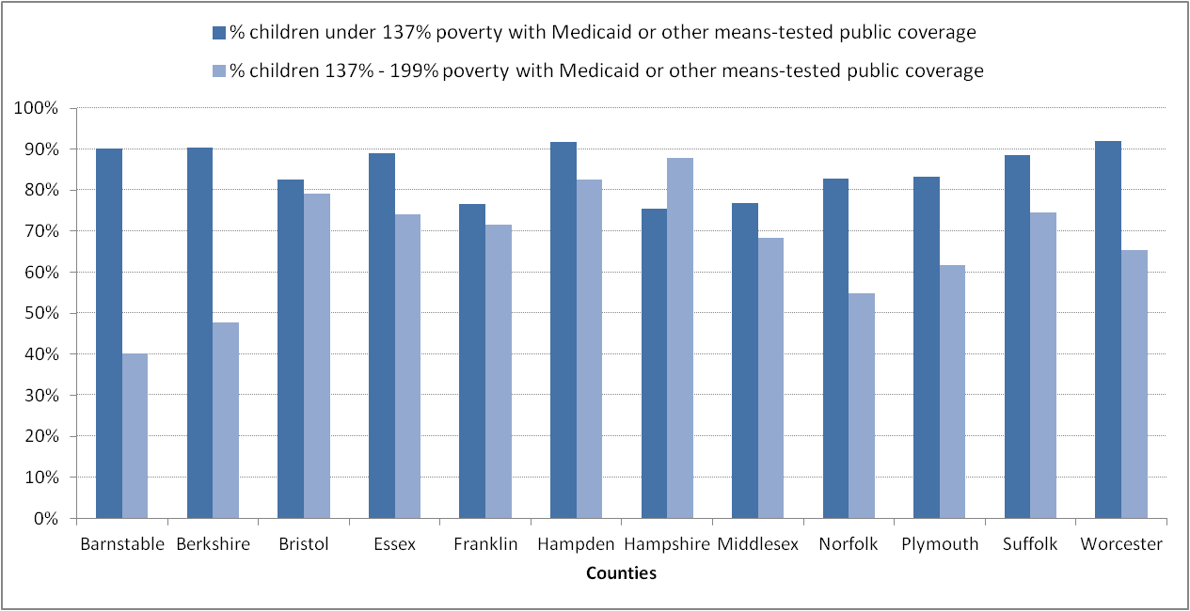
Source: U.S. Census, American Community Survey, one year estimates, 2015
It can be seen that participation rates are much more uniform at the lower income levels, and even these differences are further smoothed by the addition of other assistance programs. Up to the 137% poverty level, participation rates ranged from 75 percent to just over 90 percent. At the next level – 137% to 199% – the participation rate had much more variation, with a low of 40 percent to just under 90 percent. The greater variability in participation rates for children at the higher income levels would result in significant distributional inequities among school districts if used as the basis for calculating foundation budgets in the Chapter 70 school aid formula.

Regardless of the selected threshold level, it is impossible to design a measurement tool that will capture one hundred percent of the targeted population. Even the well-regarded FRP measure did not capture every eligible student. Not all students who were eligible for FRP applied for it, and districts varied in their level of effort in encouraging enrollment. It has also been noted that as students progressed through higher grades, they were less likely to apply for FRP because of the perceived social stigma. The economically disadvantaged matching process, while not identifying as many students overall as FRP did in the past, has identified several thousand students who were not identified as low-income under FRP.

Statistical comparisons

The Chapter 70 formula is intended to be a progressive formula both in the definition of need (foundation budgets) and in the level of state aid. The result is that poor districts have relatively higher per pupil spending requirements from state and local sources and also receive a greater share of that required spending from the state than do wealthier districts. Below we compare the overall progressivity of the formula before and after the change in poverty measures. In the chart below, school districts are stratified into ten deciles, based on their poverty rates. In the lowest decile, less than nine percent of students are identified as low-income. In the highest decile, more than 47 percent are low-income. Despite the decreases in the overall counts of economically disadvantaged students, the Commonwealth provided more aid to all school districts in FY17 than in previous years. Under the new funding structure, the districts in the highest poverty decile received on average approximately $8,000 per pupil in state aid, or $6,000 more per pupil than the lowest poverty districts. At the state level, we can see that the change in the low-income measure has not negatively affected the progressivity of the formula.

Figure 2. Average state aid per pupil, by decile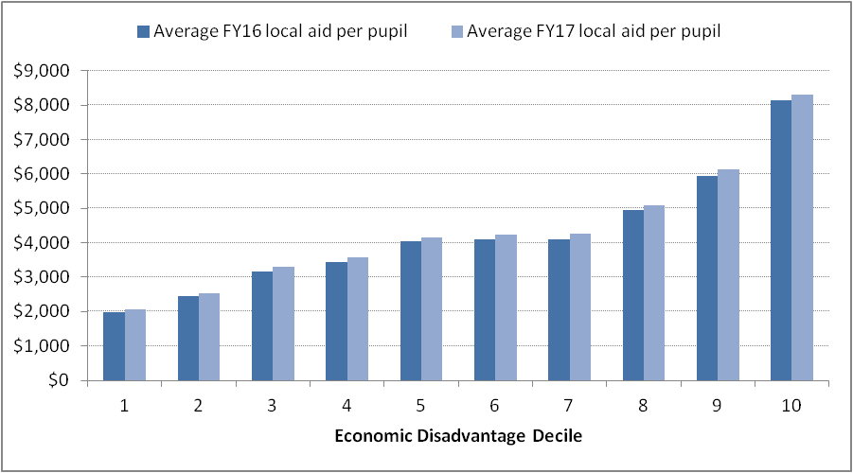

We now look at three student subgroups which school leaders have identified as being potentially under-represented in the economically disadvantaged measure. To the degree that these subgroups tend to be clustered in particular districts, rather than distributed uniformly throughout the state, they might explain why a small number of districts have been disproportionately affected by the new measure. Because the new measure is based on a threshold of 133% of the Census poverty level, we compare data to the number of previously reported students eligible for free lunch under NSLP.

Homeless students. At the beginning of the 2015-16 school year, there were just over 21,000 students reported as homeless, or approximately 2.2% of total state enrollment. As shown in the table below, two-thirds of these students come from just thirteen districts, while most districts report only a few homeless students.

Figure 3. Number of homeless students by district, for districts with the largest populations of such students
District | Number of Homeless Students | % of Total Enrollment
Boston | 3,908 | 7.3%
Worcester | 3,198 | 12.8%
Springfield | 1,574 | 6.2%
Lynn | 995 | 6.6%
New Bedford | 636 | 5.0%
Holyoke | 573 | 10.7%
Lowell | 567 | 4.0%
Brockton | 515 | 3.0%
Framingham | 494 | 5.8%
Fitchburg | 428 | 8.2%
Leominster | 423 | 7.0%
Fall River | 373 | 3.7%
Chicopee | 262 | 3.4%
All other LEAs | 7,280
State total | 21,226

Being homeless can describe a variety of experiences. The McKinney-Vento Homeless Assistance Act defines students who are homeless as “individuals who lack a fixed, regular, and adequate nighttime residence.” Students who are homeless might lack stable housing for just a few days, or sleep in cars or shelters; most are homeless multiple times in their lives.

By and large, these students also live in poverty. In FY16, approximately 85 percent were identified as economically disadvantaged, an identification rate consistent with historical levels based on free lunch eligibility. The similar identification rates under free lunch and economically disadvantaged is seen across all levels of district poverty, as shown in the next figure.

Figure 4. Identification rates of homeless students as free-lunch eligible or economically disadvantaged
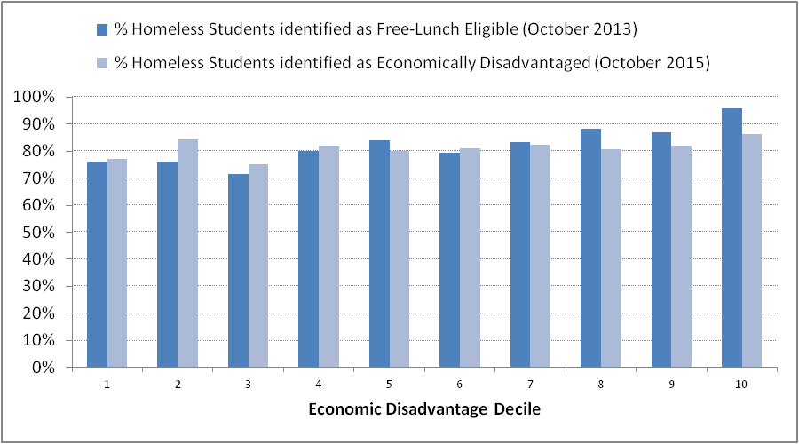

These data suggest that the change from FRP to economically disadvantaged has not introduced a significant bias with respect to the identification and counting of homeless students as living under the 133% threshold.

Children of migrant workers. Special services to children whose parents are “migratory agricultural workers and fishers” are funded through a federal grant and are provided by one of the state’s education collaboratives. Unlike many states, the number of reported children in this category is extremely small – 280 in the most recent count. In past years, under FRP, more than ninety percent were identified as low income, while less than half have been identified as economically disadvantaged. This difference possibly reflects difficulties faced by transient residents in applying for state assistance programs. The extremely low numbers would indicate an insignificant effect on foundation budgets at the district level.

Recent immigrants. A third subgroup identified for study by school leaders are students from families that have recently immigrated to the United States. Within this group are three distinct populations:
- students who have a visa permitting them to reside in the U.S.;
- students who have been legally admitted to the U.S. as a refugee; and
- students who have no documentation permitting them to legally reside in the U.S.

At the beginning of the 2015-16 school year, there were approximately 26,600 recent immigrant students, or 2.8% of total statewide enrollment. Sixty percent of recent immigrants attend one of 12 districts, as shown in the table below.

Figure 5. Number of recent immigrant students by district, for districts with the largest populations of such students
District | Number of Recent Immigrants | % of Total Enrollment
Boston | 3,800 | 7.1%
Lawrence | 2,600 | 19.0%
Worcester | 1,500 | 6.0%
Brockton | 1,400 | 8.2%
Lynn | 1,200 | 7.9%
Chelsea | 1,100 | 17.4%
Lowell | 1,000 | 7.1%
Revere | 700 | 9.8%
Brookline | 700 | 9.1%
Cambridge | 600 | 9.1%
Springfield | 600 | 2.4%
Everett | 600 | 8.4%
All other LEAs | 10,800
State total | 26,600
Data rounded to nearest hundred

In the figure below, we compare the free lunch and economically disadvantaged identification rates for the origin countries with the largest populations of students in the Commonwealth.

Figure 6. Identification rates of recent immigrant students as free-lunch eligible or economically disadvantaged, by country of origin
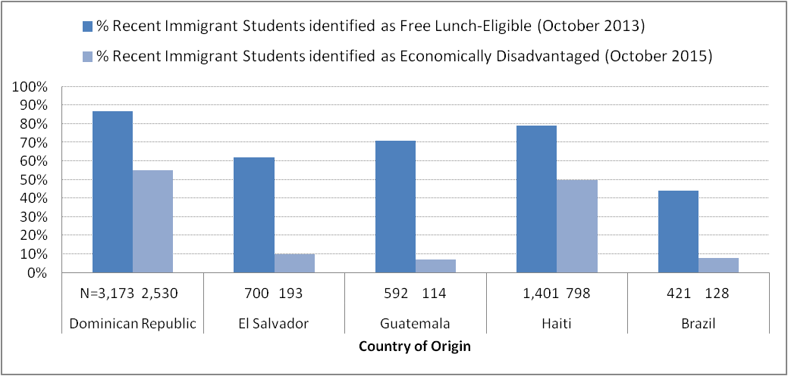

We estimate that there are in the order of 7,500 recent immigrant students who qualified for free lunch benefits but who were not identified as economically disadvantaged through the new direct certification process. School administrators have suggested that this drop-off in identification rates is in large part concentrated in the second and third groups cited above, namely refugees and undocumented immigrants. Such families are often either ineligible for state assistance programs or, even if they are eligible, reluctant to apply for benefits for fear of jeopardizing their immigration status. ,

To the degree that refugees and undocumented immigrants are disproportionately undercounted in the current economically disadvantaged model, and to the degree that these populations are disproportionately concentrated in a small number of districts, it is reasonable to assume that it creates some systemic bias. Because ESE does not currently collect data identifying students who are either refugees or undocumented immigrants, we cannot provide a definitive estimate of its impact.

Documentation on refugees who have entered the country legally is potentially available through the controlling federal agencies and possibly the Massachusetts Office for Refugees and Immigrants. More research is needed to determine how complete and accessible such data might be. By definition, undocumented immigrants provide an even greater challenge to identify.

Other programmatic impacts

In this section we review briefly how the economically disadvantaged metric relates to programs and activities other than Chapter 70.

Federal grants – For the most part, the U.S. Department of Education uses Census data rather than FRP for calculating grant entitlements. Where FRP is used, CEP schools can use the same formula they now use to calculate NSLP reimbursements.
Foundation grants – Many grant programs from foundations and other private sources consider the number of low-income students in a school or district, as defined by NSLP eligibility, as part of their application process. Some of these programs have already made adjustments in their eligibility criteria to reflect the adoption of CEP, but not all have. ESE has asked districts to bring these instances to our attention, and we will work with the funders to educate them regarding these measurement changes and ensure that our CEP schools and districts are not disadvantaged in the application process.

Charter school tuition – Tuition rates for Commonwealth charter schools are based on the same foundation budget calculations as are used for the Chapter 70 formula, so they are similarly affected by changes in the low income student counts and corresponding changes in the low income per student increments. Charter schools' relatively smaller size compared to districts also means they are more sensitive to fluctuations in the identification approach. For these reasons, efforts to improve the process by which economically disadvantaged students are identified, as discussed above and later in the Recommendations section, will also benefit the charter tuition rate calculations.

In FY17, a hold harmless provision was applied to charter tuition rates in those cities and towns that received hold harmless protection for their Chapter 70 aid. However, charter schools do not benefit from the “base aid” provisions that protect traditional districts from year-to-year losses in chapter 70 aid and are therefore much more vulnerable to revenue swings arising from swings in low income increments. There are a number of factors in addition to the foundation budget that affect year-to-year changes in tuition revenues for Commonwealth charters and, therefore, the relative importance of each is often difficult to determine

School building assistance – Reimbursement rates under the Commonwealth's school building assistance (SBA) program are determined in part by each district's poverty level. The Massachusetts School Building Authority, in consultation with ESE, has continued to use the FY15 low-income data (based on NSLP eligibility) which aligns with the statutory SBA rates. As noted later in this report, we recommend that the Legislature eventually recalibrate these rates to align with the new economically disadvantaged measure, so that reimbursements will be based on the most recent data available.

School and district accountability – Under both state and federal law, the academic performance of low-income students is one of the required elements in assessing how well our schools and districts are educating our children. The Commonwealth's school and district accountability is currently undergoing a major redesign, to accommodate the legal requirements of the recently-enacted federal Every Student Succeeds Act, to reflect the introduction of the next-generation MCAS student assessments, and to draw upon the lessons learned in our current accountability system. This redesign will allow us to make any needed recalibrations.

Individual students – It is important to emphasize that the identification of students as “low income” or “economically disadvantaged” for purposes of state aid and statistical reporting does not affect any individual student's eligibility for any particular educational program or service. Individual students who were previously identified as low-income but who are not identified as economically disadvantaged do not suddenly lose access to any tangible benefits. There are, of course, district-determined benefits that are tied to family income levels, such as school bus fee or sports fee waivers. The determination of eligibility for these benefits continues to be a local decision. Most districts and schools in the Commonwealth do not participate in CEP, and they continue to collect income applications to determine eligibility for subsidized school meals.

Alternative approaches in other states

Many states are continuing to use the NSLP eligibility standard for free and reduced price meals as their low-income measure for school funding purposes. This approach will generally require the use of a state-mandated income verification form in CEP schools for students who are not identified through any type of direct certification process. For example, districts in California participating in CEP are required to collect alternative forms to identify low-income students who are not already identified through the direct certification process or who do not meet other eligibility criteria (such as homeless or migrant students). Families may not receive any direct benefit from completing these state-mandated income verification forms, unlike the NSLP application form which established eligibility for free or reduced price school meals. So it remains to be seen what the response rate for these forms will be, particularly among recent immigrants and other groups that may be reluctant to share personal information. Low response rates in some districts could create even larger distributional inequities than we have experienced with our approach.

Another approach is to use community-level measures, such as poverty data from the U.S. Census. Community-level measures can provide valid information about differences in poverty levels across districts, but by their very definition, they cannot provide information about individual students. In addition, there are many school districts within the Commonwealth that do not align with Census regions, so even community-level Census data would not directly correspond to school district child poverty rates. We are aware of only one state – Ohio – that currently uses U.S. Census data to determine state aid for low-income students.

Several states use the count of students attending federally funded Title I schools or receiving Title I-funded supports. However, this measure leaves out low-income students who attend non-Title I schools. Connecticut, Montana and North Carolina use this approach.

Some states include children in their low-income counts based on category membership, without any other income verification. For example, the District of Columbia and Michigan include homeless children, while Michigan also includes migrants and recent immigrant children among other groups.

It does not appear that any state currently uses household income data collected for income tax purposes. Aside from privacy issues, the biggest drawback to this approach is that some families earn so little that they are not required to file tax returns.

At least four states in addition to Massachusetts are relying primarily on data from state assistance programs for the purpose of determining state aid. While other states have begun that practice more recently, Illinois has been doing so since 2004. Each year, that state’s Department of Human Services identifies the total count of students receiving benefits from SNAP, TANF, Medicaid and the Children’s Health Insurance Program and provides that data to the Illinois State Board of Education, which the agency uses to calculate general aid to schools. As in Massachusetts, Illinois relies on direct certification to determine eligibility for free meals. Though there are still qualified students who are not yet matched, Illinois has substantially improved their matching process over time to better identify all students who are qualified.

Other states that use some variation of this process include the District of Columbia and Vermont, which use SNAP, and Indiana, which uses some state-wide health programs in their direct certification process for state aid. A recent report also recommended that Connecticut adopt a direct certification-based approach that would include the state Medicaid program for children.

It is clear that states are still adjusting to the consequences of CEP adoption. We are also just starting to see significant effort on the part of academic researchers in studying the advantages and disadvantages of these various approaches. The multiple measures that states have adopted will likely create reporting anomalies when it is aggregated at the national level. For this reason, we can expect that at some point in the future, the federal government will attempt to reintroduce a national standard. The U.S. Department of Education has published several research reports on this topic and continues to study the issue, but it has given no indication when it might promulgate new standards.

Recommendations

Continue efforts to improve the matching process.

ESE and EOHHS should continue to work collaboratively to improve the process used to match student names between the two agencies’ respective databases. In particular, work should continue on incorporating ESE’s student identifiers (SASIDs) into the EOHHS databases to the greatest extent practicable, to minimize the errors associated with the alphanumeric matching of names and birthdates. Having SASIDs on file will expedite and improve the accuracy of future matches, even if a student moves to another school district.

EOHHS is also engaging in a multi-year project to better align data across several components of MassHealth, which should facilitate improved matching of student data with MassHealth records. At the time of publication, these enhancements are being tested for use with ESE’s direct certification processes.

Consideration should also be given to embedding an ESE data analyst at EOHHS, to facilitate data analysis and reporting and programming enhancements.

Expand efforts to enroll eligible families in state assistance programs.

Ensuring that families are enrolled in the state assistance programs for which they are eligible has a two-fold benefit: the families receive needed services, and the children who are enrolled in public schools will be included in the low-income counts. Many districts are already engaged in efforts to encourage these families to apply for benefits, just as in the past they encouraged enrollment in the NSLP. ESE and EOHHS should work together to expand these efforts, making sure that all schools have appropriate information and tools to proactively reach out to families.

Establish a workgroup to study issues relating to refugees and undocumented immigrants.

As noted earlier in this report, it seems likely that students in these two groups are undercounted in the economically disadvantaged model. At the same time, these students face challenges that go beyond simply being poor and having limited English proficiency. In many cases they have had inadequate schooling in their home countries. They may have experienced trauma and instability as they traveled through other countries and attended schools in different refugee camps. They face cultural and language barriers on their arrival here.

To address these issues, the task force should consider:
- whether there are feasible methods to collect and verify data on these populations;
- whether the educational needs of these populations warrant a funding increment beyond what is already provided for economically disadvantaged students; and
- whether any such incremental funding for these populations would be best provided through changes to the Chapter 70 formula, through foundation reserve (“pothole”) assistance, or through a dedicated grant program.

Evaluate the feasibility of a unified matching process.

As noted earlier, the matching process used to identify economically disadvantaged students for Chapter 70 differs somewhat from the process used by ESE for statistical reporting and the process used by districts for school lunch certification. ESE should evaluate whether it would be beneficial to the state and to districts to adopt a common process for all three purposes.

Recalibrate the school building assistance funding formula to reflect the new low-income methodology.

The statutory school building assistance funding formula, administered by the Massachusetts School Building Authority, currently contains a Community Poverty Factor based upon the old free- and reduced-price lunch metric. At some point the Legislature will need to amend this statute to align with the economically disadvantaged metric. In the short term, while additional improvements are studied for the new metric, the Authority can continue to use FY14 FRP data to establish project reimbursement rates.

Continue to monitor academic research on the subject of low-income measurement.

As states experiment with and adopt different approaches to measuring student poverty, we expect that there will be significant work on the part of researchers to study these various models. ESE should monitor and, as appropriate, participate in this work, with the expectation that at some point there will be an effort to reach consensus on a new standard.

Endnotes

Commonwealth of Massachusetts, “FY 2017 Budget Summary - Outside Section 165: Low-Income Student Calculation Study,” http://www.mass.gov/bb/gaa/fy2017/os_17/h165.htm (last accessed November 2016)
N. Wagman and L. Shuster, “Counting Kids at School: 6 Steps to Better Numbers,” Massachusetts Budget and Policy Center, November 2016, http://massbudget.org/report_window.php?loc=Counting-Kids-at-School.html (last accessed November 2016).
United States Department of Agriculture, Food and Nutrition Service, “National School Lunch Program,” http://www.fns.usda.gov/nslp/national-school-lunch-program-nslp (last accessed December 2016).
St. 1993, c.71
Massachusetts Department of Elementary and Secondary Education, “School Finance: Chapter 70 Program,” http://www.doe.mass.edu/finance/chapter70/ (last accessed November 2016)
See for example: Greg J. Duncan and others, “School Readiness and Later Achievement,” Developmental Psychology, 43(6), 1428-1446, http://steinhardt.nyu.edu/scmsAdmin/uploads/001/777/7%20Schiool%20readiness%20and%20later%20achievement%20-%20Duncan%20et%20al%202007.pdf (last accessed November 2016). Sean Reardon, “The Widening Academic Achievement Gap Between the Rich and the Poor: New Evidence and Possible Explanations,” July 2011 https://cepa.stanford.edu/sites/default/files/reardon%20whither%20opportunity%20-%20chapter%205.pdf Greg Duncan and Katherine Magnuson, “The Nature and Impact of Early Achievement Skills, Attention and Behavior Problems,” prepared for conference on “Rethinking the Role of Neighborhoods and Families on Schools and School Outcomes for American Children,” November 2009, http://education.uci.edu/docs/Duncan_Magnuson_Brookings_Merged.pdf (last accessed November 2016)
Healthy Hunger-Free Kids Act of 2010, Public Law 111-296 (2010).
Massachusetts Department of Elementary and Secondary Education, “Low-Income vs. Economically Disadvantaged,” July 2015, http://www.doe.mass.edu/infoservices/data/ChangingMetric.pdf (last accessed November 2016).
The term “economically disadvantaged” is used to distinguish the data from the old “low income” reporting category based on FRP.
FY16 chapter 70 calculations were based on low income data from FY14.
The matching process currently used by ESE for statistical purposes, and the matching process used by districts to certify FRP eligibility, both differ from the matching process described here for use with the Chapter 70 formula. Differences include the social service programs against which the names are matched and the timing of the matches. In the Recommendations section, we consider the possibility of consolidating these processes in the future.
The concept of increasing the low income increment as poverty concentration increases was discussed by the recent Foundation Budget Review Commission. See Foundation Budget Review Commission, “Final Report,” October 2015, http://www.mass.gov/legis/journal/desktop/2015/fbrc.pdf (last accessed December 2016)
See Matthew M. Chingos, “No more free lunch for education policymakers and researchers,” June 2016, https://www.brookings.edu/wp-content/uploads/2016/06/free-and-reduced-lunch3.pdf (last accessed December 2016).
The analyses in this section are based on the FY16 enrollment numbers, as the FY17 enrollment numbers were only recently reported.
In part, the increase in state aid reflects increases in the Chapter 70 foundation budget due to the higher per student rates that accompanied the switch to the economically disadvantaged measure.
The McKinney Vento Homeless Assistance Act, 42 U.S.C. 11431 et seq., Section 725(2).
Erin S. Ingram, John M. Bridgeland, Bruce Reed, and Matthew Atwell (Civic Enterprises and Hart Research Associates), “Hidden in Plain Sight: Homeless Students in America’s Public Schools,” http://www.gradnation.org/sites/default/files/HiddeninPlainSightFullReportFINAL_0.pdf (last accessed November 2016).
Massachusetts Department of Elementary and Secondary Education, “Migrant Education,” http://www.doe.mass.edu/ssce/migrant.html (last accessed December 2016)
Consistent with federal reporting guidelines, ESE defines recent immigrant students as students who have attended school in the United States for no more than three years.
Based on ESE analysis of free-lunch-eligible student percentages from the beginning of the 2013-14 school year, by country of origin.
This is consistent with other research on the major countries of origin for undocumented immigrants. See, for example, Migration Policy Institute, “Profile of the Unauthorized Population,” (2014) http://www.migrationpolicy.org/data/unauthorized-immigrant-population/state/MA, which estimates that the largest populations of undocumented immigrants in Massachusetts come from Brazil, Guatemala, El Salvador, China, and the Dominican Republic.
Patricia Baker and Victoria Negus (MassLegalHelp.org), “Food Stamp/SNAP Advocacy Guide: General Eligibility Rules: Am I eligible if I am a legal immigrant,” http://www.masslegalhelp.org/income-benefits/food-stamps/advocacy-guide/part2/q44-legal-immigrant-eligibility (last accessed November 2016).
One of the few state assistance programs available to immigrant families is MassHealth Limited, which provides emergency medical care for children. Enrollment typically occurs only if and when a child needs medical attention, and enrollment expires after a relatively short period of time. This limits its usefulness as a consistent indicator of student poverty.
The U.S. Department of Agriculture permits CEP schools to apply a multiplier to the percentage of directly certified and categorically eligible students. The multiplier, currently 1.6, is determined annually by USDA and can range between 1.3 and 1.6.
Horace Mann charter schools are funded via a budget allocation from the sponsoring district, so they were not directly affected by the change in the metric.
Mass. G.L. c.70B, §10.
Every Student Succeeds Act of 2015, Public Law 114-95 (2015).
Robert G. Croninger, Jennifer King Rice, and Laura Checovich, “Alternative Indicators of Low-Income Students, School Funding Formulas and the Community Eligibility Provision of the Healthy, Hungry-Free Kids Act,” Prepared paper for the annual meeting of the Association for Education Finance and Policy, March 2016, https://aefpweb.org/sites/default/files/webform/41/Poverty%20measures%20paper-AEFP%202016%20FINAL.pdf (last accessed November 2016)
California Department of Education, “Local Control Funding Formula - LCFF Frequently Asked Questions: Unduplicated Pupils at Schools with Provision 2 and 3 or Community Eligibility Provision (CEP) Status,” http://www.cde.ca.gov/fg/aa/lc/lcfffaq.asp#PROV2and3 (last accessed November 2016) California Department of Education, “Community Eligibility Provision,” http://www.cde.ca.gov/ls/nu/sn/cep.asp (last accessed November 2016).
Croninger et al.
Croninger et al.
Croninger et al.
Croninger et al.
Croninger et al.
Croninger et al. https://aefpweb.org/sites/default/files/webform/41/Poverty%20measures%20paper-AEFP%202016%20FINAL.pdf (last accessed November 2016)
Illinois Compiled Statutes c. 105, section 5/18-8.05, http://ilga.gov/legislation/ilcs/fulltext.asp?DocName=010500050K18-8.05 (last accessed November 2016)
Illinois State Board of Education, Nutrition and Wellness Programs Division, “School Nutrition Programs Administrative Handbook School Year 2016-17,” http://www.isbe.net/nutrition/sbn_handbook/admin-handbook-2016-17.pdf (last accessed December 2016).
Phone calls with Illinois State Board of Education, October and November 2016.
Connecticut School Finance Project, “Achieving a Better Proxy for Low-Income Students in Connecticut: An analysis of methods and programs to replace free and reduced price lunch eligibility as a means to identify low-income students,” http://ctschoolfinance.org/assets/uploads/files/Better-Proxy-for-Low-Income-Students-in-CT.pdf (last accessed November 2016)
See, for example, Matthew M. Chingos, “No More Free Lunch for Education Policymakers and Researchers,” http://educationnext.org/no-more-free-lunch-for-education-policymakers-researchers/ (last accessed January 2017).
See, for example, “Forum Guide to Alternative Measures of Socioeconomic Status in Education Data Systems,” https://nces.ed.gov/pubs2015/2015158.pdf (last accessed December 2016)
Letter from Daniel Tsai, Assistant Secretary of Health and Human Services for MassHealth, to the House and Senate Clerks, October 2, 2015, http://www.mass.gov/eohhs/docs/masshealth/research/legislature-reports/integrated-eligibility-implementation-plan-10-02-15.pdf (last accessed November 2016)
Julie Sugarman, Simon Morris-Lange, and Margie McHugh (Migration Policy Institute),“Improving Education for Migrant-Background Students: A Transatlantic Comparison of School Funding,” http://www.migrationpolicy.org/research/improving-education-migrant-background-students-transatlantic-comparison-school-funding (last accessed November 2016)
Sugarman et al. Also see, Sarah Dryden-Peterson (Migration Policy Institute), “The Educational Experiences of Refugee Children in Countries of First Asylum,” http://www.migrationpolicy.org/research/educational-experiences-refugee-children-countries-first-asylum (last accessed November 2016).

