2017 METCO Program Report
Report on the impact of the grant program on student outcomes, the expenditure of funds by districts, and the extent to which the services rendered by Metropolitan Council for Educational Opportunity support the goals of the grant program.

May 2018
Massachusetts Department of Elementary and Secondary Education
75 Pleasant Street, Malden, MA 02148-4906
Phone 781-338-3000 TTY: N.E.T. Relay 800-439-2370
www.doe.mass.edu

This document was prepared by the
Massachusetts Department of Elementary and Secondary Education
Jeffrey C. Riley, Commissioner

Board of Elementary and Secondary Education Members
Mr. Paul Sagan, Chair, Cambridge
Ms. Katherine Craven, Brookline
Mr. Edward Doherty, Hyde Park
Ms. Amanda Fernández, Belmont
Ms. Margaret McKenna, Boston
Mr. Michael Moriarty, Holyoke
Mr. James Morton, Vice Chair, Springfield
Mr. James Peyser, Secretary of Education, Milton
Ms. Mary Ann Stewart, Lexington
Ms. Hannah Trimarchi, Chair, Student Advisory Council, Marblehead
Dr. Martin West, Newton

Jeffrey C. Riley, Commissioner and Secretary to the Board

The Massachusetts Department of Elementary and Secondary Education, an affirmative action employer, is committed to ensuring that all of its programs and facilities are accessible to all members of the public.
We do not discriminate on the basis of age, color, disability, national origin, race, religion, sex, gender identity, or sexual orientation.
Inquiries regarding the Department’s compliance with Title IX and other civil rights laws may be directed to the
Human Resources Director, 75 Pleasant St., Malden, MA 02148-4906. Phone: 781-338-6105.

© 2018 Massachusetts Department of Elementary and Secondary Education
Permission is hereby granted to copy any or all parts of this document for non-commercial educational purposes. Please credit the “Massachusetts Department of Elementary and Secondary Education.”

This document printed on recycled paper

Massachusetts Department of Elementary and Secondary Education
75 Pleasant Street, Malden, MA 02148-4906
Phone 781-338-3000 TTY: N.E.T. Relay 800-439-2370
www.doe.mass.edu

Table of Contents
Introduction 1
METCO Overview 2
2017-2018 Referral and Placement to Districts 3
Transportation Department 5
METCO Student Outcomes 6
School Districts Expenditure of Funds 9

Introduction

The Department of Elementary and Secondary Education (Department) respectfully submits this Report to the Legislature pursuant to Chapter 182 of the Acts of 2008, line item 7010- 0012:

“For grants to cities, towns and regional school districts for payments of certain costs and related expenses for the program to eliminate racial imbalance, established under section 12A of chapter 76 of the General Laws; provided, that funds shall be made available for payment for services rendered by the Metropolitan Council for Educational Opportunity (METCO) Inc. and Springfield public schools; provided further, that all grant applications submitted to and approved by the department of elementary and secondary education shall include a detailed line item budget specifying how such funds shall be allocated and expended; and provided further, that the department of elementary and secondary education shall submit a report on the impact of the grant program on student outcomes, the expenditure of funds by districts, and the extent to which the services rendered by METCO, Inc. support the goals of the grant program to the joint committee on education and the house and senate committees on ways and means not later than December 1, 2017…..”

METCO Overview

Metropolitan Council for Educational Opportunity (METCO) Inc. has a contract with the Department to support participating districts and have been the service provider for over fifty years with the primary role of providing direct services to participating students, families and school districts. The districts provide a broad based educational program for all students, and METCO, Inc. provides additional options for tutorial programs, enrichment, remedial and referral services for METCO students in need of additional support.

The METCO program serves as the Boston based central office for all Boston METCO parents, students and the general public requesting information about the program. When schools are in session, METCO is open from six-thirty in the morning until eight o’clock at night. and some Saturdays from 10:00 a.m. – 1:00 p.m. for specific purposes. They provide meeting space for parent groups, the MPLC (METCO Parent Legislative Committee) and the alumni association and maintain and monitor the waiting list for interested families. There have been 858 students added to the waiting list this year and currently, there are approximately 8,485 students on the waiting list.

The Department is pleased to begin working with METCO, Inc.’s new chief executive officer, Milagros (Milly) Arbaje-Thomas, who started her new role in February 2018, and the METCO, Inc. board of directors, as the organization outlines new strategic goals.

New Applicants on Waiting List During the Period July 1, 2016 – June 30, 2017

Breakdown by Race

Total Students - 858
African American | 485
Asian | 57
Caucasian | 16
Hispanic | 216
Native American | 0
Other | 56
Undesignated | 28

Breakdown by Grade

Grade | Number Registered | Grade | Number Registered
PK | 494 | 5 | 28
K | 66 | 6 | 31
1 | 39 | 7 | 28
2 | 25 | 8 | 20
3 | 29 | 9 | 27
4 | 29 | 10-12 | 42

Active Waitlist as of June 30, 2017 – Breakdown by Race

Total Students on Active Waiting list – 8,485
African American | 5,089
Asian | 371
Caucasian | 90
Hispanic | 2,102
Native American | 39
Other | 615
Undesignated | 179

Active Waitlist as of June 30, 2017 – Breakdown by Grade

Grade | Number  Registered | Grade | Number  Registered
PK | 1,014 | 5 | 740
K | 582 | 6 | 679
1 | 559 | 7 | 683
2 | 581 | 8 | 669
3 | 631 | 9 | 719
4 | 713 | 10-12 | 915

2017-2018 Referral and Placement to Districts

METCO’s placement process for the 2017-2018 year began in October 2016 when parents of children who had been referred but had not been placed were asked to update their child’s referral/placement packet.

In late November and December mailings went out to parents of students on the waiting list in grades K-9 inviting them to an information session. Fifteen sessions were conducted with over 581 parents attending.

In June 2017, 587 placement packets folders were referred to districts and as of July 2017, 174 of those students were placed in districts.
Demographic Report 2017-2018
Org Code | District Name | Total | Fem. | Male | AA | Asian | Hisp. | Multi-race | Native Amer. | Native Haw. | White | K | 1 | 2 | 3 | 4 | 5 | 6 | 7 | 8 | 9 | 10 | 11 | 12
0010 | Arlington | 76 | 34 | 42 | 65 | 4 | 7 | 0 | 0 | 0 | 0 | 3 | 0 | 3 | 8 | 6 | 10 | 4 | 10 | 5 | 8 | 6 | 7 | 6
0023 | Bedford | 98 | 53 | 45 | 80 | 0 | 15 | 1 | 0 | 0 | 2 | 6 | 6 | 7 | 6 | 7 | 5 | 8 | 8 | 10 | 6 | 7 | 12 | 10
0026 | Belmont | 102 | 52 | 50 | 67 | 2 | 22 | 9 | 0 | 0 | 2 | 8 | 1 | 6 | 7 | 7 | 10 | 4 | 9 | 7 | 10 | 11 | 12 | 10
0040 | Braintree | 24 | 11 | 13 | 16 | 0 | 7 | 1 | 0 | 0 | 0 | 0 | 1 | 1 | 2 | 2 | 3 | 4 | 1 | 2 | 2 | 1 | 5 | 0
0046 | Brookline | 292 | 165 | 127 | 186 | 11 | 73 | 17 | 0 | 0 | 5 | 33 | 24 | 24 | 20 | 18 | 20 | 21 | 21 | 20 | 31 | 26 | 18 | 16
0065 | Cohasset | 47 | 34 | 13 | 38 | 0 | 3 | 3 | 1 | 0 | 2 | 4 | 5 | 4 | 5 | 2 | 4 | 4 | 3 | 3 | 2 | 3 | 3 | 5
0067 | Concord | 78 | 42 | 36 | 59 | 1 | 17 | 1 | 0 | 0 | 0 | 10 | 7 | 8 | 7 | 7 | 5 | 14 | 10 | 10 | 0 | 0 | 0 | 0
0078 | Dover | 8 | 4 | 4 | 8 | 0 | 0 | 0 | 0 | 0 | 0 | 2 | 0 | 0 | 1 | 3 | 2 | 0 | 0 | 0 | 0 | 0 | 0 | 0
0087 | East Longmeadow | 42 | 25 | 17 | 23 | 1 | 15 | 2 | 0 | 0 | 1 | 5 | 3 | 2 | 2 | 2 | 1 | 6 | 4 | 3 | 2 | 5 | 3 | 4
0099 | Foxborough | 37 | 24 | 13 | 28 | 0 | 8 | 0 | 1 | 0 | 0 | 0 | 0 | 0 | 0 | 0 | 5 | 4 | 5 | 2 | 3 | 8 | 3 | 7
0131 | Hingham | 42 | 20 | 22 | 30 | 0 | 11 | 0 | 0 | 0 | 1 | 0 | 3 | 3 | 7 | 1 | 1 | 9 | 3 | 2 | 4 | 1 | 3 | 5
0155 | Lexington | 219 | 127 | 92 | 164 | 6 | 43 | 6 | 0 | 0 | 0 | 8 | 21 | 17 | 25 | 24 | 14 | 28 | 6 | 22 | 14 | 14 | 10 | 16
0157 | Lincoln | 84 | 44 | 40 | 43 | 2 | 37 | 2 | 0 | 0 | 0 | 7 | 14 | 11 | 11 | 8 | 9 | 9 | 5 | 10 | 0 | 0 | 0 | 0
0159 | Longmeadow | 34 | 16 | 18 | 22 | 0 | 9 | 3 | 0 | 0 | 0 | 5 | 4 | 3 | 2 | 4 | 3 | 4 | 0 | 2 | 1 | 2 | 1 | 3
0164 | Lynnfield | 35 | 15 | 20 | 25 | 0 | 9 | 1 | 0 | 0 | 0 | 1 | 3 | 3 | 4 | 3 | 3 | 4 | 3 | 1 | 2 | 3 | 4 | 1
0168 | Marblehead | 74 | 37 | 37 | 58 | 0 | 14 | 2 | 0 | 0 | 0 | 0 | 1 | 5 | 6 | 4 | 3 | 10 | 8 | 5 | 7 | 7 | 8 | 10
0178 | Melrose | 127 | 72 | 55 | 102 | 0 | 19 | 6 | 0 | 0 | 0 | 0 | 6 | 2 | 4 | 14 | 8 | 21 | 12 | 6 | 8 | 14 | 15 | 17
0198 | Natick | 53 | 30 | 23 | 35 | 1 | 13 | 3 | 0 | 1 | 0 | 0 | 0 | 0 | 0 | 0 | 3 | 3 | 6 | 12 | 6 | 8 | 8 | 7
0199 | Needham | 177 | 107 | 70 | 88 | 10 | 66 | 12 | 0 | 0 | 1 | 11 | 23 | 21 | 16 | 18 | 12 | 13 | 10 | 4 | 5 | 18 | 11 | 15
0207 | Newton | 431 | 226 | 205 | 258 | 28 | 114 | 28 | 0 | 0 | 3 | 19 | 34 | 41 | 40 | 40 | 37 | 21 | 27 | 36 | 41 | 46 | 26 | 22
0246 | Reading | 66 | 34 | 32 | 58 | 0 | 7 | 1 | 0 | 0 | 0 | 3 | 1 | 10 | 4 | 8 | 7 | 11 | 3 | 3 | 4 | 6 | 5 | 1
0264 | Scituate | 65 | 35 | 30 | 51 | 1 | 11 | 2 | 0 | 0 | 0 | 3 | 1 | 6 | 6 | 5 | 7 | 4 | 5 | 9 | 7 | 5 | 6 | 1
0266 | Sharon | 60 | 31 | 29 | 33 | 3 | 19 | 2 | 0 | 1 | 2 | 0 | 3 | 4 | 3 | 4 | 1 | 7 | 4 | 6 | 6 | 7 | 7 | 8
0269 | Sherborn | 10 | 8 | 2 | 8 | 0 | 1 | 1 | 0 | 0 | 0 | 1 | 0 | 4 | 1 | 2 | 2 | 0 | 0 | 0 | 0 | 0 | 0 | 0
0288 | Sudbury | 67 | 35 | 32 | 52 | 0 | 13 | 2 | 0 | 0 | 0 | 0 | 7 | 9 | 9 | 10 | 10 | 9 | 10 | 3 | 0 | 0 | 0 | 0
0291 | Swampscott | 54 | 24 | 30 | 33 | 0 | 17 | 1 | 2 | 0 | 1 | 0 | 0 | 1 | 2 | 3 | 7 | 3 | 4 | 6 | 9 | 4 | 9 | 6
0305 | Wakefield | 70 | 40 | 30 | 42 | 3 | 22 | 1 | 0 | 1 | 1 | 0 | 4 | 7 | 0 | 2 | 9 | 8 | 6 | 4 | 9 | 6 | 7 | 8
0307 | Walpole | 42 | 29 | 13 | 28 | 0 | 11 | 0 | 0 | 0 | 3 | 0 | 4 | 6 | 3 | 1 | 4 | 2 | 3 | 1 | 5 | 5 | 6 | 2
0315 | Wayland | 136 | 73 | 63 | 110 | 3 | 13 | 6 | 0 | 2 | 2 | 3 | 5 | 8 | 9 | 18 | 15 | 11 | 11 | 10 | 14 | 15 | 6 | 11
0317 | Wellesley | 157 | 87 | 70 | 120 | 2 | 18 | 14 | 1 | 0 | 2 | 8 | 11 | 18 | 14 | 11 | 18 | 7 | 5 | 13 | 8 | 18 | 9 | 17
0330 | Weston | 161 | 89 | 72 | 110 | 2 | 33 | 9 | 0 | 1 | 6 | 12 | 14 | 15 | 12 | 12 | 15 | 11 | 10 | 13 | 10 | 13 | 10 | 14
0335 | Westwood | 49 | 25 | 24 | 41 | 0 | 6 | 2 | 0 | 0 | 0 | 0 | 0 | 0 | 0 | 0 | 0 | 7 | 13 | 7 | 7 | 8 | 4 | 3
0640 | Concord-Carlisle | 52 | 25 | 27 | 39 | 0 | 10 | 3 | 0 | 0 | 0 | 0 | 0 | 0 | 0 | 0 | 0 | 0 | 0 | 0 | 15 | 12 | 11 | 14
0655 | Dover-Sherborn | 23 | 12 | 11 | 23 | 0 | 0 | 0 | 0 | 0 | 0 | 0 | 0 | 0 | 0 | 0 | 0 | 3 | 6 | 2 | 3 | 4 | 4 | 1
0680 | Hampden-Wilbraham | 14 | 10 | 4 | 9 | 0 | 4 | 1 | 0 | 0 | 0 | 0 | 0 | 0 | 0 | 1 | 1 | 0 | 0 | 4 | 5 | 0 | 0 | 3
0695 | Lincoln-Sudbury | 91 | 53 | 38 | 57 | 1 | 28 | 3 | 1 | 1 | 0 | 0 | 0 | 0 | 0 | 0 | 0 | 0 | 0 | 0 | 22 | 21 | 21 | 27
0766 | Southwick-Tolland-Granville Regional School District | 19 | 10 | 9 | 17 | 0 | 0 | 1 | 0 | 0 | 1 | 1 | 1 | 2 | 1 | 2 | 2 | 2 | 1 | 2 | 1 | 1 | 2 | 1
 | Total | 3216 | 1758 | 1458 | 2226 | 81 | 715 | 146 | 6 | 7 | 35 | 153 | 207 | 251 | 237 | 249 | 256 | 276 | 232 | 245 | 277 | 305 | 256 | 271

Transportation Department

METCO provides and executes the administration of contracts with bus companies for fourteen school districts. Terms of the bid specifications and contracts are monitored for quality performance of the vendor to each school district.

The school districts are:

- Arlington
- Belmont
- Braintree
- Cohasset
- Dover/Sherborn
- Hingham
- Foxboro
- Lexington
- Lincoln
- Lincoln/Sudbury
- Natick
- Scituate
- Sudbury
- Walpole

Bus vendors are expected to supply quality service and are monitored for fiscal and operational compliance. The management services include monitoring timely service on a daily basis for both a.m. and p.m. trips, work with the Business Manager to review invoices for accuracy, “field” telephone inquiries and problem solve. They are also expected to meet and communicate with bus company management personnel as necessary. In addition, they enforce disciplinary codes for safe riding and meet or communicate with school district personnel and METCO Directors.

METCO Student Outcomes
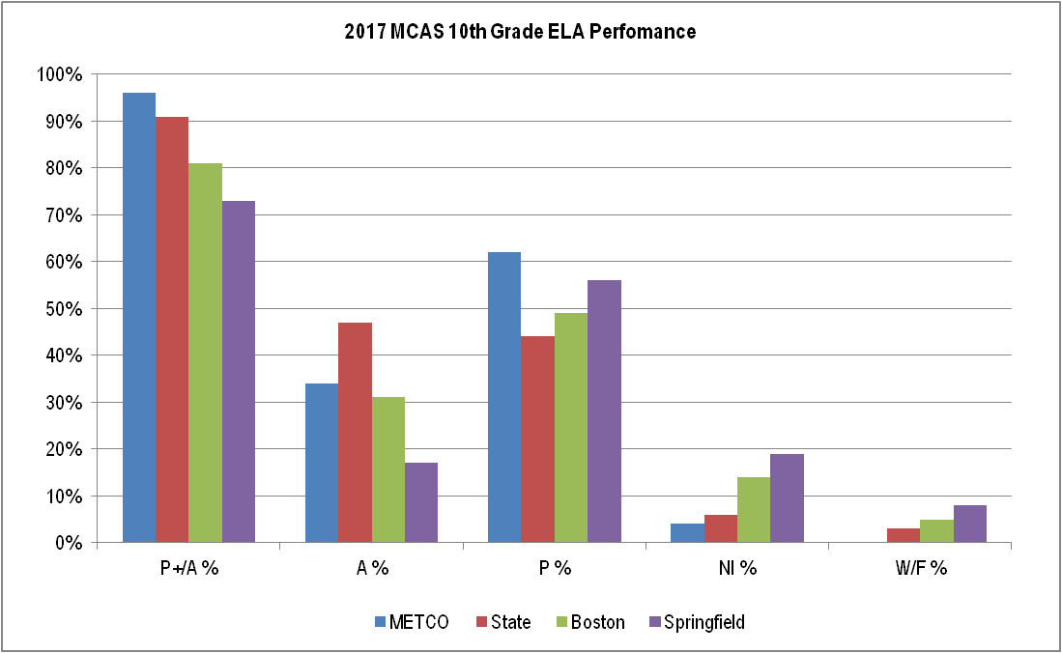
Source: Massachusetts Department of Elementary and Secondary Education, 2017 MCAS Assessment file
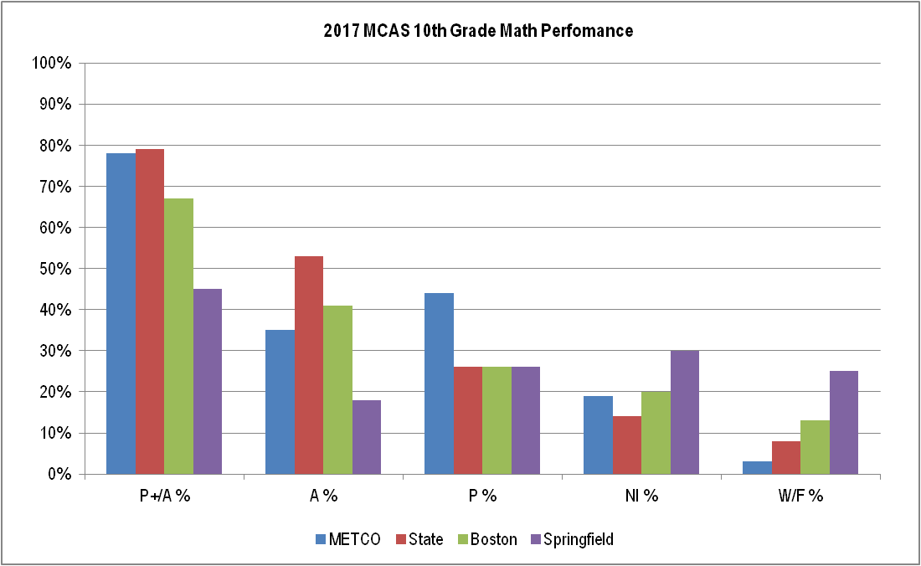
Source: Massachusetts Department of Elementary and Secondary Education, 2017 MCAS Assessment file

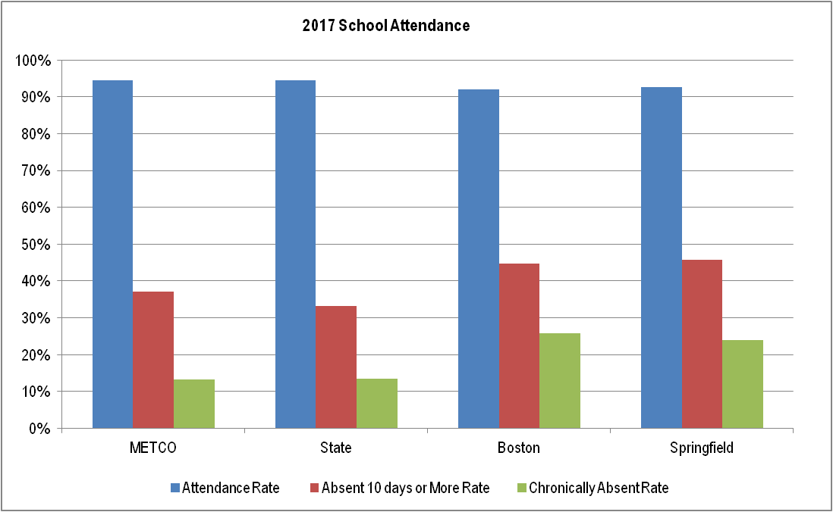
Source: Massachusetts Department of Elementary and Secondary Education, Student Information Management System (SIMS)

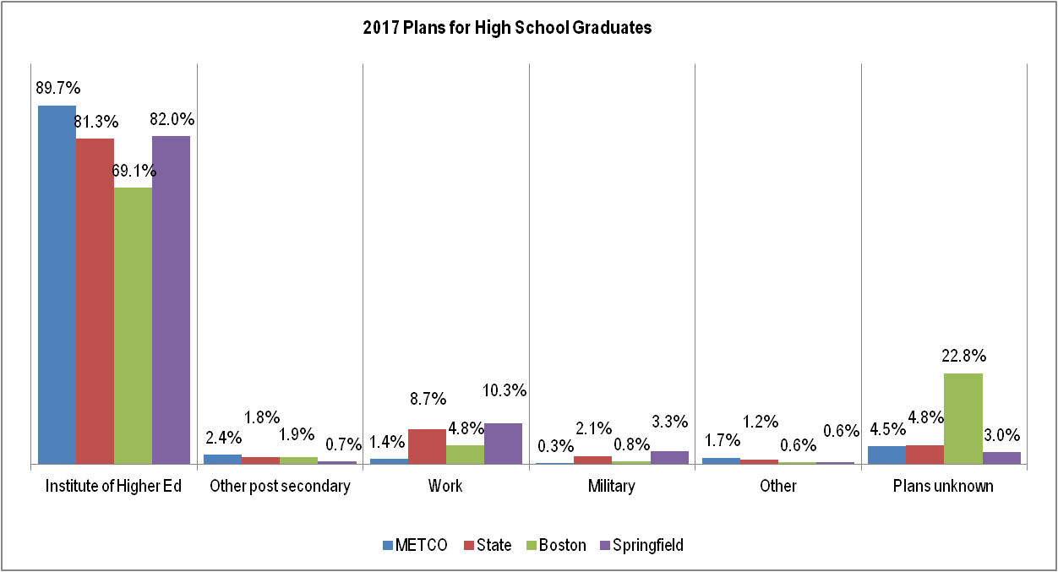
Source: Massachusetts Department of Elementary and Secondary Education, Student Information Management System (SIMS)

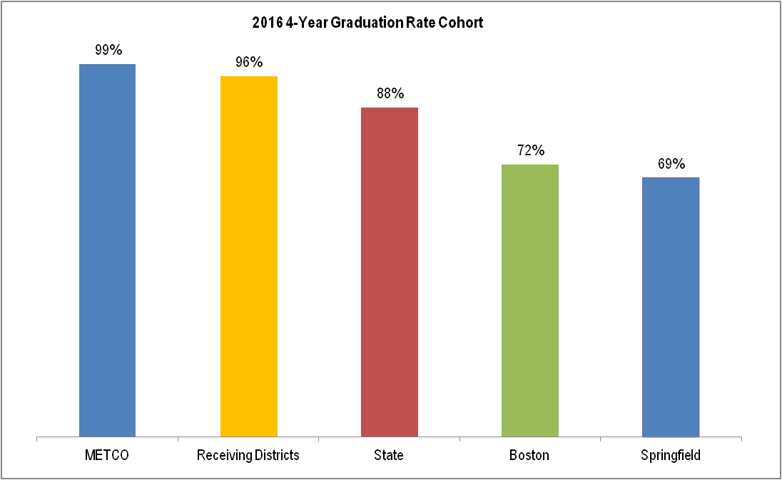
Source: Massachusetts Department of Elementary and Secondary Education, Student Information Management System (SIMS)

School Districts Expenditure of Funds
FY17 Fund Use | Admin | Professional | Support | Fringe | Contract | Supplies | Travel | Other | Indirect | Total
 |  | Staff | Staff | Benefits | Services | Materials |  | Cost | Costs | Grant
Arlington P. S. | 91,575 | 94,045 | 56,278 |  | 16,806 | 3,100 | 2,750 | 170,100 |  | 434,654
Bedford P.S. | 129,739 | 30,000 | 66,827 |  | 62,388 | 3,788 | 4,006 | 306,417 |  | 603,165
Belmont P.S. | 95,678 | 154,224 | 81,948 | 33,901 |  | 204 | 600 | 180,800 |  | 547,355
Braintree P.S. | 51,672 |  | 32,798 |  | 1,596 | 733 |  | 108,796 |  | 195,595
Brookline P.S. | 125,817 | 690,219 | 204,179 |  | 59,300 | 7,393 | 4,724 | 397,862 | 17,435 | 1,506,929
Cohasset P.S. | 80,969 | 32,452 |  |  | 3,350 | 676 | 943 | 160,550 |  | 278,940
Concord P.S. | 50,000 | 114,221 | 201,629 |  |  |  |  | 138,599 |  | 504,449
East Longmeadow P.S. | 159,010 |  |  |  |  | 500 |  | 80,367 |  | 239,877
Foxboro P.S. | 43,017 | 77,041 | 38,477 |  |  |  |  | 84,575 |  | 243,110
Hingham P.S. | 61,000 | 20,514 | 20,592 |  | 5,900 | 3,500 | 4,500 | 111,057 |  | 227,063
Lexington P.S. | 122,642 | 394,552 | 279,635 |  | 8,730 | 17,775 | 13,050 | 721,220 |  | 1,557,604
Lincoln P.S. | 51,875 | 199,453 | 55,419 |  | 7,128 | 3,400 |  | 201,559 |  | 518,834
Longmeadow P.S. | 3,000 | 81,292 | 38,354 |  |  | 1,300 |  | 87,164 |  | 211,110
Lynnfield P.S. | 20,765 | 67,621 |  |  | 3,600 |  |  | 142,960 |  | 234,946
Marblehead P.S. | 93,713 | 114,331 | 26,780 | 16,000 | 15,000 | 5,319 | 1,500 | 215,272 |  | 487,915
Melrose P.S. | 124,000 | 221,000 | 60,553 |  | 21,000 | 1,000 | 38,100 | 240,460 |  | 706,113
Natick P.S. | 79,326 | 91,982 | 825 | 20,000 | 1,000 | 2,900 | 335 | 150,500 |  | 346,868
Needham P.S. | 235,698 | 84,266 | 255,301 |  | 40,330 | 45,486 | 3,095 | 336,421 | 12,870 | 1,013,467
Newton P.S. | 117,799 | 1,241,482 | 165,756 | 86,955 | 15,425 | 4,000 | 4,000 | 869,931 |  | 2,505,348
Reading P.S. | 76,458 | 100,000 | 7,000 |  | 4,519 | 700 | 4,050 | 217,353 |  | 410,080
Scituate P.S. | 85,116 | 97,000 | 13,697 |  | 1,000 |  | 6,160 | 214,464 |  | 417,437
Sharon P.S. | 63,953 | 76,287 | 16,927 |  | 44,270 | 24,003 | 4,600 | 203,636 |  | 433,676
Springfield P.S. | 26,663 |  | 3,644 | 6,152 | 2,000 | 2,995 |  | 1,500 | 1,499 | 44,453
Sudbury P.S. | 47,380 | 8,603 | 178,955 |  | 21,051 | 4,337 | 2,721 | 187,997 |  | 451,044
Swampscott P.S. | 56,000 | 173,355 | 38,000 |  |  | 5,000 |  | 144,803 |  | 417,158
Wakefield P.S. | 75,000 |  | 30,800 |  | 29,900 |  | 6,950 | 161,334 |  | 303,984
Walpole P.S. | 86,033 | 89,808 |  | 10,000 |  | 802 |  | 88,615 |  | 275,258
Wayland P.S. | 101,211 | 308,040 | 70,812 |  | 19,594 | 6,512 | 8,421 | 228,437 |  | 743,027
Wellesley P.S. | 121,878 | 228,303 | 116,921 | 86,159 | 9,910 | 5,414 | 1,009 | 346,539 |  | 916,133
Weston P.S. | 62,457 | 587,465 | 41,128 |  |  |  |  | 267,754 |  | 958,804
Westwood P.S. | 90,054 |  | 40,643 |  | 6,051 | 28,826 | 525 | 82,334 |  | 248,433
Concord-Carlisle RSD | 75,000 | 80,809 | 38,907 |  | 21,500 | 20,000 | 3,619 | 148,901 |  | 388,736
Dover-Sherborn RSD | 75,771 |  | 24,037 |  | 7,357 | 3,600 | 2,079 | 100,104 |  | 212,948
Hampden-Wilbraham RSD | 2,760 | 85,516 |  |  |  |  | 400 | 47,776 |  | 136,452
Lincoln-Sudbury RSD | 47,150 | 91,714 | 20,000 | 12,816 | 66,000 | 58,350 | 5,755 | 209,863 |  | 511,648
Southwick/Tolland RSD |  | 98,552 |  |  |  |  | 200 | 45,582 |  | 144,334
Total | $2,830,179 | $5,734,147 | $2,226,822 | $271,983 | $494,705 | $261,613 | $124,092 | $7,401,602 | $31,804 | $19,376,947

