2019 and 2020 METCO Program Report
Report on the impact of the grant program on student outcomes, the expenditure of funds by districts, and the extent to which the services rendered by the Metropolitan Council for Educational Opportunity support the goals of the grant program.

March 2021
Massachusetts Department of Elementary and Secondary Education
75 Pleasant Street, Malden, MA 02148-4906
Phone 781-338-3000 TTY: N.E.T. Relay 800-439-2370
www.doe.mass.edu

This document was prepared by the
Massachusetts Department of Elementary and Secondary Education
Jeffrey C. Riley
Commissioner

Board of Elementary and Secondary Education Members
Ms. Katherine Craven, Chair, Brookline
Mr. James Morton, Vice Chair, Springfield
Mr. Jasper S. Coughlin, Billerica, Student member
Ms. Amanda Fernández, Belmont
Mr. Matthew Hills, Newton
Ms. Darlene Lombos, Boston
Mr. Michael Moriarty, Holyoke
Mr. James Peyser, Secretary of Education, Milton
Mr. Paymon Rouhanifard, Brookline
Ms. Mary Ann Stewart, Lexington
Dr. Martin West, Newton

Jeffrey C. Riley, Commissioner
Secretary to the Board

The Massachusetts Department of Elementary and Secondary Education, an affirmative action employer, is committed to ensuring that all of its programs and facilities are accessible to all members of the public.
We do not discriminate on the basis of age, color, disability, national origin, race, religion, sex, gender identity, or sexual orientation.
Inquiries regarding the Department’s compliance with Title IX and other civil rights laws may be directed to the
Human Resources Director, 75 Pleasant St., Malden, MA 02148-4906. Phone: 781-338-6105.

© 2021 Massachusetts Department of Elementary and Secondary Education
Permission is hereby granted to copy any or all parts of this document for non-commercial educational purposes. Please credit the “Massachusetts Department of Elementary and Secondary Education.”

This document printed on recycled paper

Massachusetts Department of Elementary and Secondary Education
75 Pleasant Street, Malden, MA 02148-4906
Phone 781-338-3000 TTY: N.E.T. Relay 800-439-2370
www.doe.mass.edu

Massachusetts Department of
Elementary and Secondary Education

75 Pleasant Street, Malden, Massachusetts 02148-4906 Telephone: (781) 338-3000 TTY: N.E.T. Relay 1-800-439-2370

Jeffrey C. Riley
Commissioner

March 2021

Dear Members of the General Court:

I am pleased to submit the 2019 and 2020 Metropolitan Council for Educational Opportunity, (METCO) Program Report to the Legislature pursuant to Chapter 41 of the Acts of 2019, line item 7010-0012, and Chapter 227 of the Acts of 2020, line item 7010-0012.

The purpose of the state-funded METCO program is to expand educational opportunities, increase diversity, and reduce racial isolation by permitting students in Boston and Springfield to attend public schools in other communities that have agreed to participate. The METCO program provides students from participating school districts the opportunity to experience the advantages of learning and working in a racially and ethnically diverse setting. The statute that authorizes the METCO program is M.G.L, Chapter 76, Section 12A – The Racial Imbalance Act. The METCO program has historically enrolled approximately 3,300 students.

As noted in the 2018 report, the Department of Elementary and Secondary Education (Department), METCO, Inc., and METCO superintendents and directors engaged in policy discussions related to the Boston application and enrollment processes during the 2018-2019 academic year. As a result of these discussions, METCO, Inc. implemented an online application process beginning October 2020. METCO, Inc. continues to implement the online application process and has shifted the supports provided to prospective families to an online platform due to the health pandemic. In response to the social justice unrest and calls for action, METCO, Inc. and participating METCO districts have continued to engage and enhance their racial equity programming and supports for students, staff, and families.

Within this report you will find an overview of the METCO program, including a description of the services provided by METCO, Inc.; a report on METCO student outcomes; school and district grant expenditures; transportation services, and student demographics.

Sincerely,

Jeffrey C. Riley
Commissioner of Elementary and Secondary Education

Table of Contents
Introduction 1
METCO Overview 2
METCO Student Outcomes 3
2019 Next Generation MCAS Tests Results 3
2020 Next Generation MCAS Test Results 4
Graduation Rates and Post-Graduation Plans 4
School Districts Expenditure of Funds on METCO-Related Programming 5
Transportation Services 9
Appendix: Demographic Report 2019-2020 10
Appendix: Demographic Report 2020-2021 11

Introduction

The Department of Elementary and Secondary Education (Department) respectfully submits this Report to the Legislature pursuant to Chapter 41 of the Acts of 2019 and Chapter 227 of the Acts of 2020, line item 7010-0012:

“For grants to cities, towns and regional school districts for payments of certain costs and related expenses for the program to eliminate racial imbalance, established under section 12A of chapter 76 of the General Laws; provided, that funds shall be made available for payment for services rendered by the Metropolitan Council for Educational Opportunity (METCO), Inc. and Springfield public schools; provided further, that all grant applications submitted to and approved by the department of elementary and secondary education shall include a detailed line item budget specifying how such funds shall be allocated and expended; provided further, that not later than December 2, 2019...”

“For grants to cities, towns and regional school districts for payments of certain costs and related expenses for the program to eliminate racial imbalance, established under section 12A of chapter 76 of the General Laws; provided, that funds shall be made available for payment for services rendered by the Metropolitan Council for Educational Opportunity (METCO), Inc. and Springfield public schools; provided further, that all grant applications submitted to and approved by the department of elementary and secondary education shall include a detailed line item budget specifying how such funds shall be allocated and expended; and provided further, that not later than February 1, 2021...”

METCO Overview
The Metropolitan Council for Educational Opportunity (METCO) Program is a grant program funded by the Commonwealth of Massachusetts. It is a voluntary program intended to expand educational opportunities, increase diversity, and reduce racial isolation by permitting students in certain cities to attend public schools in other communities that have agreed to participate. Currently, there are approximately 3,300 students participating in thirty-eight school districts in metropolitan Boston and at four school districts outside Springfield.

METCO, Inc. has a contract with the Department and has been the service provider for the Boston program for over fifty years. The primary role of METCO, Inc., is to provide direct services to participating students, families, and school districts. Districts provide a broad-based educational program for all students, and METCO, Inc. provides additional options for tutorial programs, enrichment, and remedial and referral services for METCO students in need of additional support. In addition, METCO, Inc. provides opportunities for Boston and suburban families to engage in cross-cultural learning experiences to support increased understanding of and appreciation for different cultures.

METCO, Inc. serves as the Boston based central office for all Boston METCO parents, students and the general public requesting information about the program. When schools are in session, METCO, Inc. is open from 6:30 a.m. until 8:00 p.m. and some Saturdays from 10:00 a.m. until 1:00 p.m. for specific purposes.

The Department is pleased to continue working with METCO, Inc.’s chief executive officer, Milagros (Milly) Arbaje-Thomas, METCO superintendents, directors, and the METCO, Inc. board of directors, as the program develops and implements new policies and practices intended to provide increased transparency to the METCO community.

The Springfield Public Schools serves as the program’s service provider for Western Massachusetts with slightly over 100 students participating in the program.

METCO Student Outcomes

2019 Next Generation MCAS Tests Results
The following charts reflect METCO student performance as compared to the state, Boston Public Schools, and Springfield Public Schools in Grade 10 ELA and Mathematics.

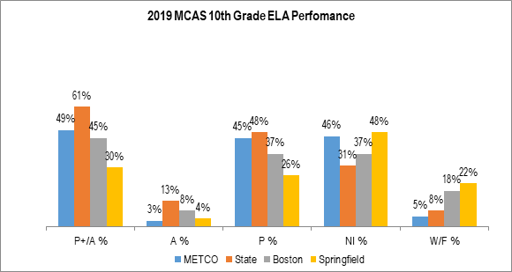
Source: Massachusetts Department of Elementary and Secondary Education, 2019 MCAS Assessment file

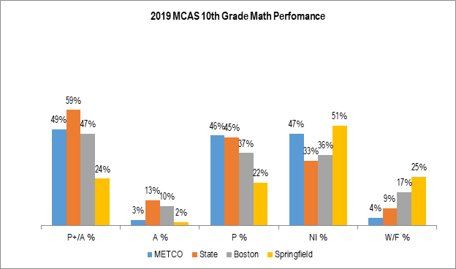
Source: Massachusetts Department of Elementary and Secondary Education, 2019 MCAS Assessment file

2020 Next Generation MCAS Test Results
The Department did not administer Spring 2020 MCAS for the 2019-2020 school year due to the cancellation of state assessments and school closures related to COVID-19.

Graduation Rates and Post-Graduation Plans
The following charts reflect 2019 METCO student graduation rates and 2020 METCO student post-graduation plans as compared to the state, Boston Public Schools, and Springfield Public Schools.
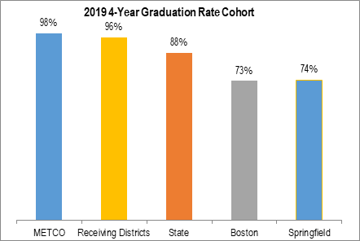
Source: Massachusetts Department of Elementary and Secondary Education, Student Information Management System (SIMS)

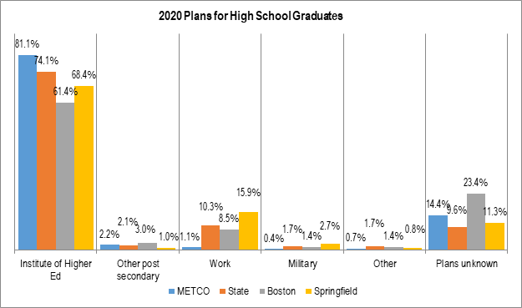
Source: Massachusetts Department of Elementary and Secondary Education, Student Information Management System (SIMS)

School Districts Expenditure of Funds on METCO-Related Programming
The following data derives from EdGrants, the Department’s online grant information system. The chart below is a snapshot of actual school district expenditure of funds during the 2018-2019 and 2019-2020 school years.

FY19 Fund Use | Admin | Professional  Staff | Support  Staff | Stipends | Fringe  Benefits | Contract  Services | Supplies &  Materials | Travel | Other  Costs | Indirect  Costs | Total Funds Expended
Arlington P.S. | 101,352 | 143,226 | 27,589 | 8,479 |  | 5,880 | 2,756 | 3,852 | 195,921 |  | 489,055
Bedford P.S. | 148,700 | 15,500 | 75,564 |  |  | 70,886 | 20,600 | 3,459 | 318,793 |  | 653,503
Belmont P.S. | 100,300 | 192,634 | 79,855 | 13,623 |  |  | 498 | 3,200 | 192,860 |  | 582,970
Braintree P.S. | 53,582 |  | 31,048 | 3,600 | 2,001 | 200 |  |  |  | 129,724 | 220,154
Brookline P.S. | 115,222 | 683,692 | 271,243 | 6,775 |  | 9,047 | 9,252 | 37,981 | 450,946 | 17,435 | 1,601,593
Cohasset P.S. | 90,458 | 17,512 | 35,255 |  |  | 12,066 | 7,625 | 2,276 | 142,195 |  | 307,387
Concord P.S. | 50,097 | 95,957 | 177,450 |  |  |  |  |  | 188,541 |  | 512,045
East Longmeadow P.S. | 79,993 | 86,231 |  |  |  | 7,470 | 532 |  | 92,366 |  | 266,592
Foxborough P.S. | 48,563 | 84,888 | 20,000 |  |  |  | 929 | 1,078 | 92,317 |  | 247,774
Hingham P.S. | 60,718 | 99,141 | 5,953 |  |  | 6,775 | 204 | 1,500 | 91,685 |  | 265,976
Lexington P.S. | 128,536 | 399,969 | 300,895 | 31,107 |  | 61,871 | 4,950 | 3,428 | 667,045 |  | 1,597,800
Lincoln P.S. | 54,634 | 231,732 | 19,885 | 12,207 |  | 3,320 | 3,931 |  | 220,613 |  | 546,322
Longmeadow P.S. |  | 50,149 | 40,292 | 3,000 |  | 12,453 | 895 |  | 119,018 |  | 225,807
Lynnfield P.S. | 78,925 |  |  |  |  | 5,100 |  |  | 157,401 |  | 241,426
Marblehead P.S. | 72,536 | 115,595 |  |  | 7,934 | 15,428 | 14,935 | 1,030 | 270,822 |  | 498,280
Melrose P.S. | 116,187 | 300,500 | 35,619 |  |  | 53,415 | 336 | 9,279 | 242,821 |  | 758,157
Natick P.S. | 82,204 | 107,814 |  |  | 19,667 |  |  |  | 154,385 |  | 364,070
Needham P.S. | 257,188 | 84,751 | 275,813 |  |  | 48,806 | 10,756 | 1,252 | 395,833 | 13,936 | 1,088,335
Newton P.S. | 137,705 | 1,243,746 | 181,651 | 2,732 | 65,395 | 49,633 | 3,349 | 4,998 | 973,299 |  | 2,662,508
Reading P.S. | 78,400 | 70,044 | 8,860 | 1,500 |  | 8,375 |  | 3,183 | 252,853 |  | 423,214
Scituate P.S. | 85,000 | 141,124 | 12,469 |  |  |  | 1,659 |  | 219,986 |  | 460,238
Sharon P.S. | 100,629 | 20,848 | 44,824 |  |  | 34,999 | 13,909 | 7,847 | 223,151 |  | 446,206
Springfield P.S. | 36,797 |  |  |  | 8,469 |  | 1,032 |  |  | 1,400 | 47,698
Sudbury P.S. | 86,275 |  | 149,237 | 4,813 |  | 33,946 | 3,331 | 1,260 | 194,570 |  | 473,432
Swampscott P.S. | 71,070 | 91,772 | 48,362 |  |  | 189,877 | 758 | 600 |  |  | 402,439
Wakefield P.S. | 81,317 |  | 84,049 |  |  | 37,482 | 2,069 | 9,425 | 174,821 |  | 389,163
Walpole P.S. | 97,125 |  | 74,852 |  |  |  |  | 1,800 | 120,069 |  | 293,846
Wayland P.S. | 81,593 | 292,345 | 43,546 | 12,059 |  | 28,661 | 15,303 | 6,624 | 311,738 |  | 791,869
Wellesley P.S. | 95,770 | 255,604 | 112,636 | 2,000 | 64,958 |  | 1,319 | 488 | 435,050 |  | 967,825
Weston P.S. | 49,809 | 606,249 | 268,346 | 11,095 |  |  |  |  | 67,385 |  | 1,002,884
Westwood P.S. | 95,455 |  | 42,919 |  |  | 23,308 | 15,493 | 7,925 | 104,666 |  | 289,766
Concord-Carlisle RSD | 75,030 | 89,653 | 60,685 |  |  |  |  |  | 161,715 |  | 387,083
Dover-Sherborn RSD | 80,862 |  | 26,388 |  |  | 18,305 | 692 | 2,618 | 110,455 |  | 239,320
Hampden-Wilbraham RSD | 53,646 |  |  |  |  |  | 500 |  | 74,494 |  | 128,640
Lincoln-Sudbury RSD | 85,000 |  | 89,343 | 2,860 |  | 49,500 | 8,745 | 3,462 | 304,204 |  | 543,114
Southwick/Tolland RSD |  | 51,258 |  | 21,663 |  | 19,850 |  |  | 52,943 |  | 145,714
Total | 3,030,678 | 5,571,934 | 2,644,628 | 137,513 | 168,424 | 806,653 | 146,358 | 118,565 | 7,774,961 | 162,495 | 20,562,205

FY20 Fund Use | Admin | Professional  Staff | Support  Staff | Stipends | Fringe  Benefits | Contract  Services | Supplies &  Materials | Travel | Other  Costs | Indirect  Costs | Equipment | Total Funds Expended
Arlington P.S. | 104,942 | 104,554 | 38,352 | 3,223 |  | 56,492 | 43,113 | 3,345 | 180,427 |  |  | 534,449
Bedford P.S. | 165,761 | 48,793 | 88,310 |  |  | 57,607 | 13,010 | 3,267 | 295,079 |  |  | 671,827
Belmont P.S. | 104,000 | 247,904 | 96,883 |  |  | 2,250 | 1,347 | 4,455 | 187,412 |  |  | 644,252
Braintree P.S.* | 57,657 |  | 14,040 |  | 6,453 |  | 19,829 | 450 | 105,523 |  |  | 203,952
Brookline P.S. | 121,411 | 734,247 | 306,237 | 9,735 |  | 22,082 | 57,984 | 44,461 | 306,107 | 52,287 |  | 1,654,551
Cohasset P.S. | 98,282 | 32,314 | 40,154 |  |  | 7,692 | 4,479 |  | 128,010 |  |  | 310,931
Concord P.S.* | 48,000 | 137,650 | 177,213 |  |  |  |  |  | 186,527 |  |  | 549,390
East Longmeadow P.S. | 81,755 | 86,319 |  |  |  | 15,500 |  |  | 100,124 |  |  | 283,698
Foxborough P.S. | 49,516 | 84,888 | 22,000 |  |  | 1,500 | 4,546 | 1,153 | 82,827 |  |  | 246,430
Hingham P.S. | 63,132 | 82,014 | 13,613 |  |  | 9,907 | 1,881 | 1,875 | 106,402 |  |  | 278,823
Lexington P.S.* | 139,946 | 412,932 | 275,022 | 5,948 |  | 90,748 | 15,630 | 817 | 668,283 |  |  | 1,609,326
Lincoln P.S.* | 116,100 | 136,524 | 30,000 | 14,000 |  | 9,800 | 4,000 | 900 | 270,480 |  |  | 581,804
Longmeadow P.S. |  | 52,328 | 41,462 | 3,000 |  |  | 9,787 |  | 129,981 |  |  | 236,558
Lynnfield P.S. | 79,889 |  | 17,020 |  |  |  |  |  | 148,003 |  |  | 244,913
Marblehead P.S. | 90,000 | 88,913 | 20,591 |  | 6,306 | 1,200 | 42,823 |  | 242,044 |  |  | 491,877
Melrose P.S. | 84,000 | 280,786 | 70,227 |  |  | 53,438 | 8,220 | 1,000 | 342,283 |  |  | 839,955
Natick P.S. | 87,175 | 89,832 | 27,504 |  | 9,999 |  | 3,947 | 442 | 147,277 |  |  | 366,176
Needham P.S. | 285,074 | 94,882 | 473,547 |  |  | 8,608 | 6,774 | 5,072 | 313,026 | 10,692 |  | 1,197,675
Newton P.S. | 143,656 | 1,361,512 | 202,202 |  | 128,545 | 35,880 | 110,249 | 24,893 | 876,844 |  |  | 2,883,781
Reading P.S. | 81,860 | 70,000 | 5,183 |  |  | 8,000 | 9,706 | 2,700 | 248,824 |  |  | 426,273
Scituate P.S. | 86,834 | 157,000 | 15,940 |  |  | 19,803 | 3,321 |  | 144,441 |  |  | 427,339
Sharon P.S. | 102,642 |  | 32,879 |  |  | 100,054 | 25,306 | 8,525 | 179,293 |  |  | 448,699
Springfield P.S. |  |  | 37,076 |  | 11,591 |  | 1,333 |  | 575 | 1,425 |  | 52,000
Sudbury P.S. | 88,220 |  | 139,605 | 15,574 |  | 26,227 | 724 | 1,000 | 191,362 |  | 20,368 | 483,080
Swampscott P.S. | 78,067 | 96,288 | 31,713 |  |  | 197,229 |  | 2,432 |  |  |  | 405,729
Wakefield P.S. | 72,190 |  | 96,397 |  |  | 36,326 | 86,604 | 391 | 159,726 |  |  | 451,634
Walpole P.S. | 99,032 |  | 78,845 |  |  |  |  |  | 117,569 |  |  | 295,446
Wayland P.S. | 160,345 | 338,614 | 42,726 | 15,723 |  | 40,253 | 26,280 | 5,340 | 195,658 |  |  | 824,939
Wellesley P.S. | 129,338 | 242,274 | 106,618 | 2,000 | 64,363 |  | 50,839 | 900 | 455,675 |  |  | 1,052,007
Weston P.S. | 78,067 | 96,288 | 31,713 |  |  | 197,229 |  | 2,432 |  |  |  | 405,729
Westwood P.S. | 112,000 | 35,297 | 32,359 | 3,487 |  | 42,547 | 18,275 | 398 | 73,392 |  |  | 317,755
Concord-Carlisle RSD* | 72,000 | 92,909 | 65,624 | 4,000 |  |  |  |  | 154,630 |  |  | 389,163
Dover-Sherborn RSD | 82,681 |  | 32,802 |  |  | 6,715 | 38,109 | 5,350 | 115,020 |  |  | 280,677
Hampden-Wilbraham RSD* |  | 59,351 |  |  |  |  | 800 |  | 69,076 |  |  | 129,227
Lincoln-Sudbury RSD | 105,000 |  | 95,000 |  |  | 43,000 | 48,535 | 10,000 | 308,341 |  |  | 609,876
Southwick/Tolland RSD |  | 47,608 |  | 22,205 |  | 16,038 |  | 184 | 53,414 |  |  | 139,449
Total | 3,268,572 | 5,312,021 | 2,798,857 | 98,895 | 227,257 | 1,106,125 | 657,451 | 131,782 | 7,283,655 | 64,404 | 20,368 | 20,969,390
*The district’s final financial report was not available at the time this report was drafted. As such, this information was compiled from the district’s most current FY20 line item totals in EdGrants.

Transportation Services
METCO, Inc. contracts with three vendors (AA Transportation, First Student, and Eastern Bus) to provide bus transportation for METCO students traveling to and from 10 school districts.

METCO, Inc. provides contract and bid services in accordance with Chapter 30B, MGL and monitors the terms of the bid specifications and contracts to assess quality performance of the vendor to each contracted school district. Bus vendors are expected to supply quality service and are monitored for fiscal and operational compliance. METCO, Inc. meets and communicates with respective bus company management personnel when necessary. The management services provided by METCO, Inc. includes daily monitoring of service for both morning and afternoon commutes, working with school district business managers and METCO Directors to review invoices (when requested) and address inquiries when they arise. It is important to note that contracted districts receive monthly invoices for services performed and issue payment directly to the vendors including deductions for penalties. The transportation manager at METCO, Inc. may be consulted when requested/warranted to assist assessment of penalties to be deducted from invoices. METCO, Inc. provides planning and routing for contracted districts as well as consultation with other METCO Directors. The Transportation Manager of METCO, Inc. stays abreast of local, state, and national trends and concerns in the school bus industry in order to provide optimum service to districts.

Transportation for Springfield METCO students is provided by the four receiving school districts. The four receiving school districts are responsible for monitoring student transportation services.

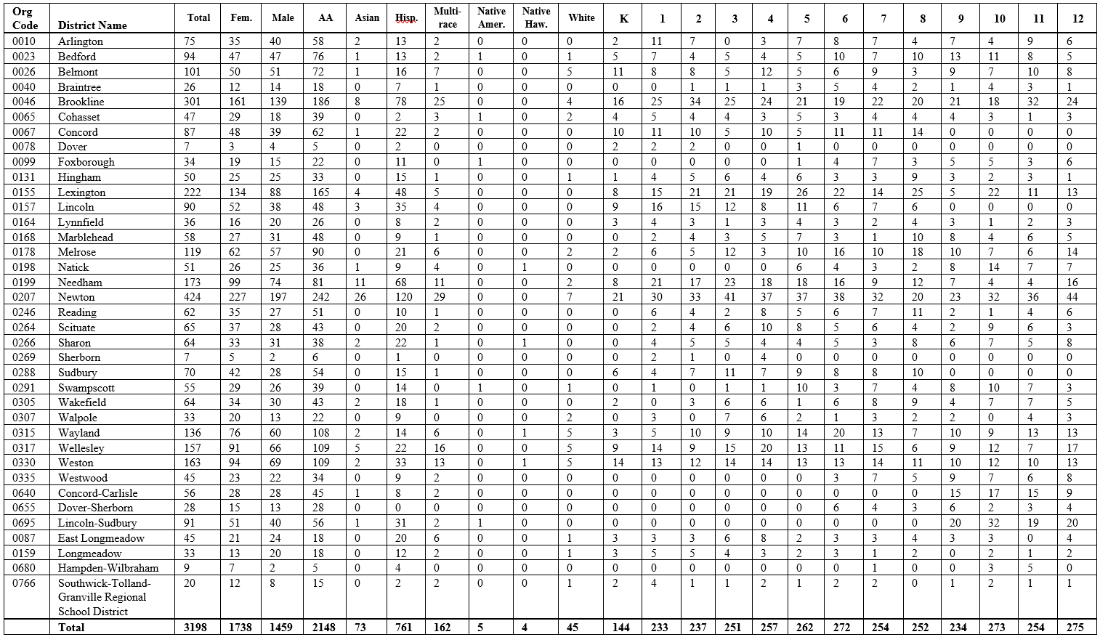
Appendix: Demographic Report 2019-2020

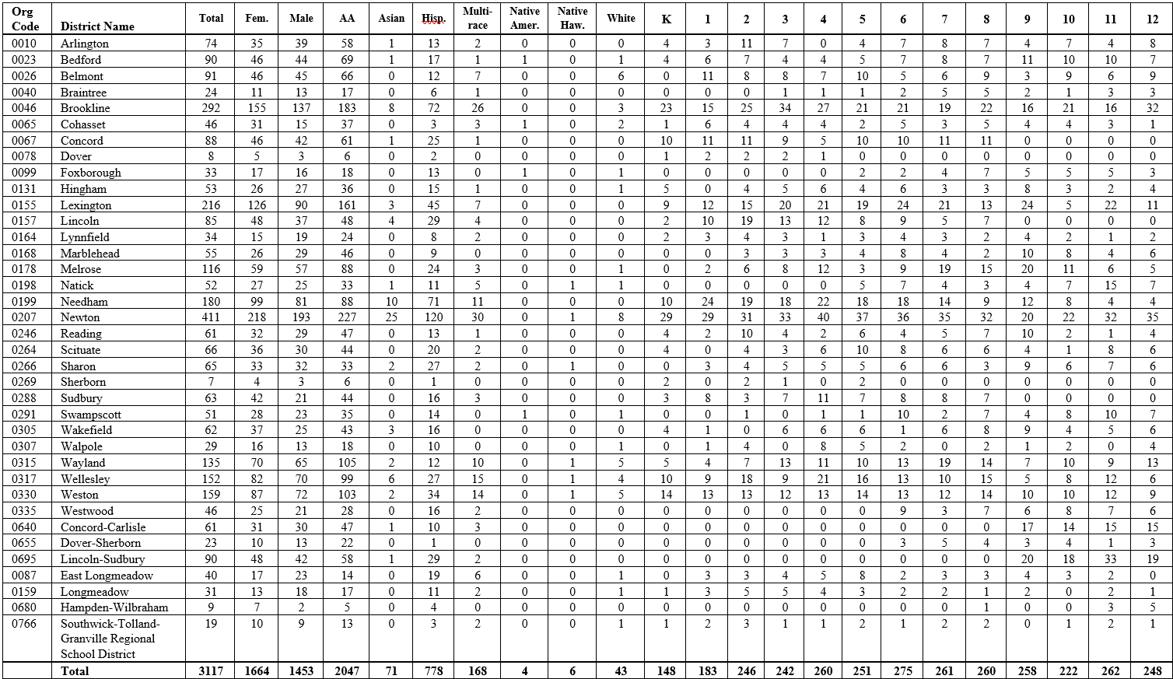
Appendix: Demographic Report 2020-2021

http://www.doe.mass.edu/Grants/edgrants.html
Arlington, Belmont, Braintree, Dover-Sherborn, Lexington, Lincoln, Lincoln/Sudbury, Natick, Sudbury, and Walpole.
East Longmeadow, Hampden Wilbraham, Longmeadow, and Southwick-Tolland.

