Influence 100
Year-end Field Guide Report 2022

Program Year 3 (SY 2021–2022)
Cohort 2, Second Year
Cohort 3, First Year

Final: September 30, 2022

Influence 100
Year-end Field Guide Report 2022

Prepared by the UMass Donahue Institute
Project Leader
Jeremiah Johnson, PhD
Project Staff
Jackie Stein, MPH, PhD, Project Manager
Katie Ledwith, MS, Research Analyst
Elizabeth W. Brown, MPH, Project Consultant

Established in 1971, the UMass Donahue Institute is a public service, research, and economic development arm of the University of Massachusetts. Our mission is to apply theory and innovation to solve real world challenges and enable our clients to achieve their goals and aspirations. We serve clients in the public, non-profit, and private sectors in the Commonwealth and throughout the nation and the world. For more information, www.donahue.umass.edu.

Contents
Introduction 2
Key Findings 3
Methods 7
Cohorts and Cohort Assignment 7
Surveys 8
Focus Groups 10
Benchmarks 11
Findings: Fellows, Mentors, Districts 12
Key Findings: Fellows 12
Cohort 2 Fellows, Second-Year Reflections 12
Cohort 3 Fellows, First-Year Reflections 14
Key Findings: Mentors 15
Cohort 2 Mentors, Second-Year Reflections 15
Cohort 3 Mentors, First-Year Reflections 16
Key Findings: Districts 17
Returning Districts, Second-Year-Plus Reflections 17
Cohort 3 Districts, First-Year Reflections 19
District Context 20
Strategic Considerations 23
Appendices – Influence 100 Year-end Field Guide Report 24

Introduction
This second Year-end Field Guide Report is part of the ongoing evaluation of Influence 100 by the UMass Donahue Institute (UMDI), under contract with the Massachusetts Department of Elementary and Secondary Education (DESE). This report focuses on high-level findings about the third year of the Influence 100 program (2021–22 school year), which was the first year of participation for Cohort 3 fellows and the second and final year of participation for Cohort 2 fellows. Findings reported here are based on data collected from fellows, mentors, and districts (see Methods section for more detail).
Key findings that cut across groups (fellows, mentors, districts) are featured in the next section, along with three pages that visually summarize benchmarking metrics for fellows and districts. Following the methods section are collections of findings organized by group and participation year (e.g., Cohort 2 Fellows, Second-Year Reflections). Each of these summaries is drawn from data that is presented in more detail in the appendix.

The Program
Influence 100 was launched at the beginning of the 2019–20 school year by DESE “to increase the racial and ethnic diversity of superintendents in Massachusetts, create more culturally responsive districts and leaders across the state, and promote better outcomes for students.” The program includes two primary elements: 1) a fellowship program for qualified educators who desire to move into the superintendent role in the next five years, and 2) support for school districts to become more culturally responsive and to engage in intentional strategy development and execution around diversifying their educator workforce.

The Evaluation
UMDI serves as an independent, third-party evaluator for the Influence 100 program, contracted by DESE. The purposes of the evaluation are: 1) to provide formative feedback about Influence 100 strategies to support prospective superintendents for the superintendency and to support participating districts as they work to diversify the educator workforce and develop equitable and culturally responsive practices; 2) to provide formative feedback about the successes and challenges of fellows’ and districts’ efforts to increase equity; and 3) to assess the impacts of the program on fellows and their districts.
The evaluation launched in August 2020, between the first and second years of the program. DESE contracted with UMDI to conduct evaluation activities through the program’s fifth year. Evaluation activities and products generated during this time are intended to position the program for continued learning beyond that time.

Key Findings
- For the third year in a row, both fellows and mentors reported that Influence 100 had positive impacts on fellows. For example, Cohort 3 fellows and their mentors reported growth in fellows’ equity mindsets over the first year of the program. Cohort 2 fellows reported that Influence 100 helped them gain relevant knowledge and supported their personal and professional development.
- Influence 100 continues to impact fellows and districts in their second year of participation and beyond. Fellows report continued knowledge gains, personal and professional development, and feelings of preparedness for the superintendent role after their second year in the program. Districts continued to change or develop their equity practices in their second year of participation (and, in some cases, their third).
- Fellows valued building a network of connections to others in the field. In survey data, both Cohort 2 and Cohort 3 fellows listed connecting to and hearing about the experiences of others in the field (including superintendents, “guest speakers,” “equity champions in other districts,” and peers and colleagues outside of their own districts) as among the most important benefits of the program.
- Monthly fellows sessions were consistently rated highly across cohorts and years. On average, 91% of first-year fellows (Cohorts 1–3, n=51 responses) rated five aspects of the monthly sessions as at least “moderately effective” in supporting their growth as equity-focused district leaders. All responding second-year fellows (Cohorts 1–2, n=31) reported being “very” or “moderately” engaged in the monthly sessions.
- COVID-related disruptions and a social context of resistance to equity work were among the key challenges to program engagement and progress on equity goals named by fellows and district leaders. COVID-related challenges included the virtual format of gatherings, navigating the return from a remote school year, a lack of access to in-person recruiting, extra resources required for social-emotional supports, and staffing shortages and related stressors. Many fellows (in the focus groups) referenced the challenge of working in a current social context/climate that feels hostile to equity work. Several district leaders noted similar challenges, such as “fear and hesitancy” to move forward on equity work or difficulty getting “staff to understand the importance of this work.”
- District engagement with Influence 100 and support for fellows (e.g., through mentorship) continued to vary by fellow and district in program Year 3. Cohort 2 and 3 fellows reported varied experiences with mentorship and district engagement in Influence 100. Please see the Lessons Learned & Implications section of the 2021 Influence 100 Year-end Field Guide Report for suggestions from mentors and fellows.
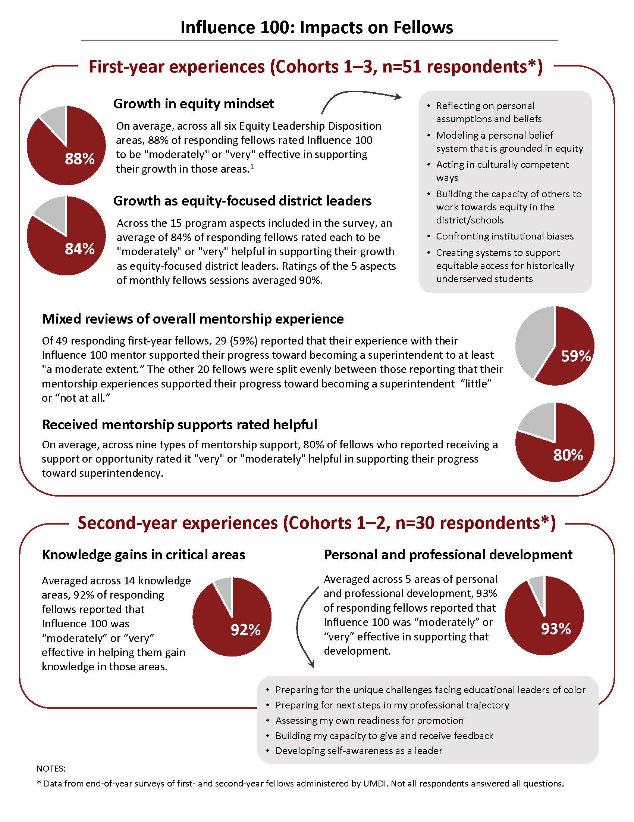
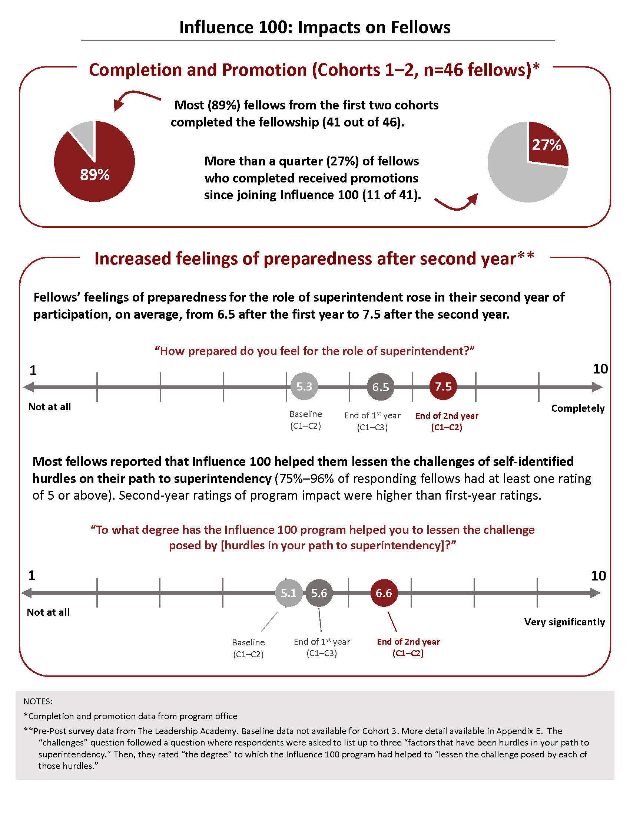
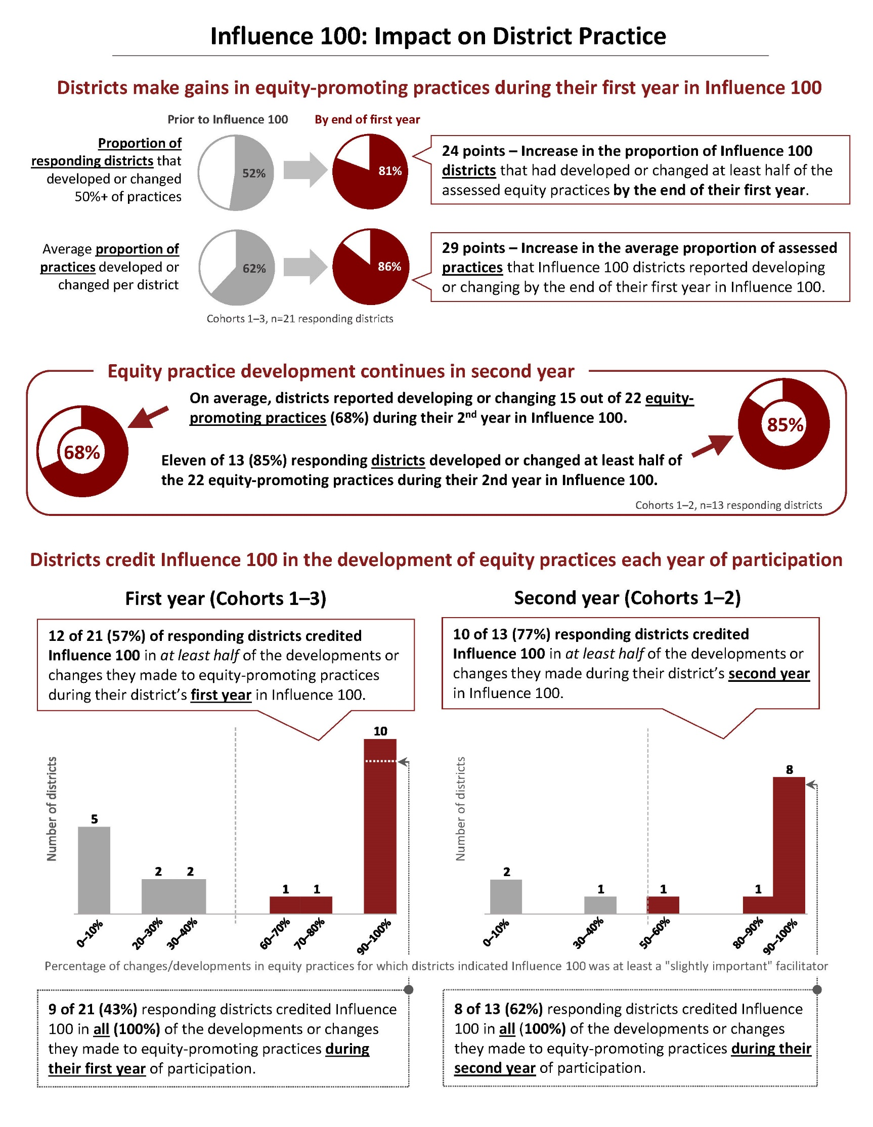

Methods
This report focuses on data collected from two primary sources: surveys of fellows, mentors, and districts in Cohorts 2 and 3 in April/May 2022, and a March 2022 focus group with a subset of Cohort 2 fellows. Both of these data collections were administered by UMDI. These primary data are supplemented with data from the program office and from the Leadership Academy (a DESE vendor collaborating on the fellowship sessions), and with district-level data from DESE. Summaries of each of the primary data collections are provided in Appendix A (survey summaries) and Appendix B (focus groups summary).
Although this report represents our best attempt to analyze and synthesize the data from Influence 100 in program Year 3, we acknowledge that our analysis was limited. The capacity and scope for the project circumscribed our ability to collect additional data (e.g., data about program implementation) or to do a deeper level of analysis with the data we did collect. Some data were unavailable (e.g., staff perceptions of racial equity in district settings are not currently collected). The data we used had its own limitations. For example, perceptions of growth and change—both at the fellow or the district level—were measured through self-report with limited baseline data. Also, response rates from mentors represented just a little over 50% of the fellows they were surveyed about (14 of 27 fellows, 52%), which is less than ideal.

Cohorts and Cohort Assignment
For fellows and mentors, cohort is defined by the fellow’s first participation in Influence 100 (See Table 1). Mentors were surveyed based on the cohort affiliation of their district’s fellow(s). Districts’ cohorts are defined by the cohort of their first fellow (many districts supported fellows in multiple cohorts). For the purposes of data collection and reporting at the district level, the survey instruments (and the resulting data) are divided between “first-year” districts and “returning” districts. In the 2021–22 school year, “first-year” districts were those in Cohort 3 and “returning” districts were those in Cohort 1 and Cohort 2. As an example, if a given district had a fellow in Cohort 1 and one in Cohort 3, the district would be defined as a Cohort 1 district and its survey responses would be grouped with the “returning” districts. The Cohort 3 fellow from that district and their mentor’s responses to the survey about that fellow would be captured as Cohort 3.
In the Year 3 survey data presented in this report (summarized in the Findings section beginning on page 12), first-year participants and returning participants are mutually-exclusive groups. However, on the benchmarks pages (pages 4, 5, and 6) data from first-year surveys are summarized across Cohorts 1–3 and data from second-year surveys are summarized across Cohorts 1–2. Thus, these data draw from overlapping pools of respondents surveyed at two different points in time.

Table 1: Cohort details
Cohort | Starting School Year | # Fellows in cohort | # Districts
 |  |  | With participating fellows (total) | Returning from a previous year | Assigned to cohort
Cohort 1 | SY19–20 | 26 | 15 | 0 | 15
Cohort 2 | SY20–21 | 20 | 10 | 5 | 5
Cohort 3 | SY21–22 | 20 | 12 | 6 | 6

The number and size of districts vary by cohort. This is particularly relevant context for interpreting district data segmented by cohort that might be used to provide benchmarking metrics or system-level context. As an example, Table 3 shows the population sizes, by cohort, of each of the staff groups whose racial/ethnic diversity is captured in the “Influence 100 System Context” figure on page 21. Since many districts from Cohorts 1 and 2 have participated in subsequent cohorts, Cohort 1 is twice as large as Cohort 2 or Cohort 3 (see Table 1). Because of this difference in the number of districts in each cohort and the varying size of participating districts, the number of district level staff is very different by cohort making proportional comparisons (e.g., % district leaders of color) challenging.

Table 2: Influence 100 Districts’ Staff Population Sizes, by Grouping and Cohort
School years 19–20, 20–21, 21–22; Source: EPIMS
 | Cohort 1 | Cohort 2 | Cohort 3
District Leaders | 37–43 | 12–15 | 11
School Building Administrators/Leaders | 1,082–1248 | 277–302 | 153–161
Teachers | 77,998–94,013 | 21,046–22,468 | 15,675–16,561
Central Office/District Staff | 657–724 | 158–172 | 94–101

Surveys
UMDI administered seven surveys in April/May 2022 to Cohort 2 and 3 fellows, mentors, and district leaders (see Table 3). Surveys were distributed via email on April 25 and closed May 20. The program office sent out an email reminder on 4/29 to the whole community, set aside time for fellows to complete the surveys during monthly sessions on 5/6 (Cohort 2) and 5/13 (Cohort 3), reminded district leaders at the quarterly district leadership session on 5/19, and sent a final email reminder on 5/20. UMDI sent email reminders to those individuals who had not completed on 5/2, 5/10, 5/16. Survey instruments were lightly-updated versions of the first-year and second-year instruments developed by UMDI in collaboration DESE and the Leadership Academy staff in fall 2020 and 2021.

Instrument summaries
Surveys administered to Cohort 2 focused on experiences during their second (and final) year of participation, as well as reflections across the two-years of the fellowship. Surveys for Cohort 3 focused on experiences during their first year of participation.
All surveys requested general reflections and feedback about the Influence 100 program, in addition to group-specific questions. Fellows and mentors surveys included questions about growth in equity mindset—measured through six Equity Leadership Dispositions (ELD) developed by the Leadership Academy.
Table 3: Survey details 2022
 | Cohort and  Participation Year | Number of questions |  |  | Response rate
 |  | Total | Closed ended | Open ended
Fellows | Cohort 2, 2nd Year | 13 | 6 | 7 | 12 of 17 fellows (71%)
 | Cohort 3, 1st Year | 17 | 8 | 9 | 17 of 20 fellows (85%)
District leaders | Returning, 2nd + Year | 9 | 5 | 4 | 8 of 12 districts (67%)
 | Cohort 3, 1st Year | 5 | 4 | 1 | 4 of 6 districts (67%)
Mentors | Cohort 2, 2nd Year | 11 | 6 | 5 | 2 of 7 mentors (29%)  (3 of 10 fellows, 30%)
 | Cohort 3, 1st Year | 13 | 7 | 6 | 7 of 12 mentors (58%)  (11 of 17 fellows, 65%)
All surveys requested general reflections and feedback about the Influence 100 program, in addition to group-specific questions. Fellows and mentors surveys included questions about growth in equity mindset—measured through six Equity Leadership Dispositions (ELD) developed by the Leadership Academy.
Survey instruments are in Appendix C and summaries of survey findings are in Appendix A.

Fellows surveys
- The Cohort 3, First Year Fellows Survey was an updated version of the first-year survey developed for Cohort 1 in fall 2020, and included questions about growth in equity mindset, preparation for superintendency, and reflections on experiences with Influence 100 mentors.
- The Cohort 2, Second Year Fellows Survey was an updated version of the second-year survey developed for Cohort 1 in fall 2021, and included questions about engagement with Influence 100 programming, skills and learning, and closing reflections at the end of the two-year program cycle.

District Leadership Team (DLT) surveys
- The Cohort 3, First Year DLT Survey was an updated version of the Cohort 1, first-year survey and asked about changes or developments in a set of 22 equity-focused practices at two time points: prior to the 2021–22 school year (before the district’s participation in Influence 100) and during the 2021–22 school year (during the district’s first year of participation). The survey also asked districts to rate the extent to which Influence 100 was important in facilitating any of the changes or developments during the 2021–22 school year.
- The Cohort 2, Second Year DLT Survey used the same set of 22 equity-focused practices as did the Year 1 survey. It asked about any changes or developments to those practices during the 2020–21 school year (the district’s second and final year of Influence 100 participation) and the importance of Influence 100 in facilitating any of those changes or developments. The Year 2 survey also included a set of reflective questions related to program improvement and district progress.

Mentor surveys
- The Cohort 3, First Year Mentor Survey asked superintendents to report on their mentorship practices and their reflections on fellows’ growth/progress.
- The Cohort 2, Second Year Mentor Survey asked superintendents to report on their efforts as a mentor, the frequencies and types of support provided to fellows, and their perceptions of the impacts of their mentorship on their mentees.
- A combined Cohort 2 + Cohort 3 version of the survey included questions about individual fellows and overall reflection questions drawn from the first- and second-year mentor surveys.

Focus Groups
UMDI conducted two one-hour focus groups, via Zoom, in March 2022—one with a subset of Influence 100 Cohort 2 fellows and one with a subset of Cohort 1 alumni. Five alumni from Cohort 1 and six fellows from Cohort 2 participated. For details about participant selection and a summary of findings from these focus groups, please see Appendix B.
A new protocol was developed in 2022 for the Cohort 1 alumni group; the protocol for Cohort 2 participants was a lightly updated version of the protocol developed in 2021 (for use with Cohort 1 fellows in their second year). Both protocols were developed by the UMDI evaluation team in collaboration with DESE and Leadership Academy staff. Questions for Cohort 1 alumni focused on lasting impacts, program effectiveness, and program improvement. Questions for Cohort 2 asked fellows to reflect on their experiences in the program to date, including impacts on themselves and their districts, experiences with mentorship, and opportunities and resources provided by the program. Both protocols are in Appendix D.

Benchmarks
In the first year of the evaluation, UMDI worked with DESE and staff from the Leadership Academy to develop a set of “benchmarks” that can be used for program monitoring in the pilot phase and to inform the development of criteria to measure programmatic success in later phases. These metrics focus on three broad areas: impact on fellows, impact on district practice, and impact on system—and were intended to be assessed across multiple points in time.
The data in this report reflect the first two cohorts’ two-year program cycles and include data from the first half of the third program cycle. Please see Appendix E for more detailed methodological notes.
- Impact on district practice metrics are summary measures derived from the list of key equity- promoting practices that were developed for the DLT Survey by UMDI, DESE, and the Leadership Academy (described above). The list of 22 practices was intended to capture a broad range of district actions that contribute to increased equity at all levels in the district. The summary metrics measure equity-practice implementation and perceptions of the impact of Influence 100 on that implementation across participating districts.
- Impact on fellows metrics include some items from the UMDI Fellows Surveys (about program effectiveness and impact on growth in equity mindset), some items measured by the program office (promotions and rate of program completion), and some items from surveys designed and administered to fellows by the Leadership Academy (perceptions of readiness for superintendency, impact of Influence 100 on reducing challenges to superintendency).
- Impact on system metrics include measures of the racial/ethnic diversity of district leadership in Influence 100 districts (drawn from DESE Education Personnel Information Management System [EPIMS] data) and summary indicators of equity in student access to teachers with certain qualifications (drawn from DESE Edwin Analytics data). At this stage in the program, we present these indicators as system context rather than as measures of system impact.

Findings: Fellows, Mentors, Districts
This section presents high-level findings about fellows, mentors, and districts organized by cohort and year of participation. They focus on reflections from Cohort 2 and Cohort 3 participants in program Year 3 (SY 2021–22). These findings are drawn from detailed summaries of the survey results and focus groups (summaries are in Appendices A and B).
Fellows’ reflections are presented first, followed by mentors (beginning on page 15) and districts (beginning on page 17).

Key Findings: Fellows

Cohort 2 Fellows, Second-Year Reflections
(N=12 survey respondents out of 17 fellows [71%] and 6 focus group participants. Please see Appendix A, page 1 for a detailed summary of Cohort 2 Fellows survey results and Appendix B for the focus group summary.)
- Fellows report that Influence 100 helped them gain relevant knowledge and supported their personal and professional development. Across 14 different knowledge areas, most responding Cohort 2 fellows (75%–92% of 12) reported that Influence 100 was at least “moderately” effective in helping them gain knowledge in each area. Nearly all respondents (11 of 12, 92%) rated Influence 100 “very effective” in supporting their personal and professional development in two areas: preparing for next steps in my professional trajectory and assessing my own readiness for promotion.
- Most Cohort 2 fellows completed the fellowship (85%, 17 of 20) and almost a quarter of those who completed (24%, 4 of 17) were promoted during their time in the program.
- Fellows value building peer and professional connections, learning from leaders in the field, skill-building related to equity practice, and exposure to equity tools and resources. This was reflected in both focus group and survey data. For example, the two aspects of the Influence 100 fellowship most commonly selected as “most helpful” by responding fellows were learning from leaders in the field and skill-building related to equity (67%, 8 of 12 survey respondents). Similarly, 9 of 10 survey respondents reported that building networks and connections to others were key benefits of the program to their development as educational leaders. Most responding Cohort 2 fellows also reported connecting or networking with Influence 100 colleagues between sessions (75%, 9 of 12). Other benefits reported by fellows related to equity leadership, including confidence building, learning to be a better advocate and ally, sharing strategies, and having a space where equity is a central commitment.
- Fellows suggest that Influence 100 make more space for discussions of challenges to equity work and resistance to leadership of color. Some Cohort 2 fellows reported experiencing resistance to their equity work and leadership, including ongoing experiences of racism and microaggressions, and suggested that more time be spent preparing fellow to work in and engage with that context (including engaging with school committees).
- Fellows report applying practices or strategies from Influence 100 in their own districts. Nearly all respondents (11 of 12, 92%) reported applying three of the suggested practices from Influence 100 in their districts or schools over the past two years: practice language and behaviors in dealing with diverse stakeholders; confront behavior that openly or covertly promotes inequity, color blindness, and deficit-thinking; and work to ensure that issues of equity are incorporated in professional learning opportunities or experiences.
- Cohort 2 fellows report that monthly sessions were engaging. All 12 responding fellows reported being either “very engaged” (58%, 7 of 12) or “moderately engaged” (42%, 5 of 12) in the monthly fellows sessions. Factors that fellows reported as facilitating their engagement included collaboration among fellows and interactions with invited guests. Of those respondents who made suggestions for how to increase their engagement in the program, most (75%, 6 of 8) suggested changes to the meeting format, timing, or duration.
- Fellows suggest that mentorship and district support for fellows are aspects of the program that need more structure and attention. Reflected in focus group and survey data, respondents’ suggestions included more uniform structures and guidance for mentorship, mentors who are not fellows’ superintendents, more coaching and support from program leaders, more individualized support, and requests that Influence 100 do more to engage school committees and superintendents in the program and in supporting fellows.

Cohort 3 Fellows, First-Year Reflections
(N=17 survey respondents out of 20 fellows [85%]. Please see Appendix A, page 15 for a detailed summary of Cohort 3 Fellows survey results)
- Most responding fellows reported that Influence 100 supported their growth in equity mindset during their first year in the program, particularly around personal assumptions and beliefs. At least 76% (13 of 17) responding fellows rated Influence 100 as “moderately” or “very” effective in supporting their growth in each equity leadership disposition area (84% averaged across all six areas).
- Most fellows reported that Influence 100 helped them become better prepared to be a superintendent (14 of 16, 88%) including through opportunities to hear from people outside of their district and role (especially superintendents), and by helping them learn more about district leadership roles as well as dynamics that are particular to the district level.
- Nearly all responding fellows (14 of 15 respondents, 93%) reported that Influence 100 had a positive impact on them in a variety of ways including through opportunities for collaboration; provision of useful tools, resources, or strategies; and opportunities for practical application of their learning.
- All surveyed aspects of the monthly sessions supported fellows’ growth as equity-minded district leaders. An average of 85% of the 16 responding Cohort 3 fellows rated five aspects of the monthly sessions to be “very” or “moderately” helpful in supporting their growth as equity-focused district leaders.
- Fellows’ experiences varied depending on their position and experience when joining the program. Some fellows suggested that the program might benefit from more differentiation based their different needs and experiences (e.g., using some sort of self-assessment tool).
- Mentorship experiences continue to receive mixed reviews. Of 16 responding Cohort 3 fellows 63% (10) reported that their overall experience with their Influence 100 mentor supported their progress toward becoming a superintendent to at least a “moderate extent.” When rating the mentorship supports they reported receiving, the majority of responding fellows (73%–100%, counts vary) rated every support as at least “moderately helpful.” Shadowing the superintendent was the most highly rated (100% “moderately” or “very” helpful), but was reported as received by only 3 of 16 (19%) fellows. No single type of mentorship support was rated “most helpful” by a majority of respondents.

Key Findings: Mentors

Cohort 2 Mentors, Second-Year Reflections
(N=2 respondents out of 7 surveyed Cohort 2 mentors [29%], representing 3 of 10 Cohort 2 fellows [30%]., Please see Appendix A, page 34 for a detailed summary of Cohort 2 Mentors survey results.)
- Respondents reported putting a “a high level of effort” into being a mentor and that this effort was either “very” or “moderately” sufficient. The mentor that selected “moderately sufficient” noted how the COVID pandemic impacted the fellow’s experience, stating that the fellow’s “attention and focus was heavily placed on getting the school up and running.”
- Both responding mentors indicated that their mentorship has had “a high level of impact” on their fellows as far as preparing them to be a superintendent. One mentor shared that the mentorship provided the opportunity to “experience the hands-on role of a superintendent,” and was an “invaluable” growth experience for both the fellow and the mentor.
- Mentors reported growth in their fellows’ equity mindsets. Both reported observing a “high amount of growth” among their 3 fellows in each of the 6 leadership dispositions (ELDs) assessed.
- Mentors supported their fellows most frequently by providing opportunities for discussion and debriefing and leadership development. The two mentors reported being able to provide three types of support “very frequently” or “often” to the fellows: opportunities to discuss district operations; access to leadership development opportunities; and opportunities for general discussion and debriefing.
- Mentors suggested debriefing sessions for superintendents and some in-person meetings. Superintendent check-ins, one suggested “would help us to gauge our fellow’s level of engagement, ensuring that every fellow got a rich experience.” The other mentor suggested that in-person meetings could help to develop “a sense of community” and would support “relationships between members.”

Cohort 3 Mentors, First-Year Reflections
(N=7 respondents out of 12 Cohort 3 mentors [58%], representing 11 of 17 Cohort 3 fellows [65%]. Please see Appendix A, page 40 for a detailed summary of Cohort 3 Mentors survey results.)
- Communication between mentors and their fellows most often occurred via in-person meetings and varied in frequency. Mentors utilized a variety of means to communicate with their fellows but in-person meetings were the most common mode of communication for both one-on-one meetings (9 of 11 fellows, 82%) and brief check-ins (8 of 11 fellows, 73%). The frequency with which mentors met with their fellows one-on-one or for brief check-ins during the 2021–22 school year ranged from “weekly” to “less frequently than monthly”.
- Mentors reported growth in their fellows’ equity mindsets after the first year of participation in Influence 100. Mentors indicated that all six equity leadership disposition practices (ELDs) were topics of conversation between themselves and at least 10 of 11 of their fellows during 2021–22 school year. Mentors reported observing at least a “moderate amount of growth” in most of their fellows across all ELD practice areas—at least 9 of 11 fellows in each area. In two of the six ELD areas (modeling a personal belief system that is grounded in equity, and confronting institutional biases), mentors indicated observing a “high amount of growth” in more than half of reported-on Cohort 3 fellows—six or seven fellows in each area.
- Mentors reported more frequently being able to support their fellows with opportunities for general discussion and debriefing and less frequently with opportunities to discuss the fellows’ action research project. Mentors reported providing for general discussion and debriefing “often” or “very frequently” for 9 out of 11 fellows. Opportunities to discuss the fellow’s action research projects occurred less frequently, with mentors reporting providing the support “sometimes” to 64% of the fellows.
- Nearly all mentors (10 of 11) provided their fellow the opportunity to participate in district leadership meetings. This was the most common leadership development opportunity mentors reported facilitating for fellows. Also commonly reported by mentors were opportunities to attend school committee meetings (for 9 of 11 fellows) or community meetings with families and/or community partners (for 8 of 11 fellows). Shadowing the superintendent was the least commonly facilitated opportunity, at one fellow.
- Mentors indicated that actively engaging with fellows in discussion and reflection and involving them in key activities were two strategies they found most helpful to their fellows. Mentors referred to how “regular, in-person, reflective conversations,” “trouble-shooting,” or in-person meetings about their projects encouraged relationship-building, reinforced equity work, and provided opportunity for reflection and guidance. Two mentors said it was most helpful to have their fellows participate and learn from key activities such as weekly district leadership meetings.
- Responding mentors suggested that Influence 100 could better support the development of culturally competent district leaders with new program content and guidance such as mentor training, the application of more real-life examples from those in the field, alignment with the Massachusetts Association of School Superintendents, or guidance regarding superintendent competencies.

Key Findings: Districts

Returning Districts, Second-Year-Plus Reflections
(N=8 respondents out of 12 returning districts with Cohort 2 or 3 fellows [67%]. Please see Appendix A, page 51 for a detailed summary of returning districts’ survey results.)
- Nearly all assessed equity practices were developed or changed by half of responding districts during the 2021–2022 school year. With one exception, at least 50% of the districts reported developing or changing each assessed equity-focused practice in all five practice areas. The most frequently reported developed/changed practices were: promote practices that support diversity/inclusion for staff (Climate, N=8); promote practices that support diversity/inclusion for students (Climate, N=8); change curriculum to be more culturally responsive (Curriculum and Instruction, N=8); change policies/practices to reduce inequitable impacts on historically marginalized groups (Policies and Practices, N=8); and support school leaders in providing ongoing (i.e., not one time only) professional learning opportunities to develop and/or deepen culturally responsive teaching practice (Leadership, N=8).
- Most responding districts (63% to 100%) reported that Influence 100 was either “very” or “moderately” important in facilitating the development of or changes to most of the equity-focused practices. However, several districts indicated that Influence 100 was “slightly” or “not at all” important for some practices. The practices most commonly receiving such ratings (from 2 or 3 responding districts) included implementing training and/or protocols in an effort to reduce hiring bias at all levels, providing professional development on culturally responsive practices for district-based staff (Human Capital area) and using data about school climate to inform district policies/practices that support diversity, equity, and inclusion (Climate area).
- Districts varied in the types of Influence 100 activities and supports they reported as helpful for facilitating the changes or improvements they made. The activities or supports reported as most helpful were the fellow’s application of tools or learning from Influence 100 programming and implementing fellow’s Influence 100 action research project (N=5). Consulting individually with Influence 100 program leadership was least frequently reported as helpful (N=1).
- Districts’ key accomplishments centered around strategic planning and goal-setting, workforce diversity practices, school- and district-wide changes, and professional development. Districts reported engaging in inclusive, strategic planning processes that address equity-focused goals (N=4); updating their recruitment, retention, and hiring practices to diversify their workforces (N=3); or making systems changes such as new student support systems, new equity and diversity office and redrawn district school boundaries (3), staff hires (2) and professional development (1).
- Districts highlighted several challenges posed by COVID-19 pandemic. Five districts described the impact of the pandemic on their capacity to work towards equitable outcomes. They referred to the overall disruption to their Influence 100 work, the challenge of using remote communication to maintain relationships with fellows and to hold events, and the need for additional investment in social-emotional supports.
- Districts used a variety of indicators to assess progress towards leading with practices that support equitable outcomes. Six responding districts reported that they used assessment and survey data, school- and district-level data, and student outcome data to assess school-wide climate (N=4), engagement of students of color in classes and programs (N=3), staff diversity (N=3), or student testing outcomes (N=2).

Cohort 3 Districts, First-Year Reflections
(N=4 respondents out of 6 Cohort 3 first-year districts [67%]. Please see Appendix A, page 68 for a detailed summary of returning districts’ survey results.)
- Districts grow their equity practice in their first year and give some credit to Influence 100. The four responding districts reported a 27-point difference in the average proportion of equity practices they had developed or changed between the time before they began participating in Influence 100 and the end of their first year of participation. Three districts (that developed or changed an average of 11 practices each during the 2021–22 school year) credited Influence 100 as at least a “slightly important” factor in all of those changes.
- Prior to the 2021–2022 school year, the most common practices developed or changed focused on administrative-level human capital and equity policy development. Across the five practice areas, the most commonly developed or changed practices prior the 2021–22 school year (practices that were indicated by all four districts) were: use of targeted recruitment strategies in an effort to increase the diversity of school building administrators/leaders (Human Capital) and advocate for the school committee to develop equity policies (Policies and Practices).
- The most commonly developed or changed practices during the 2021–2022 school year centered on classroom teachers, curriculum, and impacts on historically marginalized groups. All four of the responding districts indicated that they developed or changed the following three practices during the 2021–22 school year: Use targeted recruitment strategies in an effort to increase the diversity of classroom teachers (i.e., not paraprofessionals) (Human Capital); examine existing policies/practices for inequitable impacts on historically marginalized groups (Policies and Practices, and Leadership); and implement a plan to make instruction more culturally responsive district-wide (Curriculum and Instruction).
Notably, all of the 22 assessed equity-focused practices were developed or changed by at least one of the four responding Cohort 3 districts during their first year of participation. This differs from the Cohort 2 first-year district data, where three practices were not developed or changed by any of the five districts during their first year.
- The least commonly developed or changed practices during the 2021–2022 year focused on the climate and policies and practices areas. The practices which were selected by only one district included three in the Policies and Practices area—change policies/practices to reduce inequitable impacts on historically marginalized groups (Policies and Practices); advocate for the school committee to develop equity policies (Policies and Practices); and add district-level position(s) focused on district-wide implementation of policies/practices that support diversity, equity, and inclusion (Policies and Practices)—and one in the Climate area: use data about school climate to inform district policies/practices that support diversity, equity, and inclusion (Climate);
- Three out of four districts reported pandemic-related challenges in the form of disrupted in-person communications, distraction from equity efforts, and amplification of existing inequities. One district, on the other hand, reported using the pandemic to their advantage by using the flexibility of the emergency licensure process to increase the diversity of the teacher workforce.

District Context
Two equity metrics provide some context about the larger system in which Influence 100 and the participating districts are operating. Both were originally conceived as potential “benchmarks” for the program. At this early stage of the program—the end of Year 3—we share these indicators as system context rather than measures of system impact.
Racial/ethnic diversity of district staff (see “Influence 100 System Context: Racially and Ethnically Diverse Educator Workforce,” pg 21). The racial/ethnic diversity of district staff appears to have remained steady or slightly increased in Cohort 1 and 2 districts. However, there are currently too few data points to draw strong conclusions.
Equitable access to qualified educators (See “Influence 100 System Context: Equity in Access to Teachers Metrics,” pg 22). Preliminary data from SY21 and SY22 suggest that, on average across all Influence 100 districts, students of color, students who are learning English, students who are economically disadvantaged, and students with disabilities are more likely than students not in those groups to be assigned to teachers who are teaching out-of-field, who have received poor ratings, or who have fewer than three years of teaching experience. Students of color had the highest average risk ratios and students with disabilities had the lowest across all three types of “gaps.” However, none of the groups, on average, faces an “equity gap” (defined by DESE as a risk ratio of 1.5 or greater). The average risk ratios are largest and most varied by student subgroup when looking at likelihood of assignment to a poorly rated teacher. The trend between SY21 and SY22 (using 3-year averages) appears generally flat, with the exception of the “effectiveness gap,” where risk ratios for all subgroups dropped between the two school years. The largest drop in average “effectiveness gap” risk ratio was for students of color.

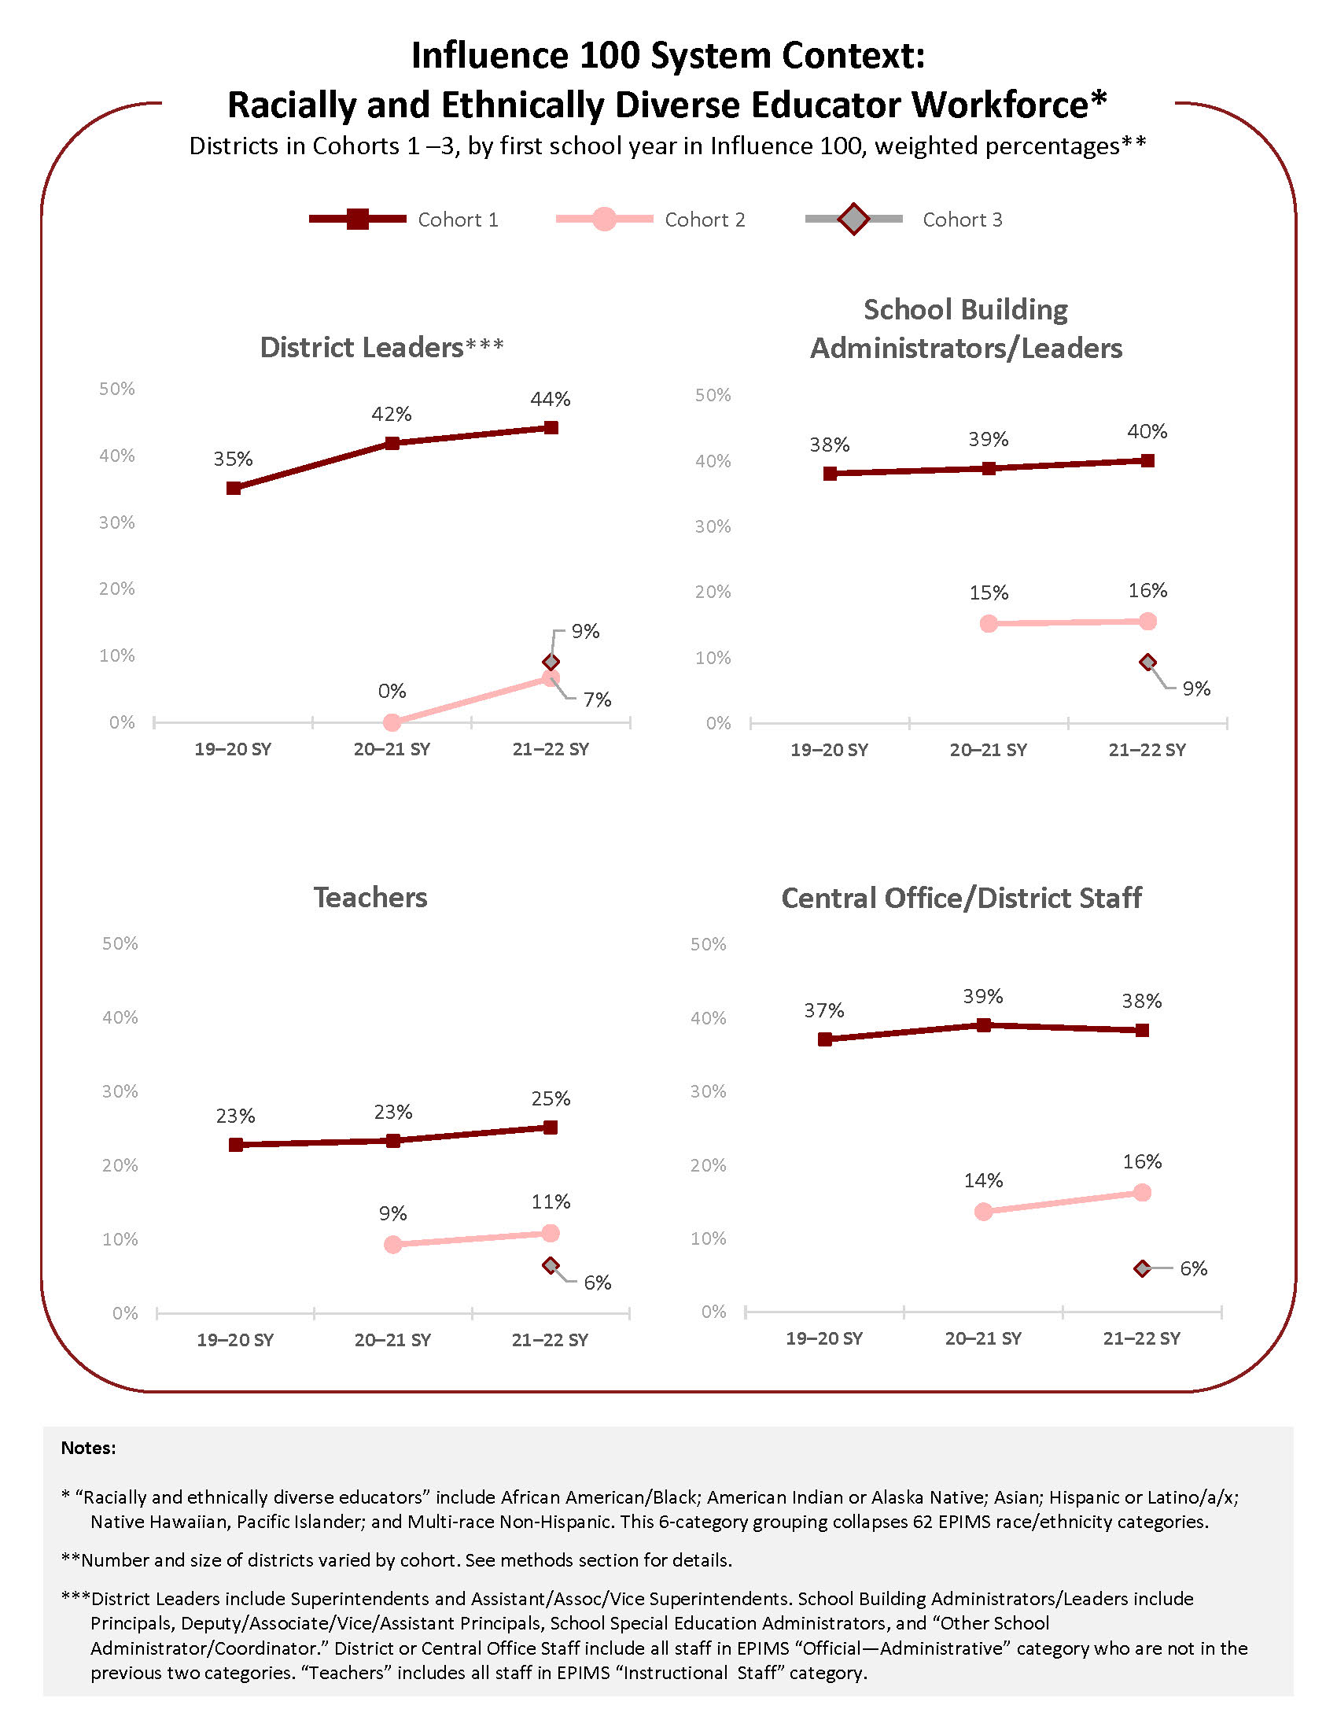

Influence 100 System Context: Equity in Access to Teachers Metrics
Three-year average risk ratios, weighted by number of students (Cohorts 1–3 combined, by school year)
Risk ratio Interpretation:
• Risk ratios of 1.00 means that both groups were assigned at the same rate to teachers with that characteristic.
• Risk ratios smaller than 1.00 indicate that students in the subgroup were less likely than students not in that group to be assigned to teachers with that characteristic.
• Risk ratios larger than 1.00 indicate that the students in the subgroup were assigned to teachers with that characteristic at a higher rate than students not in that group.
• DESE deems risk ratios of 1.5 or higher as equity gaps.

Notes:
- These charts represent data from the 26 districts that participated in Cohorts 1, 2 and 3 (with the exception of collaboratives, which do not have data available).
- In 2022, "effectiveness gap" risk ratios were missing for 6–9 (23%–35%) districts (depending on subgroup).
- Charts show weighted average risk ratios, showing the difference in the rate at which students in each subgroup group have been assigned to a teacher with the given characteristic, compared to students not in that group.

Strategic Considerations
- Consider alternative structures to provide more fellows with positive mentorship experiences. A repeated theme in feedback from fellows, across cohorts and program years, has been the variability in mentorship experiences.
“It would be helpful if there was a better process to monitor district support for fellows. I think that most of us feel that once we were nominated and accepted into the program we were pretty much on our own.”
- Consider engaging school committees as part of district engagement work. Variable district engagement in Influence 100 and related equity work has been a pattern reported across fellow cohorts. Fellows suggested that Influence 100 might contribute to building mutual understanding around equity endeavors between fellows, district leadership, and school committee members—for example, at quarterly district leadership sessions. They noted the “huge role” played by district leadership and school committees in creating the conditions for “superintendents of color to thrive” or to be “pushed out” (as one Cohort 2 fellow articulated). Fellows advocated for “ongoing training and accountability” for school committee members related to supporting equity-focused superintendents of color. Fellows and mentors also suggested strengthening the program’s relationship with the Massachusetts Association of School Committees.
“Perhaps work with the state to get school committees and superintendents serious about the BIPOC superintendency pipeline. Too many talk the talk, but have no idea how to support BIPOC leaders who aspire to the superintendency. They actually create barriers and protect the status quo. This needs to be addressed.”
- Consider incorporating skill building and discussion around managing resistance to equity work and dealing with hostile contexts. Fellows who participated in Year 3 focus groups (Cohort 1 alumni and Cohort 2 fellows) suggested that Influence 100 could do more to acknowledge and discuss the challenges facing aspiring district leaders of color in Massachusetts. Fellows’ suggestions included: bringing in more guest speakers (e.g., current or former superintendents of color in predominantly-White districts) who might be willing to discuss challenges they face(d) and using case studies to build understanding of how to react to challenges and “divergent opinions” about equity work.

Appendices – Influence 100 Year-end Field Guide Report

Contents
Appendix A – Spring 2022 Survey Summaries 1
Appendix B – Focus Groups Summary 83
Appendix C – Survey Instruments 95
Appendix D – Focus Group Protocols 142
Appendix E – Benchmark Methods 150

Some districts and mentors in both cohorts had previously participated in Influence 100 through fellows in an earlier cohort.
https://www.doe.mass.edu/teach/diversity.html
Ten of 27 participating Massachusetts districts (over the course of the first three years of Influence 100) supported fellows in multiple cohorts.
Only Massachusetts districts are counted here (two fellows moved into non-MA districts during their time in the program).
The seventh survey was a mentor survey that included questions about Cohort 2 and Cohort 3 fellows.
https://www.leadershipacademy.org/resources/equity-leadership-dispositions-2/
For mentors, the total number of questions varied depending on the number of fellows they mentored (between 1–3). The survey was structured with a section that asked about individual fellows (and looped based on the number of fellows) and then an overall reflections section.
Of the 12 districts that received the Returning District DLT survey in 2022, 7 were Cohort 1 districts and 5 were Cohort 2 districts. All had either Cohort 2 or Cohort 3 fellows participating during SY 2021–22.
These counts include partial responses. Three mentors had both Cohort 2 and Cohort 3 fellows and are counted in the total number of mentors surveyed for both cohorts. These mentors were given a combined version of the survey.
Mentors could work with more than one fellow, so response rates are presented in terms of the number of mentors surveyed and the number of fellows they responded about. The total number of fellows possibly represented in the mentor surveys is lower than the total number of fellows surveyed because of the movement of both mentors and fellows (e.g., leaving districts) meant some mentors were not surveyed.
https://www.leadershipacademy.org/resources/equity-leadership-dispositions-2/
UMDI, DESE, and The Leadership Academy collaboratively developed this list of practices to capture district-level equity-promoting actions in five broad areas: human capital, climate, curriculum & instruction, policies & practices, and leadership.
Please note, we refer to these metrics as “benchmarks,” although clearly defined criteria for progress or success have not been specified. The current “benchmarks” serve as useful measures of progress.
Metrics derived from survey data (including district and fellows metrics) only reflect those districts and fellows who responded to the surveys.
Notably, indicators of staff perceptions of school climate would be valuable additions to these system-level metrics and relevant to Influence 100. DESE has developed a model survey that includes such measures; however these surveys are optional and not widely used. See Staff Survey on DESE Model Feedback Instruments Administrations Protocols web page here: https://www.doe.mass.edu/edeval/evidence/feedback/surveys.html?section=faq4#faq
Please see Cohorts and Cohort Assignment in the Methods section to understand cohort assignment for districts and mentors.
Promotion and completion data from Influence 100 program office.
Three Cohort 2 mentors also mentored Cohort 3 fellows. These three mentors are counted in the total for Cohort 2 mentors and for Cohort 3 mentors. They were sent a version of the survey that included first-year survey questions for Cohort 3 fellows and second-year survey questions for Cohort 2 fellows.
Some mentors were not surveyed in 2022 because either the mentor or the fellow had left their district. Seven of 10 Cohort 2 mentors were surveyed, and they mentored 10 of the 17 currently participating Cohort 2 fellows.
Three of the 12 Cohort 3 mentors also mentored Cohort 2 fellows. These three mentors are counted in the total for Cohort 3 mentors and for Cohort 2 mentors. They were sent a version of the survey that included first-year survey questions for Cohort 3 fellows and second-year survey questions for Cohort 2 fellows.
Of the 12 districts that received the Returning District DLT survey in 2022, 7 were Cohort 1 districts and 5 were Cohort 2 districts. All had either Cohort 2 or Cohort 3 fellows participating during SY 2021–22.
The exception was the practice of using targeted recruitment strategies in an effort to increase the diversity of district/central office staff (Human Capital, N=3).
It is not clear whether this is an indicator of the lack of helpfulness of such consultations or a reflection of their infrequent occurrence.
As noted previously, half of the 12 districts with Cohort 3 fellows were first-year participants in Influence 100 (and were given the first-year district survey) while the other half were returning to the program (they were Cohort 1 or Cohort 2 districts that also had Cohort 3 fellows) and were given the returning district version of the survey.
The fourth district selected “don’t know/NA” for each of the developed/changed practices in answer to the question about the importance of Influence 100.
These data are presented by cohort starting year—and thus, there is three years of data for Cohort 1, 2 years for Cohort 2 and just one year for Cohort 3.
Please see methods section for a note about how variations in cohort and staff population size impact interpretations of differences between cohorts.
The exception is the “experience gap” for students with disabilities. These students have an average risk ratio below 1 of being assigned to teachers with fewer than 3 years of experience. Data from DESE Edwin Student Learning Experience Reports. https://www.doe.mass.edu/edwin/gateway/SLEreport-supp.html
Risk ratios compare rates at which students in four groups (students with disabilities, students of color, students who are learning English, and students who are economically disadvantaged) are assigned to certain kinds of teachers compared to students who are not in those groups.
Please see the Lessons Learned & Implications section of the 2021 Influence 100 Year-end Field Guide Report for suggestions from mentors and fellows.
Both quotes are from Cohort 2 fellows.
Notably, one Cohort 2 fellow reported “The Mass school Committee association speaker was terrible. He was offensive and not helpful.”

