A case study of the Monomoy Regional School District

A case study of the Monomoy Regional School District

(2023)

VO

### 

### 

### 

### 

Using Social and Emotional Learning Indicator System (SELIS) survey data in a multi-tiered system of support

Using Social and Emotional Learning Indicator System (SELIS) survey data in a multi-tiered system of support

Using Social and Emotional Learning Indicator System (SELIS) survey data in a multi-tiered system of support

Using Social and Emotional Learning Indicator System (SELIS) survey data in a multi-tiered system of support

|  |
| --- |
| ESE logo  This document was prepared by the  Massachusetts Department of Elementary and Secondary Education  Jeffrey Riley  Commissioner  The Massachusetts Department of Elementary and Secondary Education, an affirmative action employer, is committed to ensuring that all of its programs and facilities are accessible to all members of the public.  We do not discriminate on the basis of age, color, disability, national origin, race, religion, sex, gender identity, or sexual orientation.  Inquiries regarding the Department’s compliance with Title IX and other civil rights laws may be directed to the  Human Resources Director, 75 Pleasant St., Malden, MA 02148-4906. Phone: 781-338-6105.  © 2023 Massachusetts Department of Elementary and Secondary Education  Permission is hereby granted to copy any or all parts of this document for non-commercial educational purposes. Please credit the “Massachusetts Department of Elementary and Secondary Education.”  This document printed on recycled paper  Massachusetts Department of Elementary and Secondary Education  75 Pleasant Street, Malden, MA 02148-4906  Phone 781-338-3000 TTY: N.E.T. Relay 800-439-2370  www.doe.mass.edu  State Seal of Massachusetts |



Monomoy Regional School District

Dr. Scott Carpenter

Superintendent

Dr. Scott Carpenter

Superintendent

Monomoy Regional School District

Dr. Scott Carpenter

Superintendent

Dr. Scott Carpenter

Superintendent

Monomoy Regional School District

Dr. Scott Carpenter

Superintendent

Dr. Scott Carpenter

Superintendent

Monomoy Regional School District

Dr. Scott Carpenter

Superintendent

Dr. Scott Carpenter

Superintendent

This case study was written in partnership with Melissa Maguire, Director of Student Services in the Monomoy Regional School District. DESE would like to thank Melissa Maguire, Holly Thyng, and the teachers, staff, and students in the Monomoy Regional School District for their collaboration and continuous support of the SELIS survey project.

Monomoy Regional School District

425 Crowell Road, Chatham MA 02633 ●

Phone: (508) 945-5130

www.monomoy.edu



Contents

Introduction 1

Monomoy Regional School District profile 1

SELIS Content 1

DESE’s Blueprint for a Multi-tiered System of Supports (MTSS) 2

Data and Methodology 5

Monomoy’s Systems Approach to MTSS 6

Leadership Drivers 6

Staff and Curricular Development Drivers 7

Implementation Drivers: A focus on data collection and data-based decision making 9

Using SELIS Data: Monomoy’s MTSS in Action 11

Tier I: A district-wide focus on relationship skills 12

Data Deep Dive: Middle school trends and Tier 1 supports 13

Tier 2 or Tier 3: Identifying individuals and groups of students in need of more intensive support 15

Data Deep Dive: Using competency scores and SWON maps to help identify students’ SEL needs and intensity of need 17

Triangulating data to assess students’ need for additional supports 20

Data Deep Dive: Exemplar of triangulating data to inform supports 21

Conclusion 25

References 27

Appendix A: Collaborative for Academic and Social and Emotional Learning’s (CASEL) Conceptual Framework 28

Appendix B: SELIS Item Prompts 29

Appendix C: District’s Needs Assessment Questions 31

Appendix D: Systems planning document for Monomoy’s SEL/Behavior strategic initiatives 32

Appendix E: Monomoy Regional School District’s SELIS Data Usage 33

Appendix F: Social Emotional Learning Tiered Systems of Support and Usage of SELIS Data 34

Appendix G: Guidance on interpreting SE scaled score differences 36

Appendix H: Identifying students for Tier 2 or Tier 3 interventions 37

Appendix I: Student SEL goal setting template 38

Appendix J: Example of Student Goal Setting Sheet 39

Appendix K: Crosswalk of social skills domains/values with SELIS core competencies 40

Appendix L: Examples of social skills streaming cards sent to parents 41

# Introduction

The Social and Emotional Learning Indicator System (SELIS) was designed to provide schools and districts with a reliable, accessible measure of students’ social and emotional skills. Monomoy Regional School District (henceforth, Monomoy) was the first Massachusetts district to field-test the Social and Emotional Learning Indicator System (SELIS) survey and has administered the survey every fall and spring since 2018. This case study details how Monomoy uses SELIS data in combination with other sources of data to bolster its tiered system of student supports. The integration of the SELIS data into a systems approach to district leadership helped inform the district in its strategic planning, in making decisions to strengthen social and emotional learning programming, and in designing and assessing tiered supports for students’ social and emotional learning and wellbeing. In doing so, Monomoy puts SELIS data into action to help students develop their social and emotional competence and support their social and emotional wellbeing.

In the remainder of the introduction, the case study provides a profile of the Monomoy school district, background information on the SELIS survey, and outlines DESE’s blueprint for a multi-tiered system of supports (MTSS). The MTSS framework is used as a template[1] to report how Monomoy used a systems approach to improve students’ social and emotional learning (SEL) and competence. Next, the study examines how Monomoy utilized SELIS data to inform its tiered supports to students. It is important to remember that even though SELIS data use is the focus of this case study, SELIS is only one data source that Monomoy uses to inform its tiered system of supports; the strength of Monomoy’s approach is that they integrate and triangulate SELIS data with other student/systems data they collect to make informed data-based decisions on their social and emotional learning strategic goals and tiered supports.

## Monomoy Regional School District profile

Monomoy is located in southeast Massachusetts. It is a small (approximately, 1800 students K­–12) predominantly White district with just over three-fourths of the district’s students identifying as White. Compared to the state, the district has a small English learner population. The percentage of students that are low income is slightly lower than the state’s with the percentage of students with disabilities within the district comparable to the state average. More information about Monomoy is available [here](https://profiles.doe.mass.edu/general/general.aspx?topNavID=1&leftNavId=100&orgcode=07120000&orgtypecode=5).

## SELIS Content

The SELIS items are designed to measure students’ social and emotional (SE) skills in five competencies. These competencies were founded on the Collaborative for Social and Emotional and Academic Learning’s (CASEL) conceptual framework (Appendix A). The five core competencies are students’ self-awareness skills, students’ self-management skills, students’ relationship skills, students’ social awareness skills, and students’ responsible decision-making skills. The competencies are defined by CASEL as follows:

1. **Self-awareness skills (SA):** This competency measures students’ abilities to understand one’s own emotions, thoughts, and values and how they influence behavior across contexts.
2. **Self-management skills (SM):** This competency measures students’ abilities to manage one’s emotions, thoughts, and behaviors effectively in different situations and to achieve goals and aspirations.
3. **Social awareness skills (SOC):** This competency measures students’ abilities to understand the perspectives of and empathize with others, including those with different backgrounds, cultures, and contexts than their own.
4. **Relationship skills (RSK):** This competency measures students’ abilities to establish and maintain healthy and supportive relationships and to effectively navigate diverse settings.
5. **Responsible decision-making skills (RDM):** This competency measures students’ abilities to make caring and constructive choices about personal behavior and social interactions across diverse situations.

The SELIS is predicated on the Social and Emotional Competency Assessment (SECA, Davidson et al., 2018; Crowder, 2019) developed by a team of researchers, educational practitioners, and the Collaborative of Social and Emotional Learning (CASEL). New items were also developed by DESE and practitioners to improve the responsiveness and reliability of each of the five competencies (DESE, 2021). Appendix B provides a summary of the item statements used in SELIS.

## DESE’s Blueprint for a Multi-tiered System of Supports (MTSS)

DESE (2019, p.2) advocates that the MTSS framework (Figure 1) is ideally suited to help schools and districts support students’ academic, social and emotional, and behavioral goals. The framework and goal for having districts and schools use a MTSS framework is characterized below:

“MTSS is a framework designed to meet the needs of all students by ensuring that schools optimize data-driven decision-making, progress monitoring, and evidence-based supports and strategies with increasing intensity to sustain student growth. MTSS is not just about tiered interventions, but rather how all the systems in a school or district fit together to ensure a high-quality education for all students.”

Figure 1: Components of a Multi-tiered System of Support

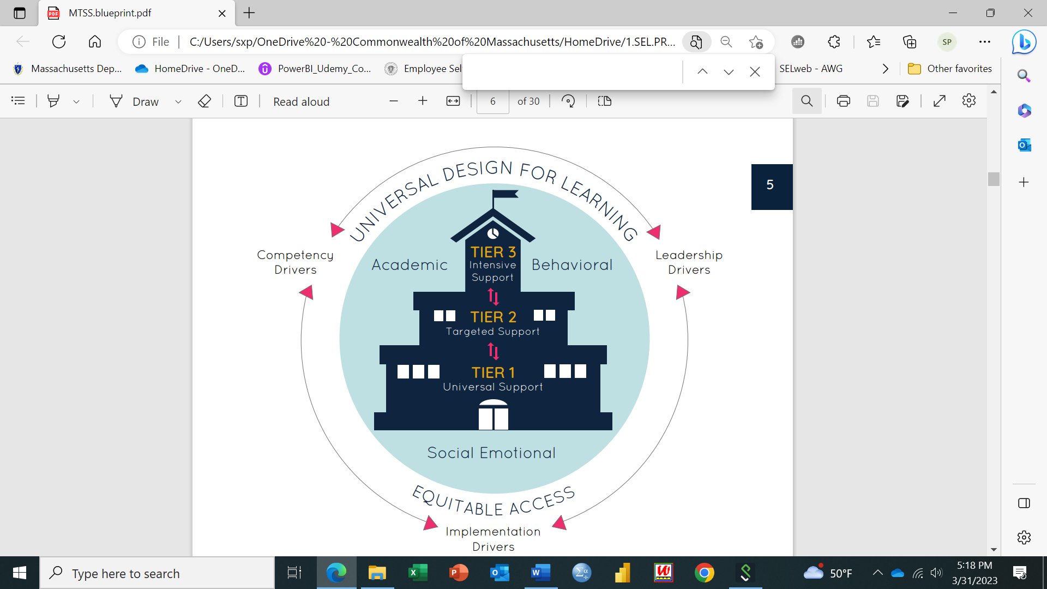

#### Components of MTSS

A MTSS is founded on universal design principles for learning, equitable access to learning and supports, and the use of a tiered system of supports that increases the intensity of support depending on a student’s needs (academic, social and emotional, or behavioral needs). Key to MTSS sustainability are three systems-level drivers that are needed to set up the conditions for an effective MTSS, namely, leadership drivers, competency drivers, and implementation drivers. This section briefly describes each of these components of MTSS. Readers can find more information on each component of MTSS [here](https://www.doe.mass.edu/sfss/mtss/blueprint.pdf).

The goal of universal design for learning (UDL) is to reduce barriers in instruction (such as physical, cognitive, intellectual, or organizational), by proactively providing appropriate accommodations and supports that enable *any* student to meet challenging grade-level expectations for learning. This is accomplished through ensuring there are multiple means of engagement, multiple representations of acquiring information and knowledge, and multiple means of expression so students have different options to show what they have learned. Equitable access is fundamental to UDL and the MTSS framework as a whole. For all students to succeed, all students need equitable access to high quality, culturally responsive instruction and supports. Learning experiences that are inclusive and value students’ identities and assets are critical to using a strength-based approach to teaching and learning. All students are considered general education students and have access to Tier 1 supports with Tier 2 and Tier 3 supports considered supplemental to these Tier 1 supports.

At the core of the MTSS framework is the concept of tiered student supports. Tier 1, or universal, supports are available to all students through an inclusive, culturally responsive curriculum (academic or social and emotional learning curriculum). Inclusive practice is defined as, “instructional and behavioral strategies that improve academic and social and emotional outcomes for all students, with and without disabilities, in general education settings” (DESE, 2019, p. 9). Culturally responsive teaching and instruction is shaped by students’ culture, values all students’ identities, promotes respect for student differences through modeling and scaffolding and reaches out to families and the local community to ensure they are engaged in students’ academic, behavioral, and social and emotional wellbeing. Tier 2 supports are in addition to Tier 1 supports and generally are targeted toward small groups where they can receive additional practice or instruction to support their core academic or SEL instruction/skill building. Tier 3 provides more intensive supports, often at the individual level or very small group level; these supports are very targeted and explicit to support a student’s academic, social and emotional, or behavioral needs.

To implement a sustainable MTSS, the *leadership* within a district have to be invested in planning and creating the conditions and systems needed to foster an effective MTSS. Leaders are tasked to identify and remove barriers that might interfere with the development of the MTSS (e.g., appropriate professional development, lack of buy-in from educators and families) and ensure that there are structures (such as time for collaboration and training) set up to effectively implement a MTSS. Without leadership driving and taking on the responsibility to implement and set up the conditions needed for a MTSS, the MTSS is unlikely to successfully meet the needs of all students and any tiered system of support is less likely to be implemented with fidelity. Building educator capacity is at the heart of the *competency driver*; educators need access to high quality professional development, effective coaching, and supports so all educators understand and have the tools to effectively implement the components of MTSS. Through planned and thoughtful strategies to increase educator capacity, the core belief that all students can learn with appropriate supports creates the mindset that all students can achieve at high levels.

Lastly, effective organizational systems are needed for tiered instruction and interventions to be successful. All educators need to be aware of tier 1 academic and social and emotional learning expectations and universal supports. Instruction, interventions, and supports are evidenced-based and form a continuum of increasing support, so all students’ needs are met. Identifying and coordinating evidence-based tiered supports, so all students (even students with disabilities and English learners) are in the least restrictive learning environment and included in the general education setting is fundamental to MTSS. Implementation of tier 2 and tier 3 interventions require trained and often specialized support staff. MTSS also requires a comprehensive data collection system, data culture, and competency within the district. Data is collected that can assess the fidelity and monitor the effectiveness and progress of the district’s tiered supports. Continuous assessment of the *implementation* of the tiered supports helps educators adapt the supports mid-course and enable them to make data-informed decisions to improve the supports provided (for example, based on data, educators may decide mid-year that a student needs more individualized supports and move a student from tier 2 to tier 3 supports).

There are many components to a MTSS (figure 1), and it is not just about describing the tiered supports provided to students in a district. A MTSS involves an integrated systems approach to ensure students have equitable access to universally designed curriculum and supports and that success can be governed by key drivers within the system (leadership, competency, and implementation drivers). Once the systems and drivers are in place, the tiered system of supports is at the core of the MTSS model. Using the MTSS framework as a template, this study will first describe Monomoy’s systems approach and the key systems drivers it used to successfully implement MTSS in the district. Because the focus of the case study is on how SELIS data informed Monomoy’s tiered systems of support, a large part of the study will concentrate on the core component of the MTSS, namely, Monomoy’s student tiered supports and how SELIS data is used to inform decisions made to provide students with support. There is limited emphasis on UDL and equitable access components of Monomoy’s MTSS as these are beyond the scope of this study.

# Data and Methodology

This study draws on artifacts provided by Monomoy and primarily uses SELIS data from their middle school to illustrate how the district used SELIS to inform their tiered student support system. Monomoy’s middle school serves approximately 450 students in grades 5 through 7.

Monomoy administers the SELIS survey using Google Forms. A Likert scale with four response options was used to rate students’ perceptions of how hard or easy each SE skill assessed was for students to acquire or apply. Coding for all items dictated that a response of “0” (*very hard*) indicated a student’s least positive response to the SE skill, with a “3” (*very easy*) denoting the most positive response. Response scoring categories “1” and “2” corresponded to *hard and easy*, respectively. Data collection in the district began in the fall 2018 and, as of this writing in 2023, approximately 5,500 students have participated in SELIS. The district did not stop survey administration during the COVID-19 pandemic.. For further information about the SELIS items and the broader implementation of SELIS in other pilot districts, please see the accompanying [Research Brief](https://www.doe.mass.edu/research/selis/research-brief.docx).

Initially in the partnership, DESE transformed students’ item responses using the Rasch Rating Scale model (Rasch, 1960; Linacre, 2023) to produce scaled scores for the five SE core competencies and the social and emotional (SE) construct as a whole. The raw item response data from Google Sheets is reported out into Excel and subsequently imported into Winsteps (Linacre, 2023) so that the six scaled scores can be computed. In addition, Winsteps produces individual student item response maps (called SWON maps). A SWON map is a data visualization tool that helps identify an individual student’s SE skills strengths and areas for SE skills growth. Readers are directed to DESE’s [user-guide](https://www.doe.mass.edu/research/selis/user-guide.docx) for a detailed explanation of how to interpret the maps. This study includes examples of how practitioners used SWON maps to support students’ social and emotional wellbeing. Monomoy is exceptional in that they underwent training by DESE to learn how to use Winsteps and they did their own SELIS scaled score analysis, SWON map production, and SELIS data analyses.

# Monomoy’s Systems Approach to MTSS

The systems approach that guided Monomoy’s integration of SELIS data into the MTSS meant that changes were made at multiple levels within the district. In what follows, this study focuses on the drivers of change in leadership, staff, curricular development, and in implementation. In each of these areas, Monomoy focused on creating systems and structures that were supported with financial resources and time commitments, that were informed by the broader community, and that encouraged sustainable change in district/school culture. Within each of these areas, Monomoy dedicated resources to student, family, and community input.

## Leadership Drivers

The first step taken by Monomoy to realize its vision for strengthening students’ social and emotional wellbeing was to incorporate a strategic objective related to social and emotional learning (SEL) into the district’s strategic plan. The impetus for including SEL in their strategic plan came from deliberate planning and inclusion of the voice of community members. In 2018, over 100 community members (parents, students, teachers, administrators, and community members) formed several focus groups to guide the strategic vision and plan for the district. Over 10 meetings within a 2‑month period, a 15-member steering committee synthesized the focus groups’ input and vision into a 3-year strategic plan. This steering committee included leaders of the district (Superintendent, Director of Student Services, Director of Curriculum, Instruction, and Assessment, principals), parents, school committee members, education specialists, and community members. Through this deliberative process, the district developed a strategic objective to strengthen students’ social and emotional wellbeing. By solidifying SEL as a strategic goal, the district was able to officially dedicate time to considering how their vision for students’ social and emotional wellbeing would fit into their academic and other behavioral goals for their students. The goals were (1) to develop healthy, supportive relationships and (2) to fully integrate a SEL curriculum into the classrooms to support the social and emotional/behavioral health of their students. To accomplish these goals, the district determined that they would target student character development and resiliency and strengthen school climate and culture using a tiered system of support.

Figure 2 summarizes the planning process that Monomoy used to realize its SEL strategic objective. A SEL/behavioral health steering committee was established; similar to the overall steering committee, the SEL/behavioral health committee included the Direct of Student Services, school psychologist, counselors, nurse, teachers, parents, and community members such as the Harwich Youth and Family Services. This committee had the shared responsibility and authority to undertake a resource and needs assessment of their staff and students, identify and schedule high-quality professional development for staff, identify and support the implementation of evidence-based programs/curricula that could help support students’ SEL/behavioral needs, integrate SEL into all three levels of school functioning, and develop and undertake ongoing monitoring of their progress. The resource and needs assessment extended to not only the needs of staff and students, but also an assessment of the needs of Monomoy’s families and community agencies. Appendix C shows questions asked that were used to support the needs assessment.

Figure 2: Social and Emotional Learning Integration Plan

The graphic shows Monomoy's social and emotional learning integration plan. This plan summarizes the planning process that Monomoy used to realize its social and emotional learning strategic objective.

## Staff and Curricular Development Drivers

Monomoy reviewed and identified professional development (PD) that staff could participate in to make sure they had the tools, resources, and internal capacity to implement a multi-tiered system of student supports. PD was structured and planned; for example, all staff spent a full day being trained on [Collaborative Problem-Solving](https://thinkkids.org/) that is offered by Massachusetts General Hospital. Having all staff trained in the program ensured that all adults serving K through 12 students have the needed understanding of SEL skills to develop healthy relationships. These skills are reinforced as students move up through the school system, and any discipline required is provided in a consistent manner and applied using a restorative lens. In addition, twenty staff members were identified who went on to receive level 2 and 3 training to be coaches; this helped maintain the consistency and the sustainability of the PD. Most staff have also participated in professional learning focused on SEL concepts that underpin the SEL programs selected for the district (see next section) and these trainings are offered at least once a year to all staff as part of an in-service day. The Positive Behavioral Interventions and Supports (PBIS) framework, similar to the MTSS framework, underpins their efforts to support students; PBIS takes a tiered systems approach to ensure that students and staff have access to appropriate programs and behavioral interventions to support students.

To support students, age-appropriate evidence-based SEL/behavioral curricula, instructional strategies, and interventions were identified or developed and executed in the district with teachers and/or counselors systematically trained in their implementation. The SEL steering committee went through a data-driven screening process (committee members rated each program under consideration) and the consensus was that the Zones of Regulation (PK to 12), Second Step® (PK – 4), and Botvin Lifeskills® (3 – 12) curricula met their students’ social and emotional and behavioral needs. All these programs are evidence-based and have been shown through research to have a positive effect on students’ wellbeing. For example, Second Step® has been shown to reduce the number of exclusionary discipline incidences in schools and increase students’ social and emotional knowledge (Low, Cook, Smolkowski, Buntain-Ricklefs, 2015; Koonce, 2019). Programs such as Second Step® have fully scripted SEL lessons that are easy to integrate into the classroom day. To facilitate integration of these programs in the classroom, counselors and the mental health coordinator are available as coaches; the level of support is guided by the needs of the classroom teacher. The teacher could ask for the specialist/counselor to observe her/his classroom and provide feedback, co-teach SEL/Behavior lessons, or fully teach and model SEL/behavior lessons. All these programs are proactive in nature as they are designed to give students the tools and knowledge they need to succeed, and being administered at Tier 1, these programs buttress the equitable provision of supports as they are designed for all students in the district. They also help educators determine what students may need additional supports and more intensive interventions. To successfully implement and sustain the internal capacity of their staff, monies were budgeted, and ongoing support was provided that both allowed teachers the time for SEL training and peer observation, and the mental health coordinator the space to help with implementation in each of the school buildings.

To integrate SEL at all three Tiers, teachers and other adults promote and model SE approaches not just in the classroom but throughout the school (e.g., in the hallways, playground etc.). Tier 2 and 3 supports are aligned with the SEL instruction taking place in Tier 1, as are the discipline guidelines used to support positive behavior in the schools. At the middle school, for example, seminar blocks are scheduled weekly where SEL lessons and activities are implemented. At the high school, there are several SEL clubs/activities during the “Jawsome” hour (e.g., yoga, mindfulness, etc.). Administrators also model SEL in the way they run their meetings and in the way decisions are made.

Finally, involvement and collaboration between students, staff, families, and community partners is considered a “key component in determining and providing appropriate supports for all students” (DESE, 2019). Knowing the importance of family to students’ wellbeing, Monomoy implemented professional development related to cultural diversity and developed ways for families to access resources. For example, skills cards are sent home to parents whose child is receiving Tier 2 interventions. At the elementary level, parents also have access to Second Step® activities that can be practiced at home. This type of family engagement ensures that communications and interactions with families are done in a consistent, collaborative, and culturally responsive ways, and that a common language is used so families can engage with their students to reinforce their SE skills. Community and external partners also supported Monomoy’s efforts. As mentioned, several parents were on the SEL steering committee which helped ensure parent buy-in for the SEL programming as a whole and a high level of student participation in the SELIS.

Appendix D shows a systems planning tool from 2018 for Monomoy’s SEL/Behavioral strategic initiatives. This artifact highlights how the district’s systems approach ensures the conditions and actions needed to successfully implement their SEL/Behavioral health initiative were put in place and were sustainable.

## Implementation Drivers: A focus on data collection and data-based decision making

Leadership and competency drivers are not the only drivers needed for successful implementation of a MTSS. Implementation drivers within the district are also needed. One of the key implementation drivers is to ensure that data is collected and analyzed to drive decisions related to the MTSS as well as to monitor and assess the fidelity of implementation and expected improvement resulting from all the SEL efforts in the district. Monomoy set up the needed structures, data culture, and data competency to enhance the use of the student data collected by the district.

The importance placed by Monomoy on using data to drive decision-making is evident in their development of staff competencies in data use, resources dedicated to their data systems, and collection of multiple sources of student data. For example, Monomoy used information acquired from the CASEL website to evaluate which evidence-based SEL programming met their local needs and in assigning their Data, Compliance, and Assessment specialist to train in the analyses of the SELIS data collected. In addition, the data collection system was designed to help the district assess, evaluate, and monitor their social and emotional learning initiatives and to ensure that they could identify their most vulnerable students in the greatest need of support. Figure 3 highlights the process used by Monomoy to collect and use data in decision-making.

This data system contains multiple sources of student data that are used in decision making. Universal screeners’ data (e.g., SELIS, Screening Brief Intervention and Referral to Treatment (SBIRT), Social Skills Improvement System (SSIS) and Social Skills Assessment (SSA)) are reviewed along with other data (e.g., classroom observations, attendance, suspension, academic, etc.) to help the district identify students and groups of students in need of more intensive support. Student support teams (SST) meet to discuss, in consultation with teachers, what types of interventions are needed to best support a student or group of students. The SST offers coaching as needed.

Figure 3: Monomoy’s data collection process1

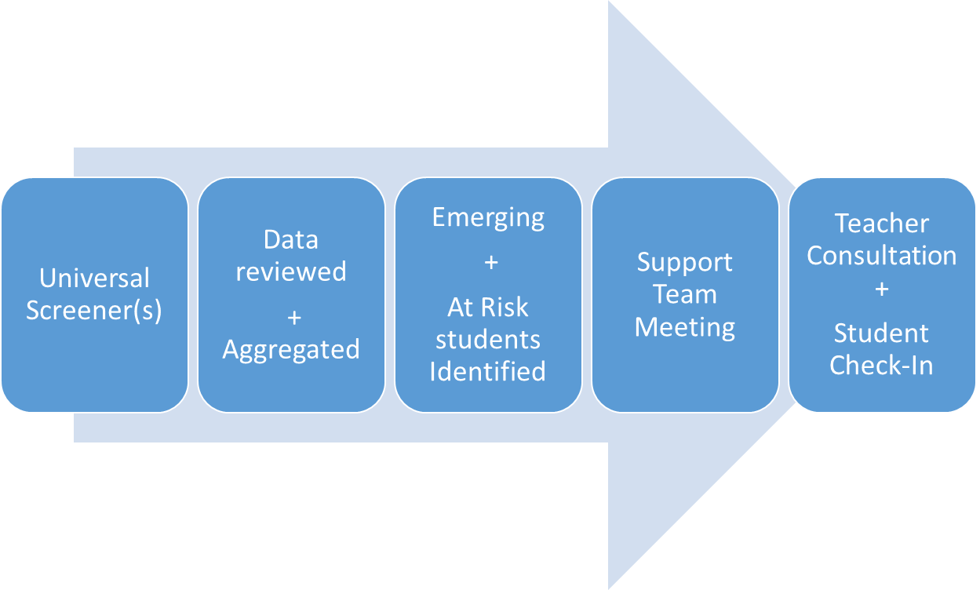

1Figure provided by MRSD

The data is also reviewed at the aggregate level to help monitor progress in SEL programming and interventions, and to determine if there are any gaps in traditionally marginalized students’ social and emotional skills and learning. Any gaps found could, for example, indicate that there is an inequitable provision of supports to these students and/or illuminate that certain student groups have, on average, lower SE skills in one competency compared to others. DESE’s SELIS [research brief](https://www.doe.mass.edu/research/selis/research-brief.docx) (DESE 2023a) found that African American/Black students report, on average, lower relationship skills than their White counterparts. This type of data can be used to better target supports for these marginalized student groups.

Important to the success of using data to drive decision-making related to SEL is the need to triangulate all data collected so as to get a more holistic picture of a student or group of students. Monomoy uses student self-report data such as SELIS alongside teacher/counselor-reported data such as SSIS or SSA. These three screeners combined with other administrative data about their students are reviewed and synthesized to develop supports. Having multiple sources of information and a culture that values assessment data helps ensure that the programmatic and instructional decisions taken to support students are valid, reliable, and effective.

Monomoy’s MTSS embeds the key components needed to help the district make informed decisions related to students’ social and emotional wellbeing. The district is proactive in implementing evidence-based instructional practices to support grade-appropriate students’ SEL and development, and decisions and processes are driven by data to ensure that students are provided the appropriate degree of support based on their needs. The three systems drivers in the district (leadership, competency, and implementation) complement and work synergistically to strengthen their supports to students. SELIS data is just one small piece of a much larger integrated system. Its place in this system is to help Monomoy collect reliable data that supports the district’s assessment, evaluation, and monitoring of their social and emotional learning initiatives (instruction and tiered supports) and to ensure that they can identify and use data to help their most vulnerable students that are in the greatest need of support.

# Using SELIS Data: Monomoy’s MTSS in Action

The remaining part of this study addresses how SELIS data is used to support decision-making related to Monomoy’s SEL tiered support system. As discussed, tiered interventions are targeted to support social and emotional development and growth. Tier 1 SEL supports (e.g., an initiative to build stronger relationships among students) can be classroom- or school- or even district-wide. They are available to all students through a general education program and inclusive practices. Students with more intensive needs are provided with supplemental supports that are characterized as Tier 2 (e.g., a small group social skills program) or as Tier 3 (e.g., individual counseling to strengthen a students’ social awareness and relationship skills). The focus is to use student data to proactively drive systems change that can better support students, and to target the right kind and intensity of support to meet all students’ social and emotional needs. Figure 4 summarizes some of the ways SELIS data is specifically used to inform the three tiers of student supports in Monomoy and these are discussed in the following sections. Appendix E and Appendix F provide additional ways in which the district uses SELIS data to inform their tiered support system. The use of SELIS data to analyze the effect of the district’s efforts in each tier are discussed next.

Figure 4: SELIS informed tiered supports

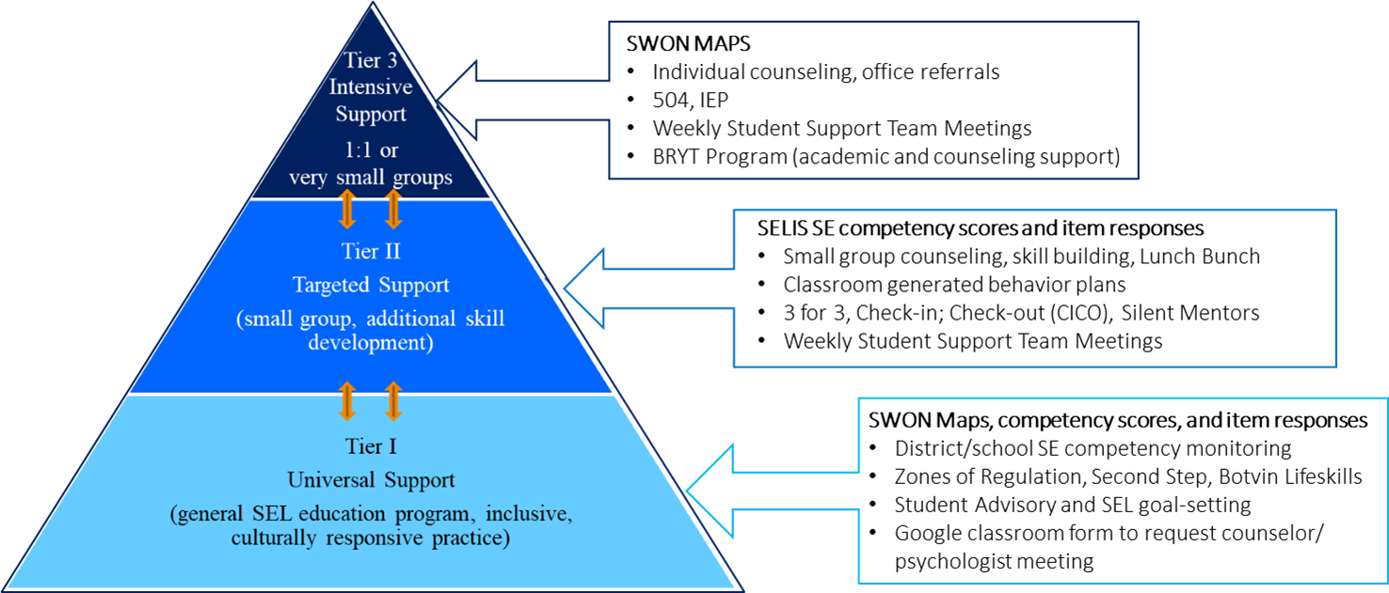

## Tier I: A district-wide focus on relationship skills

As mentioned, one goal of the SEL strategic objective is to strengthen students’ and staff’s social and emotional wellbeing by building healthy relationships among and between students and staff. The district identified relationships as a key metric in assessing their efforts to meeting this objective. One outcome of the SELIS data is a scaled score for each student’s self-reported relationship skills, which was used to monitor students’ relationship skills over time to determine if the district was making inroads into their goal of building healthy relationships. Over the course of the study, Monomoy triangulated this data with other data they collected. For example, the district implemented a Connectedness survey to all students in grades 3 through 12 that specifically asks about their relationships with staff members. The key outcome from this survey was to determine if students have one adult in their school that they can go to if they are faced with a challenge. In addition, the district implemented the Social Skills Improvement System (SSIS) performance screener in their elementary schools; this screener is a teacher report of students’ prosocial behavior, motivation behavior, and assessment of their reading and mathematics skills. This triangulation of data helps the district make more informed decisions on the type and intensity of supports provided to students.

### Data Deep Dive: Middle school trends and Tier 1 supports

In this section, SELIS data from the middle school is drawn on to demonstrate how the data is used to design, monitor, and assess Tier 1 supports. The middle school serves students in grades 5, 6, and 7 and has the most complete trend data to analyze. Figure 5 shows the trend in the middle school’s average competency scores from fall 2018 through fall 2022. Relationship skills (blue line) was the one competency in which the average score declined (albeit small in magnitude) between the fall and spring of the 2018-2019 school year; in contrast, other SE competency areas showed some improvement or remained stable. This data confirmed the district’s decision to focus on improving relationship skills and to target Tier 1 supports and professional development toward this goal.

Across the district, all staff participated in the [Collaborative Problem-Solving (CPS)](https://thinkkids.org/) program training offered by the Massachusetts General Hospital (MGH). This program provides strategies for educators to help students build skills such as, “flexibility, frustration tolerance, and problem solving” (MGH, 2021). Educators work with students to develop these skills and build relationships with and among their students. This evidence-based program has been shown to reduce challenging behaviors in the classroom by developing students’ relationship skill (MGH, 2021). The program also targets adult mindsets; its theory of action claims that if teachers better understand why students struggle to behave as expected and are provided the tools to support students, students will build the needed skills to develop strong positive relationships, and as a result, challenging behaviors in the classroom will decrease.

Complementing the MGH training, Monomoy implemented the Botvin Lifeskills Curriculum at the middle school and high school. This program is a substance abuse program that includes improving students’ self-management and social/relationship skills in order to help them resist drug, alcohol, and tobacco use. In addition, student advisory blocks were used to teach students specific SE skills. Lastly, all students could request individual support from counselors or the school psychologist by using a Google Form that is accessible to all students. These Tier 1 supports and educator professional development were designed to strengthen all students’ social and emotional wellbeing through a comprehensive skills-based education program and through improved access to counseling and psychological support.

The trend data shows that the SELIS instrument appears sensitive and able to measure change in students’ self-reports. This is particularly apparent when the district chose to continue administering SELIS after the onset of the COVID-19 pandemic (middle and high school only). Figure 5 shows that Monomoy middle school students, on average, reported less positive SE skills across all five core competencies after the pandemic’s

Figure 5: Trend in Monomoy Middle School's SE competency scores: Onset of Covid demarcated1

**Covid**

1SE: composite SE score; SA: self-awareness score; SM: self-management; SOC: social awareness; RSK: relationship skills; RDM: responsible decision-making score.

onset. The average SE score declined from 507 points in spring 2020 to 493 points in the spring of 2021; this 14-point decrease is equivalent to 6 percentiles (a small decline).

The overall SE score began to stabilize by fall 2021 with an average score of 489 (the decline between spring 2020 and fall 2021 is equivalent to 8 percentiles or moderate decline). Over the same time period, the Relationship Skills average score declined from 515 to 498 between spring 2020 and spring 2021 and further declined to 490 by fall 2021 for a total decline of 25 points between spring 2020 and fall 2021 (10 percentiles, or a moderate/large decline). Students’ relationship skills exhibited the largest point decline of the five competencies; this is not surprising given that students were relatively isolated from interacting with their peers, teachers, and other adults and unable to practice and hone their relationship skills in normal contexts (e.g., classrooms, lunchrooms, playgrounds, etc.).

However, the district’s strategic focus on building relationships skills within the district may help explain why the relationships skills competency score appears to recover better than the other four competency scores over time. Across the district, the average relationship skills score increased by 9 points from 490 in fall 2021 to 499 in fall 2022 (3 percentiles). This increase is very small/small in size but between 1.5 to 2.0 times higher than the point increases found for the other four SE skill areas.

It is not possible to definitively conclude that the CPS, Botvin curriculum, and other initiatives implemented caused students to report improved relationship skills between spring 2019 and spring 2020 (25-point increase, large difference) as there is no “control group” for comparison and students were not randomly assigned to these interventions (a needed condition to assess causality). The impact of the interventions cannot be disentangled from other SEL-related initiatives in the district and the heightened awareness among educators to focus on and support students’ social and emotional wellness in general. They also cannot be separated from the effect of the COVID-19 pandemic. However, by setting fall 2018 as the baseline administration, *trends* in students’ self-reported SE skills can be accurately measured using the SELIS.

## Tier 2 or Tier 3: Identifying individuals and groups of students in need of more intensive support

The SELIS data can be disaggregated to assess and monitor how traditionally marginalized student groups assess their SE skills; this type of analysis helps to identify potential inequities in the supports provided to these students and/or better target supports for these groups. Figure 6 shows the district trend in students’ overall social and emotional competence broken out by students with disabilities (SWD) status. When possible, data from all students in the district are used for this comparison; elementary students did not participate in the SELIS in the spring 2020 administration, so these data should be viewed with caution.

Appendix G provides a guide on how to interpret SE scaled score point differences and this guide is used in this study. The SWD gap for the two administrations before the onset of the COVID-19 pandemic was moderate to large in magnitude (24 points, ~12 percentiles) with SWD reporting lower, on average, SE skills than students without disabilities. The gap was largest (29 points, ~14 percentiles) in the spring of 2021 when all students were just returning to in-person learning. The SWD gap has narrowed from ~14 percentiles (large gap) in spring 2021 to ~4 percentiles (small in magnitude) in fall 2022.

Figure 6: Trend in SE score by students with disabilities status (District-level)**1**

|  |  |  |  |  |  |  |  |  |  |
| --- | --- | --- | --- | --- | --- | --- | --- | --- | --- |
| Point Difference | *21* | 24 | 24 | *5* | 25 | 29 | 21 | 16 | 11 |
| Participants | *6612* | 992 | 1180 | *589****3*** | 1185 | 1141 | 927 | 886 | 1188 |
| % SWD | *12.3* | 14.6 | 14.7 | *13.6* | 14.3 | 13.8 | 15.4 | 14.2 | 16.0 |

**1**SWD are under-represented in survey samples by 1% to 2.6% points; **2**Data are not comparable as SWD status of middle school students was missing; 3Data not comparable as elementary students did not participate in spring 2020 due to Covid.

To help understand if all five core competencies contributed to the narrowing of the overall SE gap, the point differences (and approximate percentile differences) were calculated for each competency across time. Because the middle school students were missing their SWD status in the fall of 2018 data collection, theses analyses began with the spring 2019 administration. Table 1 shows the gap over time for each SE competency.

Evident from the data in Table 1 is that all five competency score gaps narrowed from the peak competency gaps in spring 2021 to those assessed in fall 2022. Up until the fall of 2021, the gaps were mostly moderate or large in size. The narrowing of the gap in social awareness and relationship skills appears more pronounced when compared to the other three competencies with no gaps apparent by fall of 2021. Except for self-management skills, the gaps in the other two competencies (self-awareness and responsible decision-making) are very small or small in size by the fall 2022. The self-management gap fluctuates between moderate and large over the seven administrations with no conclusive narrowing over time. These data suggest that students with disabilities’ self-management skills are a potential area for the district to target for additional supports. Dependent on the severity of the need, these supports could be provided as a small group (Tier 2) or individual one-on-one support (Tier 3). As mentioned, one of the strengths of Monomoy’s approach to using data is that the district triangulates data from multiple sources to identify students in need of support. The SSIS artifact shown in Appendix H indicates that many at-risk students need support to improve their self-management skills and have been assigned to skills-based groups or to 1:1 support through their Individualized Education Plans (IEP). Many of these students are students with disabilities.

Table 1: Students with disabilities social and emotional competency gaps across time 1,2

|  |  |  |  |  |  |  |  |  |  |  |  |
| --- | --- | --- | --- | --- | --- | --- | --- | --- | --- | --- | --- |
| **Competency3** | **Spring 2019** | **Fall**  **2019** | **Spring 20204** | **Fall**  **2020** | | **Spring 2021** | | **Fall**  **2021** | | **Spring 2022** | **Fall**  **2022** |
| SE | 24 (12) | 24 (12) | NA | 25 (12) | | 28 (14) | | 20 (10) | | 15 (7) | 11 (5) |
| SA | 25 (12) | 22 (11) | NA | 24 (12) | | 31 (15) | | 23 (11) | | 13 (6) | 6 (3) |
| SM | 24 (12) | 34 (16) | NA | 23 (11) | | 31 (15) | | 25 (12) | | 18 (9) | 20 (10) |
| SOC | 20 (10) | 14 (6) | NA | 21 (11) | | 21 (11) | | 15 (7) | | 22 (11) | --- |
| RSK | 24 (12) | 20 (10) | NA | 17 (8) | | 18 (9) | | --- | | --- | --- |
| RDM | 38 (17) | 33 (16) | NA | 37 (17) | | 29 (14) | | 24 (12) | | 12 (6) | 5 (2) |
|  | | | | | | | | | | | |
| No gap apparent | Very small | Small | Small/  moderate | | Moderate | | Moderate/  large | | Large | Large/  v. large |  |

1Point difference shown with approximate percentile difference in parentheses; color coding of size of effect are based on ~percentile differences (see Appendix G); 2Fall 2018 data not shown as data are not comparable due to missing SWD status of middle schoolers; 3SE: composite SE score; SA: self-awareness score; SM: self-management; SOC: social awareness; RSK: relationship skills; RDM: responsible decision-making skills; 4Elementary students did not participate due to Covid.

Aggregating SE scores to identify SE gaps across student groups is one means to identify where tiered supports are needed and to monitor progress toward strengthening students’ SE skills.

### Data Deep Dive: Using competency scores and SWON maps to help identify students’ SEL needs and intensity of need

Another way is to use individual student’s SE competency scores and SWON maps to identify the need for more tailored and intensive supports. In analyzing the SELIS data related to relationship skills, the district was concerned that certain students with low relationship skills scores responded that it was, “very hard” for them to, “talk to an adult when I have problems at school” and/or “trust at least one adult in school who I can go to if I have a problem”. Many of these students were students that received discipline referrals to the principal’s office. These findings motivated the district to use a student-centered approach to the data to provide Tier 2 and 3 supports. As previously mentioned, a SWON map is a data visualization tool that helps identify an individual student’s SE skills strengths and areas for SE skills growth. The vice principal at the middle school uses the SWON maps generated from SELIS data to get a better understanding of the referred students’ strengths and areas in need of support and uses this information to inform their conversations with the student. If warranted, the SWON maps are used to discuss the student at the weekly student support team meetings. These meetings have a team leader and are attended by the principal, vice principal, grade level counselor, and psychologist. SELIS data in the form of SWON maps in combination with attendance, grades, and discipline referral data are used to develop and assign a student to an appropriate intervention based on their needs.

Figure 7 shows one sixth-grader’s average score for each of the five core competencies and SWON map. The view of these maps is interactive with the item statement showing when the viewer hovers over the item icon. The average competency scores indicate that this student has relatively strong intra-personal skills; their self-awareness (SA, 488) and self-management (SM, 521) are more developed compared to his other competency skills. This is confirmed by the SWON map with many of the SA and SM skills in the upper left quadrant of the map (these are skills that the student *unexpectedly* responded to more positively given their relatively low average SE score and the relatively high difficulty of these SE skills to acquire or apply). Their relationship skills are least developed (RSK, 363) when compared to the other competencies indicating that this is an area for growth for the student. The student particularly struggles to build trusting relationships with adults (RSK2, RSK6, SME15, bottom right quadrant). Teacher-student relationships are viewed as the most important element of school climate needed to support student learning and academic achievement (Darling-Hammond & Cook-Harvey, 2018); “when teachers view students’ experiences as an asset and intentionally bring students’ voices into the classroom, they create an “identity-safe” and engaging atmosphere for learning to take place” (p.21). As mentioned, these interpersonal skills were the ones that concerned the district the most.

The map shows the type of student responses that raise concerns within the district: they find it hard or very hard to share their feelings (RSK4), trust (SME15) or talk to an adult (RSK2) when they have problems and struggles to get along well with their teachers (RSK6). This sixth grader scored, on average, 430 on the SELIS scale; his skill level is categorized as having “developing SE skills” (DESE 2023a, DESE 2023b). There are four SE levels used to categorize a student’s SE skill level with, “developing SE skills” representing the second lowest category. If this student is not exhibiting any other areas in need of support (such as low attendance, low grades, repeated behavioral referrals, family issues), this student could be assigned to a Tier 2 intervention.

Figure 7: SE Scores and SWON map of 6th grader who needs support to develop their relationship skills1

|  |  |  |  |  |  |  |
| --- | --- | --- | --- | --- | --- | --- |
| Competency | SE | SA | SM | SOC | RSK | RDM |
| Average Score | 430 | 488 | 521 | 403 | 363 | 390 |

This SWON maps shows a sixth grade student's social and emotional (SE) skills strengths (two quadrants on the left hand side of the scale ruler), and the student's areas for growth (two quadrants on the right hand side of the map). The map is designed to identify a student's strengths and leverage them to support the SE skills in need of growth. 

Strengths

Areas for growth

Zone of Proximal Development

1DESE’s [User Guide](https://www.doe.mass.edu/research/selis/user-guide.docx) provides more detailed information on how to interpret SWON maps

At the middle school one such intervention to restore and repair students’ relationships with the adults/teachers in the building is the silent mentor program. A staff member is assigned to the student to do periodic check-ins throughout the day and to do so in the most natural way possible (the student is not aware that the staff member is mentoring them). By using the map, the mentor can leverage the student’s relative strength in self-awareness and self-management skills, and in their stronger relationship skills (RSK1, RSK3, and RSK9) to build a trusting relationship and help them improve SE skills that need additional development.

Of note, these interventions are in addition to the student being exposed to the Tier 1 middle school SEL programming (Botvin Lifeskills® curriculum) during their regular classroom instruction. At the elementary level, a Tier 2 RSK-related intervention is the Check-in Check-out (CICO) with the student; the teacher or counselor would check in with a student at the beginning and end of the school day. At the high school, the student and counselor meet and use the SWON map to create a goal and action plan; the process used ensures that the student first identifies their strengths and then identifies their most under-developed skills. Using the goal and action plan template (Appendix I), they create a goal around the under-developed skill and an action plan to help turn it into a well-developed skill (see example in Appendix J). The goal of all these Tier 2 interventions is to build a positive relationship with the student in order to better support their social and emotional needs and sense of belonging and to ensure that they have a trusted adult to go to if they are experiencing any problems.

If the 6th grade student is determined (through a comprehensive data review conducted by the student support team) to have more complex needs, the student can be assigned to a more intensive Tier 3 intervention. This could take the form of providing the student with an individual SEL/behavior support plan, one-on-one counseling, or wrap-around services such as the Bridge for Resilient Youth in Transition (BRYT) program that was recently adopted in the district. This program provides integrated clinical support, academic support, family support, and care coordination over a sustained period of time. The SWON maps are a versatile tool used by the district to help them assess a student’s needs and determine what level of support is warranted.

## Triangulating data to assess students’ need for additional supports

Triangulating data from multiple sources and/or methods helps educators have confidence in any decisions made to provide students with more intensive supports. For example, in assessing the need for more intensive interventions to support elementary students’ social and emotional wellbeing, Monomoy uses data from the SELIS (student self-report survey), the Social Skills Improvement System (SSIS, Tier 1 teacher observation assessment) and the Social Skills Assessment (SSA, Tier 2 teacher/counselor assessment), and administrative data (e.g., attendance, office referrals), to proactively determine what tier of support a student needs. When all methods reach the same conclusion, there is less chance of method bias and of the district’s limited resources being wasted.

Tier 1 in the elementary schools is provided through dedicated SEL lessons and the use of the Second Step® curriculum. All students participate in these lessons. Any Tier 2 or 3 interventions are in addition to the Second Step® programming. The Second Step®curriculum focuses on teaching empathy and skills for learning, emotion management, and problem-solving skills. Students are first assessed using the SSIS rating scale that measures students’ prosocial behaviors related to communication, cooperation, assertiveness, responsibility, empathy, engagement, and self-control. Research indicates that teachers particularly value the prosocial skills of sharing, listening to others, helping, initiating relationships, cooperating with peers, and controlling one's temper as they feel they are important to students’ academic success (Gresham, Elliot, Vance, & Cook, 2011; Pearson, 2023). If the student is identified as needing supplemental supports based on the results of the SSIS assessment, the student is administered the SSA to help target SE skills in need of support for the student. For the SSA, teachers use an ability scale to rate a student’s prosocial skills; response options are deficient (scored 1), less developed (scored 2), comparable (scored 3), well-developed (scored 4), and adept (scored 5). The teacher’s frame of reference for the SSA is to evaluate how the student behaves in the skill compared to a “typical developing peer”. Appendix K shows a crosswalk of the five SE competencies measured by SELIS to the core values/domains measured by SSA, namely, respect, safety, responsibility, and readiness to learn. The core values were developed as part of the PBIS at the elementary level.

### Data Deep Dive: Exemplar of triangulating data to inform supports

Figure 7 shows the results of the fall SSA for a third-grade student; Figure 8 shows the corresponding SE competency scores and SWON map for the same student. The teacher rated that four out the five self-management skills related to safety and three of the four readiness to learn skills as “less developed” (scores of 2). The concentration of these skills in these two prosocial domains suggested an underlying need of more intensive support. A review of the student’s SELIS scores reveals that the student has a relative strength in self-management (541) and in responsible decision-making skills (540) with the average scores residing in the “developed skills” category. The student’s self-awareness skills (364), relationships skills (401), and social awareness skills (452) are less developed, and the average scores reside in the “developing skills” category. The SWON map helps to illuminate which specific skills the student reports having most difficulty with. As expected, the SWON map indicated that the student viewed several self-awareness (SA) and social awareness (SOC) skills as “very hard” to apply (bottom right quadrant).

Figure 7: SSA (Social Skills Assessment) teacher-assessed fall results and intervention developed

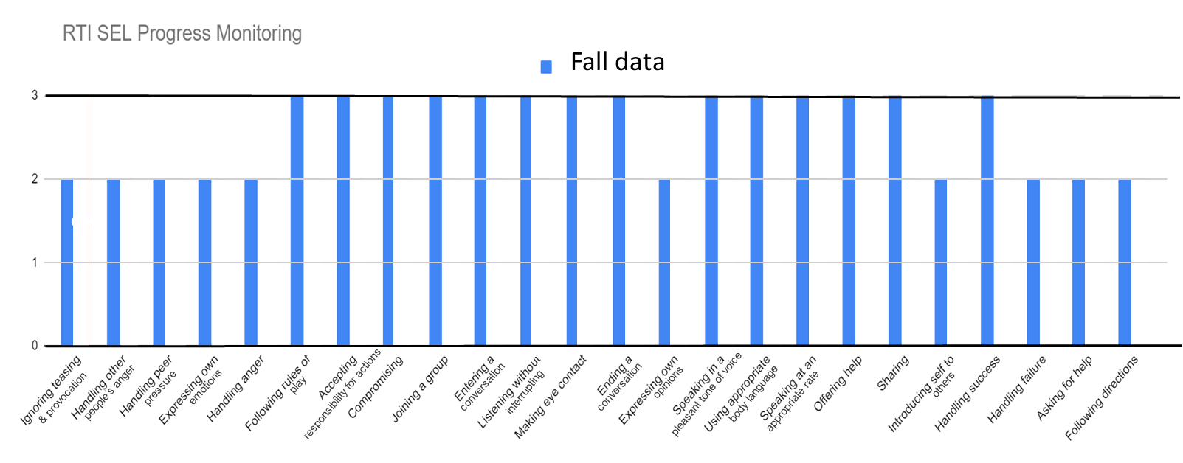

|  |  |  |
| --- | --- | --- |
| **SSIS Key**  **1=Tier III**  **2=Tier II**  **3=Tier I**  **4=well-developed**  **5=adept** | | **Areas in need of intervention:**  Ignoring teasing and provocation (self-management) 2  Handling other people’s anger (safe/self-management) 2  Handling peer pressure (responsible decision-making)  Expressing own emotions (safe/self-management) 2  Handling anger (self-management) 2  Expressing own opinions (self-awareness) 2  Introducing self to others (relationship skills) 2  Handling failure (ready to learn/self-management) 2  Asking for help (self-awareness) 2  Following directions (responsible decision-making) 2 |
| **Strategy/Intervention to be implemented:** | 1. Student will participate in a weekly tiered II social skills intervention group 1:5 during their lunch for 25 minutes. 2. Student will be taught explicit social skills using Second Step® lessons 3. Student will have opportunity for over-rehearsal/practice, immediate reinforcement, and feedback. 4. Skills worked on will be communicated to the teacher and the parent via “news you can use” Skill Streaming cards, which will be sent to the classroom/home with student weekly. 5. Skill to be reinforced in the classroom setting. | |

Figure 8: Fall SWON map for Joe Anon and self-identified areas for growth

|  |  |  |  |  |  |  |
| --- | --- | --- | --- | --- | --- | --- |
| Competency | SE | SA | SM | SOC | RSK | RDM |
| Average Score | 461 | 364 | 541 | 452 | 401 | 540 |

A picture of a SWON map.

|  |  |  |
| --- | --- | --- |
| **Student’s self-identified areas for growth** | | |
| **Item** | **Response** | **SE skill** |
| SAE4 | Very hard | Knowing the emotions I feel. |
| SAE7 | Very hard | Knowing when my mood affects how I treat others. |
| SAE8 | Very hard | Knowing ways I calm myself down. |
| SAE10 | Very hard | Knowing when my feelings are making it hard for me to focus. |
| SAS5 | Very hard | Knowing when I am wrong in the way I behave. |
| SAS9 | Very hard | Knowing when I can't control something. |
| SMS5 | Very hard | Planning ahead so I can turn a project in on time. |
| SMS9 | Hard | Finishing my schoolwork without reminders. |
| SMG8 | Very hard | Setting goals for myself. |
| SMG11 | Hard | Finishing tasks even if they are hard for me. |
| SME12 | Very hard | Getting through something even when I feel frustrated. |
| SOC3 | Very hard | Learning from people with different opinions than me. |
| SOC4 | Very hard | Knowing how my actions impact my classmates. |
| SOC7 | Very hard | Knowing the difference between bullying someone and joking with someone. |
| RSK1 | Very hard | Being welcoming to someone I don't usually eat lunch with. |
| RSK2 | Very hard | Talking to an adult when I have problems at school. |
| RSK6 | Very hard | Getting along well with my teachers. |
| RDM1 | Very hard | Helping to make my school a better place. |

These less developed SA skills (e.g., knowing the emotions I feel, knowing ways to calm myself down, knowing when my mood affects how I treat others, knowing when I am wrong in the way I behave, know how my actions impact my classmates) could be contributing to the student’s difficulty in self-control when it relates to handling his own anger and handling the anger of others, and in handling peer pressure and expressing his emotions. Conceivably the student’s difficulty in understanding the difference between bullying and joking with someone (SOC7) could also contribute to his struggle to ignore teasing and provocation.

The teacher also rates the student’s readiness to learn as an area in need of support. Along with the prior mentioned SA and SOC skills that could be impacting the student’s self-control, the student’s SWON map also shows some self-management skills (SM) are hard or very hard for the student (e.g., finishing my schoolwork without reminders, finishing tasks even if they are hard for me, setting goals, planning ahead so I can turn a project in on time, getting through something even when I am frustrated). This is despite this student having an overall relative strength in SM skills. Although there are many self-management skills that the student unexpectedly reports as easy or very easy for them to apply (upper left quadrant), the map identified SM skills that the student does struggle with. A review of the content of these SM skills suggests that the student may struggle with organization and perseverance when tasks get hard, and these SM skills combined with the SA skills might interfere with their ability to handle failure, ask for help, and follow directions. Despite finding it very easy to trust at least one adult at school to help them with a problem (SME15, top left), the student expresses it is very hard to talk to an adult if they have a problem and hard to “get along” with their teachers. The difficulty experienced by the student in these two critical relationship skills likely contributes to their difficulty in reaching out for help (academically or socially). The teacher and student viewpoints are not always aligned, however. For example, the teacher believes that the student struggles to handle peer pressure; in contrast, the student expresses that they know when people’s actions are right or wrong (RDM2.3) and when to say no to a friend who wants to break the rules (RDM4.3). The two assessments have different but related foci and by combining the information, the teacher obtains a more complete picture of the student and what targeted supports might best suit the student to help them develop their skills further.

A judgement as to whether this student needs Tier 2 or Tier 3 supports is not, however, just based on these three assessments (SELIS, SSIS, and SSA). Along with these three assessments, Monomoy looks at how the student is doing academically, behaviorally, and health wise. The third-grade student has a health-related disability and is on an IEP to support their attention deficit hyperactivity disorder. Academically, they are approaching grade level standards for language and composition, and are meeting grade-level expectations in reading, mathematics, science, and social studies. Behaviorally, they have good attendance with only one office referral. Using the totality of the evidence and the relative congruence of the results from both the SSA and SELIS assessments, this student was assigned to a Tier 2 intervention (Figure 7) for extra support. The student attends a weekly lunch group program that lasts for 25 minutes; the student is taught explicit social skills during lunch, and these skills are reinforced in the classroom and at home (the skills covered by the lesson and streaming cards are sent to the teacher and parent; see Appendix L for examples of skills streaming cards). Having information from both the student and the teacher helps to better target the content of the lunch program. Having the student’s view on what SE skills they find hard or very hard to apply also provides the teacher with a more holistic picture of the student (than just the SSA assessment data alone) and helps validate the decision to provide additional supports to the student.

It is important to realize that both the SSA and SELIS assessments are asset-based assessments and help identify a student’s strengths. A strength in social skills is one that a student performs on a consistent basis and in a developmentally appropriate way. A strength in SE skills is one that a student *in most cases* finds easy or very easy to apply in everyday situations and contexts. These skills can be leveraged and as Gresham et al., (2019, p.29) state, “used as building blocks for the improvement of the less well-developed skills”. The SWON map is ideal for quickly identifying a student’s SE skills strengths and particularly those that a student wasn’t expected to feel comfortable with given the difficulty of the SE skill to acquire or apply. It is this information that can be leveraged to support the student’s less developed skills. Both the SSA and SELIS can also be used to monitor the student’s progress towards meeting the goals of the intervention provided.

# Conclusion

The systems approach to support students’ social and emotional wellbeing discussed in this study highlights the importance of the leadership within the district and schools to the successful and sustainable implementation of a tiered SEL support system, and that building internal capacity within the district has to be done in a methodical, consistent, and inclusive manner. Monomoy used this systemic approach to develop a comprehensive set of tiered social and emotional learning supports for all of its learners. Monomoy’s system takes advantage of the support from its leadership, competency, and implementation drivers that work together to focus their resources and efforts to support students’ social and emotional wellbeing. Through this focus, Monomoy has created the conditions (e.g., high quality PD and coaching for staff, family engagement in strategic planning) and systems (e.g., data collection system and data culture) needed to provide universal (Tier 1), targeted (Tier 2), and intensive (Tier 3) SEL supports to students. Data-driven decisions are made by triangulating data (e.g., universal screeners such as SSIS and SELIS) so that students’ SEL needs are assessed reliably and accurately, and students are provided with the type of supplemental interventions warranted by their needs. Monomoy has successfully integrated SELIS data to support its tiered support system and optimally uses the SELIS’s different outputs (scaled scores, SWON maps, and item-level data) to make evidence-based decisions that ensure the students get the supports they need.

# References

Crowder, M. K., Gordon, R. A., Brown, R. D., Davidson, L. A., & Domitrovich, C. E. (2019). Linking social and emotional learning standards to the WCSD Social-Emotional Competency Assessment: A Rasch approach. *School Psychology, 34* (3), 282 – 295.

Darling-Hammond, L., and Cook-Harvey, C. M. (2018). *Educating the whole child: Improving school climate to support student success*. Palo Alto, CA: Learning Policy Institute.

Davidson, L. A., Crowder, M. K., Gordon, R. A., Domitrovich, C. E., Brown, R. D., & Hayes, B. I. (2018). A

continuous improvement approach to social and emotional competency measurement. *Journal of Applied Developmental Psychology, 55*, 93 – 106.

DESE (2019). *Multi-tiered System of Supports: Blueprint for Massachusetts*. Retrieved from

[Multi-Tiered System of Support Blueprint (mass.edu)](https://www.doe.mass.edu/sfss/mtss/blueprint.pdf).

DESE (2023a). *SELIS research brief: Actionable data for students’ social and emotional learning - results from the SELIS pilot*. Retrieved from <https://www.doe.mass.edu/research/selis/research-brief.docx>

DESE (2023b). *Social and Emotional Learning Indicator System (SELIS): User Guide for Educators (what you need to know to use SELIS data)*. Retrieved from <https://www.doe.mass.edu/research/selis/user-guide.docx>

Durlak, J. A., Weissberg, R. P., Dymnicki, A. B., Taylor, R.D., & Schellinger, K. B. (2011). The impact of enhancing

students’ social and emotional learning: A meta-analysis of school-based universal interventions. *Child Development, 82* (1), 405 – 432.

Gresham, F. M., Elliot, S. N., Vance, M. J., Cook, C. R. (2011). Comparability of the Social Skills Rating System to the Social Skills Improvement System; Content and psychometric comparisons across elementary and secondary age levels. *School Psychology Quarterly, 26* (1), 27 – 44.

Koonce, D.A., (2019). Assessing the effects of Second Step®: A program evaluation of a pilot implementation. *International Journal of Business Management and Commerce, 4* (1), 29 – 38.

Linacre, J.M. (2023). Winsteps: Rasch-Model Computer Program. Downloaded from <https://www.winsteps.com>.

Low, S., Cook, C. R., Smolkowski, K. & Buntain-Ricklefs, J. (2015). Promoting social and emotional competence: An evaluation of the elementary version of Second Step®. *Journal of School Psychology, 53*, 462 – 477.

Pearson (2023). *Social Skills Improvement System SSIS Rating Scales*. Retrieved from <https://www.pearsonassessments.com/store/usassessments/en/Store/Professional-Assessments/Behavior/Social-Skills-Improvement-System-SSIS-Rating-Scales/p/100000322.html>

Rasch, G. (1960). *Probabilistic models for some intelligence and attainment tests*. Copenhagen: Danish Institute for Educational Research. (Expanded edition, 1980. Chicago: University of Chicago Press).

## Appendix A: Collaborative for Academic and Social and Emotional Learning’s (CASEL) Conceptual Framework

The SELIS was based on the 2017 CASEL framework, which is provided below. Future work will be to update the SELIS to reflect any changes in the CASEL framework (found[**here**](https://casel.org/sel-framework/))**.**

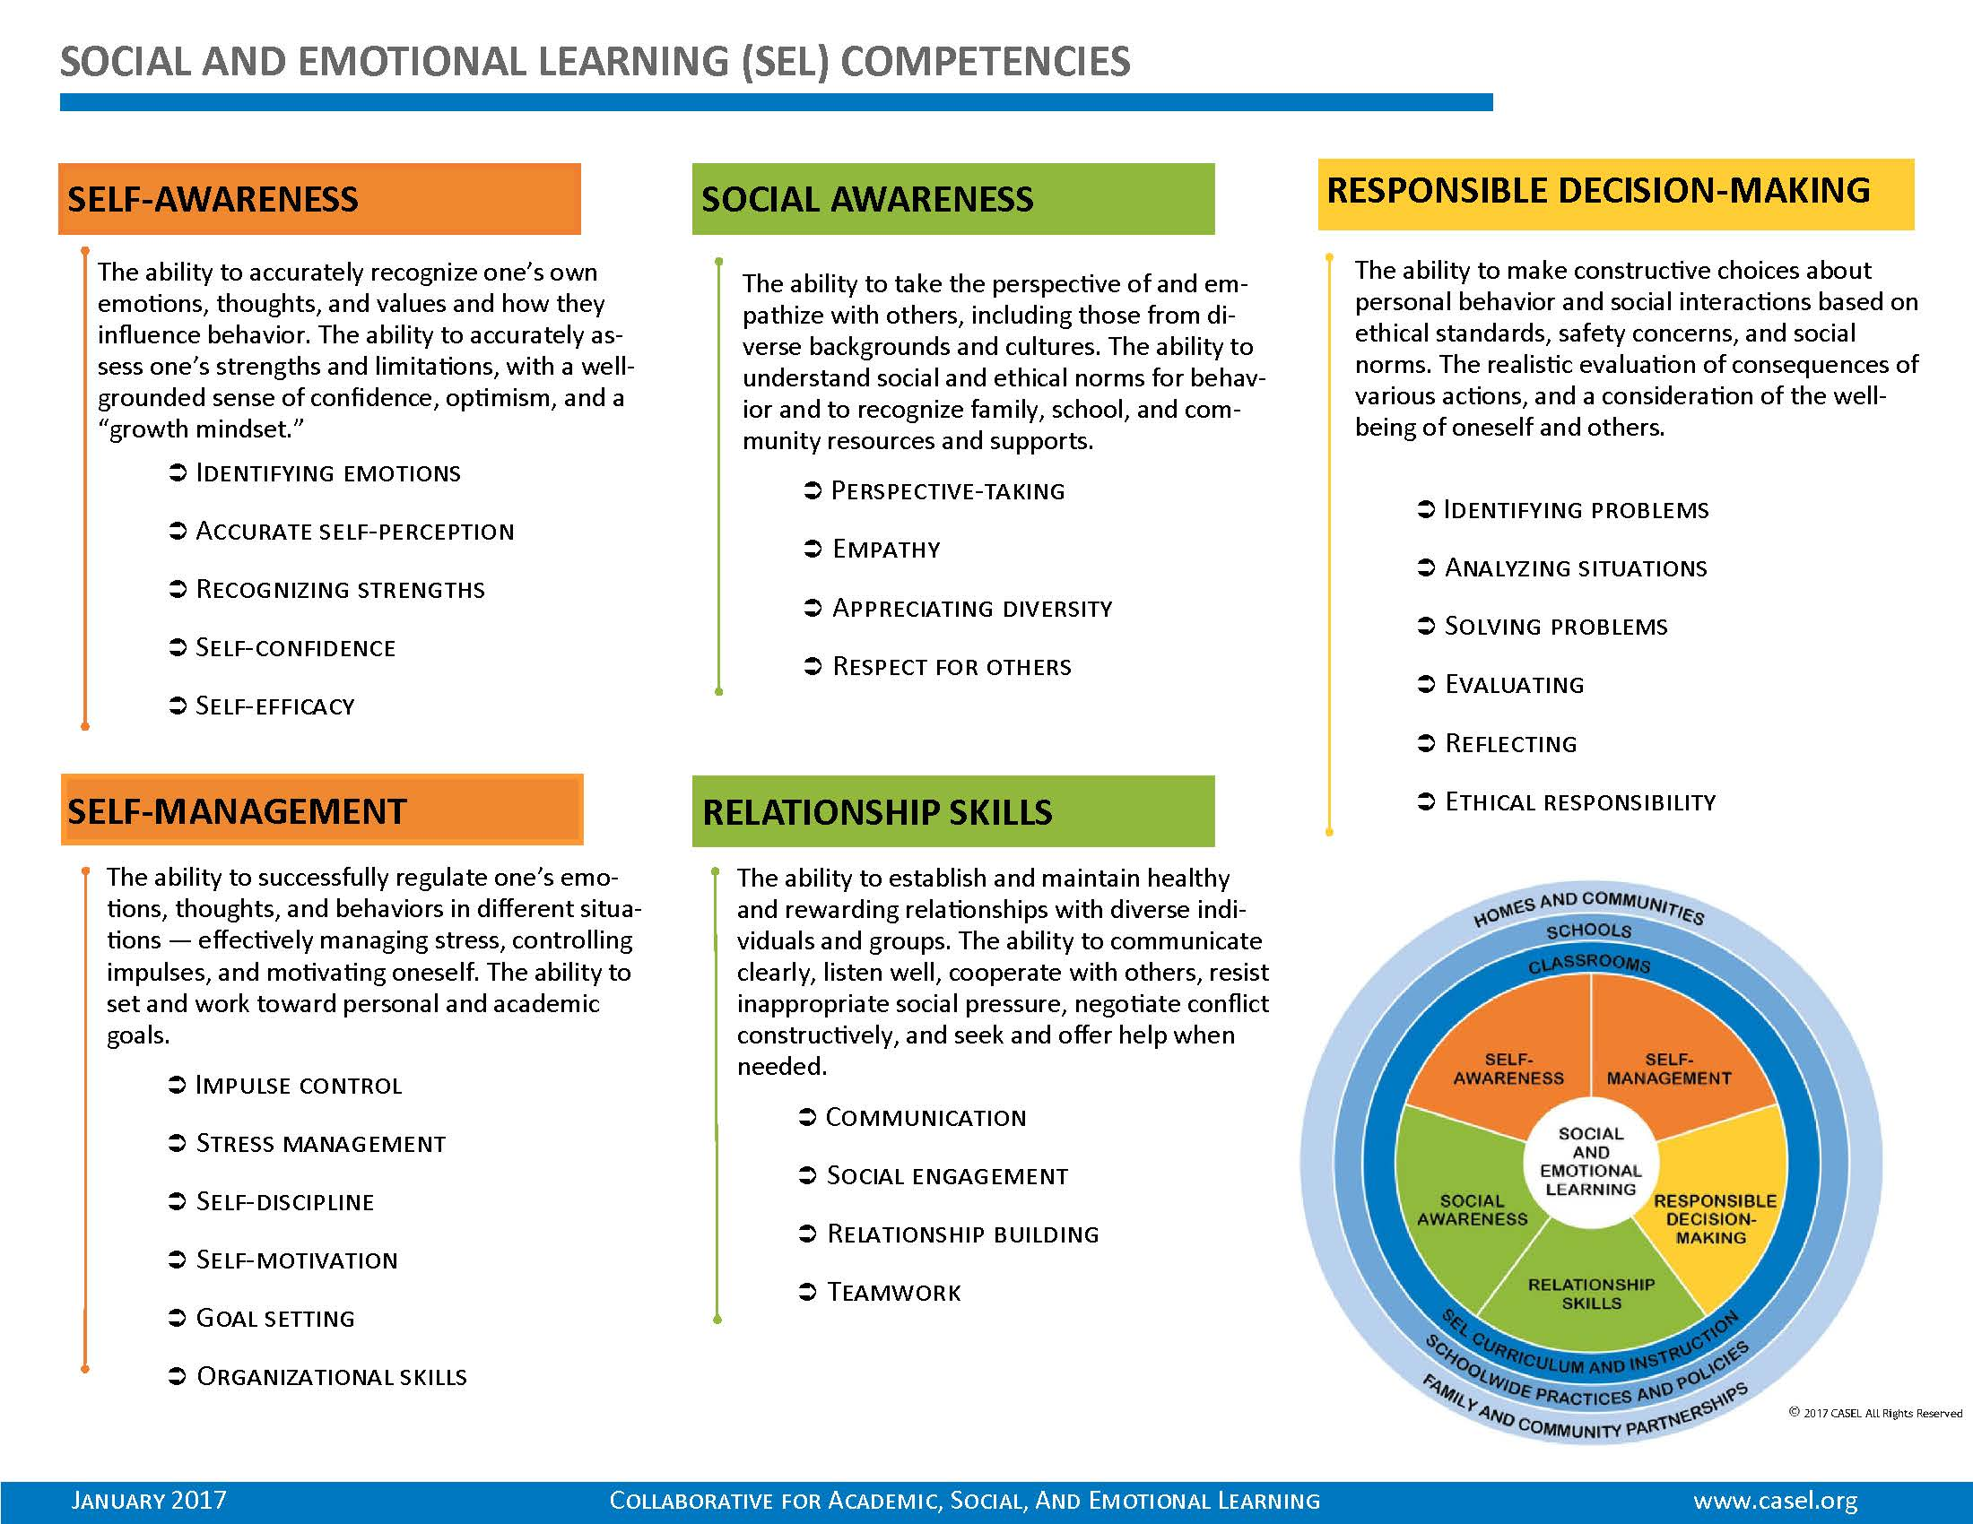

Downloaded from [www.casel.org](http://www.casel.org) (2019)

## Appendix B: SELIS Item Prompts

|  |  |  |  |  |  |  |  |  |
| --- | --- | --- | --- | --- | --- | --- | --- | --- |
| **No.1** | **Item code** | **Item Prompt: How hard to easy is the following for you?** | **ES2** | | **MS2** | | **HS2** | |
| 11 | SAS1 | Knowing what my strengths are. | X | | X | | X | |
| 21 | SAE2 | Knowing ways to make myself feel better when I'm sad. | X | | X | | X | |
| 31 | SAE3 | Noticing what my body does when I am nervous. | X | | X | | X | |
| 41 | SAE4 | Knowing the emotions I feel. | X | | X | | X | |
| 51 | SAS5 | Knowing when I am wrong in the way I behave. | X | | X | | X | |
| 61 | SAS6 | Knowing how to get better at things that are hard for me to do at school. | X | | X | | X | |
| 71 | SAE7 | Knowing when my mood affects how I treat others. | X | | X | | X | |
| 81 | SAE8 | Knowing ways I calm myself down. | X | | X | | X | |
| 91 | SAS9 | Knowing when I can't control something. | X | | X | | X | |
| 101 | SAE10 | Knowing when my feelings are making it hard for me to focus. | X | | X | | X | |
| 11 | SAE11 | Understanding the difference between how others expect me to feel and how I really feel. |  | |  | | X | |
| 12 | SAS12 | Knowing what I am interested in at school. | X | |  | |  | |
| 13 | SAS13 | Offering an answer even though I am not sure I am right. |  | | X | |  | |
| 14 | SAS14 | Knowing my opinions matter even when others don't listen to them. |  | |  | | X | |
|  |  | Total Number of SA Items | 11 | | 11 | | 12 | |
| 151 | SME1 | Staying calm when I feel stressed. | X | | X | | X | |
| 161 | SME2 | Being patient even when I am really excited. | X | | X | | X | |
| 171 | SMS3 | Working on assignments even when they are hard. | X | | X | | X | |
| 181 | SMS4 | Staying focused in class even when there are distractions. | X | | X | | X | |
| 191 | SMS5 | Planning ahead so I can turn a project in on time. | X | | X | | X | |
| 201 | SMS6 | Being prepared for tests. | X | | X | | X | |
| 211 | SMG7 | Thinking through the steps it will take to reach my goals. | X | | X | | X | |
| 221 | SMG8 | Setting goals for myself. | X | | X | | X | |
| 231 | SMS9 | Finishing my schoolwork without reminders. | X | | X | | X | |
| 241 | SMS10 | Doing my schoolwork even when I do not feel like it. | X | | X | | X | |
| 251 | SMG11 | Finishing tasks even if they are hard for me. | X | | X | | X | |
| 261 | SME12 | Getting through something even when I feel frustrated. | X | | X | | X | |
| 271 | SME13 | Working on things even when I don't like them. | X | | X | | X | |
| 281 | SMG14 | Reaching goals that I set for myself. | X | | X | | X | |
| 29 | SME15 | Trusting at least one adult in school who I can go to if I have a problem. | X | | X | | X | |
| 30 | SME16 | Being careful about what information I share about myself on social media (e.g., TikTok, Facebook, Instagram, etc.). |  | | X | |  | |
| 31 | SMG17 | Catching up on my work when I get behind. | X | |  | |  | |
| 32 | SMG18 | Planning my work when I have multiple assignments due at the same time. |  | |  | | X | |
| Total Number of Self-management (SM) Items | | | | 16 | | 16 | | 16 | |

|  |  |  |  |  |  |
| --- | --- | --- | --- | --- | --- |
| **Appendix B: SELIS Item Prompts continued** | | | | | |
| No.1 | Item code | Item Prompt: **How hard to easy is the following for you?** | ES2 | MS2 | HS2 |
| 331 | SOC1 | Knowing what people are feeling by the look on their face. | X | X | X |
| 341 | SOC2 | Knowing how to get help when I'm having trouble with a classmate. | X | X | X |
| 351 | SOC3 | Learning from people with different opinions than me. | X | X | X |
| 361 | SOC4 | Knowing how my actions impact my classmates. | X | X | X |
| 371 | SOC5 | Knowing when someone needs help. | X | X | X |
| 38 | SOC6 | Waiting for other students to finish talking before I speak. | X |  |  |
| 39 | SOC7 | Knowing the difference between bullying someone and joking with someone. |  | X |  |
| 40 | SOC8 | Knowing when to tell my friends how I really feel |  | X |  |
| 41 | SOC9 | Knowing when my tone of voice may cause someone to misunderstand what I intended to say. |  |  | X |
| 42 | SOC10 | Recognizing when I am making someone uncomfortable. |  |  | X |
| Total Number of Social Awareness (SOC) Items | | | 6 | 7 | 7 |
| 431 | RSK1 | Being welcoming to someone I don't usually eat lunch with. | X | X | X |
| 441 | RSK2 | Talking to an adult when I have problems at school. | X | X | X |
| 451 | RSK3 | Getting along well with my classmates. | X | X | X |
| 461 | RSK4 | Sharing what I am feeling with others. | X | X | X |
| 471 | RSK5 | Respecting a classmate's opinions during a disagreement. | X | X | X |
| 481 | RSK6 | Getting along well with my teachers. | X | X | X |
| 49 | RSK7 | Leading a discussion in class. |  | X |  |
| 50 | RSK8 | Asking a classmate to do their fair share of a group project. |  |  | X |
| 51 | RSK9 | Standing up for someone even if they are outside of my friend group. |  |  | X |
| Total Number of Relationship Skills (RSK) Items | | | 6 | 7 | 8 |
| 521 | RDM1 | Helping to make my school a better place. | X | X | X |
| 531 | RDM2 | Knowing when people's actions are "right" or "wrong" (e.g., helpful or harmful) | X | X | X |
| 541 | RDM3 | Thinking of different ways to solve a problem (e.g., a disagreement with another student). | X | X | X |
| 551 | RDM4 | Saying "no" to a friend who wants to break the rules. | X | X | X |
| 561 | RDM5 | Thinking about what might happen before making a decision. | X | X | X |
| 57 | RDM6 | Taking responsibility for my choices. | X |  |  |
| 58 | RDM7 | Knowing when to accept help when it is offered. |  | X |  |
| 59 | RDM8 | Understanding the importance of what I am learning to my future success. |  | X |  |
| 60 | RDM9 | Deciding what courses to take to get me into the college or career I want. |  |  | X |
| 61 | RDM10 | Knowing something is wrong to do even when it happens all the time. |  |  | X |
| Total Number of Responsible Decision-making (RDM) Items | | | 6 | 7 | 7 |
| Total Number of SELIS Items | | | 45 | 48 | 50 |
| 1Items taken or adapted from the Social and Emotional Competency Assessment (SECA), (Crowder et al, 2019; Davidson et al, 2018) | | | | | |
| 2ES: Elementary (G3 - G5) items; MS: Middle school (G6 - G8); HS: High school (G9-G12) | | | | | |

## Appendix C: District’s Needs Assessment Questions

These questions were developed with the support the [exSEL network](https://www.renniecenter.org/exSELnet).

1. What is your vision for SEL integration? And are elements of this SEL vision already explicitly articulated in key district strategies? Which ones, and why?
2. Where does growth mindset fit? Is there alignment between growth mindset and your district’s SEL vision that needs to be articulated?
3. Do any of your schools, administrators, or teachers already demonstrate a positive climate or strong SEL focus? E.g., where are your “pockets of excellence”?
4. Who are the key stakeholders to engage? Who already supports a SEL-based approach, inclusive of growth mindset? Of those who are not engaged, what would convince them of the importance of a SEL-based approach?
5. What about local community partners -- who needs to “be at the table”? How have local early education and care programs addressed SEL?
6. What avenues already exist for communicating about, and receiving, SEL information with administrators, teachers, families, and community members? How can these be enhanced?
7. Thinking about your “pockets of excellence”, how can communication about these be made more universal so that the entire district begins to “own” these as standards of practice?
8. What are the key challenges in my district? To what extent are these currently being addressed through the existing SEL focus? Where does growth mindset fit in?
9. If challenges are not addressed, are there existing growth mindset/SEL priorities that should be enhanced? Are there new priorities that should be added?
10. Thinking about your “pockets of excellence”, to what extent are these aligned with the most critical local challenges or needs in your district? How can alignment be improved to strengthen SEL integration?

## Appendix D: Systems planning document for Monomoy’s SEL/Behavior strategic initiatives

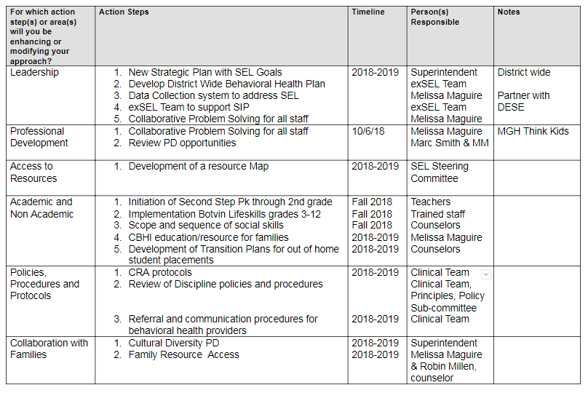

## Appendix E: Monomoy Regional School District’s SELIS Data Usage

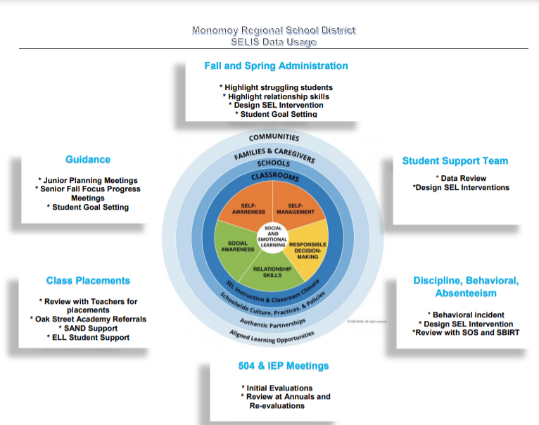

## Appendix F: Social Emotional Learning Tiered Systems of Support and Usage of SELIS Data

**Tier I**

Elementary

* Check-In/Check-Out
* Clarification for all students of school rules, expectations, and purpose
* targeted relationship skills development based on SELIS response
* Second Step Curriculum

Middle School

* Advisory block is used to deliver targeted SEL lessons
* Google classroom form for students to be able to request counseling/psychologist support independently
* Botvin Lifeskills Curriculum

High School

* Reviewed when there is a discipline referral that considers students SEL weaknesses in regard to the incident
* Google classroom form for students to be able to request counseling/psychologist support independently

**Tier II**

Elementary

* All students are given SSIS-SEL (Social Skills Improvement System Social-Emotional Learning Edition) to identify weak skills
* SSA is administered for students with higher needs to identify targeted skill areas to be addressed
* Consistent home-school communication for the students that require it
* Lunch groups based on results of initial SELIS and SSIS
* Scheduled weekly check ins for students with more intensive needs based on results of initial SELIS and SSIS

Middle

* Repair and restoration of relationships whenever possible (Teacher/student or Peer/peer) based on discipline referral and review of SELIS data.

High School

* Targeted skill building in the identified SEL competency
* Student goal and action plan developed with counselor

**Tier III**

**Elementary**

* Weekly Team meetings with each individual teaching team attended by principal, vp, grade level counselor, and psychologist and team chair as needed to provide strategies, share information and engage in the RTI process as needed using SELIS, attendance, grades, discipline referrals
* Individual behavior support/incentive plans according to need
* Counselor/psychologist collaboration with outside mental health providers and wrap-around services of identified students based. Data used include SELIS data, discipline referrals, attendance, and parent input
* Referrals to outside mental health community providers

Middle

* Weekly Team meetings with each individual teaching team attended by principal, vp, grade level counselor, and psychologist and team chair as needed to provide strategies, share information and engage in the RTI process as needed using SELIS, attendance, grades, discipline referrals
* Opening of the BRYT program to support students with mental health and SEL challenges that require more intensive supports.

High School

* Weekly Team meetings with each individual teaching team attended by principal, vp, grade level counselor, and psychologist and team chair as needed to provide strategies, share information, and engage in the RTI process as needed using SELIS, attendance, grades, discipline referrals

## Appendix G: Guidance on interpreting SE scaled score differences

|  |  |  |  |
| --- | --- | --- | --- |
| **Scaled score point difference** | **Size of effect (negative or positive)** | | |
| **Point difference description1** | **Percentile difference2** | **Difference in standard deviation units (s.d.)1** |
| Less than 5 points | Not meaningful | Less than 2 | Less than 0.05 |
| 5 points to less than 8 points | Very small | 2 to less than 4 | 0.05 to less than 0.10 |
| 8 points to less than 16 points | Small | 4 to less than 8 | 0.10 to less than 0.20 |
| 16 points to less than 24 points | Moderate | 8 to less than 12 | 0.20 to less than 0.30 |
| 24 points to less than 40 points | Large | 12 to less than 19 | 0.30 to less than 0.50 |
| 40 points or greater | Very large | 19 and above | 0.5 and greater |

1This is a **rough guide** to scaled score point differences; the standard deviations of the average scaled score comparisons can vary when analyzed leading to different results. 2Effect can be interpreted as the percentile difference from the lowest group’s, or school’s outcome standardized mean score (set at the 50th percentile on the normal distribution) and the highest group’s standardized mean score.

## Appendix H: Identifying students for Tier 2 or Tier 3 interventions

Students’ real names are replaced with pseudonyms.

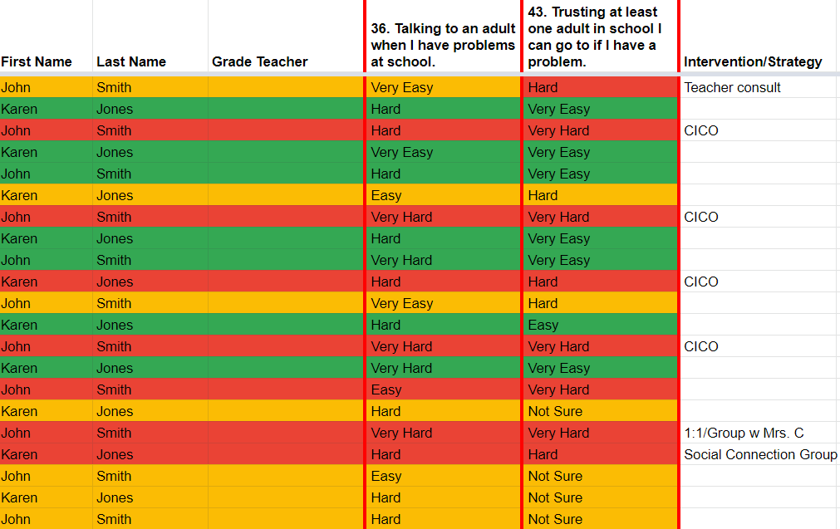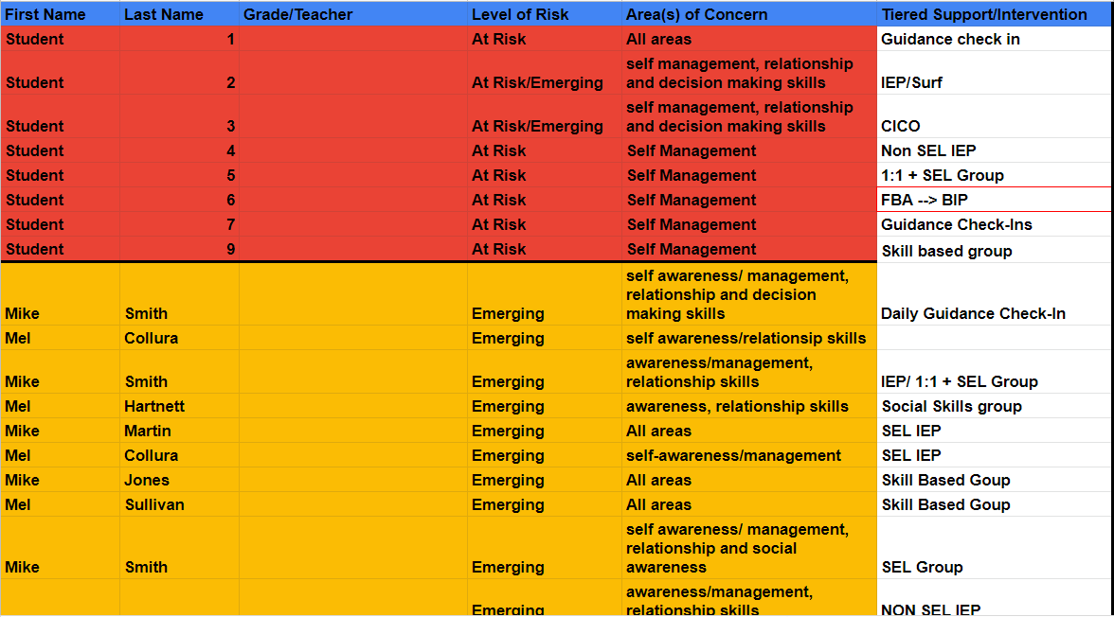

## Appendix I: Student SEL goal setting template

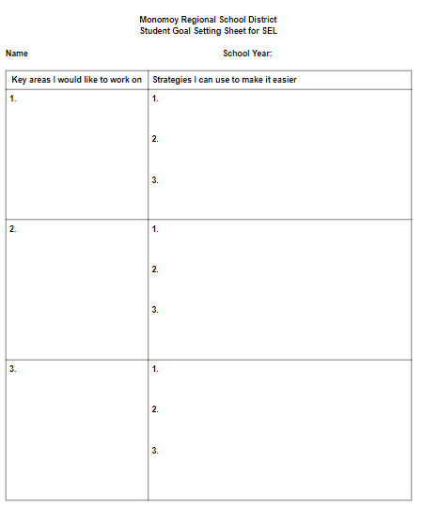

## Appendix J: Example of Student Goal Setting Sheet

**Monomoy Regional School District**

**Student Goal Setting Sheet for SEL**

**Student:** Suzie Student and counselor engage in a discussion of their SWON map

|  |
| --- |
| Process   1. First we asked her to look at all of the data points and together we examined what the map looked like as a whole. 2. We then asked her to identify her most refined strengths and explain. 3. We asked her to pick one item in the emerging area and describe how she could get that to "most developed" 4. Then we asked her to isolate the most crucial "underdeveloped" skill and we looked at three ways to brainstorm how to build this up as an area of strength. |

|  |  |
| --- | --- |
| **Key area(s) I would like to work on** | **Strategies I can use to make it easier** |
| **How do I stay calm when I am feeling stressed?** | 1. I like movement breaks in class 2. Using fidgets to help calm down 3. It helps me to take a walk in the hall for 5 minutes to regroup 4. Breathing exercises |

## Appendix K: Crosswalk of social skills domains/values with SELIS core competencies

|  |  |  |
| --- | --- | --- |
| **SSA item** | **Monomoy’s**  **SSA Core Values and SE competency1** | **SELIS competency** |
| Asking for help | Ready to learn/self-awareness | Self-Awareness |
| Handling success | Ready to learn/self-management | Self-Awareness/management |
| Handling failure | Ready to learn/self-management | Self-Awareness/management |
| Following directions | Ready to learn/Responsible decision-making | Responsible Decision Making |
| Handling peer pressure | Safe/responsible decision-making | Responsible Decision Making |
| Following rules of play | Safe/responsible decision-making | Responsible Decision Making |
| Expressing own emotions | Safe/self-management | Self-management |
| Ignoring teasing and provocation | Safe/self-management | Self-management |
| Handling anger | Safe/self-management | Self-management |
| Handling other people’s anger | Safe/self-management | Self-management |
| Expressing own opinions | Respectful/self-awareness | Self-Awareness |
| Listening without interrupting | Respectful/self-management | Self-management |
| Speaking in a pleasant tone of voice | Respectful/self-management | Social Awareness |
| Using appropriate body language | Respectful/self-management | Social Awareness |
| Speaking at an appropriate rate | Respectful/self-management | Social Awareness |
| Entering a conversation | Respectful/social awareness | Social Awareness |
| Ending a conversation | Respectful/social awareness | Social Awareness |
| Joining a group | Respectful/social awareness | Social Awareness |
| Compromising | Respectful/social awareness | Social Awareness |
| Sharing | Respectful/social awareness | Social Awareness |
| Offering help | Respectful/social awareness | Social Awareness |
| Making eye contact | Respectful/relationship skills | Social Awareness |
| Introducing self to others | Respectful/relationship skills | Relationship Skills |
| Accepting responsibility for actions | Responsible/responsible decision-making | Responsible Decision Making |

1In some cases the related SELIS competency differs from those assigned by Monomoy. DESE felt that the assignments in the third column aligned with the SELIS more accurately.

## Appendix L: Examples of social skills streaming cards sent to parents

Examples of social skills:
Reacting to failure:
1. Decide if you have failed
2. Think about why you failed
3. Think about what you could do next time
4. Make your plan to do this.

Dealing with being left out.
1. Decide what has happened to cause you to feel left out.
2. Think about your choices: ask to join in, choose someone else with whom to play, or do an activity you enjoy.
3. Act out your best choice.

1. The MTSS framework is considered as an umbrella framework that includes both Response to Intervention (RTI) and Positive Behavioral Instruction and Supports (PBIS); both RTI and PBIS are used in Monomoy to support students’ academic and behavioral needs, respectively. DESE encourages districts to use the MTSS framework as it is designed to integrate both the academic and social and emotional/behavioral needs of students so as to address them more holistically.