Focus on Early Learning Overview

Three-to eight-year olds are full of wonder and stories, ready to explore and to practice and take up new skills. The Focus on Early Learning curriculum, PreK through second grade—aligned to the Massachusetts Curriculum Frameworks, the science of reading, a pedagogy of learning by doing, and the BPS Equitable Literacy initiative—supports children’s developing independence as learners and citizens, fosters connectedness and collaboration, and affirms children’s identities and uplifts their funds of knowledge. Constantly improving and evolving, Focus is informed by current research and the experiences and expertise of teachers and coaches in the Boston Public Schools.
In Focus, cross-disciplinary topics of study illuminate children’s curiosity, connect to their lived experiences, and give them windows into the wider world; texts and discussions intrigue and provoke; foundational skill-building develops critical tools for reading and participating; and activities and projects offer opportunities for expressing ideas and manifesting agency. Aspiring to be a tool for antiracist and liberatory teaching, experiences in the Focus curriculum should lead every child in a Focus classroom to feel inherently valued, with paths to authentic and expansive learning charted and propelled by their own brilliance.
In the design of Focus on Early Learning, with texts acting as the animating feature of each unit of study and each day’s experiences, all of the parts work in concert with each other. The components that support children’s learning and development in literacy and language, science and engineering, social studies, arts, and the social-emotional realms reference each other and connect to long term topics of study. When visitors walk into a Focus classroom, it is immediately apparent what the children are learning about and learning to do; the curriculum is alive on the walls and shelves, in the meeting area and work spaces. Focus is designed to take advantage of, build upon, and expand children’s established understandings and skills. In turn, this learning is supported by vigorous attention to social emotional development, by helping each child find a place in a community of learners.
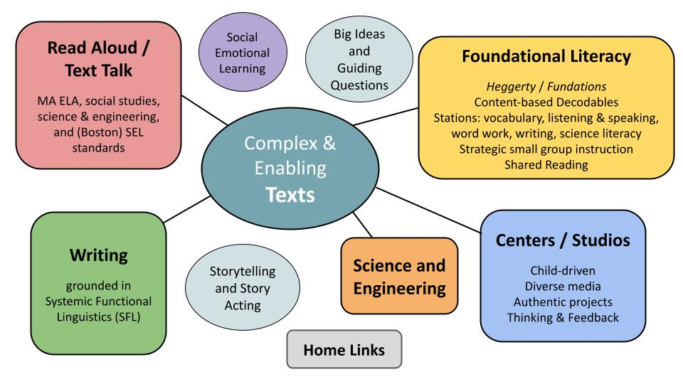
Learning in Focus is driven by content (the units of study), and all experiences are designed to reinforce children’s opportunities to activate and build knowledge, language, and vocabulary. These units of study alternate in bringing social studies and science to the foreground. Attention is paid to all the disciplines across components in order to promote connections and deeper thinking and to integrate experiences interpreting, communicating in, and taking action in the real world. Throughout the year, using artwork to think about the topic of study expands competency in both arenas and opens engagement for many learners. Further, the framework from Universal Design for Learning (UDL) informs curricular guidance for providing multiple means of engagement, representation, and action/expression, and the BPS Social Emotional Learning Competencies and Skills remind teachers to attend to children’s wellbeing across instructional components and beyond academic progress.

Curriculum components across the grades
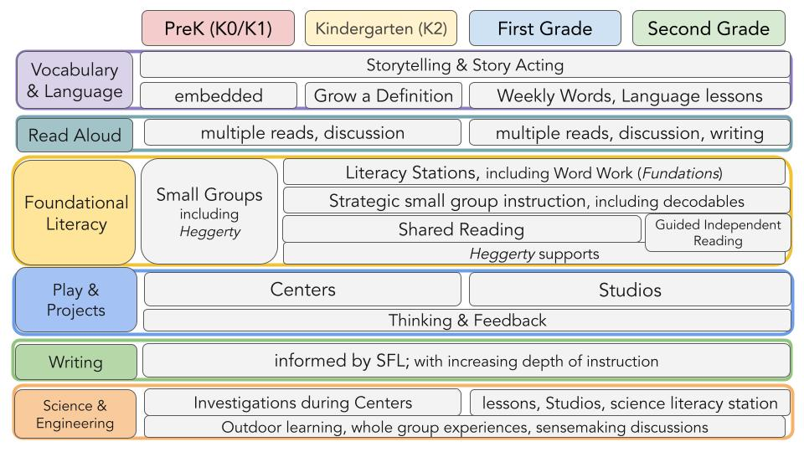

...children learn best when the learning is active (minds-on), engaging (not distracting), meaningful (applied to prior knowledge and transferred to the outside world), andoccurring in a socially interactive environment. Two additional characteristics of learning in playful contexts may also help explain why this pedagogical approach increases educational value: the joy and iteration that are inherent in play. Joy, or positive affect, has been linked to increased executive functions and academic outcomes (Diamond, 2014) and even brain flexibility (Betzel, et. al., 2017). Iteration, or the mindful construction of new knowledge based on hypothesis testing and revising one’s own knowledge over time, is a hallmark of learning and play (Piaget, 1962).
- Zosh et al, “Accessing the Inaccessible: Redefining Play as a Spectrum,” 2018

