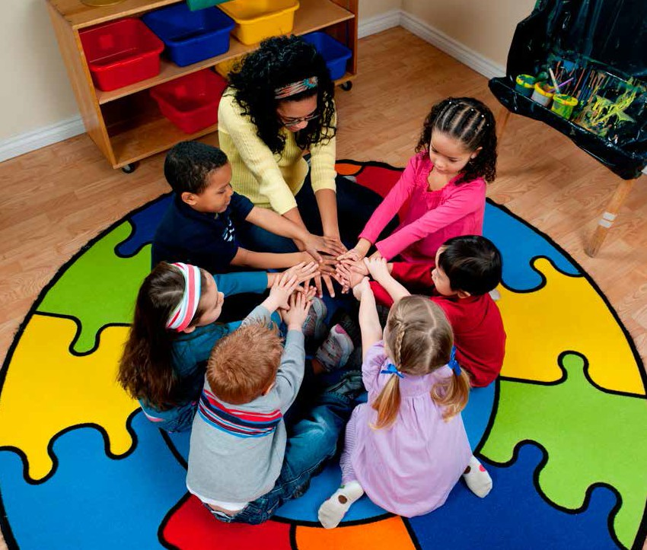

Massachusetts Standards for Preschool and Kindergarten
Social and Emotional Learning, and Approaches to Play and Learning
June 2015

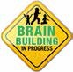

Massachusetts Standards for Preschool and Kindergarten
Social and Emotional Learning, and Approaches to Play and Learning
June 2015

This project was funded by the Race to the Top-Early Learning Challenge Grant.

Developed in collaboration with:
The Massachusetts Department of Early Education and Care
The Massachusetts Department of Elementary and Secondary Education
Staff at the Institute for Community Inclusion, University of Massachusetts Boston

With special thanks to the diverse early childhood community in the Commonwealth of Massachusetts for their input.

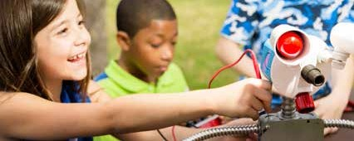

TABLE OF CONTENTS

Introduction 3
The Guiding Principles 5
Using the Standards Document 7
Social and Emotional Learning Standards 8
Self-Awareness 9
Standard SEL1: The child will be able to recognize, identify, and express his/her emotions 9
Standard SEL2: The child will demonstrate accurate self-perception 10
Standard SEL3: The child will demonstrate self-efficacy (confidence/competence) 11
Self-Management 12
Standard SEL4: The child will demonstrate impulse control and stress management 12
Social Awareness 13
Standard SEL5: The child will display empathetic characteristics 13
Standard SEL6: The child will recognize diversity and demonstrate respect for others 14
Relationship Skills 15
Standard SEL7: The child will demonstrate the ability to communicate with others in a variety of ways 15
Standard SEL8: The child will engage socially, and build relationships with other children and with adults 16
Standard SEL9: The child will demonstrate the ability to manage conflict 17
Standard SEL10: The child will demonstrate the ability to seek help and offer help 18
Responsible Decision Making 19
Standard SEL11: The child will demonstrate beginning personal, social, and ethical responsibility 19
Standard SEL12: The child will demonstrate the ability to reflect on and evaluate the results of his or her actions and decisions 20
Approaches to Play and Learning Standards 21
Standard APL1: The child will demonstrate initiative, self-direction, and independence 22
Standard APL2: The child will demonstrate eagerness and curiosity as a learner 23
Standard APL3: The child will be able to maintain focus and attention, and persist in efforts to complete a task 24
Standard APL4: The child will demonstrate creativity in thinking and use of materials 25
Standard APL5: The child will cooperate with others in play and learning 26
Standard APL6: The child will seek multiple solutions to a question, task, or problem 27
Standard APL7: The child will demonstrate organizational skills 28
Standard APL8: The child will be able to retain and recall information 29
Glossary 30
References 33

FOREWORD

he Massachusetts Standards for Preschool and Kindergarten in the domains of Social and Emotional Learning, and Approaches to Play and Learning represent a collaborative
T
initiative between the Department of Early Education and Care (EEC) and the Department of Elementary and Secondary Education (DESE) that will bring particular attention to these critical areas of development and learning, and further support a learning continuum from birth through school age.
The Standards for Social Emotional Learning and Approaches to Play and Learning represent the work of a dedicated team from the University of Massachusetts Boston. The team, Sandra Putnam-Franklin, Mary Lu Love, Su Theriault, and Jennifer Kearns-Fox, had extensive input from national experts and early childhood professionals in Massachusetts. In collaboration with staff from the EEC and DESE, the team convened and began work in August 2014, researching other states’ standards and guidelines; reviewing currently used child assessments; and conferencing with personnel from the Collaborative for Academic, Social, and Emotional Learning and the National Governor’s Association.
In addition, the team reviewed research and materials suggested by recognized national experts: Sharon Lynn Kagan (Columbia University), Stephanie Jones (Harvard University), Marilou Hyson (former associate executive director for professional development at NAEYC), Betty Bardige (developmental psychologist and author), Gregory Nelson (Bridgewater State University), and Angel Fettig (University of Massachusetts Boston). This resulted in a literature review available at: http://learningstandards.wikispaces.com/Literature+Review
The team held two focus groups in October to share the guiding principles and framework they had developed and to determine values and concerns from early childhood professionals. The 86 participants that attended the two focus groups represented family child care providers, preschool special educators, universal preschool teachers, kindergarten teachers, public school principals, higher education faculty and students; mental health consultants; and community
child care and nursery school directors and teachers, including Head Start, Montessori, and other interested community leaders. In December, an additional 41 people attended a focus group to provide feedback to an initial draft of the Standards. There were also 47 respondents who gave feedback to the initial draft through an online survey.
In January 2015, three public hearings were held and attended by 158 people, and an additional 118 people partially or fully completed the online survey. Two people emailed their testimony. In all formats, the feedback was 98% positive and enthusiastic in support of the Standards, with 2% of respondents suggesting minor rewording.
In February and March 2015, the feedback was incorporated into the document. It was submitted for copyediting and to the national experts again for review.

he preponderance of outcomes from both research and evidence-based practice clearly indicate the positive connection between social and emotional learning, academic learning, and success in life.
T

“Positive social and emotional development provides a critical foundation for lifelong development and learning. In early childhood, social and emotional well-being predicts favorable social, behavioral, and academic adjustment into middle childhood and adolescence. It helps children navigate new environments, facilitates the development of supportive relationships with peers and adults, and supports their ability to participate in learning activities.” (U.S. Department of Health & Human Services, 2010: Head Start Child Development and Early Learning Framework, Social & Emotional Development)

Young children’s evolving social-emotional development must be a key consideration in developing curriculum, as well as in guiding children’s social interactions and behaviors.
As Preschool children enter group settings, they engage in a growing circle of deepening relationships with adults and peers outside of the family, and move from self-focused activity to participation in groups. They develop a growing set of skills with guidance and meaningful feedback from caring adults, including skills in developing friendships, following rules and routines, playing in a group, resolving conflicts, sharing, and taking turns, along with essential
dispositions for learning. At the Kindergarten level, children extend these skills through practice, expanding relationships with others, and through diverse experiences designed by caring adults. These skills support children’s
participation in learning activities The foundations of social
by opening the doors to listening, competence that are developed collaborating, and cooperating with in the first five years are linked others; in the process, they learn to emotional well-being and affect
to seek and use resources outside later ability to functionally adapt
themselves. in school and to form successful relationships throughout life.

“The foundations of social
competence that are developed in the first five years are linked
—National Scientific Council on the Developing Child, 2004

to emotional well-being and affect later ability to functionally adapt in school and to form successful relationships throughout life.” (National Scientific Council on the Developing Child, 2004). The ability to establish and maintain healthy and rewarding relationships has far- reaching implications for growth and success in life (Weissberg & Cascarino, 2013). These relationships, first with family, then with other children and adults outside the family, provide children with vital information about who they are and can be as individuals, how to interact
INTRODUCTION

with others, and how to respond to situations. They provide comfort and safety, as well as pleasure, and enable children to take risks as they explore and learn about their world.

Both research and evidence-based practice clearly show the strong connections between social and emotional learning, academic learning, and success in life (Domitrovich, Dusenbury
& Hyson, 2013; US DHHS, 2010). In fact, this synergistic development of social and emotional and academic skills promotes and facilitates higher-order thinking. Guiding children’s development so that they integrate thinking, feeling, and behaving requires that we begin early to intentionally model, teach, and reinforce emotional and social skills and positive approaches to play and learning (CSEFEL, 2008). Participation in this quest is essential for individuals working in early education and care programs and elementary through secondary schools, for families, and for communities.

Currently, Massachusetts has some social-emotional learning (SEL) standards that are embedded in the Curriculum Frameworks (DESE) and/or the Guidelines for Preschool Learning Experiences (EEC) in various academic areas (with the primary focus found in standards for Comprehensive Health), but these documents do not specifically address social-emotional development or approaches toward learning. In 2013, an alignment study (Kagan, Scott-Little, & Reid, 2013) was conducted which recommended attention to these key areas. Developing free-standing standards for social and emotional development and approaches toward play and learning will fill in the gaps and put in place the missing pieces of Massachusetts’ strong foundations for early development and learning.
Children enter early education programs with a vast diversity in experiences, language, culture, development, and ability, creating the widest developmental range of any age group. Some may have spent extensive time in group settings, others no time at all. For children with little or no prior group experience, learning social-emotional skills and building relationships may be more challenging.
These Standards are crafted for both the Preschool and Kindergarten ages, as we understand that development occurs in a continuum. This can also help promote a successful transition from Preschool into Kindergarten, which is shown to help promote students’ future academic success and their family involvement with the education system (Malsch, Green, & Kothari, 2011; Skouteris, Watson, & Lum, 2012).

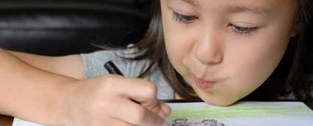

THE GUIDING PRINCIPLES

The Massachusetts Preschool and Kindergarten Learning Standards in Domains of Social and Emotional Learning, and Approaches to Play and Learning will:
- Build on the Massachusetts foundational documents from EEC: Early Learning Guidelines for Infants and Toddlers, Guidelines for Preschool Learning Experiences, and from DESE: the Kindergarten Learning Experiences, and Guidelines on Implementing Social and Emotional Learning Curricula, and will link with the Massachusetts Curriculum Frameworks.

- Be grounded in research from: Collaborative for Academic, Social, and Emotional Learning (CASEL): Head Start; National Association for the Education of Young Children (NAEYC); Council for Exceptional Children, Division of Early Childhood, (DEC); Center on the Social and Emotional Foundations for Early Learning (CSEFEL); Classroom Assessment Scoring System (CLASS); Strengthening Families; and World Class Instructional Design and Assessment (WIDA).

- Be developed with input from across the early education field, and national experts.

- Support educators, administrators in the mixed delivery system, and families.

- Emphasize the interrelation with all other areas of child development: cognitive development and general knowledge, language and communication development, and physical development and well-being.

- Communicate that children’s development in social-emotional skills, and their attitudes towards play and learning, are influenced by multiple social and cultural contexts and prior experiences, and impact children’s success throughout school.

- Respect children’s diverse learning styles and trajectories.

- Be compatible with the current assessment tools: Work Sampling System, Teaching Strategies Gold, and High Scope’s Child Observation Record (COR).

- Focus on the developmental aspects of the standards, and continuous improvement of skills for all individual children, especially those with special needs and dual language learners.

- Promote continuity of development between preschool and kindergarten programs.

THE STANDARDS
The Social-Emotional Learning Standards present objectives in five areas: Self-Awareness (emotional expression, self-perception, self-efficacy), Self-Management (impulse control and self-management), Social Awareness (empathy, respect for others and for diversity), Relationship Skills (communication, relationship building, conflict management, seeking help), and Responsible Decision Making.

Social and Emotional Learning Standards

SELF-AWARENESS
Standard SEL1: The child will be able to recognize, identify, and express his/her emotions.
Standard SEL2: The child will demonstrate accurate self-perception.
Standard SEL3: The child will demonstrate self-efficacy (confidence/competence).

SELF-MANAGEMENT
Standard SEL4: The child will demonstrate impulse control and stress management.

SOCIAL AWARENESS
Standard SEL5: The child will display empathetic characteristics.
Standard SEL6: The child will recognize diversity and demonstrate respect for others.

RELATIONSHIP SKILLS
Standard SEL7: The child will demonstrate the ability to communicate with others in a variety of ways. Standard SEL8: The child will engage socially, and build relationships with other children and with adults. Standard SEL9: The child will demonstrate the ability to manage conflict.
Standard SEL10: The child will demonstrate the ability to seek help and offer help.

RESPONSIBLE DECISION MAKING
Standard SEL11: The child will demonstrate beginning personal, social, and ethical responsibility. Standard SEL12: The child will demonstrate the ability to reflect on and evaluate the results of his or her actions and decisions.

The Standards for Approaches to Play and Learning present objectives in eight areas: Initiative, Curiosity, Persistence and Engagement, Creativity, Cooperation, Problem Solving, Organization Skills, and Memory.

Approaches to Play and Learning Standards
Standard APL1: The child will demonstrate initiative, self-direction, and independence.
Standard APL2: The child will demonstrate eagerness and curiosity as a learner.
Standard APL3: The child will be able to maintain focus and attention, and persist in efforts to complete a task.
Standard APL4: The child will demonstrate creativity in thinking and use of materials.
Standard APL5: The child will cooperate with others in play and learning.
Standard APL6: The child will seek multiple solutions to a question, task, or problem.
Standard APL7: The child will demonstrate organizational skills.
Standard APL8: The child will be able to retain and recall information.

As Massachusetts continues to develop comprehensive learning standards for all children that address students’ total span of education, professionals can ensure that each child has robust learning experiences in all the domains: the Arts, English Language Arts, Comprehensive Health, Mathematics, History and Social Sciences, Science/Technology and Engineering.
Information for professionals around facilitating the essential experiences for children in both Social and Emotional Development and Approaches to Play and Learning will be provided in an accompanying document on guidance for these Standards.

USING THE STANDARDS DOCUMENT
The Standards are formatted to provide a description and information about each of the skills. The Standards themselves are broad and generic, and are intended to reflect the wide range of children’s development and learning that professionals are likely to encounter in an early childhood programs (Preschool or Kindergarten). Children will develop and demonstrate various skills and learning competencies along a continuum, depending on their individual experiences within their families and in early childhood programs, as well as on their language, culture, and individual abilities or disabilities.
Following the Standards are sections on “Examples of Evidence” that illustrate competencies related to each Standard. The Evidence items show examples of a variety of ways that children may demonstrate competence, and a developmental progression of what children can typically demonstrate at certain ages, based on research (e.g., an example of what you might see at the end of Preschool or Kindergarten).
However, it is critical to keep in mind that not all children will reach those levels at the same time or at any specific ages, nor will all children achieve competence on every item illustrated in the Evidence. The Standards and Evidence provide a guide to understanding and enabling children’s ability to integrate thoughts, feelings and behaviors in order to achieve goals and success.
The Examples of Evidence are not intended to be used as checklist items to measure children’s achievement or success, but rather to illustrate behaviors that might be observed at the end of Preschool or at the end
of Kindergarten. Authentic assessment of these standards is best approached as a continuum of progress. Development in these areas is a dynamic, ongoing process that each individual experiences in a unique way. See the sample below.

Sample
Description of
the Standard
SEL1: RECOGNIZING, IDENTIFYING, AND EXPRESSING EMOTIONS
Emotions can facilitate or impede children’s academic engagement, work ethic, commitment and ultimate school success (Elias et al., 1997). By the end of the Preschool years, children who have acquired a strong emotional foundation have the capacity to anticipate, talk about, and use their awareness of their own and others’ feelings to better manage everyday social interactions. When feelings are not well-managed, thinking can be impaired (National Scientific Council on the Developing Child, 2004). Young children who are guided by caring adults to be aware of and acknowledge their own emotions as real and valid with appropriate/ acceptable ways to express these feelings begin to develop a secure sense of self. The display of emotions, and therefore the understanding of others’ emotions, is a gateway to forming relationships with others. This awareness and expression is strongly associated with cultural norms. The domain of self-awareness links
closely with self-management and with social awareness.
Standard
Preschool
Column
Kindergarten
Column
Preschool
Evidence
Kindergarten
Evidence

Standard SEL1: The child will be able to recognize, identify, and express his/her emotions.
Examples of Evidence
By the end of Preschool, a child may… | By the end of Kindergarten, a child may…
» recognize and label basic emotions (e.g., » label basic emotions and recognize some happiness, sadness, anger, fear, surprise) and complex emotions, and associate them with facial associate them with words, facial expressions, expressions, body language, and behaviors (e.g., and/or gestures. pride, embarrassment, frustration, nervousness,
» begin to develop a rich vocabulary related to loneliness).
emotions/feelings. » use richer and more specific vocabulary related
» express a range of emotions appropriately to the nuances of emotions (e.g., happy=ecstatic, through gestures, actions, drawing, or language, glad, joyful, elated, delighted, pleased, etc.).
with modeling and support. » express and share own feelings in a variety of
» demonstrate beginning understanding of ways (e.g., through speaking, writing, drawing, connection between feelings and behaviors (e.g., dramatization).
“If..., then...”). » with support, describe reasons for own feelings and situations that cause them (stimuli/ provocations).
Each child may require differing levels of support based on ability, learning style, culture, family, and experience to progress developmentally.

SOCIAL AND EMOTIONAL LEARNING STANDARDS
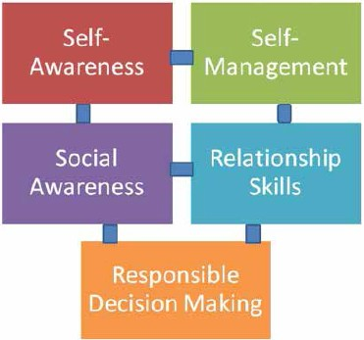
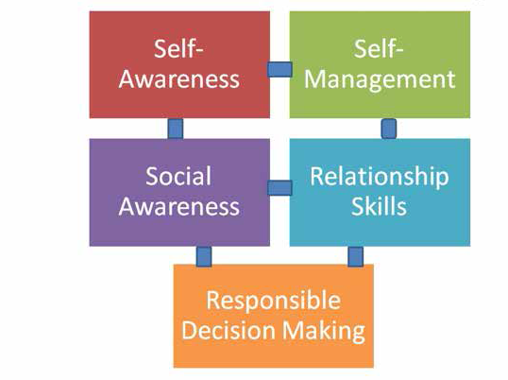
The Massachusetts Standards for Preschool and Kindergarten Social Emotional Learning and Approaches to Play and Learning use a framework based on five interrelated sets of competencies for social and emotional learning identified by the Collaborative for Academic, Social, and Emotional Learning (CASEL): Self-Awareness, Self-Management, Social Awareness, Relationship Skills, and Responsible Decision Making. These areas are interrelated, as are the skills within and across each area. Recognizing the overlapping nature of these developmental areas, it is challenging to neatly sort the competencies into specific categories. As illustrated in the graphic, the skills related to self-awareness and self-management, as well as social awareness and relationship skills, all connect and contribute to responsible decision making.

SELF-AWARENESS
Standard SEL1: The child will be able to recognize, identify, and express his/her emotions.
Standard SEL2: The child will demonstrate accurate self-perception.
Standard SEL3: The child will demonstrate self-efficacy (confidence/competence).

SELF-MANAGEMENT:
Standard SEL4: The child will demonstrate impulse control and stress management.

SOCIAL AWARENESS:
Standard SEL5: The child will display empathetic characteristics.
Standard SEL6: The child will recognize diversity and demonstrate respect for others.

RELATIONSHIP SKILLS:
Standard SEL7: The child will demonstrate the ability to communicate with others in a variety of ways. Standard SEL8: The child will engage socially, and build relationships with other children and with adults. Standard SEL9: The child will demonstrate the ability to manage conflict.
Standard SEL10: The child will demonstrate the ability to seek help and offer help.

RESPONSIBLE DECISION MAKING:
Standard SEL11: The child will demonstrate beginning personal, social, and ethical responsibility.
Standard SEL12: The child will demonstrate the ability to reflect on and evaluate the results of his or her actions and decisions.

SELF-AWARENESS

Self-awareness is defined as “the ability to accurately recognize one’s emotions and thoughts and their influence on behavior. This includes accurately assessing one’s strengths and limitations and developing a sense of self and optimism” (CASEL, 2013). The core features of emotional development include the ability to identify and understand one's own feelings, to accurately read and comprehend emotional states in others, to manage strong emotions and their expression in a constructive manner, to regulate one’s own behavior, to develop empathy for others, and to establish and sustain relationships (National Scientific Council on the Developing Child, 2004). Self-awareness and the ability to understand and label emotions are foundational to healthy interactions and relationships with others, and therefore critical to school success and to a satisfying and successful life. The standards in this section refer to children’s awareness and expression of their own feelings, needs, preferences, and capabilities.

SEL1: RECOGNIZING, IDENTIFYING AND EXPRESSING EMOTIONS
Emotions can facilitate or impede children’s academic engagement, work ethic, commitment and ultimate school success (Elias et al., 1997). By the end of the preschool years, children who have acquired a strong emotional foundation have the capacity to anticipate, talk about, and use their awareness of their own and others’ feelings to better manage everyday social interactions. When feelings are not well-managed, thinking can be impaired (National Scientific Council on the Developing Child, 2004). Young children who are guided by caring adults to be aware of and acknowledge their own emotions as real and valid with appropriate/ acceptable ways to express these feelings begin to develop a secure sense of self. The display of emotions, and therefore the understanding of others’ emotions, is a gateway to forming relationships with others. This awareness and expression is strongly associated with cultural norms. The domain of self-awareness links closely with self-management and with social awareness.

Standard SEL1:
The child will be able to recognize, identify, and express his/her emotions.
Examples of Evidence
By the end of Preschool, a child may… By the end of Kindergarten, a child may…

» recognize and label basic emotions (e.g., » label basic emotions and recognize some happiness, sadness, anger, fear, surprise) and complex emotions, and associate them with facial associate them with words, facial expressions, expressions, body language, and behaviors (e.g., and/or gestures. pride, embarrassment, frustration, nervousness,
» begin to develop a rich vocabulary related to loneliness).
emotions/feelings. » use richer and more specific vocabulary related
» express a range of emotions appropriately to the nuances of emotions (e.g., happy=ecstatic, through gestures, actions, drawing, or language, glad, joyful, elated, delighted, pleased, etc.).
with modeling and support. » express and share own feelings in a variety of
» demonstrate beginning understanding of ways (e.g., through speaking, writing, drawing, connection between feelings and behaviors (e.g., dramatization).
“If..., then...”). » with support, describe reasons for own feelings and situations that cause them (stimuli/ provocations).
Each child may require differing levels of support based on ability, learning style, culture, family, and experience to progress developmentally.

SEL 2: ACCURATE SELF-PERCEPTION
Self-perception/self-concept can be defined as recognition of the attributes, abilities, attitudes, and values that children believe about themselves and that define them. It includes the awareness that these factors make them unique, and that these factors also make them part of groups of others who share them. In both views, children define their worth, both as individuals and as members of something bigger than themselves.
Children’s beliefs about themselves are largely self-constructed; their self-assessments may or may not be accurate. When children assess themselves fairly accurately, they are in a good position to choose age- appropriate activities and work toward realistic goals (Ormrod, 2008). It’s important for children to be fundamentally satisfi with the person they are, but also to have an increasingly accurate appraisal of their strengths and limitations. This will encourage them to work hard to improve in areas where they are less able. It will also help them respect the abilities of those who excel in areas where they themselves do not (Harter, 1993).
Children’s self-concept, whether positive or negative, can greatly impact their motivation to learn, as well as their engagement in social interactions, satisfaction with efforts, willingness to take on challenges,
etc. Culture, environment, and experience influence self-perception. Understanding and respecting these elements is essential to fostering healthy development.

Standard SEL2:
The child will demonstrate accurate self-perception.
Examples of Evidence
By the end of Preschool, a child may… By the end of Kindergarten, a child may…

» identify some personal characteristics such » describe multiple personal characteristics
as physical features, abilities, preferences, realistically (e.g., physical characteristics, abilities/ interests, gender (e.g., “I am/I can…”). skills, interests, preferences).
» know some important information about self » share information about self with others, and (e.g., first and last name, parents’/guardians’ recognize when sharing information is not
names). appropriate (e.g., recognize family or cultural norms
» show recognition of self as a unique individual about sharing information).
(i.e., some things that distinguish him/her from » compare/differentiate own physical characteristics, others). preferences, thoughts, and feelings from those of
» identify personal and family structures (show others (e.g., “I have brown eyes, she has blue eyes;” awareness of themselves as belonging to one “I like X; he likes Y”).
or more groups). » demonstrate awareness and appreciation of self
» demonstrate or express personal preferences as part of a family, culture/ethnicity, language, and explain the reason for the choice. community, or group.
» explain the rationale for one preference/choice over another (e.g., “I need to do more work on my project in the art center,” “I like milk better than juice.”)
Each child may require differing levels of support based on ability, learning style, culture, family, and experience to progress developmentally.

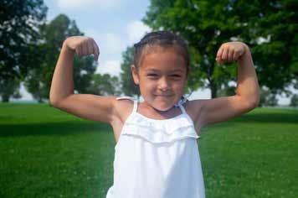

SEL 3: SELF-EFFICACY (CONFIDENCE/COMPETENCE)
Self-efficacy is the belief that one can achieve a task by using one’s own capabilities. “Children who are more self-aware and confident about their learning capacities try harder and persist in the face of challenges” (Aronson, 2002). Confident children feel positive about their ability to do things or to adapt to changing situations. They are willing to take a reasonable risk, express or defend ideas, try new experiences, or
engage in challenging tasks. “A strong sense of efficacy enhances human accomplishment and well-being in countless ways. Confident individuals approach difficult tasks as challenges to be mastered rather than as threats to be avoided” (Pajares & Schunk, 2001). Confidence (self-concept) is related to a person’s belief and feelings about their self-worth. Self-worth is not constant, but develops over time. It is influenced by environment, external feedback, challenges, social context, cultural, and other factors (e.g., some cultures value interdependence more than independence).

Standard SEL3:
The child will demonstrate self-efficacy (confidence/competence).
Examples of Evidence
By the end of Preschool, a child may… By the end of Kindergarten, a child may…

» show confidence in own ability to accomplish » display confidence in personal competencies, and tasks and satisfaction in completion. satisfaction with results of own work (e.g., make
» show pleasure in mastery of skills or tasks. positive statements about self).
» attempt to use skills for daily living. » appropriately share successful mastery of skills or
tasks with others.
» demonstrate reasonable confidence and/or
caution in approaching new experiences. » independently use skills for daily living with
confidence and competence.
» speak out for, or take appropriate action to defend
self or meet own needs/rights. » demonstrate confidence in own abilities as well as realistic perception of limitations (e.g., challenges
» demonstrate willingness to take some risks (e.g., or areas in which he/she might need assistance). taste unfamiliar foods, try a new activity, use
unfamiliar materials or equipment). » express independent thoughts, defend ideas, and
take appropriate action to defend own rights.
» demonstrate willingness to take reasonable risks (e.g., participate in an unfamiliar activity, try a new skill, attempt a challenging experience again).
Each child may require differing levels of support based on ability, learning style, culture, family, and experience to progress developmentally.

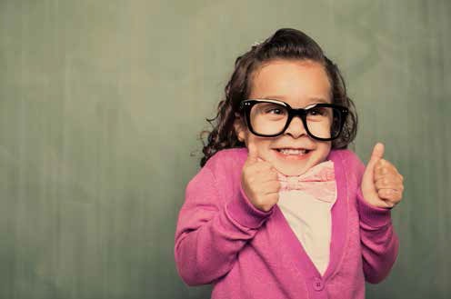

SELF-MANAGEMENT

Self-management is the ability to regulate one’s emotions, thoughts, and behaviors effectively in different situations. This includes managing stress, controlling impulses, motivating oneself, and setting and working toward achieving personal and academic goals (CASEL, 2013). These are long-term life goals.

SEL 4: IMPULSE CONTROL AND STRESS MANAGEMENT
“Children’s ability to label and manage different emotions provides them with powerful social tools: Using words, children can ‘talk through’ rather than act out their negative feelings” (Raver, 2002). The ability to control/manage one’s impulses and behaviors impacts relationships as well as attentiveness and academic performance. In order to function well in school and in life, children need to develop the ability to pause and think before they speak and act, and to stop themselves from acting impulsively. This skill also involves adaptability/flexibility and the ability to curtail a behavior or engage in a particular behavior on demand.
The beginnings of adaptability occur early in life through social settings/experiences and can gradually be refined and applied to other areas.

Standard SEL4:
The child will demonstrate impulse control and stress management.
Examples of Evidence
By the end of Preschool, a child may… By the end of Kindergarten, a child may…

» with support, use strategies to manage intense » independently use coping strategies to manage or difficult feelings (e.g., pounding clay, taking a intense or difficult feelings or decrease levels of
deep breath, drawing a picture). distress (e.g., separating self, counting to ten, etc.).
» with support, begin to regulate impulses (e.g., » manage, regulate, and communicate wants/needs communicate wants/needs; wait for something (e.g., use strategies to help delay gratification, he/she wants). such as choosing an alternative).
» identify challenging situations and use positive » analyze challenging situations and identify healthy skills to deal with them (e.g., recognize that ways to address them (e.g., strategies for handling everyone makes mistakes). mistakes such as erasing, correcting, starting over,
» adjust/modulate behaviors appropriately in etc.).
familiar settings with some reminders (e.g., » adjust/modulate behaviors (voice level, body indoor/outdoor). movement, etc.) appropriate to various settings
» adapt/transition from one environment or activity with minimal support (e.g., library, hallways, to another with support (e.g., home to school; auditorium, bus, cafeteria, etc.).
playground to program; familiar to unfamiliar » independently adapt/transition among settings, etc.). environments or activities with minimal support
» make changes in thinking or actions. (e.g., (e.g., re-entering program after out-of-class implement suggestions from adult or peer, activities; moving from one activity to another).
substitute materials, etc.). » demonstrate flexibility in thinking or actions (e.g., ask for suggestions; think of alternatives; adapt to unexpected changes).
Each child may require differing levels of support based on ability, learning style, culture, family, and experience to progress developmentally.

SOCIAL AWARENESS

Social awareness is defined as the ability to take the perspective of and empathize with others from diverse backgrounds and cultures, to understand social and ethical norms for behavior, and to recognize family, school, and community resources and supports (CASEL, 2013). In this competency cluster, children develop the ability to take information and understanding that they are gaining about themselves, and turn it outward and apply it to others as they observe behavior, attitudes, the display of emotions, and engagement in relationships and activities. Cultural, familial, and experiential information influence this area of development.

SEL 5: EMPATHY
Empathy is the experience of understanding another person’s emotions or situations from their perspective. It is the ability to participate in the feelings or ideas of others, to feel bad about their unhappiness or pain, and to feel good about their joy. In order to develop empathy, a child must be able to feel attachment to another person (Kagan, Moore & Bredekamp, 1995). This ability is rooted in an understanding of other people’s mental states (their thoughts, feelings, desires, motivations, intentions). It requires the application of self-awareness to the understanding of others, because if children cannot identify and label their own feelings, then recognizing, naming, and understanding others’ emotions is out of reach. Social awareness is essential to social competence and to the development of a sense of fairness; it is a foundation for conflict resolution. “A strong sense of empathy allows children to make decisions that are right for them without hurting others or seeking approval or acceptance. This may strengthen them against negative peer pressure and a range of behaviors such as substance abuse, bullying, narcissism, aggression or violence against others” (Sack, 2012).

Standard SEL5:
The child will display empathetic characteristics.
Examples of Evidence
By the end of Preschool, a child may… By the end of Kindergarten, a child may…

» begin to recognize that different people may have » distinguish others’ feelings and begin to speculate different emotional reactions. on why they might be different from his or her own.
» demonstrate awareness of others’ expressions of » recognize, label, and connect with others’
feelings (both verbal and non-verbal). expression of feelings (e.g., explain reasons/causes).
» respond to another’s emotions and needs (e.g., » respond to another’s emotions and needs (e.g., give comfort; report to an adult). share a similar personal experience; advocate for
» with support (e.g., what will happen if…?), begin to someone; relinquish an object or turn for another). anticipate others’ feelings and responses. » predict others’ feelings, responses, and behavior,
» show kindness or regard for other people or for and make decisions accordingly.
other living things much of the time. » show kindness or regard for others or for other
living things most of the time.
Each child may require differing levels of support based on ability, learning style, culture, family, and experience to progress developmentally.

SEL 6: RESPECT FOR OTHERS
Respect means seeing and honoring the value in others. Showing respect means acting in a way that demonstrates care about others’ feelings and well-being through courtesy, consideration, and appreciation. Its foundation is in identifying and appreciating one’s own strengths and vulnerabilities (Galinsky, 2010) and applying that understanding to other people. As children gradually begin to understand themselves in a broader context, they begin to recognize and respect differences such as race, culture, language, abilities, and family structures. Embracing differences and recognizing commonalities contributes to empathy, reduces bias, and greatly lessens the likelihood of bullying behaviors. Children gain knowledge of social conventions in various contexts through adult and peer modeling.

Standard SEL6:
The child will recognize diversity and demonstrate respect for others.
Examples of Evidence
By the end of Preschool, a child may… By the end of Kindergarten, a child may…

» demonstrate awareness of commonalities and » acknowledge and identify commonalities and differences among people (e.g., gender, race, differences among people (e.g., race, culture, ability/disability, language, family structure). language, abilities, etc.).
» demonstrate interest in or curiosity about others’ » communicate differences in families, languages, and families, languages, and cultures. cultures, in positive ways.
» begin to understand that different people have » identify and appreciate the abilities, skills, and different abilities. qualities of others.
» begin to understand that different people may » accept the validity of others’ perspectives, ideas, have different ideas, desires, and perspectives. and motivations (i.e., they are not “wrong,” just
» with some support, show respect for others by different).
using social conventions (e.g., saying “please/ » show respect for others by using social conventions thank you”; listening when others speak). (e.g., raising hand to speak, taking turns, respecting
» with support, balance own needs with others’ authority).
needs (e.g., sharing materials, asking for a turn). » independently balance own needs with needs of
others (e.g., sharing, dividing materials, giving up an object, moving to make space for another).
Each child may require differing levels of support based on ability, learning style, culture, family, and experience to progress developmentally.

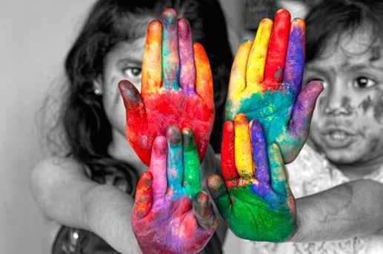

RELATIONSHIP SKILLS

Relationship skills are defined as the ability to establish and maintain healthy and rewarding relationships with diverse individuals and groups. This includes communicating clearly, listening actively, cooperating, resisting inappropriate social pressure, negotiating conflict constructively, and seeking and offering help when needed (CASEL, 2013).

SEL 7: COMMUNICATION
Interpersonal communication is essential to developing and maintaining relationships. Communication enables children to share commonalities and connect with others in a meaningful way. In this context, communication goes beyond speech and oral language, and extends to the recognition, sharing, and understanding of thoughts, ideas, and feelings. Children may communicate/share their personal thoughts, feelings, and needs with other children or adults in a variety of non-verbal ways (e.g., facial expression, body language, communication boards, drawings, movement, etc.). This is especially true for children with
disabilities and/or those who are dual language learners (WIDA, 2007). Communication is greatly influenced by cultural experiences (e.g., who speaks to whom and about what topics).

Standard SEL7: The child will demonstrate the ability to communicate with others in a variety of ways.
Examples of Evidence
By the end of Preschool, a child may… By the end of Kindergarten, a child may…

» engage in meaningful communication or » initiate and engage in multiple and reciprocal conversations with other children throughout communications or conversations with other children the day (including home language or throughout the day (including home language or alternative communication systems as needed). alternative communication systems as needed).
» engage in meaningful communication or » initiate and engage in substantive/focused conversations with adults in the program communication or conversations with adults in the (including home language or alternative program (including home language or alternative communication systems as needed). communication systems as needed).
» with support, listen or demonstrate attention » listen or demonstrate attention and respond when when others talk (or communicate in non­ peers or adults talk (or communicate in non-verbal verbal ways that have been taught, such as ways such as sign language, gestures, body language). gestures, sign language).
Each child may require differing levels of support based on ability, learning style, culture, family, and experience to progress developmentally.

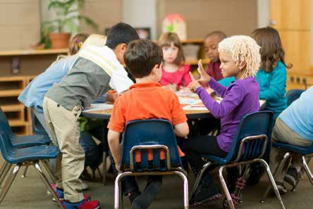

SEL 8: SOCIAL ENGAGEMENT AND RELATIONSHIP BUILDING
The formation of social relationships is influenced by children’s culture, family, and experiences and begins in infancy with attachment. Attachment is the capacity to form and maintain healthy emotional bonds with another person. Healthy attachments allow a child to love, to become a good friend, and to have a positive model for future relationships (Perry, 2002). Children who demonstrate attachment are able to engage in positive social interactions, can use their knowledge of self to understand and form bonds with others, and have also been found to show more enthusiastic attitudes toward learning. Strong teacher/child relationships have been shown to support academic success. Both peer and adult relationships can support positive self-image and feelings of confidence. It is important to honor children’s differing experiences, family styles, and cultural expectations in order to build to their capacity to fully participate in educational opportunities and in society.

Standard SEL8:
The child will engage socially, and build relationships with other children and with adults.
Examples of Evidence
By the end of Preschool, a child may… By the end of Kindergarten, a child may…

» engage in interactions with other children » initiate, expand, and maintain interactions with other much of the time. children most of the time (e.g., invent/set up activities).
» develop one or more special, nurturing » form and maintain increasingly closer and more friendships (e.g., seek out one or more nurturing friendships (e.g., show loyalty, demonstrate particular children). concern for needs/wants of particular children).
» demonstrate trusting, caring relationships » demonstrate trusting, caring relationships with more with one or more adults in the early than one adult in the program and school community. education and care setting. » use play with others to practice and extend
» use play with others to explore and practice understanding of social roles and relationships (e.g., social roles and relationships (e.g., assume create and enact more complex dramatizations using various roles in dramatic play). dialogue and/or props).
Each child may require differing levels of support based on ability, learning style, culture, family, and experience to progress developmentally.

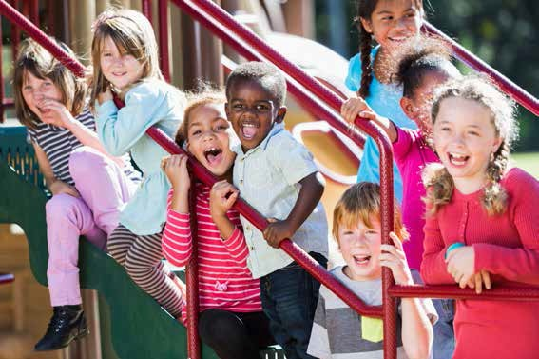

SEL 9: CONFLICT MANAGEMENT
Conflict occurs when a person or group has needs, desires, opinions, or goals that interfere with those of another person or group. Conflict is a natural part of life, with which children must cope as they develop. Learning to cope with conflict is one of the maturational tasks of childhood. Conflict management requires the ability to analyze social situations, identify problems, set pro-social goals, and determine effective ways to solve differences. Conflict management abilities begin with the acquisition of basic self and social skills, especially listening and perspective-taking. The opportunity to observe, engage in, and practice these skills is often presented for the first time when children enter social groups. Skills expand with support and with multiple and varied opportunities to identify and resolve simple social problems using reasoning, judgment, critical thinking, and communication (CSEFEL, 2014). Negotiation is one way children learn to manage confl and is evident when they begin to use various means of communication to meet their needs or resolve conflict. Development of this skill requires self-awareness, perspective-taking, empathy, and respect (e.g.,
“What do I need/want? What does the other person need/want? How can both our needs be met?”). Positive negotiation processes include finding a shared interest in the issue and working towards a “win-win” outcome.

Standard SEL9:
The child will demonstrate the ability to manage conflict.
Examples of Evidence
By the end of Preschool, a child may… By the end of Kindergarten, a child may…

» recognize the existence of a social conflict (e.g., » recognize and act on conflict situations in a positive acknowledge/identify a conflict). manner most of the time (e.g., explain situation with
» use beginning negotiation skills (e.g., state own objectivity; listen to others’ perspectives or solutions). position/perspective with rationale). » be able to listen to and acknowledge another’s
» seek advice or assistance from peers and/or adults perspective and rationale (e.g., explain/restate to resolve conflict, when appropriate (e.g., listen to understanding of another person’s perspective).
guidance; talk through conflict; develop solutions). » distinguish when it is appropriate to seek adult help and
» with modeling and support, negotiate with when conflict can be managed by peers.
others to meet own needs and goals; recognizing » be able to initiate and engage in compromise or compromise as a part of the solution (e.g., if you bargaining strategies to seek a middle ground or
, I will ; trades, etc.). a mutually satisfactory outcome (e.g., use if/then
» with support, consider prevention strategies for statements, concessions, etc.).
interpersonal conflicts. » identify some strategies for preventing interpersonal conflicts.
Each child may require differing levels of support based on ability, learning style, culture, family, and experience to progress developmentally.

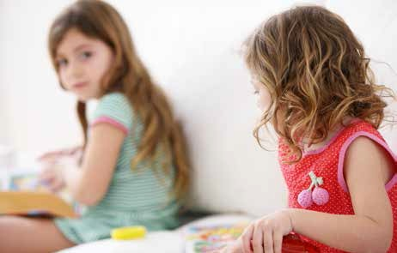

SEL 10: SEEKING HELP AND OFFERING HELP
Seeking help is the ability to get one’s needs met, requiring self-awareness and reaching out for support. Sungok, Kiefer, & Wang (2013) explain the role of help-seeking in the context of academic learning: “Help- seeking is actually part of the process of self-regulation. During help-seeking behavior, students are engaged in metacognitive processes. To make a bid for help, students need to cognitively appraise the task difficulty as well as their present level of competence... To get help successfully, a student has to understand that he or she has a problem, decide whether and whom to ask for help, do so clearly, and process the help that’s given… some students ask for help before they even start thinking about a problem, while others avoid seeking help even after struggling fruitlessly on their own…”.
Both seeking and offering help can contribute to the development of relationships, self-confidence, communication skills, and mutual satisfaction. Asking for help promotes independence. Offering help contributes to self-efficacy. Children need to communicate to get materials, activities, attention, or assistance from others. Having the capabilities to do that supports children’s positive choices. Offering help requires sensitivity to others’ needs and reaching out to give support. Both skills help children understand the use of adults, peers, and materials as resources (CSEFEL, 2005).

Standard SEL10:
The child will demonstrate the ability to seek help and offer help.
Examples of Evidence
By the end of Preschool, a child may… By the end of Kindergarten, a child may…

» recognize when assistance is needed (e.g., when » often attempt reasonably challenging tasks independently frustration level is reached). before requesting assistance.
» identify external supports (e.g., a trusted adult; » describe and use appropriate strategies for seeking how/where to get help and support). assistance (e.g., big problem vs. small problem).
» ask for help from adults and identify support » ask for assistance from adults in socially acceptable ways. needed. » ask for assistance from peers in socially acceptable ways.
» ask for help from peers. » recognize when another needs help and offer assistance.
» recognize when another needs help.
Each child may require differing levels of support based on ability, learning style, culture, family, and experience to progress developmentally.

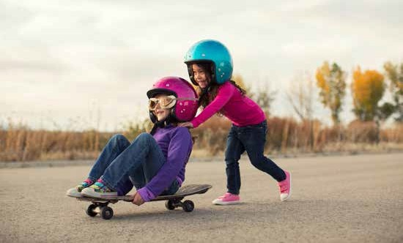

RESPONSIBLE DECISION MAKING

Responsible decision making is defined as the ability to make constructive and respectful choices about personal behavior and social interactions based on consideration of ethical standards, safety concerns, social norms, the realistic evaluation of consequences, and the well-being of self and others (CASEL, 2013). According to Massachusetts DESE (2011), “Responsible decision making includes problem identification and situation analysis; problem solving; evaluation and reflection, and personal, social, and ethical responsibility.” These definitions represent long-term life goals that are gradually developed with education and support, but the foundations begin in early childhood.

SEL 11: PERSONAL, SOCIAL, AND ETHICAL RESPONSIBILITY
For young children, ethics may be defined as the capacity to anticipate outcomes and consider the welfare of others. As part of their evolving social behavior, children learn to distinguish between right and wrong, and they learn to use refusal skills and to resist negative influences. For preschool and kindergarten children, such decisions mostly relate to following program rules, resisting peer pressure, and controlling aggression or disruptive behavior.
Young children often think of themselves before others, and self-interest tends to be the first motivator of their behavior. This is very normal. In order to grow toward an expanded focus, they must be given opportunities to see the value of thinking of the group, and to demonstrate personal, social and ethical behavior. Children can also be socially aware, connected, and concerned about others. With increased experience in being part of a group or community, and with the guidance of responsible adults, children
develop the ability to view the impact of individual decisions on a larger social sphere, and consider the well­ being of the group, school, or community.
Opportunities to feel responsible, trusted, and helpful allow children to demonstrate self-efficacy, and provide the beginning foundations of being good citizens of their community (e.g., doing one’s fair share, helping each other and the environment, and working together for a common goal). Over time, mastering social and emotional competencies results in a shift from being predominantly controlled by external factors to acting in accord with internalized beliefs and values, showing caring and concern for others, making good decisions, and taking responsibility for one’s choices and behaviors (Bear & Watkins, 2006).

Standard SEL11:
The child will demonstrate beginning personal, social, and ethical responsibility.
Examples of Evidence
By the end of Preschool, a child may… By the end of Kindergarten, a child may…

» demonstrate beginning understanding of reasons » communicate reasons for rules (benefits to self for rules (benefits to self and others). and others).
» understand and follow rules, limits, and » understand and follow rules, limits, and expectations with prompting/assistance. expectations with minimal prompting/assistance.
» show willingness to take on responsibilities (e.g., » take on responsibilities and follow through on helper or leader role). them (e.g., volunteer for and carry out tasks).
Each child may require differing levels of support based on ability, learning style, culture, family, and experience to progress developmentally.

SEL 12: REFLECTION AND EVALUATION
Reflection, which requires remembering with analysis, engages children in interpreting an event or action. It requires thinking about what they have learned, the processes used, what was interesting, and what might be done as a next step. Reflection transforms a simple exercise of recall into a thoughtful procedure that explores means-ends connections. Planning and reflection thus involve decision making and problem solving. Reflection can help children to generalize knowledge to other situations, thereby leading to further prediction and evaluation. Young children can begin to examine what has worked and what has not and to think about the reasons. These self-reflections and evaluations contribute to self-awareness and understanding the consequences of behaviors, and help children to extend knowledge (Epstein, 2003). Reflection does not come easily or naturally, and young children need help with understanding the rationale for, and the process of, reflecting on actions, behaviors, and outcomes.

Standard SEL12:
The child will demonstrate the ability to reflect on and evaluate the results of his or her actions and decisions.
Examples of Evidence
By the end of Preschool, a child may… By the end of Kindergarten, a child may…

» accept beginning responsibilities toward the well » identify personal opportunities and take being/comfort of others and the group (e.g., responsibility for the well- being/comfort of taking care of a pet, helping younger or less able others and the group (e.g., making a guest feel children). welcome, helping someone who is less able).
» understand what a problem is (e.g., define/ » identify and communicate a social/ethical problem describe examples of a social/ethical problem). (e.g., describe and report a problem).
» with support, discuss and identify possible » with support, discuss and identify possible causes solutions for a social/ethical problem. and solutions for a social/ethical problem.
» recognize situations that are safe vs. dangerous » recognize situations as safe vs. dangerous and (e.g., appropriate vs. inappropriate touch). know what action to take (e.g., stranger danger,
» recognize negative peer pressure (e.g., when safety, etc.).
peer suggestions are in conflict with rules or » resist negative peer pressure (e.g., refuse to appropriateness). participate in peer actions that are in conflict with
» recognize teasing/bullying and seek support from rules or appropriateness).
an adult. » take steps to stop teasing/bullying and/or deal with it effectively (e.g., speaking up; seeking support from an adult).
Each child may require differing levels of support based on ability, learning style, culture, family, and experience to progress developmentally.

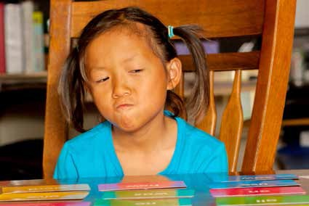

APPROACHES TO PLAY AND LEARNING
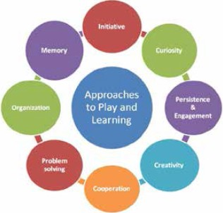
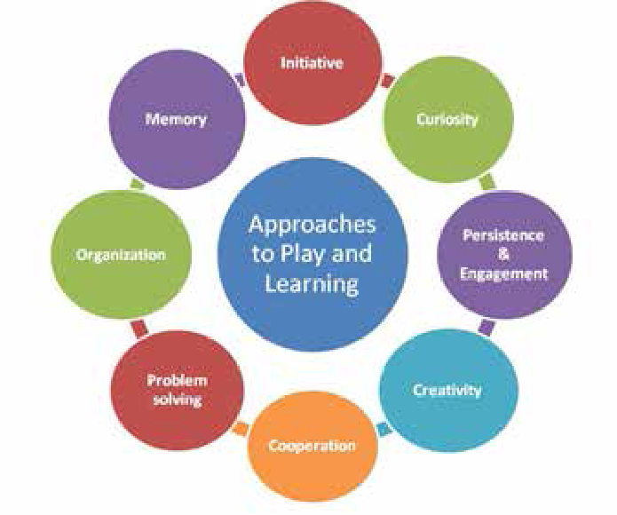
Approaches to Play and Learning are considered important factors in school readiness, including the ability to tackle and persist at challenging or frustrating tasks, follow directions, take risks and make mistakes, and work as part of a group (US DHHS, 2010). Children’s approaches to play and learning are powerful predictors of their later success in school (Child Mental Health Foundations and Agencies Network [FAN], 2000).
Approaches toward learning refer to the inclinations, dispositions, or attitudes with which children attempt or respond to learning situations. Children’s approaches to learning contribute to their success in school and interact with their development and learning in all other domains. These approaches help children develop resiliency, and are needed for higher-order thinking. Ultimately, individuals with these skills are productive workers and better citizens.

The Impact of Cultural Patterns and Values

Perhaps no other dimension is so subject to individual variation as approaches toward learning. The report of the National Education Goals Panel (1995) explains that this is partially due to differences in parental child­ rearing practices. Children learn how to confront tasks through parents’ instruction, guidance, modeling,
and responses to children’s initiatives (e.g., parental child-rearing practices influence whether children they believe that they have control over events in their lives or that they are helpless, with other sources controlling their fates).
Cultural patterns and values predispose children to learn in different ways. For example, in some cultures, children are encouraged to learn by engaging actively in dialogue with their parents; in other traditions, children play a more receptive role, listening quietly to parents’ instructions and guidance; in still other cultures, children learn through observation, imitation, and non-verbal communication.
Cultural variation may affect children’s work styles, including their comfort working independently or socially; and it may affect children’s distractibility or ability to focus. Such variations must not be perceived as deficiencies, but as equivalent strategies. Culture also influences children’s predispositions for different learning modalities (the way they prefer to approach learning tasks) with some children learning more easily by manipulating concrete materials, others by talking through a problem, and others by using visual representations to comprehend its nuances; indeed, some children work best when presented with a changing array of problem-solving formats. Variations in approaches toward learning within and between
cultures must be respected in order to enhance and not discourage children’s engagement (Kagan, Moore, & Bredekamp, 1995).
Approaches to Play and Learning Standards
Standard APL1: The child will demonstrate initiative, self-direction, and independence.
Standard APL2: The child will demonstrate eagerness and curiosity as a learner.
Standard APL3: The child will be able to maintain focus and attention, and persist in efforts to complete a task.
Standard APL4: The child will demonstrate creativity in thinking and use of materials.
Standard APL5: The child will cooperate with others in play and learning.
Standard APL6: The child will seek multiple solutions to a question, task, or problem.
Standard APL7: The child will demonstrate organizational skills.
Standard APL8: The child will be able to retain and recall information.

APL 1: INITIATIVE
Initiative refers to the ability to make intentional choices, to take leadership. Initiative is related to children’s ability to exhibit a spirit of independence and a sense of control over their choices. It also reflects children’s willingness to pursue social relationships and to demonstrate a growing sense of self-sufficiency and confidence while interacting with others. During the early years of life, children’s initiative and curiosity lead them to explore and experiment in ways that contribute to brain development (NCQTL, 2014). As young children begin to make intentional choices/decisions with a specific goal or purpose in mind (e.g., what they will do, with whom, and under what conditions; what materials they will use), they are developing initiative. Shyness, cultural differences, or prior experiences may inhibit initiative, but need not be a barrier to success. Other skills associated with initiative include planning, predicting, and anticipating.

Standard APL1:
The child will demonstrate initiative, self-direction, and independence.
Examples of Evidence
By the end of Preschool, a child may… By the end of Kindergarten, a child may…

» spontaneously pursue own interests in play and » consider diverse personal interests and goals, and learning. select among them.
» demonstrate eagerness to learn about a range of » demonstrate eagerness to learn about and participate topics, ideas, and tasks. in a variety of topics, ideas, and tasks, and explore
» demonstrate willingness to try new or challenging these interests in depth.
experiences. » independently seek new experiences and attempt
» begin to plan, set goals, and make decisions, with increasingly complex challenges (physically, assistance (e.g., describe what he/she intends to cognitively, or socially).
do in an activity area, with whom, and under what » engage in planning, goal-setting, and decisions with circumstances). some assistance (e.g., decide with whom to work and
» with support, use a variety of resources to explore play, and under what circumstances; describe steps to materials and ideas. reaching goals, and processes/materials to be used).
» independently use a variety of resources to find answers to questions, to solve problems, or to create.
Each child may require differing levels of support based on ability, learning style, culture, family, and experience to progress developmentally.

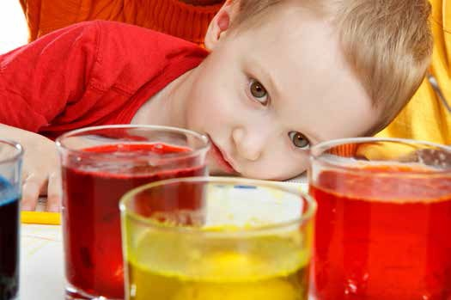

APL 2: CURIOSITY
Curiosity relates to children’s natural tendencies as active learners to explore all aspects of the environment, including objects, people, ideas, and customs. Curiosity also implies “inquisitiveness,” or going beyond
what is known often with a questioning spirit/intent, hence--exploration. Curiosity leads to higher levels of intellectual engagement resulting in more knowledge acquired over time, especially in education (Chamorro- Premuzic, 2014). It is through raising questions and seeking answers that children construct knowledge.

Standard APL2:
The child will demonstrate eagerness and curiosity as a learner.
Examples of Evidence
By the end of Preschool, a child may… By the end of Kindergarten, a child may…

» with support and modeling, ask “what” and “how” » ask “why” questions about unknown future events questions to gain information about familiar and and phenomena, as well as about the here and unfamiliar events and phenomena. now (e.g., how, what if).
» try new sensory and other experiences (e.g., » try a wide range of new experiences (e.g., explore, examine, and experiment with materials, materials, tasks, academic or physical skills), both constructions, nature). independently and with peers or adults.
» with support, seek information from a variety of » with support, seek information from a variety of sources, such as books, experts, observations. sources, such as books, the Internet, experts, and
» use a variety of learning approaches, such as observations.
observing, imitating, asking questions, hands-on » describe or demonstrate how he/she likes to learn investigation. best (e.g., observing, imitating, asking questions,
hands-on investigation).
Each child may require differing levels of support based on ability, learning style, culture, family, and experience to progress developmentally.

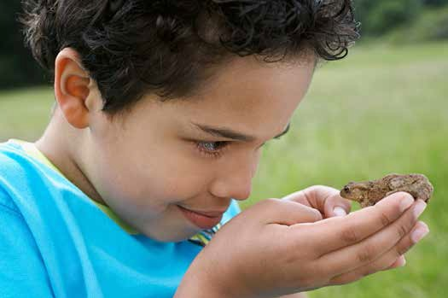

APL 3: ENGAGEMENT/PERSISTENCE
Engagement refers to attentiveness, or the ability to focus on an activity with deliberate concentration. Persistence refers to the capacity of children to remain involved in what they are doing and to meet challenges appropriate to their level of development (staying longer in a center and engaging in an activity with increasing regularity). Persistence also includes re-trying tasks to achieve success, or to reach a higher level of challenge or satisfaction; it means not giving up despite setbacks. Children’s active and sustained engagement in program activities is linked with gains in their emotion management (Williford, Vick-Whittaker, Vitiello, & Downer, 2013). In addition, Rimm-Kaufman, La Paro, Downer, and Pianta (2005) found that academic success in kindergarten programs could be predicted from children’s active engagement in activities.

Standard APL3:
The child will be able to maintain focus and attention, and persist in efforts to complete a task.
Examples of Evidence
By the end of Preschool, a child may… By the end of Kindergarten, a child may…

» with support, maintain concentration on a task or » independently maintain focus on a project for a activity for short periods of time, until completed. sustained period of time, until completed.
» with support, resist distraction and maintain » resist distraction and maintain attention to a attention to a task or activity (e.g., stories task or activity (e.g., teacher instruction, multiple read aloud, demonstrations, different activities activities occurring simultaneously) with minimal occurring simultaneously). support.
» with support, continue with or return to activities » continue with or return to activities despite after distractions or interruptions. distractions or interruptions.
» maintain focus on a topic during a conversation or » contribute to discussions, holding in mind both discussions. the topic of discussion and the contributions of
» with support, cope with some frustration or others.
disappointment. » independently persist in spite of frustration or
» work with purpose, determination, and enjoyment disappointment.
on self-chosen tasks. » work to complete projects to own satisfaction based on personal standards of quality or completion (“good enough” or “finished”).
Each child may require differing levels of support based on ability, learning style, culture, family, and experience to progress developmentally.

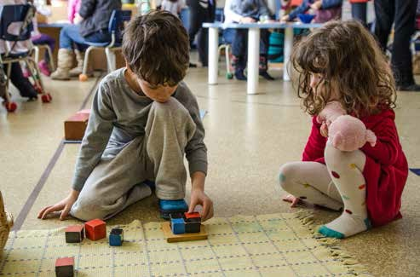

APL 4: CREATIVITY
Creativity is how children show originality. While often associated with the expressive arts, creativity also applies to multiple areas (creative writing, problem solving). Creativity/inventiveness involves willingness to cope with new situations and problems, as well as being able to explore new ideas, and see things from a different perspective. Creative children extend and elaborate on ideas and appreciate humor within their own cultural context. Creativity also fosters mental growth in children by providing opportunities for trying out new ideas, and new ways of thinking and problem-solving (PBS Kids, 2014).

Standard APL4:
The child will demonstrate creativity in thinking and use of materials.
Examples of Evidence
By the end of Preschool, a child may… By the end of Kindergarten, a child may…

» use materials, tools, information, and experiences » use materials, tools, information, and experiences in new and different ways. to express ideas or convey meaning in new and
» begin to recognize the difference between different ways.
pretend/fantasy situations and reality with adult » describe or represent the difference between support (e.g., what could/could not happen in real fantasy situations and reality.
life?). » use humor to play with concepts/language
» begin to understand and use humor to gain or to engage or entertain others as culturally attention (e.g., words, actions). appropriate (e.g., jokes, riddles, songs, rhymes).
» use imagination to express an idea or concept. » use imagination and other materials to produce
» express ideas through art, music, movement, new ideas.
drama. » combine materials and equipment to express ideas through various creative arts.
Each child may require differing levels of support based on ability, learning style, culture, family, and experience to progress developmentally.

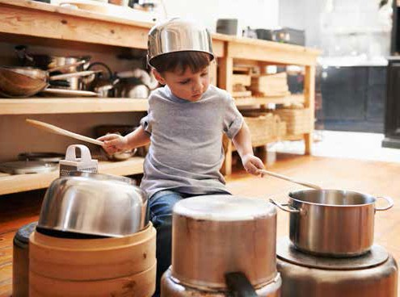

APL 5: COOPERATIVE PLAY AND LEARNING
Cooperation begins to appear as children develop their abilities for reciprocity, taking turns, and sharing. They continue to build cooperative skills as they engage in positive relationships, friendships, and collaborative projects. Cooperative learning connects with and supports social skills such as listening to and respecting the perspective of others, leadership, conflict resolution, and helping one another.
Interacting with others with different points of view helps to develop higher-order thinking skills, as children challenge each other’s assumptions and bring different information to the process, taking them to a
higher level than they might have reached by themselves. Children typically do not learn alone, but rather in collaboration with their teachers, in the company of their peers, and with the encouragement of their families (Elias et al., 1997).
Through play, children try out new skills, explore their imagination and creativity, and develop relationships with other people in their lives (Child Action, Inc., 2014). Children learn from many types of play (defined as engagement in activities for enjoyment or fun):
- Solitary play – when children participate in an independent activity, showing no interest in joining in or interacting with the play of others.
- Parallel play – an activity in which children play with toys like those the children around them are using, but each child is absorbed in his/her own activity, playing beside rather than with one another.
- Pretend play – using an object to represent something else while giving it action and motion; actively experimenting with the social and emotional roles of life; can build skills in many developmental areas.
- Cooperative play – any organized recreation among a group of children in which activities are planned for the purpose of achieving some goal.

It is important for children to experience all types of play, but shared play has a particular role as a means of developing cooperation and diverse social skills. As children gradually learn how to play and work together with a common interest or for a common goal, they share ideas, skills, knowledge, experience, and discoveries, and begin to recognize the benefits in working together.

Standard APL5: The child will cooperate with others in play and learning.
Examples of Evidence
By the end of Preschool, a child may… By the end of Kindergarten, a child may…

» suggest and listen to ideas for play with » suggest and listen to ideas for play with others (e.g., board others (e.g., block play, puppets, games). games, playground games, role play).
» plan and negotiate play with another » collaborate and negotiate play with two or more children child (e.g., roles/ responsibilities each (e.g., who will go first, roles each participant will play, child will assume). assuming various responsibilities).
» begin to use cooperative strategies in » cooperate successfully in play and work with others with play with others (e.g., sharing materials, little prompting (e.g., listening and responding to needs of taking turns, listening to the needs of others, helping or advising one another).
others). » use cooperative learning strategies to accomplish a task
» cooperate with others to accomplish a or solve a problem (e.g., brainstorming ideas or steps,
task or solve a problem (e.g., offering identifying resources, designating/accepting responsibilities, and listening to suggestions, determining co-constructing processes to be used, sharing knowledge or a process). discoveries).
» begin to accept and share leadership. » recognize and respect shared leadership (e.g., be a leader
» share his/her processes with adults and respect others as leaders).
or other children (e.g., demonstrating, » explain (or represent) how cooperative strategies facilitated explaining, or representing what he/she the process for accomplishing a task or solving a problem. did).
Each child may require differing levels of support based on ability, learning style, culture, family, and experience to progress developmentally.

APL 6: PROBLEM SOLVING
Problem solving refers to the processes used to explore questions or situations and to try different solutions. Social problem solving is addressed in the SEL standards for conflict management. In the context of APL6,
it refers primarily to cognitive tasks (such as scientific or mathematical questions of how, why, or what if…?) involving children’s ability to look for or find multiple solutions to a question, task, or problem. This ability is crucial for constructing knowledge as children build on prior experiences and integrate new information.
Young children who can solve their own problems feel confident and enjoy learning. They are willing to make mistakes and learn from them and keep trying until they succeed (NAEYC, 2014). Children who were more flexible in their approach to problem solving had higher academic achievement in kindergarten (George & Greenfield, 2005).

Standard APL6:
The child will seek multiple solutions to a question, task, or problem.
Examples of Evidence
By the end of Preschool, a child may… By the end of Kindergarten, a child may…

» recognize and try to solve problems using a » identify increasingly complex problems and variety of methods (e.g., trial and error, discussion strategies for solving them (e.g., experimentation, with others). reasoning, research).
» think of possible solutions and identify one to put » identify pros and cons of possible solutions, then into action. select and implement one.
» recognize relationships between cause and effect » verify cause and effect predictions and speculate (e.g., predict possible results and try out one or about how or why the outcome might have been more solutions). different.
» with support, formulate and test hypotheses, and » with support, formulate and test hypotheses, draw connections to previous experiences and make inferences, and draw connections to information. previous experiences and information.
» make multiple attempts to solve problems. » try different solutions when the first attempt does
not work.
Each child may require differing levels of support based on ability, learning style, culture, family, and experience to progress developmentally.

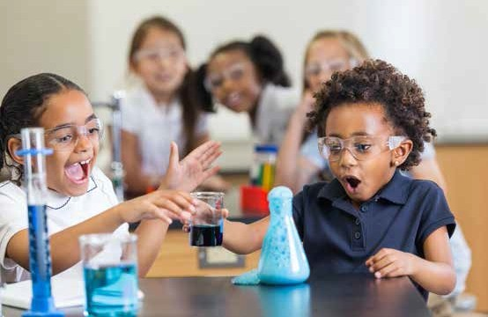

APL 7: ORGANIZATIONAL SKILLS
Organizational skills require that children use logic to arrange things in an orderly way. The important components of organizational skills are environmental management, task management, and time management. As children’s organization skills develop, they begin to integrate and prioritize the concepts of time, tasks and materials. These skills help children navigate the day: finding belongings and materials, understanding routines, and participating in transitions. Organizational skills support the development of thinking skills such as sorting and sequencing; they also support planning and are an important component of executive functioning—the command-and-control ability that allows one to manage and execute tasks (Zelazo & Muller, 2002).

Standard APL7:
The child will demonstrate organizational skills.
Examples of Evidence
By the end of Preschool, a child may… By the end of Kindergarten, a child may…

» with support, organize materials appropriately » independently organize materials appropriately (e.g., put things away; sort materials by categories (e.g., put away materials when finished, organize such as color, shape). materials by categories).
» develop organizational routines with reminders » independently carry out organizational routines (e.g., check cubby or personal space for take- (e.g., gather personal belongings at end of day).
home materials and projects to share with » describe and implement multiple steps to be families). followed for an activity or project.
» begin to develop processes for organizing tasks » demonstrate awareness of the weekly schedule (e.g., describing or representing several steps in a (e.g., specials, half days, etc.); anticipate and process). prepare for coming events.
» recognize the daily schedule, follow program » manage time for tasks or activities with minimal routines, and identify what comes next. support (e.g., recognize when and how to prepare
» begin to manage time required for tasks or for or close an activity, task, or process). activities (e.g., how to prepare for or end an
activity, task, or process).
Each child may require differing levels of support based on ability, learning style, culture, family, and experience to progress developmentally.

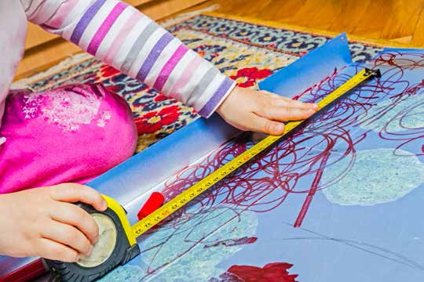

APL 8: MEMORY
Memory refers to the retention and recall of objects, events, and ideas processed in the past. Preschoolers can recognize information that they have encountered before, and reconstruct it in the present. Children tend to remember things that matter most to them, and they also recall and maintain information that
is repeated and used frequently. They can be guided in using simple strategies for developing working memory, such as association (connecting objects and terms with other concepts that relate in some way). Early working memory skills are a better predictor of later academic achievement than are early IQ scores (Alloway & Alloway, 2010).
For children who are dual language learners, it can be particularly important to associate new concepts with terms in their home language. Storing information in the form of “scripts” (sequences of steps or events) can help children to predict what will happen in future scenarios. By Kindergarten, children can begin to learn strategies for retaining and recalling information for specific purposes (e.g., using knowledge of the alphabet and letter sounds to sound out and read words). As metacognition (the ability to think about thinking) develops, children can begin to consciously choose specific strategies for approaching learning tasks.

Standard APL8:
The child will be able to retain and recall information.
Examples of Evidence
By the end of Preschool, a child may… By the end of Kindergarten, a child may…

» relate past experiences. » relate past experiences with details.
» recall visual items/cues. » use intentional strategies to support visual
» recall auditory cues and comments. memory (e.g., focusing on specific details, spatial placement).
» use prior knowledge to predict and ask questions.
» recall and relate auditory information.
» apply prior knowledge to new situations, relationships, and problem solving.
Each child may require differing levels of support based on ability, learning style, culture, family, and experience to progress developmentally.

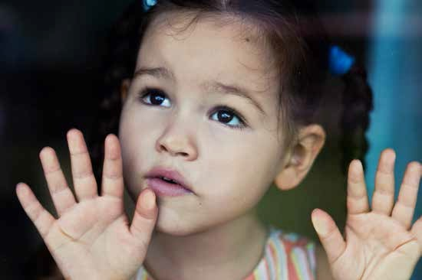

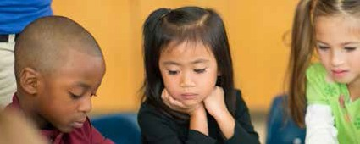
GLOSSARY

FOR SOCIAL-EMOTIONAL LEARNING AND APPROACHES TO PLAY AND LEARNING

ACTIVE EXPLORATION - Manipulating materials, thoughts, and ideas, which may lead to understanding or knowledge
ACTIVE LEARNERS - Children who learn by doing, participating, and playing

ACKNOWLEDGE - To show recognition or interest with facial expression or words

ACTIVITIES - Experiences, either spontaneous or planned by the educator, that create opportunities for children to explore and learn
APPROACHES TO PLAY AND LEARNING - A child’s characteristic responses to play and learning situations, such as curiosity, flexibility, persistence, reasoning, and problem solving
APPROPRIATE - The usual expectations for a child’s age and ability

ATTACHMENT - The strong emotional bonds that tie one person to another person. This tie binds people together and endures over time.
CAUSE AND EFFECT - A relationship between actions or events such that one is a result of the other

COLLABORATION - Adults or children working together as a team to solve problems and accomplish tasks in order to achieve a common goal
COMMUNICATION - Understanding and/or expressing wants, needs, feelings, and thoughts with others. Forms of communication include crying, vocalizing, facial expressions, speech, gestures, sign language, and/ or pictures.
COMPETENCY - Ability to perform a specific task, action, or function successfully

CONFLICT - A situation where one person or group has needs, desires, opinions, or goals that interfere with those of another person or group
COOPERATE - To work or act with others willingly and agreeably

CREATIVITY - Originality or imagination

CULTURE - Shared attitudes, beliefs, histories, arts, customs, and social or family practices that generally characterize a particular group of people
CURIOSITY - Inquisitiveness; the desire to know or learn more about people and things, especially the new and novel, and eventually abstract ideas
DEMONSTRATE - To show clearly

DISPOSITION - An attitude; an individual’s tendency to act in a certain manner under given circumstances

DIVERSITY - The differences among people such as race, culture, language, abilities, family structure, etc.

DUAL LANGUAGE LEARNERS - Children, age birth to five years, who are learning two or more languages simultaneously
EMPATHY - Being aware of and responding to the feelings of others

ENGAGEMENT - The amount of time that children spend interacting with people/and or experiences, with focused attention, in a developmentally and contextually appropriate manner
EXECUTIVE FUNCTION - Set of mental processes that include being able to break down a task into its components, organize a plan of work, follow through on it, and reflect on the success of one’s efforts
EXAMINE - To observe, test, or investigate

EXECUTIVE FUNCTIONING SKILLS - The set of mental skills that work together to help a person achieve goals. Includes tasks like: manage time and attention, switch focus, plan and organize, remember details, curb inappropriate speech or behavior, and integrate past experience with present action.
EXPERIMENT - An action used to discover something unknown, or to test a principle or idea

EXPLORE - To investigate or study

EVALUATE - The ability to consider the consequences of a decision or possible choices

EVIDENCE - The way a child demonstrates a skill; one of many ways to show competence

FAMILY - The closest relationships that a child has, customarily thought of as a mother or father and siblings, but often including foster family, grandparents, and others who are significant in the child’s life
FAMILY ENGAGEMENT - Partnering with families so schools and families are working in parallel to ensure child success. May be a variety of frequency and levels of involvement: communication; volunteering; or support at home for school goals, policy, and decision-making.
FLEXIBILITY - The ability to change or alter plans in response to changing information and goals

HOME LANGUAGE - First language a child learns to speak with family

IMPULSE CONTROL - The ability to think before speaking and acting, as well as stopping oneself from acting impulsively
INDEPENDENCE - The ability to be self-sufficient, to self-organize, to self-manage, and to act without the guidance of others
INITIATIVE - The ability to make intentional choices, to take leadership

INVESTIGATE - To study the details, to examine, or to observe in order to gain knowledge

LEARNING STANDARDS - Concise, written descriptions of what students are expected to know and be able to do at a specific stage of their education; educational objectives
MEMORY - The ability to retain and recall information

METACOGNITION - The ability to think about thinking

MIXED DELIVERY SYSTEM - All settings where Preschoolers and Kindergarteners receive education and care: public schools, early education and care programs, family child care, Head Start, Coordinated Family and Community Engagement (CFCE) programs, home, etc.
MODEL - To teach children through example, by demonstrating the desired behavior or action

ORGANIZATIONAL SKILLS - Use of logical processes to systematize time, tasks, thoughts, materials, and relationships
PEERS - Children who are about the same age

PERSISTENCE - The ability to maintain attention despite interruptions or distractions

PLAY - Engaging in a physical or mental activity for the purpose of pure enjoyment or amusement

PROBLEM SOLVING - The process of exploring questions or situations and intentionally trying different solutions

PROMPT - To encourage an action or behavior

PROP - An object used by children during play

PRO-SOCIAL BEHAVIOR - Showing concern, cooperation, kindness, and consideration for others; demonstrating a sense of caring for others
RECIPROCAL - Present or existing on both sides; mutual
REFLECTION - Recalling and interpreting an object, event, or behavior in one’s mind

RESPECT - To show esteem for another person; to communicate that the other’s person’s ideas, feelings, and needs are worthy of consideration
RESPONSIBLE DECISION MAKING - Making choices and taking actions based on consideration of safety concerns, appropriate social norms, respect for others, and likely consequences; applying these skills to academic and social situations; contributing to the well-being of one’s school and community
ROUTINE - A pattern of events or interactions planned and occurring on a regular basis

SELF-EFFICACY - The perception that one is capable of successfully making decisions, accomplishing tasks, and meeting goals
SELF-MANAGEMENT - The ability to handle one’s emotions in productive ways; being aware of feelings, monitoring them, and modifying them when necessary so that they aid rather than impede the ways in which the child is able to cope with varying situations
SELF-REGULATION - Controlling one’s behaviors to conform to accepted norms

SELF-PERCEPTION/SELF-CONCEPT - The ability to recognize the attributes, abilities, attitudes, and values that children believe characterize them.
SOCIAL AWARENESS - Recognizing and understanding others’ behaviors and perspectives; appreciating and interacting positively with diverse groups
SOCIAL ENGAGEMENT - Participating in interpersonal interactions with children or adults

SOCIAL COMPETENCE - The ability to demonstrate conscious control of thoughts and actions in social interactions
SOCIAL NORMS - Standards of behavior shared by members of a group

SOCIAL RELATIONSHIPS - Healthy relationships and interactions with adults and peers

SPECIAL NEEDS - The educational requirements for children with disabilities as identified by the Individuals with Disabilities Education Act (IDEA)
STRATEGIES - Collection of methods to promote development or learning

STRESS MANAGEMENT - The ability to regulate physical and/or emotional reactions to stress; part of impulse control
TEMPERAMENT - The unique way a child responds to the world; usually refers to a child’s adaptability and emotional style
TOOL - Anything tangible used or created to accomplish a task or purpose TRANSITION - Time of change or moving children from one activity or place to another TRIAL AND ERROR - Attempting to solve a problem by trying different approaches WORKING MEMORY - The ability to hold information in mind and use it

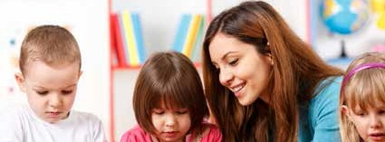
REFERENCES

Alloway, T. P., & Alloway, R. G. (2010). Investigating the predictive roles of working memory and IQ in academic attainment. Journal of Experimental Child Psychology, 106(1), 20–29.

Aronson, J. (Ed.) (2002). Improving academic achievement: Impact of psychological factors on education. New York, NY: Academic Press.

Bear, G. G., & Watkins, M. (2006). Developing self-discipline. In G. Bear & K. Minke (Eds.), Children’s needs III: Development prevention, and intervention (pp. 29–44). Bethesda, MD: National Association of School Psychologists.

Center on the Social and Emotional Foundations for Early Learning (CSEFEL). (2005). What works brief: Helping express their wants and needs. Retrieved from http://csefel.vanderbilt.edu/briefs/wwb19.pdf

Center on the Social and Emotional Foundation for Early Learning (CSEFEL). (2008). Inventory of practices for promoting social and emotional competence.
Retrieved from http://csefel.vanderbilt.edu/modules/module1/handout4.pdf

Center on the Social and Emotional Foundations for Early Learning (CSEFEL). (2014). What works brief. Role of time­ out: A comprehensive approach for addressing challenging behaviors in preschool children. Retrieved from http:// csefel.vanderbilt.edu/briefs/wwb14.pdf

Chamorro-Premuzic, T. (2014). Curiosity is as important as intelligence. Harvard Business Review. Retrieved from https:// hbr.org/2014/08/curiosity-is-as-important-as-intelligence/

Child Action, Inc. (2014). Importance of play activities for children.
Retrieved from www.childaction.org/families/publications/docs/guidance/Handout13-The_Importance_of_Play.pdf

Child Mental Health Foundations and Agencies Network [FAN]. (2000). A good beginning: Sending America’s children to school with the social and emotional competence they need to succeed.
Retrieved from http://files.eric.ed.gov/fulltext/ED445810.pdf

Collaborative for Academic, Social, and Emotional Learning. (2013). 2013 CASEL guide: Effective social and emotional learning programs (preschool and elementary edition). Chicago, IL: Author.

Domitrovich, C., Dusenbury, L., & Hyson, M. (2013). Beyond academic competence: The foundations of school success.
Retrieved from www.nga.org/files/live/sites/NGA/files/pdf/2013/1303EduPolicyForumNonCogniti

Elias, M., Zins, J. E., Weissberg, R. P., Frey, K. S., Greenberg, M. T., Haynes, N. M. & Shriver, T. P. (1997). Promoting social and emotional learning: Guidelines for educators. Alexandria, VA: Association for Supervision and Curriculum Development.

Epstein, A. S. (2003). How planning and reflection develop young children’s thinking skills. Young Children, 58(5), 28–36. Galinsky, E. (2010). Mind in the making: The seven essential life skills every child needs. New York, NY: William Morrow.
George, J., & Greenfield, D. B. (2005). Examination of a structured problem solving flexibility task for assessing approaches to learning in young children: Relation to teacher ratings and children’s achievement. Applied Developmental Psychology, 26(1), 69–84.

Harter, S. (1993). Developmental changes in self-understanding across the 5 to 7 shift. In A. Sameroff & M. Haith (Eds.), Reason and responsibility: The passage through childhood (pp. 207-236). Chicago, IL: University of Chicago Press.

Kagan, S. L., Scott-Little, C., & Reid, J. L. (2013). Massachusetts Department of Early Education and Care alignment study deliverable V: Summary of findings and recommendations.

Kagan, S. L., Moore, E. & Bredekamp, S. (Eds.). (1995). Reconsidering children’s early development and learning: Toward common views and vocabulary. National Education Goals Panel Report.

Malsch, A. M., Green, B. L., & Kothari, B. H. (2011). Understanding parents’ perspectives on the transition to kindergarten: What early childhood settings and schools can do for at-risk families. Best Practices in Mental Health, 7(1), 47–67.

Massachusetts Department of Elementary and Secondary Education. The Massachusetts Curriculum Frameworks.
Retrieved from www.doe.mass.edu/frameworks/current.html

Massachusetts Department of Elementary and Secondary Education. (2011). Guidelines on implementing SEL curricula.
Retrieved from http://www.doe.mass.edu/bullying/SELguide.doc

Massachusetts Department of Early Education and Care. (2003). Guidelines for preschool learning experiences.
Retrieved from http://www.eec.state.ma.us/docs1/curriculum/20030401_preschool_early_learning_guidelines.pdf

Massachusetts Executive Office of Education. (September, 2014). Building the foundation for college and career success for children from birth through grade 3 [Draft].
Retrieved from www.mass.gov/edu/government/special-initiatives/birth-grade-three/

National Association for the Education of Young Children (NAEYC). (2014). Help your child become a great problem solver. NAEYC for Families.
Retrieved from http://families.naeyc.org/child-development/help-your-child-become-great-problem-solver

National Educational Goals Panel. (1995). Building a nation of learners.
Retrieved from http://files.eric.ed.gov/fulltext/ED389097.pdf

National Center on Quality Teaching and Learning (NCQTL). (2014). Approaches to learning. Retrieved from http://eclkc. ohs.acf.hhs.gov/hslc/tta-system/teaching/eecd/Domains%20of%20Child%20Development/Approaches%20to%20 Learning/edudev_art_00017_061705.html

National Scientific Council on the Developing Child. (2004). Children’s emotional development is built into the architecture of their brains. Working Paper #2. Boston, MA: Harvard University, Center on the Developing Child.

Ormrod, J. E. (2008). Development of a sense of self. In Ormrod, J. E., Educational psychology: Developing learners (pp.
69–72). Pearson Allyn Bacon Prentice Hall. Retrieved from www.education.com/reference/article/development-sense-self PBS Kids. (2014). Creativity and play: Fostering creativity. Retrieved from www.pbs.org/wholechild/providers/play.html
Pajares, F., & Schunk, D. H. (2001). Self-beliefs and school success: Self-efficacy, self-concept, and school achievement. In
R. Riding & S. Rayner (Eds.) Perception (pp. 239–266). London, U.K.: Ablex Publishing.

Perry, B. D. (2002). Six core strengths for healthy child development. The Child Trauma Academy (Training Series 2).
Retrieved from www.lfcc.on.ca/Perry_Six_Core_Strengths.pdf

Raver, C. C. (2002). Emotions matter: Making the case for the role of young children’s emotional development for early school readiness. Social Policy Report. Vol. XVI (3).

Rimm-Kaufman, S. E., La Paro, K., Downer, J. T., & Pianta, T. C. (2005). The contribution of classroom settings and quality of instruction to children’s behavior in kindergarten classrooms. Elementary School Journal, 105(4), 377–395.

Sack, D. (2012). From mine to ours: Nurturing empathy in children.
Retrieved from www.huffingtonpost.com/david-sack-md/empathy_b_1658984.html

Skouteris, H., Watson, B., & Lum, J. (2012). Preschool children’s transition to formal schooling: The importance of collaboration between teachers, parents and children. Australasian Journal of Early Childhood, 37(4), 78–85.

Sungok, S. S., Kiefer, S. M., & Wang, C. (2013). Help seeking among peers: The role of goal structure and peer climate.
Journal of Educational Research, 106(4), 290–300.

U.S. Department of Health and Human Services, Administration for Children and Families, Office of Head Start. (2010). Head Start child development and early learning framework. Arlington, VA: Head Start Resource Center.

Weissberg, R. P., & Cascarino, J. (2013). Academic learning + social-emotional learning = national priority. Phi Delta Kappan, 95(2), 8–13.

WIDA. (2007). English language proficiency standards PreKindergarten through Grade 5.
Retrieved from https://www.wida.us/get.aspx?id=7

Williford, A. P., Vick-Whittaker, J. E., Vitiello, V. E., & Downer, J. T. (2013). Children’s engagement in preschool and the development of self-regulation. Retrieved from http://curry.virginia.edu/uploads/resourceLibrary/CASTL_Research_ Brief-Williford_et_al._%282013%29_EED.pdf

Zelazo, P. D., & Muller, U. (2002). Executive function in typical and atypical development. In U. Goswami (Ed.), Handbook of childhood cognitive development. Oxford, U.K.: Blackwell.





