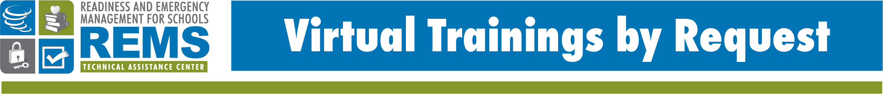

School Behavioral Threat Assessments: An Introduction Train-the-Educator (TtE)
An overview of school behavioral threat assessments to prevent and reduce targeted violence

The REMS TA Center is excited to offer the NEW School Behavioral Threat Assessments: An Introduction Train-the-Educator (TtE) Virtual Training by Request (VTBR) created in partnership with the U.S. Department of Education’s Office of Safe and Supportive Schools (OSSS). This dynamic and interactive 4-hour training is designed to help familiarize staff at schools and school districts with how school behavioral threat assessments can help in preventing and reducing targeted violence at K-12 schools.
TRAINING DESCRIPTION
It is important for schools and school districts to create plans that outline how to prevent, protect against, mitigate, respond to and recover from hazards and threats that become critical incidents as part of a comprehensive school emergency operations plan (school EOP). This can include adversarial- and human-caused threats, as well as biological hazards, natural hazards, and technological hazards. A school behavioral threat assessment analyzes communication and behaviors to determine whether or not a student, staff, or other person may pose a threat, and is therefore focused on adversarial- and human-caused threats.
TRAINING OBJECTIVES
The aim of this training is to help participants be able to:
- Describe key findings of the SSI & NTAC reports.
- Understand the purpose of a school threat assessment and the role of a Threat Assessment Team (TAT).
- List effective elements of a school threat assessment.
- Identify the five stages of a school threat assessment.
- Recognize how threats can be made online and how to identify these threats.

This training introduces participants to the various components of school behavioral threat assessments, which were originally put forth within Final Report and Findings of the Safe School Initiative: Implications for the Prevention of School Attacks in the United States, a collaborative report released by the U.S. Secret Service's National Threat Assessment Center and the ED’s OSSS, formerly known as the Safe and Drug-Free Schools Program, in 2004. The training will also present NEW findings from Protecting America’s Schools: A U.S. Secret Service Analysis of Targeted School Violence, which was released in 2019.

WHO SHOULD ATTEND?
The intended audiences for this training are:

- district and school administrators, teachers, counselors, school psychologists, support staff, and additional staff who play a role in threat assessments and/or school safety, security, emergency management and preparedness;
- community partners, such as law enforcement, including School Resource Officers, and local mental/behavioral health representatives; and
- representatives from community groups, including youth-serving organizations.

TRAINING DETAILS
When: Wednesday, December 13, 2023 OR Thursday, December 14, 2023
Time: 9:00 a.m. to 1:00 p.m. ET
THERE IS NO COST TO ATTEND

Register for these virtual training sessions online at:
12/13 online registration form
12/14 online registration form
Registration for these events closes on Monday, December 11, 2023 at 5:00 p.m. (ET).
Note: This is the same training offered on two separate days

