Center for School &

District Partnership

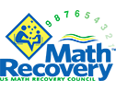

**TIERED MATH ACADEMY**

**Dina Mendola**

**dina@mathrecovery.org**

**Kristin Frang**

**kfrang@mathrecovery.org**

Alignment to

DESE

Strategic Priority

#2:

*Promote*

*deeper*

*learning so*

*that all*

*students*

*engage in*

*grade*

*-*

*level*

*work that is*

*real*

*-*

*world, relevant,*

*and*

*interactive.*

**Program Description**

Math Recovery® transforms numeracy education through customized and unique professional

learning with meaningful assessment and instruction. Educators learn to design, implement, and

analyze mathematics instruction based on individual student learning.

Research based diagnostic

assessments, learning progressions, and high

-

quality instructional tools help participants increase

student understanding and achievement.

**Goals/Outcomes**

The content of the Mathematics Academy coursework and support will focus on:

-

Developing educators' math content and pedagogical knowledge through a series of

professional development courses and follow

-

up support

-

Increasing capacity at the school and district level by developing an in

-

district trainer/coach

-

Supporting distributed leadership

-

Establishing routines and structures that support continuous improvement in instructional

practices

-

Improving student outcomes by utilizing data and enhancing teacher practices

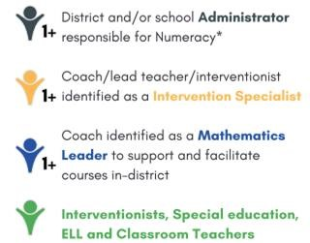

**Team Composition**

**Readiness Requirements**

-

Monthly meeting time set aside for core team to focus

on action planning

-

Dedicated time for staff to attend courses and/or

sessions

-

Culture of inquiry stance towards growth and readiness

to incorporate new practices



Center for School &

District Partnership

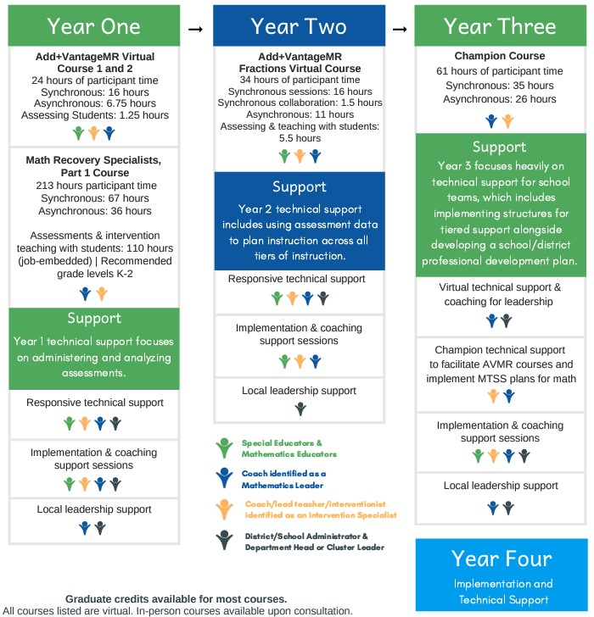

**Dina Mendola**

**dina@mathrecovery.org**

**Kristin Frang**

**kfrang@mathrecovery.org**

*“I have sat in many*

*grade level data*

*meetings*

*and it has been*

*mentioned in*

*every one*

*that there is a big trend*

*upwards for math*

*achievement and*

*progress! Many teachers*

*have stated, “I think we*

*are doing so well in math*

*because we are so well*

*trained in Math*

*Recovery*

*and it is working with our*

*curriculum.”*

*>*

*administrator*

*<*

**Program**

**Expectations and**

**Commitments**

Participation in the

Academy begins with a

series of courses where

each team member

learns how to

administer and analyze

diagnostic assessments

and plan instruction

based on assessment

results. Schools may

take different routes

when choosing where to

start, but all will end at

the same destination.

The graphic to the right

is shows one example of

what a possible timeline

and support offered

from the US Math

Recovery Council® might

look like.

**TIERED MATH ACADEMY**



**PHASE One**

**PHASE Three**

**PHASE Two**

**PHASE Four**

**Implementation**

**support**

**and**

**technical**

**assistanc**

**e**

**Support**

**Phase**

**1**

**technical support**

**focuses on administering**

**and analyzing assessments.**

**Support**

**Phase**

**3**

**focuses**

**on**

**support**

**for**

**school**

**teams,**

**which**

**includes**

**implementing**

**structures for tiered support**

**alongside developing a**

**school/district professional**

**development plan.**

**Support**

**Phase 1 technical support**

**includes using assessment**

**data to plan instruction**

**across al tiers of**

**instruction.**