Student Opportunity Act Plan: SY 2021-2023

Excel Academy Charter Schools

→ Commitment 1: Focusing on Student Subgroups

Which student groups will require focused support to ensure all students achieve at high levels in school and are successfully prepared for life?

Excel Academy is committed to supporting all students to achieve at high levels. However, a review Excel’s student data by subgroup illuminates achievement gaps across subgroups. There currently exist significant gaps in performance of students with disabilities and students who are English language learners compared to all students in both math and ELA as measured by MCAS. These gaps persist across all grade levels. Excel has designed and implemented comprehensive programs, both teacher and student facing, to address these gaps.

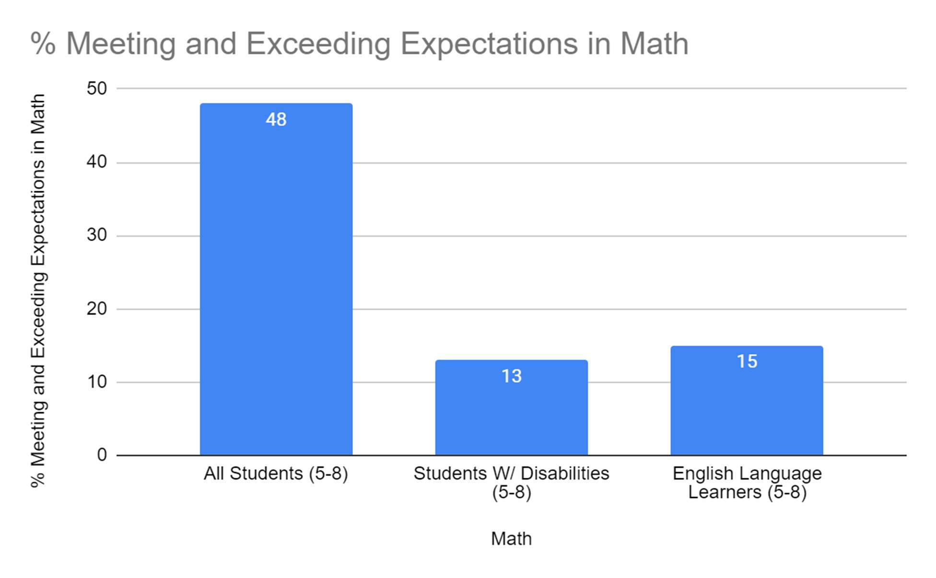

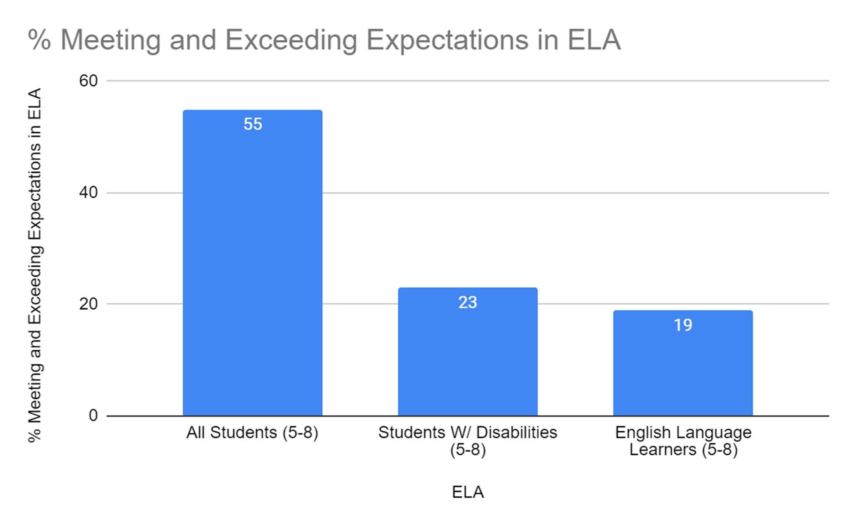

→ Commitment 2: Using Evidence-Based Programs to Close Gaps

What evidence-based programs will your charter school adopt, deepen, or continue to best support the closure of achievement and opportunity gaps? What resources will be allocated to these programs?

To address these troubling gaps for students with disabilities and English language learners, Excel has pursued multiple programs over the past several years. In the coming years, Excel plans to continue and deepen the work to address these disparities. In particular, Excel plans to continue to drive individualized and small group support through the What I Need (WIN) program and develop a new program to increase educator diversity and broaden the pipeline of talent into special educator roles at Excel.

Evidence-based program #1: Special Education Licensure Course

Excel plans to provide a special education licensure course through Excel Academy Charter Schools during the 2020 - 2021 school year. This course would provide a pathway for teachers without licensure who require it for their roles and to provide mobility and opportunity for staff members who would like to move into a full learning specialist role (teaching fellows, paraprofessionals, building substitutes, non- instructional staff, etc.). Excel would more systematically equip its newest teachers, and increase the percentage of teachers who become licensed within their first year at Excel, thereby increasing retention of special education teachers. Additionally, because Excel staff currently in non-licensed roles are more likely to be staff members of color, this strategy will also increase racial diversity of Excel’s licensed teaching staff, which research shows will positively impact student outcomes. The Special Education Licensure Course will target support of Excel’s students with IEPs specifically, as Excel’s special education teaching team lacks points of intersection with our student population.

FY21 budget item | Amount | Foundation Category
SPED Licensure Course | $5000 | Professional Development
Network Special Education Director (partial) | $10,000 | Classroom & Specialist Teachers, Employee Benefits / Fixed Charges
Evidence-based program identified by the Department: |  | Diversifying the educator workforce through recruitment and retention (D and H)
SOA program categories: |  | D) Hiring school personnel that best support improved student performance and H) Diversifying the educator and administrator workforce

Evidence-based program #2: WIN

WIN (What I Need) is an opportunity to provide students with the daily interventions they need, including literacy and math interventions, at each grade level. Excel piloted WIN in the 2018-19 school year for 5th graders and now has expanded the program to all grades. Daily small group instruction

ensures more students receive interventions specifically targeted toward their needs, while also allowing Excel space and time to provide social emotional support to students and develop strong student culture. WIN provides an avenue for students to feel successful and to not just see but also celebrate their growth as students.

All students in all grades participate in a WIN group daily, 4 times per week. This is an “all hands on deck” effort among the staff; all teachers in all grades will teach a WIN group daily, 4 times per week. For example, an ELA teacher might teach a literacy block to students needing more reading intervention, while a science teacher might run a science enrichment geared toward students who need more challenging work.

FY21 budget item | Amount | Foundation Category
Illuminate Fastbridge | $6000 | Instructional materials and technology
ELL Specialists Salary (Partial) | $20,000 | Classroom & Specialist Teachers, Employee Benefits / Fixed Charges
Learning Specialist Salary (Partial) | $20,000 | Classroom & Specialist Teachers, Employee Benefits / Fixed Charges
Evidence-based program identified by the Department: |  | Inclusion/co-teaching for students with disabilities and English learners
SOA program categories: |  | D) Hiring school personnel that best support improved student performance and E) Increased or improved professional development

→ Commitment 3: Monitoring Success with Outcome Metrics and Targets

What metrics will your charter school use to monitor success in reducing disparities in achievement among student subgroups? Select from the list of Department metrics or provide your own.

Department outcome metrics:

- English language arts (ELA) achievement

- Mathematics achievement

- ELA mean student growth percentile (SGP)

- Mathematics mean SGP

Custom metrics (must include targets as well):

- Student growth through formative assessments using Illuminate Fastbridge

- Educator participation and success in SPED Licensure course (see below)

SPED Licensure Course:
Metrics for Success:
- 85% of unlicensed teachers requiring license in Moderate Disabilities participate in the course.
- 100% of course participants obtain Subject Matter Knowledge Competency Review Requirements for a provisional license in Moderate Disabilities, as evidenced by Verification Letter signed by Owen Stearns
- 80% of participants obtain provisional license in Moderate Disabilities by June 2021.
- 100% of participants who do not obtain a provisional license in Moderate Disabilities by June 2021 have a completed Qualifications Attainment Plan approved by the Director of Student Supports

How will these chosen metrics demonstrate the reduction of opportunity or achievement gaps for specific groups of students:

- The primary goal of the SPED licensure course is to support staff members who lack appropriate credentials and are disproportionately staff of color to earn licensure and become special education teachers. Evidence shows that staff members of color have a positive impact on the academic achievement of students of color. Given the confounding factors that affect student achievement, it makes more sense to evaluate

the success of the SPED licensure course as a pathway into teaching for staff members of color than to measure student achievement itself. Therefore, Excel has created the metrics above to measure the effectiveness of the SPED licensure course.

→ Commitment 4: Engaging All Families

How will your charter school ensure that all families, particularly those representing the student subgroups most in need of support, have the opportunity to meaningfully engage with the charter school regarding their students’ needs?

Excel Academy engages families through monthly Special Education Parent Advisory Committee (SPED PAC) meetings, quarterly conferences, and an annual survey. Excel will continue to conduct outreach to increase participation in these forums through targeted mailings, phone calls, and student advisor follow up. Excel will measure engagement through attendance (in person or virtual) at SPED PAC meetings, family conferences, and survey response rates.

Certifications:

X By checking here, I certify that our charter school has engaged stakeholders in our community in accordance with the Student Opportunity Act
Please summarize your stakeholder engagement process, including specific groups that were engaged:
Excel Academy engaged families of special education students through monthly Special Education Parent Advisory Council meetings and surveys. Families overwhelmingly encouraged Excel to develop more small group interventions and target individual supports for their children. The WIN program provides those specific supports to all students and special education students in particular. Excel Academy also engaged in individual conversations with staff members in paraprofessional, assistant teacher, building substitute and non-instructional roles to discuss career pathways. These staff members indicated that licensure was a real impediment to their career growth and stated their interest in pursuing licensure should Excel Academy develop a program and additional supports to help them attain it.

X By checking here, I certify that the Excel Academy Charter School’s Board of Trustees voted on our Student Opportunity Act Plan.

Date of vote: 9/4/2020 Outcome of vote: Approved

