Data Advisory Commission
Annual Report for 2020
Chapter 132, Section 17 of the Acts of 2019
January 2021

Massachusetts Department of Elementary and Secondary Education
75 Pleasant Street, Malden, MA 02148-4906
Phone 781-338-3000 TTY: N.E.T. Relay 800-439-2370
www.doe.mass.edu

Table of contents
Introduction 1
Data Advisory Council Membership 2
Overview of Each Charge Given to the Commission 3
Charge 1: establishing a data collection and reporting system to: (A) track funding allocated for low-income students and students identified as English learners pursuant to chapter 71A and ensure spending is targeted to the intended populations; and (B) allow for access to school-level expenditures and data across all districts to inform the public and policy-makers of high impact, cost-effective school-level interventions and investments; 3
Charge 2: strengthening the department’s capacity to analyze and report staffing, scheduling and financial data in ways that support strategic resource allocation decisions at the district and school levels, including a review of national best practice models that ensure greater financial transparency; 5
Charge 3: strengthening district capacity to use state, district and school-level data to inform strategic resource allocation and implementation decisions; 6
Charge 4: streamlining data reporting, eliminating duplicative reporting requirements and improving data quality 7
Data Advisory Commission Focus Areas for 2021 7

Introduction
The Department of Elementary and Secondary Education (DESE) respectfully submits this Report to the Legislature: Data Advisory Commission Annual Report: 2020 pursuant to the statutory requirement in chapter 132 of the acts of 2019:

Section 17.(a) There shall be a data advisory commission to promote the improved use of state, district and school-level data to inform effective resource allocations at the district and school levels.
The data advisory commission shall assist the department in identifying, analyzing and making recommendations on high-impact, cost-effective data strategies for assessing student needs and addressing persistent disparities in achievement, including, but not limited to:
(i) establishing a data collection and reporting system to: (A) track funding allocated for low-income students and students identified as English learners pursuant to chapter 71A and ensure spending is targeted to the intended populations; and (B) allow for access to school-level expenditures and data across all districts to inform the public and policy-makers of high impact, cost-effective school-level interventions and investments;
(ii) strengthening the department’s capacity to analyze and report staffing, scheduling and financial data in ways that support strategic resource allocation decisions at the district and school levels, including a review of national best practice models that ensure greater financial transparency;
(iii) strengthening district capacity to use state, district and school-level data to inform strategic resource allocation and implementation decisions; and
(iv) streamlining data reporting, eliminating duplicative reporting requirements and improving data quality.
(b) The data advisory commission shall consist of: the commissioner of elementary and secondary education, who shall serve as chair; the secretary of education, or a designee; 1 member to be appointed by each of the following organizations, all of whom shall have demonstrated knowledge, experience and interest in data collection and analysis for the purpose of improving student performance: the Massachusetts Association of School Committees, Inc.; the Massachusetts Association of School Superintendents, Inc.; the Massachusetts School Administrators Association, Incorporated; the Massachusetts Association of School Business Officials, Inc.; the Massachusetts Association of Vocational Administrators, Inc.; the Massachusetts Association of Regional Schools, Inc.; and the Massachusetts Business Alliance for Education, Inc.; and 4 members to be appointed by the commissioner, 1 of whom shall be a teacher in a district of not less than 15,000 students who has experience in an underperforming or chronically underperforming school that has utilized data to successfully improve student performance, 1 of whom shall be a parent of a student currently enrolled at a kindergarten, elementary school, middle school or junior high school or high school in the commonwealth and 2 of whom shall have professional experience and knowledge in the area of data collection, quality and usage in establishing education policy and improving student outcomes.
(c) The data advisory commission shall report annually, not later than December 1, on its progress to the board of elementary and secondary education; provided, however, that the report shall be made publicly available on the department’s website.

Data Advisory Commission Membership
- Matthew Deninger, Acting Chief Strategy and Research Officer, Designee of the Commissioner of Elementary and Secondary Education, Chair
- Ann Reale, Undersecretary of Education, Massachusetts Executive Office of Education (EOE), Designee of the Secretary of Education
- Kevin Farr, Massachusetts Association of Vocational Administrators (MAVA)
- Deborah Boyd, Massachusetts Association of Regional Schools (MARS)
- Joe Esposito, Massachusetts Business Alliance for Education (MBAE)
- Mercy Nunez, Parent, New Bedford Public Schools
- Mary Bourque, Massachusetts Association of School Superintendents (MASS)
- Aldo Petronio, Massachusetts Association of School Business Officials (MASBO)
- Paul Schlichtman, Massachusetts Association of School Committees (MASC)
- Matt Mattos, Massachusetts School Administrators Association (MSAA)
- Dominic Santo, Third Grade Teacher, Arnone Elementary School, Brockton, MA
- At-large, to be determined
- At-large, to be determined
Data Advisory Commission – 2020 Overview
Due to the COVID-19 pandemic and the resulting state of emergency, the Data Advisory Commission did not begin to take form until the late fall of 2020. Because of these circumstances, the group was able to meet only once toward the end of calendar year 2020.

The Commission accomplished three fundamental objectives during its first meeting:
- The commission affirmed its charge as outlined in state statute.
- The commission reviewed the latest baseline data and research on data-informed practices for high impact and cost-effective resource allocation; the data collection and reporting systems in existence, the agency’s capacity to analyze staffing, scheduling, and financial data; districts’ capacity to use data to inform strategic resource allocation; and the agency’s capacity to streamline and improve data quality.
- The commission began to detail potential focus areas in calendar year 2021, including but not limited to:
  - Determining the most pressing questions for stakeholders, and determining the extent to which state data can answer them
  - Looking into DESE’s efforts to provide clear data stories to teachers and parents on student learning
  - Looking into DESE’s efforts to track financial data at all levels
  - Other efforts not currently being undertaken by DESE

Overview of Each Charge Given to the Commission

Charge 1: establishing a data collection and reporting system to: (A) track funding allocated for low-income students and students identified as English learners pursuant to chapter 71A and ensure spending is targeted to the intended populations; and (B) allow for access to school-level expenditures and data across all districts to inform the public and policy-makers of high impact, cost-effective school-level interventions and investments;

The Department of Elementary and Secondary Education (DESE), has developed systems that track our various funding streams and sources, as well as reporting tools that enable DESE to publish critical information on investments in K-12 education.

All districts in Massachusetts are required to keep detailed financial records and adhere to strict reporting requirements as part of a controlled fiscal environment. DESE collects information at various points throughout the fiscal year from districts, processes the data, and reports on the data publicly. Through the various public reports that DESE produces, one can start tracking the extent to which state funding is making its way to intended student populations.

Starting in 2019, DESE began tracking and reporting on school-level expenditure data, which also happens to be a requirement of the federal Every Student Succeeds Act. DESE produces a few reports for a variety of audiences. For legislators, state officials, and district administrative officials interested in tracking spending down to the school level, the annual Per Pupil Expenditures by School report is intended to give viewers a picture of school-level expenditures both within a particular district that the user may select, as well as across all school districts in the Commonwealth.

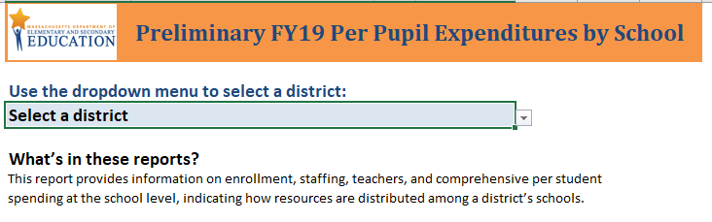
Geared more toward a parent or teacher audience, school level expenditures are now included in the annual School/District Report Cards that DESE publishes and school districts distribute to all public school parents. This report provides basic data that allows users to compare a school’s spending to the average spending on schools within their district and to the average spending on schools across the state.
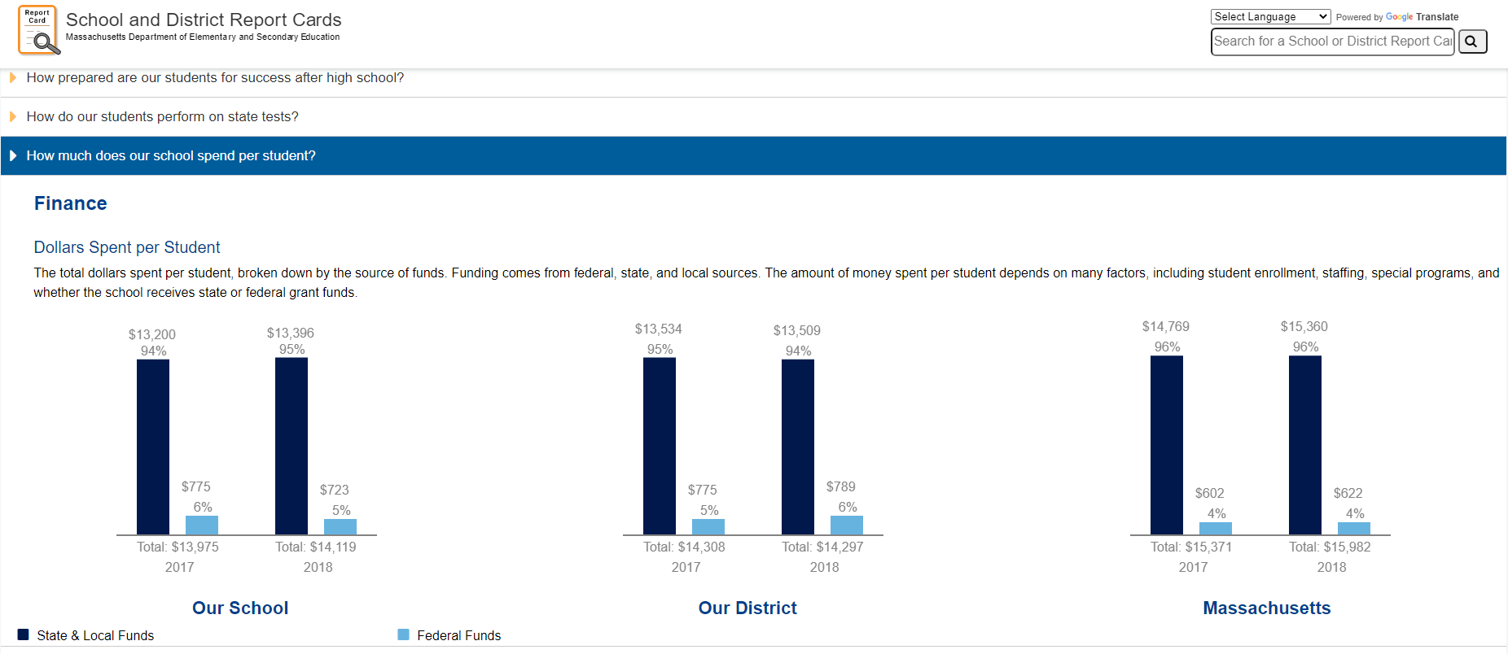

It is important to note here that school-level expenditure data does not come without caveats. It is often difficult, if not impossible, to determine high-impact or cost-effective interventions and strategies at the school level due to the wide range of strategies that districts and schools employ and the fidelity of implementation for each strategy. Furthermore, some districts may consider their interventions or programs to be district-level endeavors that are delivered to their schools (and therefore expenditures are reported as district-level costs), while others may consider similar interventions as school-level programs (and therefore they report those expenditures as school-level costs). Disentangling district-level approaches and expenditures from school-level approaches and expenditures is not easy, as neither approach is “right” or “wrong.” However, over time and on an ongoing basis, DESE will continue to promote consistency in reporting across districts, so that between-district and intra-district comparisons about school-level expenditures can be made with more validity.

Despite these challenges, the DESE data collections and the reports that come from them allow for questions to be asked about school-level spending and conversations to be started about whether resources reach intended audiences. To that end, DESE commissioned an independent study in 2019 to understand the very question asked in this charge: are resources in Massachusetts reaching the intended student populations?

The December 2019 report, written by education researchers Kristen Blagg and Victoria Lee at the Urban Institute, makes several claims about school-level funding in Massachusetts and the extent to which it reaches high-need student populations:
- Schools vary substantially in how much they spend per pupil. Most schools spend between $12,000 and $18,000 per pupil, though some schools, especially vocational high schools, spend substantially more.
- Recent national evidence, based on district spending data, shows that education expenditures matter for student outcomes.
- Studies of school-level spending indicate that, on average, schools with higher shares of high-need students tend to spend as much as, or slightly more than, schools with lower shares of high-need students.
- Massachusetts allocates state education aid to districts based on student needs, community wealth, and local labor costs. Although the formula allocates more state money to districts with students with greater need, districts can use local funds to spend more than what is required.
- Across the state, high schools tend to spend more per pupil than elementary and middle schools.
- To fairly compare schools with different kinds of student needs requires looking at all three high-need subgroups (economically disadvantaged pupils, pupils with disabilities, and English learners) simultaneously.
- Within districts, schools with higher shares of economically disadvantaged pupils, pupils with disabilities, and English learners spend more per pupil.
- Across the state, schools with higher shares of economically disadvantaged students spend less per pupil, unless we account for local labor costs.

Because the report relies on data from 2017 and 2018, prior to the passage of the Student Opportunity Act and the pandemic, it represents an important baseline measure that Massachusetts can use to track the effectiveness of the act.

This study, along with the many reports DESE produces, increases transparency and public accountability to all taxpayers for the use of education dollars. DESE will continue to update and improve this information on an ongoing basis, so that the most up-to-date data will be available to a variety of audiences.

Charge 2: strengthening the department’s capacity to analyze and report staffing, scheduling and financial data in ways that support strategic resource allocation decisions at the district and school levels, including a review of national best practice models that ensure greater financial transparency;

Since 2016, DESE has been producing an innovative suite of reports that analyze staffing, scheduling, and financial data in ways that allow users to make more informed resource allocation decisions. Dubbed “RADAR,” (Resource Allocation and District Action Reports), the reports aim to provide state and district-level data about how districts use their people, time, and money resources in a visually accessible way. They are intended to support districts in making effective strategic decisions as they develop plans and budgets.

Users can select their district, and then select up to 10 comparison districts, allowing them to see how they are allocating resources relative to those selected districts, as well as compared to state averages. The reports enable users to visualize district and state trends over 5 years, investigate various staffing levels, per pupil spending levels, special education services, and more.

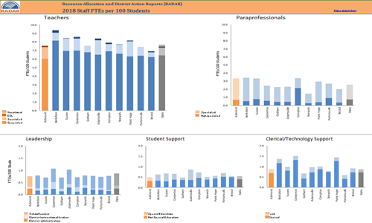

RADAR represents one of the most accessible and user-friendly ways for stakeholders to look at and share district data, and use the data to make strategic resource allocation decisions.
To date, DESE has not yet begun a review of national best practice models of financial transparency.

Charge 3: strengthening district capacity to use state, district and school-level data to inform strategic resource allocation and implementation decisions;

DESE maintains strong relationships with district administrators, providing both ad hoc support and ongoing resource allocation planning and implementation support. DESE offers a wide variety of opportunities to connect with districts in various settings, from webinars to conference presentations (often heavily subscribed and receiving positive responses from attendees) to specialized communities of practice focused on resource allocation. Furthermore, DESE has created case studies of the resource allocation work done by districts that are available online and circulated among DESE staff in relevant program areas. These case studies provide a glimpse into internal processes districts use in making reallocation decisions and even tracking return on investment.

In addition, a long-planned connection was made between Planning for Success, the Department’s online resource for district strategic planning, and resource allocation, including using RADAR and other DESE tools. Several options for including resource allocation work in the planning process were developed and have been integrated into Planning for Success materials. As districts use these strategic planning tools for their future planning needs, each will be able to make strategic resource allocation a main component.

Even with these initiatives in place, DESE finds that its capacity to support districts in making resource allocation decisions rarely meets demand. Reaching all stakeholders who need and could benefit from this support is an ongoing challenge for DESE.

Charge 4: streamlining data reporting, eliminating duplicative reporting requirements and improving data quality

DESE is constantly working to streamline reporting, eliminate duplicative requirements, and improve the quality of our data. Commissioner Riley has made this a priority, to reduce the administrative burden on districts to the extent possible and within the requirements of state and federal law. This work is ongoing. DESE understands that the more current the data, the more meaningful it is for districts. Streamlining data collection, ensuring data is as accurate as possible, and providing timely updates of tools will help keep these resource allocation tools maximally useful.

Data Advisory Commission Focus Areas for 2021
The Commission started to home in on two tiers of purpose, each of which is important. One tier is compiling data in a straightforward manner to tell local stories, particularly stories from classrooms that teachers and parents can use to analyze learning and use of educational resources. The second tier concerns the data associated with the foundation budget, net school spending, rising fixed costs, and other complexities that are inherent in the school finance law and its execution. While both tiers are under the education umbrella, they are dissimilar in many ways, likely having a different primary audience, and therefore they may need to be addressed separately.

