Student Opportunity Act

Implementation Indicators for 2021-2022

Overview
The SOA legislation calls for districts to describe progress in implementation and closing gaps for student groups in their annual updates to DESE. We know that many of you are already making headway in implementing the evidence-based practices included in your original plans; at the same time, we know that thanks to the pandemic, implementation of some components of your plan may be delayed.
In order to capture descriptive information on what districts are implementing and, at the same time, reduce the amount of narrative information we ask districts to provide, we worked with our DESE program offices to develop between 3-10 program components that are hallmarks of high-quality approaches to implementation for each evidence-based program area. These lists are not comprehensive, and we know that not every district’s approach will incorporate all program components listed.

Completing Closed-ended Implementation Indicator items
This document includes screen shots of the implementation items for all 21 recommended SOA evidence-based program areas. A complete list of the FY22 Evidence-Based Program areas appears on the next page. Click on the link to see the implementation indicators for the evidence-based programs in your SOA plan.
For each component that is part of your district’s approach, indicate the current stage of implementation from the following options:
- Not started: Select this if this is a component of your district’s approach, but you have not yet begun to plan for its implementation.
- Pre-implementation planning or capacity building: If your district is still in the process of developing an action plan for implementing a particular approach or strategy, but has not yet begun implementing it, you would select pre-implementation planning or capacity building.
- Partial implementation: Select this if your district is in the early to mid-stage of implementation.
- Full implementation: Full implementation indicates that your school has a reached a mature level of implementation of a strategy. (For some items, it would also indicate that you have completed a finite task (e.g., your curriculum selection committee recommended a set of high-quality curriculum materials that were subsequently adopted).
- Not a component of our approach. If an item isn’t a component of your district’s approach, simply select this option, in the far-right column.
Once you complete the closed-ended items for each evidence-based program area, you will be asked to share what your district’s next key step is in implementation – just a sentence or two to give a sense of where you are headed next.

What if we are implementing strategies/components that are not on the list provided?
If there are other great, high-impact strategies you are implementing that you want us to know about that are not included in implementation components on our list, there is also an optional open-ended item where you can tell us about them.

FY22 SOA Evidence-based Program Areas

Enhanced Core Instruction
- Expanded access to full-day, high-quality pre-kindergarten for 4-year-olds, including potential collaboration with other local providers (SOA categories D, F, and G)
- Research-based early literacy programs in pre-kindergarten and early elementary grades (E, F, and G)
- Early College programs focused primarily on students under-represented in higher education (I)
- Supporting educators to implement high-quality, aligned curriculum (E and F)
- Expanded access to career-technical education, including “After Dark” district-vocational partnerships and innovation pathways reflecting local labor market priorities (I)
- Culturally responsive teaching and other strategies that create equitable and culturally responsive learning environments for students. (D, E, and F)
- Expanded learning time for all students in the form of a longer school day or school year (A,B, D, and E)

Targeted Student Supports
- Inclusion/co-teaching for students with disabilities and English learners (D and E)
- English Learner Education programs, including dual language (DL) and transitional bilingual education (TBE) (D, E, and F)
- Acceleration Academies and/or summer learning to support skill development and accelerate advanced learners (A and E)
- Dropout prevention and recovery programs (I)

Talent Development
- Diversifying the educator/administrator workforce through recruitment and retention (D and H)
- Leadership pipeline development programs for schools (D and E)
- Strategies to recruit and retain educators/administrators in hard-to-staff schools and positions (D and E)
- Increasing opportunities for educators and support staff to engage in a cycle of continuous improvement, utilizing district and school teaming structures (B and E)

Conditions for Student Success
- Expanding capacity to address social-emotional learning (SEL) and mental health needs of students and families (C, D and E)
- Increasing opportunities for all students to engage in arts, enrichment, world languages, athletics, and elective courses. (D and B)
- Developing effective family/school partnerships (E)
- Community partnerships for in-school enrichment and wraparound services (C)
- Labor-management partnerships to improve student performance (E)
- Facilities improvements to create healthy and safe school environments (J)

1. Expanded access to full-day, high-quality pre-kindergarten for 4-year-olds, including potential collaboration with other local providers (SOA categories D, F, and G)

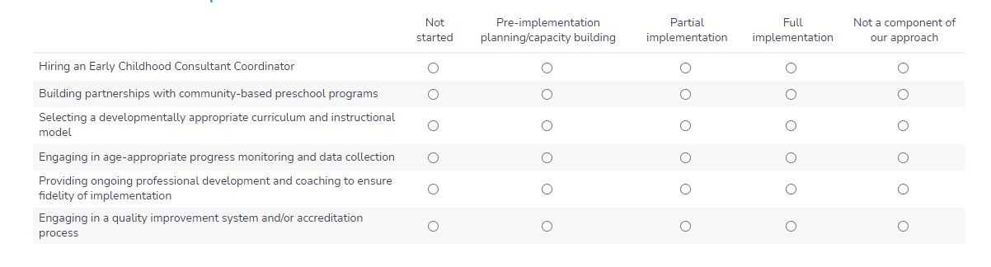

2. Research-based early literacy programs in pre-kindergarten and early elementary grades (E, F, and G)

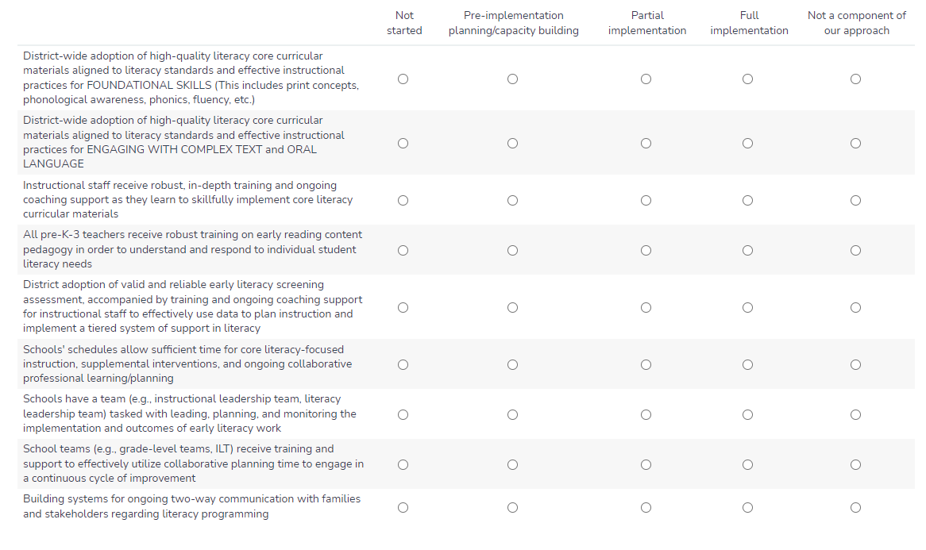

3. Early College programs focused primarily on students under-represented in higher education (I)

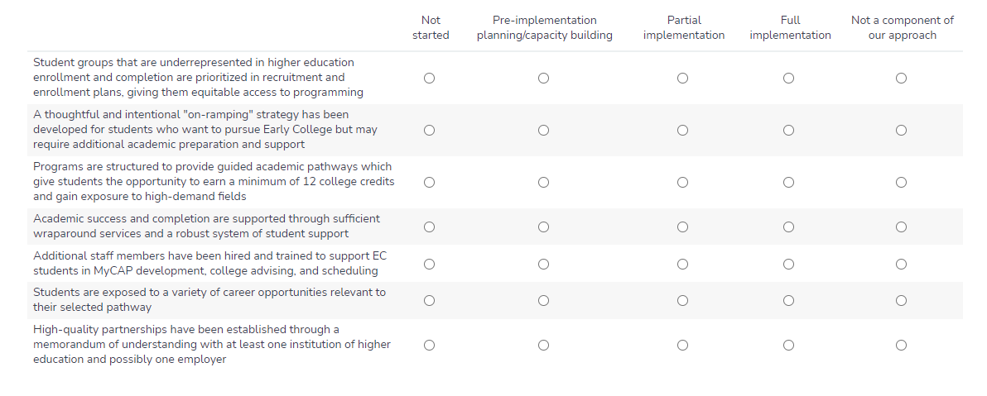

4. Supporting educators to implement high-quality, aligned curriculum (E and F)

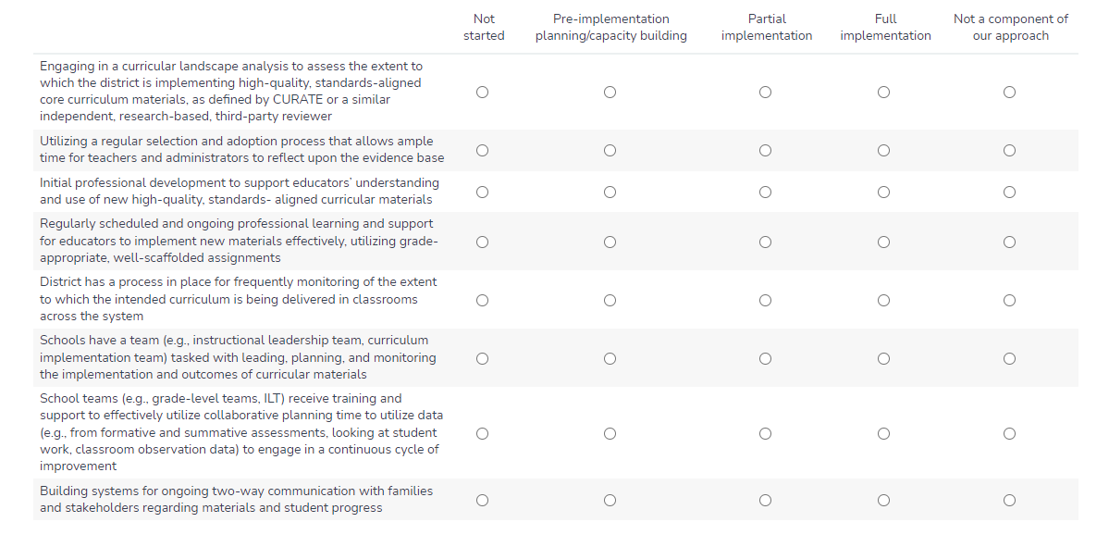

5. Expanded access to career-technical education, including “After Dark” district-vocational partnerships and innovation pathways reflecting local labor market priorities (I)
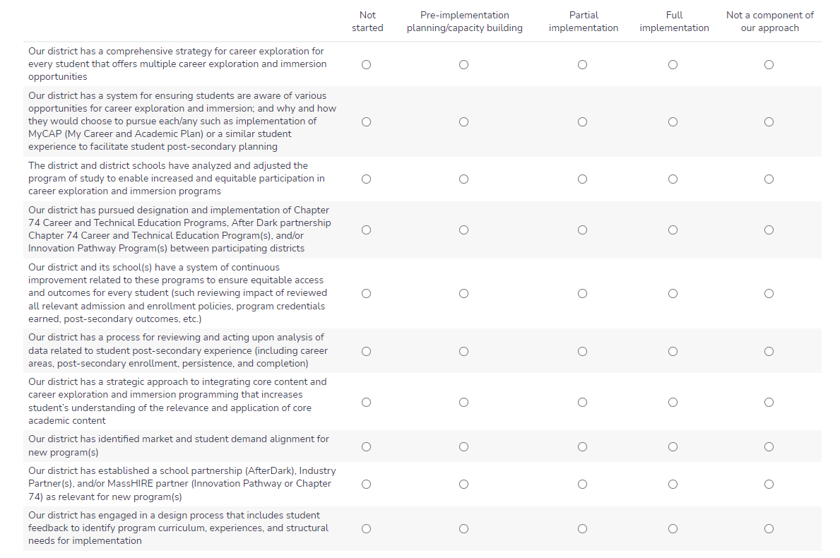

6. Culturally responsive teaching and other strategies that create equitable and culturally responsive learning environments for students. (D, E, and F)

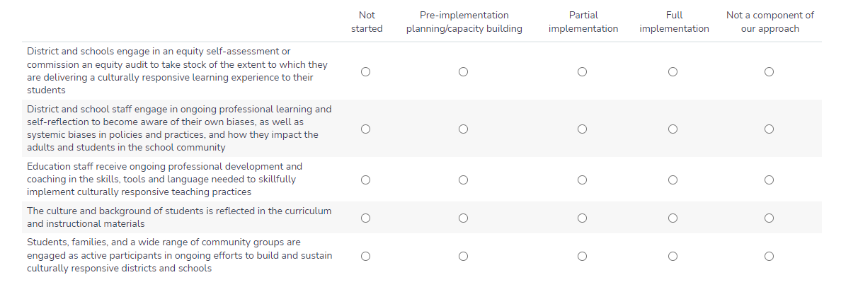

7. Expanded learning time for all students in the form of a longer school day or school year (A,B, D, and E)
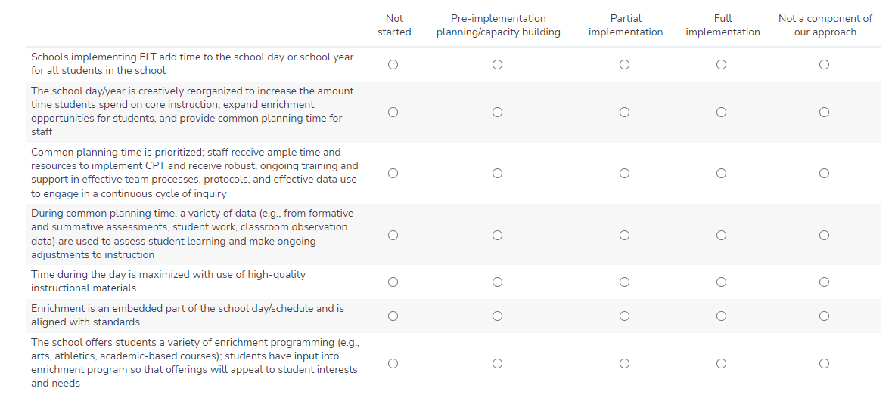

8. Inclusion/co-teaching for students with disabilities and English learners (D and E)

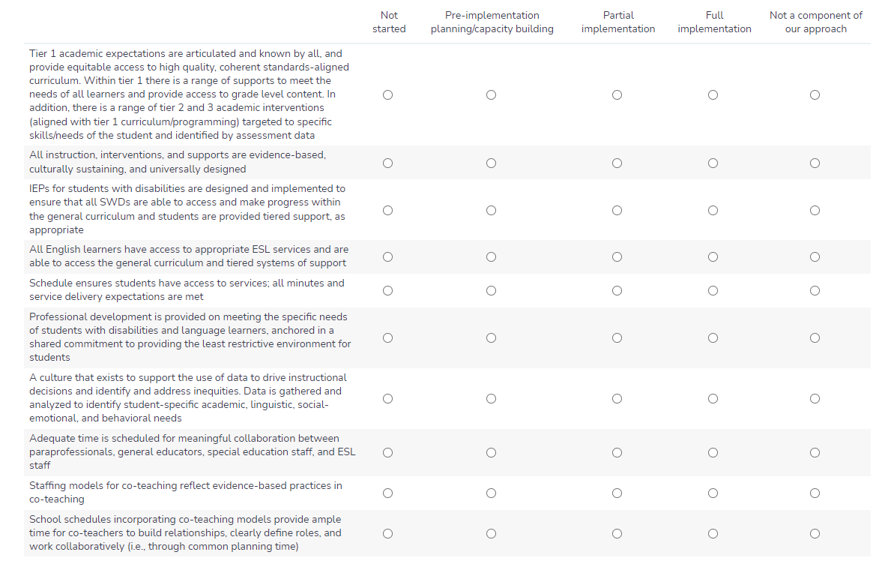

9. English Learner Education programs, including dual language (DL) and transitional bilingual education (TBE) (D, E, and F)

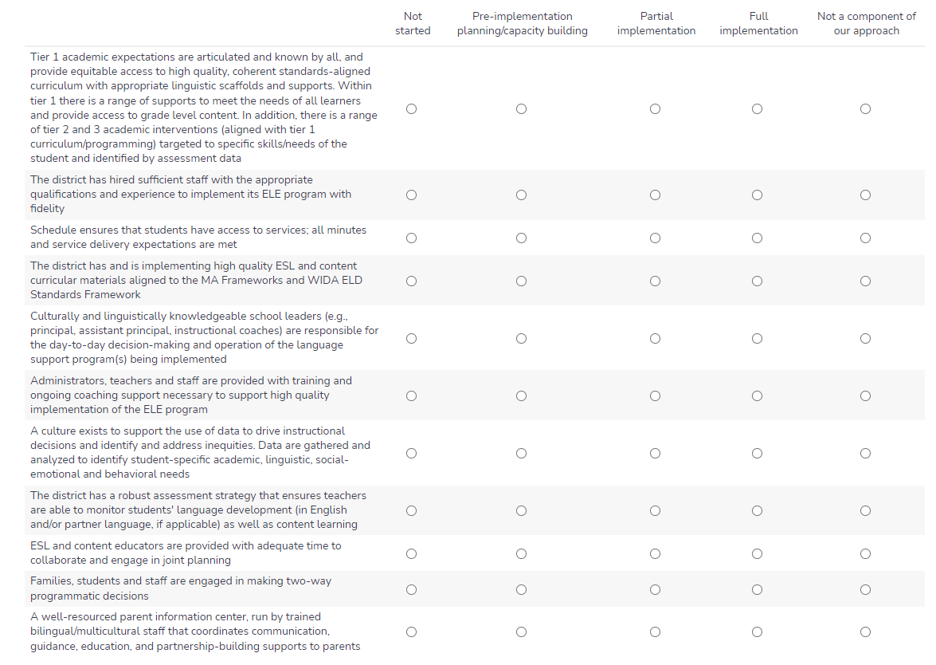

10. Acceleration Academies and/or summer learning to support skill development and accelerate advanced learners (A and E)

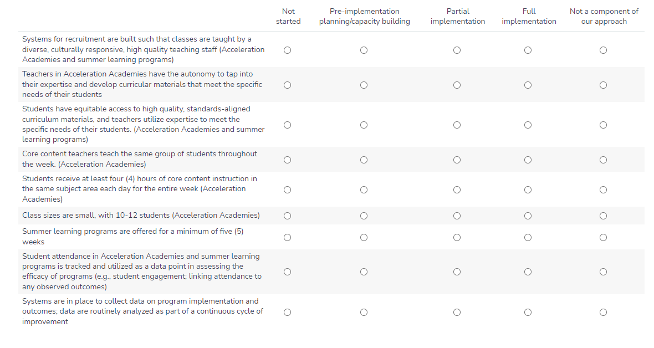

11. Dropout prevention and recovery programs (I)

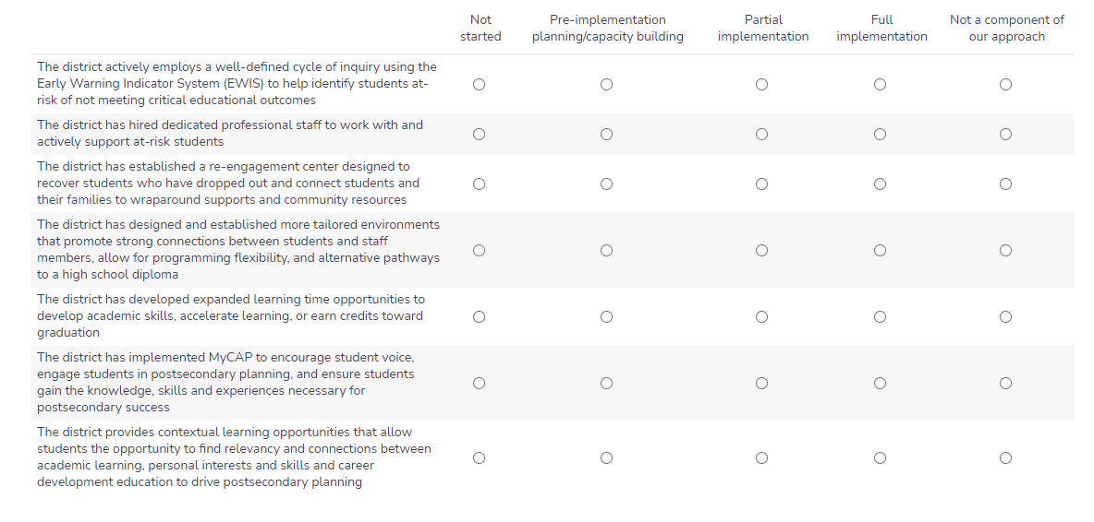

12. Diversifying the educator/administrator workforce through recruitment and retention (D and H)

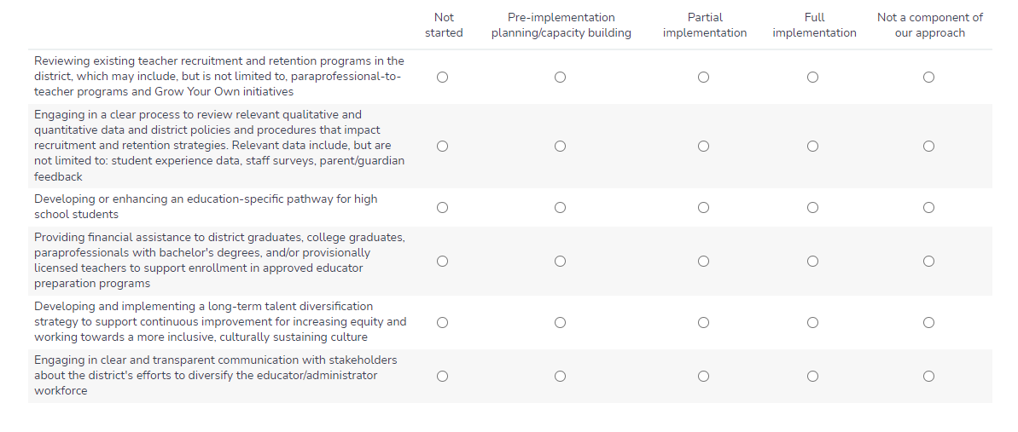

13. Leadership pipeline development programs for schools (D and E)

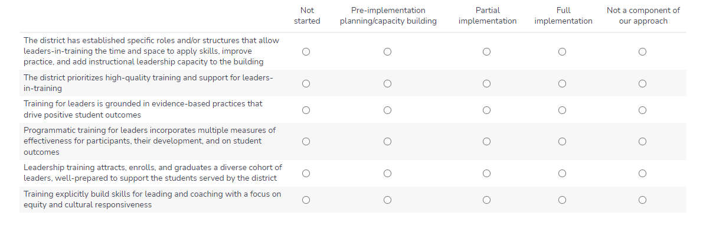

14. Strategies to recruit and retain educators/administrators in hard-to-staff schools and positions (D and E)

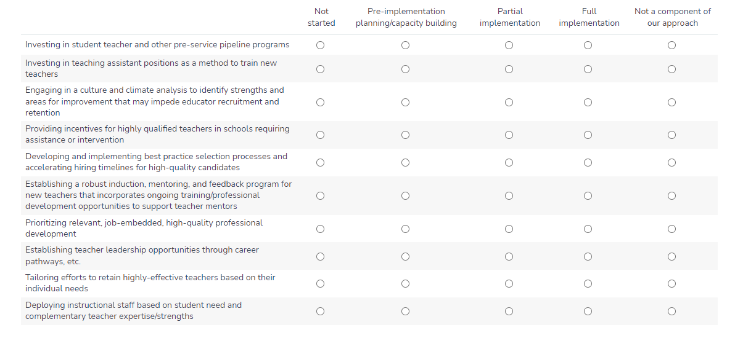

15. Increasing opportunities for educators and support staff to engage in a cycle of continuous improvement, utilizing district and school teaming structures (B and E)

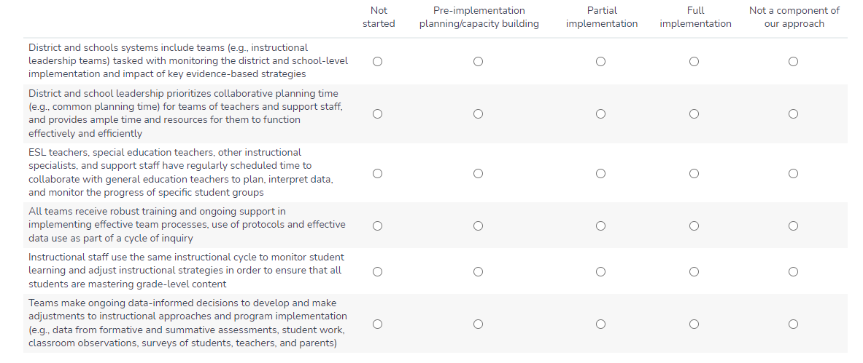

16. Expanding capacity to address social-emotional learning (SEL) and mental health needs of students and families (C, D and E)

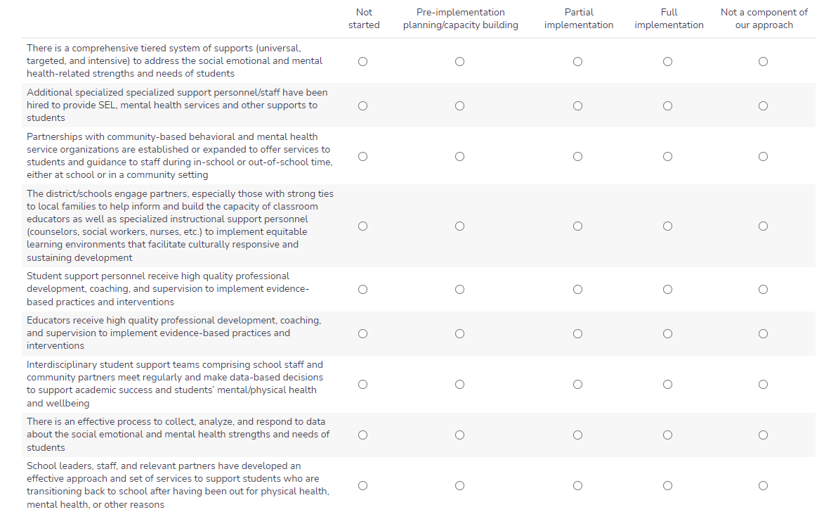

17. Increasing opportunities for all students to engage in arts, enrichment, world languages, athletics, and elective courses. (D and B)

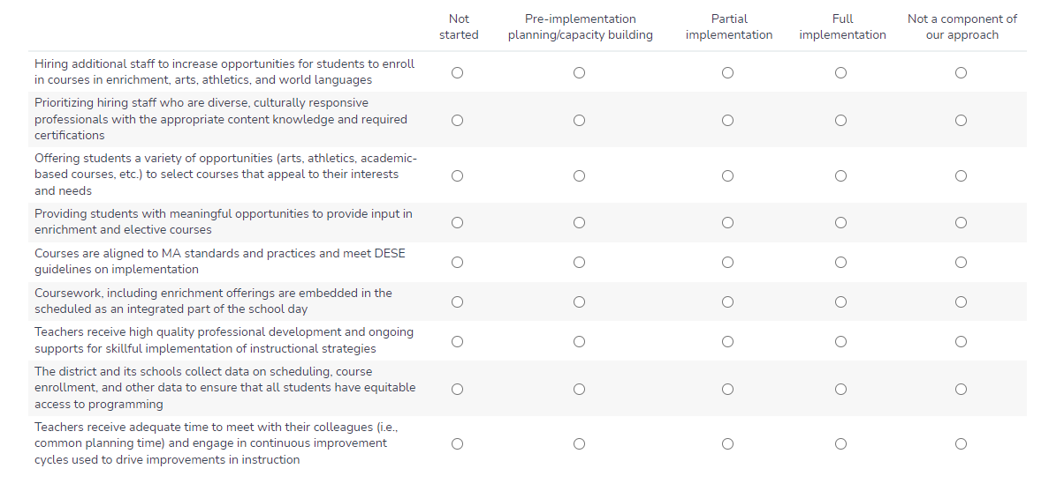

18. Developing effective family/school partnerships (E)

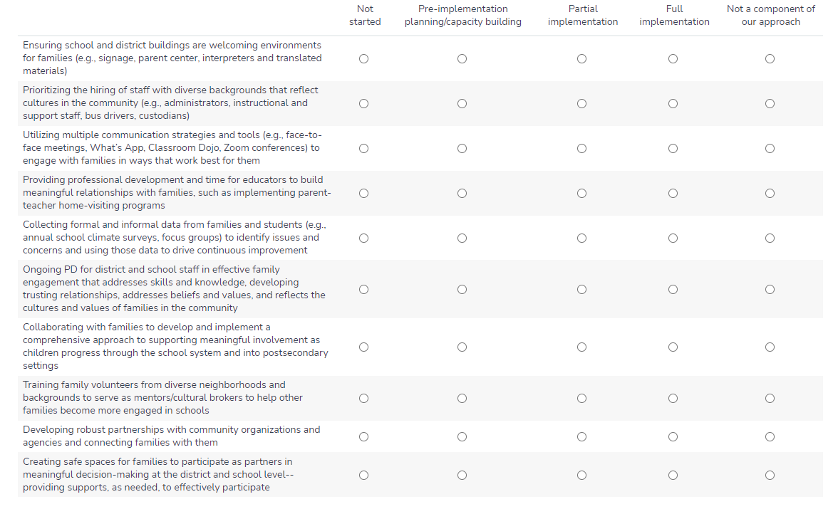

19. Community partnerships for in-school enrichment and wraparound services (C)

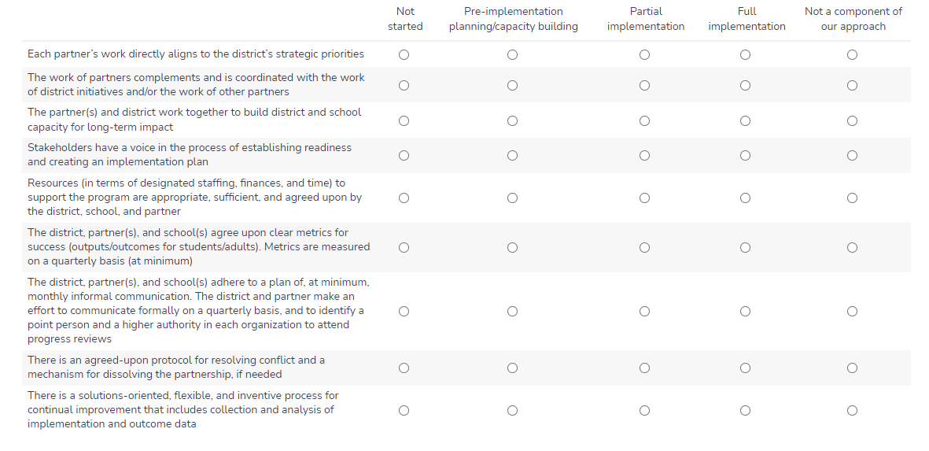

20. Labor-management partnerships to improve student performance (E)

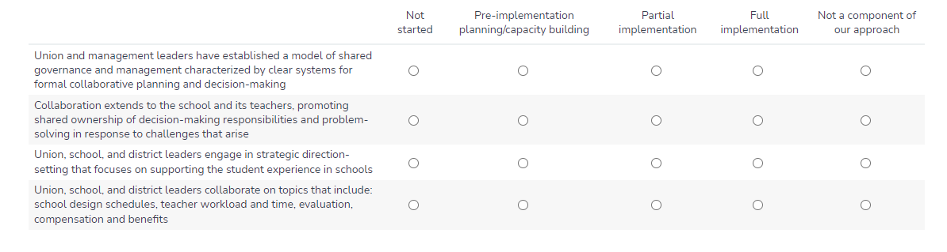

Facilities improvements to create healthy and safe school environments (J)

