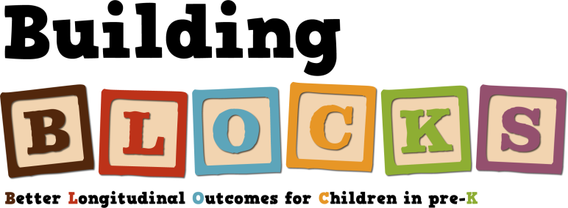
Building Inclusive Communities in Early Childhood
March 15, 2019 (Snow date of April 23rd)
Devens Common Center, Devens, MA
9:00-3:30
Check in begins at 8:30

Registration link: https://www.surveygizmo.com/s3/4810622/March-15-2019-Conference

The Departments of Early Education and Care (EEC) and Elementary and Secondary Education (DESE) invite:

Special Education Directors, Early Childhood Coordinators, Elementary Principals, Teachers, Early Care and Education Directors, Head Start Disabilities/Education Coordinators, Family Services Coordinators, PEG Coordinators, Early Intervention Directors and Community Partners

Join us to:
- Hear from 10 Massachusetts school and community teams about their successes and challenges in implementing recommended practices in early childhood inclusive education.
- Learn with Dr. Richard Villa and Dr. Jacqueline Thousand about a decision-making process for determining where, when, and how to address IEP goals for young children with intensive and pervasive support needs. Understanding of the time-tested process provides participants with a communication tool and a blueprint for collaboratively creating meaningful inclusive opportunities for young children in home, school, early care, and other community settings.
- Preview chapters from Drs. Villa and Thousand’s upcoming book on inclusive approaches in educating young children in inclusive early education settings.

Outcomes of the Building Inclusive Community (BIC) Initiative:
- Develop or refine an action plan that describes how your community team will create strong partnerships with community partners to strengthen inclusive early childhood practices.
- Receive strategies for engaging families and providers in collaborative decision-making.
- Receive strategies, resources, and tools for developing appropriate practices for promoting inclusive experiences.

There is no cost to attend this conference or to participate in this initiative.
PDPs will be available to participants that attend the entire conference.

