What is Significant Disproportionality
Quick Reference Guide

What is significant disproportionality?
The Individuals with Disabilities Education Act (IDEA) requires states to collect and examine data to determine if significant disproportionality in special education based on race and ethnicity is occurring in the State and in local education agencies (LEAs). State education agencies must examine and determine if disproportionality is occurring in LEAs with respect to:
- the identification of children as children with disabilities, including the identification of children as children with disabilities in accordance with a particular impairment that is described in IDEA;
- the placement in particular educational settings of these children; and
- the incidence, duration, and type of disciplinary removals from a student’s placement, including suspensions and expulsions.

How is significant disproportionality calculated?
The Massachusetts Department of Elementary and Secondary Education (DESE) must calculate disproportionality with respect to:
 | Details
Identification | The identification of children, ages 3 through 21, with:  - A disability  - An intellectual disability  - A specific learning disability  - Emotional disturbance  - Speech or language impairments  - Other health impairments  - Autism
Placement | Placements of children with disabilities, ages 6 through 21:  - Inside a regular class less than 40% of the day  - Inside separate schools and residential facilities
Discipline | Disciplinary removals involving children with disabilities ages 3 through 21:  - Out-of-school suspensions and expulsions of 10 days or fewer  - Out-of-school suspensions and expulsions of more than 10 days  - In-school suspensions of 10 days or fewer  - In-school suspensions of more than 10 days  - Disciplinary removals in total

DESE must calculate identification, placement and rates of disciplinary removal in the above categories for seven racial or ethnic groups (African American/Black, American Indian or Alaskan Native, Asian, Hispanic or Latino, Multi-racial, Native Hawaiian or Pacific Islander, and White), comparing rates for each group to rates for all other children within the LEA. Where numbers are too small for comparison, DESE compares the rates for each groups to the state’s rate in a category. These analyses must be done annually.

To make these calculations and identify LEAs with significant disproportionality, DESE uses a risk ratio. In SY 2021-2022, an LEA will be identified with significant disproportionality if its risk ratio for a particular racial or ethnic group in a particular category is 3.0 or greater for each of the previous three years.

What is a risk ratio?
A risk ratio is a calculation performed by dividing the risk of a particular outcome for children in one racial or ethnic group within an LEA by the risk for children in all other racial and ethnic groups within the LEA.

Risk Ratio Example #1 - Identification
Example: The likelihood that an African American child will be identified as a child with a disability, compared to children in all other racial and ethnic groups.
- The example below compares the risk for African American children being identified as a child with a disability to the risk for non-African American children being identified as a child with a disability.
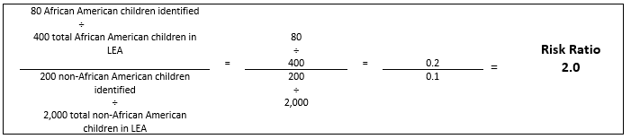

- In the example above, African American children in the LEA are 2.0 times as likely to be identified as a child with a disability, compared to children in all other racial and ethnic groups in the LEA.

Risk Ratio Example #2 - Placement
Example: The likelihood that a Hispanic/Latino child’s placement will be in a general education classroom less than 40% of the day, compared to that likelihood for a child in all other racial and ethnic groups.
- The example below compares the risk for Hispanic/Latino children being placed in general education classroom less than 40% of the day to the risk for non-Hispanic/Latino children being placed in general education classroom less than 40% of the day.
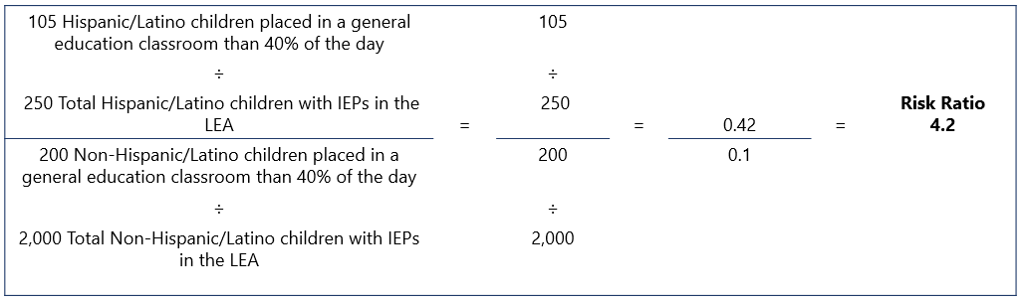
- In the example above, Hispanic/Latino children in the LEA are 4.2 times as likely to be placed in general education classroom less than 40% of the day, compared to children in all other racial and ethnic groups with IEPs in the LEA.

What if my district is very small?
DESE will only calculate a risk ratio for groups that meet the minimum cell size (6) and n-size (20).

Cell size refers to the number of children in the racial/ethnic group(s) experiencing a particular outcome. It is the numerator in the risk calculation.

N-size refers to the number of children in the racial/ethnic group(s) enrolled in a district with respect to identification, or the number of children with disabilities enrolled in an LEA with respect to placement and discipline. N-size is the denominator in the risk calculation.

What if the comparison group is too small?
If the group meets the minimum cell and n-size, but there are not enough students in all other racial or ethnic groups in the LEA, DESE will use an alternate risk ratio. An alternate risk ratio is calculation performed by dividing the risk of a particular outcome for children in one racial or ethnic group within an LEA by the risk of that outcome for children in all other racial or ethnic groups in the State.

Alternate Risk Ratio Example-Disciplinary Removal
Example: The likelihood that a Hispanic/Latino child with an IEP will experience a disciplinary removal, compared to children in all other racial and ethnic groups.
- The example below compares the risk for Hispanic/Latino children with IEPs to the risk for non-Hispanic Latino children with IEPs
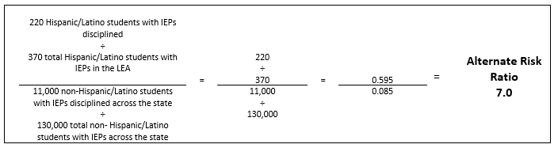

- In the example above Hispanic/Latino students with IEPs in the LEA are 7.0 times as likely to be disciplined, compared to students with IEPs in all other racial and ethnic groups across the state.

Are there any other exceptions?
A State is not required to make an identification of significant disproportionality if the LEA is making reasonable progress. Reasonable progress means lowering the risk ratio or alternate risk ratio for the group and category in each of the two prior consecutive years. In Massachusetts, an LEA is considered to have made reasonable progress if it has lowered its risk ratio or alternate risk ratio by at least 0.1 in each of the two prior consecutive years.

 | Year 1 | Year 2 | Year 3 | Reasonable Progress
District 1 | 5.6 | 5.3 | 5.2 | Meets Reasonable Progress
District 2 | 4.9 | 4.8 | 4.6 | Meets Reasonable Progress
District 3 | 4.7 | 4.9 | 4.3 | Does Not Meet Reasonable Progress

DESE Significant Disproportionality Resources
- Memorandum on Significant Disproportionality in Special Education:
  - http://www.doe.mass.edu/sped/advisories/2019-0621dispro.docx
- Massachusetts’ Significant Disproportionality Website:
  - http://www.doe.mass.edu/sped/idea2004/sig-dispro/
- Significant Disproportionality Webinars and Presentations:
  - http://www.doe.mass.edu/sped/idea2004/sig-dispro/webinars.html
- Other Significant Disproportionality Resources:
  - http://www.doe.mass.edu/sped/idea2004/sig-dispro/resources.html

For questions related to Significant Disproportionality, please email specialeducation@doe.mass.edu.

34 C.F.R. §300.647
34 C.F.R. §300.647(a)(6)
34 C.F.R. §300.647
34 C.F.R. §300.647(a)(3)
34 C.F.R. §300.647(a)(4)
34 C.F.R. §300.647(b)(5)
34 C.F.R. §300.647(b)

