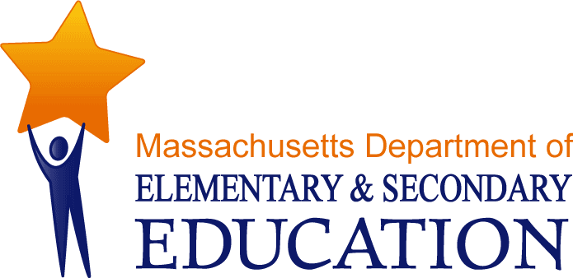

Guidelines:
For the Specialized Assessment of Students with Visual Impairments

July 2012

2. Parent/Guardian Interview (see Appendix B, Form D)

2.1 Purpose
The parent/guardian interview determines the parents’ knowledge and understanding of their child’s visual impairment, what they perceive to be the child’s immediate and long-term needs, and how the child’s vision is impacting his/her overall development. The purpose of the interview is to create an opportunity for open-ended dialogue, rather than to provide a checklist of functional activities.

Note: If English is not the primary language in the home, or if anyone in the family has a hearing impairment, an interpreter may be required for the parent interview.

2.2 Interview Guide Description
The interview guide provides generic questions designed to elicit purposeful information in five main categories: medical background, visual functioning, social/emotional development, social/educational milestones, and general life experiences. If a question is not applicable, “NA” should be indicated and a brief explanation added.

2.3 Completing the Assessment
Districts should consider a Teacher of Students with Visual Impairments as the appropriate person to conduct the interview. Recommended for Home Assessment on the Evaluation Consent Form (N1A)

