Synopsis of high-quality task:
This task should be completed within a measurement and data unit. This task allows students to use and analyze data (using bar graphs and numbers lines) about the 4th grade hot lunches at a particular school in Boston Public Schools. Students utilize the data to calculate how many hot lunches are created vs. eaten. Students also use this information to make suggestions for fine-tuning the current system in place for making hot lunches.

Anticipated student time spent on task: 40 mins

Student task structure(s): Individual work and partner work

Math Content Standards and Practices:

4.MD.A.1 Know relative sizes of measurement units within one system of units including km, m, cm; kg, g; lb, oz.; l, ml; hr, min, sec. Within a single system of measurement, express measurements in a larger unit in terms of a smaller unit. Record measurement equivalents in a two-column table.
4.MD.A.2 Use the four operations to solve word problems involving distances, intervals of time, liquid volumes, masses of objects, and money, including problems involving simple fractions or decimals, and problems that require expressing measurements given in a larger unit in terms of a smaller unit. Represent measurement quantities using diagrams such as number line diagrams that feature a measurement scale.
4.MD.B.4 Make a line plot to display a data set of measurements in fractions of a unit (1/2, 1/4, 1/8). Solve problems involving addition and subtraction of fractions by using information presented in line plots.

SMP1 Make sense of problems and persevere in solving them.
SMP3 Construct viable arguments and critique the reasoning of others.
SMP4 Model with mathematics.

Prior Knowledge:

3.MD.B.3 Draw a scaled picture graph and a scaled bar graph to represent a data set with several categories. Solve one- and two-step “how many more” and “how many less” problems using information presented in scaled bar graphs.

Connections to the real-world:
The assignment topic of school lunch is directly connected to the real world that the students encounter every day. There are various districts that have a high population of students that receive reduced-lunch or free-lunch. In Boston Public Schools, there is a universal free lunch program, meaning that everyone is able to receive one free lunch. As to not be wasteful, there are parameters in place that dictate how much food will actually be prepared each day, even on pizza day, the most popular hot lunch day of all!

Mastery Goals:

Learning Objective:
Students will be able to organize, compare, and draw final conclusions about data sets based on open-ended questions.

Language Objective:
Students will read data sets in order to make comparisons and answer questions.
Students will provide written responses to represent their conclusions.
Students will listen and speak with a table partner to discuss the data sets.

Instructional Tips/Strategies/Suggestions:

Intro/review: 5 min
- Discuss with students what jumps out to them/what they see on the paper/what it reminds them of (looking for responses about graphs and charting data).
- Let students share vocabulary they remember and how to read the graph properly.

Dive In: 30 mins
- Popcorn read the top paragraphs and have students identify important information and share/discuss with class, underlining what is potentially important.
- Ask: “What kind of labels or notes should be added to the graph to make it really clear?” (looking for label bars with HR numbers, add tick marks to the side for accuracy)
- Ask: “What do we do with this blank chart?” (organize/fill in data)
- Students work with a table partner to fill in the chart and calculate totals (10 mins).
- Tell students they will use all the information on the front to answer the questions on the back.
- Instruct students to answer the first 2 questions independently.
- Ask: “What does a number line look like? How do you make it? How do you use it to show your math work?”
- Students work in partners again.
- Ask: “What symbol can we put over the word difference?” (looking for subtraction symbol)
- Students do the last 2 problem independently.

Summarize/Debrief: 5 min
- Bring class back together to debrief the activity and learning

Instructional Materials/Resources/Tools:
Include:
- Student handouts (see below)

Accessibility and Supports:
As needed, provide students with a graph that already includes the tick marks (counting by ones).

Potential sentence starters:
The number of ____________________.
During the week, students _______________.
The total number of ___________________.

Key academic vocabulary: data, nutrition, difference, number line, total

Student Worksheet

Boston Public Schools offers universal free lunch to all students. That means that up to 57,000 lunches can be served in one day! At the Sarah Greenwood School there are 400 students, but they only prepare lunch for 280 on any given day. The food and nutrition department does not allow for a second lunch to be distributed. There are 45 students in grade 4 (23- in Homeroom 211, and 22 in Homeroom 212), yet only 30 lunches are prepared for 4th grade daily. But on Fridays most students want pizza!

Look at the Chart below and answer the following questions:

Numbers of lunch served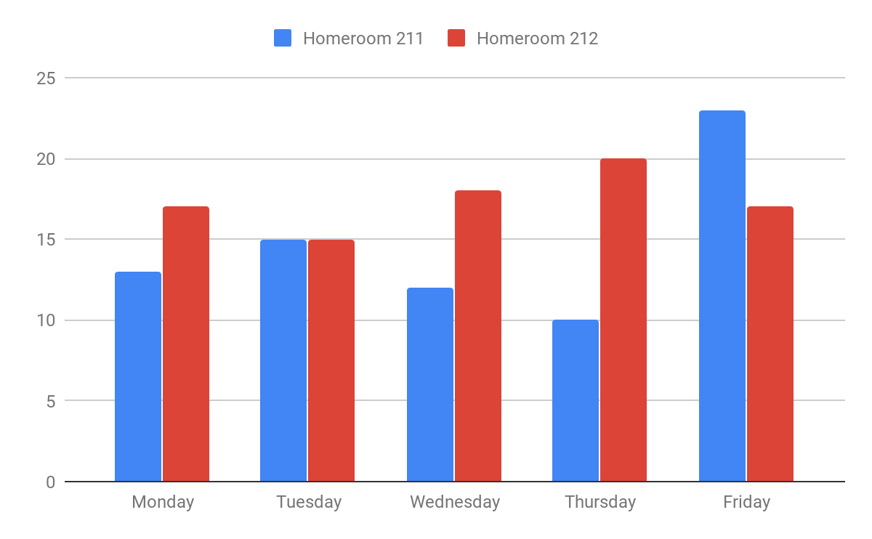

How many students ate lunch throughout the week?
Homerooms | Monday | Tuesday | Wednesday | Thursday | Friday
211
212
Total

What is the total number of students in Homeroom 211 that ate lunch during the week?

______________________________________________
Use a number line to demonstrate the difference in the total number of students that ate lunch on Monday and Friday.

What is the difference of lunch served in 4th grade vs. the total number of lunches served in the school?
__________________________________________________________________________

How many more lunches are needed during the week if all students in homeroom 212 decide to participate in the lunch program?

Explain your answer:

On Fridays most students want pizza, yet the number of lunches prepared does not change since the kitchen prepares the average number of 280 lunches. The school does not want to prepare too many lunches and have food that is wasted, because some students bring their own lunch. What do you think the school should do in order to provide enough pizza for those that want it and also prevent the school from preparing food that will be thrown away? Explain your answer.

Explain your answer:

Sample Student Work:
