Synopsis of high-quality task:

This is a 3-Act math task that focuses on multi-digit multiplication, specifically a two-digit number by a single-digit number. Students use the number of servings in a bag of M & M’s and the quantity in each serving to determine how many M & M’s are in a large bag.

Task would be appropriate prior to instruction on multi-digit multiplication in 4th grade. Task would bring to the surface students’ understandings or misunderstandings about multiplication, the relationship between repeated addition and multiplication, and their ability to decompose numbers in different but efficient ways.

Anticipated student time spent on task: Approximately 45 minutes

Student task structure(s): Partners or individual

Math Content Standards and Practices:

4.NBT.B.5. Multiply a whole number of up to four digits by a one-digit whole number, and multiply two two-digit numbers, using strategies based on place value and the properties of operations. Illustrate and explain the calculation by using equations, rectangular arrays, and/or area models.

SMP2. Reason abstractly and quantitatively.
SMP4. Model with mathematics.
SMP7. Look for and make use of structure.

Prior Knowledge:

3.NBT.A.3. Multiply one-digit whole numbers by multiples of 10 in the range 10–90 (e.g., 9 x 80, 5 x 60) using strategies based on place value and properties of operations.

3.OA.B.5. Apply the properties of operations to multiply.

Connections to the real-world:
Students of this age often have experience sharing food items. In order to share a big bag of M & M’s amongst a few friends, students at this age would likely want to count out the exact number of M & M’s in order to share accurately. You could also present the task as if the class were going to share this bag of
M & M’s. This would set a real purpose of needing to know how many M & M’s are in the bag.
Mastery Goals:

Learning Objective:
Students will to be able to apply their understanding of strategies for solving single-digit by single-digit multiplication and single digit by multiples of ten to multiplying two-digit by single-digits (and possibly two-digit by two-digit in the bonus).

Language Objective:
Students will be able to engage effectively in a range of collaborative discussions (one-on-one and teacher-led whole group) with diverse partners regarding mathematical ideas of multiplication, building on others' ideas and expressing their own clearly.

Reference content vocabulary: tens, ones, decompose, arrays

Teacher instructions
Instructional Tips/Strategies/Suggestions:

Pose the situation and identify the question and information needed to solve.
Show Act 1: https://youtu.be/e08jdekQ3yk

Afterwards, students turn and talk and then share out to generate a class list of what they notice and what they wonder about.
After deciding on solving the question of “How many M & M’s are in the bowl?”, students estimate how many - including their reasoning for that estimate. Then, ask students what they need to solve the problem. You may have to remind the students about the bag of M & M’s and ask them if there might be any information on the bag that would help.

Provide information needed to solve.
Show Act 2 (2 parts):
Show image of bag first, (find below) which shows about 8 servings per bag and a serving size of ¼ cup. Facilitate discussion, as needed, for students to understand what “servings per container” means. Then show video for Act 2 https://youtu.be/JFR5X24pynQ which shows 58 M & M’s being counted out in one ¼ cup serving.

Students work to solve the problems.
If using prior to teaching multi-digit multiplication, you will likely have a range of work from repeated addition to using the distributive property to multiply. If students are adding, encourage them to add in a more efficient way than 58 eight times. Ask questions like, “Do you know how many M & M’s are in two servings? Could you use that to help you?”
Encourage students to solve two different ways.
Answer: Student will calculate 58 x 8 = 464.

Bonus questions:
How many M & M’s would each person in their class get if they got to share the bag equally?
How would your strategy for multiplying 58 x 8 change if you had the XXL bag (shown below) with 37 servings in it?

Reveal
Show Act 3: https://youtu.be/Hg2KDQJtf4M

In this video students will see all the M & M’s counted out in piles of 10, lined up in columns of 100. The total count does not equal what student have calculated (464). Facilitate discussion around why the number of M & M’s is not what was calculated. Their calculation is accurate, but the real package has fewer because the serving size is approximate, not exact.

After Act 3, or on another day, you may want to choose some student work to show to begin learning about multiplying multi-digit numbers efficiently. During this discussion, you can facilitate students engaging in SMP 3 - construct arguments and critique the reasoning of others - by selecting and scaffolding student work to show use of the distributive property or using doubling to multiply.

The bonus image could be used later to see how multiplication strategies change when it involves two-digit by two-digit multiplication.

Instructional Materials/Resources/Tools:

Images of M & M bags
Acts 1, 2 and 3 on Youtube

Accessibility and Supports:
Graph paper to draw an array

Potential sentence starters:
There are __________servings in a bag.
Each serving has about ____________ M & M’s.

Key academic vocabulary: arrays, factors, decompose

Image for Act 2:

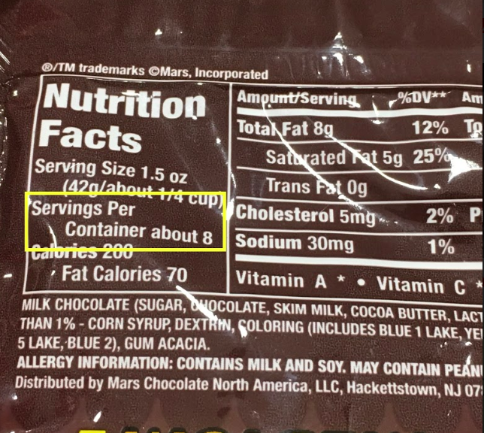

Bonus image:

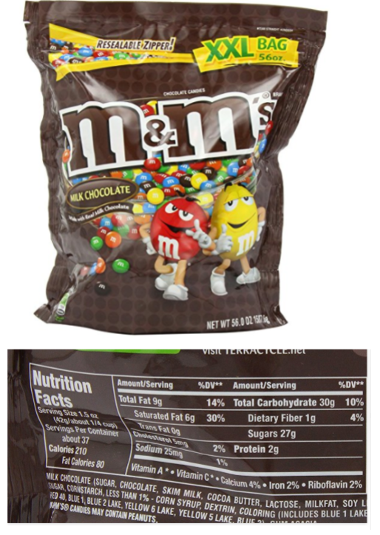

Sample Student Work:

Student 1
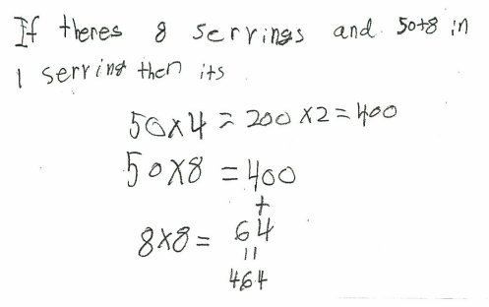

Student 2

