Synopsis of high-quality task:
This task uses summer activities to improve students’ understanding of the relationship between fractions, ratios, and decimals.

Anticipated student time spent on task: 60 minutes

Student task structure(s): Partner work
Math Content Standards and Practices:
4.NF.A.2 Compare two fractions with different numerators and different denominators, e.g., by creating common denominators or numerators, or by comparing to a benchmark fraction such as 1∕2. Recognize that comparisons are valid only when the two fractions refer to the same whole. Record the results of comparisons with symbols >, =, or <, and justify the conclusions, e.g., by using a visual fraction model.

4.NF.B.3a Understand addition and subtraction of fractions as joining and separating parts referring to the same whole. (The whole can be a set of objects.)

4.NF.C.5 Express a fraction with denominator 10 as an equivalent fraction with denominator 100, and use this technique to add two fractions with respective denominators 10 and 100. For example, express 3∕10 as 30∕100, and add 3∕10 + 4∕100 = 34∕100.

4.NF.C.6 Use decimal notation to represent fractions with denominators 10 or 100. For example, rewrite 0.62 as 62∕100; describe a length as 0.62 meters; locate 0.62 on a number line diagram.

SMP.1 Make sense of problems and persevere in solving them.
SMP.2 Reason abstractly and quantitatively.
SMP.4 Model with mathematics.
SMP.7 Look for and make use of structure.
Prior Knowledge:
3.NF.A.1 Understand a fraction 1∕b as the quantity formed by 1 part when a whole (a single unit) is partitioned into b equal parts; understand a fraction a∕b as the quantity formed by a parts of size 1∕b.
3.NF.A.2 Understand a fraction as a number on the number line; represent fractions on a number line diagram.
3.NF.A.3 Explain equivalence of fractions in special cases, and compare fractions by reasoning about their size.
Connections to the real-world:
- exciting activities during the summer
- getting to know each other through sharing
- working collaboratively
- building a community of learners within the classroom by sharing
- activities with families or groups
- fractions and decimals
- student surveys
Mastery Goals:

Learning Objective:
- Compare fractions and decimals
- Convert a decimal to a fraction
- Add fractions with different denominators
- Create a model of a fraction as well as plot a decimal on a number line

Language Objective:
- Follow directions of task by reading carefully
- State and justify their responses
- Discuss solutions involving work with fractions and decimals by using key vocabulary
- Restate questions
- Explain how they compared fractions and decimals in the synthesizing reflection
Teacher instructions
Instructional Tips/Strategies/Suggestions:
- This task should be considered for use at the end of a 4th grade unit on fractions and decimals to synthesize some key ideas
- Prepare reflection questions ahead of time, but do not display until after students work on the task
- Record information about students’ favorite summer activity (or, alternatively, use Kahoot survey to collect data that is limited to going to the beach, going fishing, going to a pool, or going camping, but can easily be kept for comparison as a follow up)
- Record “notices” and “wonders” about the Summer Fun! display on the board
- Introduce the task to the students and read the questions
- Hand out the assignment and assign partners
- Make sure each student has a blue, red, green, and orange crayon to complete part D
- Have students work in pairs to respond the prompts
- Remind students as they work about needing to explain some of their answers
- Display reflection questions on the board to allow students the think about

Reflection Questions:
Part A
- How did you decide on which operation to use for task A?
- What were the key words to help you make that decision?
- Once you wrote the equation, what did you notice?
- Why do you need to have a common denominator?
Part B
- When comparing fractions what are the strategies you used?
- Again, why is it beneficial to have a common denominator?

Part C
- What do you notice about this number line?
- How did you decide where to place the number of students who enjoyed fishing on the number line?

Part D
- Should all models look the same with the coloring pattern? Why or why not?
- How could we write an equation to match one of the models? What would the sum in this equation represent?
Instructional Materials:
- Student copies of task
- Computers/Chromebooks to complete Kahoot
- Board to display survey results
- Paper/pencil/clipboards
- Blue, red, green and orange crayons or colored pencils
- Scoring rubric – Focus on including the standards-content and practices for performance criteria. Less focus should be on presentation style, design, etc. unless it is tied directly to an ELA standard.
Accessibility and Supports:

Potential sentence starters:
I noticed…
Another way to solve this is…

Key academic vocabulary:
Number line, Fraction, Decimal, Equivalent Fraction, Equation, Model, Survey, Greater than/Less than

Student Handout:

Name __________________________

4th Grade Summer Fun with Fractions & Decimals!

Summer is so much fun! Students completed a survey about their favorite summer activity and the following data was collected.

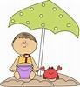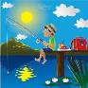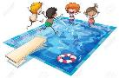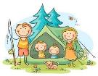

Going to the beach  38/100 students | Going fishing  9/100 students | Going to a pool  3/10 students | Going camping  .23 students

Using the information listed above please respond to the following questions.

A. What is the total fraction of students whose favorite activity is either going to the beach or going to the pool? Write an equation and solve.

B. Use <, > or = to compare the fraction of students whose favorite activity is fishing to the fraction of students whose favorite activity is going to the pool. Explain your reasoning.

C. Mark a point on the number line below to show the fraction of students whose favorite activity is camping. Explain your reasoning.

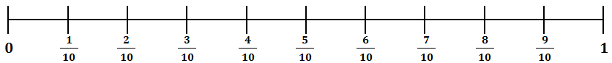

Using the information from the survey, color the model based on the following information.
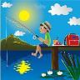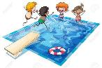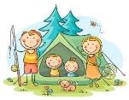

Going to the beach  38/100 students  Color blue | Going fishing  9/100 students  Color red | Going to a pool  3/10 students  Color green | Going camping  .23 students  Color orange

Sample Student Work:
- What is the total fraction of students whose favorite activity is either going to the beach or going to the pool? Write an equation and solve.
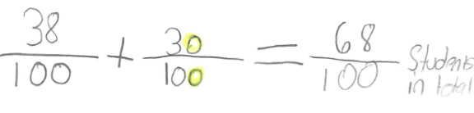

- Use <, > or = to compare the fraction of students whose favorite activity is fishing to the fraction of students whose favorite activity is going to the pool. Explain your reasoning.
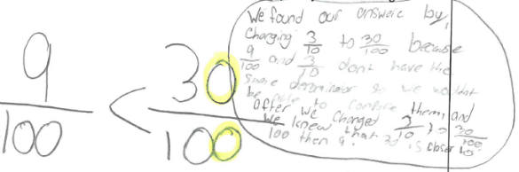

- Mark a point on the number line below to show the fraction of students whose favorite activity is camping. Explain your reasoning.

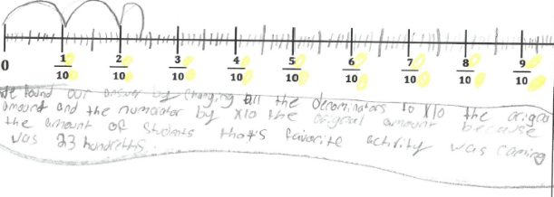
- Using the information from the survey, color the model based on the following information.
