Synopsis of high-quality task:
- This task begins with a comparison between the populations of Alaska and Vermont. Ask students to make a prediction of which population will be greater based on the relative size of the two states captured in the image below:

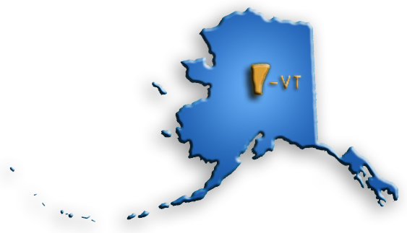

- Students then work in groups of two or three to complete parts 1 - 6 using the student handout at the end the task:

In 2018, Vermont had a population of 623,960 people and Alaska had a population of 738,068 people.
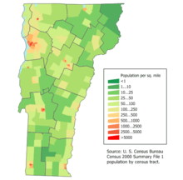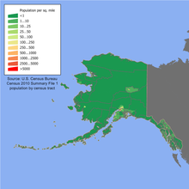

- Write each state’s population in word form.
- The value of the 6 in Alaska’s population is how many times the value of the 6 in
Vermont’s population?
- The value of the 3 in Alaska’s population is how many times the value of the 3 in
Vermont’s population?

Kenai Lake in Alaska has a maximum depth of 299.756 feet.
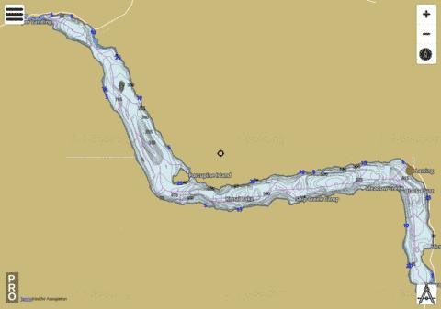

- Write the depth of Lake Kenai in expanded form.
- 299. __ __ __ Change the last three digits of Kenai Lake’s depth to make the
number smaller. Explain your reasoning.
6. Rearrange the original numbers so that the depth of the lake can be rounded to
299.5 feet.

3. The task concludes with review of solutions and a synthesizing discussion of mathematical thinking
for parts 4 - 6.

Anticipated student time spent on task: 50 minutes

Student task structure(s): Partner work and group work
Math Content Standards and Practices:
5.NBT.A.1 Recognize that in a multi-digit number, a digit in one place represents 10 times as much as it represents in the place to its right and 1/10 of what it represents in the place to its left.
5.NBT.A.2 Explain patterns in the number of zeros of the product when multiplying a number by powers of 10, and explain patterns in the placement of the decimal point when a decimal is multiplied or divided by a power of 10. Use whole-number exponents to denote powers of 10.
5.NBT.A.3 Read, write, and compare decimals to thousandths.
- Read and write decimals to thousandths using base-ten numerals, number names, and expanded form, e.g., 347.392 = 3 * 100 + 4 10 + 7 1 + 3 (1∕10) + 9 (1∕100) + 2 (1∕1000).
- Compare two decimals to thousandths based on meanings of the digits in each place, using >, =, and < symbols to record the results of comparisons.
5.NBT.A.4 Use place value understanding to round decimals to any place.
SMP.2 Reason abstractly and quantitatively.
SMP.6 Attend to precision.
SMP.7 Look for and make use of structure.
Prior Knowledge:
4.NBT.A.1 Recognize that in a multi-digit whole number, a digit in any place represents 10 times as much as it represents in the place to its right.

4.NBT.A.2 Read and write multi-digit whole numbers using base-ten numerals, number names, and expanded form. Compare two multi-digit numbers based on the meaning of the digits in each place, using >, =, and < symbols to record the results of comparisons.

4.NBT.A.3 Use place value understanding to round multi-digit whole numbers to any place.

4.NF.C.6 Use decimal notation to represent fractions with denominators 10 or 100.

4.NF.C.7 Compare two decimals to hundredths by reasoning about their size. Recognize that comparisons are valid only when the two decimals refer to the same whole. Record the results of comparisons with the symbols >, =, or <, and justify the conclusions, e.g., by using a visual model.
Connections to the real-world:
- US Geographical knowledge
- Understanding of key Math vocabulary
- Comparisons
Mastery Goals:
Learning Objective:
- Students will demonstrate their understanding of place value and rounding.
- Students will correctly represent a number in word form and expanded form.

Language Objective:
- Students will be able to use mathematical vocabulary to explain the solution to the problem.
- Students will discuss possible solutions and outcomes with group members.
- Students will brainstorm different entry points to the task.
- Students will describe the place value of numeral digits relative to the place to the left and right.
Teacher instructions
Instructional Tips/Strategies/Suggestions
- Break students up into partners or small groups.
- Each student receives a worksheet to fill out on their own while working with their partner(s).
- Look over all six parts as a whole class to clarify directions and expectations.
- Circulate the room as students work independently.
  - Make sure students are showing their work.
  - On part 4, make sure they are using the decimal when writing in expanded form.
  - Students should answer part 5 in complete sentences.
  - Parts 5 and 6 can have the same answer.
- After completed, review answers as whole class.
Instructional Materials
Include:
- Teacher Instruction Packet
- Student Packet
  - One copy for each student.
  - Pencil.
Accessibility and Supports:

Potential sentence starters:
- I rearranged the number to ___________________

Key academic vocabulary:
- Word Form
- Expanded Form
- Population
- Depth
- Rounding
Supports:
- Place Value Chart

Sample Student Work:
In 2018, Vermont had a population of 623,960 people and Alaska had a population of 738,068 people.
- Write each state’s population in word form.
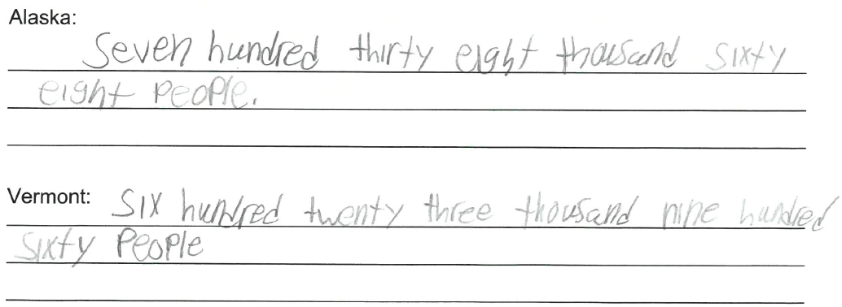
- The value of the 6 in Alaska’s population is how many times the value of the 6 in Vermont’s population?
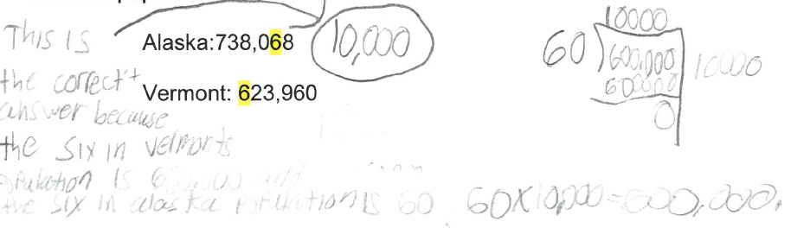
- The value of the 3 in Alaska’s population is how many times the value of the 3 in Vermont’s population?

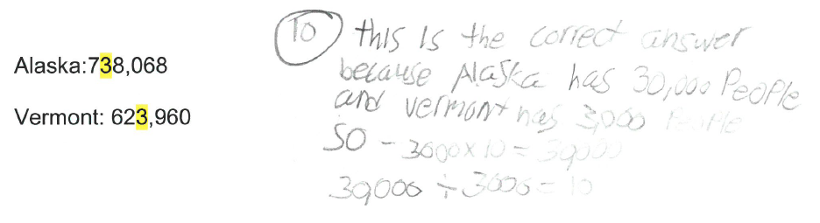

Kenai Lake in Alaska has a maximum depth of 299.756 feet.
4. Write the depth of Lake Kenai in expanded form.
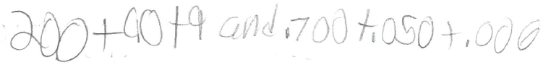

5. 299. __ __ __ Change the last three digits of Kenai Lake’s depth to make the number smaller.
Explain your reasoning.
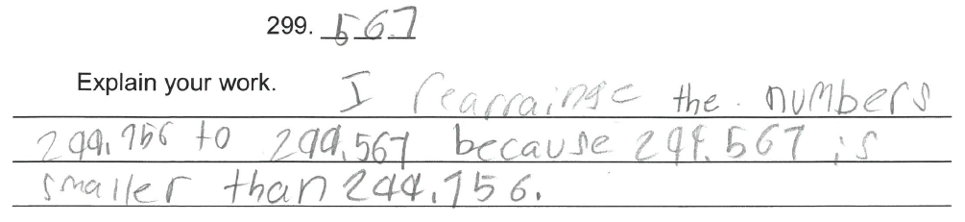
6. Rearrange the original numbers so that the depth of the lake can be rounded to 299.5 feet.

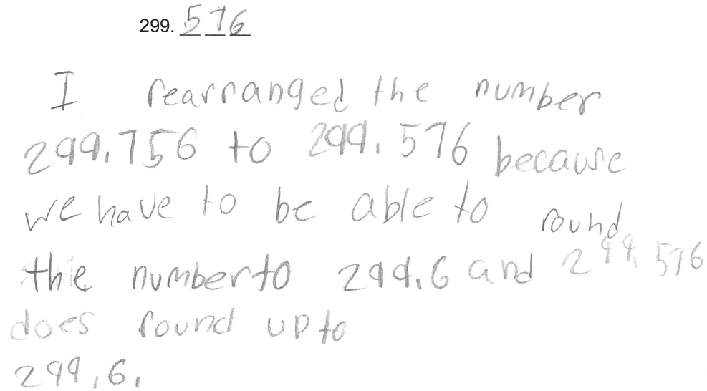

Student Handout:

Name __________________________

Alaska vs Vermont: What state population will win? (5th Grade Place Value)

In 2018, Alaska had a population of 738,068 people.
and Vermont had a population of 623,960 people
- Write each state’s population in word form.

Alaska:
________________________________________________________________________________________________________________________________________________________________________________________________________________________________________________________________________
Vermont:
________________________________________________________________________________________________________________________________________________________________________________________________________________________________________________________________________
2. The value of the 6 in Vermont’s population is how many times the value of the 6 in Alaska’s population? Show your work.

Alaska:738,068

Vermont: 623,960

3. The value of the 3 in Alaska’s population is how many times the value of the 3 in Vermont’s population? Show your work.

Alaska:738,068

Vermont: 623,960

Kenai Lake in Alaska has a maximum depth of 299.756 feet.

4. Write the depth, 299.756 feet, of Lake Kenai in expanded form.

5. 299. __ __ __ Rearrange the last three digits of Kenai Lake’s depth to make the number smaller.

299. __ __ __

Explain your work.
________________________________________________________________________________________________________________________________________________________________________________________________________________________________________________________________________
6. Rearrange the original numbers so that the depth of the lake can be rounded to 299.6 feet.

299. __ __ __s

